Whole of Government
Cloud Policy
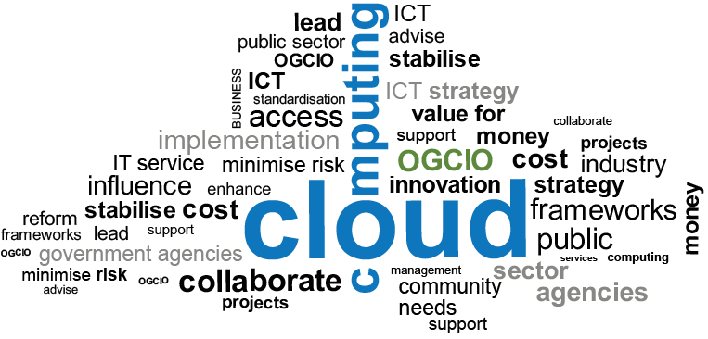

Document Control
The Western Australian Whole of Government Cloud Policy: Version 3 - September 2020
Produced and published by: Office of Digital Government
Acknowledgements: This Policy was developed in collaboration with the Western Australian public sector agencies.
Contact:
Office of Digital Government
2 Havelock Street
WEST PERTH WA 6005
Telephone: (08) 6552 5000 (Switchboard – please ask for the Office of Digital Government)
Email: dgov-administrator@dpc.wa.gov.au
Document version history
Date | Author | Version | Revision Notes
May 2016 | DGov | 1 | Release
October 2020 | DGov | 3 | Revised. References to the Office of the Government Chief Information Officer changed to Office of Digital Government. Contact details and attribution information updated. Related guidance removed.

This document, the Western Australian Whole of Government Cloud Policy, Version 1 is licensed under a Creative Commons Attribution 4.0 International Licence. You are free to re-use the work under that licence, on the condition that you attribute the Government of Western Australia (Office of Digital Government) as author, indicate if changes were made, and comply with the other licence terms. The licence does not apply to any branding or images.
License URL: https://creativecommons.org/licenses/by/4.0/legalcode
Attribution: © Government of Western Australia (Office of Digital Government) 2020
Notice Identifying Other Material and/or Rights in this Publication:
The Creative Commons licence does not apply to the Government of Western Australia Coat of Arms. Permission to reuse the Coat of Arms can be obtained from the Department of the Premier and Cabinet.
The cover image by Maxiphoto is reproduced with the permission of istock.

Policy Statement
The Western Australian Government is committed to moving away from being an owner of information and communications technology (ICT) assets to becoming a consumer of technology services from specialist third party providers. Central to this new direction is the adoption of cloud services that enable Government to be more flexible, scalable and deliver better services to more people.
To ensure government is capable of embracing this new environment, agencies should ensure that the appropriate skills are available to successfully identify, deploy and maintain cloud solutions that aid in the realisation of business objectives while effectively managing risk and achieving value for money.

Purpose
The purpose of the Western Australian Government Cloud Policy (the Policy) is to establish a cloud mindset for the consumption of infrastructure, software and platforms and encourage the widespread adoption of cloud services across the Western Australian Government.

Objectives
The objectives of the policy are to:
- establish the expectation across government that cloud services should be adopted in favour of traditional, own and operate ICT solutions where appropriate;
- create a more flexible, connected and agile public sector that fully understands the cost of its ICT;
- build the requisite skills within Government’s ICT workforce to effectively leverage cloud offerings to deliver new and improved services; and
- reduce Government’s physical footprint of owned infrastructure such as replicated servers and static storage.

Principles
The following principles describe the priorities of the Western Australian Government in its adoption of cloud services.

Consumption by default
Agencies are skilled experts in planning, consuming and leveraging cloud services that enable the achievement of business objectives. Costs can be fully understood, and agencies only pay for what they use.

High agility, scalability and mobility
Resources are available in real time, on demand, anywhere, on any device, and are not limited to the physical constraints of agency owned infrastructure.

Simplified, connected Government
Agencies are able to share information via interoperable cloud services, supporting interagency collaboration and facilitating the development of integrated government services.

Strategic ICT Delivery
Agency ICT functions work alongside business managers to deliver strategic objectives and enhance service delivery, while dedicating minimal resources to the management of physical assets.

Holistic Security
Agencies are able to leverage the capabilities of mature cloud providers with state-of-the-art security and dedicated teams of professionals monitoring and responding to threats. Secure, cloud services align with and complement agencies own security policies and practices.

Resilient services that ensure business continuity
The failure of one component of cloud services has less impact on overall service availability and reduces the risk of downtime. Agencies adopt cloud services that are consistent with their business continuity and disaster recovery plans.

Risk-based Decision Making
Agencies identify, assess and understand the risks of cloud services, including the security and privacy of data being stored and maintained by third party providers, and consider these risks in their cloud planning.

Definitions
Cloud Computing and the cloud service models (including SaaS, PaaS and IaaS) are defined in NIST Special Publication 800-145 in accordance with National Institute of Standards and Technology (NIST) definitions, available from:
http://nvlpubs.nist.gov/nistpubs/Legacy/SP/nistspecialpublication800-145.pdf.

