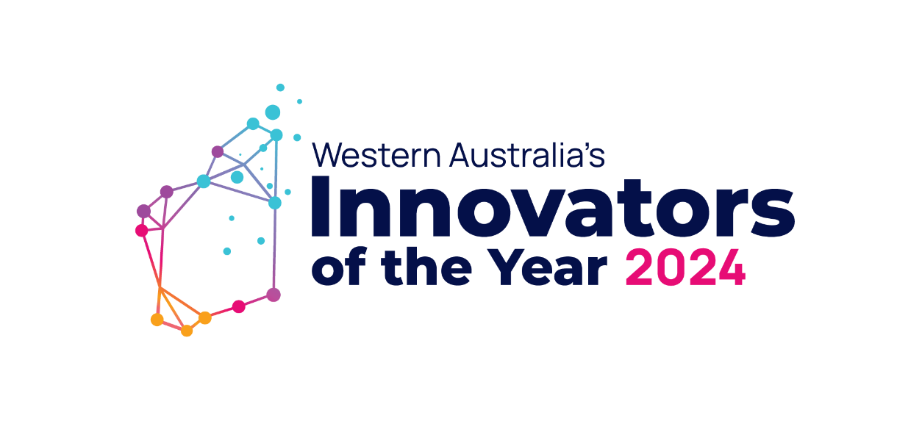
Key Messages for General Correspondence
- Applications are open for Western Australia’s Innovators of the Year 2024 and close at 11:00AM (AWST) on Friday, 31st May 2024
- The Awards are in their 18th year, showcasing Western Australian innovative and entrepreneurial individuals, businesses, and creative minds since 2006.
- The awards program is an initiative of the New Industries Fund. The fund aims to support an accelerate new and emerging businesses in WA.
- The innovations must demonstrate an economic, social, and/or environmental benefit to WA.
- The 2024 program recognises Western Australian innovators through 7 awards across 5 categories.
- Award winners will share a prize pool of $240,000, with the Growth and Emerging category winners to be awarded $60,000 each.
- The awards are:
  - WA’s Innovators of the Year – Rio Tinto Emerging Innovation
  - WA’s Innovators of the Year – Runner up Rio Tinto Emerging Innovation
  - WA’s Innovators of the Year – Rio Tinto Growth Innovation
  - WA’s Innovators of the Year – Runner-up Rio Tinto Growth Innovation
  - Woodside Energy Platinum Award for Energy Innovation
  - Wesfarmers Wellbeing Platinum Award
  - Business News Great for the State Platinum Award
- In addition to the funding available, the WAIOTY program offers all finalists:
  - A professionally edited 2-minute video of their innovation which is shown at the Awards Ceremony and is gifted to the finalist following the conclusion of the program for marketing and promotion of their business and innovation.
  - Professional photographs of the company and their innovation.
  - Featured in a Business News full-page spread with their finalist peers.
  - An invitation to an 'Accelerator Program', with workshops and webinars to refine your pitch presentation, protect your IP, grant writing and more.
- Find more information and apply on the 2024 application information page.
Post Suggestion | Applications are now open for Western Australia’s Innovators of the Year 2024 program!  If you have an outstanding product, technology, or service currently in its emerging or growth development phase, don’t miss out on your chance to win a share of the program’s $240,000 prize pool money!  Finalists will receive a professional video and photographs, an invitation to a skills development program and more!  📅 Applications close at 11am (AWST) Friday, 31 May 2024  To learn more or to apply, visit: https://www.wa.gov.au/organisation/department-of-jobs-tourism-science-and-innovation/western-australias-innovators-of-the-year-2024-application-information?auHash=6XbJqkT2vHTsu1C7UqUKtAw93D9WHrH0M00I6T2zjY0
Tags | @LikeNoOtherWA  @Department-of-Jobs-Tourism-Science-and-Innovation  @StephenDawson @RogerCookMLA @RioTintoAustralia @BusinessNews @Wesfarmers @WoodsideEnergy @GriffithHack @NexiaPerth @Wrays @CSIRO @MooreAustralia @Betterlabs @AIMI @CERI @BiodesignAustralia
Hashtags | #WAIOTY24 #IOTY #WAIOTY #NewIndustriesFund #Innovation #WesternAustralia #LikeNoOtherWA

