COPP 9.7 Change of Sex or Gender Process of a Prisoner
Prison
Principles
As referenced in the Guiding Principles for Corrections in Australia, 2018:

1.3.1 Effective systems provide prisoners/offenders with opportunities to make requests or complaints and access appropriate information.

1.5.1 Comprehensive and contemporary information is recorded to support appropriate assessment and continued management of prisoners/offenders.

Contents
1 Scope 3
2 Policy 3
3 Approval to Apply to Register a Change of Sex or Gender Application or Apply for an Acknowledgment Document 4
3.1 Pre-requisites and eligibility 4
3.2 Procedure 5
3.3 Commissioner approval 6
4 Registry of Births, Deaths and Marriages (Registry) Approval 8
5 Annexures 10
5.1 Definitions and acronyms 10
5.2 Related legislation 11
5.3 Other documents 11
6 Assurance 12
7 Document Version History 12
Appendix A – Approval to Apply to Register a Change of Sex or Gender or Issue an Acknowledgment Document 13

Scope
This Commissioner’s Operating Policy and Procedure (COPP) applies to all prisons administered by or on behalf of the Department of Justice (the Department).

Policy
In accordance with the Births, Deaths and Marriages Registration Act, 1998 (the BDMR Act), a restricted person must make an application to a supervisory authority for approval to make an application to the Registry of Births, Deaths and Marriages (the Registry):
- to change their sex or gender in their birth registration; or
- for an acknowledgment document, acknowledging their sex or gender.
The Commissioner, Department of Justice, Corrective Services (the Commissioner), delegated by the Chief Executive Officer is the supervisory authority responsible for approving prisoner applications to make an application to the Registry:
- to change the sex or gender of a restricted person; or
- for an acknowledgment document for a restricted person.
An application for approval to apply to the Registry to change sex or gender or be issued with an acknowledgment document, must be made in a manner approved by the Commissioner.
A prisoner can apply to change their name in accordance with COPP – 9.4 Prisoner Change of Name.

Approval to Apply to Register a Change of Sex or Gender Application or Apply for an Acknowledgment Document

Pre-requisites and eligibility

A prisoner can make an application to the Commissioner for approval to make a change of sex or gender application to the Registry, if the:

prisoner is aged 18 years or over;

prisoner’s birth is registered in Western Australia (WA); and

prisoner believes that their sex or gender is the sex or gender specified in the application.

If the prisoner is aged under 18 years of age, please refer to Youth Detention Centre COPP 7.8 – Change of Sex or Gender Process of a Young Person.

A prisoner can make an application to the Commissioner for approval to apply to the Registry for an acknowledgment document if the prisoner:
- is born outside of Australia; and
- has lived in the State for at least 12 consecutive months immediately before the day the application is made; and
- believes that their sex or gender to be the sex or gender specified in the application.

If the prisoner’s birth is registered in a different Australian State or Territory, they are not eligible to apply under the Western Australian process and must apply to change their sex or gender under the process in their birth of State or Territory.

The eligibility criteria to apply to the Registry to change sex or gender or make an application for the issue of an acknowledgment document, is detailed on the Application for a change of registration of a sex or gender for an adult (18 years or older) born in Western Australia form BDM501 (BDM501) and the Application to the Registrar for a document acknowledging sex or gender of an adult (18 year or older) born overseas form BDM502 (BDM502).

An application fee is required when applying to the Registry (refer BDM501 or BDM502). Note: the prisoner should be advised that the application fee is retained regardless of the outcome of the application.

At least three forms of identification are required for the application to the Registry, including one with a photo (refer to form BDM501or BDM502), which may include:
- birth certificate of the applicant
- any two documents showing proof of residency
- a statement from a doctor or psychologist certifying appropriate clinical treatment
- photographic identification.

The Approval to Apply to Register a Change of Sex or Gender application on TOMS, must:
- be in the approved application on TOMS
- specify the prisoner’s sex or gender as a kind prescribed in the Births, Deaths and Marriages Registration Regulations 1999, being either ‘male, ‘female’ or ‘non-binary’
- be accompanied by a statement from a doctor or psychologist certifying that the prisoner has received appropriate clinical treatment in relation to the prisoner’s sex or gender
- be accompanied by any other documentation/information prescribed in the BDMR Act
- contain a declaration by the prisoner setting out whether the prisoner is, at the time the application is made, a required declarant.

Procedure

Where a prisoner requests to apply to the Registry to change their sex or gender, whether in their birth of registration or through the issue of an acknowledgment document, the following procedures shall apply:
- staff shall ensure the prisoner meets the eligibility criteria listed in the BDM501 or BDM502 form
- staff shall print a hard copy of the Approval to Apply to Register a Change of Sex or Gender application from TOMS (refer to Appendix A), and where required, assist the prisoner with completing the hard copy application
- once the Approval to Apply to Register a Change of Sex or Gender application is completed, staff shall forward the hardcopy application to the assigned staff member (eg Transitional Manager, Case Coordinator) who shall enter the details provided onto the TOMS Approval to Apply to Register a Change of Sex or Gender application
- the assigned staff member shall then print a hard copy of the application and have the prisoner complete and sign Part B, sections 6 and 7. The assigned staff member shall complete and sign Part B, sections 8 and 9
- the assigned staff member shall then forward the printed and signed Approval to Apply to Register a Change of Sex or Gender application along with any relevant history/charges of the prisoner and confirmation that the prisoner’s Victim Notification Register (VNR) / Victim-offender Mediation Unit (VMU) has been checked before being forwarded to the Superintendent for review (Part B, section 9; and Part C, section 10).

The Superintendent shall review the Approval to Apply to Register to Change of Sex or Gender application on TOMS, in accordance with the eligibility criteria listed in the BDM501 or BDM502 form and state whether the application is supported in Part C, section 10 of the Approval to Apply to Register to Change of Sex or Gender application.

The Superintendent shall not support the Approval to Apply Register to Change of Sex or Gender application, if the change of sex or gender, whether in the prisoner’s birth registration, or through the issue of an acknowledgment document is:

reasonably likely to have an adverse effect on the security, discipline or good order of the prison where the prisoner is to be detained; or

reasonably likely to be considered offensive by a victim of the prisoner’s crime or a significant sector of the community or;

frustrate the administration of any of the following:
- High Risk Serious Offenders Act 2020
- Prisons Act 1981
- Sentence Administration Act 2003
- Sentencing Act 1995.

The Superintendent, in completing Part C, section 10 of the Approval to Apply to Register a Change of Sex or Gender application, shall:

consult with and obtain comment/advice from the victim(s) through the VNR, where the prisoner has a TOMS VNR Alert; and

consider any other matters outlined in Part C, section 10.

The Superintendent shall prepare an internal memorandum attaching the completed Approval to Apply to Register a Change of Sex or Gender application with supporting evidence and forward to the relevant Assistant Commissioner:

Adult Male Prisons - CS-AMP-Operations@justice.wa.gov.au

Adult Women’s Prisons - AWP@justice.wa.gov.au.

The Superintendent must ensure the application is saved in accordance with Departmental record keeping practices and recorded on TOMS.

The relevant Assistant Commissioner shall review and sign the application, prior to progressing it to the Office of the Commissioner (Part C, section 10).

The completed form shall be progressed to the Office of the Commissioner for the Commissioner’s consideration (Part D, section 11).

Commissioner approval

The Commissioner shall not approve the Approval to Apply to Register a Change of Sex or Gender application, unless satisfied that the request, in all the circumstances is necessary and reasonable and all matters have been considered as set out under section 3.2.3 of this COPP.

If approved by the Commissioner, the completed and signed Approval to Apply to Register a Change of Sex or Gender application shall be emailed back to the Superintendent of the sending prison, who shall notify the prisoner in writing of the outcome.

Staff shall ensure that a copy of the BDM501 or BDM502 form is printed and shall give the prisoner assistance to complete the form, as required.

Once completed, the Transitional Manager shall compile the:

signed hardcopy of the BDM501 or BDM502 form

signed copy of the Approval to Apply to Register a Change of Sex or Gender application

required proof of identity (refer to section 3.1.7)

application fee and all other application requirements (refer to the BDM501 or BDM502 form)

save all documents in accordance with the Department record keeping practices.

The Superintendent or delegate shall ensure the compiled documents at section 3.3.4, are sent to:

Registry of Births Deaths & Marriages
PO Box 7720, Cloisters Square
Perth, Western Australia 6850

Any supporting documents, which are originals, shall be copied and the originals returned to the prisoner or the prisoner's property. Only copies of the supporting documentation will be forwarded to Operational Information Management.

If an Approval to Apply to Register a Change of Sex or Gender application is not approved by the Commissioner, the application will not progress to the Registry.

On receiving notification of the decision, the Superintendent shall inform the prisoner in writing as to the reason why the Approval to Apply to Register a Change of Sex or Gender application was not approved, as soon as practicable.

Registry of Births, Deaths and Marriages (Registry) Approval

The Registry must not change a prisoner’s sex or gender in their birth registration or issue an acknowledgment document to a restricted person, unless they have received the Approval to Apply to Register a Change of Sex or Gender application approved by the Commissioner.

The Commissioner, if requested by the Registry, shall provide the following additional information for the purpose of verifying details of the prisoner, prior to a decision being made on an application:
- the name they are currently known by
- any other name by which they are, or have previously been known
(of which the Commissioner is aware)
- date of birth
- any other information that may be used to identify the person.

On receipt of the BDM501 or BDM502 form and accompanying documents (refer to section 3.3.4), the Registry, if applicable, will register the change of sex or gender or register the issuing of an acknowledgement document and notify the datamanagementgroup@justice.wa.gov.au, who will if applicable, change the prisoner’s sex or gender on TOMS.

Following the changing of a prisoner’s sex or gender or receipt of an acknowledgment document on TOMS, an automated TOMS notification shall be sent via email to the following stakeholders:
- Supervisory Authority (Commissioner) via the Office of the Commissioner
- CS-DIV-Superintendents
- CS-AMP-Operations
- Adult Women’s Prisons (AWP).

Upon receiving an automated TOMS notification of the approval by the Registry to change the prisoner’s sex or gender or issue of an acknowledgment document, the Superintendent shall inform the:

prisoner

relevant business areas, to include Health Services and Education Services within the prison to amend all hard copy records held in relation to the prisoner (eg Prisoner ID Card, Unit Files, Count Boards etc); and

VNR, for a prisoner with a TOMS VNR alert.
    - If not approved, the Registry shall notify in writing as soon as practicable, the following:
- Supervisory Authority (Commissioner) via email at the Office of the Commissioner: Commissioner@justice.wa.gov.au
- prisoner, outlining the reason why the application was not approved.

If the Registry does not approve a prisoner’s application to change their sex or gender or application to obtain an acknowledgment document, the prisoner can apply to the State Administrative Tribunal for a review of the decision.

The Registry may notify the Commissioner of an application to change the sex or gender of a prisoner or, an application for the issue of an acknowledgment document, if they identify that the prisoner has not sought the Commissioner’s approval.

Annexures

Definitions and acronyms
Term | Definition
Acknowledgment Document | A document issued under the Births, Deaths and Marriages Registration Act 1998, which acknowledges a person’s sex or gender
Commissioner’s Operating Policy and Procedures (COPP) | COPPs are Operational Instruments that provide instructions to staff how the relevant legislative requirements are implemented.
Guiding Principles for Corrections in Australia, 2018 | The guidelines and the accompanying principles constitute outcomes or goals to be achieved, rather than a set of absolute standards or laws to be enforced. They represent a statement of intent that each Australian State and Territory can use to develop their own range of relevant legislative policy and performance standards to reflect best practice and community demands.
Required declarant | Required declarant has the meaning given under s. 28A of the Births, Deaths and Marriages Registration Act 1998 and means a person who is any of the following —  (a) a high risk serious offender;  (b) a detainee;  (c) a person subject to an early release order;  (d) a prisoner;  (e) a reportable offender;  (f) a supervised offender.
Restricted Person | Restricted person has the meaning given under s. 36A of the Births, Deaths and Marriages Registration Act 1998 and means a person, other than a reportable offender, who is any of the following –  - a high risk serious offender;  - a detainee;  - a person subject to an early release order;  - a prisoner;  - a supervised offender.
Superintendent | The Superintendent as defined in s. 36 Prisons Act 1981 and includes any reference to the position responsible for the management of a private prison under Part IIIA Prisons Act 1981. Does not extend to the Officer in Charge of a prison.
Supervisory authority | Supervisory authority has the meaning given under s. 36A of the Births, Deaths and Marriages Registration Act 1998 (WA) and means –  - for a high risk serious offender, the chief executive officer of the department principally assisting in the administration of the High Risk Serious Offenders Act 2020 Part 4 Division 2; or  - for a person subject to an early release order, the Prisoners Review Board established under s. 102(1) of the Sentence Administration Act 2003; or  - for a prisoner, the chief executive officer as defined in  s. 3(1) of the Prisons Act 1981; or  - for a supervised offender, the chief executive officer of the department principally assisting in the administration of the provision of the Act under which the supervised offender is supervised or monitored.  In the context of this COPP, the supervisory authority is the Commissioner who has the delegated authority of the chief executive officer (Director General of the Department of Justice) to carry out the powers and duties of the supervisory authority under Part 5A Division 4 of the Births, Deaths and Marriages Registration Act 1998.
Total Offender Management Solution (TOMS) | An electronic database used by the Department of Justice to record and manage comprehensive information relating to prisoners.

Related legislation
- Births, Deaths and Marriages Registration Act 1998
- Births, Deaths and Marriages Registration Regulations 1999
- Prisons Act 1981
- Prisons Regulations 1982
- State Records Act 2000.

Other documents
- Records Management Policies and Procedures

Assurance
It is expected that:
- Prisons will undertake local compliance in accordance with the Compliance Manual.
- The relevant Deputy Commissioner will undertake management oversight as required.
- Operational Compliance will undertake checks in accordance with the Operational Compliance Framework.
- Independent oversight will be undertaken as required.

Document Version History

Version no | Primary author(s) | Description of version | Date completed | Effective date
1.0 | Operational Policy | Approved by the Commissioner, Corrective Services  CM Ref: S25/25586 | 15 May 2025 | 30 May 2025
2.0 | Operational Policy | Approved by Deputy Commissioner, Operational Support  CM Ref: S25/87977 | 17 October 2025 | 17 October 2025

Appendix A – Approval to Apply to Register a Change of Sex or Gender or Issue an Acknowledgment Document
- In TOMS open a prisoner, detainee or young person record
- Select Assessment – ACM Checklists – Perform

Image 1
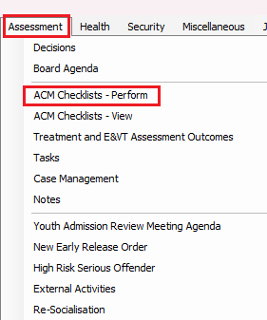
Image 2
ACM Checklists – Perform Wizard opens
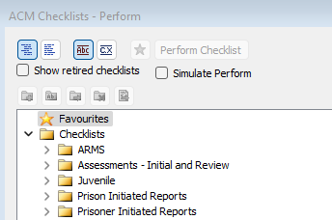
- Navigate to the ‘Assessments – Initial and Review’ folder and expand it by clicking on the > symbol
- Select ‘Approval to Apply to Register a Change of Sex or Gender’
- Click on ‘Perform Checklist’ to start the process.
- Refer to section 3.2 Procedure in this COPP to follow the order of the procedures.

Image 3

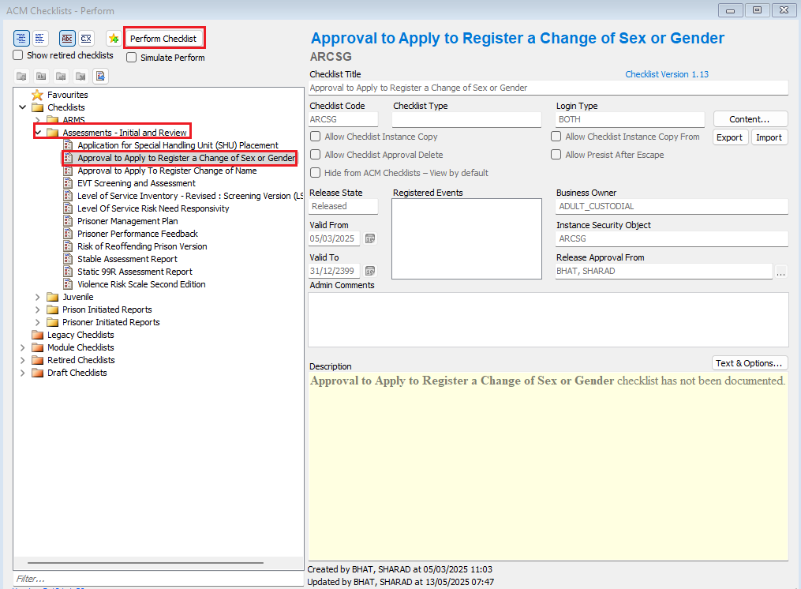

s. 36ZH and s. 36ZJ of the Births, Deaths and Marriages Registration Act 1998
s. 36ZJ of the Births, Deaths and Marriages Registration Act 1998
s. 36A of the Births, Deaths and Marriages Registration Act 1998
s. 36ZJ(3) of the Births, Deaths and Marriages Registration Act 1998
Division 2, s. 36J of the Births, Deaths and Marriages Registration Act 1998
s. 36T of the Births, Deaths and Marriages Registration Act 1998
s. 36J(2)(b) and s. 36T (2)(b) of the Births, Deaths and Marriages Registration Act 1998
r. 5 of the Births, Deaths and Marriages Registration Regulations 1999
s. 36J(2)(c)(ii) and 36T(2)(c)(ii) of the Births, Deaths and Marriages Registration Act 1998
s. 36J(2)(d) and s. 36T (2)(d) of the Births, Deaths and Marriages Registration Act 1998
s. 67(1) of the Births, Deaths and Marriages Registration Act 1998

