COPP 7.8 Change of Sex or Gender Process of a Young Person
Youth Detention Centre
Principles
In the context of the following:

Australian Human Rights Commission National Principles for Child Safe Organisations, 2018

Risk management strategies focus on preventing, identifying and mitigating risks to children and young people.

The organisation, including staff and volunteers, understands children and young people’s diverse circumstances and provides support and responds to those who are vulnerable.

Australasian Youth Justice Administrators Standards, 2009

Privacy and confidentiality rights are protected.

Family and community contact is facilitated for children and young people in custody.

Continuity of service is provided.

Contents
1 Scope 3
2 Policy 3
3 Approval to Apply to Register to Change Sex or Gender Application or Apply for an Acknowledgment Document 4
3.1 Pre-requisites and eligibility 4
3.2 Procedure 6
3.3 Commissioner approval 8
4 Registry of Births, Deaths and Marriages (RBDM) Approval 9
5 Annexures 11
5.1 Definitions and acronyms 11
5.2 Related legislation 12
6 Assurance 12
7 Document Version History 13
Appendix A – Approval to Apply to Change Sex or Gender 14

Scope
This Commissioner’s Operating Policy and Procedure (COPP) applies to all Youth Detention Centres (YDCs) administered by or on behalf of the Department of Justice (the Department).

Policy
In accordance with the Births, Deaths and Marriages Act 1998 (WA), the parents or guardians of a child aged 12 years or over who is a restricted person (young person) must make an application to a supervisory authority for approval to make an application to the Registry of Births, Deaths and Marriages (RBDM) to either:
- change the child’s sex or gender in their birth registration (change of sex or gender application), or;
- If the child is born overseas, issue an acknowledgment document, acknowledging the sex or gender of the child.
If a protection order (time-limited) or a protection order (until 18) under the Children and Community Services Act 2004 (WA) is in force in respect to the young person, then the application to the supervisory authority and the application to the RBDM must be made by the Chief Executive Officer (CEO),Children and Community Services. The CEO (Children and Community Services) can only apply if no parent(s) opposes the making of the application.
The Commissioner, Department of Justice, Corrective Services (the Commissioner), delegated by the Chief Executive Officer, is the supervisory authority responsible for approving a young person’s application to the RBDM to change sex or gender in their birth registration or be issued with an acknowledgment document.
An application for approval from the supervisory authority to make an application to the RBDM to change sex or gender or be issued with an acknowledgment document, must be made in a manner approved by the Commissioner, if a young person is aged 12 years or over.
If one or both of the young person’s parents or guardians do not consent to the change of sex or gender application or acknowledgment document application; then the approval of the supervisory authority is not required. Rather, an application must be made to the Family Court for approval to make an application to the RBDM.
In accordance with the Births, Deaths and Marriages Act 1998 (WA), the parents or guardians of a child aged 12 years or over, who is a restricted person (young person) must make an application to a supervisory authority for approval to make an application to the RBDM to apply to change a young person’s name (refer to COPP 7.7 – Change of Name (Young Person).

Approval to Apply to Register to Change Sex or Gender Application or Apply for an Acknowledgment Document

Pre-requisites and eligibility

The parents or guardians of a young person or the CEO, Children and Community Services can make an application to the Commissioner for approval to make a change of sex or gender application, if:

the young person’s birth is registered in Western Australia (WA);

the young person consents to the change in accordance with the application; and

each applicant believes the young person’s sex or gender to be the sex or gender specified in the application

both parents or guardians of the young person, if the young person has more than one parent or guardian, consent to the making of a change of sex or gender application.

The parents or guardians of a young person or the CEO, Children and Community Services can make an application to the Commissioner for approval to make an application to BDMR for the issue of an acknowledgment document if:
- the young person is born outside of Australia; and
- the young person has lived in the State for at least 12 consecutive months immediately before the day the application is made; and
- the young person consents to the issue of the acknowledgment document in accordance with the application; and
- each applicant believes the young person’s sex or gender to be the sex or gender specified in the application; and
- both parents or guardians of the young person, if the young person has more than one parent or guardian, consent to the making of an application for the issue of an acknowledgment document.

If the young person’s birth is registered in a different Australian state or territory, they are not eligible to apply under the Western Australian process and must apply to change their sex or gender under the process in their birth of state or territory.

The eligibility criteria to apply to the RBDM to make a change of sex or gender application or make an application for the issue of an acknowledgment document in relation to a young person, is detailed on the following applications:

Application for a change of registration of sex or gender for a child (12 to 17 years) born in Western Australia (BDM503)

Application to the Registrar for a document acknowledging sex or gender of a child (12 to 17 years) born overseas (BDM504)

Application for a change of registration of a sex or gender for a child (under 12 years) born in Western Australia (BDM 505)

Application to the Registrar for a document acknowledging sex or gender for a child (under 12 years) born overseas (BDM 506).

An application fee is required (refer BDM 503, BDM 504, BDM 505 or BDM 506.

Note: the parent/guardian or CEO, Children and Community Services shall be advised that the application fee is retained regardless of the outcome of the application.

At least three forms of identification are required for the application to the BDMR, including one with a photo (refer BDM 503, BDM 504, BDM 505 or BDM 506), which may include:
- the original, or certified copy of the birth certificate of the applicant
- the original, or certified copies, of any documents showing proof of residency.

The Approval to Apply to Change Appendix A – Approval to Apply to Change Sex or Gender Sex or Gender Application form on TOMS, shall be completed by the Senior Case Manager, Case Planning, in consultation with the young person, their parents or guardians or the CEO, Children and Community Services, and must:
- be in the approved form on TOMS
- specify the young person’s sex or gender as a kind prescribed in the Births, Deaths and Marriages Registration Regulations 1999 (WA), being either ‘male’, ‘female’ or ‘non-binary’
- be accompanied by a statement from a doctor/psychologist certifying that the young person has received appropriate clinical treatment in relation to the young person’s sex or gender and understands the meaning and implications of the application
- be accompanied by a statement from the young person, consenting to the change of sex or gender, or, issuing of an acknowledgment document
- be accompanied by any other documentation/information prescribed in the Births, Deaths and Marriages Registration Regulations 1999 (WA); and
- contain a declaration by each applicant setting out whether the young person is, at the time the application is made, a required declarant.

Procedure

Where the parents or guardians or CEO, Children and Community Services requests to make a change of sex or gender application in relation to an application to change the young person’s sex or gender in their birth registration or in relation to an application for the issue of an acknowledgment document) the following procedures shall apply:
- the Superintendent or delegate, in consultation with the Senior Case Manager, Case Planning shall seek confirmation from the young person that they agree to the request to change their sex or gender and record their response in the ‘Approval to Apply to Change Sex or Gender Application form on TOMS
- the Senior Case Manager, Case Planning shall:
- ensure the young person meets the eligibility criteria listed in the BDM 503, BDM 504, BDM 505 or BDM 506 forms
- print out the ‘Approval to Apply to Change Sex or Gender Application form on TOMS and assist the young person and their parents, guardians or the CEO (Children and Community Services) to complete the hard copy application
- on completion of the ‘Approval to Apply to Change Sex or Gender Application form, forward the hardcopy application to the assigned staff member (eg Transitional Manager, Case Coordinator).
- The assigned staff member, on receiving the hardcopy ‘Approval to Apply to Change Sex or Gender Application’ form, shall:
- enter the details provided onto the TOMS ‘Approval to Apply to Change Sex or Gender Application’ form
- print out the application and have the young person complete and sign part 6
- complete and sign part 7 and part 8.

The assigned staff member shall then forward the printed and signed ‘Approval to Apply to Change Sex or Gender Application’ to the Superintendent for consideration, (along with any relevant history/charges of the young person and confirmation that the young person Victim Notification Register (VNR)/Victim Engagement Unit (VEU) has been checked, contact via email: VEU@justice.wa.gov.au or telephone: 1800 214 655).

The Superintendent shall review the Approval to Apply to Change Sex or Gender Application form on TOMS, in accordance with the eligibility criteria listed in the BDM 503, BDM 504, BDM 505 or BDM 506 forms and state whether the application is supported in Part B, section 9 of the Approval to Register to Change Sex or Gender Application form, prior to forwarding to the relevant Assistant Commissioner for their consideration.

The Superintendent shall not support the Approval to Apply to Change Sex or Gender Application form if, the changes of sex or gender or the issue of an acknowledgment document is reasonably likely to:
- have an adverse effect on the security, discipline or good order of the YDC where the young person is to be detained, or;
- be considered offensive by a victim of the young person’s crime or a significant sector of the community or;
- frustrate the administration of any of the following:
- High Risk Serious Offenders Act 2020
- Sentence Administration Act 2003
Sentencing Act 1995
- Young Offenders Act 1994
- Young Offenders Regulation 1995.
- any other reasons outlined in Part B section 9 of BDM 503, BDM 504, BDM 505 or BDM 506 forms.

The Superintendent, in completing Part B, section 9 of the ‘Approval to Apply to Register to Change Sex or Gender Application’ form, shall:

consult with and obtain comment/advice from the victim(s) through the VNR, where the young person has a TOMS Victim Notification Register (VNR) Alert
- consider any other matters outlined in Part B, section 10.

The Superintendent shall forward the ‘Approval to Apply to Register to Change Sex or Gender Application’ form to the Deputy Commissioner, Young People, who shall review the application, prior to progressing to the Office of the Commissioner.

The completed ‘Approval to Apply to Change Sex or Gender Application form shall be scanned and progressed to the Office of the Commissioner via an Internal Memorandum, for the Commissioner’s consideration (Part B section 10).

Commissioner approval

The Commissioner shall not approve the ‘Approval to Apply to Change Sex or Gender Application form unless they are satisfied that the request is in all the circumstances necessary and reasonable, and they have considered all the matters set out in section 3.2.4).

If approved by the Commissioner, the completed and signed ‘Approval to Apply to Change Sex or Gender Application’ form shall be emailed back to the Superintendent of the sending Youth Detention Centre.

If the ‘Approval to Apply to Change Sex or Gender Application’ has been approved by the Commissioner, the Superintendent or Officer in Charge, must, as soon as practicable:

advise the parents, guardians or CEO, Children and Community Services of the Commissioner’s decision and provide them a copy of the signed ‘Approval to Apply to Change Sex or Gender Application’ form and required proof of identity (refer to section 3.1.4)

forward the signed copy of the ‘Approval to Apply to Change Sex or Gender Application’ form to the Registrar

Registry of Births Deaths & Marriages

PO Box 7720, Cloisters Square

Perth, Western Australia 6850.

If an ‘Approval to Apply to Change Sex or Gender Application’ form is not approved by the Commissioner, the application will not progress to the RBDM.

On receiving notification of the decision, the Superintendent shall notify the parents, guardians or CEO (Children and Community Services) in writing as to the reason why the application was not approved, as soon as practicable.

Registry of Births, Deaths and Marriages (RBDM) Approval

The RBDM must not change a young person’s sex or gender in their birth registration or issue an acknowledgment document to a young person, unless they have received a copy of the approved ‘Approval to Apply to Change Sex or Gender Application’ form from the Commissioner and a signed copy of the BDM 503, BDM 504, BDM 505 or BDM 506.

The Commissioner, if requested by the RBDM, shall provide the following additional information, for the purpose of verifying the details of the young person, prior to a decision being made on an application:
- the name they are currently known by
- any other name by which they are, or have previously been known (of which the Commissioner is aware)
- date of birth;
- any other information that may be used to identify the person.

On receipt of the BDM 503, BDM 504, BDM 505 or BDM 506 forms and accompanying documents (refer to section 3.3.4), the RBDM will register the change of sex or gender or register the issuing of an acknowledgment document and notify the datamanagementgroup@justice.wa.gov.au who will, if applicable, change the young person’s sex or gender on TOMS.

Following the changing of a young person’s sex or gender on TOMS, an automated TOMS notification shall be sent via email to the following stakeholders:
- Supervisory Authority (Commissioner) via the Office of the Commissioner
- CS-DIV-Superintendents
- Young People Leadership team.

Upon receiving an automated TOMS notification of the approval by the RBDM to change the young person’s sex or gender or issue of an acknowledgement document, the Superintendent shall inform the:

young person

relevant business areas, to include Health Services and Education Services within the YDC to amend all hard copy records held in relation to the young person (eg young person ID Card, Unit Files, Count Boards etc.) of the change of sex or gender and

VNR, for young persons with a TOMS VNR alert.
    - If not approved, the RBDM shall notify in writing as soon as practicable the following:
- Supervisory Authority (Commissioner) via email at the Office of the Commissioner: Commissioner@justice.wa.gov.au
- parents, guardians or CEO, Children and Communities, outlining the reason why the application was not approved.

If the RBDM does not approve a young person’s application to change their sex or gender or obtain an acknowledgment document, the parents, guardians or CEO, Children and Communities, can apply to the State Administrative Tribunal for a review of the decision.

The RBDM may notify the Commissioner via email/writing of an application to change the sex or gender of a young person or of an application for the issue of an acknowledgment document for a young person, if they identify that the young person’s parents/guardians or the CEO, Children and Communities did not seek the Commissioner’s approval.

Annexures

Definitions and acronyms
Term | Definition
Acknowledgment document | A document issued under the Births, Deaths and Marriages Registration Act 1998 (WA) which acknowledges a person’s sex or gender.
Commissioner’s Operating Policy and Procedures (COPP) | COPPs are Operational Instruments that provide instructions to staff how the relevant legislative requirements are implemented.
Guardian | A guardian is a child’s legal guardian.
Guiding Principles for Corrections in Australia, 2018 | The guidelines and the accompanying principles constitute outcomes or goals to be achieved, rather than a set of absolute standards or laws to be enforced. They represent a statement of intent that each Australian State and Territory can use to develop their own range of relevant legislative policy and performance standards to reflect best practice and community demands.
Required declarant | Required declarant has the meaning given under section 28A of the Births, Deaths and Marriages Registration Act 1998 (WA) and means a person who is any of the following —  (a) a high risk serious offender;  (b) a detainee;  (c) a person subject to an early release order;  (d) a prisoner;  (e) a reportable offender;  (f) a supervised offender;  (g) a supervised young offender.
Restricted Person | For the purposes of this COPP, a restricted person, in accordance with s. 36A, Births, Deaths and Marriages Registration Act 1998, means a person, other than a reportable offender, who is any of the following:  - a detainee  - a supervised young offender
Superintendent | In accordance with s.3 of the Young Offenders Act 1994, ‘The person in charge of a detention centre’.
Supervisory Authority | A supervisory authority, in accordance with s. 36A, the Births, Deaths and Marriages Registration Act 1998, means:  - for a detainee, the chief executive officer as defined in the Young Offenders Act 1994 section 3; or  - for a supervised young offender, the Supervised Release Review Board established under the Young Offenders Act 1994 section 151(1).  In the context of this COPP, the supervisory authority is the Commissioner who has the delegated authority of the chief executive officer (Director General of the Department of Justice) to carry out the powers and duties of the supervisory authority under Part 5A Division 4 of the Births, Deaths and Marriages Registration Act 1998 (WA).
Total Offender Management Solution (TOMS) | An electronic database used by the Department of Justice to record and manage comprehensive information relating to young persons.

Related legislation
- Births, Deaths and Marriages Registration Act 1998 (WA)
- Young Offenders Act 1994
- Young Offenders Regulations 1995

Assurance
It is expected that:
- Prisons will undertake local compliance in accordance with the Compliance Manual.
- The relevant Deputy Commissioner will undertake management oversight as required.
- Operational Compliance will undertake checks in accordance with the Operational Compliance Framework.
- Independent oversight will be undertaken as required.

Document Version History

Version no | Primary author(s) | Description of version | Date completed | Effective date
1.0 | Operational Policy | Approved by the Commissioner, Corrective Services  CM Ref: D25/146205 | 15 May 2025 | 30 May 2025

Appendix A – Approval to Apply to Change Sex or Gender
Process:
- In TOMS choose Assessment – ACM Checklists – Perform.
- Once user clicks on it opens ACM Checklists – Perform Wizard.
- Navigate down to Assessments – Initial and Review
- The Approval to Apply to Register Change of Sex or Gender is 2nd from the top
- Once selected, users will need to select Perform Checklist to start the process

Image 1.
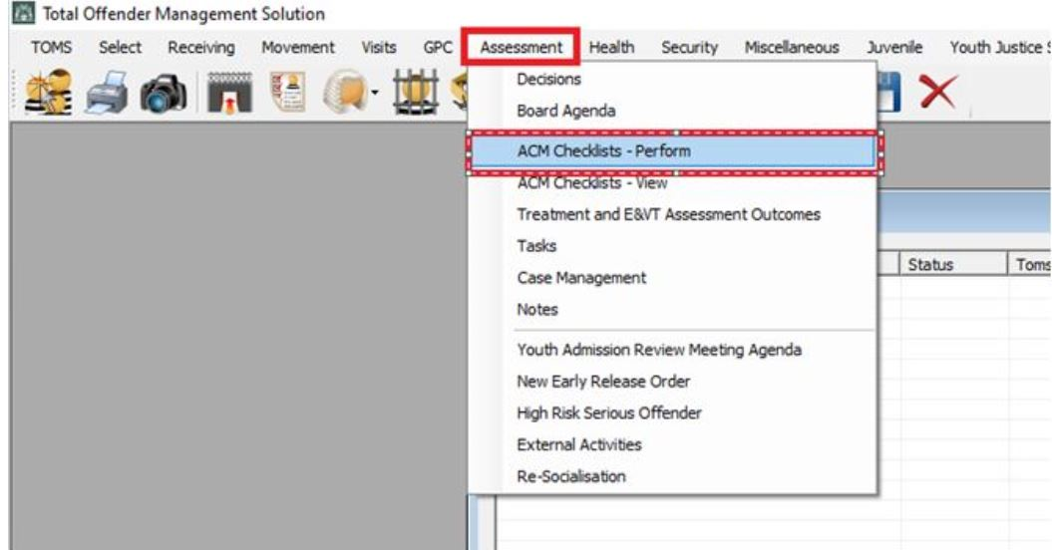

Image 2.
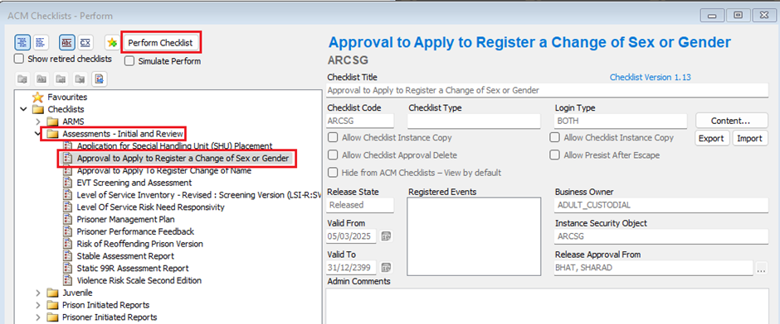

A child is a person under 18 years of age
s.36ZJ Births, Deaths and Marriages Registration Act 1998 (WA)
The CEO (Children and Community Services) is the Director General of the Department of Communities. Refer s. 36O(4) and s. 36Y Births, Deaths and Marriages Registration Act 1998 (WA)
s. 36O(4) and s.36Y(4)Births, Deaths and Marriages Registration Act 1998 (WA)
s.36K, Births, Deaths and Marriages Registration Act 1998 (WA)
s. 36K(5) and s. 36U(5) Births, Deaths and Marriages Registration Act 1998 (WA)
s.36L, s. 36M, s. 36V and s. 36W Births, Deaths and Marriages Registration Act 1998 (WA)
s. 36J Births, Deaths and Marriages Registration Act 1998 (WA)
s. 36k Births, Deaths and Marriages Registration Act 1998 (WA)
s. 36U Births, Deaths and Marriages Registration Act 1998 (WA)
s. 36U Births, Deaths and Marriages Registration Act 1998 (WA)
r.5 Births, Deaths and Marriages Registration Regulations 1999 (WA)
s. 36K(2)(c) and s.36U(2)(c) Births, Deaths and Marriages Registration Act 1998 (WA),
Currently, there is no additional documentation/ information prescribed in the Births, Deaths and Marriages Registration Regulations 1999 (WA
s. 36ZJ(5) Births, Deaths and Marriages Registration Act 1998 (WA)
s. 67(1) Births, Deaths and Marriages Registration Act 1998 (WA)

