COPP 6.12 Young Person Change of Name
Youth Detention Centre
Principles
As referenced in the Australasian Youth Justice Administrators Standards, 2009

1.2 Children, young people and families are provided with information about their rights and responsibilities in the justice system.

2.1 Advice complies with legislative and court requirements.

As referenced in the National Principles for Child Safe Organisations

1.6 Staff and volunteers understand their obligations on information sharing and record keeping.

4.2 Children and young people have access to information, support and complaints processes in ways that are culturally safe, accessible and easy to understand.

Contents
1 Scope 3
2 Policy 3
3 Approval to Apply to Register to Change of Name Application 3
3.1 Eligibility and Pre-requisites 3
3.2 Who can apply 4
3.3 Restriction on changes of young person’s name 4
3.4 Application to register a change of young person’s name approved by Family Court 4
3.5 Supporting documentation 5
3.6 Procedure 5
4 Registry of Births, Deaths and Marriages (the Registry) Approval 7
5 Annexures 9
5.1 Definitions and acronyms 9
5.2 Related legislation 9
6 Assurance 9
7 Document Version History 10
Appendix A – Approval to Apply to Register Change of Name 11

Scope
This Commissioner’s Operating Policy and Procedure (COPP) applies to all Youth Detention Centres (YDCs) administered by or on behalf of the Department of Justice (the Department).

Policy
The parent/s or (legal guardian) of a young person, who is a restricted person, 12 – 17 years (young person) must make an application via a supervisory authority for approval to change their name in accordance with the Births, Deaths and Marriages Registration Amendment Act 2024.
The Commissioner, Department of Justice, Corrective Services (the Commissioner), delegated by the Chief Executive Officer, shall be the supervisory authority for approving a young person’s change of name application.
An application by a young person, to change their name must be made in a manner approved by the Commissioner.
The change of name application, once approved, shall be forwarded to the Births, Deaths and Marriages Registry (the Registry).

Incomplete applications may cause delays and may be refused by the Registry.
The Senior Case Manager in conjunction with a Youth Justice Services (YJS) staff member (where applicable) are required to inform the young person of the requirements and responsibilities of changing their name while they are subject to a Custodial Order.

Approval to Apply to Register to Change of Name Application

Eligibility and Pre-requisites

The parent/s or a legal guardian of a young person on behalf of the young person can make an application to the Commissioner for approval to make a change of name registration if:
- the young person’s birth is registered in Western Australia (WA)
- the young person (born outside Australia) has become an Australian citizen or permanent resident and has resided in WA for the past continuous 12 months
- the young person consents to the change of name in accordance with the application
- the young person is able to consent and understand the meaning and implications of the change of name; and
- the eligibility and pre-requisite requirements have been met.

The eligibility criteria to register for a name change is detailed on the ‘Application to register a change of name’ (child under 18 years) BDM401

For young people over the age of 18 years refer to prison COPP 9.4 Change of Prisoner Name and BDM 400 Application to register a change of name (Adult 18 years or over).

An application fee is required (refer BDM401). Note: the young person’s parent/s or legal guardian shall be advised that the application fee is retained regardless of the outcome of the application.

Who can apply

Where a young person is under 17 years and has not been married:
- both parents must apply to change the young person’s name; or
- one parent may apply if they are the sole parent named in the young person’s birth registration
c) one parent may apply where the other parent is deceased (a death certificate must be provided)
d) any person where a sealed court order from the Family Court is provided with the application
e) a legal guardian may apply if both parents are deceased, cannot be found or where parental responsibility cannot be exercised.

Restriction on changes of young person’s name

The young person must not have been registered for a change of name in any state within 12 months immediately before the application is made (does not apply if the Family Court approve an application to register the young person’s change of name in accordance with court orders).

Any young person who was born interstate must apply to the Registry in the State or Territory of the young person’s birth.

Application to register a change of young person’s name approved by Family Court

Where the Family Court has approved the change of a young person’s name(s), any person may (in an approved form), apply to the Registrar for registration of the change of a young person’s name in accordance with court orders (refer to section 3.5.5).

Supporting documentation

At least three forms of identification are required for the parent/s or legal guardian who are making the application (refer to BDM401).

Photographs are to be provided for the young person (over 12 years) and the parent/s or legal guardian making the application (refer to BDM401). Identification photos may be used to support the application.

Proof of previous legal name is required, e.g. citizenship (where applicable (refer to BDM401).

Proof of guardianship (where applicable).

Where an application is being lodged in accordance with a court Order (e.g. by a court appointed guardian, single parent or otherwise), formal issues and sealed copies of all orders must be provided. Applicants should contact the Registry and confirm if the court orders are suitable for changing the young person’s name (refer to BDM401).

The signed consent section must be signed by the young person (age 12 years and over).

Any other documents requested by the Registry.

Procedure

Where the parent/s or legal guardian on behalf of the young person requests to make an application to change the young person’s name the following procedures shall apply:
- the Superintendent or delegate, in consultation with the Senior Case Manager (and if applicable in conjunction with the YJS staff member) shall seek confirmation from the young person that they consent to the request to change their name and record the response in the young person’s TOMS case notes
- the Senior Case Manager in conjunction with the YJS staff member (if applicable) shall ensure the young person meets the eligibility criteria listed in BDM401
- the Senior Case Manager in conjunction with the YJS staff member (if applicable) shall print out the ‘Approval to Apply to Register Change of Name’ form on TOMS (see Appendix A – Approval to Apply to Register Change of Name form) and where required, assist the young person in completing the hard copy application. This should be done with the parent/s or legal guardian present via whatever means necessary
- once the ‘Approval to Apply to Register Change of Name’ form is completed, the Senior Case Manager with the YJS staff member (if applicable) shall enter the details provided onto the ‘Approval to Apply to Register Change of Name’ form
- the Senior Case Manager in conjunction with the YJS staff member (if applicable) shall then print out the application and have the young person complete and sign part 6.
- the Senior Case Manager shall ensure all required identity documents for the parent/s or legal guardian have been verified as original and take copies to support the application
- the Senior Case Manager in conjunction with the YJS staff member (if applicable) shall complete and sign part 7 and part 8
- the Senior Case Manager in conjunction with the YJS staff member (if applicable) shall then forward the printed and signed ‘Approval to Apply to Register Change of Name’ form and confirmation that the Victim Notification Register (VNR)/Victim Engagement Unit (VEU) have been contacted, via any means, to the Superintendent or delegate for consideration (Part B section 9).
- the Superintendent shall consider the application and if supported, state that the application is supported in Part B section 9
- the Superintendent shall not support the application, if the name change is considered reasonably likely to:
- have an adverse effect on the safety or security and the good order of the YDC
- be considered offensive by a victim of the young person’s crime or a significant sector of the community.
- Where the young person has a TOMS VNR Alert, the Superintendent shall ensure to consult with and obtain comment/advice from the victim(s) through the VNR/VEU
- if the young person is registered against the Australian National Child Offender Register (ANCOR), the provisions of the Community Protection (Offender Reporting) Act 2004 apply
- any other reasons outlined in Part B section 10
- Where the Superintendent has not supported the application, this shall be noted on ‘Approval to Apply to Register Change of Name’ form.

The scanned ‘Approval to Apply to Register Change of Name’ form shall be emailed to the Assistant Commissioner Young People for review.

Once reviewed, the scanned ‘Approval to Apply to Register Change of Name’ form shall be emailed to the Deputy Commissioner Young People noting the level of support for the application.

Once approved, the approved scanned ‘Approval to Apply to Register Change of Name’ form shall be progressed with the accompanying memo noting the level of support for the application or whether the application is unsupported. The memo shall be progressed to the Office of the Commissioner for the Commissioner’s approval (Part B section 10).

The Superintendent shall ensure the application is saved in accordance with Departmental record keeping practices.

Once considered and approved by the Commissioner, the completed Approval to Apply to Register Change of Name’ form shall be emailed back to the originating YDC. If not approved by the Commissioner the application will not progress to the Registry, refer to section 4.1.6.

Once completed, the Senior Case Manager in conjunction with the YJS staff member (if applicable) are to compile the:

signed hardcopy of the ‘BDM401,

signed copy of the ‘Approval to Apply to Register Change of Name’ form

required proof of identity

application fee and all other application requirements (refer to the BDM401).

Any supporting documents which are originals shall be copied and the originals returned to the young person or the young person's property. Only copies of the supporting documentation will be sent to the Registry (faxed or emailed applications will not be accepted) and forwarded to the YDC Records Management Officer.

The compiled documents at section 3.6.5 shall be sent to:

Registry of Births Deaths & Marriages
PO Box 7720, Cloisters Square
Perth, Western Australia 6850

Registry of Births, Deaths and Marriages (the Registry) Approval

The Registry must not change a young person’s name unless they have received in writing, an approved copy of the (BDM401) from the Commissioner.
    - The Commissioner, if requested by the Registry, shall provide the following additional information for the purpose of verifying the details of the young person, prior to a decision being made on an application:
- the name they are currently known by
- any other name by which they are, or have previously been known (of which the Commissioner is aware)
- date of birth
- any other information that may be used to identify the person

On receipt of the BDM401 and accompanying documents (refer to section 3.6.6), the Registry (if applicable) will register the application in their system and notify the datamanagementgroup@justice.wa.gov.au who will, if applicable, change the young person’s name on TOMS.

Following the changing of a young person’s TOMS Master Name, an automated TOMS notification shall be sent to the following:
- Supervisory Authority (Commissioner) via the Office of the Commissioner
- CS-DIV Superintendents
- Young People Leadership Team.

Upon receiving an automated TOMS notification of the approval by the Registry to change the young person’s name, the Superintendent shall inform the:
- young person
- relevant business areas, to include Health Services and Education Services within the YDC to amend all hard copy records held in relation to the young person (eg ID card, Unit Files, Count Boards etc) and;
- VNR, for young people with a TOMS VNR alert.
    - If not approved, the Registry shall notify in writing as soon as practicable the following:
- Supervisory Authority (Commissioner) via email at the Office of the Commissioner: Commissioner@justice.wa.gov.au
- parents, legal guardians or CEO, Children and Communities, outlining the reason why the application was not approved.

If the Registry does not approve a young person’s application to change their name, the young person can apply to the State Administrative Tribunal for a review of the decision.

The Registry may notify the Commissioner via email of an application to change the name of a young person, if they identify that the young person’s parent/s or legal guardian did not seek the Commissioner’s approval.

Annexures

Definitions and acronyms
Term | Definition
Commissioner’s Operating Policies and Procedures (COPPs) | COPPs are Operational Instruments that provide instructions to staff how the relevant legislative requirements are implemented.
Guiding Principles for Corrections in Australia, 2018 | The guidelines and the accompanying principles constitute outcomes or goals to be achieved, rather than a set of absolute standards or laws to be enforced. They represent a statement of intent that each Australian State and Territory can use to develop their own range of relevant legislative policy and performance standards to reflect best practice and community demands.
Superintendent | The Superintendent as defined in s.3 Young Offenders Act 1994 means the person in charge of a detention centre.
Supervisory Authority | The Commissioner for Corrective Services who is delegated to approve Change of Name Applications in accordance with s36A of the Births, Deaths and Marriages Registration Act 1998.
Total Offender Management Solution (TOMS) | An electronic database used by the Department of Justice to record and manage comprehensive information relating to young people.
Young Person | Means a person who is detained in a detention centre as defined in s.3 Young Offenders Act 1994.

Related legislation
- Births, Deaths and Marriages Registration Act 2024
- Community Protection (Offender Reporting) Act 2004
- Young Offenders Act 1994

Assurance
It is expected that:
- YDCs will undertake local compliance in accordance with the Compliance Manual.
- The relevant Deputy Commissioner will undertake management oversight as required.
- Operational Compliance will undertake checks in accordance with the Operational Compliance Framework.
- Independent oversight will be undertaken as required.

Document Version History

Version no | Primary author(s) | Description of version | Date completed | Effective date
1.0 | Operational Policy | Approved by the Commissioner Corrective Services  CM: F2025/17561  Memo 2 minor amendments | 15 July 2025 | 21 July 2025

Appendix A – Approval to Apply to Register Change of Name
Process:
- In TOMS choose Assessment – ACM Checklists – Perform.
- Once user clicks on it opens ACM Checklists – Perform Wizard.
- Navigate down to Assessments – Initial and Review
- The Approval to Apply to Register Change of Name is 2nd from the top
- Once selected, users will need to select Perform Checklist to start the process

Image 1.
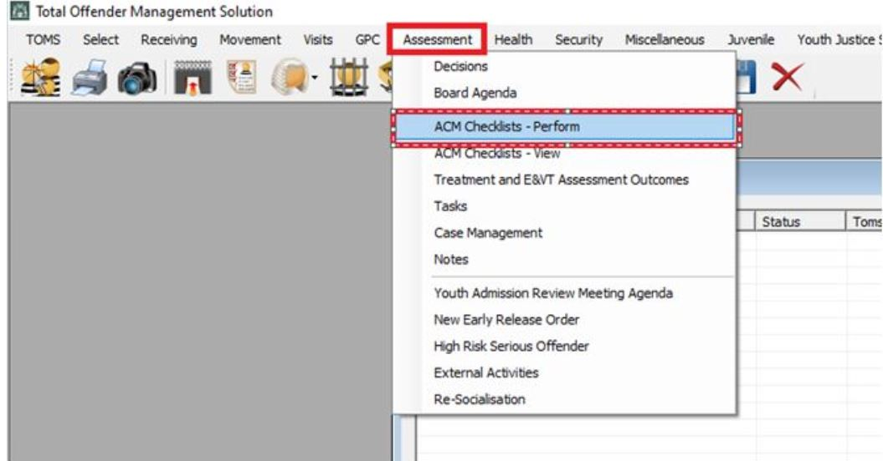

Image 2.
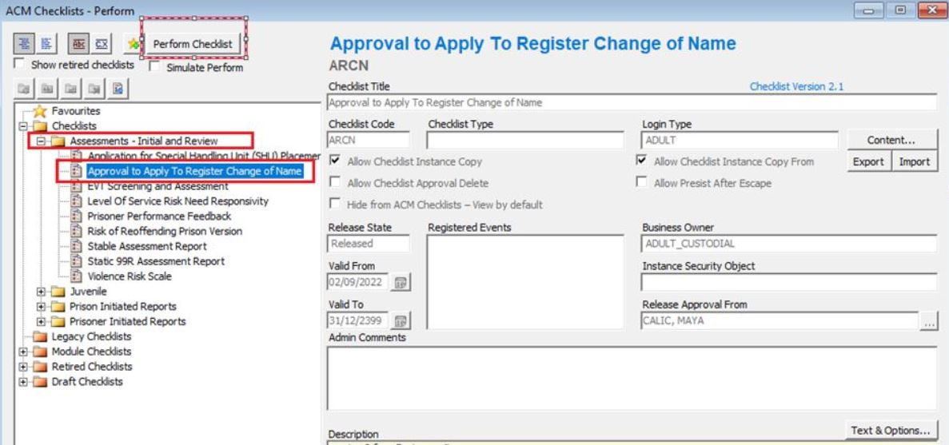

S36 (b) Births, Deaths and Marriages Registration Amendment Act 1998
s.36(a) Births, Deaths and Marriages Registration Amendment Act 1998
s. 67(1) Births, Deaths and Marriages Registration Act 2025

