Clean Schools survey
sample questions

Choose about 10 questions.
Copy and paste into a new document.
Number 1-10.
Quick Import into Microsoft Forms
Import a Form
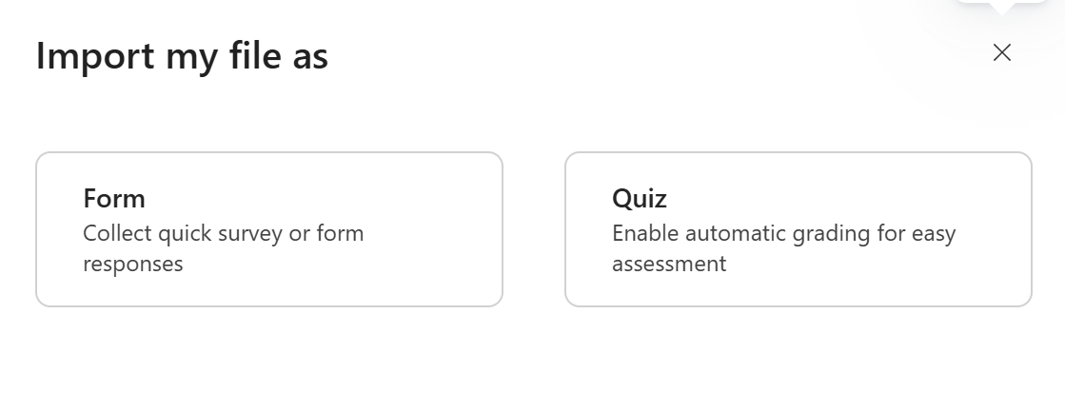

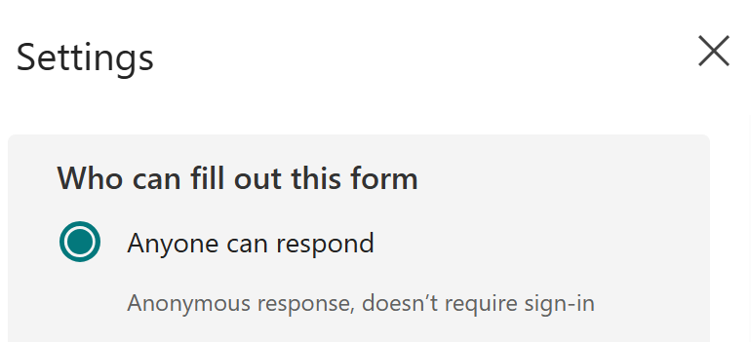

Why do you think people litter?
- Because they don't care about the environment
- Because there aren't enough bins
- Because it's fun
- All of the above

Where do you mostly see litter at school?
- In the classroom
- On the playground
- In the lunch area
- Everywhere!

Why do you think it is important to keep our school clean?
- To make it look nice and feel safe
- To help protect animals and the environment
- To make everyone feel happy
- All of the above

What should you do if you see litter on the ground?
- Walk away and ignore it
- Pick it up and throw it in a bin
- Wait for someone else to clean it
- Make a mess of it

How can we encourage others to keep the school clean?

How do you feel when you see litter around the school?
- Happy
- Sad
- Indifferent (don’t care)
- Confused

What should you do with food wrappers after lunch?
- Keep them in your lunchbox
- Throw them on the ground
- Put them in the rubbish bin
- Put them in your backpack

Do you think it’s important to pick up litter in public places like parks?
- Yes, it helps keep the environment clean
- No, someone else will do it
- I don't know
- Only if it’s near me

What can we do to make our school litter-free?
- Have more bins around the school
- Remind everyone to pick up their rubbish
- Organize school clean-up events
- All of the above

How important do you think it is to keep the school clean?
- Very important
- Somewhat important
- Not important
- I don't think about it

When you see someone littering, how do you feel?
- Upset or disappointed
- Mad or angry
- I don’t really care
- Happy, because it's not my problem

Do you think it's important to take care of the environment?
- Yes, it’s very important
- It’s somewhat important
- Not really
- No, I don’t think it matters

Would you tell a friend if you saw them littering?
- Yes, I would politely ask them to pick it up
- No, I would just ignore it
- Maybe, depending on the situation
- I would join them and litter too

How much do you care about animals getting hurt by litter?
- I care a lot and want to protect them
- I care a little, but it doesn’t matter much to me
- I don’t care
- I think it’s just part of life

How do you feel about people who clean up litter in the community?
- I think they are doing a great job and I appreciate it
- I think it’s okay, but it’s not my responsibility
- I think it’s unnecessary
- I think they are wasting their time

Do you think it’s important to be responsible for cleaning up your own rubbish?
- Yes, everyone should be responsible
- Only if I’m the one who made the mess
- Not really, it’s someone else’s job
- No, I think someone else should always clean up for me

If you find rubbish on the playground, what would you do?
- Pick it up and throw it away
- Leave it for someone else to pick up
- Ignore it and keep playing
- Tell a teacher to pick it up

Would you encourage your friends to pick up litter if you saw them drop something?
- Yes, I would encourage them to pick it up
- No, it’s not my business
- I would ignore it
- I would tell them it’s fine to leave it there

Do you think it’s important to teach younger students not to litter?
- Yes, it’s very important to set a good example
- It’s somewhat important
- Not really, they can figure it out themselves
- No, it’s not my job to teach others

How do you feel when your school or neighborhood is clean?
- Happy and proud to be in a clean place
- Neutral, it’s okay but doesn’t really matter
- It’s no different from being dirty
- I don’t think about it

How important is it to you that your school stays litter-free?
- Very important, I want my school to be nice and clean
- Somewhat important, but not a big deal
- Not important at all
- I don’t really think about it

Would you feel proud of your school if everyone worked together to keep it clean?
- Yes, I would feel really proud
- It would be nice, but I wouldn’t think about it much
- Not really, I wouldn’t care
- I think it would be boring to work together

What do you think is the best way to make sure your school is litter-free?

Do you believe that everyone has a responsibility to keep the environment clean?
- Yes, everyone should do their part
- Only some people should do it
- Not really, it’s someone else’s job
- No, I don’t think anyone should worry about it

How often do you see litter in your school?
- Daily
- Weekly
- Monthly
- Rarely

Do you think littering is a serious problem in your school?
- Yes, very serious
- Somewhat serious
- Not very serious
- Not a problem at all

What do you think is the main reason people litter?
- Lack of bins
- Laziness
- Lack of awareness
- Indifference to the environment

How likely are you to pick up litter that you see on the ground?
- Very likely
- Somewhat likely
- Unlikely
- Never

What type of litter do you see most often?

How do you feel when you see someone littering?
- Angry
- Disappointed
- Indifferent
- Amused

How often do you personally litter?
- Never
- Rarely
- Sometimes
- Often

How important is it to you to keep your school clean?
- Very important
- Somewhat important
- Not very important
- Not important at all

What motivates you to dispose of litter properly?
- Environmental concerns
- Social responsibility
- Fear of fines
- Personal cleanliness

How often do you see litter in your community?
- Daily
- Weekly
- Monthly
- Rarely

