
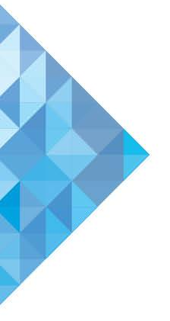

Approval Policy
  - Regional Subsidiaries
July 2017
E1705162
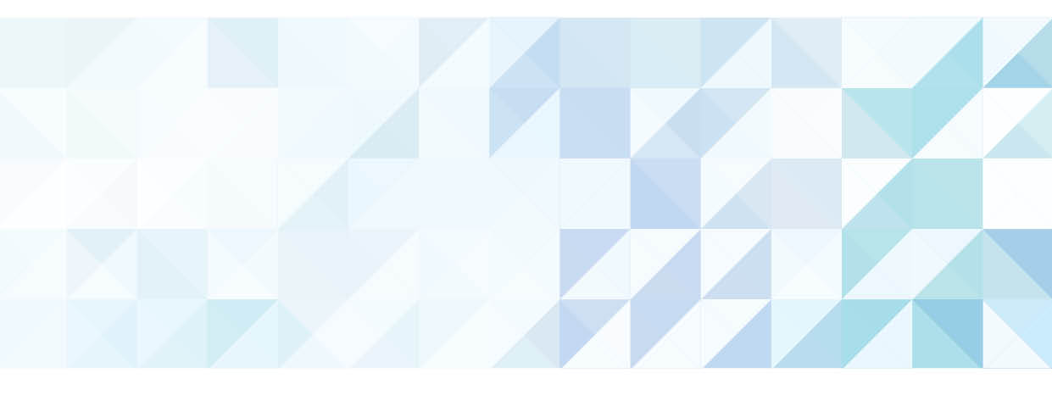
Contents
Introduction 3
Objective 3
Legislation 4
Local Government Act 1995 4
3.69. Regional subsidiaries 4
3.70. Regional subsidiaries to have charter 4
Local Government (Regional Subsidiaries) Regulations 2017 5
9. Matters to be dealt with in regional subsidiary’s charter 5
Ministerial approval of charter 6
Policy statement 6
Key values 6
Legality 6
Transparency 7
Effectiveness 7
Accountability 7
Guidance for Local Governments 8
Application to the Minister 8
Determining an application 8
Amendment of charter 9
Content of charter 9
Posting of application 10
More information 10

Approval Policy – Regional Subsidiaries (July 2017)
Prepared by: Department of Local Government, Sport and Cultural Industries
140 William Street, Perth WA 6000, GPO Box R1250, PERTH WA 6844
Tel: (08) 6551 8700 Fax: (08) 6558 1555 Freecall: 1800 620 511 (Country Only)
Email: legislation@dlgsc.wa.gov.au Web: www.dlgsc.wa.gov.au
Translating and Interpreting Service (TIS) - Telephone: 13 14 50

All or part of this document may be copied. Due recognition of source would be appreciated. If you would like more information please contact the Department of Local Government, Sport and Cultural Industries.

Introduction
Two or more local governments have the ability to form a corporate entity for the purposes of carrying out joint services or activities in their collective districts. This entity is known as a “regional subsidiary”.
A regional subsidiary is governed by a charter document, the content of which is tailored to suit the function that the subsidiary will perform.
The regional subsidiary is similar to a statutory regional local government as defined in the Local Government Act 1995 (also known as a “Regional Council”). It differs in the sense that:
- It is predominantly regulated by its charter.
- It cannot borrow money except from participant local governments.
- The management board of the subsidiary is not restricted to councillors and
local government officers.
To form a regional subsidiary, a group of two or more local governments (‘the participant councils’) must prepare a charter that is approved by the Minister for Local Government.

Objective
This document describes the legislative and policy basis for the application for the Minister’s approval to establish a regional subsidiary. In particular, it sets out the policy that guides the Minister’s exercise of the power to approve the charter that will govern how the subsidiary is to operate.
The second part of this document provides guidance for local governments in requesting such an approval.

Legislation

Local Government Act 1995

3.69. Regional subsidiaries
(1) Two or more local governments making arrangements under which they are to provide a service or carry on an activity jointly may, with the Minister’s approval and in accordance with the regulations, form a subsidiary body (called a regional subsidiary) to provide that service or carry on that activity.
(2) If the Minister approves the formation of a regional subsidiary, the Minister must, by notice in the Gazette, declare that the regional subsidiary is established -
- On the date set out in the notice; and
- Under the name set out in the notice.
(3) A regional subsidiary –
- Is a body corporate with perpetual succession and a common seal; and
- Is to have a governing body consisting of members appointed in accordance with the regional subsidiary’s charter (as approved by the Minister in accordance with section 3.70(3)).

3.70. Regional subsidiaries to have charter
(1) Local governments proposing to form a regional subsidiary must prepare a charter addressing the following matters –
- The establishment and powers and duties of the regional subsidiary;
- The process for selecting and appointing members of the regional subsidiary’s governing body;
- The qualifications that members of the regional subsidiary’s governing body must have;
- The administration of the regional subsidiary, including the membership and procedures of its governing body, and the fees, allowances and expenses to be paid or reimbursed to the members of its governing body;
- The financial management, planning, auditing and reporting to be undertaken by the regional subsidiary;
- The process for amending the charter;
- The winding up of the regional subsidiary;
- Any other matters required by the regulations to be dealt with in a charter.
(2) The local governments must forward the charter to the Minister when applying for approval for the formation of the regional subsidiary.
(3) A charter, and an amendment to a charter, are of no effect unless approved by the Minister.

Local Government (Regional Subsidiaries) Regulations 2017

9. Matters to be dealt with in regional subsidiary’s charter
For the purposes of section 3.70(1)(h), the following matters are required to be dealt with in a charter –
- the employment, appointment or engagement of staff by the regional subsidiary;
- the execution of documents by the regional subsidiary;
- a means of determining the procedures for meetings of the regional subsidiary’s governing body and of any committees of the governing body;
- procedures for the participants to request information from the regional subsidiary and, if information is requested by only one participant, for determining whether the regional subsidiary must provide the information to each of the other participants;
- procedures for the participants to give directions to the regional subsidiary’s governing body and the consequences of a failure to comply with a direction;
- a means of resolving disputes between participants as to matters relating to the regional subsidiary;
- in relation to the financial management of the regional subsidiary — details of any of the listed provisions (as defined in regulation 19(1) and applied by that subregulation to a regional subsidiary subject to its charter) that do not apply to the regional subsidiary, and the reasons why they do not apply;
- a means of determining the continuing financial contributions (if any) of the participants to the funds of the regional subsidiary;
- the way in which any profits produced by the regional subsidiary are dealt with;
- the circumstances (if any) in which the regional subsidiary may operate at a loss and, if it does operate at a loss, a means for preventing its insolvency;
- the circumstances in which the regional subsidiary is to be wound up and procedures for the winding up of the regional subsidiary;
- procedures for the withdrawal of a participant from the regional subsidiary;
- procedures for another local government being included in the charter as a further participant;
- procedures for the division of assets and liabilities between the participants in the event of the regional subsidiary being wound up or a participant withdrawing from the regional subsidiary;
- the way in which money may be invested by the regional subsidiary in accordance with the Act, as modified by regulation 22;
- procedures for the disposal of property;
- a means of developing a code of conduct (if any) for the employees of the regional subsidiary, for the members of the regional subsidiary’s governing body or for the members of a committee of the governing body;
- the fees and charges (if any) that may be imposed by the regional subsidiary;
- the process for reviewing the charter.

Ministerial approval of charter
The Minister may approve a charter for a proposed regional subsidiary. If the charter is approved, the Minister will publish a notice in the Government Gazette which will establish the regional subsidiary on a date specified in the notice. The regional subsidiary will exist as a corporate entity in its own right from the establishment date.

Policy statement
The Minister will only approve a charter which is compliant with WA legislation and which achieves the key values of legality, transparency and accountability.
Applications will be determined on their merit and in accordance with all the available information.

Key values
The Minister’s approval under section 3.69(1) of the Act will only be granted if the Minister is satisfied that the charter will lead to the outcomes listed below.

Legality
The charter:
- Is endorsed by an absolute majority resolution by each participant council
- Covers all matters that the charter must address under the Act and Regulations
- Must not involve a delegation of statutory powers
- Must not be an attempt to circumvent existing laws
- Must not allow the subsidiary to borrow money except from participant councils
- Must not be a commercial enterprise.

Transparency
The charter:
- Confers powers and obligations which are clearly identifiable
- Must be sufficiently advertised to the residents in each of the affected districts in the form of a business plan as described in the “Regional subsidiaries – Public Consultation Guidelines”.
- Must be endorsed only after the member councils have considered any submissions received during the public consultation process
- Clearly states any ability to set fees or charges.

Effectiveness
The charter:
- Sets out an appropriate framework by which the regional subsidiary will operate
- Addresses all necessary subjects with a sufficient level of detail
- Provides enough flexibility for the subsidiary to deal with contingencies
- Meets a genuine need of the community in an effective and financially responsible manner as demonstrated in the business plan.

Accountability
The charter:
- Sets an appropriate framework for financial reporting and oversight
- Ensures that participants retain overriding control over the subsidiary’s conduct in the event of an emergency
- Does not involve a level of financial risk or financial complexity that would be more appropriately managed by a Regional Local Government
- Has systems and safeguards in place to prevent insolvency.

Guidance for Local Governments

Application to the Minister
The Regulations provide that an application to establish a regional subsidiary must be “in the form determined by the Minister”.
For the purposes of the Regulations, the Minister has determined that an application will include the following documents:
- A copy of the endorsed charter
- A copy of the business plan that was advertised
- Evidence that the business plan was advertised in a sufficient manner
- The resolutions endorsing the charter
- Evidence that submissions were considered, and
- A preferred establishment date.
The documents submitted to the Minister should be copies rather than originals, since they may need to be retained for record purposes.
If the proposal was amended after the public submission period, details of those amendments should be provided to the Minister so it can be determined whether these changes were significant enough to require re-advertising.
Individual submissions do not automatically need to be provided to the Minister, but the Minister may request copies if the Minister wishes to consider them in further detail.
The Minister will consider the application and may request more information from the local government before deciding whether to grant approval.
The Minister may grant an approval subject to conditions. If this occurs, the participant councils will be notified of these conditions prior to approval being granted.

Determining an application
In considering an application, the Minister will consider whether -
- the application meets the key values specified in this policy document
- the charter meets the legal requirements of the Act and Regulations
- the public consultation process has been followed, and
- there is a need for additional conditions to be imposed on the subsidiary.
If the Minister approves the application, the Minister will issue a notice in the Government Gazette specifying the date that the subsidiary will come into existence and any additional conditions that are applicable to the subsidiary.

Amendment of charter
Once a charter has been approved and a regional subsidiary is established, the Minister’s approval will be needed for any amendment to the charter.
The policies and processes applicable to the approval of a charter also apply to the approval of an amendment to a charter, subject to the following changes:
- The amendments only need to be publicly advertised if they will change the powers, functions or membership of the subsidiary, and
- The amendments come into effect on the date they are approved by the Minister.
In deciding whether to approve an amendment, the Minister will consider whether the proposal is made in accordance with the charter.
Since the unanimous agreement of the participant councils is needed to approve a charter, the Minister will begin with the presumption that a unanimous agreement is required to amend the charter. The Minister can accept a non-unanimous amendment proposal if the charter expressly allows this.
Notwithstanding that a proposal is in accordance with the charter, the Minister reserves the right to reject an amendment that is unfairly prejudicial to one or more of the participant councils.

Content of charter
The specific content of a charter depends on the circumstances and the agreements between the participant councils. The Department’s website provides guidance material which may assist local governments in preparing a charter and the associated
business plan.

Posting of application
The application for approving a charter and relevant attachments must be sent to:
Hon David Templeman MLA
Minister for Local Government; Heritage; Culture and the Arts
7th Floor, Dumas House
2 Havelock Street
PERTH WA 6055

More information
For more information, please contact:

Department of Local Government, Sport and Cultural Industries
Gordon Stephenson House, 140 William Street, Perth WA 6000
GPO Box R1250, Perth WA 6844, Telephone: (08) 6551 8700, Fax: (08) 6552 1555,
Freecall: 1800 620 511 (Country only)
Email: legislation@dlgsc.wa.gov.au
Website: www.dlgc.wa.gov.au/AdviceSupport/Pages/Regional-Subsidiaries.aspx
Translating and Interpreting Service (TIS) – Telephone: 13 14 50

