Information for Parents
Cadets WA
The Cadets WA program incorporates a range of Youth Programs across Western Australia. Further information about the program and its participating units is available on the Cadets WA web page.

There are a number of Cadet Unit types:
- Bush Rangers
- River Rangers
- Police Rangers
- Emergency Services Cadets Corps
- Surf Life Saving Cadets
- Navy Cadets
- Army Cadets
- Air Force Cadets

Where are Cadet units located?
Most Cadets WA units are based at public and private schools and are generally run after school hours.
- An interactive map is available on the Cadets WA web page showing:
  - Cadet unit locations
  - Host schools
  - Unit contact details.
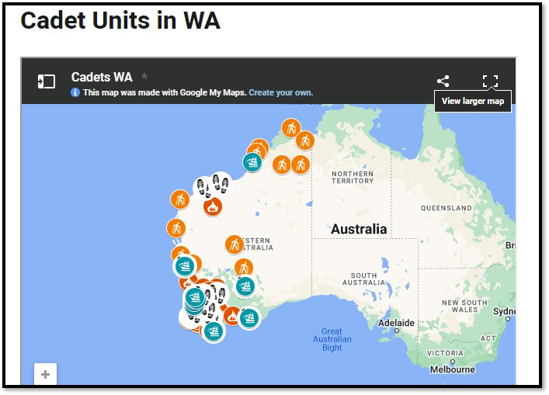

- What if my child’s school does not host a Cadet unit? Contact another local school in your area that hosts a Cadet unit (see interactive map) to explore whether they accept students not enrolled at that school.
- Explore joining an Australian Defence Force (ADF) unit, which operates independently of schools
- Explore joining the Department of Fire and Emergency Services (DFES) Junior or Youth Brigade.

Option 1: Contact a local school
Use the interactive map on the Cadets WA web page to identify potential, local schools and contact their Unit Leader.
- Please note that acceptance of non-enrolled students is at the discretion of the host school.

Option 2: Join an Australian Defence Force unit
Australian Defence Force Cadet units (Army Cadets, Air Force Cadets and Navy Cadets) operate independently of schools.
- Links to individual Defence Force Cadet organisations and local unit contacts are:
  - Navy Cadets
  - Army Cadets
  - Air Force Cadets

You can contact local Unit Leaders to:
- Discuss participation
- Attend a Cadet session
- Complete a registration form, which can also be done online.

Option 3: Join a DFES Junior or Youth Brigade
There are several types of Emergency Services programs operated by DFES that run separately from the Cadets WA program.
- Further information is available at the DFES website.
- You can contact the DFES Youth Programs Coordinator by emailing volunteering@dfes.wa.gov.au.

