Youth Custodial Rule 7 – Terminating Confinement
Youth Detention Centres
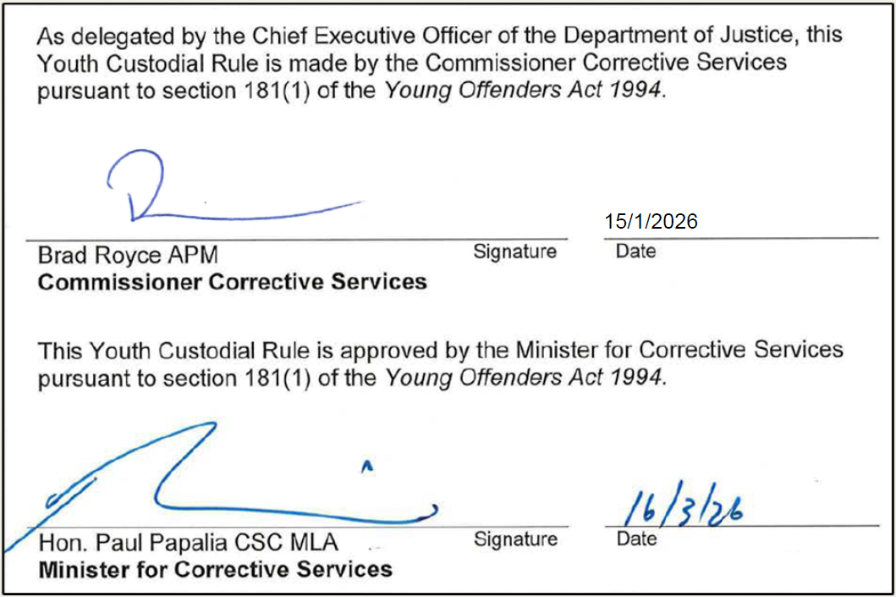
 | As delegated by the Chief Executive Officer of the Department of Justice, this Youth Custodial Rule is made by the Commissioner Corrective Services pursuant to section 181(1) of the Young Offenders Act 1994.
 | Brad Royce APM  Commissioner Corrective Services | Signature |  | Date
 | This Youth Custodial Rule is approved by the Minister for Corrective Services pursuant to section 181(1) of the Young Offenders Act 1994.
 | Hon. Paul Papalia CSC MLA  Minister for Corrective Services | Signature |  | Date

Version 1.0 approved | 16 March 2026
Current version | 1.0
Current version approved | 16 March 2026
Current version effective | 17 April 2026
Document reference | D25/1323268

Contents
1 Purpose 3
2 Scope 3
3 Terminating a Confinement Order 3
3.1 Automatic termination of a confinement order 3
3.2 Early termination of a confinement order 3
3.3 Record keeping and placement 4
4 Issuing a Subsequent Confinement Order 4
5 Related Instruments and Legislation 5
5.1 Related COPPs 5
5.2 Related legislation 5
6 Definitions 5
7 Document Version History 5

Purpose

This Youth Custodial Rule (Rule) outlines the requirements of terminating confinement orders (and issuing subsequent orders if required) to young people according to the relevant legislative provisions:

Confinement ordered by Custodial Officers under section 11B(d) of the Young Offenders Act 1994 for the security, good order, or management of a Youth Detention Centre (YDC).
- Confinement ordered by the Superintendent (or delegate) under regulation 74(2) of the Young Offenders Regulations 1995 for the good government, good order, or management of a YDC.
- Confinement ordered by the Superintendent or a Visiting Justice under regulation 74(1) of the Young Offenders Regulations 1995 in response to the commission of a detention centre offence.

Scope

This Rule applies to all YDCs and all YDC Custodial Officers and staff involved in the management of young people in confinement.

This Rule is operationalised by Commissioner’s Operating Policy and Procedure (COPP) 6.10 – Confinement, which outlines the processes by which staff shall manage young people issued with a confinement order to maintain the good government, good order, or security of the YDC or in response to the commission of a detention offence.

Terminating a Confinement Order

Automatic termination of a confinement order

Releasing a young person from the cell designated for confinement for any purpose other than exercise (e.g., such as a visit, medical appointment, or court appearance) will automatically terminate a confinement order issued under section 11B(d), regulation 74(2), or regulation 74(1).

Early termination of a confinement order

Custodial Officers may terminate a section 11B(d) confinement order early and return the young person to the scheduled program or activity according to the relevant daily timetable in COPP 6.9 – Unit Management and Timetables.

The Superintendent (or delegate) may terminate a regulation 74(2) or 74(1) confinement order early and return the young person to the scheduled program or activity according to the relevant daily timetable in COPP 6.9 – Unit Management and Timetables.

Early termination shall occur when the purpose of a confinement order (e.g., keeping a young person safe during a disturbance) is no longer justified (e.g., a disturbance is subdued).

In circumstances where the Superintendent (or delegate) is not available to terminate a period of regulation 74(2) confinement early, and it is reasonable to do so according to 3.2.3, Custodial Officers may release the young person from confinement.

Record keeping and placement

Custodial Officers shall document the time the confinement order ended on the Total Offender Management Solution (TOMS) and inform the relevant Unit Manager (or authorised officer).

The relevant Unit Manager (or authorised officer) shall:
- ensure that the release of the young person from confinement is documented in the Notes module on TOMS

determine the unit placement of the young person following confinement and update TOMS accordingly.

Issuing a Subsequent Confinement Order

If further confinement is required after an order is terminated according to 3.1 or 3.2, either of the following shall occur:

A Custodial Officer shall issue a new and entirely separate confinement order under section 11B(d) according to COPP 6.10 – Confinement.
- The Superintendent (or delegate) shall issue a new and entirely separate confinement order under regulation 74(2) according to COPP 6.10 – Confinement.

While confinement shall only be ordered as a last resort and for the shortest time necessary, further confinement of a young person beyond the 24-hour limit may be required in certain circumstances (e.g., a young person who was issued with a regulation 74(2) confinement order to stop the spread of an illness is still contagious after 24 hours).

Where a subsequent confinement order is required, the Superintendent (or delegate) shall again consider all relevant circumstances and factors specific to the young person in accordance with the relevant section of COPP 6.10 – Confinement.

Related Instruments and Legislation

Related COPPs
- COPP 6.9 – Unit Management and Timetables
- COPP 6.10 – Confinement

Related legislation
- Young Offenders Act 1994
- Young Offenders Regulations 1995

Definitions
Terms used within this Rule are defined within the Young Offenders Act 1994, the Young Offenders Regulations 1995, and COPP 6.10 – Confinement unless otherwise specified.

Document Version History
Version no | Primary author(s) | Description of version | Date completed | Effective date
1.0 | Operational Policy | Approved by the Minister for Corrective Services | 16 March 2026 | 17 April 2026

Young Offenders Regulations 1995, regulation 79(5)

