Thriving Kids

Easy Read summary
The WA Government Department of Communities made this Easy Read.

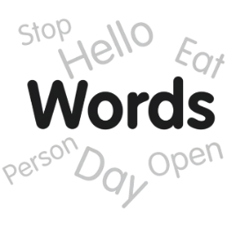
Hard words are in bold.

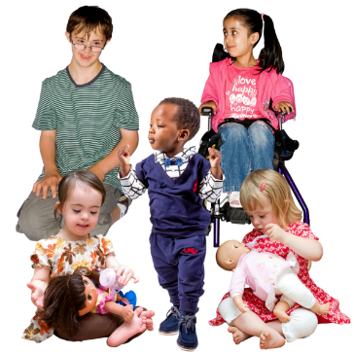
Thriving Kids is coming soon to WA.

Thriving Kids is new government supports to help some children with disability.

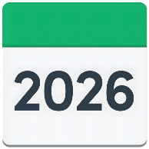

Thriving Kids will start from 1 October 2026.

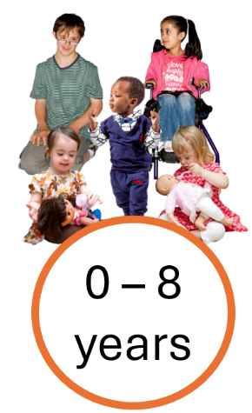
Who can get Thriving Kids?

Thriving Kids is for children aged 0 to 8 years old and the people who look after them.



It is for children with developmental delay or autism who need low or medium support.

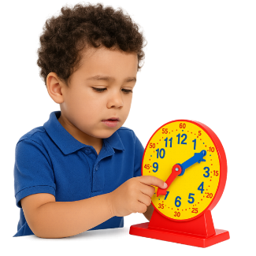
Developmental delay means growing or learning at a different pace to other children their age.



Children do not need a diagnosis to get Thriving Kids supports.

What are Thriving Kids supports?

Thriving Kids supports will be things like


- Information and advice



- Help to find services



- Learning for parents and families

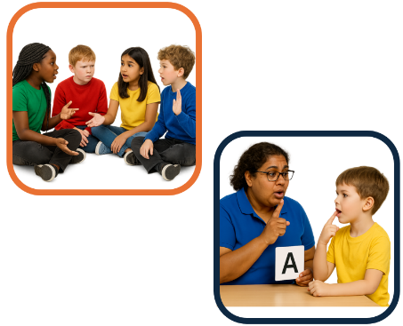
- Therapy for children

Therapy can be for 1 child or a small group.

What is the WA Government doing?

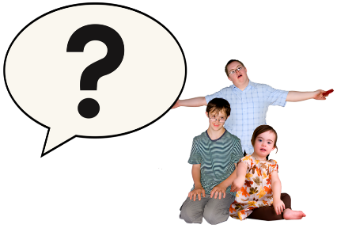
The WA Government will talk to

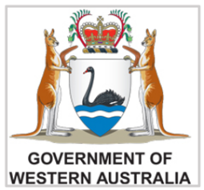
- Children

- Families

- The people who help them now

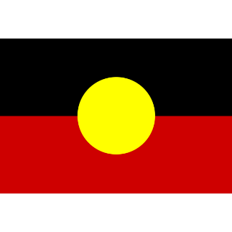

We will work together with Aboriginal communities.



We will make sure Thriving Kids works for families from different cultures and languages.



We want Thriving Kids to help families in the places where they live, learn and play.

What about the NDIS?


Nothing will change for children who already have NDIS supports.

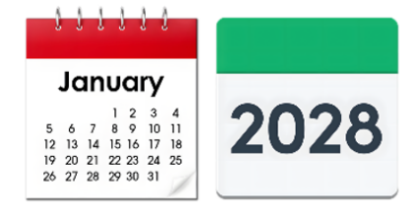
Thriving Kids will be all set up by January 2028.

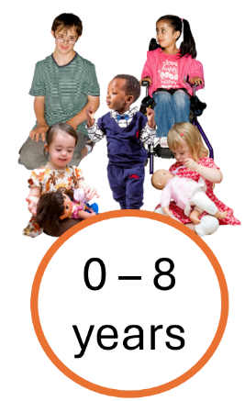

After that some children will get Thriving Kids supports instead of NDIS.

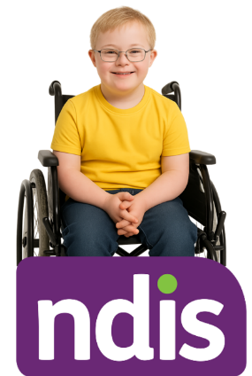

Children who need lots of support will still use the NDIS.

More information
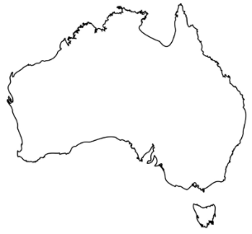

Thriving Kids is for all of Australia.

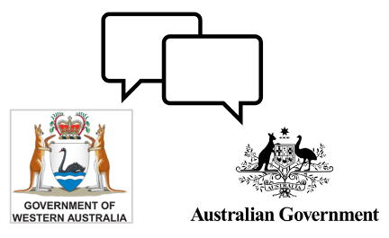
The WA Government work together with the Australian Government to support families.

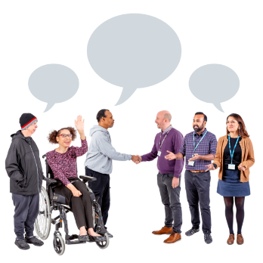

We will ask people in WA to tell us what you think.


Go to our website for more information
https://www.wa.gov.au/organisation/department-of-communities/thriving-kids

