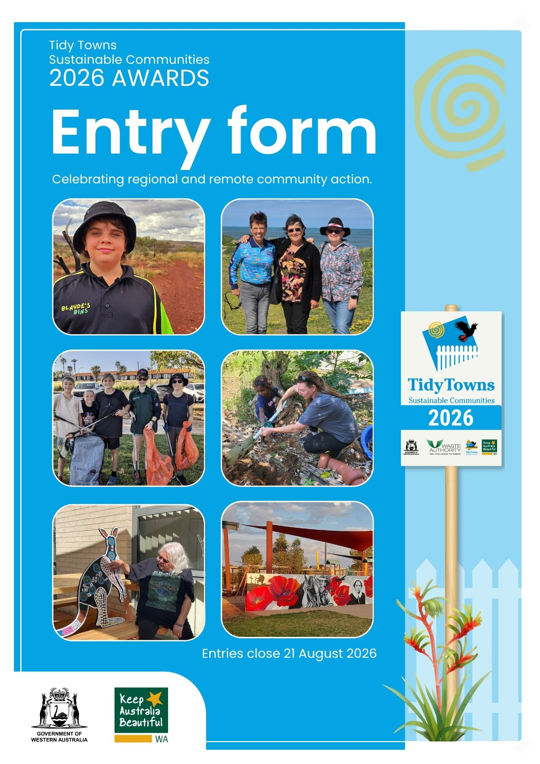
Entry form
Keep Australia Beautiful WA’s Tidy Towns Sustainable Communities Awards recognise regional and remote communities across a diverse range of categories. Communities that demonstrate litter and environmental action, positive community engagement and social outcomes are rewarded and highlighted.
State title | To be eligible for the overall state title, a community must enter projects in at least six of the ten categories. View all about the Awards here.  The overall state winner will represent Western Australia in the National Tidy Towns Sustainability Awards.
Award  categories | General Appearance  Community Action and Wellbeing  Heritage and Culture  Waste Management  Litter Action | Community Containers for Change  Young Legends  Environmental Sustainability  Environmental Education  Leadership
Prize money | The overall state award winner will receive $2,000. Category winners will receive $500 – $1,000. There are additional sponsor prizes.
Key dates | 12 June  Awards and online entries open.  27 July  *Early entrants can enter to win a bench seat with artwork by Helen Ansell  21 August  Entries close (submissions are due by 12 noon)  7-11 September  Judges visit communities to assess projects  (entrants will be contacted in advance to arrange a visit)  October  Finalists are announced  27 November  State Awards event at Optus Stadium
Eligibility | Towns, cities and regional and remote communities in Western Australia can enter projects that have been initiated, completed or maintained between 1 July 2025 and 30 June 2026. Any local individual, group, shire, council, business, organisation or school can enter their regional or remote community and projects in the awards.  Please note any information collected in this form will be used for the purpose of the Tidy Towns Sustainable Communities Awards.

Community name | Click to enter text.
Local government authority | Click to enter text.
Postal address | Click to enter text.
Postcode | Click to enter text.
Primary contact | Contact name
Primary contact | Phone number |  | Email address
Secondary contact | Contact name
Secondary contact | Phone number |  | Email address
Community population | Click to enter text.
How many volunteers (if any) are engaged across all projects? | Click to enter text. |  |  | Number of hours volunteers worked on project/s | Click to enter text.
Photograph use authorisation
Please attach documents or pictures when you email your entry to tidytowns@kabc.wa.gov.au. Please do not embed them in the form, we would like high resolution images for promotional use.
I, Click to enter text., give permission to Keep Australia Beautiful Council to use any images presented as part of the entry. I understand that they may be used to promote the program. If any children appear in the photographs, their permission or parent/guardian permission has been granted.
Signed: Click to enter text or insert an image.
Please indicate the category/categories you are entering.
☐ Litter Action  ☐ General Appearance  ☐ Community Action and Wellbeing  ☐ Heritage and Culture  ☐ Young Legends |  | ☐ Leadership  ☐ Environmental Education  ☐ Community Containers for Change  ☐ Waste Management  ☐ Environmental Sustainability
To be eligible for the overall State title you must enter at least 6 of the 10 categories. Judges will determine finalists for the State title.
Categories, detailed descriptions and judging criteria
Learn more about the categories and judging criteria here.
Preparing your entry
Please provide as much detail as you like. The content fields will expand as you add text.
You can delete any categories/pages you are not entering. Be sure to save as you progress.
Submitting your entry instructions can be found on the back page of this form.

Litter Action
Recognises innovation and achievements in reducing and managing litter, including actions that reduce litter and promote prevention and education. Judges look for:
- Community and/or local government litter clean-up activities.
- Litter prevention and education initiatives.
- Integration of litter management into broader waste management strategies.
- Community or regional actions that support long-term litter reduction.
- Cigarette butt disposal facilities in parks and public areas.
Project title
Provide a description of the project
List the proponents (who was involved)
Outline the project outcomes
General Appearance
Recognises achievements in improving the visual appearance of communities. Judges look for:
- A tidy and well-maintained community, including parks and streets.
- Projects that have enhanced a streetscape - ie murals, buildings, signs.
- Restoration or completion of prominent buildings.
- Water wise roadside planting.
Project title
Provide a description of the project
List the proponents (who was involved)
Outline the project outcomes
Community Action and Wellbeing
Recognises achievements that build healthy, vibrant communities through strong engagement, partnerships and inclusive community facilities and activities. Judges look for:
- Good working relationships between the community and the Shire or council.
- Includes town management strategies and development of facilities.
- Involvement of youth groups, schools and clubs in positive activities.
- Fauna and flora protection and/or rehabilitation activities.
- Provision for an accessible community ie playground, parks.
Sponsored by Rural Aid Australia
Project title
Provide a description of the project
List the proponents (who was involved)
Outline the project outcomes
Heritage and Culture
Recognises commitment to conserving and celebrating Indigenous and non-Indigenous heritage, culture and community identity. Judges look for:
- Successful outcomes addressing preservation of cultural or natural history buildings and sites.
- Development and/or implementation of plans relating to historic or cultural preservation and/or restoration.
- Research into, the protection, and display, of culturally significant sites, records and artefacts.
- Celebration, of community significant events and traditions.
Project title
Provide a description of the project
List the proponents (who was involved)
Outline the project outcomes
Young Legends
Recognises youth-led or youth-focused initiatives that demonstrate leadership and positive community impact. This category is open to an individual or group of young people aged 25 years or under. Judges look for:
- Demonstrated leadership, initiative and positive action.
- Meaningful contribution to one or more Tidy Towns award categories.
- Projects or actions that inspire others and create positive change.
Sponsored by Bank of I.D.E.A.S
Project title
Provide a description of the project
List the proponents (who was involved)
Outline the project outcomes
Environmental Education
Recognises education initiatives that build environmental awareness, skills and behaviour change within schools or communities. Judges look for:
- Education initiatives/awareness programs on sustainability, the environment and conservation.
- Education leading to empowerment and behaviour change.
- Youth education in environment and conservation activities.
Sponsored by WA Landcare Network
Project title
Provide a description of the project
List the proponents (who was involved)
Outline the project outcomes
Leadership
Recognises outstanding leadership demonstrated by an individual (not a group) who has inspired positive change within their community. Judges look for
- Driving or coordinating a positive community project across any of the Award Categories.
- Mentoring and inspiring volunteers.
- Encouraging broad community involvement with impactful projects.
- Ongoing commitment for positive change in their community.
Sponsored by Department of Primary Industries and Regional Development
Project title
Provide a description of the project
List the proponents (who was involved)
Outline the project outcomes
Community Containers for Change
Recognises projects that use Containers for Change to deliver broader environmental, social or community benefits. Judges look for:
- An initiative that has impacted the community. Schools, local councils, business, organisations or individuals can lead the initiative.
- It's not the amount of refunds that are assessed but the positive benefit to the community.
Sponsored by Containers for Change
Project title
Provide a description of the project
List the proponents (who was involved)
Outline the project outcomes
Waste Management
Recognises achievements in reducing, reusing and managing waste, including recycling, resource recovery and innovative waste solutions. Judges look for:
- Integration of recycling, resource recovery and waste management activities into a broader waste management strategy, new tip facilities and management.
- Accessible and visible recycling bins in public areas.
- Recovery and re-use of resources including organics, green materials, glass, circular economy or recovered resources such as composting.
Project title
Provide a description of the project
List the proponents (who was involved)
Outline the project outcomes

Environmental Sustainability
Recognises actions that protect, restore or enhance the natural environment, including biodiversity and long-term environmental stewardship. Judges look for:
- Water - Water management or waste water re-use.
- Energy/climate adaptation- Sustainable energy management focusing on energy efficiency measures. Programs which encourage community involvement in renewable energy and climate change issues.
- Nature conservation - Strategies focusing on environmental protection. Examples include wildlife corridors, feral animal management plans, weed eradication or addressing salinity and soil erosion.
Project title
Provide a description of the project
List the proponents (who was involved)
Outline the project outcomes

Submitting your form
- Entries are due by 12pm on Friday 21 August.
- Email your entry to: tidytowns@kabc.wa.gov.au.

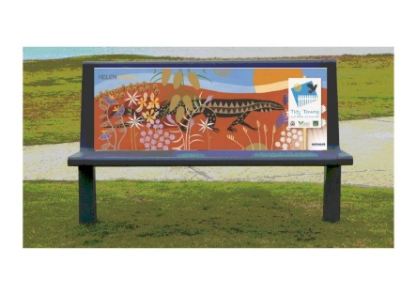
- Early entries by 27 July can be in the running to win a bench seat.
View here for details.

Entry tick list
High resolution images in support of projects, can be: | ☐
Attached to the emailed submission | ☐
Dropbox or other sharing link for images and documents | ☐
Emailed separately | ☐
Project details entered | ☐
Available for community judging visit in September | ☐
Have you ordered community entry signs or stickers? Order here | ☐

Entries can also be printed and mailed to:
Tidy Towns Sustainable Communities Awards
Keep Australia Beautiful WA
Locked Bag 10
JOONDALUP DC 6027

If you require assistance, please email tidytowns@kabc.wa.gov.au or phone 6364 6643

