Enter your organisation’s name


Child Safe
Risk Management Plan

Instructions
A Child Safe Risk Management Plan explains what your organisation does to prevent or lower the risk of child harm or abuse occurring in its physical and online environments. Follow these steps to develop your own Child Safe Risk Management Plan.
Organisations are encouraged to complete further reflection and consultation to create a meaningful Child Safe Risk Management Plan, which aligns with your organisation's purpose, values, legal obligations and risks. Policies should be embedded in practice and considered in everyday behaviours and decision-making.
A child safe risk is any circumstance, practice, environment (both physical and online), behaviour or organisational decision that increases the likelihood that a child may experience abuse, neglect, exploitation, harm or feel unsafe.

- Adapt the content provided in the sample to suit your organisation as it relates to your physical locations, online environments and communications, and activities.
- Ask people across your organisation to review and provide feedback.
- Delete these instructions and any Notes in purple boxes when finished.
- Add your organisation’s name and branding.
- Share this plan across your organisation and make sure it is easily available on your website and offline for everyone who accesses your services and events.
Ongoing consideration is recommended for how your organisations’ expectations, provided in the Child Safe Risk Management Plan, can be reinforced through leadership, supervision, training, accountability, and organisational culture.

Purpose of plan
Creating a child safe environment includes:
- identifying environmental risks to children’s safety in relation to the activities and services we provide, our physical settings and our online spaces and communication
- taking action to reduce these risks and children’s exposure to harm or abuse.
These risks can change over time if our physical and online spaces change, or different activities or services are provided by our organisation. This may also include unique events, excursions or travel involving children. Our plan will be regularly reviewed and updated to reflect any changes.
Our Risk Management Plan in the table below sets out these risks, assesses their potential impact, the strategies to help prevent or reduce them, and keeps track of our progress.

Nature of our settings and services provided
Enter your organisation’s name provides Identify the types of activities and services your organisation provides that involve any interaction with children and include the age range of children involved to children.
These activities and services take place in the following locations:
List your physical locations on-site and off-site, any transport used etc

Responsibility for Risk Management Plan
Note
Depending on the size of your organisation, people in different roles may be responsible for different sections of the Risk Management Plan. List these below to make sure governance arrangements are in place to formally manage identified and emerging risks.
Note where staff, children and parents and carers can access the plan.

Enter the person or people responsible for Risk Management Plan.
Enter the person or people responsible are responsible for making sure that the strategies to manage risks are implemented and monitored.
This version of the plan was completed on Enter date
Everyone in our organisation should be alert to any risks to children’s safety and draw attention to any concerns that may arise, as set out in our Child Safe Policy.
Our Risk Management Plan is available on our website.

Next review date
Note
Include a date when the plan will be reviewed and who is responsible for the review, noting that if there are any critical incidents the plan will be reviewed immediately.
You may like to consider circumstances that could lead to a review of the plan, which could include:
- there is an incident, allegation, complaint, near miss or breach relating to child safety or wellbeing
- children, young people, families or staff identify new or emerging risks through consultation or feedback
- legislative, regulatory or National Principle requirements change
- findings from audits, investigations, evaluations or reviews identify gaps or opportunities for improvement
- a new safeguarding risk or emerging issue is identified.

Enter the person or people responsible for review will review this plan annually on Enter date.
The plan will be reviewed and updated immediately if there are:
- any incidents involving children
- any changes to our physical or online spaces or online communications
- any changes to the types of activities and services involving children that we deliver, including unique events on or off-site.

Risk assessment matrix
Assess the consequence – What is the extent of the probably impact of the risk event?
Table 1 Risk Consequence Table
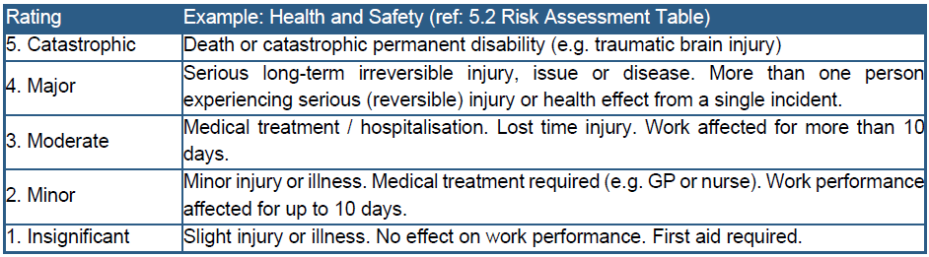

Assess the likelihood – What is the probability of the risk event occurring with current controls in place?
Table 2 Risk Likelihood Table
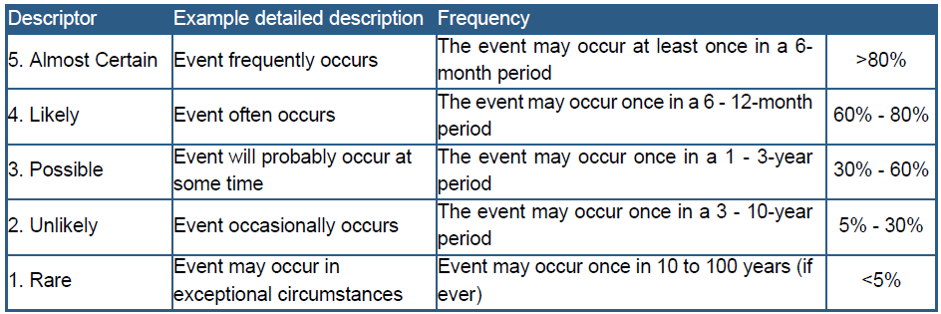

Determine the overall level of risk using the risk matrix table.
Table 3 Risk assessment matrix
Likelihood | 1. Rare | 2. Unlikely | 3. Possible | 4. Likely | 5. Almost certain
5. Catastrophic | Medium | High | High | Extreme | Extreme
4. Major | Low | Medium | High | High | Extreme
3. Moderate | Low | Medium | Medium | High | High
2. Minor | Low | Low | Medium | Medium | High
1. Insignificant | Low | Low | Low | Low | Medium

Risk Management Plan
Note
The table below provides some examples that may or may not be relevant to your organisation. You can use these to get started, referring to your list of your services and settings above to consider how children may be exposed to risk of harm or abuse across your organisation. This table should be reviewed and updated regularly.
Identify settings where interactions occur | Identify risks in these settings | Assess likelihood of risk | Assess consequence of risk | Determine risk rating | Identify and implement strategies to manage risk | Track progress and regularly review
Identify the different environmental settings or activity types in your organisation, physical and online, where adults work or interact with children. The same setting could have multiple risks. | Identify the specific risks to children in these settings or activities in terms of exposure to harm or abuse | Assess how likely it is that the risk will occur, using the following scale:  - 1. Rare  - 2. Unlikely  - 3. Possible  - 4. Likely  - 5. Almost certain | Assess the impact if the risk occurs, using the following scale:  - 1. Insignificant  - 2. Minor  - 3. Moderate  - 4. Major  - 5. Catastrophic | Use the risk assessment matrix to decide the overall risk rating, using the following scale:  - Low  - Medium  - High  - Very high | Describe what protective strategies already exist and what strategies need to be developed to help minimise the risk. | Keep track of whether these strategies are in place and responsibilities.  Regularly review to make sure any protective strategies implemented are working and note follow up actions.
First aid care area | Posters placed over the windows, interfering with lines of sight to first aid area | Unlikely | Catastrophic | High | Stickers put under the windows to let everyone know not to place posters over the windows | Have these strategies been implemented?  - Yes  - No  If no, include a reason for why not.  [SIGNATURE OF PERSON RESPONSBILE]  Reviewed on [insert date for review] – no posters placed over the windows since last year
Change rooms and toilet blocks | Hidden from view from supervising adults | Possible | Major | High | Organisation’s Child Safe Code of Conduct specifies appropriate change room and toilet block etiquette; reporting posters put up around the organisation to make sure everyone knows what to do if they need to report an allegation, breach or disclosure; regular pop quizzes done with staff to make sure they know and understand the organisation’s child safe documents. | Have these strategies been implemented?  - Yes  - No  If no, include a reason for why not.  [SIGNATURE OF PERSON RESPONSBILE]  Reviewed on [insert date for review] – new quiz to be developed on understanding and responding to reports
Use of mobile phones | Adults may use their personal devices to take photos of children or young people without permission | Likely | Moderate | High | Organisation’s Child Safe Code of Conduct specifies no photos to be taken of children or young people without parental permission; regular reminders sent out to everyone when there are special events | Have these strategies been implemented?  - Yes  - No  If no, include a reason for why not.  [SIGNATURE OF PERSON RESPONSBILE]  Reviewed on [insert date for review] – continue to remind everyone in the organisation that taking photos of children or young people is not allowed
Overnight stays | Insufficient supervision of children and young people | Possible | Major | High | Appropriate staff levels are maintained at all times, to ensure supervision of children and young people.  A standby/on call roster is in place to support unplanned leave requirements. | Have these strategies been implemented?  - Yes  - No  If no, include a reason for why not.  [SIGNATURE OF PERSON RESPONSBILE]  Reviewed as needed – a separate Child Safe Risk Management Plan will be developed for overnight hours.
Excursions | Adults may become frustrated with extra responsibility and yell at children or young people | Unlikely | Moderate | Medium | Regular meetings in the lead up to the excursion clearly establish that no breaches to the Child Safe Code of Conduct will be tolerated; it’s been decided that adults will supervise in pairs to share the workload | Have these strategies been implemented?  - Yes  - No  If no, include a reason for why not.  [SIGNATURE OF PERSON RESPONSBILE]  Reviewed as needed – a separate Child Safe Risk Management Plan will be developed for longer excursions of more than a couple of hours or if there are children with diverse needs on the excursion

For more free child safe templates and other resources, please go to Child Safe Organisation Knowledge Hub

