Prison Rule 1 –
Designation of Officers as Prison Officers

 | Rule made by the Chief Executive Officer pursuant to section 35 of the Prisons Act 1981
 |  |  |  |  | 23 October 2019
 | Adam Tomison  Director General | Signature |  |  |  | Date
 | Rule approved by the Minister for Corrective Services pursuant to section 35 of the Prisons Act 1981
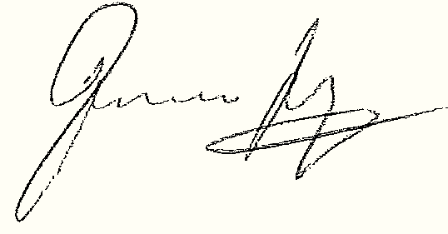 |  |  |  |  | 27 December 2019
 | Hon. Francis Logan MLA  Minister for Corrective Services | Signature |  |  |  | Date

Version 1.0 approved | 25 November 2015
Current version | 2.0
Current version approved | 27 December 2019
Current version effective | 16 April 2020
Document reference | AD2019/137092

Contents
1 Purpose 3
2 Scope 3
3 Designation of officers 3
4 Relevant instruments and other documents 3
4.1 Legislation 3
5 Schedule 3
6 Schedule 1 – Officers designated as prison officers 4
6.1 Designation of officers 4
6.2 Positions with custodial functions 4
7 Positions with custodial functions 5
7.1 Prison based staff 5
7.2 Non-prison based staff 5

Purpose

To establish rules for the designation of officers as prison officers.

Scope

This Rule applies to all prisons.

This Rule applies to all persons employed by the Department of Justice (the Department), and to all contract workers authorised by the Chief Executive Officer in accordance with s 15I (1) Prisons Act 1981 to perform a function.

Designation of officers

For the purposes of s 3 of the Prisons Act 1981, persons appointed or deemed to have been appointed under section 6 to the offices listed in Schedule 1 are designated as and deemed to be prison officers.

Relevant instruments and other documents

Legislation

Prisons Act 1981

Schedule

Schedule 1 – Officers designated as prison officers

Schedule 1 – Officers designated as prison officers

Designation of officers

In accordance with Prison Rule 1 – Designation of Officers as Prison Officers, this Schedule lists those persons appointed or deemed to be appointed under section 6 of the Prisons Act 1981 as prison officers.

This Schedule applies to any officer in any position listed herein, whether undertaking the duties of such a position on a full time, part time, casual, or acting basis.

An occupant of any position designated as a prison officer in accordance with this Schedule shall comply with the requirements of the Prison Induction – Designated prison officer program, as may be varied from time to time. Additional training requirements may be identified on an individual basis. Compliance with the requirements of the Prison Induction – Designated prison officer program does not affect any requirement to complete Corporate Induction.

Positions with custodial functions

An occupant of any position with custodial functions, as listed below, by their inclusion in this instrument, has any power or may undertake any duty of a prison officer, as permitted by the Prisons Act 1981 and Prisons Regulations 1982.

An occupant of any position with custodial functions shall ensure that they are fully conversant and compliant with the Prisons Act 1981, Prisons Regulations 1982, and any other rules, policies, instructions, orders, or procedures applicable to their duties.

An occupant of any position with custodial functions should only undertake tasks for which they have completed training.

Positions with custodial functions

Prison based staff
- Superintendent
- Deputy Superintendent
- Prison Officer
- Senior Officer
- Principal Officer
- Assistant Senior Officer

Non-prison based staff
- Director, Integrity and Accountability
- Assistant Director, Integrity and Accountability
- Principal Investigator, Integrity and Accountability
- Senior Investigator, Integrity and Accountability
- Senior Investigative Analyst, Integrity and Accountability
- Investigator, Integrity and Accountability

Document version history
Version no | Primary author(s) | Description of version | Date completed
1.0 | Operating Standards and Procedures | Approved by the Commissioner and Minister | 25 November 2015
1.1 | Operating Standards and Procedures | Schedule 1 amended in accordance with the new Department of Justice organisational structure | 9 September 2019
1.2 | Operating Standards and Procedures | Amended to include Professional Standards positions | 17 October 2019
2.0 | Operating Standards and Procedures | Amendments to Schedule 1 approved by the Minister | 27 December 2019

