Youth Custodial Rule 1 –
Designation of Officers as Custodial Officers

 | Rule made pursuant to Section 181 (1) of the Young Offenders Act 1994 by the Commissioner, who has been delegated this authority by the Chief Executive Officer of the Department of Justice with the approval of the Minister for Corrective Services.
 |  |  |  | 23 October 2019
 | Tony Hassall  Commissioner | Signature |  | Date
 | Rule approved by the Minister for Corrective Services pursuant to section 35 of the Young Offenders Act 1994
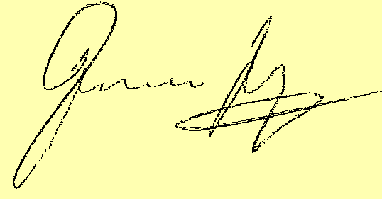 |  |  |  | 27 December 2019
 | Hon. Francis Logan MLA  Minister for Corrective Services | Signature |  | Date

Version 1.0 approved | 25 November 2015
Current version | 3.0
Current version approved | 24 November 2021
Current version effective | 26 November 2021
Document reference | D21/848353

Contents
1 Purpose 3
2 Scope 3
3 Designation of officers 3
4 Relevant instruments and other documents 3
4.1 Legislation 3
5 Schedule – Officers designated as custodial officers 4
5.1 Designation of officers 4
5.2 Positions with custodial functions 4
5.3 Positions with limited custodial functions 4
6 Positions with custodial functions 5
6.1 Detention centre based staff 5
6.2 Non-detention centre based staff 5
7 Amendment 5

Purpose

To establish rules for the designation of officers as custodial officers.

Scope

This Rule applies to all detention centres in Western Australia.

Designation of officers

For the purposes of section 11 of the Young Offenders Act 1994, persons appointed or deemed to have been appointed under section 11(1) to the offices listed in the attached schedule are designated as and deemed to be custodial officers.

Relevant instruments and other documents

Legislation

Young Offenders Act 1994

Young Offenders Regulations 1995

Schedule – Officers designated as custodial officers

Designation of officers

In accordance with Youth Custodial Rule 1 – Designation of officers as custodial officers, this Schedule lists those persons appointed or deemed to be appointed under section 11(1) of the Young Offenders Act 1994 as custodial officers.

This Schedule applies to any officer in any position listed below, whether undertaking the duties of such a position on a full time, casual, or acting basis.

An occupant of any position designated as a custodial officer in accordance with this Schedule shall comply with the requirements of the training program for designated custodial officers, as may be varied from time to time. Additional training requirements may be identified on an individual basis. Compliance with the requirements of the training program does not affect any requirement to complete Corporate Induction.

Positions with custodial functions

An occupant of any position with custodial functions, as listed below, by their inclusion in this instrument, has any power or may undertake any duty of a custodial officer, as permitted by the Young Offenders Act 1994 and Young Offenders Regulations 1995.

An occupant of any position with custodial functions shall ensure that they are fully conversant and compliant with the Young Offenders Act 1994, Young Offenders Regulations 1995, and any other rules, policies, instructions, orders, or procedures applicable to their duties.

An occupant of any position with custodial functions should only undertake tasks for which they have completed training.

Positions with limited custodial functions

An occupant of any position with limited custodial functions, as listed below, by their inclusion in this instrument, may only issue detainees with lawful orders in accordance with the Young Offenders Act 1994, Young Offenders Regulations 1995, and any other rules, policies, instructions, orders, or procedures applicable to their duties.

An occupant of any position with limited custodial functions should only undertake tasks for which they have completed training.

Positions with custodial functions

Detention centre based staff
- Superintendent
- Deputy Superintendent
- Assistant Superintendent Operations
- Assistant Superintendent Female and Cultural Services
- Assistant Superintendent Security
- Senior Officers
- Unit Managers
- Youth Custodial Officers

Non-detention centre based staff
- Director, Integrity and Accountability
- Assistant Director, Integrity and Accountability
- Principal Investigator, Integrity and Accountability
- Senior Investigator, Integrity and Accountability
- Investigator, Integrity and Accountability

Amendment
As specified in Youth Custodial Rule 1, the Commissioner of Corrective Services may amend this Schedule as necessary to reflect changes in the structure or functions of the Department.

Document version history
Version no | Primary author(s) | Description of version | Date completed | Effective date
1.0 | Operating Standards and Procedures | Approved by the Commissioner and Minister | 25 November 2015 | N/A
1.1 | Operating Standards and Procedures | Schedule amended in accordance with the new Department of Justice organisational structure | 10 July 2019 | N/A
2.0 | Operating Standards and Procedures | Amendments to Schedule approved by the Minister | 27 December 2019 | N/A
3.0 | Operational Policy | Added Unit Manager to section 6.1 | 24 November 2021 | 26 November 2021

