COPP 9.6 Searching
Youth Detention Centre
Principles
In context of the following:

Australasian Youth Justice Administrators Standards, 2009:

Risk management strategies focus on preventing, identifying, and mitigating risks to children and young people.

Australian Human Rights Commission National Principles for Child Safe Organisations, 2018:

Custodial environments are safe and secure.

The least intrusive developmentally appropriate options are deployed in responding to security and safety risks posed by children and young people in custody.

Contents
1 Scope 4
2 Policy 4
3 General Requirements 5
3.1 Search information 5
3.2 Prior to a search 5
3.3 Gender of the Custodial Officer conducting the search 5
3.4 People with disabilities 5
3.5 Pregnant persons 5
3.6 Religious and cultural headwear 6
4 Search Equipment and Methods 6
4.1 Personal protective equipment 6
4.2 Search kits 6
4.3 Approved searching apparatus 6
4.4 Search Methods 6
4.5 Pat search 6
4.6 Full search 6
4.7 Handheld metal detectors 7
4.8 Searching using drug detection dogs 7
4.9 Electronic trace device 8
4.10 Equipment exemptions 8
5 Unauthorised Items 9
6 Recording Searches 9
7 Detainee Searches 9
7.1 Superintendent empowered to search 9
7.2 When a detainee should be searched 9
7.3 Risk assessment to inform search method 10
7.4 Pat searches 11
7.5 Full searches 12
7.6 Force ordered and used to conduct a search 13
8 Officer or Other Employee Searches 13
8.1 When an officer or other employee may be searched 13
8.2 General 13
8.3 Record keeping 14
8.4 Refusal to be searched 14
8.5 People, Culture and Standards Division 15
9 Searching Other Persons 15
9.1 When other persons can be searched 15
9.2 General 16
9.3 Refusal to be searched 16
9.4 Babies and children searches 17
10 Other Searches 17
10.1 Cell searches 17
10.2 Cell integrity checks 17
10.3 Building and Perimeter Searches 18
10.4 Vehicle Searches 18
11 Annexures 20
11.1 Related COPPs and documents 20
11.2 Definitions and acronyms 20
11.3 Related legislation 23
12 Assurance 23
13 Document Version History 24
Appendix A: Approved Searching Apparatus 25
Appendix B: Searches of Persons with Injuries or Disabilities 28
Appendix C: Religious and Cultural Headwear 29
Appendix D: Pat Searching Procedures – Detainees 30
Appendix E: Pat Search Procedures: Officers or other Employees and Visitors (Including children apparently under the age of 10 years) 32
Appendix F: Handheld Metal Detector Searching Procedures 34
Appendix G: Full Searching Procedure 35
Appendix H: Cell Searching Procedure and Cell Integrity Check 37
Appendix I: Perimeter Area Searching Procedure 39
Appendix J: Vehicle Search Procedure 40

Scope
This Commissioner’s Operating Policy and Procedure (COPP) applies, where applicable, to all Youth Detention Centre (YDC) Custodial Officers and staff.

Policy
The purpose of this COPP is to establish clear and consistent searching procedures at a YDC.
Within a youth detention centre, searching is necessary to reduce the risk of:

- harm to the public, detainees and/or staff
- possession of any unauthorised items
- damage to property
- escapes, attempted escapes and assisting escapes, from custody.

The presence of unauthorised items has the potential to adversely impact the safety of staff and detainees and the good order and management of a YDC. To detect unauthorised items, searches are conducted on persons and environments within and around a YDC by staff with appropriate training.

Searches are a preventative mechanism to locate and remove anything posing an adverse risk to safety and security whilst ensuring the dignity, self-respect and privacy of persons and property being searched.

Routine full searching (previously known as strip searching) shall not be conducted at a YDC. The decision to conduct a full search of a detainee shall only be conducted where there is a reasonable suspicion or intelligence that the detainee is in possession of an unauthorised item on their person which:

- may jeopardise the safety, good order, or security of the detention centre
- may be used for self-harm.

Search procedures shall be based on assessment of risk and shall adopt the least intrusive method possible to minimise the possibility of any re-traumatisation and/or negative impact on a person; without compromising the effectiveness of the search.

Searching is governed by rigorous recording and reporting procedures providing transparency and accountability.

General Requirements

Search information

The Assistant Superintendent Security shall ensure visible signs and information are displayed within and around the YDC advising that persons, property, or vehicles may be searched.

Prior to a search

The Custodial Officer shall provide the following information to a person prior to a search;
- ask if the person understands the search process
- what actions a person should do in advance (e.g., removing coats)
- the reason and method of search
- privacy options available for persons with religious or cultural headwear
- actions if an unauthorised item is found.

The Custodial Officer may ask the person to be searched if they have any item that may affect the safety, good order, or security of the YDC.

Where a person hands over an item or an item is found that is deemed to be unauthorised refer to section 5 of this COPP.

Gender of the Custodial Officer conducting the search

Searches of a person shall be conducted by a Custodial Officer of the same gender.

Custodial Officers conducting the search of a detainee who has self-identified as trans, non-binary or intersex shall conduct the search in accordance with COPP 7.5 – Trans, Gender Diverse and Intersex Detainees.

Where a detainee provides or states they possess a birth certificate or an acknowledgment document under the Births Deaths and Marriages Registration Act 1998, that lists their sex as that other than what they appear or different to their biological sex, the Superintendent and Security Manager shall be notified as soon as practicable and the detainee managed in line with COPP 7.5 – Trans, Gender Diverse and Intersex Detainees.

Once the gender of the person has been established, the same search procedures apply (e.g., full, pat, handheld metal detector).

People with disabilities

Searches of persons with injuries or disabilities shall be conducted in accordance with Appendix B – Searches of Persons with Injuries or Disabilities.

Pregnant persons

Where a person advises that they are pregnant, the Custodial Officer shall use the least intrusive search technique based on risk to maintain the safety and good order of the YDC and the dignity and respect of the person being searched.

Religious and cultural headwear

Searches on persons wearing religious and cultural headwear shall be conducted in accordance with Appendix C – Religious and Cultural Headwear.

Consideration shall be given to an Aboriginal detainee in accordance with COPP 2.2 – Cultural and Religious Requirements.

Search Equipment and Methods

Personal protective equipment

Custodial Officers undertaking search activities shall utilise all required personal protective equipment (PPE).

Search kits

Tools in search kits shall be managed in accordance with COPP 9.8 – Tools and Materials.

Approved searching apparatus

Approved searching apparatus may be used to detect unauthorised items.

Purchase and approved searching apparatus are detailed in Appendix A: Approved Searching Apparatus.

Search Methods

Search methods include:
- pat
- full search (only conducted where there is a reasonable suspicion or intelligence that the detainee is in possession of an unauthorised item on their person)
- handheld metal detector
- search involving a drug detection dog
- search involving Electronic Trace Detection (ETD).

Pat search

Procedures for a pat search shall be conducted in accordance with Appendix D - Pat Searching Procedures Detainees and Appendix E – Pat Search Procedures Officers or Other Employees and Visitors (including children apparently under the age of 10 years).

Where possible, five percent (5%) of the total daily pedestrian movement through BHYDC shall be pat searched and a search undertaken of personal property.

If this is not possible, the reasons for not achieving this should be documented on the Gatehouse daily personnel search record and by written advice to the Assistant Superintendent Security.

Full search

Full searches (previously known as strip searching) shall not be conducted routinely at a YDC.

The decision to conduct a full search of a detainee shall only be conducted where there is a reasonable suspicion or intelligence that the detainee is in possession of an unauthorised item on their person which:
- may jeopardise the safety, good order, or security of the detention centre
- may be used for self-harm.

A full search is a visual check and shall not involve physical contact.

Procedures for a full search shall be conducted in accordance with Appendix G: Full Searching Procedures.

Handheld metal detectors

Handheld metal detectors may be used on their own or in conjunction with other search methods.

Where possible, the Custodial Officer conducting a search with a handheld metal detector on a detainee should be the same gender as the detainee being searched.

The Custodial Officer conducting the search shall ensure a handheld metal detector is not used on a person with a pacemaker or other metal medical device.

Procedures for a search using a handheld metal detector shall be conducted in accordance with Appendix F – Handheld Metal Detector Searching Procedures.

Searching using drug detection dogs

The Superintendent (or the Deputy Superintendent or Assistant Superintendent Security as delegates) may authorise the use of a drug detection dog to assist a search to detect illegal or unauthorised substances.

The Superintendent may require a drug detection dog to assist in a search of a detainee, an officer or another employee, a vehicle, building or a person:
- seeking to enter a YDC
- on entry to a YDC
- while in a YDC
- on seeking to leave a YDC
- immediately before leaving a YDC
- having just left a YDC
- when outside but near a YDC (anywhere on the gazetted grounds), if the Superintendent is of the opinion that it is necessary for the security and good order of a YDC.

The Senior Officer Gatehouse shall assume responsibility for BHYDC operational requirements for visitor searches where the DDU is present.

Drug Detection Officers shall be responsible for conducting the search with the drug detection dogs.

Drug Detection Officers shall conduct searches using a drug detection dog in accordance with DDU procedures.

Where a positive indication is given by a drug detection dog, the person shall be requested to submit to a personal property and pat search.

Where the person refuses to be searched section 8.3 of this COPP shall apply.

Where a visitor has a positive indication, but no unauthorised or illegal item is found, the visitor and visit shall be managed in accordance with COPP 11.2 – Social and Inter-facility Visits.

In all instances where a positive indication has been given either by a drug detection dog or ETD this shall be referred to the Assistant Superintendent Security for further action.

The Custodial Officer shall submit a TOMS report where entry has been refused to a visitor.

Electronic trace device

Visitors attending BHYDC may be subject to searches by an ETD.

An ETD search can occur on the person or on any property or vehicle they may have in their possession or control.

Assistive technology includes the use of an ETD and involves a swab of the visitor in locations such as clothing surfaces, pockets, belt buckles and bags.

The Custodial Officer shall inform the visitor of the requirement to undergo ETD screening as a condition of entry to BHYDC.

An ETD search of a person must be conducted by an officer of the same gender as the person being searched.

If an officer of the same gender as the person is unavailable to conduct the search the visitor may swab themselves under the direction of the officer.

ETD searches shall be recorded in TOMS.

If the ETD alarms as a result of a drug trace detected on the visitor, the visitor will be referred to attending Custodial Officers or Assistant Superintendent Security for consideration of further action

Equipment exemptions

Exemptions related to electronic and other equipment permitted into a YDC, shall be managed in accordance with COPP 9.5 – Approved and Prohibited Items.

Unauthorised Items

The Custodial Officer discovering unauthorised items shall notify the Superintendent or Senior Officer immediately.

Custodial Officers shall refer to COPP 9.5 – Approved and Prohibited Items.

The Custodial Officer discovering unauthorised items shall manage the items in accordance with Policy for Gathering and Preservation of Evidence, Continuity of Exhibits and Procedures for the Preservation of Evidence, Continuity of Exhibits, Drug Movements and Inventory Control.

Recording Searches

Custodial Officers shall ensure that all searches are recorded in the Total Offender Management Solution (TOMS) with the exception of staff searches.

Staff searches shall be recorded in accordance with section 8.2 of this COPP.

The following information shall be recorded on TOMS:
- time and date of the search
- reason for search (including identified risks)
- method of search
- name of the person or property who is the subject of the search
- persons conducting the search
- compliance issues
- details of any suspected, unauthorised items recovered during the search
- any complaint made by the person who was searched.

The Superintendent or delegate shall review the TOMS information.

Detainee Searches

Superintendent empowered to search

The Superintendent is empowered to search a detainee and empowered to direct an officer to undertake the search on their behalf.

When a detainee should be searched

A detainee should be searched:
- on admission to a detention centre
- immediately before discharge
- on leaving or returning.

A detainee may be searched at any time, and in such a manner, as is considered necessary at the time by the Superintendent.

Risk assessment to inform search method

The assessed level of risk may determine if a search should be conducted and the method of search commensurate to the level of risk assessed.

The Custodial Officer shall complete a risk assessment as per 7.1.7, Table 1, Detainee Searching Risk Assessment to determine if a search is required.

The Custodial Officer shall consider the following:
- Risks associated with the detainee including:
    - previous relevant behaviours including previous incidents in a YDC and offence history
    - current mental health issues which may have an impact on the detainee’s behaviour
    - history of possession and/or use of restricted, prohibited, or illegal items
    - past or present self-harm or suicide risk
    - drug or alcohol history
    - the possible intended outcome/use of the item they are suspected to be hiding
    - any other risk factors.
- Situational factors such as:
- whether a potentially dangerous item has gone missing from a secure area (e.g., a piece of cutlery, tools, writing implement)
- the detainee’s current behaviour
- intelligence which indicates that the detainee may be in possession of an unauthorised or illegal item.
- Movement factors such as:
- whether the detainee is returning from a location within a YDC where they may have had access to potentially dangerous items or unauthorised or illegal items (including visits area, programs or education precinct)
- whether the detainee is being admitted to BHYDC
- whether the detainee is returning from a leave of absence
- whether the detainee is being transferred from Western Australia (WA) Police Force custody (and whether the detainee was searched by the WA Police Force).
- Any other risk factor which may be relevant.

The Custodial Officer shall consider the safety and wellbeing of the detainee. Security considerations shall not override or expose the detainee to a search which may be detrimental to their safety or wellbeing.

The Custodial Officer shall obtain approval from the Senior Officer who has the delegated authority to approve a search of a detainee.

Table 1 – Detainee Searching Risk Assessment
No risk | Low risk | High risk
Search Method: No search | Search Method: Pat and/or handheld metal detector search | Search Method: Full search
Factors which may lead to a ‘no risk’ assessment:  - No risk factors associated with the detainee.  - No risk factors associated with the situation. | Factors which may lead to a low risk assessment:  - A low-risk item missing from a secure area but with no intelligence on who may possess it or what happened to it.  - Detainee admission into BHDC with no specific Detainee risks.  - Detainee attendance at workshops. | Factors which lead to a high-risk assessment for a full search:  - Reasonable suspicion and or intelligence received that the detainee has  - possession of an item.  - The item may jeopardise the safety, good order, or security of a YDC.  - The item may be used for self-harm.

The above table is intended as a guide, a risk assessment shall be determined on a case-by-case basis. Any item (for example, a rock or a stick) in the possession of a detainee with intent to harm or cause damage to property may be determined as a risk.

The Custodial Officer shall record all identified risks in the TOMS Search Module.

The Superintendent may authorise a detainee to be forcibly searched in exceptional circumstances in accordance with COPP 8.2 – Use of Force and Restraints.

Pat searches

Pat search procedures shall be in accordance with Appendix D: Pat searching procedures - Detainees.

The Custodial Officer conducting a pat search shall be of the same gender as the detainee, another Custodial Officer shall be present during the pat search.

Unauthorised items shall be managed in accordance with section 5 of this COPP.

Full searches

Full searches (previously known as strip searching) shall not be conducted routinely at a YDC.

The decision to conduct a full search of a detainee shall include a reasonable suspicion or intelligence that the detainee has possession of an unauthorised item on their person which:
- may jeopardise the safety, good order, or security of the detention centre
- may be used for self-harm.

A full search is a visual check and shall not involve physical contact.

The delegated authority to a full search at a YDC only extends to Detainees.

A full search should not cause humiliation or degradation and shall be conducted with dignity and respect.

A full search shall only be conducted using the ‘Half and Half’ method in accordance with Appendix G: Full Searching Procedures.

Full searches shall be conducted as quickly as possible in a private area by 2 Custodial Officers.

The Custodial Officers shall be of the same gender as the detainee being searched.

A detainee shall not be searched in the presence of another detainee.

The Custodial Officer shall inform the Senior Officer where they believe the detainee has an item concealed.

The Custodial Officer shall place the detainee in an observation cell if they suspect the detainee has an item concealed.

The Custodial Officer shall request the detainee remove the concealed item and surrender the item to staff.

The detainee shall remain in an observation cell until the item is surrendered or until the Senior Officer advises attendance at a hospital for a medical examination is required.

The Superintendent or Officer in Charge (OIC) shall authorise attendance at a hospital for a medical examination. Notification to the Operations Centre shall be in accordance with COPP 8.1 – Incident Reporting.

When a detainee refuses a full search, the Superintendent may order the detainee to be placed in an observation cell without being searched until willing to comply.

The relevant Senior Officer shall counsel the detainee to assist with compliance to a search.

The detainee shall not be placed in an observation cell for a period exceeding 24 hours in accordance with COPP 6.11 – Confinement.

Unauthorised items shall be managed in accordance with section 5 of this COPP.

Force ordered and used to conduct a search

Force to conduct a search is a last resort and attempts to resolve an incident shall be conducted without force where possible.

Force ordered and used to conduct a search shall be in accordance with COPP 8.2 Use of Force and Restraints.

Officer or Other Employee Searches

When an officer or other employee may be searched

An officer or other employee may be searched
- on entering or leaving a detention centre; and
- at such a time as is considered necessary at the time by the Superintendent.

General

The Superintendent is empowered to search any officer or other employee, including contractors, subcontractors, and volunteers, entering, or exiting a YDC or as considered necessary.

Where the employee is a member of the Professional Standards Division, refer to section 8.4.

Only items approved by the Superintendent, or their delegate shall be permitted into BHYDC in accordance with COPP 9.5 – Approved and Prohibited Items.

To identify random searches for the following day, each afternoon, the Senior Officer Security shall draw 25 numbers from bunches of 1-250 using the randomised search generator.

The numbers shall be documented on the Gatehouse daily personnel search record and forwarded to the Senior Officer assigned to the Gatehouse.

The Senior Officer assigned to the Gatehouse shall be responsible for:
- identifying the corresponding staff member to the number identified
- ensuring the search is conducted
- documenting the search.

The Senior Officer assigned to the Gatehouse shall draw another number using the randomised search generator where the number is not drawn. The number and reason for drawing another number shall be recorded in the Gatehouse daily personnel search record.

Pat search procedures for officers or other employees shall be conducted in accordance with Appendix E: Pat Search Procedures: Officers or Other Employees and Visitors (including children apparently under the age of 10 years).

Searches involving a handheld metal detector shall be conducted in accordance with this COPP.

Drug detection dogs may also be used to search staff.

Unauthorised items discovered during a search shall be managed in accordance with section 5 of this COPP.

Where an unauthorised item is discovered on a staff member, the searching officer shall report directly to the Superintendent or OIC.

The WA Police Force shall be informed where an illegal item or substance is discovered. The person who was in possession of the illegal item or substance shall be requested to wait for the WA Police Force and Professional Standards staff to arrive.

Record keeping

The Superintendent shall maintain a record of all searches conducted on staff.

Staff searches shall be recorded on Search of a Person Entering/Leaving Banksia Hill Detention Centre Form.

The form shall contain the following details:
- time and date of the search
- method of search
- name and position of the person subject to the search
- details of any suspected unauthorised or illegal items or substances
- any complaint made by the person who was searched
- name of the Custodial Officer(s) who conducted the search.
- Staff member being searched shall sign the register.

The Custodial Officer conducting the search shall sign the record.

Refusal to be searched

Refusing to submit to a search or attempting to bring unauthorised items into a YDC is deemed to be a breach of security which may result in disciplinary action.

The person shall not be permitted to enter a YDC until the Superintendent (or Deputy Superintendent or Assistant Superintendent Security) authorises entry.

People, Culture and Standards Division

The Director General has approved staff who are engaged in positions within People Culture and Standards Division (PCSD) as authorised to enter and have unrestricted access to all Department premises and facilities (including prisons and custodial facilities) and to take possession of all Departmental assets, personnel, records and any other documentation and information necessary to carry out PCSD’s functions.

PCSD staff may bring into any Department premises and facility any equipment that the Executive Director PCSD deems necessary to carry out its functions.

Searching staff shall note that staff within PCSD cannot be refused entry.

PCSD staff may be searched with approved apparatus such as a handheld metal detector (refer Appendix F – Handheld Metal Detector Searching Procedures).

Following a positive indication from a handheld metal detector and where the Searching Officer is of the opinion that further a search is required (e.g., basic or strip search), the matter must be reported immediately to the Superintendent or OIC.

The Superintendent will request guidance directly from the Executive Director PCSD where a further search is required, or the PCSD staff refuses a search.

The provisions of 8.5 regarding PCSD staff, override any other requirements listed in this COPP.

Searching Other Persons

When other persons can be searched

A person who is not a detainee, or an officer or other employee, may be searched in the following circumstances:
- seeking to enter a YDC
- on entry to a YDC
- while in a YDC
- on seeking to leave a YDC
- immediately before leaving a YDC
- having just left a YDC
- when outside but near a YDC (anywhere on the gazetted grounds), if the Superintendent is of the opinion that it is necessary for the security and good order of a YDC.

A person’s property may also be searched including lockers, vehicle, and personal belongings.

General

The Superintendent is empowered to search any person who is not a detainee, officer, or other employee to a YDC. This power is delegated to Custodial Officers.

The Custodial Officer shall assess visitors with assistive technology, medical equipment and/or DDU dogs to determine the searching procedures required.

The Senior Officer Gatehouse shall randomly identify a minimum of 2 social visitors per visit to be pat searched (inclusive of DDU dog indications).

Any visitor entering or leaving a YDC may be subject to a random search by the DDU dog.

Searches using a handheld metal detector shall be conducted in the Gatehouse Reception area in accordance with section 4.6 of this COPP.

Pat searches shall be conducted in the search room in the Reception area of the Gatehouse.

Pat search procedures for social visitors shall be conducted in accordance with Appendix D: Pat Search Procedures: Officers or Other Employees and Visitors (including children apparently under the age of 10 years).

The visitor shall be refused entry where unauthorised items are discovered during a pat search. The WA Police Force shall be contacted, the visitor shall be requested to wait for the WA Police Force to attend.

Discovery of unauthorised items shall be managed in accordance with section 5 of this COPP.

The Custodial Officer shall complete A Search of a Person Entering/Leaving Banksia Hill Detention Centre Form for a search of a visitor and record the search on TOMS.

Any social visitor requesting to provide feedback regarding the search procedure shall be provided with a Social Visits Feedback Form located in the Gatehouse to complete.

The Senior Officer assigned to the Gatehouse shall ensure the completed Social Visits Feedback Form is placed in the locked box in the Gatehouse and forward the box to the Assistant Superintendent Security at the completion of each visiting session.

Refusal to be searched

Visitors who refuse to be searched or who do not wait for WA Police Force to attend may not be permitted to enter a YDC and shall be managed in accordance with COPP 11.2 – Social and Inter-facility Visits.

Babies and children searches

If required, 2 female Custodial Officers shall conduct pat searching on children under the age of 10 years in the presence of the parent/guardian of the child.

Searches shall be conducted in accordance with Appendix E: pat Search Procedures: Officers or Other Employees and Visitors (including children apparently under the age of 10 years).

Refusal by a parent/guardian to be present at the search of a child shall be deemed a refusal and the parent/guardian and the child may be refused entry to a YDC.

Pat searching of children over the age of 10 years shall be conducted by 2 Custodial Officers of the same gender as the child in the presence of their parent/guardian.

Other Searches
A cell search or a cell integrity check shall be managed in accordance with Appendix H: Cell Searching Procedures and Cell Integrity Checks.

Cell searches

Fifteen percent (15%) of cells shall be searched randomly each week, utilising the detainee property list, the results of the search shall be recorded on TOMS.

Where possible, detainees shall be present when the cell is being searched. The search shall be conducted in a respectful manner.

The Unit Manager shall be requested to attend the cell where a detainee has excess property. The Unit Manager shall complete a TOMS Incident Report where excess property has been found. No items shall be removed from the cell without informing the detainee and without the Unit Manager’s approval.

Unauthorised item(s) shall be managed in accordance with section 5 of this COPP.

A searched cell shall be returned to the original condition or as close as possible at the completion of a search to maintain respect and decency, including bed linen folded neatly at the end of the bed or where practical the bed re-made.

The Unit Manager shall immediately report any faults, defects or damage to security or maintenance for rectification.

A cell search shall be undertaken in accordance with Appendix H: Cell Searching Procedures and Cell Integrity Checks.

Cell integrity checks

An integrity check is an examination of the condition and functionality of the cell and its ongoing security.

A cell integrity check shall include:
- a test of the cell call system
- an examination of all fixtures and fittings
- an examination of the window and grill
- an examination of the door and locking furniture
- an examination of the ceiling and light fitting.

A cell integrity check shall be conducted by Custodial Officers daily, or prior to the placement of a new detainee to that cell.

The Unit Manager or Custodial Officer who conducted the cell integrity check shall record the check in the unit occurrence book and TOMS.

Unauthorised item(s) discovered during an integrity check shall be managed in accordance with section 5 of this COPP.

The Unit Manager shall immediately report any faults, defects or damage to security or maintenance for rectification.

An integrity check shall be undertaken in accordance with Appendix H: Cell Searching Procedures and Cell Integrity Checks.

Building and Perimeter Searches

All searches conducted of buildings and perimeter areas of a YDC will be recorded on the search module in TOMS.

The unit common areas, recreational areas and workshops, including education areas, shall be searched daily, under the direction of the Senior Officer Operations.

The Senior Officer Operations shall ensure the family visits area and the visits area toilets are searched following each visit period.

Other areas of a YDC shall be searched weekly under the direction of the Assistant Superintendent Security.

The perimeter and grounds integrity check and external grounds check shall include a search of the sterile zone and immediate surrounds for any damage and unauthorised items in accordance with COPP 9.3 – Security Systems.
Searches of the perimeter and grounds shall be in accordance with Appendix I: Perimeter Area Searching Procedures.

Vehicle Searches

The BHYDC Superintendent or Senior Officer may approve a search of a vehicle outside but on BHDC land for the security and good order of BHYDC.

Entry of vehicles into BHYDC shall be in accordance with this COPP and COPP 9.9 – Vehicle and Buggies.

All goods entering the Sallyport shall be searched, and documentation checked.

All vehicles are to be searched in accordance with Appendix J: Vehicle Search Procedures.

Vehicles may also be searched by a drug detection dog or ETD.

Any item not authorised for entry into BHYDC shall be removed from the vehicle and placed in a locker within the Gatehouse in accordance with COPP 9.5 – Approved and Prohibited Items.

Weapons shall be secured in the weapons safe located within the Sallyport in accordance with COPP 9.1 – Gatehouse.

All vehicle searches shall be recorded on the search module in TOMS.

Annexures

Related COPPs and documents
- COPP 2.2 – Cultural and Religious Requirements
- COPP 4.1 – Property
- COPP 6.11 – Confinement
- COPP 8.1 – Incident Reporting
- COPP 8.2 – Use of Force and Restraints
- COPP 9.1 – Gatehouse
- COPP 9.3 – Security Systems
- COPP 9.5 – Approved and Prohibited Items
- COPP 9.8 – Tools and Materials
- COPP 9.9 – Vehicles and Buggies
- COPP 11.2 – Social and Inter-facility Visits
- Policy for Gathering and Preservation of Evidence, Continuity of Exhibits
- Procedures for the Preservation of Evidence, Continuity of Exhibits, Drug Movements and Inventory Control

Definitions and acronyms
Term | Definition
Acknowledgment document | A document acknowledging a person’s sex or gender as per section 36ZA (1) of the Births, Deaths and Marriages Registration Act 1998 (WA)
Assistant Superintendent | Officers designated by the Superintendent to be an Assistant Superintendent of Banksia Hill Youth Detention Centre.
Assistive Technology | Assistive, adaptive, and rehabilitative devices that help people with practical solutions to everyday life activities. Examples include wheelchairs, prostheses, hearings aids and visual aids.
Banksia Hill Youth Detention Centre (BHYDC) | BHYDC is the gazetted facility declared by the Minister to be a detention centre to accommodate male and female, remanded or sentenced detainees. Refer to section 13 of Young Offenders Act 1994.
Commissioner’s Operating Policy and Procedures (COPP) | COPPs are policy documents that provide instructions to staff as to how the relevant legislative requirements are implemented.
Custodial Officer | An officer with custodial functions, appointed under section 11(1) of the Young Offenders Act 1994; or a person who is appointed under section 11(1a)(a) as a custodial officer. This includes but is not limited to Youth Custodial Officers, Unit Managers and Senior Officers.
Delegate | An officer delegated a function in accordance with s 197 Young Offenders Act 1994.
Dog Handler | As defined in regulation 81A of the Prisons Regulations 1982 as a prison officer who is a member of the canine section referred to in regulation 81B and regulation 95 of the Young Offenders Regulations 1995.
Disability  (Disability Discrimination Act 1992 (Cth)) | In relation to a person means  - total or partial loss of the person’s bodily or mental functions; or  - total or partial loss of a part of the body; or  - the presence in the body of organisms causing disease or illness; or  - the presence in the body of organisms capable of causing disease or illness; or  - the malfunction, malformation, or disfigurement of a part of the person’s body; or  - a disorder or malfunction that results in the person learning differently from a person without the disorder or malfunction; or  - a disorder, illness or disease that affects a person’s thought processes, perception of reality, emotions, or judgment or that results in disturbed behaviour  - and includes a disability that:  - presently exists; or  - previously existed but no longer exists; or  - may exist in the future (including because of a genetic predisposition to that disability); or  - is imputed to a person.
Drug Detection Unit (DDU) | The DDU contributes to the safe, secure, and efficient operation of Custodial Facilities by utilising canines and other technologies to detect and prevent drugs and other contraband coming into Custodial Facilities
Drug Detection Dog | Means ‘prison dog’ as defined in section 49(A) of the Prisons Act 1981.
Gender | Gender refers to how a person identifies; the ways they express their personal and social identity and the way they are recognised within a community
Gender Diverse | An umbrella term that is used to describe gender identities that demonstrate a diversity of expression beyond the binary framework.
Gender Identity | The way a person defines their internal sense of gender.
Guiding Principles for Corrections in Australia, 2018 | The guidelines and the accompanying principles constitute outcomes or goals to be achieved, rather than a set of absolute standards or laws to be enforced. They represent a statement of intent that each Australian State and Territory can use to develop their own range of relevant legislative policy and performance standards to reflect best practice and community demands.
Handheld metal detector | A device used to detect metallic items on a person or within areas or goods/property.
Integrity Check | An integrity check is an examination of the condition and functionality of the cell and its ongoing security.
Intersex Person | A person born with genetic, hormonal, or other sex characteristics that are not typically male or female.
Officer in Charge (OIC) | The officer, as designated by the Superintendent or their delegate, who is at the relevant time the Officer in Charge of a detention centre.
Officers and Employees of Particular Classes | The following descriptions of classes of officers and employees are prescribed for the purpose of s 11(1a)(b) of the Young Offenders Act 1994, in r 49(2) of the Young Offender Regulations 1995:  - Medical staff persons who have undergone medical, nursing or health training and hold qualifications indicating successful completion of that training.  - Teaching staff persons who provide recreation or sports supervision, teachers, vocational trainers, and social trainers.  - Program support staff counsellors, program facilitators and librarians.  - Centre support staff cleaning staff, laundry staff, gardening staff, vehicle driving staff, maintenance staff and hairdressers.
Pat Search | A pat search is a search of a person’s outer clothing by a Custodial Officer who runs their hands firmly along the outer garments of a person to detect any concealed and/or unauthorised items.
PPE | Personal Protective Equipment
Public Service Officer | An officer employed in the State Government Public Service, subject to Part 3 of the Public Sector Management Act 1994 and includes such officers and other persons as are necessary to implement or administer this Act.
Sallyport | The designated secure area in which vehicles enter and leave the secure facility.
Senior Officer | A Youth Custodial Officer who is substantive to this rank, or a Unit Manager, or Youth Custodial Officer acting in the capacity of Senior Officer, appointed by the Chief Executive Officer with reference to s 11 of the Young Offenders Act 1994.
Special Operations Group (SOG) | Provides specialist emergency response and security support services for all correctional facilities within the State.
Staff | Any person in the paid or unpaid employment of the Department of Justice, Corrective Services, including contractors, subcontractors, and volunteers.
Sterile Zone | The area located between the outer perimeter wall and the inner management fence that is not accessible by detainees.
Superintendent | In accordance with section 3 of the Young Offenders Act 1994, ‘The person in charge of a detention centre’.
Total Offender Management Solution (TOMS) | An electronic database used by the Department of Corrective Services to record and manage comprehensive information relating to prisoners.
Trans | Umbrella term used to describe all people whose gender identity is different to the sex they were assigned at birth.
Unauthorised Item | Any item that is prohibited from being brought into BHYDC in accordance with section 81(1) Young Offender Regulations 1995.
Unit Manager | A Youth Custodial Officer substantive to this rank or Youth Custodial Officer acting in the capacity of Unit Manager, appointed by the Chief Executive Officer with reference to s11 of the Young Offenders Act 1994.
Full Search | A full search is a strip search as referred to in r86 (1) of the Young Offenders Regulations 1995.
Visitor | Any person visiting the detention centre as a social or official visitor.
Visual Search | Custodial Officer conducting an active scan of the person or environment using their eyes.
Youth Custodial Officer | In accordance with section 11 (1a) (a) of the Young Offender Act 1994, a Youth Custodial Officer is a person appointed as a custodial officer for non- administrative functions.

Related legislation
- Inspector of Custodial Services Act 2003
- Prisons Act 1981
- Public Sector Management Act 1994
- Young Offenders Act 1995
- Young Offenders Regulations 1995

Assurance
It is expected that:
- YDC’s will undertake local compliance in accordance with the Compliance Manual.
- The Women and Young People, Head Office will undertake management oversight as required.
- Operational Compliance will undertake checks in accordance with the Operational Compliance Framework.
- Independent oversight will be undertaken as required.

Document Version History

Version no | Primary author(s) | Description of version | Date completed | Effective date
1.0 | Operational Policy | Approved by the A/Director Operational Policy, Compliance and Contracts | 5 May 2020 | 31 May 2020
2.0 | Operational Policy | Approved by the Commissioner | 9 December 2021 | 24 December 2021
3.0 | Operational Policy | Approved by the A/Director Operational Policy, Compliance and Contracts | 6 April 2022 | 8 April 2022
4.0 | Operational Policy | Approved by the A/Director Operational Policy, Compliance and Contracts | 05 September 2022 | 05 September 2022
5.0 | Operational Policy | Approved by the Deputy Commissioner Operational Support  CM Ref: S23/101313 | 15 November 2023 | 18 December 2023
6.0 | Operational Policy | Approved by the Commissioner Corrective Services  CM Ref: S25/58389 | 3 July 2025 | 4 July 2025

Appendix A: Approved Searching Apparatus
Purchase
The Superintendent shall seek approval from the Corrective Services Security and Intelligence Committee when considering purchasing new equipment which is currently not an approved item or an item to be purchased from an alternative supplier.

Special Operations Group (SOG) is responsible for operational testing and evaluation of any searching apparatus.

Description
Fish Bone Tweezers | 
ETD | The Drug Detection Unit is responsible for procuring Electronic Drug Trace Detection Devices (ETD)  The Assistant Director Drug Mitigation shall seek approval from the Corrective Services Security and Intelligence Committee when renewal and replacement of current ETD is required.  The Drug Detection Unit is responsible for operational testing and evaluation of any ETD.  The Drug Detection Unit will maintain a register of all ETD used at each prison.  Current approved ETD are as follow:  Electronic Drug Trace Detection (ETD)  - Nuc Tech TR1000QC (portable)  - Nuc Tech TR2000DC  - Nuc Tech Raman Narcotic Identifier  - Smith’s Ionscan 500  - L3 Harris B220  - Safran Morhpo Itemiser  - Smith’s Narcotic Identifier
Extendable Clip Pen Search Mirror | 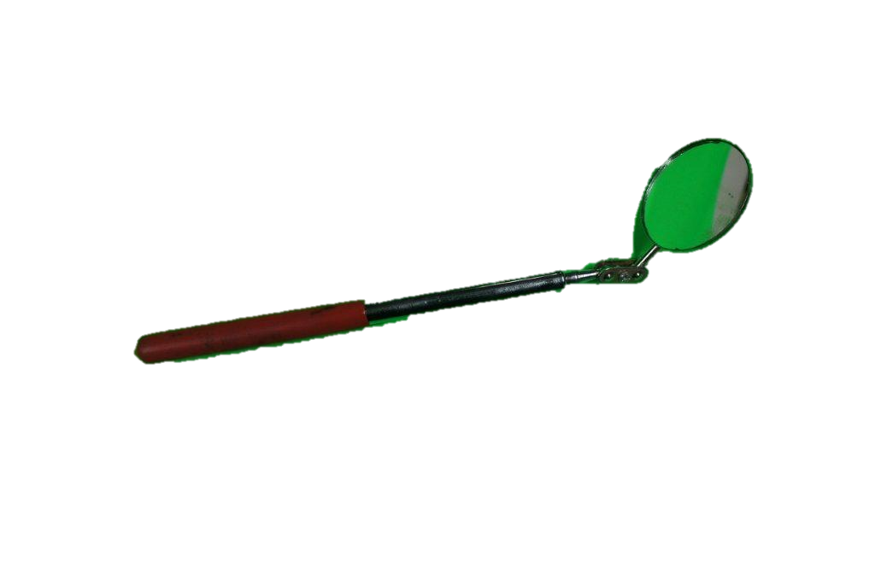  
Adjustable Spanner | 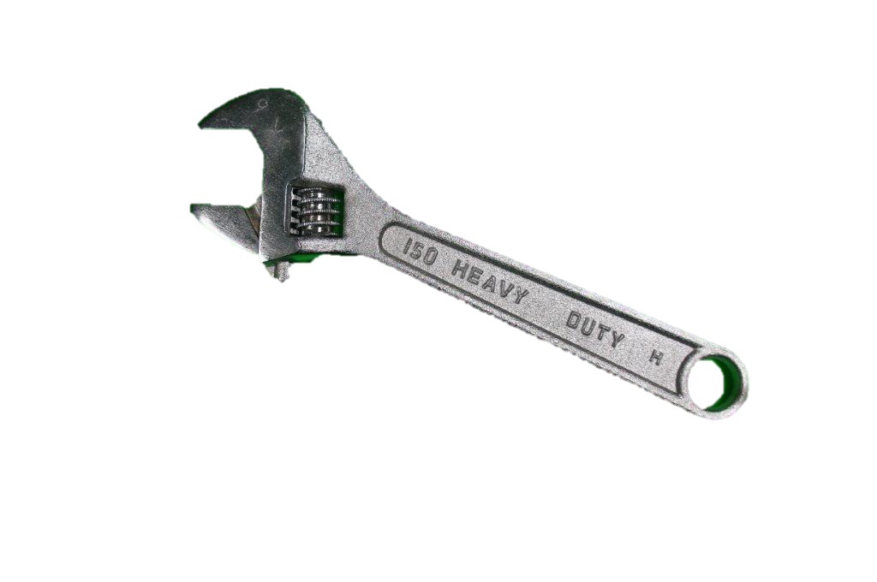
Leatherman Multi-tool | 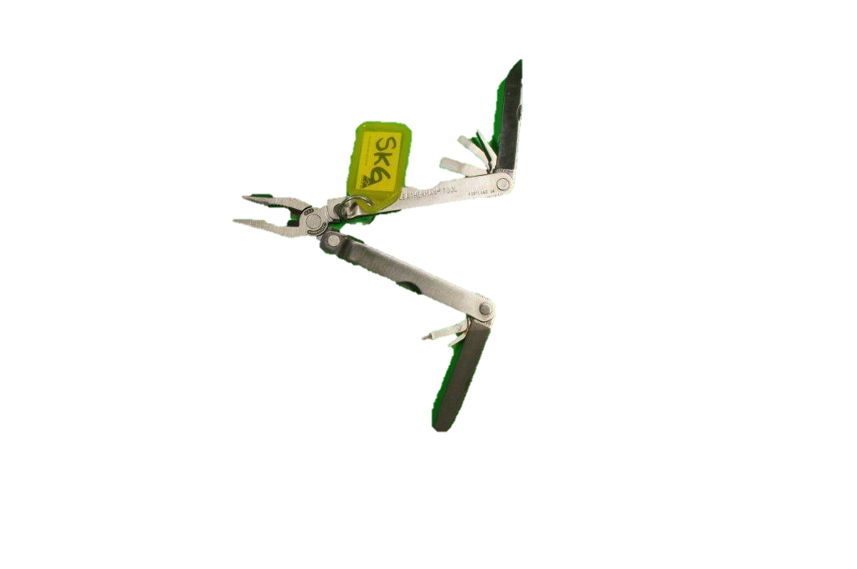
Handheld Torch | 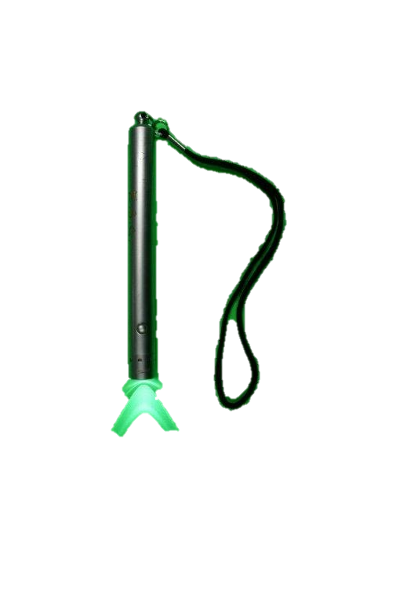
Extendable Telescopic Torch with Magnet | 
Flathead Screwdriver | 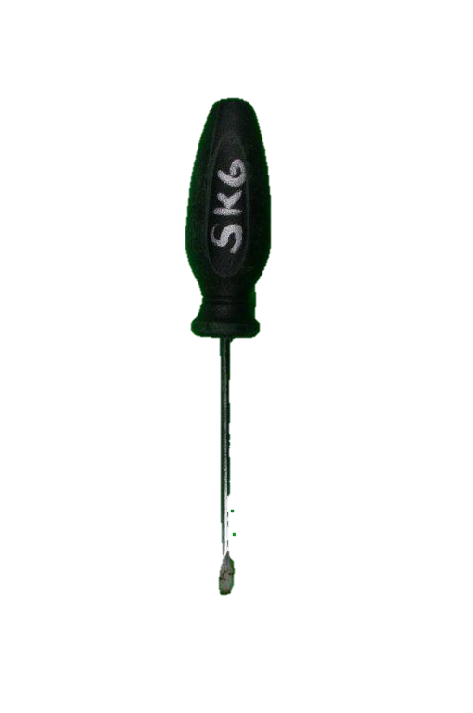
Philips Head Screwdriver | 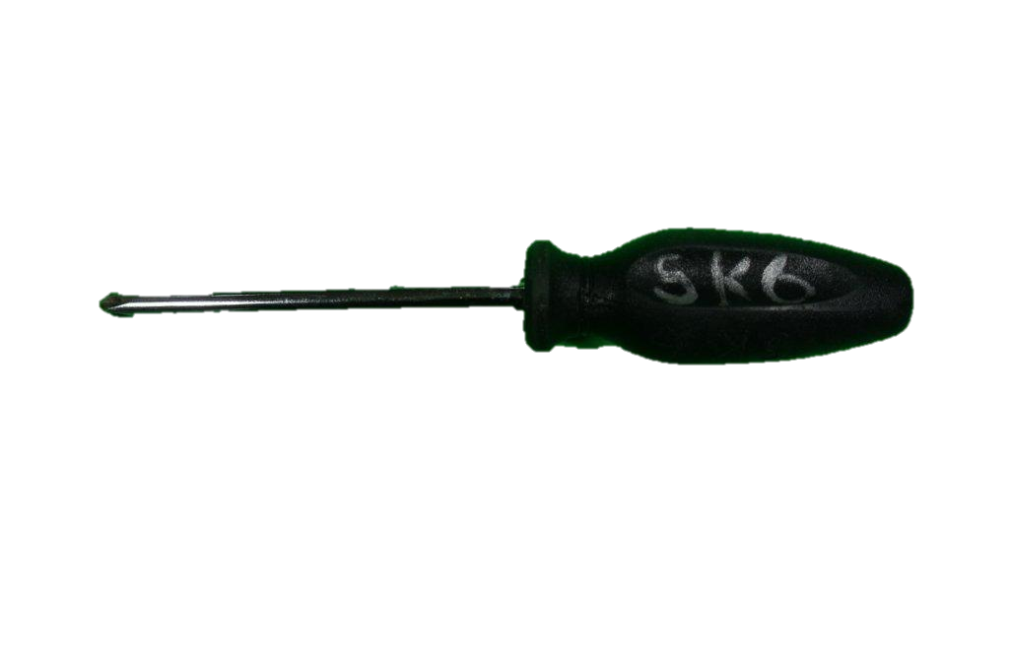
Inspection Camera with 9mm Camera Head | 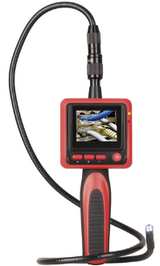
Garrett Handheld Metal Detector | 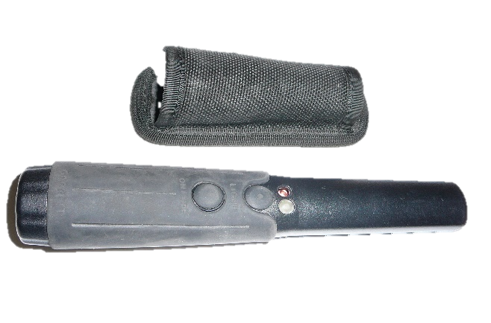
Needle Stick Gloves – (Department Issued)(various) | 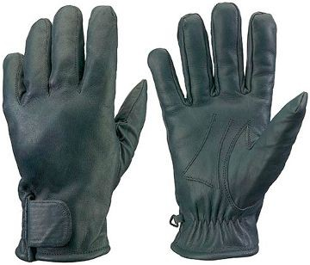
Under Vehicle Inspection Mirror
P-9410L-Black | 
Sony Handheld Digital Video Camera | 
Garrett At Pro | 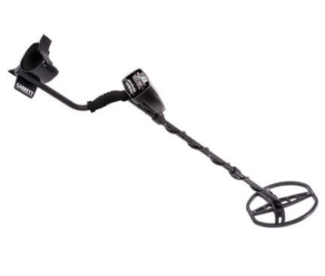
Various sizes for escorts or deployments | 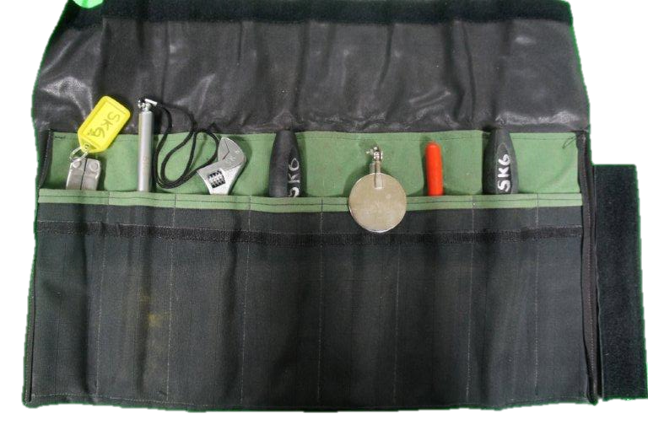
XENVOPOLY Small  XHARCOR PULLTIGHT | 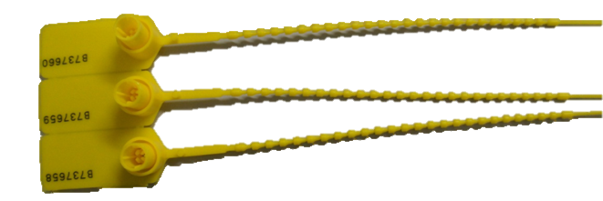  
Security Movement Envelopes (SMEs) | 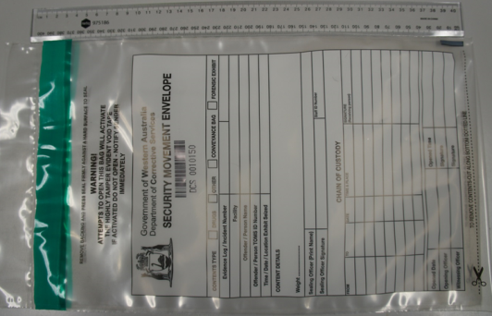

Appendix B: Searches of Persons with Injuries or Disabilities
 | Procedure | Responsibility
1. | Ask the person if they are in any pain or discomfort and consider seeking advice from Health Services staff, prior to the search. | Custodial Officer
2. | Ask the person if they have a pacemaker. | Custodial Officer
3. | Conduct a risk assessment prior to the search and consider;  - whether to transfer the person to a wheelchair (if available)  - the level/nature of the person’s disability  - the person’s size and weight etc. | Custodial Officer
4. | If applicable, collapse the person’s wheelchair and closely inspect removable parts, such as the arms. | Custodial Officer
5. | If an artificial limb, bandage, plaster cast etc. impedes the search and there is suspicion/intelligence of an unauthorised concealed item the Custodial Officer shall;  - where practicable, seek health service advice about the removal of the item  - consider the use of a DDU dog if deemed appropriate by the Superintendent. | Custodial Officer
6. | Provide persons with an injury and those with disabilities the opportunity to sit down as required. | Custodial Officer
7. | Where required, on completion of the search the person shall be transferred back into their own wheelchair. | Custodial Officer

Appendix C: Religious and Cultural Headwear

 | Procedure | Responsibility
1. | Ensure the area where the search shall be conducted is out of sight of all persons of the opposite gender to the person being searched. | Custodial Officer
2. | Veils or other face coverings shall be removed in a private area and conducted by a Custodial Officer of the appropriate gender. | Custodial Officer
3. | Use a handheld metal detector to search headwear. | Custodial Officer
4. | Following the search provide a mirror and privacy to the person when reapplying the veil, face covering or headwear. | Custodial Officer

Appendix D: Pat Searching Procedures – Detainees
 | Procedure | Responsibility
1. | Wear appropriate PPE as required. | Custodial Officer
2. | The search shall be conducted by Custodial Officer of the same gender. | Custodial Officer
3. | Where a detainee self identifies as trans, gender diverse, intersex or identifies as neither male nor female, ask the preference regarding the gender of the Custodial Officer conducting the search. The Custodial Officer conducting the pat search shall act in accordance with the answer. If there is no answer, the detainee shall be searched as the gender the detainee outwardly appears. | Custodial Officer
4. | Consider other applicable search requirements:  - Religious Cultural Headwear  - Injuries or disabilities. | Custodial Officer
5. | Ask the detainee if they have anything on their person which is unauthorised or may cause injury. | Custodial Officer
6. | Ask the detainee to empty their pockets and remove their hat.  - The Custodial Officer shall search the items removed from pockets and hats. | Custodial Officer
7. | Ask the detainee to shake out their hair and untie their hair if necessary.  - Using flat, open hands, the Custodial Officer shall search around the top of the detainee’s shirt and shoulders. | Custodial Officer
8. | Ask the detainee to raise their arms with fingers apart and palms downwards.  - Using flat, open hands, the Custodial Officer shall search each arm or check visually if not covered with clothing.  - The Custodial Officer shall check the hands visually, including between fingers. | Custodial Officer
9. | If the Detainee is male:  - Using flat, open hands, check the front of the body from neck to waist, sides from armpits to waist, to and including the waistband. | Custodial Officer
10. | If the detainee is female:  - Using flat, open hands, check the front of the body from neck to top of bra, then from bottom of bra to waist, to and including the waistband.  - check the sides from armpits to waist. | Custodial Officer
11. | Ask the detainee to turn around to assist the search, if required. | Custodial Officer
12. | Using flat, open hands the Custodial Officer shall check back, front and sides of each leg from crutch to ankle and;  - check the top of the socks or shoes, or if necessary, ask the detainee to remove their shoes and socks;  - provide a mat or similar item for the detainee to stand on if footwear is to be removed. | Custodial Officer
13. | Ask the detainee to move to one side and inspect the area for items dropped.  - The Custodial Officer shall ensure that the detainee is not standing on any item dropped. | Custodial Officer
14. | Record the search on TOMS and include anything found. | Custodial Officer

Appendix E: Pat Search Procedures: Officers or other Employees and Visitors (Including children apparently under the age of 10 years)
 | Procedure | Responsibility
1. | Inform the person of the officer’s authority for conducting the search and the reason for the search | Custodial Officer
2. | Inform the person of the officer’s authority for conducting the search and the reason for the search. | Custodial Officer
3. | Inform the person if they do not submit to a search the Superintendent may refuse admission to the centre or may have the person removed from the centre. | Custodial Officer
4. | The search shall be conducted by Custodial Officers of the same gender. | Custodial Officer
5. | Wear PPE as required. | Custodial Officer
6. | The search shall occur out of sight of other persons unless the person requests the presence of another person. The search shall be conducted with decency and respect. | Custodial Officer
7. | If the person identifies as trans, gender diverse or intersex or identifies as neither male nor female, ask the person their preference regarding their gender. The officer conducting the full search shall act in accordance with the answer. If there is no answer, the person shall be searched as if of the gender the person outwardly appears. | Custodial Officer
8. | Children apparently under the age of 10 years are to be:  - Searched by a female officer in the presence of at least one other female officer.  - In the presence of the person accompanying the child unless that person refuses to remain.  - No male officers shall be present. | Custodial Officer
9. | Ask the person if he/she has anything on their person which may jeopardise the safety, good order or security of BHYDC or which may be used by a detainee to self-harm and to produce the article  - Allow them the opportunity to respond | Custodial Officer
10. | Ask the person to empty his/her pockets and remove their hat or jacket.  - Search the items removed from pockets, hat, and jacket. | Custodial Officer
11. | Ask the person to shake out their hair and untie their hair if necessary.  - Using flat, open hands, search around the top of the person’s shirt and shoulders. | Custodial Officer
12. | Ask the person to raise their arms with fingers apart and palms downwards.  - Using flat, open hands, search each arm or check visually if not covered with clothing.  - Check the hands visually, including between fingers. | Custodial Officer
13. | If the person is male using flat, open hands, check the front of the body from neck to waist, sides from armpits to waist, to and including the waistband. | Custodial Officer
14. | If the person is female using flat, open hands, check the front of the body from neck to top of bra, then from bottom of bra to waist, to and including the waistband.  Check the sides from armpits to waist. | Custodial Officer  (female officers only)
15. | Ask the person to turn around to assist the search, if required | Custodial Officer
16. | Check the back, front and sides of each leg from crutch to ankle | Custodial Officer
17. | When conducting a pat search of the lower body the Custodial Officer shall:  - Using flat, open hands check back, front and sides of each leg from crutch to ankle.  - Check the top of socks or shoes, or if necessary, ask the visitor to remove their shoes and socks.  - Provide a mat or similar item for the person to stand on if footwear is to be removed. | Custodial Officer
18. | If the person is wearing a skirt, search on the outside of the clothing and use a handheld metal detector, if required. | Custodial Officer
19. | Ask the person to move to one side and inspect the area for items dropped.  - Ensure the person is not standing on any item dropped. | Custodial Officer
20. | A report shall be submitted to the Superintendent by all officers involved in the search. | Custodial Officer

Appendix F: Handheld Metal Detector Searching Procedures
 | Procedure | Responsibility
1. | Inform the person of the Custodial Officer’s authority for conducting the search and the reason for the search | Custodial Officer
2. | Ask the person if they have a pacemaker | Custodial Officer
3. | Ask the person being searched if they have any items on their person that may alarm the detector | Custodial Officer
4. | If yes, ask the person to remove those items | Custodial Officer
5. | Ask the person to stand with their arms spread out and legs shoulder width apart. | Custodial Officer
6. | Run the handheld metal detector closely along the person from head to toe front and back, ensuring no contact is made with the person. | Custodial Officer
7. | Should the detector alarm, ask the person to provide an explanation. | Custodial Officer

Appendix G: Full Searching Procedure
Routine full searching (previously known as strip searching) shall not be conducted at a YDC. The decision to conduct a full search of a detainee shall only be conducted where there is a reasonable suspicion or intelligence that the detainee is in possession of an unauthorised item on their person which:
- may jeopardise the safety, good order, or security of the detention centre
- may be used for self-harm.
 | Procedure | Responsibility
1. | Custodial Officer shall obtain the authority from the Superintendent to conduct the full search. | Custodial Officer
2. | Two Custodial Officers 2 of the same gender shall conduct the search. | Custodial Officer
3. | The Superintendent or OIC authorising the search shall ensure where a search of a detainee is conducted in an area covered CCTV, the Custodial Officer viewing the CCTV is of the same gender of the detainee. | Superintendent/OIC
4. | Where a detainee identifies as trans, gender diverse, intersex or identifies as neither male nor female, the Custodial Officer shall ask the preference of the detainee regarding the gender of the Custodial Officer conducting the full search. The officer conducting the full search shall act in accordance with the answer. If there is no answer, the detainee shall be searched as if of the gender the detainee outwardly appears. | Custodial Officer
5. | Inform the detainee of the officer’s authority for conducting the search, the reason for the search and how the search will be conducted. | Custodial Officer
6. | Ask the detainee if they have anything on them which may jeopardise the safety of the detainee, the good order or security of a YDC or that they know they shouldn’t have on them and to hand over the item.  Allow the detainee the opportunity to respond. | Custodial Officer
7. | In the event the detainee refuses the full search, the Searching Officer may use such force as is prescribed in the regulations for the purpose of performing a search of a detainee and taking anything found, as ordered by the Superintendent / OIC.  Guidance on using force and restraints to facilitate a strip search is contained within COPP 8.2 Use of force
8. | Ask the detainee to remove all items from pockets (ask the detainee to turn their pockets inside out). Shoes, socks, jewellery and hair decorations, wigs and weaves shall be requested to be removed. If prosthetics are worn, the detainee shall remove, and the Custodial Officer inspect the item before it is returned. | Custodial Officer
9. | The Officer shall check the detainee’s mouth. The Officer shall ask the detainee to show that there is nothing in their mouth. If dentures are worn, the detainee shall remove the dentures to allow an inspection of their mouth, and then re-apply the dentures. | Custodial Officer
10. | Ask the detainee to remove clothing from above waist. Clothing should be handed to the searching officer, who shall pass it to the second officer for inspection. | Custodial Officer
11. | Ask the detainee to face the front and extend their arms while armpits and fingers are checked. | Custodial Officer
12. | As the detainee to lean forward and flick their hair over top of the head, running fingers through the hair and exposing behind the ears. | Custodial Officer
13. | The detainee shall be asked by the Custodial Officer to turn around and redress their top half. | Custodial Officer
14. | The Custodial Officer shall ask the detainee to remove clothing below the waist  - Female detainees shall not be required to remove tampons.  - detainees shall not be required to squat.  - Clothing should be handed to the searching officer, who shall pass it to the second officer for inspection. | Custodial Officer
15. | Facing forward, the Custodial Officer shall ask the detainee to lift their shirt to waist height. | Custodial Officer
16. | The Custodial Officer shall request the detainee to turn around and show the soles of the feet while spreading their toes. | Custodial Officer
17. | The Custodial Officer shall request the detainee to replace their clothing to the lower half of their body. | Custodial Officer

Appendix H: Cell Searching Procedure and Cell Integrity Check
 | Procedure | Responsibility
Cell Search
1. | Print the cell inventory report from TOMS to identify any items which are not issued to the detainee. | Custodial Officers
2. | Obtain the relevant equipment prior to the search. | Custodial Officers
3. | Wear PPE as required. Gloves shall be worn and then discarded and replaced with a new pair between cell searches. | Custodial Officers
4. | The detainee may be present where appropriate | Custodial Officers
5. | Ask the detainee if they have any unauthorised items in their cell or on their person(s) including items which may cause harm.  Note* If articles are surrendered, the Custodial Officer shall continue the search.
6 | The detainee shall vacate the cell. | Custodial Officers
7. | Commence search at the cell door and systematically work around the cell (one to the left, one to the right) searching all contents thoroughly from top to bottom, to include:  - voids  - vents  - ceilings  - floors  - walls  - doors  - windows (inside, and where possible, outside)  - grilles  - pipes  - fixed furniture and fittings  - bedding  - property. | Custodial Officers
8. | The Custodial Officer shall ask the detainee for an explanation if any unauthorised item is found | Custodial Officers
9. | The Custodial Officer shall inform the detainee of any items which have been removed, on completion of the search. Any items damaged during the search shall be managed in accordance with COPP 4.1 – Property. | Custodial Officers
10. | The Custodial Officer shall leave the detainee’s cell as tidy as possible. | Custodial Officers
11. | Ensure all equipment used for the search is removed and accounted for prior to vacating the cell. | Custodial Officers
Cell Integrity Check
An integrity check is an examination of the condition and functionality of the cell and its ongoing security. An integrity check is not a cell search, however, during an integrity check, Custodial Officers may discover items not issued to the detainee. For example, while examining the integrity of the window or grill, items such as contraband may be discovered at the same time.
1. | A cell integrity check shall be conducted by Custodial Officers daily, or prior to the placement of a new detainee to that cell. | Unit Manager or Custodial Officer
2. | Wear PPE as required. Gloves shall be worn and then discarded and replaced with a new pair between cell integrity checks. | Unit Manager or Custodial Officer
3. | A cell integrity check shall include:  - a test of the cell call system  - an examination of all fixtures and fittings  - an examination of the window and grill  - an examination of the door and locking furniture  an examination of the ceiling and light fitting. | Unit Manager or Custodial Officer
4. | While checking the integrity of the cell any unauthorised items discovered shall be managed in accordance with section 5 of this COPP. | Unit Manager or Custodial Officer
5. | The Unit Manager or Custodial Officer who conducted the cell integrity check shall record the check in the unit occurrence book and TOMS. | Unit Manager or Custodial Officer

Appendix I: Perimeter Area Searching Procedure
 | Procedure | Responsibility
1. | Commence the search of the perimeter at the main gate, outside BHYDC. | Custodial Officers
2. | Proceed around the perimeter, return to the main gate. | Custodial Officers
3. | Check the perimeter for any signs of damage, markings, or other interference. | Custodial Officers
4. | Observe and, if necessary, test in accordance with, any technical security aids fitted to the perimeter. | Custodial Officers
5. | Ensure the area adjacent to the perimeter is free from obstruction or potential items which may be used for an escape. | Custodial Officers
6. | Enter the sterile area (if applicable) and proceed around the perimeter of BHYDC again, once the initial circuit is complete. | Custodial Officers
7. | Ensure the immediate area inside the internal perimeter, is free from contraband or other objects. | Custodial Officers
8. | If a security breach is determined the Custodial Officer shall remain at the site where the breach has been discovered and request assistance. | Custodial Officers
9. | On completion of the search:  - Report any potential security breaches to the Security Manager immediately. | Custodial Officers

Appendix J: Vehicle Search Procedure
A search of a vehicle in the Sallyport shall include:

 | Procedure | Responsibility
1. | The driver shall be asked to turn the vehicle off and alight from the vehicle. | Custodial Officer
2. | Confirm the identity of the driver and any passengers. | Custodial Officer
3. | The Key Issue Officer shall record the vehicle registration, driver’s name, and time of entry/exit. | Custodial Officer
4. | Ask driver if they have any item that may not be permitted in BHYDC e.g., mobile phone. | Custodial Officer
5. | A systematic search shall be conducted of the:  - Inside driver and passenger area  - Boot cargo area, under the bonnet (where practicable)  - Outside, underneath, and top of the vehicle  - Wheel arches and spare wheel  - Vehicle’s underside. | Custodial Officer
6. | Vehicles may also be searched by a drug detection dog or ETD. | Custodial Officer
7. | Where the vehicle is a truck or utility vehicle the Custodial Officer shall inspect the vehicle’s tray. | Custodial Officer
8. | If applicable, determine the names of all detainees in an escort vehicle. | Custodial Officer
9. | Any equipment not required for the purpose of the vehicle’s entry shall been stored at the gate. | Custodial Officer
10. | If any unauthorised item (refer to COPP 9.5 – Approved and Prohibited Items and Youth Custodial Rule 9) is found which is likely to result in the person being charged in accordance with legislation or a charge by the WA Police Force, refer to section 3.10.1. | Custodial Officer

r 94(1) Young Offenders Regulations 1995
r. 94(3) Young Offenders Regulations 1995
r. 86(8), 89(5) and 92(6) Young Offenders Regulations 1995
r.81(4) Young Offenders Regulations 1995
r.85(1)(2) Young Offenders Regulations 1995
r. 84 Young Offenders Regulations 1995
r. 86(1) Young Offenders Regulations 1995
s.196(2)(e) Young Offenders Act 1994
r.88 Young Offenders Regulations 1995
r.82(2) and r.88 Young Offenders Regulations 1995
r. 91(1)(2) Young Offenders Regulations 1995
r. 83(3) and (4) Young Offenders Regulations 1995
s. 196(3)(c) and 197(1) Young Offenders Act 1994
r 91(2) Young Offenders Regulations 1994

