Meet the members
Ministerial Youth Advisory Council
The Ministerial Youth Advisory Council (MYAC) was established in 2017 to provide advice to the Minister for Youth on matters relating to young people. MYAC is made up of 11 young Western Australians, aged 15 to 25 years, who draw upon their relevant knowledge, experience and skills. The members below will serve until 30 June 2026.

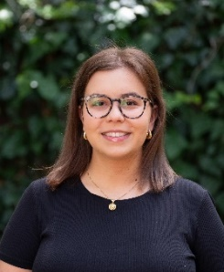
Co-chair – Alessia Maio || 22 || she/her || Perth
What made you want to be a part of MYAC?
I wanted to be a part of MYAC because I am passionate about advocating for issues that affect young people in our community. I believe that youth voices are crucial in shaping policies and initiatives that directly impact our lives. Being a part of MYAC will give me the opportunity to contribute to meaningful discussions and influence decisions that lead to positive change. Furthermore, I am eager to collaborate with other like-minded young individuals and learn from their experiences and perspectives.
Living with an incurable auto-immune disease has given me a unique perspective on the challenges that young people face and the impact of those challenges. After working in multiple high schools around Perth, I have witnessed firsthand the struggles and triumphs of youth in our community. These experiences have fuelled my passion for advocating on their behalf and striving to make a meaningful difference. Many young people feel as though they do not have a voice, so I am committed to ensuring that their needs and perspectives are heard and addressed effectively. Joining MYAC offers me the platform to voice these concerns and work collaboratively towards creating positive changes that will benefit young people. This role aligns with my personal values and aspirations of making a tangible difference in society.
If you studied/are studying, what course did you complete/are you completing and how is this setting you up for the future?
In December of 2023 I graduated from the University of Western Australia, completing a Bachelor of Arts with an Italian major and French minor. My degree at UWA was enriching and it was a time of self-discovery, learning and personal growth. After my educational experience at UWA, I was eager to further my education and pursue a career in the field of healthcare, specifically paramedicine. From a young age, I have had a strong desire to help and support others, especially those who are in vulnerable states, or those who are less fortunate than myself. This led me to dream of becoming a paramedic; a career in which I can save lives, support individuals in need and make a lasting impact on patients. I am now studying a Bachelor of Paramedical Science at Edith Cowan University, with the hopes of continuing my studies to a Masters in Critical Care Paramedicine. My ideal job title is a Critical Care Paramedic, a role that provides advanced life support for patients requiring a higher level of medical care in a pre-hospital setting.
I am confident that pursuing a degree in Paramedical Science will allow me to make a meaningful contribution to society, whilst also fulfilling my desire for continuous learning. I am eager to become a part of the community of professionals who strive to make a difference in the world of healthcare. There is a consistent demand for skilled Paramedics, providing strong job security and opportunities for employment across various regions. Paramedics play a vital role in their communities by providing critical emergency care and support, making a significant impact on public health and safety. I look forward to the challenges this career will bring, as well as the dynamic work environment.

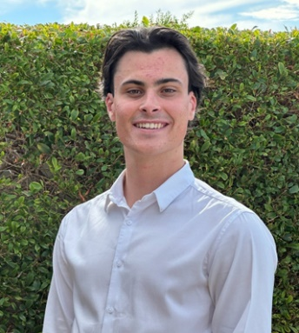
Co-Chair – Joshua Peckover || 21 || he/him || Peel
What made you want to be a part of MYAC?
I believe that the Government can have an incredibly positive impact on young people’s lives. I wanted to be part of the conversations that help frame how State Government will interact with young people and address youth issues in Western Australia.
I hope to help Government make the community aware of the services they provide to young people. Too often are young people shrugged off as having no interest in government and being too apathetic to engage in civic processes. I firmly believe that it is not the case that young people have no interest in government, but instead that young people are not aware of just how big of a role Government plays in their lives. I want to advise State Government and the Minister on ways they can meaningfully interact with young people to include them better in civic processes and providing services.
What is your job? How does being a young person help you in your chosen job?
I am the coordinator of a program called Youth Parliament in Western Australia. This program gathers 59 young people to each represent an electorate of the WA Legislative Assembly, and craft bills that address youth issues in Western Australia. Being a young person in this role is very rewarding. I get to appreciate first-hand the passion of our young people in Western Australia and support them in advocating for the issues they care most about. I also work along a team of fantastic young people who generously volunteer their time to help run this program. Being involved in a program that is run by young people, for young people, is an incredibly empowering experience.

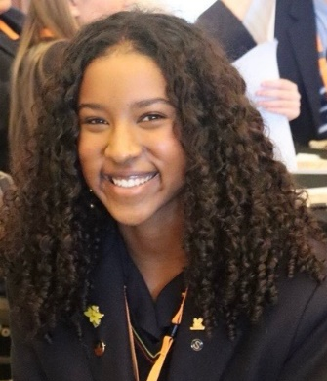
Member – Amani Kariuki || 17 || she/her || Perth
What are you most excited about with the possibility of serving on MYAC?
I’m so excited about the opportunity to meet a variety of fellow young people through serving on MYAC and being able to discuss the areas I’m passionate about with the Minister for Youth like youth justice and civic engagement. Hearing from peers about their lived experience is incredibly important to me and I am thrilled to have the opportunity to lend my voice to the chorus of advocates for youth issues.
What are you most enthusiastic about in life?
I am super enthusiastic about sport – likely owing to my competitive streak! I’ve been taking dance classes since I was in Kindy and nowadays, you can often find me at the studio training for competitions or doing some Pilates at the gym. Otherwise, I’m a keen Formula One and footy fan that yells at the TV!

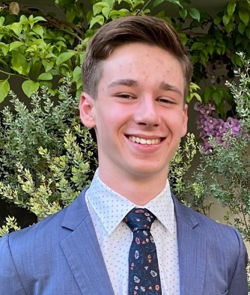
Member – Henry Bird || 17 || he/him || Perth
What made you want to be a part of MYAC?
I want to be a part of MYAC because I believe that young people can provide valuable insights to the government. Personally, I believe that environmental protection, in terms of greenhouse gas emissions, waste and land use, and supporting all West Australian young people to have diverse and fulfilling careers is of utmost priority for our government. I am excited to work with other passionate young people to make sure that these issues are on the government’s agenda.
What are you most enthusiastic about in life?
I am most enthusiastic about learning new ways of looking at things and meeting interesting people with different perspectives. I also love to unwind whilst enjoying the West Australian sunshine with my golden retriever-poodle Enzo in King’s Park or at the beach.

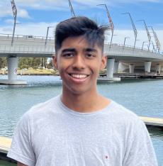
Member – Joshoa Zilani || 19 || he/him || Peel
Why is it important for young people to have their voices heard by government?
Young people need to have their voices heard by Government as the policy being created now will affect them both now and especially in the future. Young people make up a significant portion of the population, however, their unique perspectives on issues and concerns are often overlooked in policymaking, which may affect them as they grow into future leaders and stakeholders in society. Young people can bring fresh perspectives and innovative ideas to the table. Their experiences can lead to creative solutions for issues, especially those affecting young people. Policies such as education, employment, and environmental sustainability, should require input from those who will be most affected by them in the long term.
Moreover, engaging young people in policymaking fosters a sense of empowerment and civic responsibility from an early age. It encourages them to actively participate in shaping their communities and societies, promoting a culture of informed citizenship and democratic engagement. By listening to and respecting young voices, governments can further build trust among younger generations, ensuring that future policies are fair and just. By listening to and consulting with young people now on policy, governments will be able to further address inter-generational inequity and ensure that policies created now will be fair and sustainable in the future.
What's your favourite way to give back to the community?
My favourite way to give back to the community is through active civic engagement in a way that creates equal opportunities and positive change for everybody. I mainly like to give back by advocating for issues that are important to the community and by empowering young people to achieve beyond their limits. I accomplish this by mentoring and facilitating young people in leadership and advocacy through workshops and events and assisting in programs that aim to build on a young person’s character development. My advocacy focuses more on the economic development of my community and providing ways to create new opportunities through policy.

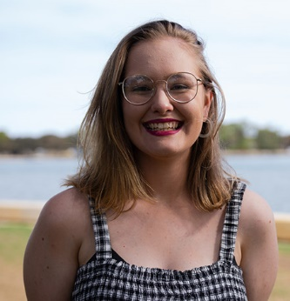
Member – Lilijana Nicholls || 20 || she/her || Perth
What made you want to be a part of MYAC?
I wanted to be a part of MYAC as I have enjoyed the time I have spent on local council advisory groups and have seen the impact that voicing my opinions and sharing my ideas can have on a local scale. I wanted to be able to take the skills I've learnt and apply them on a state-wide scale, working with other like-minded young people to enact change and provide a voice for youth.
What's your favourite way to give back to the community?
My favourite way to give back to the community is through volunteering. I have been involved with the Mandurah Youth Advisory group, running events for young people and advising on city strategies. I have also recently joined the Cockburn Youth Advisory Collective. I have volunteered with various organisations for several years, running stalls and events and mentoring STEM camps for high school students.


Member – Nandini Gera || 19 || she/her || Goldfields/Esperance
What made you want to be a part of MYAC?
I wanted to be a part of MYAC because I believe in the power of young voices to shape meaningful change. I have actively engaged in leadership roles and advocacy to learn and see first-hand how important it is for young people to have a seat at the table when decisions are made. I am passionate about ensuring that youth from diverse backgrounds feel heard, valued and represented.
Through my experience working with the council and leadership programs, I have developed a strong commitment to community engagement and youth empowerment. I want to use this opportunity to collaborate with like-minded individuals, contribute to discussions on key issues, and help create initiatives that directly impact young people in our community. MYAC is an incredible opportunity to turn ideas into action. I am very excited to be a part of a team that is dedicated to making a difference.
What are you most enthusiastic about in life?
I am most enthusiastic about personal growth, new experiences, and pushing myself to reach my full potential. Whether it's learning a new skill, taking on a challenge, or stepping outside my comfort zone, I thrive on continuous self-improvement. I'm passionate about exploring the world, understanding the universe, and making deep connections with people.
I also find joy in creative expression—whether through playing the guitar, dancing, or engaging in meaningful conversations. I love the thrill of adventure, whether it’s traveling, trying something daring like skydiving, or immersing myself in nature. Ultimately, I want to live a life filled with learning, passion, and impact, always striving to become the best version of myself.


Member – Om Sharma || 19 || he/him || Perth
Why is it important for young people to have their voices heard by government?
It’s often claimed that ‘solving’ the current issues affecting young people today like mental health, cost of living or climate change should take precedence over youth voices in government. However, the opposite is true. By empowering young people and giving them spaces like the MYAC to be heard by key decision-makers in government, you actually make ‘solving’ many of the key challenges they face much easier. Young people are uniquely able to comment on and problem-solve the issues that are close to them, and providing them a platform to contribute their ideas only strengthens any work the government does to support them.
What is your job? How does being a young person help you in your chosen job?
I work as a Communications Officer for the Department of Communities, which mostly involves me writing a variety of materials including communication plans for our internal teams, feature articles and good news stories for our inter- and intranet, and content for government campaigns and state ministers. I love my job, and I like to think that being a young person allows me to have a unique perspective on the work I do, especially on topics I have personal experience with. The fact that I’m currently pursuing a degree in public relations also means I can apply the latest content from university into a real, practical environment. I wouldn’t give it up for the world.

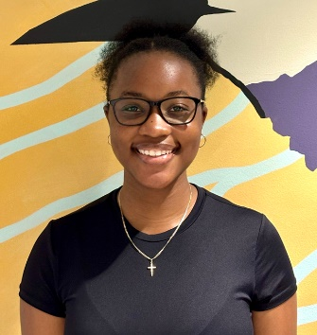
Member – Takunda Bere || 16 || she/her || Perth
What are you most excited about with the possibility of serving on MYAC?
I am most excited about the possibility of serving on MYAC, because it gives me the chance to proudly represent and advocate for the Kwinana community. Being able to voice not just my own opinion but also those of my peers is something I value deeply. I am also eager to foster my passion for youth advocacy. I enjoy embracing new experiences and I am looking forward to immersing myself in this opportunity.
What is your biggest passion?
Since I started my volunteering journey, my passion for youth advocacy has grown immensely and the love I’ve developed for my community is indescribable. I hope to inspire others to engage actively in their communities, fostering a similar passion for service learning. Representing young people in my community is a role I cherish deeply and it fuels my determination to encourage kindness.

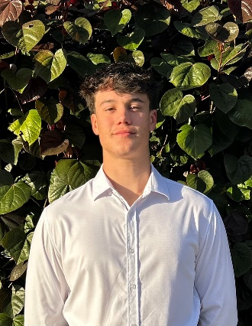
Member – Ryan Rawlinson || 16 || he/him || Perth
Why is it important for young people to have their voices heard by government?
Young people in Western Australia make up a large proportion of electorates, yet many are ineligible to vote yet still desperate to have their voice heard beyond the booths. Australia being a representative democracy, it is only logical that a group representing 1/5th of the population is equitably advocated on behalf.
Young people are the future, although blatant, this fact is often neglected. Youth representation such as MYAC, bridge a gap between members of parliament and young constituents and ensure that policy is made for the future. This is of great importance as young people offer unique perspectives on issues close to our hearts. Politics impacts young people every day, ensuring youth representation solidifies positive future society. Young people are the cohort impacted by legislation made today, the voice of the youth is paramount for a sustainable future for us as current young people in addition to future West Australian youth.
What matters most to you in life?
In the broadest sense, happiness is what matters to me most in life. This applies to all aspects of my work as I find happiness in accomplishment and through appreciation and gratitude. One of the most fulfilling aspects of my life has been helping others discover their own sense of happiness, particularly in connecting people to the beauty and opportunities of our incredible state of Western Australia. I find happiness through giving back to our communities through homelessness support and advocacy as well as smaller moments of gratuity like those awesome sunsets over our amazing West Australian beaches or bush walks through our great biodiverse regions. These moments remind me of the simple, yet powerful joy that comes from feeling connected to the place we live.
I believe that as a member of MYAC, it is a goal of mine to allow as many young people as possible to find true happiness within their lives and I believe that policy makers play a pivotal role in ensuring a high quality of life through a myriad of means including fostering mateship and sense of community as well as planning sustainable and community orientated developments with diverse housing and work opportunities thus allowing greater youth happiness. Happiness isn’t just a personal pursuit it’s a collective one in which all young people should benefit from.

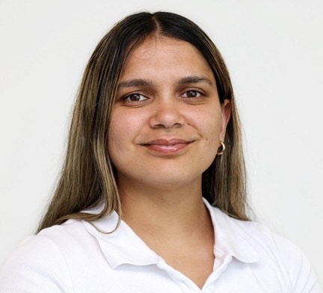
Member – Amber Ugle-Hayward || 24 || she/her || Perth
What made you want to be a part of MYAC?
I want to be part of MYAC because, as a proud Noongar woman, I’m passionate about supporting First Nations youth and ensuring our voices are heard in shaping the future. My journey through adversity has allowed me to be commitment to mental health, cultural strength, and leadership. MYAC offers a platform to advocate for change, support young leaders, and embed First Nations perspectives in public policy and community life.
What is your biggest passion?
Helping others is at the heart of everything I do. Coming from a family and community that has faced cycles of hardship, including the impacts of domestic violence, I’ve seen how powerful support, advocacy, and connection can be. Whether it’s checking in on someone quietly struggling, creating space for young mob to feel proud of who they are, or speaking up when it matters, I carry this responsibility with determination. My passion comes from lived experience, I know what it means to be heard, and I’m committed to making sure others are too.

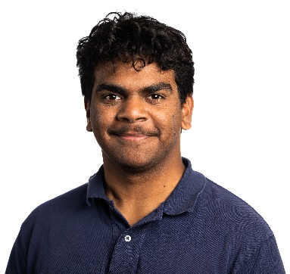
Member – Tremane Baxter-Edwards || 18 || he/him || Kimberley
What made you want to be a part of MYAC?
I believe young people are an intrinsically powerful cohort, unafraid to speak up and share their views. We know what matters to us, and MYAC is a unique platform to advocate for the interests of young Western Australians. I felt compelled to join so I could offer my advice, lived experience, and perspectives, especially as a young person from remote Australia. I’m passionate about ensuring opportunities are made available to all young people, not just those from the city, and particularly to First Nations kids from remote communities like me.
What do you think is the greatest thing about being a young person in WA?
In my opinion, the greatest thing about being a young person in Western Australia is the privilege of growing up in one of the most stunning and diverse states in the country. Our unique backyard makes WA an incredible place to live—from my home in the beautiful Kimberley, with escarpments as old as time itself, to the red dirt of the Pilbara, and the pristine beaches of the South-West. There’s truly something for every young person here, and that connection to land, nature, and culture is something really special.

