Notice of proposed complaint
The Building Services (Complaint Resolution and Administration) Regulations 2011 require that, at least 14 days before making a complaint to the Building Commissioner, the complainant provides the respondent with written notice of the proposed complaint, including the remedy the complainant proposes to seek and the evidence on which the complainant proposes to rely. This template may be used by a complainant for this purpose. Proof that the notice has been served will be required. If served by email, a copy of the sent email will suffice.

COMPLAINANT
Name | Address
Contact number | Email

RESPONDENT
Name | Address
Contact number | Email

The complainant proposes to make a complaint against the respondent to the Building Commissioner in relation to the below matters

Item no. | Location (e.g. bed 3) | Description of issue (not editable) | Remedy sought | Evidence relied upon
1 | Whole dwelling/building | 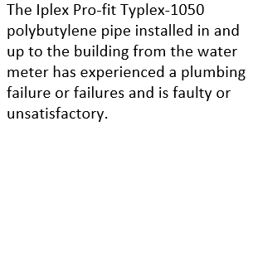 | That the respondent remedies the water supply pipework to ensure it is of an acceptable quality and that it is safe, durable and free from defects.  That the respondent makes good all areas and surfaces affected by any repairs in a proper and proficient manner. | Photo(s) of Iplex piping in roof space, wall cavity in kitchen/bathroom, etc.
2 | Specific leaks have been identified in [please list locations by particular rooms/areas in the dwelling/building]. | 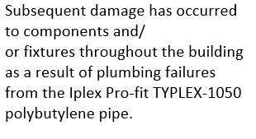 | That the respondent remedies the water damaged components and or fixtures in [particular rooms/areas in the dwelling/building].  That the respondent makes good all areas and surfaces affected by any repairs in a proper and proficient manner. | Photo(s) of damaged ceiling and carpets in [particular rooms/areas in the dwelling/building].
3 | Specific leaks have been identified in [please list locations by particular rooms/areas in the dwelling/building]. | 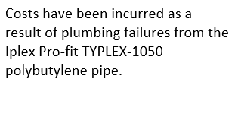 | That the respondent pays the complainant in the amount of $A. | Tax invoice from ABC plumber, dated X.  EFT receipt of payment to ABC plumber, dated X.

