Office of the Government Chief
Information Officer

Annual Report 2016 - 17

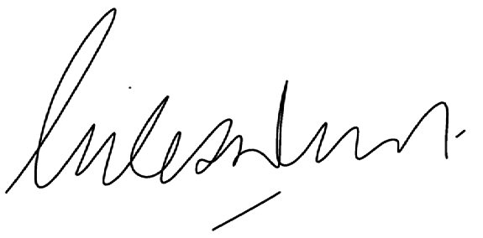About this report

STATEMENT OF COMPLIANCE
Hon Dave Kelly MLA
Minister for Water; Fisheries; Forestry;
Innovation and ICT; Science
For the year ended 30 June 2017
In accordance with section 63 of the Financial Management Act 2006, I hereby submit for your information and presentation to the Parliament, the Annual Report for the Office of the Government Chief Information Officer for the financial year ended 30 June 2017.
The Annual Report has been prepared in accordance with the provisions of the Financial Management Act 2006.

Giles Nunis
Chief Executive and Government Chief Information Officer
10 August 2017
This Annual Report is divided into five main areas and every effort has been made to ensure the readability and accessibility of this report in print and online.
The Office of the Government Chief Information Officer, referred to in this report as the Office of the GCIO, supports sustainability and encourages readers to view the report at www.gcio.wa.gov.au. Only limited professional copies have been produced.
As part of the Office of the GCIO’s focus on continuous improvement, we encourage your feedback about the document. Contact details for the Office are listed on page 73.
© 2017 Office of the Government Chief Information Officer. All rights reserved. This publication may be reproduced in whole or part provided the source is acknowledged.

ISSN 2206-8899 (Print)

ISSN 2206-8902 (Online)

Key Legislation
The Office of the GCIO complies with all relevant legislation that governs its functions.

Contents

Overview 4
Executive summary 4
Organisational structure 7
Performance management framework 8
Governance 9
Agency performance 10
Transformation 10
Collaboration 15
Innovation 16
Significant issues and future trends 21
Summary of financial performance for 2016-17 24
Summary of non-financial performance for 2016-17 25
Financial statements 26
Certification of financial statements 26
Audit opinion 27
Statement of Comprehensive Income 29
Statement of Financial Position 30
Statement of changes in equity 31
Statement of cash flows 32
Schedule of income and expenses by service 33
Schedule of assets and liabilities by service 34
Summary of consolidated account appropriations and income estimates 35
Notes to the financial statements 36
Performance indicators 64
Certification of key performance indicators 64
Performance assessment 65
Key effectiveness indicators 66
Key efficiency indicators 68
Disclosures 69
Ministerial Directives 69
Other financial disclosures 69
Governance disclosures 70
Other legal requirements 71

This report highlights the work undertaken by the Office of the GCIO in 2016-17 to lead and support digital reform in the Western Australian public sector.

The 2016-17 financial year was the second year of operation for the Office of the GCIO, with many projects moving to implementation.
During the year, the Office of the GCIO progressed a range of initiatives under the Digital WA Information and Communications Technology Strategy 2016- 2020 (Digital WA). The vision for Digital WA is to create an innovative public sector with mature capabilities, which delivers efficient, reliable and high quality services to business and the community.
One of the major achievements under Digital WA was the introduction of GovNext-ICT, a new Common Use Arrangement (CUA) to move the public sector from owner/operators of Information Communications Technology (ICT) infrastructure to consumers of ICT infrastructure services on demand. Modernising ICT infrastructure will underpin improvements in government service delivery and efficiency. The Office of the GCIO established
the GovNext Service Broker to assist agencies transition to the new arrangements and oversee the implementation and operation of the CUA.
Another significant achievement was the launch of the prototype myWA digital services portal in December 2016 for public consultation. This site, now known as ServiceWA Alpha, allows users to search for and find
government digital services that are currently available across more than 450 government websites. Eventually, members of the community will be able to login and access their information or services from any department or agency through this single portal.
To maximise the advantages of the new technologies available, the Office of the GCIO focussed on developing frameworks to build ICT skills across the public sector. The Capability Maturity Model in Digital WA was more

fully developed and guidance material provided to agencies to assist agencies identify and improve their level of ICT maturity. The Office of the GCIO also developed an ICT Capability and Capacity Building Program for non-ICT employees, and partnered with the Public Sector Commission to develop the ICT Capability Framework to support the development of ICT professionals within the public sector.
In 2016-17, the Office of the GCIO was given responsibility for the innovation function and developed the State’s first Innovation Strategy. A range of initiatives were implemented by the Office to support Western Australian innovators commercialise their ideas.
A major achievement was the development of the Innovation Hub, which went live in November 2016. The Hub is a resource for the State’s innovation ecosystem to learn from and connect with other innovators. The Hub was launched as part of the Innovation Worth Sharing branding and marketing campaign to promote Western Australia’s competitive advantages.
Supporting the State’s local home grown innovators is a key pillar of the Innovation Strategy. The Office of the GCIO managed the Innovator of the Year program, which celebrated its 10th anniversary in 2016, and
administered two competitive grants programs (Start IT Up and Innovation Vouchers).
In April 2017, the State Government announced that the Innovation function would be transferred to the Department of Jobs, Tourism, Science and Innovation from 1 July 2017 as part of machinery of government changes.

The Office works across government and with industry and has identified the following significant emerging issues affecting business, the community and the public sector:
- increasing threat of cyber intrusions
- the need for an enhanced data analytics function within Government
- continuous improvement of ICT procurement outcomes across government
- better internet connectivity to enable smart cities and growth in regionally based sectors
- greater demand for on demand digital government services
- utilisation of common digital platforms across government to support the delivery of integrated business functions and services in agencies
- demand for digital skills and capabilities
- rationalisation of agency software licences and moving to licensing on a whole of government scale
- the slower than anticipated speed of adoption of Digital WA initiatives, limiting business and financial benefits for government, and
- ability for the ICT industry to respond to new changes led by the Office. The Office of the GCIO is funded until 30 June 2018.

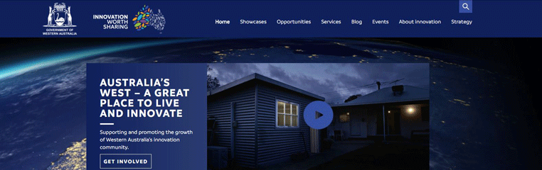
The Innovation Hub, accessible at www.innovation.wa.gov.au

OVERVIEW
AGENCY PERFORMANCE
FINANCIAL STATEMENTS
PERFORMANCE INDICATORS
DISCLOSURES

OPERATIONAL STRUCTURE

AT A GLANCE

Simple, connected and digital public sector

Leadership for ICT
in the public sector

Collaboration with agencies and industry

Staying true to our values
Our Vision
The creation of a simple, connected and digital public sector.
Our purpose
To provide leadership for ICT in the public sector. This translates into improved services, transparency, governance, delivery, consistency, commonality, savings, efficiencies and reform.

Our objectives
To collaborate with government agencies and industry to stabilise cost, increase value-for- money and minimise risk in the delivery of ICT across the public sector.

We will:
- lead, influence and advise on governance of ICT projects and implementations
- establish and drive a whole-of-government ICT strategy, policy and reform agenda
- identify and advise on ICT innovations which will support and enhance government services to meet business and community needs
- promote a standardised approach to ICT across government
- implement frameworks which improve public sector ICT capability and capacity.

Our Values
The Office of the GCIO is motivated by the following values:
- Accountability
We ‘walk the talk’ and do what we say we will
- Empowerment
We give people the tools to help themselves
to deliver better services
- Efficiency
We find the best route from ideas to action
- Teamwork
We value a diverse range of input
- Vision
We look ahead to what can be done better
- Communication
We are transparent and clear in our language.

6 Office of the GCIO Annual Report 2016-17

OVERVIEW
AGENCY PERFORMANCE
FINANCIAL STATEMENTS
PERFORMANCE INDICATORS
DISCLOSURES

ORGANISATIONAL STRUCTURE

Minister for Innovation & ICT
Hon Dave Kelly MLA

Chief Executive & Government Chief Information Officer
Giles Nunis
The Office of the GCIO was established on 1 July 2015 as a sub-department of the Department of Finance under section 56 of the Financial Management Act 2006.
The Office of the GCIO reports to the Minister for Innovation and ICT, the Hon Dave Kelly MLA.

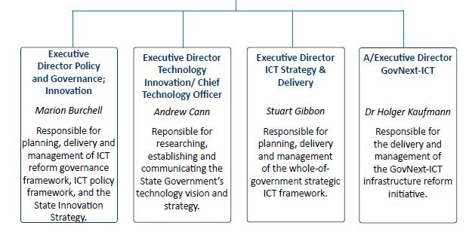

In 2016-17, the Office of the GCIO is reporting against a new Outcome Based Management Framework that seeks to better reflect the Government’s desired outcomes for ICT reform in the public sector at this stage of the reform process. For 2016-17, this includes reporting against effectiveness and efficiency indicators for the innovation function, which the Office acquired responsibility for on 1 July 2016. This function will be transferred to the Department of Jobs, Tourism, Science and Innovation from 1 July 2017 as a result of the machinery of government changes announced by the State Government on 28 April 2017.
Government Goals
Financial and Economic Responsibility:
Responsibly managing the State’s finances through the efficient and effective delivery of services, encouraging economic activity and reducing regulatory burdens on the private sector.
Desired Outcomes
Enabling effective utilisation of best practice technology in the public sector
To pave the way for Western Australians to take ideas from discovery to commercialisation, increase investment in Western Australian innovation, increase the number of scaled innovations and reduce the time and cost of doing so.

Shared responsibilities with other agencies
The Office of the GCIO collaborates with government agencies and industry to facilitate the efficient operation of government, drive technology innovation and improve the delivery of government digital services to achieve value for money for the community.
This is achieved by providing leadership and strategic advice to the Government on initiatives to improve the operations and management of ICT across the public sector.
Services
Establishment of a platform for the delivery of better government services
through efficient development of ICT strategy, policies and solutions.
Establishment of a $20 million innovation package to grow the WA innovation ecosystem and innovation activity through the delivery of programs, services and events.

The Office of the GCIO provides leadership and strategic advice to government on ICT reform. This role is supported by three key governance groups that provide oversight, direction and advice on ICT reforms.
The structure and the membership of these groups ensures the strategies, policies and initiatives progressed by the Office are:
- developed in collaboration with agencies driving the ICT reform process in the sector
- informed by technical advice and expertise
- driven by business need.
The Office of the GCIO chairs these groups and provides the secretariat support.
Decisions of these groups are published on Office of the GCIO website and the Chief Information Officer (CIO) portal administered by the Office to ensure CIOs across government and the community are informed of the direction and progress of ICT projects and programs.

Directors General ICT Council
The Directors General ICT Council (the Council)
provides strategic oversight and direction of whole of government ICT reform, and decides the allocation of the discretionary components of the ICT Reform and Renewal Fund. This Fund supports agencies develop
and implement specific ICT reforms to improve efficiency and effectiveness.
Government
Minister for Innovation and ICT
Government Chief Information Officer
Directors General ICT Council
Business Impact Group & CIO Advisory
Committee
The Council comprises Directors General from the Departments of Finance; Housing; Health; Education; Commerce; Transport; and Treasury, the Chief Executive of Landgate and the Commissioner for Police.
The Council meets quarterly with four meetings held in 2016-17, and reports regularly to Government on progress with whole of government ICT reform.

Business Impact Group
The Business Impact Group provides advice to the Council on ICT reform generally, and on whole of government projects and initiatives from a business perspective.
The group comprises business executives from the Departments of Commerce; Corrective Services; Education; Health; Housing; Premier and Cabinet; Transport; and Finance, as well as Landgate, and the WA Police.

CIO Advisory Committee
The CIO Advisory Committee provides advice to the Council on ICT reform projects and initiatives from an ICT perspective.
Membership comprises CIOs the Departments of Commerce; Finance; Health; Parks and Wildlife; Premier and Cabinet; and Transport, with Landgate, the Government Employees Superannuation Fund, and the Metropolitan Cemeteries Board.

Meetings
In 2016-17, meetings for the Business Impact Group and the CIO Advisory Committee were combined to ensure business and technical issues were discussed together in the same context and to facilitate greater collaboration between the business and ICT areas of the member organisations.
Four meetings of this combined group were held in 2016-17.

OVERVIEW

TRANSFORMATION
AGENCY
PERFORMANCE
FINANCIAL STATEMENTS
PERFORMANCE INDICATORS
DISCLOSURES

Digital WA provides the direction to transform the way public sector agencies use ICT to improve service delivery to business and the community.

The objectives of Digital WA are to:

simplify technology platforms, systems and standards as part of a unified government
- connect agencies and the community through digital services and system integration
- inform decision makers, frontline staff and the public with quality data and analysis.
Digital WA was launched on 25 May 2016, and a Premier’s Circular was issued on 1 July 2016 to require Western Australian government agencies to apply the principles and requirements of the Strategy into all current and future projects, normal operational procedures and practices.
In raising awareness about Digital WA, the Office of the GCIO engaged with public sector agencies and industry to communicate the strategic intent of government and encourage agency engagement and involvement. This included presentations to fourteen agencies and cross- agency groups and seven industry conferences.
During the year, the Office commenced the first annual review of Digital WA to ensure it remains relevant and appropriate. This involved analysis and consultation with the public sector and industry.

Government ICT policies and whole
of government requirements
Accompanying Digital WA in setting the direction and requirements for agencies to realise the benefits from digital transformation is the
suite of ICT policies and initiatives. These are operationalised by agencies in the context of their business priorities.
The ICT policies adopt a progressive and evolving implementation approach which recognises the varying ICT maturity and capabilities across the public sector.
In developing and revising the policies, the Office of the GCIO works in collaboration with cross-agency working groups, which
comprise representatives from agencies on the Governance bodies.
The ICT policies are:
- Open Data policy – requires public sector agencies to prioritise the public release of their data for the benefit of all Western Australians
- ICT Business Continuity and Disaster Recovery policy (updated 3 April 2017) – provides agencies with direction on the systems and processes to enable continued service delivery and recovery of information in the event of a disruption or disaster
- Digital Security policy (updated 28 June 2017)
– provides direction for public sector agencies to manage their digital security risks based
on the International Standards Organisation Standard 27001
- Interoperability policy – provides direction on frameworks and standards to ensure systems across the public sector can interact
seamlessly, exchange data and, share functions and resources where required
- Cloud policy – establishes a cloud mindset for the consumption of infrastructure, software and platforms and encourage the adoption of cloud services across the public sector
- Digital Services policy – provides direction on how to manage the services they provide to the community.

10 Office of the GCIO Annual Report 2016-17

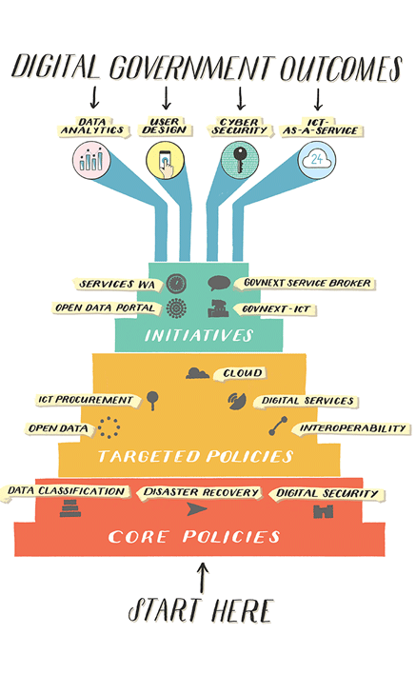
Figure 1: ICT Capability and Capacity Building
Program
In 2016-17, the Office reviewed and updated the ICT Disaster Recovery for Business Continuity Policy and the Digital Security Policy, and developed additional guidance materials to support agencies.
In June 2017, the Office of the GCIO also developed a “How to” mini guide for senior executives which communicates how the ICT policies combine to achieve digital government outcomes and the practical actions they can take to drive digital reform. Clear direction and oversight from agency executives is essential to the reform process.

Programs and Initiatives
The programs and initiatives in Digital WA are directed at achieving the following whole of government outcomes:
- stability of ICT project and service delivery
- efficiency in the cost of delivering ICT services
- transparency in ICT governance and service delivery
- capability of the public sector to respond to changing community needs.
In 2016-17, the Office of the GCIO progressed a range of initiatives towards achieving these outcomes.

Stability of ICT project and service delivery
The Office of the GCIO assisted agencies in the governance of their ICT projects by:
  - providing input on and reviews of agency ICT, business and strategic planning
  - reviewing agency business and ICT strategies
  - participating on agency project governance boards for major projects.
For example, the Office worked with the State Emergency Management Committee
(SEMC), WA Police and the Department of Fire and Emergency Services (DFES) to develop and review a business case for DFES to buy additional modules for the Computer Aided Dispatch (CAD) system already in use by WA Police. This option cost more than $10 million less than implementing a stand-alone system at DFES, and was approved as part of the first stage of implementing the SEMC Emergency Services Communications Strategy.

Efficiency in the cost of delivering ICT services
To deliver better digital services to the community, public sector ICT systems need to be modernised and consolidated. Savings achieved by agencies in moving to new technologies may be reinvested by agencies to help fund these improvements. The two key projects to achieve efficiencies are GovNext-ICT and ServiceWA (Digital), formerly known as the myWA program.

GovNext-ICT
GovNext-ICT is an ICT infrastructure reform initiative that aims to progress the WA Government from an owner/operator of ICT infrastructure to consumers of ICT infrastructure services.
In 2016-17, the Office of the GCIO delivered a significant key milestone under Digital WA by establishing the GovNext-ICT whole of government CUA for agencies to purchase ICT infrastructure services on demand.
GovNext-ICT will decommission more than 60 expensive data centres and server rooms and deliver an interconnected State-wide communications network for all government offices. To do this, over 50 physical networks with approximately 50,000 links will be consolidated into one physical network with less than 6000 links, improving capability and reducing cost at the same time.
Full adoption of GovNext-ICT will allow the State to realise savings of up to
$80 million per annum by consolidating and simplifying its infrastructure footprint, leveraging its whole of government buying power, and increasing market competition for ICT services.
The Office worked closely with the Department of Finance to develop a unique buying regime, articulated in a new “as a service” CUA. Following a competitive process and extensive negotiations with the three preferred
vendors - Atos, Datacom and NEC Australia – contracts were signed in January 2017. The new arrangements were launched to the sector in February 2017. Service catalogues with each vendor have been in place since April 2017 and agencies can compare prices and choose the best solution from a list of pre-defined services to meet their ICT needs.
The Office of the GCIO established the GovNext Service Broker during the year to assist agencies transition to the new buying arrangements and oversee the implementation of the CUA, including monitoring prices, consumption volumes, innovation and service quality.
Launch of the GovNext-ICT CUA

ServiceWA (Digital) Program
A major initiative under Digital WA is the ServiceWA (Digital) program which aims to make it easier for business and the community to find and access Government information and services online. The number of agency websites will also be reduced as a result of this program.
A key achievement for the Office in 2016-17 was the launch of the ServiceWA (Digital) alpha prototype website in December 2016, which provides a single entry point or portal to government online services and search capabilities. Over six months, the site received 4100 unique visitors, 6700 site visits, and 22,400 page views. The Office of the GCIO undertook a public consultation process on the features of the site. Seventy-nine percent of survey respondents said that being able to log in and access digital services from any department or agency from the one website was important or very important, and 60 percent agreed or strongly agreed that the site was useful.
The Office of the GCIO also commenced work on the architecture and operating model for the longer-term ServiceWA (Digital) program.
Significant planning towards a secure digital identity to enable users of the portal to access data from multiple agencies without compromising data privacy or security, was also undertaken.
The Office of the GCIO is working on the ServiceWA (Digital) program in partnership with the Departments of Transport and Commerce, and with the support of the Department of Finance and the Department of the Premier and Cabinet.

Enterprise Architecture (EA) Framework
To assist agencies plan for and review collaboration projects, the Office of the GCIO has developed a whole of government Enterprise Architecture (EA) Framework. This Framework models how a system, its components, and their relationship to each other and other systems can best be organised to meet strategic ICT objectives, and will allow for comparisons to
be made across government.
The Office of the GCIO has drafted the following standards and frameworks to assist public sector agencies create their own EA frameworks:
  - a Skills Model to identify the key skills staff need to understand and undertake an EA exercise
  - a Services Framework that identifies how and when EA should be used within an agency
  - a Collaboration Framework to assist senior executives understand how they can better leverage ICT capabilities across the public sector rather than duplicate jobs and systems in each agency.

Transparency in ICT governance and service delivery
To measure progress of agencies in delivering ICT reform, the Office of the GCIO commenced a process in June 2017 for agencies to report against the following key performance indicators (KPIs) in Digital WA:
  - >90 percent of the ICT components of major projects are completed on time and within budget
  - >90 percent of government digital services meet or exceed agreed and published service levels
  - 10 percent overall reduction in the annual cost of delivering current (2016-
17) ICT services by the end of the Strategy, aggregated across the sector
  - >90 percent of ICT reinvestment plans deliver the targeted return on investment from savings made through the Strategy or agency ICT reforms
  - >90 percent of agency chief executives are confident in the quality of their ICT governance to inform good decisions
  - >75 percent of agencies reach maturity level 3 or higher in all strategic core capabilities
As at 30 June 2017, agencies were compiling this data, which will be reported during next financial year.

TRANSFORMATION - DIGITAL WA

Building Capability within the Public Sector
Digital WA is driven by a vision for an innovative public sector, with mature digital capabilities.
The rapid evolution of the technology presents significant opportunities for improving government service delivery and business outcomes.
Innovations in private sector digital service delivery have increased the public’s expectations of government service delivery.
The Office of the GCIO had a particular focus during the year in developing the frameworks for building the organisational capability of public sector agencies and the digital skills of the public sector workforce within agencies to maximise opportunities for the future.

Capability Maturity Model
The Capability Maturity Model within Digital WA was further developed during the year to identify the capabilities agencies need to be digital-ready. The Office also developed tools and a guideline to assist agencies identify their current maturity level in different areas and provide advice on how they can improve their maturity. The Office developed this model in collaboration with a cross-agency working group.

ICT Capability Framework
The Office of the GCIO partnered with the Public Sector Commission to develop the ICT Capability Framework, which was launched in June 2017. This Framework:
  - provides a common language for describing ICT capabilities across the Western Australian public sector
  - aligns public ICT job descriptions to the international Skills Framework for the Information Age standard
  - provides a practical approach to ICT staff development across the sector.
The Public Sector Commission has oversight of the Framework, which will help build the digital skills of ICT professionals across the Western Australian public sector and improve workforce mobility.

ICT Capability and Capacity Program
An ICT Capability and Capacity Building program was endorsed by the Council in June 2017. This outlines a plan for building skills and knowledge across the public sector workforce in non-ICT roles. The plan will enable agencies to participate in cross-agency initiatives as shown in Figure 2.

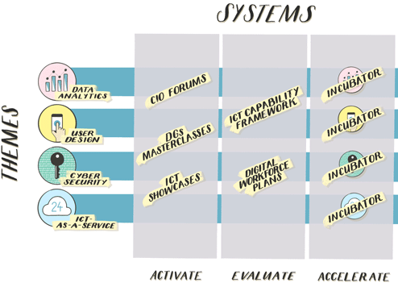
Figure 2: ICT Capability and Capacity Building Program

COLLABORATION

Sponsorship
In 2016-17, the Office of the GCIO sponsored events that showcased Western Australia’s ICT and innovation capabilities.

WAITTA INCITE Awards
The Office of the GCIO is a principal partner of the WA Information Technology and Communications Alliance (WAITTA) INCITE Awards, which recognises ICT innovation and excellence. Winners and national finalists compete in the national Australian Information Industry Association iAwards and/or the Australian Computer Society Digital Disrupters Awards.
In September 2016, the winner of the Most Innovative Collaborative Technology in 2016, Optika Solutions, went on to become the National iAward winner in the Big Data Innovator of the Year category, and also won the overall Innovator of the Year award for its Akumen platform. This platform was showcased internationally in December 2016 at the Asia Pacific ICT Alliance Awards in Chinese Taipai.
The Office sponsored the Awards again in 2017, which were held on 16 June 2017.

GovHack 2016
The Office of the GCIO sponsored GovHack 2016, held in July 2016. This event provided an opportunity for over 120 local participants – the largest GovHack event nationally – to unlock the value of Western Australia government open data and create proofs of concept demonstrating how this data can be used. For the first time, hackers in Perth were joined by a regional node of 18 hackers in Geraldton1.
The team “Anaconda Don’t” developed a solution to simplify the maintenance of the Water Corporation’s network. This work has continued, supported by Landgate’s SPURonWA Grant scheme.
1 https://pollinators.org.au/learning/govhack/

West Tech Fest
The Office of the GCIO sponsored the West Tech Fest, held in December 2016. This event celebrates innovation and technology in the Asia-Pacific region, and is the premier entrepreneurial-technology conference and pitching event for start-ups. It brings together early-stage start-ups, researchers, innovators, experienced investors and industry to stimulate partnerships and collaboration.

Professional Development

Techtober 2016
In October 2016, the Office of the GCIO initiated the inaugural Techtober to increase awareness of how digital government creates value for the Western Australian businesses and the community, and the capabilities required to support implementation.
The Office coordinated a masterclass on Digital Government attended by 24 Directors General focusing on global and national trends in service delivery enabled by technology.
The Office also coordinated a Business Executive forum which was attended by Senior Executives and Chief Information Officers within public sector agencies. This event included national and international keynote speakers who shared insights on global digital government initiatives.

OVERVIEW

INNOVATION
AGENCY
PERFORMANCE
FINANCIAL STATEMENTS
PERFORMANCE INDICATORS
DISCLOSURES

In 2016-17, the Office of the GCIO was given responsibility for innovation within the Western Australian Government.
The Office developed the State’s first Innovation Strategy with the following four pillars:
- talent and skills
- investment and infrastructure
- culture and collaboration

- marketing and promotion
An Innovation Fund of $20 million over four years was allocated to support this function.
The Innovation Strategy was based on over 750 ideas generated at the Innovation Summit held on 28 July 2016 which brought together 250 representatives from a cross-section of the State’s business, research and innovation communities.
The Innovation Strategy focuses on delivering programs which aim to:
- create an environment where innovation, entrepreneurship and commercialisation are the norm
- engage local business and industry partners to expand existing and future capabilities
- make Western Australia a regional innovation hub by investment in local talent and providing the right opportunities to keep talent in the State
- encourage Western Australians who have achieved success elsewhere to bring their skills, expertise and experience home to help increase innovation locally
- attract the world’s best innovators to relocate to Western Australia by emphasising the State’s natural and geographic advantages and globally acknowledged excellence.
The Office of the GCIO undertook a range of initiatives under the Strategy in 2016-17.

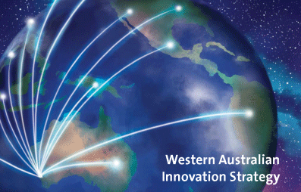

16 Office of the GCIO Annual Report 2016-17

Innovator of the Year (IOTY)

The IOTY program showcases WA innovators and rewards winners with financial and professional support to assist with the commercialisation of their innovative products and/or services.

The IOTY program celebrated its tenth anniversary in 2016, and 230 representatives of the innovation community marked this occasion at the Awards ceremony on 2 November 2016.
A prize pool of $120,000 was shared across a number of award categories, with Fastbrick Robotics Ltd winning the Mitsubishi Corporation overall Innovator of the Year Award for their innovation Hadrian X, the world’s first fully automated end-to-end 3D bricklaying machine and system.
The program has uncovered many local innovators, who have gone on
to achieve success, such as attracting additional investment and funding, collaborating with international research partners, and commercialising products that have made a difference to industry.
In May 2017, an expanded IOTY program was launched which extends business capability training to all semi-finalists and recognises young innovators participating in the Just Start IT program for secondary students. Regional champions from within the business community were also identified to encourage and support regional innovators to apply for the program.

2016 Innovator of the Year Awards Ceremony

Start IT Up Challenge
The Start IT Up Challenge aims to nurture innovative, technology-based solutions to government problems, and build capability within the Western Australian start-up community. The Challenge offered a pool of
$100,000 to successful applicants, in addition to securing an opportunity to develop, beta test and demonstrate the commercial viability of projects in collaboration with a State government agency.
Innovators were invited to apply for the Challenge via an open tender process, and three were selected from the 54 applications received. The winners were:
- All of Me, who were awarded $20,000 for their mental health awareness and evaluation application
- Hacker Pals, who received $30,000 for their in-browser coding application project Binary Crate, and
- KinChip Systems Pty Ltd, who were awarded $50,000 for their child development cloud based and mobile application KindomTM.
The Challenge has enabled winners to validate their ideas and value to the market, with two immediately rising into the top 5 of the Techboard rankings2 in October 2016.
One of the winners has also attracted further investment, established commercial premises, and hired additional local staff.

Public Sector Innovation program
The Western Australian public sector will play an important role in supporting the growth of innovation in Western Australia. The Office of the GCIO held forums with public sector agencies in February and April 2017 to:
- help build a culture in agencies that is open and receptive to new ideas and ways of doing business with others, including start-ups and SMEs
- identify how government can be a first customer of innovation
- identify how agencies can incubate innovation relevant to their business needs
- build cross-agency networks where government problems are shared with start-ups and SMEs and solved collaboratively.

- Techboard is a national community engagement and discovery platform for Australian start-ups and young technology companies.

Investment and Infrastructure

Innovation Vouchers Program (IVP)
The IVP is a competitive grants program with the aim of assisting small to medium enterprises improve their capability and commercialise their ideas and innovations.
In 2016-17, a total of 179 applications were received, and twenty-two grants of up to $20,000 each were awarded to innovators from a range of sectors, including agriculture, renewables, manufacturing, education and life sciences. Successful recipients are required to provide a net cash co-investment of matched funds at a rate no less than 20:80 recipient to State Government funding.
The Hon. Dave Kelly MLA, Minister for Innovation and ICT with the Innovation Voucher recipients
Recipients must use the grants towards: research and development; product development; technology transfer and intellectual property; commercialisation support services; or proof of market.
The program has supported many local innovators. Past recipients have been able to further develop their products and services, enabling them to attract investment, develop new markets, and/or incubation opportunities.

Culture and Collaboration

Innovation Hub
The Office of the GCIO launched the Innovation Hub website in November 2016 to provide a channel for Western Australian innovators, potential investors, service providers and customers of innovation to collaborate.
The Hub showcases the journeys of successful innovators, the lessons they learned and the people and services who helped them along the way.
As at 30 June 2017, the Hub contained over 100 showcases, services and opportunities, and had attracted nearly 14,000 visitors and 48,000 page views.

Innovation Summit and Leaders Forum
As noted earlier, the Innovation Summit brought the State’s innovation eco-system together to help co-design the Strategy.
The Summit was live-streamed to 600 local, national and international viewers, including Singapore, the USA, Canada, Thailand, Italy and India, and was broadcast live to rural and remote areas via the State’s satellite network.
The Office of the GCIO held an Innovation Leaders Forum on 27 September 2016 to discuss the outcomes of the Innovation Summit and provide feedback on the draft Strategy. Leaders had met for the first time in June 2016 to shape the themes for the Innovation Summit.

Marketing and Promotion
An Innovation Worth Sharing branding and marketing campaign was developed to promote Western Australian innovation and the State’s competitive advantages. The campaign ran from November 2016-January 2017 and consisted of TV and digital video advertising. The TV campaign reached 67.7 percent of the 18+ audience in Perth, with 1.008 million people seeing it at least once and on average nine times each. The digital campaign resulted in over 830,000 full views generating 8652 clicks to the Innovation Hub which showed that the content was engaging and relevant to the audience.
The Office of the GCIO sent Innovation packs to the Singapore Trade office, and also developed material for use at Tech Australia, a London Tech Week event in June 2017.
An Innovation Newsletter with articles and events of interest to the Western Australian innovation community was also developed. As at 30 June 2017, the Newsletter had nearly 300 domestic and international subscribers.

The 2016 Innovation Summit

Cyber Security
The May 2017 Wannacry global ransomware crisis demonstrated the threats posed by increasing cyber intrusions. Cyber crime is the number one threat to the business community (including government) with costs to the economy conservatively reported at $1 billion per year3. As the threat of cyber crime continues to increase in sophistication, many businesses and government agencies are unprepared for an attack.
The Office led the response to the Wannacry attack, updated the Digital Security Policy and developed tools to assist agencies manage their security risks.

Data Analytics
The importance of using data to tailor services to business and the community will help improve the efficiency and effectiveness of government services. Agencies need greater ability to share data and other jurisdictions have passed legislation to facilitate this function across government.
Progress has been made in laying the foundations including the Open Data policy and fact sheets, the Open Data portal, and the draft Data Classification policy. Future initiatives will build on these foundations and move the public sector towards data analytics, which the Office of the GCIO can support.
The Office is using data on the Open Data portal to create better data visualisations of government services being delivered to communities.

- Trident Insurance Group 2015, Cyber Crime – the biggest threat to Australian business, accessed at http://www.tridentinsurance.com.au/blog/cyber-crime-the-biggest-threat-to- australian-business/

ICT Procurement
In transforming the way agencies procure ICT infrastructure, the Office of the GCIO has identified the need for further reform of ICT procurement. Procurement is a key vehicle through which public sector agencies access ICT products and services, and more importantly, bring innovative technologies into government. In particular, increasing small to medium enterprises (SME) involvement is one way to drive greater innovation in government service delivery.
Current contracting models do not allow the flexibility required to take advantage of more agile ‘as-a-service’ delivery models, where agencies can change suppliers without restriction. Contracting models established for lengthy terms with a limited number of suppliers do not support the
dynamic technology environment. Such models also limit SME involvement due to the cost and time required to participate in lengthy procurement processes, and expensive and duplicated market testing exercises.
In investigating improvements to ICT procurement, the Office of the GCIO will examine options for enhancing business and service delivery outcomes throughout the contract planning, formation and management stages.

Better connectivity
“Smart Cities” use digital technologies to join together various parts of communities and their infrastructure, in a way which makes fast and meaningful interactions between them easy to develop and maintain.
Smart Cities initiatives show significant potential to create jobs and support the industries of the future, and better connectivity, particularly in regional areas, is fundamental to growth.
The Office of the GCIO will explore developing a path for Western Australia’s cities and communities to adopt smart technologies. Collaboration with regional communities, industry and research institutes will identify how best to support and grow opportunities.

The Hon. Dave Kelly MLA, Minister for Innovation and ICT, using Virtual Reality technology at the World Wide Web Conference welcome function

Digital Services
According to research published by the Digital Transformation Agency, Australia Post and the Australian Information Industry Association, the majority of Australians want governments to make more services
available online4. The Office of the GCIO plays a lead role in coordinating and assisting agencies re-design their online services and in improving community access and use of these services through a consistent whole of government online user experience.
Public confidence in the security of digital services offered by government is paramount, and users will need some form of “digital ID” or whole of
government logon. The Office of the GCIO is working with a range of agencies, the Commonwealth government and the private sector to identify the best way to engage with the community and deliver trusted digital services.

Demand for Digital Skills
The rapid evolution of technology presents significant opportunities for improving Government service delivery and business outcomes. Innovations in private sector digital service delivery have increased the public’s expectations of government service delivery. However, with approximately 80 percent of Australian government agencies considering that their digital capabilities are behind the private sector, and only 27 percent confident in their readiness to
respond to digital trends, the Office of the GCIO recognises that transformation of the public sector to a modern digital government to be a complex undertaking.

- DWA+JM Bruce 2015, Transformation Index Monitor Baseline Report 2015, Digital Transformation Agency, accessed at https://www.dta.gov.au/files/DTO-Transformation-In- dex-Monitor-Baseline-Report.doc;
Australia Post 2016, Choice and convenience drive ;’digital first’ success insight paper, Australian Postal Corporation, retrieved 10 June 2017, accessed at https://auspostenterprise. com.au/content/dam/corp/ent-gov/documents/egov-insights-paper.pdf;
Australian Information Industry Association and Galaxy Research 2017, AIIA Technology and Government Study, Australian Information Industry Association, accessed at https:// www.aiia.com.au/ data/assets/pdf_file/0019/75034/gov-study.pdf

Transformation of the Western Australian public sector will be enabled, in part, by building a workforce with the right digital skill set and knowledge, and leveraging more effectively the digital expertise and experience that exists across agencies. The Office of the GCIO recognises a staged, focused approach that builds the digital skills and knowledge of employees, and the digital capacity of the sector as whole, has a higher likelihood of success.

Rationalisation of software licences
Historically, the public sector has purchased software on an agency-by- agency basis. The Office of the OGCIO is exploring the opportunity to move towards licensing on a whole of government scale. This will better leverage the bulk buying power of government and reduce overall costs as licences are better utilised and shared across agencies.

Common Platforms
Many of the functions carried out by agencies are sufficiently similar to be supported by a single common digital platform or platforms. Reducing the number of different technologies in use across government and
adopting a standards-based approach will improve interoperability, simplify procurement, and reduce overall platform spending.
The Office of the GCIO will play a key role in identifying business functions and services that are suitable to be supported by one or more common platforms, and in assisting agencies move towards a simpler and more consistent technology environment.

Slow adoption of Digital WA initiatives
The whole of government benefits to be derived from Digital WA depend on the collaborative efforts and active involvement of public sector agencies.
The rate of adoption by agencies has been slower than anticipated due in part to the competition between agency-specific and whole-of-government objectives and outcomes, particularly in relation to GovNext-ICT, the State election, and the machinery of government changes announced in April 2017.
The Office will continue to work with Government to ensure that agencies have the capability and discretion to prioritise the sector-wide digital transformation agenda in Digital WA to accelerate the delivery of the savings and other benefits.

Agility of the local ICT industry
The Western Australian government sector is the largest purchaser of
ICT goods and services in the State, and any changes to government procurement arrangements will have an impact on the local industry. The ability of the local industry to provide the types of modern services the Government is seeking to move towards will also influence how quickly agencies can transform.
The Office of the GCIO liaises regularly with industry and professional bodies to provide clarity around current and future directions in government ICT reform and respond to issues raised. By moving towards consumption and other “as a service” pricing models, rather than traditional up-front purchases, the public sector seeks to both reduce overall government spend on current ICT activities, and free up resources to direct towards improved service delivery using innovative technologies and approaches, many of which will create new business opportunities within Western Australia.

SUMMARY OF FINANCIAL PERFORMANCE FOR 2016-17

The Office of the GCIO 2016-17 gross expense allocation was approximately $4.7 million, funded largely through appropriations from government ($3.4 million). The other key funding source was income from the ICT Renewal and Reform Fund ($1.3 million).
The $4.7 million in expenses primarily relates to employee expenses ($3.1 million) and supplies and services ($1.0 million).

Actual results versus estimate
Total cost of services (expense limit)
Estimate (a)

$000
4,662

Variance

$000 Reason for significant variation between actual and estimate

Actual
$000
9,430

(5,385)

1,440

4,596

4,129

450
4,768 The variance reflects the approval of additional funding from the ICT Renewal and Reform Fund, including the GovNext-ICT and myWA projects as well as the transfer of the Innovation Fund and its administration to the Office of the GCIO.

Net cost of services (3,387)

Total equity –
(1,998) Increased expenditure in 2016-17 reflects the approval of additional funding from the ICT Renewal and Reform Fund, including the GovNext-ICT and myWA projects.
1,440 The Office of the GCIO was created in 2015-16 with equity figures first identified at 30 June 2016 end. This was after the budget allocation for 2016-17 was published in May 2016, as such there were no opening equity figures.

Net increase/(decrease) in –
cash held
4,596 Cash was higher than estimated due to additional funding being approved during 2016-17 for a number of projects but not being fully expended in 2016-17 with carryovers subsequently approved for the myWA and GovNext-ICT projects, and the Innovation Fund.

Approved salary expense level 2,172
Working Cash limit 233
1,957 The actual salary expense was above the estimate largely due to additional funding being approved during the 2016-17 financial year for the salary costs associated with the GovNext-ICT and myWA projects, and the transfer of the Innovation Fund and its administration to Office of the GCIO.
217 The working cash limit was above the estimate largely due to additional funding being approved during the 2016-17 financial year for the salary costs associated with the GovNext-ICT and myWA projects, and the transfer of the Innovation Fund and its administration to Office of the GCIO.

(a) Further explanations are contained in Note 26 of the financial statements.

SUMMARY OF NON-FINANCIAL PERFORMANCE FOR 2016-17
Outcome
Key effectiveness indicator | Unit | Target | Actual
Percentage of ICT policies endorsed by Governance groups for development by OGCIO that have been developed and approved by Government | % | 75 | 75
Percentage of Innovation submissions received that have been actioned | % | 100 | 100
Service
Key efficiency indicator | Unit | Target | Actual
Average cost of Policy Development $’000 201 192 (a)

Cost of GovNext and myWA project implementation as a percentage cost of the overall government spend on related services
% 2.5 3.1 (b)

Administrative costs per innovation initiative and/or grant application $ 5,279 5,311 (c)

- The lower result is due to slightly lower costs than anticipated incurred by OGCIO on policy development activities.
- Actual whole-of-government expenditure on related ICT services was lower than initial estimates resulting in a higher comparative result. This was primarily due to agencies reducing ICT spend as they prepare for a transition into the new GovNext-ICT framework
- Actual numbers of activities against the Innovation initiative were greater than anticipated, resulting in lower average costs, however launch and start-up costs that were not anticipated in the target have pushed administrative costs higher for the 2016-17 actuals resulting in a slightly over target result.

CERTIFICATION OF FINANCIAL STATEMENTS

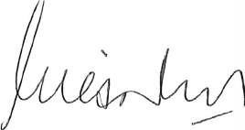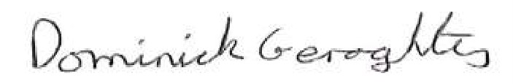
Certification of Financial Statements
For the year ended 30 June 2017
The accompanying financial statements of the Office of the Government Chief Information Officer have been prepared in compliance with the provisions of the Financial Management Act 2006 from proper accounts and records to present fairly the financial transactions for the reporting period ended 30 June 2017 and the financial position as at 30 June 2017.
At the date of signing we are not aware of any circumstances which would render the particulars included in the financial statements misleading or inaccurate.
Giles Nunis
Dominick Geraghty
Chief Executive and
Government Chief
Information Officer
Chief Finance Officer
10 August 2017
10 August 2017

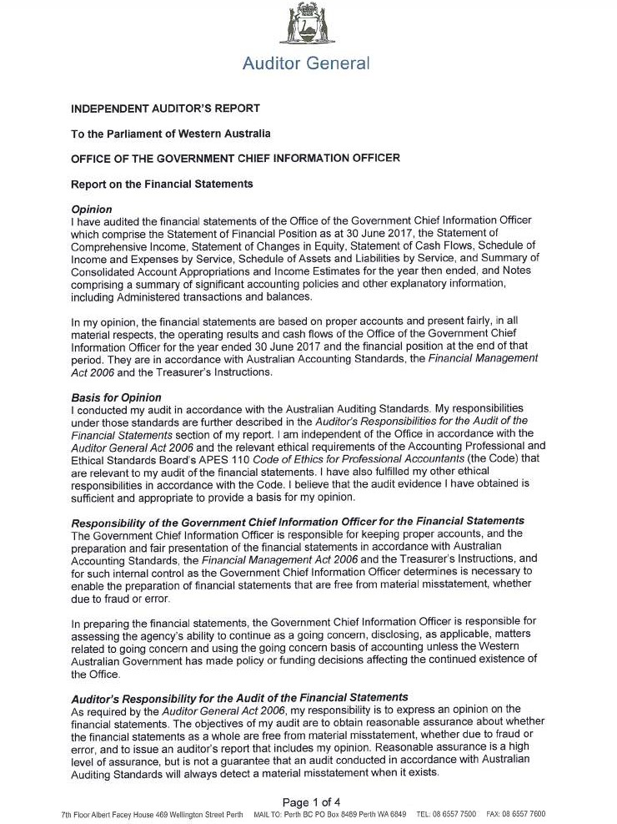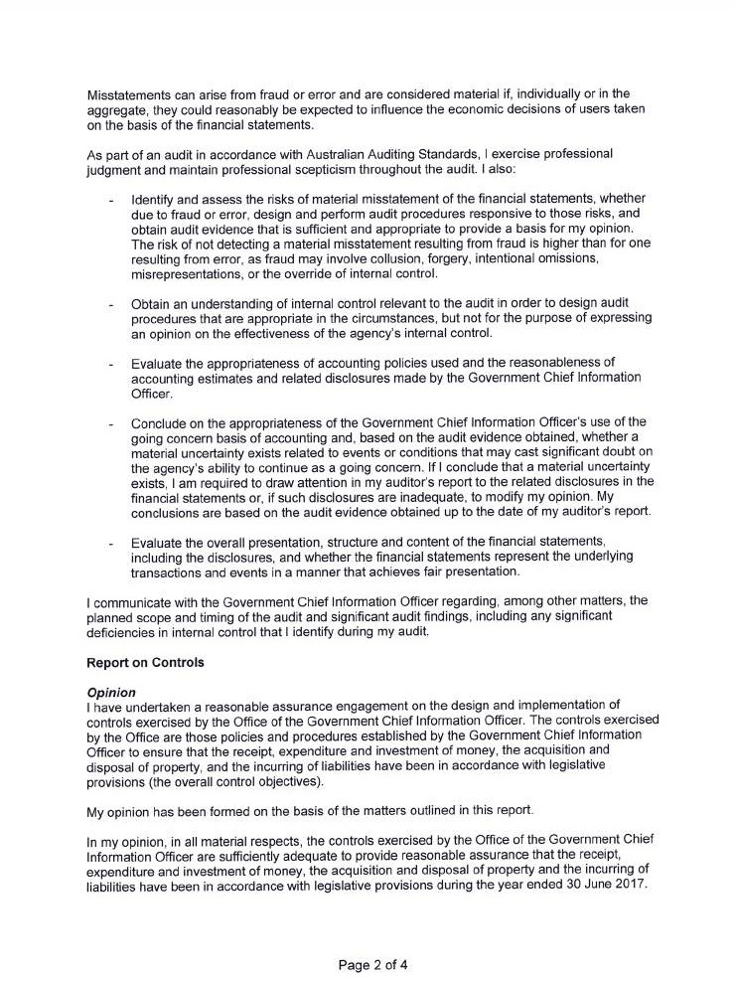

OVERVIEW

AUDIT OPINION
AGENCY PERFORMANCE
FINANCIAL STATEMENTS
PERFORMANCE INDICATORS
DISCLOSURES

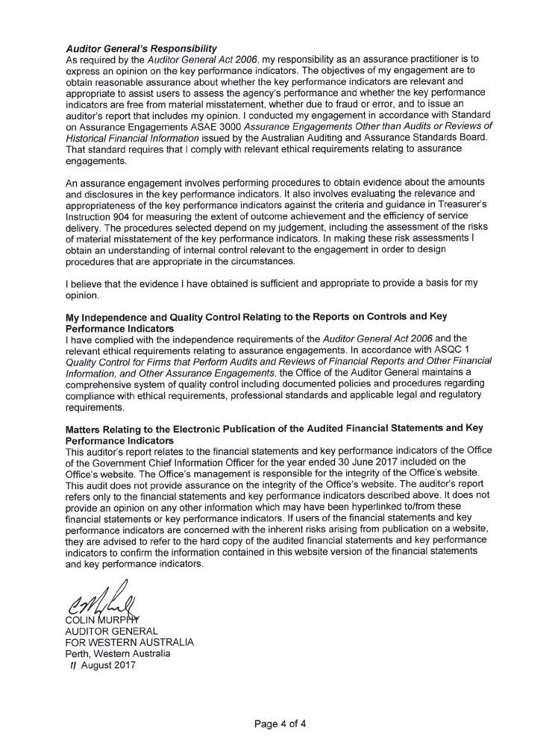
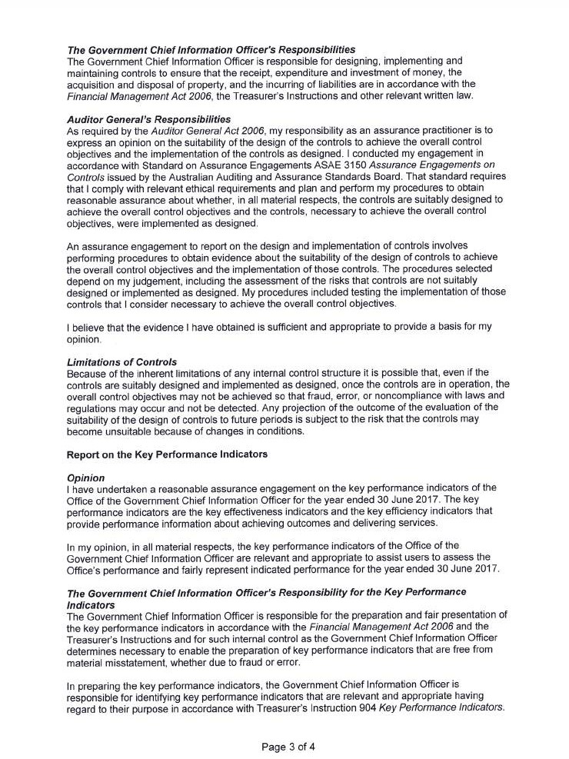

STATEMENT OF COMPREHENSIVE INCOME For the year ended 30 June 2017 |  | 2017 | 2016
 | Note | $000 | $000
COST OF SERVICES
Expenses
Employee benefits expense | 7 | 4,408 | 2,722
Supplies and services | 8 | 4,246 | 1,444
Accommodation expenses | 9 | 313 | 199
Grants and subsidies | 10 | 369 | 15
Other expenses | 11 | 94 | 13
Total cost of services |  | 9,430 | 4,393
Income
Revenue | 12
Grants and subsidies |  | 4,030 | 205
Other revenue |  | 15 | 83
Total Revenue |  | 4,045 | 288
Total income other than income from State Government |  | 4,045 | 288
NET COST OF SERVICES (5,385) (4,105)
Income from State Government | 13
Service appropriation |  | 7,413 | 3,370
Services received free of charge |  | 111 | 36
Total income from State Government |  | 7,524 | 3,406
SURPLUS/(DEFICIT) FOR THE PERIOD |  | 2,139 (699)
TOTAL COMPREHENSIVE INCOME FOR THE PERIOD |  | 2,139 (699)
The Statement of Comprehensive Income should be read in conjunction with the accompanying notes.

STATEMENT OF FINANCIAL POSITION As at 30 June 2017
 |  | 2017 | 2016
 | Note | $000 | $000
ASSETS
Current Assets
Cash and cash equivalents | 19 | 5,177 | 581
Receivables | 14 | 206 | 134
Total Current Assets |  | 5,383 | 715
Non-Current Assets
Total Non-Current Assets |  | – | –
TOTAL ASSETS 5,383 715
LIABILITIES
Current Liabilities
Payables | 15 | 1,209 | 872
Other current liabilities | 16 | 1,746 | –
Provisions | 17 | 844 | 509
Total Current Liabilities |  | 3,799 | 1,381
Non-Current Liabilities
Provisions | 17 | 144 | 33
Total Non-Current Liabilities |  | 144 | 33
TOTAL LIABILITIES |  | 3,943 1,414
NET ASSETS |  | 1,440 (699)
EQUITY | 18
Contributed equity |  | – –
Accumulated surplus/(deficit) |  | 1,440 (699)
TOTAL EQUITY/(EQUITY DEFICIT) |  | 1,440 (699)
The Statement of Financial Position should be read in conjunction with the accompanying notes.

Note Contributed equity
$000
Accumulated surplus/(deficit)
$000
Total equity/ (Equity deficit)
$000

Balance at 1 July 2015 18 – – –
Total comprehensive income for the period – (699) (699)

Balance at 30 June 2016 – (699) (699)

Balance at 1 July 2016 – (699) (699)
Total comprehensive income for the period – 2,139 2,139

Balance at 30 June 2017 – 1,440 1,440
The Statement of Changes in Equity should be read in conjunction with the accompanying notes.

 |  | 2017 | 2016
CASH FLOWS FROM STATE GOVERNMENT | Note | $000 | $000
Service appropriation(a) |  | 9,159 | 3,370
Net cash provided by State Government |  | 9,159 | 3,370
Utilised as follows:  CASH FLOWS FROM OPERATING ACTIVITIES  Payments  Employee benefits |  | (3,862) | (1,975)
Supplies and services |  | (3,945) | (819)
Accommodation |  | (313) | (200)
Grants and subsidies |  | (369) | –
GST payments on purchases |  | (453) | (103)
Other payments |  | (58) | (11)
Receipts  Grants and contributions |  | 4,030 | 205
GST receipts on sales |  | 7 | 3
GST receipts from taxation authority |  | 330 | 82
Other receipts |  | 70 | 28
Net cash provided by/(used in) operating activities | 19 | (4,563) | (2,789)
Net increase/(decrease) in cash and cash equivalents |  | 4,596 | 581
Cash and cash equivalents at the beginning of the period |  | 581 | –

CASH AND CASH EQUIVALENTS AT THE END OF THE PERIOD 19 5,177 581
(a) The Service Appropriation includes an amount of $1.746 million that relates to the reflow of Innovation Fund appropriation received from Treasury in 2016-17 to be repaid in 2017-18 and reallocated to the Department of Jobs, Tourism, Science and Innovation.
The Statement of Cash Flows should be read in conjunction with the accompanying notes.

 | 2017 | Service 1  2016 | 2017 | Service 2  2016 2017 | Total  2016
 | $000 | $000 | $000 | $000 $000 | $000
COST OF SERVICES  Expenses  Employee benefits expense | 3,594 | 2,722 | 814 | – 4,408 | 2,722
Supplies and services | 3,280 | 1,444 | 966 | – 4,246 | 1,444
Accommodation expenses | 249 | 199 | 64 | – 313 | 199
Grants and subsidies | – | 15 | 369 | – 369 | 15
Other expenses | 79 | 13 | 15 | – 94 | 13
Total cost of services | 7,202 | 4,393 | 2,228 | – 9,430 | 4,393
Income  Grants and subsidies | 4,030 | 205 | – | – 4,030 | 205
Other revenue | 13 | 83 | 2 | – 15 | 83
Total income other than income from State Government | 4,043 | 288 | 2 | – 4,045 | 288
NET COST OF SERVICES | (3,159) | (4,105) | (2,226) | – (5,385) | (4,105)
Income from State Government  Service appropriation | 3,077 | 3,370 | 4,336 | – 7,413 | 3,370
Resources received free of charge | 111 | 36 | – | – 111 | 36
Total income from State Government | 3,188 | 3,406 | 4,336 | – 7,524 | 3,406

SURPLUS/(DEFICIT) FOR THE PERIOD 29 (699) 2,110 – 2,139 (699)

The Schedule of Income and Expenses by Service should be read in conjunction with the accompanying notes.
Service 1: Establishment of a Platform for the Delivery of Better Government Services through Efficient Development of ICT Strategy, Policies and Solutions Service 2: Establishment of a $20 million innovation package to grow the WA innovation ecosystem and innovation activity through the delivery of programs, services and events

 |  | Service 1 |  | Service 2 |  | Total
 | 2017 | 2016 | 2017 | 2016 | 2017 | 2016
 | $000 | $000 | $000 | $000 | $000 | $000
Assets
Current assets | 2,565 | 715 | 2,818 | – | 5,383 | 715
Non-current assets | – | – | – | – | – | –
Total Assets | 2,565 | 715 | 2,818 | – | 5,383 | 715
Liabilities
Current liabilities | 1,977 | 1,381 | 1,822 | – | 3,799 | 1,381
Non-current liabilities | 140 | 33 | 4 | – | 144 | 33
Total Liabilities | 2,117 | 1,414 | 1,826 | – | 3,943 | 1,414
NET ASSETS | 448 | (699) | 992 | – | 1,440 | (699)

The Schedule of Assets and Liabilities by Service should be read in conjunction with the accompanying notes.
Service 1: Establishment of a Platform for the Delivery of Better Government Services through Efficient Development of ICT Strategy, Policies and Solutions
Service 2: Establishment of a $20 million innovation package to grow the WA innovation ecosystem and innovation activity through the delivery of programs, services and events

 | 2017  Estimate | 2017  Actual | Variance | 2017  Actual | 2016  Actual | Variance
 | $000 | $000 | $000 | $000 | $000 | $000
Delivery of Services
Item 71 Net amount appropriated to deliver services | 3,387 | 7,413 | 4,026 | 7,413 | 3,370 | 4,043
Total appropriations provided to deliver services | 3,387 | 7,413 | 4,026 | 7,413 | 3,370 | 4,043
Administered Transactions
Item 72 Amount provided for Administered grants, subsidies and other transfer payments | 5,632 | 5,632 | – | 5,632 | 5,429 | 203
Total administered transactions | 5,632 | 5,632 | – | 5,632 | 5,429 | 203

GRAND TOTAL 9,019 13,045 4,026 13,045 8,799 4,246

Details of Expenses by Service
Establishment of a platform for the delivery of better government services through efficient development of Information and
Communications Technology (ICT) strategy, policies and solutions 4,662 9,430 4,768 9,430 4,393 5,037

Total Cost of Services | 4,662 | 9,430 | 4,768 | 9,430 | 4,393 | 5,037
Less Total Income | (1,275) | (4,045) | (2,770) | (4,045) | (288) | (3,757)
Net Cost of Services | 3,387 | 5,385 | 1,998 | 5,385 | 4,105 | 1,280
Adjustments | - | 2,028 | 2,028 | 2,028 | (735) | 2,763
Total appropriations provided to deliver services | 3,387 | 7,413 | 4,026 | 7,413 | 3,370 | 4,043
Details of Income Estimates  Income disclosed as Administered Income | 5,632 | 5,632 | – | 5,632 | 5,429 | 203

Total income estimates 5,632 5,632 – 5,632 5,429 203
Adjustments comprise movements in cash balances and other accrual items such as receivables, payables and superannuation.
Note 26 ‘Explanatory statement’ and Note 30 ‘Explanatory statement for Administered Items — Income and Expenses’ provide details of any significant variations between estimates and actual results for 2017 and between the actual results for 2017 and 2016.

Note 1. Australian Accounting Standards

General
The sub-department’s financial statements for the year ended 30 June 2017 have been prepared in accordance with Australian Accounting Standards. The term ‘Australian Accounting Standards’ includes Standards and Interpretations issued by the Australian Accounting Standards Board (AASB).
The sub-department has adopted any applicable new and revised Australian Accounting Standards from their operative dates.

Early adoption of standards
The sub-department cannot early adopt an Australian Accounting Standard unless specifically permitted by TI 1101 Application of Australian Accounting Standards and Other Pronouncements. There has been no early adoption of any Australian Accounting Standards that have been issued or amended (but not operative) by the sub-department for the annual reporting period ended 30 June 2017.

Note 2. Summary of significant accounting policies

General statement
The sub-department is a not-for-profit reporting entity that prepares general purpose financial statements in accordance with Australian Accounting Standards, the Framework, Statements of Accounting Concepts and other authoritative pronouncements of the AASB as applied by the Treasurer’s instructions. Several of these are modified by the Treasurer’s instructions to vary application, disclosure, format and wording.
The Financial Management Act 2006 and the Treasurer’s instructions impose legislative provisions that govern the preparation of financial statements and take precedence over Australian Accounting Standards, the Framework, Statements of Accounting Concepts and other authoritative pronouncements of the AASB.
Where modification is required and has had a material or significant financial effect upon the reported results, details of that modification and the resulting financial effect are disclosed in the notes to the financial statements.

Basis of preparation
The financial statements have been prepared on the accrual basis of accounting using the historical cost convention. The accounting policies adopted
in the preparation of the financial statements have been consistently applied throughout all periods presented unless otherwise stated.
The financial statements are presented in Australian dollars and all values are rounded to the nearest thousand dollars ($’000).
Note 4 ‘Judgements made by management in applying accounting policies’ discloses judgements that have been made in the process of applying the sub-department’s accounting policies resulting in the most significant effect on amounts recognised in the financial statements.
Note 5 ‘Key sources of estimation uncertainty’ discloses key assumptions made concerning the future, and other key sources of estimation uncertainty at the end of the reporting period, that have a significant risk of causing a material adjustment to the carrying amounts of assets and liabilities within the next reporting period.

Reporting entity
The reporting entity is the Office of the Government Chief Information Officer.
Mission
We connect people, processes and technology to empower individuals to deliver better outcomes for government and citizens. We do this by collaborating with government agencies and

industry to stabilise costs, increase
value-for-money and minimise risk in Information and Communications Technology (ICT) delivery.
Services
The sub-department provides the following services:
Service 1: Establishment of a Platform for the Delivery of Better Government Services through Efficient Development of Information and Communications Technology (ICT) Strategy, Policies and Solutions.
Service 2: Establishment of a $20 million innovation package to grow the WA innovation ecosystem and innovation activity through the delivery of programs, services and events.
The sub-department administers assets, liabilities, income and expenses on behalf of government which are not controlled by, nor integral, to the function of the sub- department. These administered balances and transactions are not recognised in the principal financial statements of the sub-department but schedules are prepared using the same basis as the financial statements and are presented at Note
30 ‘Explanatory statement for Administered Items – Income and Expenses’ and Note 31 ‘Administered assets and liabilities’.
Note that no breakup of administered activity by services has been provided as this activity solely relates to Service 1.

Contributed equity
AASB Interpretation 1038 Contributions by Owners Made to Wholly-Owned Public Sector Entities requires transfers in the nature of equity contributions, other than as a result of a restructure of administrative arrangements, to be designated by the Government (the owner) as contributions by owners (at the time of, or prior to transfer) before such transfers can be recognised as equity contributions. Capital appropriations have been designated as contributions by owners by TI 955 Contributions by Owners made to Wholly Owned Public Sector Entities and have been credited directly to Contributed Equity.
The transfers of net assets to/from other agencies, other than as a result of a restructure of administrative arrangements, are designated as contributions by owners where the transfers are non-discretionary and non-reciprocal.

Income
Revenue recognition
Revenue is recognised and measured at the fair value of consideration received or receivable. Revenue is recognised for the major business activities as follows:
Service Appropriations
Service Appropriations are recognised as revenues at fair value in the period in which the sub-department gains control of the appropriated funds. The sub-department gains
control of appropriated funds at the time those funds are deposited to the bank account.
Net Appropriation Determination
The Treasurer may make a determination providing for a prescribed receipt to be retained for services under control of the sub- department. In accordance with the most recent determination, as quantified in the
2016-17 Budget Statements, the
sub-department retained $4.045 million ($0.288 million in 2016) from the following:
- Grants and subsidies
- Other revenue
Grants, donations, gifts and other non-reciprocal contributions.
Revenue is recognised at fair value when the sub-department obtains control over the assets comprising the contributions, usually when cash is received.

Leases
The sub-department has entered into an operating lease arrangement for the rent of the office building where the lessor effectively retains the entire risks and benefits incidental to ownership of the items held under the operating lease.
Operating leases are expensed on a straight line basis over the lease term as this represents the pattern of benefits derived from the leased properties.

Financial instruments
In addition to cash, the sub-department has two categories of financial instruments:
- Receivables
- Financial liabilities measured at amortised cost.
Financial instruments have been disaggregated into the following classes:
- Financial Assets
  - Cash and cash equivalents
  - Receivables
- Financial Liabilities
  - Payables
  - Other current liabilities
Initial recognition and measurement of financial instruments is at fair value which normally equates to the transaction cost or the face value. Subsequent measurement is at amortised cost using the effective interest method.
The fair value of short-term receivables and payables is the transaction cost or the face value because there is no interest rate applicable and subsequent measurement is not required as the effect of discounting is not material.

Cash and cash equivalents
For the purpose of the Statement of Cash Flows, cash and cash equivalent assets comprise cash on hand and short-term deposits with original maturities of three months or less that are readily convertible to a known amount of cash and which are subject to insignificant risk of changes in value.

Accrued salaries
Accrued salaries (see Note 15 ‘Payables’) represent the amount due to staff but unpaid at the end of the reporting period. Accrued salaries are settled within a fortnight of reporting period end. The sub-department considers the carrying amount of accrued salaries to be equivalent to its fair value.

Receivables
Receivables are recognised at original invoice amount less an allowance for any uncollectible amounts (i.e. impairment). The collectability of receivables is reviewed on an ongoing basis and any receivables identified as uncollectible are written-off against the allowance account. The allowance for uncollectible amounts (doubtful debts) is raised when there is objective evidence that the sub-department will not be able to collect the debts. The carrying amount is equivalent to fair value as it is due for settlement within 30 days.

Payables
Payables are recognised at the amounts payable when the sub-department becomes obliged to make future payments as a result of a purchase of assets or services. The carrying amount is equivalent to fair value, as settlement is generally within 30 days.

Borrowings
All loans payable are initially recognised at
fair value, being the net proceeds received. Subsequent measurement is at amortised cost using the effective interest rate method.

Provisions
Provisions are liabilities of uncertain timing or amount and are recognised where there is a present legal or constructive obligation as a result of a past event and when the outflow of resources embodying economic benefits is probable and a reliable estimate can be made of the amount of the obligation. Provisions are reviewed at the end of each reporting period.
Provisions - employee benefits
All annual leave and long service leave provisions are in respect of employees’ services up to the end of the reporting period.
Annual leave
Annual leave is not expected to be settled wholly within 12 months after the end of the reporting period and is therefore considered to be ‘other long-term employee benefits’. The annual leave liability is recognised and measured at the present value of amounts expected to be paid when the liabilities are settled using the remuneration rate expected to apply at the time of settlement.
When assessing expected future payments consideration is given to expected future wage and salary levels including non-salary

components such as employer superannuation contributions, as well as the experience of employee departures and periods of service. The expected future payments are discounted using market yields at the end of the reporting period on national government bonds with terms to maturity that match, as closely as possible, the estimated future cash outflows.
The provision for annual leave is classified as a current liability as the sub-department does not have an unconditional right to defer settlement of the liability for at least 12 months after the end of the reporting period.
Long service leave
Long service leave is not expected to be settled wholly within 12 months after the end of the reporting period and is therefore recognised and measured at the present value of amounts expected to be paid when the liabilities are settled using the remuneration rate expected to apply at the time of settlement.
When assessing expected future payments consideration is given to expected future wage and salary levels including non-salary components such as employer superannuation contributions, as well as the experience of employee departures and periods of service. The expected future payments are discounted using market yields at the end of the reporting period on national government bonds with terms to
maturity that match, as closely as possible, the
estimated future cash outflows.
Unconditional long service leave provisions are classified as current liabilities as the
sub-department does not have an unconditional right to defer settlement of the liability for at least 12 months after the end of the reporting period. Pre-conditional and conditional long service leave provisions are classified as non-current liabilities because the sub-department has an unconditional right to defer the settlement of the liability until the employee has completed the requisite years of service.
Superannuation
The Government Employees Superannuation Board(GESB) and other fund providers administer public sector superannuation arrangements in Western Australia in accordance with legislative requirements. Eligibility criteria for membership in particular schemes for public sector employees vary according to commencement and implementation dates.
Eligible employees contribute to the Pension Scheme, a defined benefit pension scheme closed to new members since 1987, or the Gold State Superannuation Scheme (GSS), a defined benefit lump sum scheme closed to new members since 1995.
Employees commencing employment prior to 16 April 2007 who were not members of either the Pension Scheme or the GSS became non-contributory members of the West State Superannuation Scheme (WSS). Employees commencing employment on or after 16 April 2007 became members of the GESB Super Scheme (GESBS). From 30 March 2012, existing members of the WSS or GESBS and new employees have been able to choose their preferred superannuation fund provider. The sub-department makes contributions to GESB or other fund providers on behalf of employees in compliance with the Commonwealth Government’s Superannuation Guarantee (Administration) Act 1992. Contributions to these accumulation schemes extinguish the sub-department’s liability for superannuation charges in respect of employees who are not members of the Pension Scheme or GSS.
The GSS is a defined benefit scheme for the purposes of employees and whole-of-government reporting. However, it is a defined contribution plan for agency purposes because the concurrent contributions (defined contributions) made by the sub-department to GESB extinguishes the agency’s obligations to the related superannuation liability.
The sub-department has no liabilities under the Pension Scheme or the GSS. The liabilities for the unfunded Pension Scheme and the

unfunded GSS transfer benefits attributable to members who transferred from the Pension Scheme, are assumed by the Treasurer. All other GSS obligations are funded by concurrent contributions made by the sub-department to the GESB.
The GESB makes all benefit payments in respect of the Pension Scheme and GSS, and is recouped from the Treasurer for the employer’s share.
Provisions - other
Employment on-costs
Employment on-costs, including workers’ compensation insurance, are not employee benefits and are recognised separately as liabilities and expenses when the employment to which they relate has occurred. Employment on- costs are included as part of ‘Other expenses’ and are not included as part of the sub-department’s ‘Employee benefits expense’. The related liability is included in ‘Employment on-costs provision’.

Superannuation expense
Superannuation expense is recognised in the profit or loss of the Statement of Comprehensive Income and comprises employer contributions paid to the GSS (concurrent contributions), the WSS, the GESBS, or other superannuation funds. The employer contribution paid to the GESB in respect of the GSS is paid back into the Consolidated Account by the GESB.

Assets and services received free of charge or for nominal cost
Assets or services received free of charge or for nominal cost that the sub-department would otherwise purchase if not donated, are recognised as income at the fair value of the assets or services where they can be reliably measured. A corresponding expense is recognised for services received. Receipts of assets are recognised in the Statement of Financial Position.
Assets or services received from other State Government agencies are separately disclosed under Income from State Government in the Statement of Comprehensive Income.

Note 3. Comparative figures
Comparative figures are, where appropriate, reclassified to be comparable with the figures presented in the current reporting period.

Note 4. Judgements made by management in applying accounting policies
The preparation of financial statements requires management to make judgements about the application of accounting policies that have a significant effect on the amounts recognised in the financial statements. The sub-department evaluates these judgements regularly.

Operating lease commitments
The sub-department has entered into a lease for office accommodation. This lease is of a temporary nature and it has been determined that the lessor retains substantially all the risks and rewards incidental to ownership. Accordingly, this lease has been classified as operating lease.

Note 5. Key sources of estimation
uncertainty
Key estimates and assumptions concerning the future are based on historical experience and various other factors that have a significant risk of causing a material adjustment to the carrying amount of assets and liabilities within the next reporting period.

Long service leave
Several estimations and assumptions used in calculating the sub-department’s long service leave provision include expected future salary rates, discount rates, employee retention rates and expected future payments. Changes in these estimations and assumptions may impact on the carrying amounts of the long service leave provision.

Note 6. Disclosure of changes in accounting policy and estimates

Initial application of an Australian Accounting Standard
The sub-department has applied the following Australian Accounting Standards effective, or adopted, for annual reporting periods beginning on or after 1 July 2016 that impacted on the sub-department.

AASB 1057 Application of Australian Accounting Standards
This Standard lists the application paragraphs for each other Standard (and Interpretation), grouped where they are the same. There is no financial impact.
AASB 2014-3 Amendments to Australian Accounting Standards – Accounting for Acquisitions of Interests in Joint Operations [AASB 1 & 11]
The sub-department establishes Joint Operations in pursuit of its objectives and does not routinely acquire interests in Joint Operations. Therefore, there is no financial impact on application of the Standard.
AASB 2014-4 Amendments to Australian Accounting Standards – Clarification of Acceptable Methods of Depreciation and Amortisation [AASB 116 & 138]
The adoption of this Standard has no financial impact for the sub-department as depreciation and amortisation is not determined by reference to revenue generation, but by reference to consumption of future economic benefits.
AASB 2014-9 Amendments to Australian Accounting Standards – Equity Method in Separate Financial Statements [AASB 1, 127 & 128]
This Standard amends AASB 127, and consequentially amends AASB 1 and AASB 128, to allow entities to use the equity method of accounting for investments in subsidiaries, joint ventures and associates in their separate financial statements. As the sub-department has no joint ventures and associates, the application of the Standard has no financial impact.
AASB 2015-1 Amendments to Australian Accounting Standards - Annual Improvements to Australian Accounting Standards 2012-2014 Cycle [AASB 1, 2, 3, 5, 7, 11, 110, 119, 121, 133, 134, 137 & 140]
These amendments arise from the issuance of International Financial Reporting Standard Annual Improvements to IFRSs 2012-2014 Cycle in September 2014, and editorial corrections. The sub-department has determined that the application of the Standard has no financial impact.

AASB 2015-2 Amendments to Australian Accounting Standards - Disclosure Initiative: Amendments to AASB 101 [AASB 7, 101, 134 & 1049]
This Standard amends AASB 101 to provide clarification regarding the disclosure requirements in AASB 101. Specifically, the Standard proposes narrow-focus amendments to address some of the concerns expressed about existing presentation and disclosure requirements and to ensure entities are able to use judgement when applying a Standard in determining what information to disclose in their financial statements. There is no financial impact.
AASB 2015-6 Amendments to Australian Accounting Standards - Extending Related Party Disclosures to Not-for-Profit Public Sector Entities [AASB 10, 124 & 1049]
The amendments extend the scope of AASB 124 to include application by not-for-profit public sector entities. Implementation guidance is included to assist application of the Standard by not-for-profit public sector entities. There is no financial impact.
AASB 2015-10 Amendments to Australian Accounting Standards - Effective Date of Amendments to AASB 10 & 128
This Standard defers the mandatory effective date (application date) of amendments to AASB 10 & AASB 128 that were originally made in AASB 2014-10 so that the amendments are required to be applied for annual reporting periods beginning on or after 1 January 2018 instead of 1 January 2016. There is no financial impact.

Future impact of Australian Accounting Standards not yet operative
The sub-department cannot early adopt an Australian Accounting Standard unless specifically permitted by TI 1101 Application of Australian Accounting Standards and Other Pronouncements or by an exemption from TI 1101. Where applicable, the sub-department plans to apply the following Australian Accounting Standards from their application date.

AASB 9 Financial Instruments
This Standard supersedes AASB 139 Financial Instruments: Recognition and Measurement, introducing a number of changes to accounting treatments.
The mandatory application date of this Standard is currently 1 January 2018 after being amended by AASB 2012-6, AASB 2013-9 and AASB 2014-1 Amendments to Australian Accounting Standards. The sub-department has not yet determined the application or the potential impact of the Standard.

Operative for reporting periods beginning on/after
1 Jan 2018

AASB 15 Revenue from Contracts with Customers
This Standard establishes the principles that the sub-department shall apply to report useful information to users of financial statements about the nature, amount, timing and uncertainty of revenue and cash flows arising from a contract with a customer.
The sub-department’s income is principally derived from appropriations which will be measured under AASB 1058 Income of Not-for-Profit Entities and will be unaffected by this change. However, the sub-department has not yet determined the potential impact of the Standard on ‘User charges and fees’ and ‘Sales’ revenues. In broad terms, it is anticipated that the terms and conditions attached to these revenues will defer revenue recognition until the sub-department has discharged its performance obligations.
1 Jan 2019

AASB 16 Leases
This Standard introduces a single lessee accounting model and requires a lessee to recognise assets and liabilities for all leases with a term of more than 12 months, unless the underlying asset is of low value.
Whilst the impact of AASB 16 has not yet been quantified, the entity currently has operating lease commitments for $568,577.
1 Jan 2019

AASB 1058 Income of Not-for-Profit Entities
This Standard clarifies and simplifies the income recognition requirements that apply to not-for-profit (NFP) entities, more closely reflecting the economic reality of NFP entity transactions that are not contracts with customers. Timing of income recognition is dependent on whether such a transaction gives rise to a liability, a performance obligation (a promise to transfer a good or service), or, an obligation to acquire an asset.
The sub-department has not yet determined the application or the potential impact of the Standard.

Operative for reporting periods beginning on/after
1 Jan 2019

AASB 2010-7 Amendments to Australian Accounting Standards arising from AASB 9 (December 2010) [AASB 1, 3, 4, 5, 7, 101, 102, 108, 112, 118, 120, 121, 127, 128, 131, 132, 136, 137, 139, 1023 & 1038 and Int 2, 5, 10, 12, 19 & 127]
This Standard makes consequential amendments to other Australian Accounting Standards and Interpretations as a result of issuing AASB 9 in December 2010.
The mandatory application date of this Standard has been amended by AASB 2012-6 and AASB 2014-1 to 1 January 2018. The sub-department has not yet determined the application or the potential impact of the Standard.
1 Jan 2018

AASB 2014-1 Amendments to Australian Accounting Standards
Part E of this Standard makes amendments to AASB 9 and consequential amendments to other Standards. It has not yet been assessed by the sub-department to determine the application or potential impact of the Standard.
1 Jan 2018

AASB 2014-5 Amendments to Australian Accounting Standards arising from AASB 15
This Standard gives effect to consequential amendments to Australian Accounting Standards (including Interpretations) arising from the issuance of AASB 15. The mandatory application date of this Standard has been amended by AASB 2015-8 to 1 January 2018. The sub-department has not yet determined the application or the potential impact of the Standard.
1 Jan 2018

AASB 2014-7 Amendments to Australian Accounting Standards arising from AASB 9 (December 2014)
This Standard gives effect to the consequential amendments to Australian Accounting Standards (including Interpretations) arising from the issuance of AASB 9 (December 2014). The sub-department has not yet determined the application or the potential impact of the Standard.
1 Jan 2018

AASB 2014-10 Amendments to Australian Accounting Standards – Sale or Contribution of Assets between an Investor and its Associate or Joint Venture [AASB 10 & 128]
This Standard amends AASB 10 and AASB 128 to address an inconsistency between the requirements in AASB 10 and those in AASB 128 (August 2011), in dealing with the sale or contribution of assets between an investor and its associate or joint venture. The mandatory effective date (application date) for the Standard has been deferred to 1 Jan 2018 by AASB 2015-10. The sub-department has determined that the Standard has no financial impact.

Operative for reporting periods beginning on/after
1 Jan 2018

AASB 2015-8 Amendments to Australian Accounting Standards – Effective Date of AASB 15
This Standard amends the mandatory effective date (application date) of AASB 15 Revenue from Contracts with Customers so that AASB 15 is required to be applied for annual reporting periods beginning on or after 1 January 2018 instead of 1 January 2017. For Not-For-Profit entities, the mandatory effective date has subsequently been amended to 1 January 2019 by AASB 2016-7. The sub-department has not yet determined the application or the potential impact of AASB 15.
1 Jan 2019

AASB 2016-2 Amendments to Australian Accounting Standards – Disclosure Initiative: Amendments to AASB 107
This Standard amends AASB 107 Statement of Cash Flows (August 2015) to require disclosures that enable users of financial statements to evaluate changes in liabilities arising from financing activities, including both changes arising from cash flows and non-cash changes. There is no financial impact.
1 Jan 2017

AASB 2016-3 Amendments to Australian Accounting Standards – Clarifications to AASB 15
This Standard clarifies identifying performance obligations, principal versus agent considerations, timing of recognising revenue from granting a licence, and, provides further transitional provisions to AASB 15. The sub-department has not yet determined the application or the potential impact.
1 Jan 2018

AASB 2016-4 Amendments to Australian Accounting Standards – Recoverable Amount of Non-Cash-Generating Specialised Assets of Not-for-Profit Entities
This Standard clarifies that the recoverable amount of primarily non-cash-generating assets of not-for-profit entities, which are typically specialised in nature and held for continuing use of their service capacity, is expected to be materially the same as fair value determined under AASB 13 Fair Value Measurement. The sub-department has not yet determined the application or the potential impact.

Operative for reporting periods beginning on/after
1 Jan 2017

AASB 2016-7 Amendments to Australian Accounting Standards – Deferral of AASB 15 for Not-for-Profit Entities
This Standard amends the mandatory effective date (application date) of AASB 15 and defers the consequential amendments that were originally set out in AASB 2014-5 Amendments to Australian Accounting Standards arising from AASB 15 for not-for-profit entities to annual reporting periods beginning on or after 1 January 2019, instead of 1 January 2018. There is no financial impact.
1 Jan 2017

AASB 2016-8 Amendments to Australian Accounting Standards - Australian Implementation Guidance for Not-for-Profit Entities
This Standard inserts Australian requirements and authoritative implementation guidance for not-for-profit entities into AASB 9 and AASB 15. This guidance assists not-for-profit entities in applying those Standards to particular transactions and other events. There is no financial impact.
1 Jan 2019

AASB 2017-2 Amendments to Australian Accounting Standards – Further Annual Improvements 2014-2016 Cycle
This Standard clarifies the scope of AASB 12 by specifying that the disclosure requirements apply to an entity’s interests in other entities that are classified as held for sale, held for distribution to owners in their capacity as owners or discontinued operations in accordance with AASB 5. There is no financial impact.
1 Jan 2017

Changes in accounting estimates
There have been no changes in accounting estimates during the year.

Note 7. Employee benefits expense

2017
$000
2016
$000
Note 11. Other expenses

2017
$000
2016
$000
Legal costs (b) 1,331 253
Other (c) 392 31

2017

$000

2016

$000

Wages and salaries 3,634 2,279
Superannuation (a) 272 153
Long service leave (b) 137 71
Annual leave (b) 358 211
Other related expenses 7 8

4,408 2,722
(a) Includes West State, Gold State, GESB and other eligible

4,246 1,444

- $424,781 was relevant to payments for corporate services provided by the Department of Finance.
- $46,985 was relevant to payments for legal advice to State Solicitor’s Office.
- $11,486 was relevant to payments for vehicle operating costs provided by the Department of Finance.
Minor equipment 72 2
Employment on-costs 1 –
Audit fees 14 –
Other 7 11
94 13

Note 12. Income

funds.
(b) Includes a superannuation contribution component.
Employment on-costs expenses, such as workers’ compensation insurance, are included at Note 11 ‘Other expenses’. Employment on-costs liability is included at Note 17 ‘Provisions’.

Note 8. Supplies and services
Note 9. Accommodation expenses

(a) $234,776 was relevant to lease rentals paid to the
 | 2017 | 2016 | Grants and subsidies | 4,030 205
 | $000 | $000 | Grants and subsidies | 4,030 205
Cleaning | 75 | 47 | Other revenue
Lease rentals (a) | 238 152 |  | Recoups | – | 28
 | 313 199 |  | Government Vehicle | 8 | –

Scheme (GVS)

2017
$000
2016
$000

2017
$000
2016
$000
consolidated account.

Note 10. Grants and subsidies
Communications | 12 | 11 |  |  | 4,045 288
Contractors and | 2,451 | 1,076 | 2017 | 2016
professional services (a) |  | $000 $000
Consumables | 22 | 56 Grants - recurrent 369 15
Repairs and | 4 | – 369 15
Maintenance
Travel | 34 | 17

Other 7 55
15 83

Note 13. Income from State
Note 15. Payables |  |  | Note 17. Provisions
 | 2017 | 2016 |  | 2017 | 2016
 | $000 | $000 |  | $000 | $000
Current |  |  | Current
Trade payables | 787 | 375 | Employee benefits
Accrued salaries | 13 | – | provision
Accrued expenses | 409 497 |  | Annual leave (a) | 282 175
Total current | 1,209 872 |  | Long service leave (b) | 560 333
 |  |  |  | 842 508

Government

Appropriation received during the period:

2017
$000
2016
$000

Service appropriation (a) 7,413 3,370
7,413 3,370

Services received free of charge from other State government agencies

Note 16. Other current liabilities

Other provisions
Employment on-costs (c) 2 1
during the period: |  |  |  | 2017 | 2016
Department of Finance | 51 | 34 |  | $000 | $000
State Solicitor’s Office | 60 | 2 | Current
111 36 |  |  | Other liabilities (a) | 1,746 –
7,524 3,406 |  |  | Total current | 1,746 –

2 1
844 509

(a) Service appropriation fund the net cost of services delivered. Appropriation revenue only comprises a cash component.

Note 14. Receivables

(a) This liability relates to the reflow of Innovation Fund appropriation received from Treasury in 2016-17 to be repaid in 2017-18 and reallocated to the Department of Jobs, Tourism, Science and Innovation.

Non-current Employee benefits provision
Long service leave (b) 144 33
144 33
Other provisions

Current

2017
$000
2016
$000
Employment on-costs (c) – –

– –
144 33

Receivables – 61
GST receivable 206 73

Total current 206 134
The sub-department does not hold any collateral or other credit enhancements as security for receivables.

- Annual leave liabilities have been classified as current as there is no unconditional right to defer settlement for at least 12 months after the end of the reporting period.

Assessments indicate that actual settlement of the liabilities is expected to occur as follows:
provision is the present value of expected future payments. The associated expense, apart from the unwinding of the discount (finance cost), is disclosed in Note 11 ‘Other

Note 18. Equity
The Western Australian Government holds the

2017
$000
2016
$000
expenses’.

Movements in other provisions
Within 12 months of  the end of the reporting |  |  | 2017 | 2016
period | 203 128 |  | $000 | $000
More than 12 months after the end of the reporting period | 79 47 | Movements in each class of provisions during the period,

equity interest in the sub-department on behalf
of the community. Equity represents the residual interest in the net assets of the sub-department.

Accumulated surplus/(deficit)

Balance at start of

2017
$000
2016
$000

282 175
- Long service leave liabilities have been classified as current where there is no unconditional right to defer settlement for at least 12 months after the end of the reporting period.
Assessments indicate that actual settlement of the liabilities is expected to occur as follows:
other than employee benefits, are set out below.
Employment on-cost provision
Carrying amount at
start of period
period (699) –
Result for the period 2,139 (699)
Balance at end of
period 1,440 (699)
Total equity/(Equity
1 – deficit) at end of period 1,440 (699)

Note 19. Notes to the Statement of Cash Flows
 |  |  | Additional/(reversals | 1 | 1
 | 2017 | 2016 | of) provisions
 | $000 | $000 | recognised
Within 12 months of  the end of the reporting period | 251 | 96 | Payments/other sacrifices of economic benefits | – | –
More than 12 months |  |  | Unwinding of the | – | –

Reconciliation of cash
Cash at the end of the reporting period as shown in the Statement of Cash Flows is reconciled to the related items in the Statement of Financial Position as follows:

after the end of the
reporting period 453 270
704 366
discount

Carrying amount at
end of period 2 1

Cash and cash

2017
$000
2016
$000

- The settlement of annual and long service leave
liabilities gives rise to the payment of employment on- costs including workers’ compensation insurance. The
equivalents 5,177 581

5,177 581

Reconciliation of net cost of services to net cash flows provided by/(used in) operating activities
- This is the net GST paid/received, i.e. cash transactions.
- This reverses out the GST in receivables and payables.

Note 21. Related and affiliated bodies

2017
$000
2016
$000
Note 20. Commitments
Non-cancellable operating lease commitments
The sub-department has no related or affiliated bodies.

Net cost of services (5,385) (4,105)
Non-cash items Services received free of charge (Note 13
‘Income from State
Government’) 111 36
(Increase)/decrease in
assets
Current receivables (a) 54 (55)
Increase/(decrease) in liabilities
Current payables (a) 224 606

2017 2016
$000 $000
Commitments for minimum lease
payments are payable as follows:
Within 1 year 569 193 Later than 1 year and not later
than 5 years – 193
569 386
The sub-department has entered into a property lease which is a non-cancellable lease with a 3 year term, with rent payable monthly in advance. The lease term ends on
30/06/2018. No options exist.

Note 22. Events occurring after the end of the reporting period
From 1 July 2017, the Innovation service has been transferred to the Department of Jobs, Tourism, Science and Innovation as part of the Machinery of Government Changes.

Note 23. Remuneration of auditor
Remuneration paid or payable to the Auditor General in respect of the audit for the current reporting period is as follows:

Accrued salaries 13 –

Other expenditure commitments

Auditing the accounts, financial statements, controls, and, key

2017
$000
2016
$000

receivables/payables (c) (446) (100)
Accrued employee |  |  |  | 2017 | 2016
benefits | 536 | 747 |  | $000 | $000
Net GST receipts/  payments (b) | 330 | 82 | Other expenditure commitments for supplies and
Change in GST in |  |  | services contracted for at the

Net cash provided by/ (used in) operating
activities (4,563) (2,789)
(a) Note that the Australian Taxation Office (ATO) receivable/payable in respect of GST and the receivable/ payable in respect of the sale/purchase of non-current assets are not included in these items as they do not form part of the reconciling items.

end of the reporting period but not recognised as liabilities, are payable as follows:
Within 1 year 1,251 360 Later than 1 year and not later
than 5 years – –
1,251 360
performance indicators 17 15

Note 24. Compensation of Key
Management Personnel
The sub-department has determined that Key management personnel include the responsible Minister and senior officers of the sub- department. However, the sub-department is not obligated to compensate the responsible Minister and therefore disclosures in relation to Minister’s compensation may be found in the Annual Report on State Finances.
Total compensation for senior officers of the sub-department for the reporting period are presented within the following bands:

Note 25. Related Party Transactions
The sub-department is a wholly owned and controlled entity of the State of Western Australia. In conducting its activities, the sub-department is required to pay various taxes and levies based on the standard terms and conditions that apply to all tax and levy payers to the State and entities related to State.
Related parties of the sub-department include:
- all Ministers and their close family members, and their controlled or jointly controlled entities;
- all senior officers and their close family
- lease rentals payments to the consolidated
account (Note 9);
- remuneration for services provided by the Auditor General (Note 23);
- payments for legal advice to State Solicitor’s Office (Note 8);
- payments for corporate services provided by
the Department of Finance (Note 8);
- payments for vehicle operating costs provided
by the Department of Finance (Note 8);
- commitments for future lease payments to the
consolidated account (Note 20);

Compensation Band ($)
2017
$000
2016
$000
members, and their controlled or jointly
controlled entities;
- other departments and public sector entities,
- grants and subsidies income received from
Department of Treasury (Note 12)
- other current liabilities related to the reflow

$190,001 - 200,000 1 –
$200,001 - 210,000 – 3
$220,001 - 230,000 1 –
$230,001 - 240,000 2 –
$430,001 - 440,000 1 –
$450,001 - 460,000 – 1
including related bodies included in the whole of
government consolidated financial statements;
• associates and joint ventures, that are included in the whole of government consolidated financial statements; and
• the Government Employees Superannuation Board (GESB).
of Innovation Fund appropriation received in 2016-17 to be repaid back to consolidated account in 2017-18 (Note 16).

Material transactions with other related parties
During the year, the sub-department paid
$184,869 in employee superannuation contributions to GESB.

2017
$000
2016
$000
Significant transactions with government related entities
The sub-department had no material related party transaction with Ministers/senior officers or their

Short-term employee benefits 1,060 870
Post-employment benefits 106 87
Other long-term benefits 154 117
Termination benefits – –
Total compensation of senior
officers 1,320 1,074
Significant transactions include:
- service appropriation (Note 13);
- services received free of charge from the Department of Finance and the State Solicitor’s Office (Note 13);
close family members or their controlled (or jointly controlled) entities for disclosure.

Note 26. Explanatory Statement
All variance between estimates (original budget) and actual results for 2017, and between the actual results for 2017 and 2016 are shown below. Narratives are provided for selected major variances, which are generally greater than:
  - 5% and $88,000 for the Statement of Comprehensive Income and Cash Flows; and
  - 5% and $14,000 for the Statement of Financial Position

Statement of Comprehensive Income (Controlled Operations) Expenses
Variance
Note
Estimate | Actual | Actual 2016  $000  2,722  1,444  199  15  13 | Variance between estimate and  actual  $000  1,323  3,260  32  369  (216) | Variance between actual results for 2017 and 2016  $000  1,686  2,802  114  354  81
2017 | 2017
$000 | $000
3,085 | 4,408
986 | 4,246
281 | 313
– | 369
310 | 94
4,662 | 9,430 | 4,393 | 4,768 | 5,037
1,275 | 4,030 | 205 | 2,755 | 3,825
– | 15 | 83 | 15 | (68)
1,275 | 4,045 | 288 | 2,770 | 3,757
1,275 | 4,045 | 288 | 2,770 | 3,757
(3,387) | (5,385) | (4,105) | (1,998) | (1,280)
3,387 | 7,413 | 3,370 | 4,026 | 4,043
– | 111 | 36 | 111 | 75
3,387 | 7,524 | 3,406 | 4,137 | 4,118
– | 2,139 | (699) | 2,139 | 2,838
– | 2,139 | (699) | 2,139 | 2,838

Employee benefits expense 1
Supplies and services 2
Accommodation expenses 3
Grants and subsidies 4
Other expenses 5
Total cost of services Income
Revenue
Grants and subsidies 6
Other revenue
Total Revenue
Total income other than income from State Government NET COST OF SERVICES
Income from State Government
Service appropriation 7
Services received free of charge 8
Total income from State Government SURPLUS/(DEFICIT) FOR THE PERIOD
TOTAL COMPREHENSIVE INCOME FOR THE PERIOD

Note 26. Explanatory Statement

Major Estimate and Actual (2017) Variance Narratives
- Additional funding was approved during the 2016-17 financial year for the salary costs associated with the GovNext-ICT and myWA projects, and the transfer of the Innovation Fund and its administration to Office of the Government Chief Information Officer (OGCIO).
- Additional funding was approved during the 2016-17 financial year associated with the GovNext-ICT and myWA projects, and the transfer of the Innovation Fund and its administration to OGCIO.
- Additional funding was approved during the 2016-17 financial year associated with the transfer of the Innovation Fund and its administration to OGCIO, including grant expenditure, such as the Innovator of the Year awards.
- Corporate Service charges from the Department of Finance were initially budgeted against other expenses but have been recognised against supplies and services.
- Additional funding was approved from the ICT Renewal and Reform Fund for the GovNext-ICT and myWA projects during the 2016-17 financial year.
- Additional funding was approved during the 2016-17 financial year associated with the transfer of the Innovation Fund and its administration to OGCIO.
- Services provided by the State Solicitor’s Office and Department of Finance as resources free of charge were not anticipated in initial budget allocations.

Major Actual (2017) and Comparative (2016) Variance Narratives
- Additional funding was approved during the 2016-17 financial year for the salary costs associated with the GovNext-ICT and myWA projects, and the transfer of the Innovation Fund and its administration to OGCIO.
- Additional funding was approved during the 2016-17 financial year associated with the GovNext-ICT and myWA projects, and the transfer of the Innovation Fund and its administration to OGCIO.
- Additional funding was approved during the 2016-17 financial year for increased accommodation requirements associated with staffing increases for the GovNext-ICT and myWA projects, and the transfer of the Innovation Fund and its administration to OGCIO.
- Additional funding was approved during the 2016-17 financial year associated with the transfer of the Innovation Fund and its administration to OGCIO, including grant expenditure, such as the Innovator of the Year Awards.
- Additional funding was approved from the ICT Renewal and Reform Fund for the GovNext-ICT and myWA projects during the 2016-17 financial year.
- Additional funding was approved during the 2016-17 financial year associated with the transfer of the Innovation Fund and its administration to OGCIO.

Note 26. Explanatory Statement
 |  | Estimate | Actual | Actual | Variance  between estimate and | Variance  between actual results for 2017
 | Variance | 2017 | 2017 | 2016 | actual | and 2016
Statement of Financial Position (Controlled Operations) | Note | $000 | $000 | $000 | $000 | $000
ASSETS
Current Assets
Cash and cash equivalents | 1 | – | 5,177 | 581 | 5,177 | 4,596
Receivables |  | – | 206 | 134 | 206 | 72
Total Current Assets |  | – | 5,383 | 715 | 5,383 | 4,668
Non-Current Assets
Amounts receivable for services |  | – | – | – | – | –
Total Non-Current Assets |  | – | – | – | – | –
TOTAL ASSETS |  | – | 5,383 | 715 | 5,383 | 4,668
LIABILITIES
Current Liabilities
Payables |  | – | 1,209 | 872 | 1,209 | 337
Other current liabilities | 2 | – | 1,746 | – | 1,746 | 1,746
Provisions | 3 | – | 844 | 509 | 844 | 335
Total Current Liabilities |  | – | 3,799 | 1,381 | 3,799 | 2,418
Non-Current Liabilities
Provisions | 4 | – | 144 | 33 | 144 | 111
Total Non-Current Liabilities |  | – | 144 | 33 | 144 | 111
TOTAL LIABILITIES |  | – | 3,943 | 1,414 | 3,943 | 2,529

Note 26. Explanatory Statement

NET ASSETS
–
(699)
1,440
2,139
–
–
–
–
(699)
(699)
–
1,440
1,440
–
2,139
2,139
1,440

– 1,440
1,440

EQUITY
Contributed equity Accumulated surplus/(deficit)

TOTAL EQUITY/(EQUITY DEFICIT)

Major Estimate and Actual (2017) Variance Narratives
No balance sheet items were budgeted for the OGCIO as the sub-department only came into existence in 2015-16 and no balance sheet closing balances were available prior to the publication of the 2016-17 budget papers.

Major Actual (2017) and Comparative (2016) Variance Narratives
- A number of projects were not able to be fully expended in 2016-17 with carryovers subsequently approved for the myWA and GovNext-ICT projects, and the Innovation Fund.
- This amount relates to the return to Treasury of appropriation funding approved for reflow into 2017-18 in relation to the Innovation Fund.
- Increasing leave liabilities associated with increased staffing due to approvals for myWA and GovNext-ICT projects, and the transfer of the Innovation Fund and its administration to OGCIO.
- Increasing leave liabilities associated with increased staffing as a result of approvals for myWA and GovNext-ICT projects, and the transfer of the Innovation Fund and its administration to OGCIO.

Note 26. Explanatory Statement |  | Estimate | Actual | Actual | Variance between estimate and | Variance between actual results for 2017
 | Variance | 2017 | 2017 | 2016 | actual | and 2016
Statement of Cash Flows (Controlled Operations) | Note | $000 | $000 | $000 | $000 | $000
CASH FLOWS FROM STATE GOVERNMENT
Service appropriation | 1 | 3,387 | 9,159 | 3,370 | 5,772 | 5,789
Net cash provided by State Government |  | 3,387 | 9,159 | 3,370 | 5,772 | 5,789
CASH FLOWS FROM OPERATING ACTIVITIES
Payments
Employee benefits | 2 | (3,085) | (3,862) | (1,975) | (777) | (1,887)
Supplies and services | 3 | (986) | (3,945) | (819) | (2,959) | (3,126)
Accommodation | 4 | (281) | (313) | (200) | (32) | (113)
Grants and subsidies | 5 | – | (369) | – | (369) | (369)
GST payments on purchases | 6 | – | (453) | (103) | (453) | (350)
Other payments | 7 | (379) | (58) | (11) | 321 | (47)
Receipts
Grants and contributions | 8 | 1,275 | 4,030 | 205 | 2,755 | 3,825
GST receipts on sales |  | 69 | 7 | 3 | (62) | 4
GST receipts from taxation authority | 9 | – | 330 | 82 | 330 | 248
Other receipts |  | – | 70 | 28 | 70 | 42
Net cash provided by/(used in) operating activities |  | (3,387) | (4,563) | (2,789) | (1,176) | (1,774)
Net increase/(decrease) in cash and cash equivalents |  | – | 4,596 | 581 | 4,596 | 4,015
Cash and cash equivalents at the beginning of the period |  | – | 581 | – | 581 | 581
CASH AND CASH EQUIVALENTS AT THE END OF THE PERIOD |  | – | 5,177 | 581 | 5,177 | 4,596

Note 26. Explanatory Statement

Major Estimate and Actual (2017) Variance Narratives
- Additional funding was approved during the 2016-17 financial year associated with the transfer of the Innovation Fund and its administration to OGCIO.
- Additional funding was approved during the 2016-17 financial year for the salary costs associated with the GovNext-ICT and myWA projects, and the transfer of the Innovation Fund and its administration to OGCIO.
- Additional funding was approved during the 2016-17 financial year associated with the GovNext-ICT and myWA projects, and the transfer of the Innovation Fund and its administration to OGCIO.
- Additional funding was approved during the 2016-17 financial year associated with the transfer of the Innovation Fund and its administration to OGCIO, including grant expenditure, such as the Innovator of the Year Awards.
- No budget was initially identified for the GST impacts of OGCIO activities.
- Corporate Service charges from the Department of Finance were initially budgeted against other expenses but have been recognised against supplies and services.
- Additional funding was approved from the ICT Renewal and Reform Fund for the GovNext-ICT and myWA projects during the 2016-17 financial year.
- No budget was initially identified for the GST impacts of OGCIO activities.

Major Actual (2017) and Comparative (2016) Variance Narratives
- Additional funding was approved during the 2016-17 financial year associated with the transfer of the Innovation Fund and its administration to OGCIO.
- Additional funding was approved during the 2016-17 financial year for the salary costs associated with the GovNext-ICT and myWA projects, and the transfer of the Innovation Fund and its administration to OGCIO.
- Additional funding was approved during the 2016-17 financial year associated with the GovNext-ICT and myWA projects, and the transfer of the Innovation Fund and its administration to OGCIO.
- Additional funding was approved during the 2016-17 financial year for increased accommodation requirements associated with staffing increases for the GovNext-ICT and myWA projects, and the transfer of the Innovation Fund and its administration to OGCIO.
- Additional funding was approved during the 2016-17 financial year associated with the transfer of the Innovation Fund and its administration to OGCIO, including grant expenditure, such as the Innovator of the Year Awards.
- The GST impacts of OGCIO activities increased as project activity grew in 2016-17.
- Additional funding was approved from the ICT Renewal and Reform Fund for the GovNext-ICT and myWA projects during the 2016-17 financial year.
- The GST impacts of OGCIO activities increased as project activity grew in 2016-17.

Note 27. Financial instruments

Financial risk management objectives and policies
Financial instruments held by the
sub-department are cash and cash equivalents, receivables, payables and other current liabilities. The sub-department has limited exposure to financial risks. The sub-department’s overall risk management program focuses on managing the risks identified below.
appropriate credit history. In addition, receivable balances are monitored on an ongoing basis with the result that the sub-department’s exposure to bad debts is minimal. At the end of the reporting period there were no significant concentrations of credit risk.
Liquidity risk
Liquidity risk arises when the sub-department is unable to meet its financial obligations as they fall due.
Other than as detailed in the interest rate sensitivity analysis table at Note 27(c), the sub- department is not exposed to interest rate risk because the majority of cash and cash equivalents are non-interest bearing.

Categories of financial instruments
The carrying amounts of each of the following categories of financial assets and financial liabilities at the end of the reporting period are:

Credit risk
Credit risk arises when there is the possibility of
The sub-department is exposed to liquidity risk through its trading in the normal course of business.

Financial Assets

2017
$000
2016
$000

the sub-department’s receivables defaulting on
their contractual obligations resulting in financial loss to the sub-department.
The maximum exposure to credit risk at the end of the reporting period in relation to each class of recognised financial assets is the gross carrying amount of those assets inclusive of any allowance for impairment as shown in the table at Note 27(c) ‘Financial instruments disclosures’ and Note 14 ‘Receivables’.
Credit risk associated with the sub-department’s financial assets is minimal. For receivables other than government, the sub-department trades only with recognised, creditworthy third parties. The sub-department utilises Department of Finance policies to ensure that sales of products and services are made to customers with an
The sub-department has appropriate procedures to manage cash flows including drawdown of appropriations by monitoring forecast cash flows to ensure that sufficient funds are available to meet its commitments.
Market risk
Market risk is the risk that changes in market prices such as foreign exchange rates and interest rates will affect the sub-department’s income or the value of its holdings of financial instruments. The sub-department does not trade in foreign currency and is not materially exposed to other price risks.
Cash and cash equivalents 5,177 581
Receivables(a) 61

5,177 642
Financial Liabilities
Payables(b) 1,209 872
Other current liabilities 1,746 –

2,955 872

- The amount of receivables excludes GST recoverable from the ATO (statutory receivable).
- The amount of payables excludes GST payable to the ATO (statutory payable).

Financial instrument disclosures
Credit risk
The following table details the sub-department’s maximum exposure to credit risk and the ageing analysis of financial assets. The sub-department’s maximum exposure to credit risk at the end of the reporting period is the carrying amount of financial assets as shown below. The table discloses the ageing of financial assets that are past due but not impaired and impaired financial assets. The table is based on information provided to senior management of the sub-department.
The sub-department does not hold any collateral as security or other credit enhancement relating to the financial assets it holds.

Ageing analysis of financial assets
Carrying Amount  $000  5,177  – | Not past due  and not impaired  $000  5,177  – | Up to 1 month  $000  –  – | Past due but not impaired  1 - 3 3 months  months to 1 year  $000 $000  – –  – – |  | 1 - 5 years  $000  –  – | Impaired financial assets  $000  –  –
5,177 | 5,177 | – | – | – | – | –
581 | 581 | – | – | – | – | –
61 | – | 61 | – | – | – | –
642 | 581 | 61 | – | – | – | –

2017
Cash and cash equivalents
Receivables(a)

2016
Cash and cash equivalents
Receivables(a)

(a) The amount of receivables excludes the GST recoverable from the ATO (statutory receivable).

Liquidity risk and interest rate exposure
The following table details the sub-department’s interest rate exposure and the contractual maturity analysis of financial assets and financial liabilities. The maturity analysis section includes interest and principal cash flows. The interest rate exposure section analyses only the carrying amounts of each item.

Interest rate exposure and maturity analysis of financial assets and financial liabilities
Carrying Amount  $000  5,177  – | Interest Rate Exposure  Fixed  interest Variable  rate interest rate  $000 $000  – –  – – |  | Non-interest  bearing  $000  5,177  – | Nominal Amount  $000  5,177  – | Up to 1 month  $000  5,177  – | Maturity Dates  1-3 3 months  months to 1 year  $000 $000  – –  – – |  | 1 - 5 years  $000  –  –
5,177 | – | – | 5,177 | 5,177 | 5,177 | – | – | –
1,209  1,746 | – | – | 1,209  1,746 | 1,209  1,746 | 1,209  1,746 | – | – | –
2,955 | – | – | 2,955 | 2,955 | 2,955 | – | – | –
581  61 | –  – | –  – | 581  61 | 581  61 | 581  61 | –  – | –  – | –  –
642 | – | – | 642 | 642 | 642 | – | – | –
872 | – | – | 872 | 872 | 872 | – | – | –
872 | – | – | 872 | 872 | 872 | – | – | –

2017
Financial Assets
Cash and cash equivalents
Receivables(a)

Financial Liabilities
Payables(b)
Other current liabilities

2016
Financial Assets
Cash and cash equivalents
Receivables(a)

Financial Liabilities
Payables(b)

- The amount of receivables excludes the GST recoverable from the ATO (statutory receivable).
- The amount of payables excludes the GST payable to the ATO (statutory payable).

Fair values
All financial assets and liabilities recognised in the Statement of Financial Position, whether they are carried at cost or fair value, are recognised at amounts that represent a reasonable approximation of fair value unless otherwise stated in the applicable notes.

Note 28. Special purpose accounts - administered
ICT Renewal and Reform Fund (a)
The purpose of the account is to expedite the delivery of Information and Communication Technology (ICT) reform across the Western Australia Public Sector in an efficient and cost-effective manner as approved by the Economic and Expenditure Reform Committee and/or Cabinet.

Note 29. Supplementary financial information

Write-offs
No public property was written-off by the sub-department during the reporting period.

Losses through theft, defaults and other causes

2017
$000

2016
$000

Losses of public money and public and other - -
 | 2017 | 2016
 | $000 | $000
Balance at start of period | 5,224 | -
Receipts | 5,632 | 5,429

property through theft or default

Payments (4,030) (205)

Balance at end of period 6,826 5,224
Amounts recovered - -
- -

(a) Established under section 16(1)(d) of Financial Management Act 2006.

(c) Gifts of public property

2017
$000

2016
$000

Gifts of public property provided by the sub-department
- -

- -

Note 30. Explanatory Statement for Administered Items - Income and Expenses
All variance between estimates (original budget) and actual results for 2017, and between the actual results for 2017 and 2016 are shown below. Narratives are provided for key major variances, which are generally greater than 5% and $109,000.

 |  | Estimate | Actual | Actual | Variance between  estimate and | Variance between  actual results for
 | Variance | 2017 | 2017 | 2016 | actual | 2017 and 2016
INCOME FROM ADMINISTERED ITEMS | Note | $000 | $000 | $000 | $000 | $000
Income  Administered grants and transfer payments |  | 5,632 | 5,632 | 5,429 | – | 203
Total administered Income |  | 5,632 | 5,632 | 5,429 | – | 203
Expenses  ICT renewal and reform fund | 1 | 5,632 | 4,128 | 205 | (1,504) | 3,923
Total administered expenses |  | 5,632 | 4,128 | 205 | (1,504) | 3,923
Major Estimate and Actual (2017) Variance Narratives
1. Funding allocated to the ICT Renewal and Reform Fund was budgeted to be fully allocated during the financial year. Approved project allocations were lower than anticipated as some project requirements for GovNext-ICT and myWA have been deferred to 2017-18.

Major Actual (2017) and Comparative (2016) Variance Narratives
1. Project approvals increased in 2016-17 as activity by OGCIO moved into the implementation phase of the whole-of-government ICT strategy.

Note 31. Administered assets and liabilities
 | 2017 | 2016
 | $000 | $000
Current Assets
Cash and cash equivalents | 6,826 | 5,224
Total Administered Current Assets | 6,826 | 5,224
TOTAL ADMINISTERED ASSETS 6,826 5,224
Current Liabilities
Payables | 98 | –
Total Administered Current Liability | 98 | –

TOTAL ADMINISTERED LIABILITIES 98 –

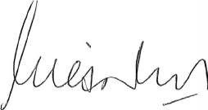
Certification of key performance indicators
For the year ended 30 June 2017
I hereby certify that the key performance indicators are based on proper records, are relevant and appropriate for assisting users to assess the Office of the Government Chief Information Officer’s performance, and fairly represent the performance of the sub- Department for the financial year ended 30 June 2017.

Giles Nunis
Chief Executive and Government Chief Information Officer
10 August 2017

Outcomes
The Government desired outcomes that the sub-Department works to achieve through its services are:

Measuring the Performance
Government goals | Order | Desired outcomes | Services
Financial and economic responsibility
Responsibly | One | Enabling effective | Establishment of
managing the State’s |  | utilisation of best | a Platform for the
finances through |  | practice technology in | Delivery of Better
the efficient and |  | the public sector. | Government
effective delivery of |  |  | Services
services, encouraging |  |  | through Efficient
economic activity |  |  | Development of
and reducing |  |  | Information and
regulatory burdens |  |  | Communications
on the private sector. |  |  | Technology (ICT)
 |  |  | Strategy, Policies
 |  |  | and Solutions.
 | Two | To pave the way for | Establishment
 |  | Western Australians | of a $20 million
 |  | to take ideas | innovation
 |  | from discovery to | package to grow
 |  | commercialisation, | the WA innovation
 |  | increase investment | ecosystem and
 |  | in Western Australian | innovation
 |  | innovation, increase | activity through
 |  | the number of scaled | the delivery of
 |  | innovations and | programs, services
 |  | reduce the time and | and events.
 |  | cost of doing so.

The Office of the Government Chief Information Officer measures its performance through a comparison of policy and costs against overall government direction and ICT spend.

Outcome 1:

Enabling effective utilisation of best practice technology in the public sector
Key indicators of effectiveness

Key indicators of effectiveness

2016-17
target

2016-17
actual

This outcome supports the Government’s goals for an efficient and cost effective public service and reflects the OGCIO role in establishing the framework and policy to assist agencies in achieving more efficient services.
Percentage of ICT policies endorsed by Governance groups for development by OGCIO that have been developed and approved by Government. (a)
(%) 75 75 (1)

The Digital WA strategy provides a whole of government vision and roadmap for ICT in Western Australia. By working together as part of one government, public sector agencies will work towards aligning their technology and business functions to improve service delivery to the community.
The Western Australian Government ICT Strategy will help transform the way public services are designed, supported and delivered for a community living and working in a digital world.
The Strategy and associated policies set a framework for government agencies to adopt to achieve business benefits and improved service delivery. The Digital WA: State ICT Strategy identifies the key policy initiatives to be implemented. The Strategy and whole of government policies were/are endorsed by the governance groups (e.g. CIO Council, Business Impact Group and DG Council), and are developed by the OGCIO for approval by Government.
(a) The percentage of policies endorsed by the governance groups for development by OGCIO that have been implemented and approved by Government, reflect the effectiveness of OGCIO in delivering these policy directions. This indicator was developed for use in 2016-17 and no historical comparison is available.
- Twelve policies were endorsed to be developed with nine developed by OGCIO and approved by Government during 2016-17.
 | Policy Title | Progress
1 | Open Data | Developed and approved
2 | GovNext-lCT | Developed and approved
3 | Digital WA | Developed and approved
4 | Business Continuity for Disaster Recovery | Developed and approved
5 | Cloud | Developed and approved
6 | Digital Security | Developed and approved
7 | Digital Services | Developed and approved
8 | Interoperability | Developed and approved
9 | Data Classification | Under development
10 | ICT Procurement | Under development
11 | Privacy | Under development
12 | myWA | Developed and approved

Outcome 2:

To pave the way for Western Australians to take ideas from discovery to commercialisation, increase investment in Western Australian innovation, increase the number of scaled innovations and reduce the time and cost of doing so.
Effective review and recommendation on all submissions for innovation grants received ensures all opportunities for Government support of Innovation are considered. Verification of those submissions that are viable for support by Government ensures the effectiveness of the Innovation initiative.
Innovation grants will provide the opportunity for West Australian business ideas to progress commercialisation and thereby improve overall investment and economic growth for the State.
Key indicators of effectiveness |  | 2016-17  target | 2016-17  actual
Percentage of Innovation submissions received that have been actioned. (a) | (%) | 100 | 100

(a) The percentage of innovation grant submissions received that were actioned. This outcome was added for the 2016-17 financial year through additional funding allocated to the OGCIO to create the Innovation Fund, therefore no historical comparison is available.

Service 1:

Establishment of a Platform for the Delivery of Better Government Services through Efficient Development of Information and Communications Technology (ICT) Strategy, Policies and Solutions.
The OGCIO continues to develop the ICT platform, through policy development and project implementation, for the delivery of better government services.
The indicators represent the costs per unit of policy development and the cost of project implementations as a percentage of overall government spent on related ICT services. Taken into account with the notes explaining any variances, it provides a measure of efficiency.
To ensure the cost of policy change for government is efficient, the overall cost of implementing the change needs to be cost effective when compared to the total government spend on the related activities. In this case the costs impacted relate to server, internet and related services.
- Actual whole-of-government expenditure on related ICT services was lower than initial estimates, thereby resulting in a higher comparative result. The lower expenditure is primarily a result of agencies reducing ICT spend as they prepare for a transition into the new GovNext framework.

Service 2:

Establishment of a $20 million innovation package to grow the WA innovation ecosystem and innovation activity through the delivery of programs, services and events.
Efficient utilisation of resources achieves value for money outcomes for government in the delivery of services.
This indicator reflects the cost of managing the Innovation fund and delivery of its programs and grants.
For 2016-17 the cost is impacted by the set-up of the program, including the launch and promotional activities.

2016-17
Key indicators of efficiency target

2016-17
actual

This KPI covers the effective management of the full cost of the Innovation outcome.

2016-17
Average cost of Policy Development (a) | ($ ’000) | 201 | 192 (1)
Cost of GovNext and MyWA project | (%) | 2.5 | 3.1 (2)
implementation as a percentage cost of the
overall government spend on related services (b)

Key indicators of efficiency target
2016-17
actual

Administrative costs per innovation initiative and/or grant application (a)

($) 5,279 5,311 (1)

(a) Cost of policy and strategic services divided by the number of policy initiatives endorsed by the governance groups for development by OGCIO. This calculation includes an overhead for the administrative costs of the OGCIO, including executive and office management costs. This KPI was developed for use in 2016-17 thus no comparative figures are available.
- Total cost of projects as a percentage of the overall lCT Services spend by government. This calculation includes the full cost of the Projects, including administration, project spend and overheads. This KPI was developed for use in 2016-17 thus no comparative figures are available.
  - The lower result is due to slightly lower costs than anticipated incurred by OGCIO on policy development activities.
- The cost of administering the Innovation activities and grants divided by the number of activities and grants during the year. This calculation includes an overhead for the
administrative costs of the OGCIO, including executive and associated office costs. This KPI was developed for use in 2016-17 thus no comparative figures are available.
  - Actual numbers of activities against the Innovation initiative were greater than anticipated, resulting in lower average costs, however launch and start- up costs that were not anticipated in the target have pushed administrative costs higher for the 2016 -17 actuals resulting in a slightly over target result.

Ministerial Directives
Treasurer’s Instruction 903 (12) requires agencies to disclose information on any Ministerial Directives relevant to the setting or achievement of desired outcomes or operational objectives, investment activities, and financing activities.
The Office of the GCIO did not receive any Ministerial Directives during 2016-17.

Other Financial Disclosures

Pricing policies of services provided
Not applicable

Capital Projects
Nil

Unauthorised use of credit cards
Officers of the Department of Finance hold corporate credit cards where their functions warrant usage of this facility. The Office of the GCIO did not have any unauthorised use of credit cards during the 2016-17 reporting period.

2016-2017 $
Aggregate amount of personal use expenditure for the reporting period | Nil
Aggregate amount of personal use expenditure settled by the due date (within 5 working days) | Nil
Aggregate amount of personal use expenditure settled after the period (after 5 working days) | Nil
Aggregate amount of personal use expenditure outstanding at balance date | Nil

Employment and Industrial Relations

Comparative full time equivalent (FTE) allocation by category
The Office of the GCIO was established on 1 July 2015 for a period of three years. As the Office of the GCIO has no permanent employees, for reporting purposes, the number of full-time and part-time contracted employees is noted below, as well as the number of employees seconded from State Government agencies whose substantive position remains with that agency.

Category | 2016-17 | 2015-16
Full-time | 19 | 9.5
Part-time | 1 | 1.6
Seconded in | 16 | 13.5
Total | 36 | 24.6
Source Data: 2016-2017 MOIR Data

Notes:
Part-time = hours less than normal hours of
37.5 per week.

Workers Compensation
In accordance with Treasurer’s Instruction 903 (13iiic), the Office had the following workers’ compensation disclosures.

Workers’ compensation
claims
Lost time injuries
2015-16
0
0
2016-17
0

0

Industrial Relations
Staff at the Office of the GCIO are employed under the conditions of the Public Service Award 1992 and Public Service and Government Officers General Agreement 2014. As a
sub-department of the Department of Finance, the Office of the GCIO is also covered by an Agency Specific Agreement with provisions for a wellness program, motor vehicle allowance for business use and flexible working arrangements.

Staff Development
The Office of the GCIO works closely with
the Department of Finance in the area
of professional development. Since its commencement the priority has been to recruit and maintain a high performing workforce.
Continuing development is supported through the Performance and Development Program.

Governance disclosures
The Office of the GCIO is part of the Department of Finance’s Governance environment in terms of both the delegation framework and many
of the internal committees. Rather than create duplicate committees, the Office of the GCIO has minimised cost through utilising as much of the Department’s framework as possible.
The Office of the GCIO has its own Corporate Executive and also operates a sub-committee focused on Financial Management.
The Office of the GCIO Corporate Executive meets weekly and includes the Government Chief Information Officer and Executive Directors.
The Financial Management sub-committee meets monthly and membership includes the Government Chief Information officer, Executive Director Policy and Governance and the Chief Finance Officer of the Department of Finance.

Senior officers
As at the date of reporting, no senior officers, firms of which senior officers are members, or entities in which senior officers have substantial interests, had any interests in existing or proposed contracts with the sub-department or the Office of the GCIO other than normal contracts of employment of service.

Board and committee remuneration
Nil

Other legal requirements

Expenditure on advertising, market research, polling and direct mail
In accordance with section 175ZE of the Electoral Act 1907, the Office of the GCIO incurred $336,829 expenditure during the year for the Innovation Worth Sharing branding and marketing campaign.

Organisation
Advertising agencies
- Rare Pty Ltd
- Adcorp Australia Limited Market research organisations Polling organisations Direct mail organisations Media advertising organisations
- Carat Australia Media Services
Total
2016-17
Expenditure (incl. GST)

87,978
5616
Nil
Nil
Nil

243,235
336,829

Access and Inclusion –
sub-department’s Disability Access and Inclusion Plan
The Office of the GCIO has adopted the Disability Access and Inclusion Plan developed by the Department of Finance.

Compliance with public sector standards and ethical codes
Over the year, the Office of the GCIO has provided proactive guidance to managers and staff to ensure recruitment processes complied with public sector standards.
No breach of standard claims were lodged in 2016-17. No disclosures were received in 2016-17 under the Public Interest Disclosure Act 2003.

Recordkeeping plans
The Office of the GCIO continues to follow recordkeeping compliant protocols developed by the Department of Finance and all staff have access to instructions and guides for
the use of the recordkeeping system via the agency’s intranet.
The release of a new customised online learning module for recordkeeping supports the Department of Finance’s commitment to maintaining good recordkeeping practices and is an extension to the recordkeeping obligations and compliance training provided during induction training.

Freedom of information
In compliance with the Freedom of Information Act 1992 the Office of the GCIO has published an Information Statement describing the types
of documents in its possession that could be accessed under Freedom of Information. In 2016-17 the Office of the GCIO did not receive any Freedom of Information applications.

Government Policy Requirements

Government Building Contracts
Nil

Substantive equality
The Office of the GCIO supports the provision of services that address the different needs of Western Australia’s diverse community and supports the Equal Opportunity Commission to eliminate systemic racism by creating a community based on equality for everyone.

Occupational safety, health and injury management
The Office of the GCIO continues to provide a safe and healthy workplace in accordance with the requirements of the Public Sector Commissioner’s Circular 2012-05: Code of
Practice Occupational Safety and Health (OSH) in the Western Australian Public Sector, and in support of the State Government’s commitment to achieving the goals of the Australian Work Health and Safety Strategy 2012 - 2022.

Injury management
The Office of the GCIO through the Department of Finance has applied the Worksafe assessment self-evaluation tool. Its application included the:
  - ongoing consultation on emerging health, safety and wellbeing issues with staff across the Department.
  - ongoing provision of up-to-date training on health and safety matters to all staff.
  - developing the Hazard/Incident Reporting and Issue Resolution process.

Public Sector Commissioner’s Occupational Safety and Health performance requirements 2016-17

Indicator | 2016-17 | 2015-16 Target Comment on result
Number of fatalities | Nil | Nil | Nil Achieved  At least nil or 10% improvement Achieved - No lost time injuries during on the previous two years 2016/17  Nil Achieved - No Lost time injuries during 2016/17  Nil  Greater than or equal to 80% Corporate Executive has engaged with the  OSH team at Finance about alternative training initiatives including streamlining of mandatory training to ensure that  the number of managers trained in occupational safety, health and injury management is at appropriate levels.
Lost time injury and/or disease incidence rate | Nil | Nil
Lost time injury and/or disease severity rate | Nil | Nil
Percentage of injured workers returned to work: | Nil | Nil
- Within 13 weeks | N/A | N/A
- Within 26 weeks | N/A | N/A
Percentage of managers trained in occupational safety, health and injury management responsibilities | 0% | 0%

Legislation administered
The Office of the GCIO does not administer any legislation.

Contact us

Postal Address:

Locked Bag 11
CLOISTERS SQUARE WA 6850

Phone:
08 6551 3900
Website:
www.gcio.wa.gov.au

Email:
enquiries@gcio.wa.gov.au

