Whole-of-Government
Cloud Policy

A Supplementary Guide

Document Control

The Western Australian Whole of Government Cloud Policy: A supplementary guide
Version 1 – June 2018

Produced and published by: The Office of the Government Chief Information Officer (now Office of Digital Government)

Contact:
The Office of Digital Government
2 Havelock Street
WEST PERTH WA 6005
Telephone: (08) 6551 3900 Email: dgov-administrator@dpc.wa.gov.au

Document version history

Date | Author | Version | Revision Notes
June 2018 | Office of the GCIO | 1 | First release
September 2018 | Office of Digital Government | 2 | Second Release

This document, Cloud Policy: A Supplementary Guide, Version 1 is licensed under a Creative Commons Attribution 4.0 International Licence. You are free to re-use the work under that licence, on the condition that you attribute the Government of Western Australia (Office of Digital Government) as author, indicate if changes were made, and comply with the other licence terms. The licence does not apply to any branding or images.

License URL: https://creativecommons.org/licenses/by/4.0/legalc ode

Attribution: © Government of Western Australia (Office of Digital Government) 2017

Notice Identifying Other Material and/or Rights in this Publication:

The Creative Commons licence does not apply to the Government of Western Australia Coat of Arms. Permission to reuse the Coat of Arms can be obtained from the Department of Premier and Cabinet.

Introduction
The Western Australian (WA) Information and Communications Technology (ICT) Strategy—
Digital WA—sets the vision and roadmap for digital transformation of the WA public sector.
The WA Whole of Government Cloud Policy (the Policy) and this Supplementary Guide are key components of the implementation of Digital WA.
This Supplementary Guide to the Policy describes key considerations for agencies to consider when transitioning to the cloud, and introduces a suite of factsheets that outline practical issues and additional guidance as they progressively mature their cloud capabilities.

What is “the cloud”?
Key Cloud Concepts
Cloud computing is delivered as a service, not as a product and has little up-front cost. This “as-a- Service” model has three key advantages:
- Scalability – services can be speedily increased or decreased to meet needs;
- No sunk cost—services are metered so you only pay for what you use, and can turn off what you don’t; and
- Self-service—trying a new service does not require up-front investment, or lengthy involvement from ICT teams. Business managers can take charge of what they use.
The three main “as-a-Service” (aaS) categories for cloud computing are:
- Infrastructure-as-a-Service (IaaS) – which provides fundamental ‘back-end’ computing such as storage, networks and servers. The WA Government’s new core network, GovNext-ICT, is an IaaS solution;
- Platform-as-a-Service (PaaS), which provides everything required to develop and maintain web-based applications and services (e.g. a Government website); and
- Software-as-a-Service (SaaS), which provides applications and services that are based on remote servers, and available to users anywhere (typically through a web browser window).
“Cloud” is a catch-all term, that broadly applies to computing resources that are provided at a distance via the internet, rather than locally via an organisation’s own hardware and ICT teams. The term ‘cloud’ is inherited from early descriptions of the internet—which was conceived as a complex mass, or cloud, of interconnected computers.
Cloud computing is near-synonymous with its business model, in which computing resources are provided as a service (operational expenditure), as opposed to products that are bought and owned (capital expenditure).
This differs from more traditional approaches to computing, where all data, networking, software and physical hardware was typically paid for, maintained and managed individually (and within each building) by organisations’ ICT teams.
Because cloud computing services do not have to be “in the building” where they are used, they provide greater flexibility than traditional ICT procurement, which requires expensive hardware and software to be owned and set up in every location where an organisation operates.
Cloud solutions are also mobile-friendly and flexible by design. Because cloud services are not tied to specific locations, they allow agency staff to work remotely with little additional support from ICT teams.

Cloud represents a significant opportunity for the Western Australian Public Sector to stop paying to run its own computing hardware, and pay only for what it needs —with greater security and flexibility as a result.

The role of the Cloud Policy
An Example of What Cloud Computing Looks Like
One straightforward example is cloud storage— common examples of which include Dropbox and Microsoft OneDrive. Prior to cloud computing, each computer would only have access to the files stored on its own individual hard disk—or those it was directly connected to via a network. Even files from the internet would have to be downloaded and stored “locally” in order to be used, and each organisation would have to maintain its own “servers”—storage computers to provide the data.
With cloud storage, data is instead kept in massive warehouses, called “data centres”, which are built and maintained centrally by the cloud storage provider. Each customer’s files are then made instantly accessible to them (and only them) via an internet connection. The cloud data centre is able to provide data to potentially thousands of separate customers, wherever they are—and typically features far higher levels of security, backup and data availability than separate users could individually provide. The economy of scale, and ability to start and stop serving new data with ease, means that cloud storage can be provided for a relatively low monthly cost—and with no up- front cost to customers.
The same principle applies to virtually any kind of computing service (including the whole operating system of a computer itself, and all the software it runs)—such that it is now possible to run an organisation’s entire corporate ICT system via cloud services. The organisation can start paying only for what it needs, and break free of the costly cycle of buying, maintaining and replacing all its own hardware and software.
Current ICT procurement practices frequently default to the traditional model,
without considering the numerous advantages that cloud options can provide. As a result, agencies incur higher up-front costs for ICT solutions which are expensive and may not be the best for their business needs.
The Policy mandates that agencies change this, and instead consider cloud- based options by default—and adopt them wherever business, risk and value-for- money requirements are met.

Key considerations
Several WA agencies have successfully transitioned to cloud services. Their experience indicates that the transition is best managed with a staged approach, moving one manageable workload at a time.
The result is a transition that is easier to plan and implement, where business executives and staff learn through experience, building confidence and capability across the agency.
Regardless of the scale of an agency’s
transition to cloud services, common topics for agencies to consider are the project’s governance framework, their workforce capability, and the agency’s current situation. Applying an agency’s existing business and risk management frameworks to plan the process, agencies should assess cloud options, plan their procurement and implement regular review and management processes following the purchase.

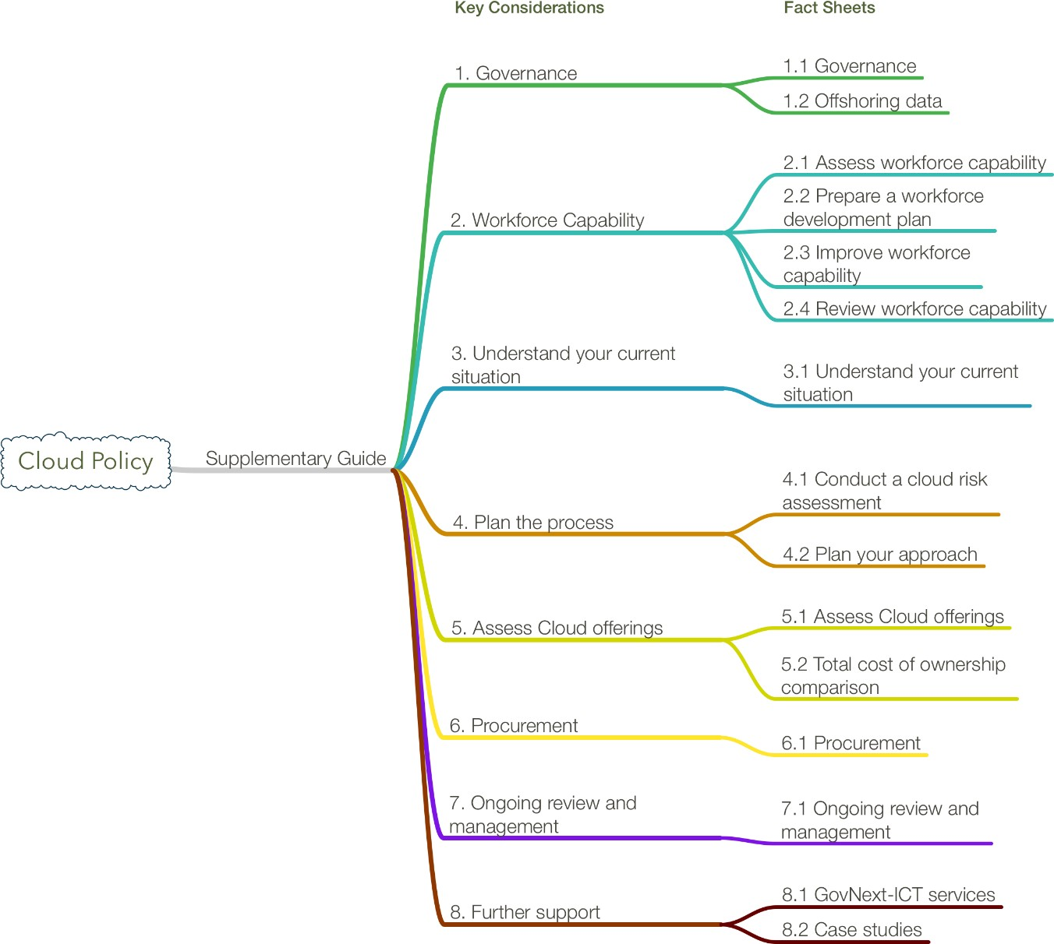

Figure 1: Key Considerations and Fact Sheets

Fact sheets
Fact sheets addressing these key topics have been developed to assist agencies with the move to cloud services, by providing further details on process and key considerations for their transition.

Table 1: Cloud Policy Fact Sheets

Topic | Factsheet | Objective
1. Governance | 1.1 Governance | Establish a business-led governance framework with supporting ICT policies and a management framework to enable cloud transformation.
 | 1.2 Offshoring data | Establish a governance framework to enable transfer,  storage and processing of data in compliance with Western Australian law.
2. Workforce capability | 2.1 Assess workforce  capability | Assess your agency’s skills and capability to plan, assess  and implement cloud offerings.
 | 2.2 Prepare a workforce  development plan | Establish an ICT workforce development plan that includes  cloud capabilities.
 | 2.3 Improve workforce capability | Determine whether the skills required can be developed through training or if specialist expertise is required.
 | 2.4 Review workforce capability | Implement regular review of job description forms and update where necessary.
3. Understand  your current  situation | 3.1 Understand your  current situation | Assess your agency’s workloads, and the maturity of  existing policies and systems.
4. Planning the process | 4.1 Conduct a cloud risk assessment | Assess the risks associated with transition to cloud.
 | 4.2 Plan your approach | Develop project documents, with relevant supporting materials, to justify and acquire the appropriate approvals  for your agency’s transition to cloud.
5. Assess cloud offerings | - Assess cloud offerings  - Total cost of  ownership comparison | Develop a market sounding approach to determine different service offerings and price models.  Choose service model/s based on your agency’s needs,  and compare the total costs of ownership.
6. Procurement | 6.1 Procurement | Plan your procurement strategy in accordance with the  Policy, and State Supply Commission Policies.
7. Ongoing  review and management | 7.1 Ongoing review and management | Implement regular review of market offerings and price points and continually assess service delivery of existing contracts.
8. Further  support | 8.1 GovNext-ICT  services | Learn more about the Office of Digital Government’s  GovNext Service Broker (GSB) team.
 | 8.2 Case studies | Learn from case studies of cloud deployments in other agencies.
Further Support
For further support in transitioning to cloud, contact the Office of Digital Government.

