GovNext-ICT
Program Governance Board
Terms of Reference

Document Control
Document control
Document Title | GovNext-ICT Program Governance Board Terms of Reference
Trim File Name | GovNext-ICT Program Governance Board - ToR V1.1 (Mar 2019)
Trim File No. | 85760 |  | Trim Doc No. |  | W19010786
Status | Open
Author | Niamh Toohey
Version Number | V1.1 | Version Date |  | 05 March 2019

Version | Date | Reason and comments
0.1 | 7 May 2018 | Initial release to OGCIO Transition Steering Committee (OTSC)
0.2 | 24 July 2018 | Amendments following inaugural Board Meeting 5 July 2018
0.3 | 03 August 2018 | Amendments following Board Meeting 2 August 2018
0.4 | 4 December 2018 | Amendments requested by Council September 2018
1.0 | 5 March 2019 | Amendments requested by Council 4 December 2018
1.1 | 5 March 2019 | Amendments to indicative 2019 meeting dates and members, following Board meeting 28 February, for the purpose of publishing the Terms of Reference.

Produced and published by: The Office of Digital Government
Contact:
Department of the Premier and Cabinet
Office of Digital Government
2 Havelock Street
WEST PERTH WA 6005
Telephone: (08) 6552 5444
Email: GovNext-DPC@dpc.wa.gov.au

Vision and purpose
The GovNext-ICT Program is a whole of government reform program that aims to modernise government’s enabling infrastructure technologies to drive improved services delivery, reduce costs, improve security and enable information sharing. The Program sets up the common platforms required for digital services and data analytics; two key focus areas for government. These outcomes underpin a public sector that applies interoperable, fit-for-purpose solutions based on extensive and efficient use of cloud, and “as a service” delivery models that support and drive business process improvements to create public value.
GovNext-ICT has undergone two gateway reviews, an external review of its business case, and has been examined as part of the Special Inquiry into Government Programs and Projects. A consistent theme stemming from the reviews is the need for strengthened governance in order for the anticipated benefits to be realised.
The Special Inquirer reported that for the GovNext-ICT to be a success there needs to be leadership and coordination of an integrated plan for implementation by the whole-of-government.
The Program Governance Board (the Board) has been established to oversee whole-of-government implementation. The Board will provide direction to the Program Management Office (yet to be established) on the coordination of an integrated plan for GovNext-ICT implementation by whole-of-government.
Successful implementation of the GovNext-ICT reform initiative and the uptake of services seeks to achieve seven measurable outcomes:
- reduced cost;
- improved transparency;
- more agile services;
- more reliable service delivery;
- greater security;
- reduced risk; and
- implemented information sharing.

Responsibilities
The Board will be responsible for:
- overseeing implementation and roll-out of the GovNext-ICT Program, including the decision making authority for program related matters at the whole-of-government system level. Agencies shall remain accountable for local level implementation matters.
- providing oversight and direction to the Program Management Office (PMO) on the coordination of an integrated plan for GovNext-ICT implementation by whole-of-government;
- overseeing the timely transition of agencies into GovNext-ICT, and monitoring the realisation of benefits across whole-of-government,
- providing quarterly reporting to the Directors General ICT Council (Council), including clear articulation of risks and milestones;
- delivering communications in line with the Program communications plan;
- championing the adoption of GovNext-ICT across whole-of-government, and ensuring support to agencies in the adoption of the GovNext-ICT infrastructure and service offering framework;
- engaging and ensuring the effective management of the three GovNext-ICT vendors; and
- providing direction and advice to WA Government on ICT infrastructure reform elements that support government’s strategic objectives.

Authority of the Board
The Board will have authority for overseeing the implementation and roll out of the GovNext-ICT Program, through the PMO, and does not hold any budgets.

Membership
The Board will have an independent chair and comprise of senior executives of the Departments of the Premier and Cabinet, Treasury, Finance and the Office of Digital Government (DGov) and other agencies by invitation.
Members are required to attend meetings or provide a proxy (that has a delegated authority for the agency) on their behalf. Other organisations or individuals may be invited by the Chair to make presentations or participate in meetings as appropriate.
See Appendix A for a list of current Board members.

Governance
The Governance Structure of the Board is illustrated as follows:
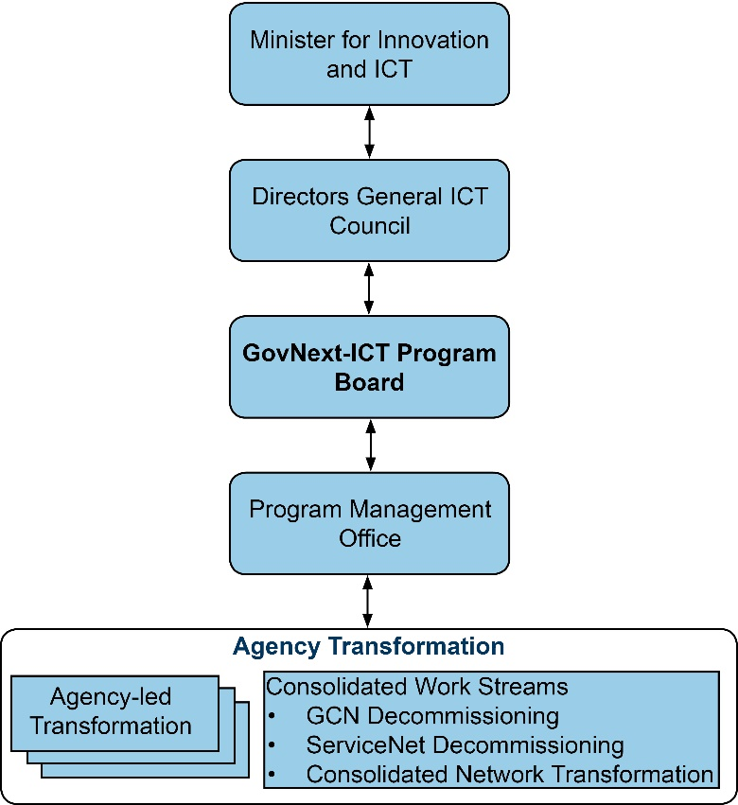
Figure 1: GovNext-ICT Program Governance Board Structure

Relationship between the Council and Board:
The Board will be a sub-committee of the DG ICT Council (the Council). The Chair of the GovNext-ICT Program Governance Board will be a member of the Council to ensure alignment of the Board with the direction of the Council.
The Board will provide recommendations on the establishment of the GovNext-ICT Program, for approval by the Council. Once established, the Board will have delegated authority for decision making to support and address problems/issues that apply to the whole system level or require a whole-of-government perspective. The Board will seek the Council’s input under the following circumstances:
- establishment and scope of GovNext-ICT program including reporting requirements;
- where a decision resulting in an adjustment to the intent or strategic direction of the Program is required that has sector wide implications;
- where the Board seeks the involvement of agencies in resourcing and delivering particular components of the Program;
- provide quarterly GovNext-ICT Program reporting; and
- as otherwise directed by Council.

Administration
The Board will be provided executive support by DGov, including:
- Program management of the GovNext-ICT Program stages;
- Executive Officer and Secretariat support to the Board;
- research and preparation of papers; and
- a liaison and contact point for Board inquiries.

Decision-making
Decisions will be made by consensus. Where consensus is not reached, further discussion and deliberation shall be entered into until either a consensus is reached or the matter is rejected or deferred.
Any decisions made by the Board in the presence of a quorum will be considered final.

Reporting and communication arrangements
The Board will provide quarterly Program status reports to the Council.
The Board will be responsible for establishing and implementing the Program’s communication plan.

Confidentiality and Conflict of Interest
Members of the Board must declare any conflict, potential conflict or apparent conflict of interest in matters that are considered by the Board.
Whilst the Board will generally operate in an environment of openness and transparency, from time to time, confidential matters will be discussed and members of the Board (including all officers in attendance) must respect the sensitivity of the information.

Record keeping
All formal records for the Board will be managed by DGov and in accordance with the State Records Act 2000 (WA).

Process

Meetings
The Board will meet monthly until further notice. With agreement, out-of-session meetings or decisions can be made. An indicative schedule of meeting dates is at Appendix B.
A quorum must be present before the Board can transact any business. A meeting may continue as an inquorate with decisions carried over until a quorum is present or informal decisions can be brought forward to the next meeting. A quorum of the Board is the next whole number above one half of the number of members of the Board.
All Board meetings will be held at Dumas House in West Perth (or as scheduled). Notice of any meeting of the Board shall be in writing at least ten working days prior to the day of the meeting.

Agendas, Minutes and Papers
The agenda for all Board meetings shall be prepared by DGov and distributed at least five working days prior to the meeting. Agenda items and papers can be submitted by any member of the Board.
The minutes will be taken by DGov and distributed to Board members within one week of meeting.

Amendments
The Board may amend these terms of reference at any time upon agreement of all members or a quorum.

A review of the terms of reference will be undertaken annually to assess currency and relevance, or when deemed necessary.

Appendix A –

GovNext-ICT Program Governance Board Membership

The GovNext-ICT Program Governance Board comprises the following members as at
28 February 2019:

Name | Role | Title | Agency
David Etherton | Independent Chair | Chief Executive Officer | VenuesWest
Malcolm Bradshaw | Executive Sponsor | Deputy Director General | Department of the Premier and Cabinet
Michael Court | Executive Sponsor | Deputy Under Treasurer | Department of Treasury
Robert Toms | Senior User | Chief Executive | Health Support Services
Andrew Cann | Senior User | Chief Information Officer | WA Police
Jennifer McGrath | Senior User | Deputy Director General | Department of Education
Greg Italiano | Senior Supplier | Government Chief Information Officer | Department of the Premier and Cabinet
Stephanie Black | Senior Supplier | Executive Director | Department of Finance
Niamh Toohey | Senior Supplier | A/Executive Director GovNext-ICT | Department of the Premier and Cabinet

Executive Officer and Secretariat support will be provided by DGov.

Appendix B –

Indicative Meeting Dates for GovNext-ICT Program Governance Board

Indicative Meeting Dates - 2019
1 | 28 February 2019
2 | 16 May 2019
3 | 8 August 2019
4 | 7 November 2019

To be confirmed with Board Members

