The South West Native Title Settlement
An Agreement reached between the Noongar People and
the Western Australian Government

Co-operative and Joint Management of the Conservation Estate:
Fact Sheet

The South West Native Title Settlement (the Settlement) is the largest and most comprehensive agreement to settle Aboriginal interests over land in Australia. The Settlement, involving six Noongar Native Title Agreement Groups, and covering 200,000 square kilometres of land, represents significant social and economic investment in the Noongar community and the shared future of Western Australia.

On 8 June 2015, after extensive negotiations, and authorisation by the Noongar people, the Western Australian Government signed (executed) the six South West Native Title Settlement Agreements with the Ballardong, Gnaala Karla Booja, South West Boojarah, Wagyl Kaip & Southern Noongar, Whadjuk and Yued groups.

The Settlement as a whole will only become fully effective after all of the six Agreements have been conclusively registered in accordance with the Native Title Act 1993 (Cth), and any related court proceedings have been resolved.

For the latest information see the ‘status of the Settlement’ section of the Department of the Premier and Cabinet website (http:/www.dpc.wa.gov.au/lantu).

Co-operative and Joint Management of the South West Conservation Estate
As part of the South West Native Title Settlement (the Settlement), the Department of Biodiversity Conservation and Attractions (DBCA) and the six Noongar Regional Corporations will enter into Co-operative and Joint Management Agreements for the care and protection of the South West Conservation Estate.

What is the South West Conservation Estate?

The South West Conservation Estate refers to all lands and waters within the South West Native Title Settlement Area and includes State forests, national parks, nature reserves, and other areas set aside for conservation, currently managed by DBCA.

Map of the South West Native Title Settlement Area and the South West Conservation Estate
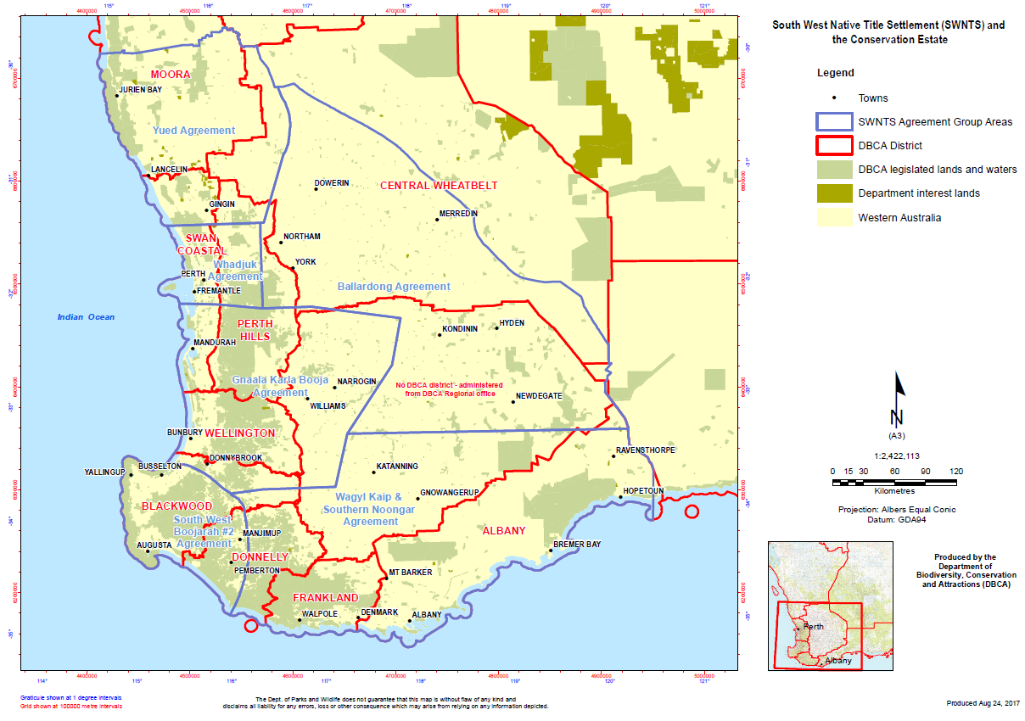
Note: The South West Conservation Estate is separate and distinct from the Noongar Land Estate (NLE) - information about the Noongar Noongar Land Estate can be found on the DPC website www.dpc.wa.gov.au/lantu/).

Why is co-operative and joint management important?

The Noongar people are the traditional owners of the land and waters in the South West Native Title Settlement Area and have cultural responsibilities in relation to the Settlement Area. The DBCA has a statutory responsibility to manage the Conservation Estate. Through the Settlement the Noongar People and the DCBA will enter into agreements to recognise their mutual rights and obligations. Specifically, the agreements will acknowledge the continuing cultural, spiritual and social connections of the Noongar people to the Settlement Area, and their unique traditional knowledge and expertise in the future management of the Conservation Estate.

Further information about the terms of the Co-operative and Joint Management Agreements can be found at Annexures M and N of the ILUAs on the Department of the Premier and Cabinet website (https://www.dpc.wa.gov.au/lantu). Learn more about Noongar Recognition Act (www.dpc.wa.gov.au/lantu).

How will Co-operative and Joint Management arrangements be established?

Following the commencement of Settlement, Co-operative and Joint Management arrangements will be established in a two-staged process.

Stage 1: Co-operative Management

Six Co-operative Management Agreements (CMA), one for each of the six Agreement (ILUA) areas, will be signed by the DBCA and the relevant Noongar Regional Corporation. The CMA will apply to the whole of the South West Conservation Estate within that Agreement (ILUA) area. A Co-operative Management Committee (CMC) will be established to implement each Cooperative Management Agreement.

Stage 2: Joint Management

Once established, the Co-Operative Management Committees will, among other things, work to identify and prioritise specific areas of the Conservation Estate to be jointly managed by Joint Management Bodies established under Joint Management Agreements.

What will Co-operative Management involve?

The six Co-operative Management Committees established under the Co-operative Management Agreements will comprise DBCA employees and Noongar representatives as nominated by the respective Noongar Regional Corporations. The Co-operative Management Committees will be responsible for providing high level advice on matters affecting the Conservation Estate within a particular Agreement (ILUA) area.

What will Joint Management involve?

Joint Management Bodies (JMB) established under the Joint Management Agreements will include up to six members from the Noongar Regional Corporation and representatives from DBCA. The Joint Management Bodies will be required to manage the specific park or reserve in accordance with the Management Plan and the conditions of the Joint Management Agreement.

How much of the South West Conservation Estate will be jointly managed?

The DBCA and the Noongar Regional Corporations, through the six Co-operative Management Committees, will work together to put in place Management Plans that include joint management arrangements over areas of the South West Conservation Estate. This will take considerable time to implement; however, at least one Joint Management Agreement for a specific park of reserve in each ILUA area will be put in place within the first five years of the commencement date of the Settlement. At least one further Joint Management Agreement will also be created in another part of each ILUA area within ten years of the commencement date of the Settlement.

Will public access to national parks and State forests be affected by the changes?

No, generally speaking public access to national parks, nature reserves, conservation reserves, rivers, beaches and any other public spaces, will not be not affected. State and Commonwealth laws governing access to land and environmental protection will remain in place, including protection of Aboriginal sites.

Will the Public be able to comment on Management Plans in the South West Conservation Estate?

Yes, both new and updated Management Plans will be subject to standard public notification and submission processes. This includes any Management Plans prepared or updated to facilitate joint management over particular priority areas identified by Co-operative Management Committees.

The Conservation Estate is the lands and waters that are subject to the provisions of the Conservation and Land Management Act 1984 (CALM Act, section 5(1)).
As set out in Annexure M to the ILUAs.

