**The South West Native Title Settlement**

News Bulletin October 2018

**All Six South West Native Title Settlement Agreements Registered**

On 17 October 2018, the Native Title Registrar registered all six South West Native Title Settlement Indigenous Land Use Agreements (Agreements). This milestone is a significant step towards commencement of the South West Native Title Settlement (Settlement) for the Noongar community and the State of Western Australia.

The Settlement will resolve all native title claims in the South West of Western Australia in exchange for land and other negotiated benefits. The Settlement will provide a significant opportunity for the Noongar people to achieve sustainable social, economic and cultural outcomes, and for the WA Government and other stakeholders to work in partnership with the Noongar community to realise these goals.

**Immediate Implications**

There is no immediate change to current *Native Title Act 1993 (Cth)* (NTA) ‘future act’ obligations, nor to pre-Settlement Agreement heritage obligations, as a result of the successful registration of the Agreements.  The NTA future act regime will only cease to operate in the Agreement areas 30 business days after Settlement commencement (see flowchart below).

**Next Steps**

The earliest possible date for Conclusive Registration of the Agreements (as explained in the next section) is mid-January 2019, with a mid-February date for commencement of the Settlement. The establishment of the Noongar Boodja Trust, and then the Central Services Corporation and the six Noongar Regional Corporations, will follow the commencement of the Settlement. However, any party who may be aggrieved by the registration decisions has 28 days from the decision date to seek from the Native Title Registrar the reasons for decision, and may then seek an application for judicial review of the decision (ADJR application) within 28 days of those reasons being given.

In the event that there are ADJR applications made to the Federal Court, these proceedings will delay the timeframe for Conclusive Registration by at least 6 months from the date any ADJR applications are lodged, which will delay commencement of the Settlement and the flow of Settlement benefits to the Noongar community.

**Settlement Milestones- Update**

The full details of the Settlement are recorded in the six Agreements, drafted as Indigenous Land Use Agreements (ILUAs), made in compliance with the *Native Title Act 1993* (Cth).  The content and function of all six Agreements is the same except each Agreement is between the WA Government and the specific Noongar Agreement Group and refers to the relevant geographic area of the South West.

Since the signing of the Agreements in 2015, many important milestones and pre-conditions for the Settlement to commence have been fulfilled:

* [Proclamation of the *Noongar (Koorah, Nitja, Boordahwan) (Past, Present, Future) Recognition Act 2016*](https://www.dpc.wa.gov.au/swnts/Settlement-Package/Noongar-Recognition/Pages/default.aspx)(WA)
* [Proclamation of the *Land Administration (South West Native Title Settlement) Act 2016*](https://www.dpc.wa.gov.au/swnts/Settlement-Package/Valid-Land-Access/Pages/Land-Administration-Act.aspx) (WA)
* [Gazettal of the Water By-Laws Amendments](https://www.dpc.wa.gov.au/swnts/Settlement-Package/Valid-Land-Access/Pages/Water-By-Laws.aspx)
* [Operation of the Noongar Standard Heritage Agreement (NSHA) for WA Government agencies and the Mining and Petroleum Industry,](https://www.dpc.wa.gov.au/swnts/Noongar-Heritage-and-History/Noongar-Standard-Heritage-Agreement/Pages/default.aspx)including the development of a [range of NSHA resources](https://www.dpc.wa.gov.au/swnts/Noongar-Heritage-and-History/Noongar-Standard-Heritage-Agreement/Pages/NSHA-Resources.aspx) to assist all users of the NSHA
* [Selection and announcement of the initial Noongar Boodja Trustee](https://www.dpc.wa.gov.au/swnts/Governance/Noongar-Boodja-Trust/Pages/Initial-Noongar-Boodja-Trustee.aspx) (formal appointment of the Trustee will follow Settlement commencement)
* Preparations toward the establishment of the Central Services Corporation and six Noongar Regional Corporations to represent the Agreement Groups

The only condition remaining for the Settlement to commence is the [Conclusive Registration of the six Agreements.](https://www.dpc.wa.gov.au/swnts/Indigenous-Land-Use-Agreements/Pages/default.aspx) The Native Title Registrar’s decision to register all six Agreements is a significant step towards Conclusive Registration. Conclusive Registration follows the completion of any legal proceedings that may be brought against the decision of the Native Title Registrar to register the Agreements. That means, all six Agreements must be registered on the Register of Indigenous Land Use Agreements and remain registered:

* 60 Business Days after the decision is made to register the Agreements, provided that no legal proceedings have been commenced in relation to their registration; or
* 40 Business Days following the exhaustion of the final available legal proceedings in respect to their registration.

**Response to the Registration Decisions**

To mark this milestone, the Minister for Aboriginal Affairs, Noongar signatories to the six Agreements and representatives of the South West Aboriginal Land and Sea Council (SWALSC) met at Parliament House on 18 October 2018 to reflect on the registration of the Agreements and talk about what it means to the Noongar community.

See media statements from the [Minister](https://www.mediastatements.wa.gov.au/Pages/McGowan/2018/10/All-six-South-West-Native-Title-Settlement-Agreements-registered.aspx), the [South West Aboriginal Land and Sea Council](http://www.noongar.org.au/news-and-events/) and the [National Native Title Tribunal](http://www.nntt.gov.au/News-and-Publications/latest-news/Pages/South-West-Indigenous-Land-Use-Agreements-Registered.aspx) released on the day of the decisions.

Jeanice Krakouer, Chair of SWALSC, and the Honourable Ben Wyatt MLA, Minister for Aboriginal Affairs, observed the following when they joined together for a media conference on the same day:

***The South West Aboriginal Land and Sea Council is delighted with today’s outcome. We see this as an opportunity for our Noongar People to come together, to control our own destiny, and to build a solid future for generations to come (Jeanice Krakouer, SWALSC Chair).***

***The registration gets us to a key point in the history of the relationship between the State Government and the Noongar people of the South West of Western Australia. I think it’s as close as we’ve come in Australia to a treaty between a group of traditional owners and a government (Honourable Ben Wyatt MLA, Minister for Aboriginal Affairs).***

**Settlement Registration and Commencement Flowchart**

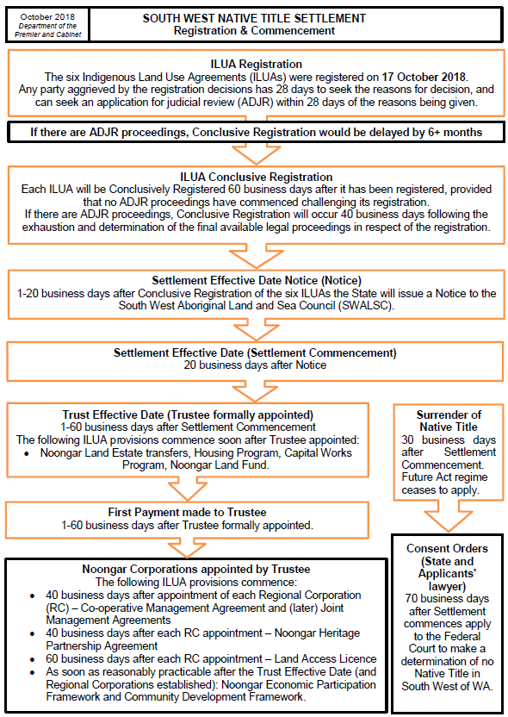

**Map of the South West Native Title Settlement Area with the six ILUA boundaries**



**More Information**

Relevant documentation is available on the Department of the Premier and Cabinet’s website: [www.dpc.wa.gov.au](https://www.dpc.wa.gov.au/Pages/Default.aspx) and can be accessed through the South West Settlement link.

This includes:

* Copies of each of the six signed ILUAs;
* Maps of the relevant ILUA area boundaries;
* Technical descriptions of the six ILUA boundaries; and
* Fact Sheets and other supporting information that may assist in understanding the Settlement.

DPC’s South West Settlement staff within the Recognition and Partnerships team of the Aboriginal Policy and Coordination Unit can also be contacted directly at:

Email: southwestsettlement@dpc.wa.gov.au

Phone: 08 6552 6191

Postal Address: Aboriginal Policy and Coordination Unit, Locked Bag 3001, West Perth WA 6872.