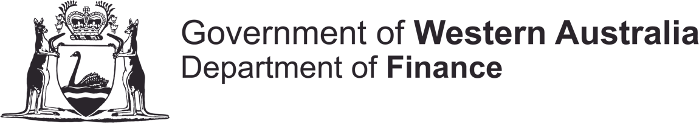

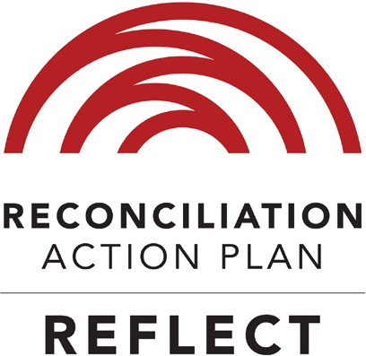
reflect
Reconciliation Action Plan
July 2018 - July 2019

DIRECTOR GENERAL’S FOREWORD

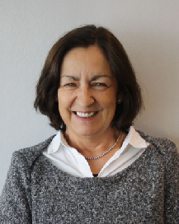
The Department of Finance (Finance) acknowledges the Aboriginal1 people as the Traditional Owners and Custodians of Australia. I also acknowledge and deeply respect the Aboriginal people as the Traditional Owners and Custodians of Australia.
I am delighted to present the Western Australian Department of Finance Reconciliation Action Plan (RAP) 2018 - 2019. Though Finance has had a RAP in place since 2008, this is the first to be registered with Reconciliation Australia.
Our plan lays the foundation for a unified and strong commitment to reconciliation across
the organisation, and guides us in making a positive contribution to Australia’s reconciliation journey.
This plan is built on a vision where reconciliation is everyone’s responsibility and helps us all to be aware that each of us has the capacity and the obligation to support our reconciliation plans.
The RAP is designed to nurture an inclusive culture that values the contribution, skills and knowledge of all
staff and supports values embraced by, and significant to, Aboriginal employees.
I thank the Finance Reconciliation Committee for developing this plan and look forward to supporting the committee in its implementation of the actions set out in this document.
I encourage all Finance staff to familiarise themselves with this RAP, think about ways in which they can infuse their day-to-day roles with acts of reconciliation, and realise that all staff are empowered to help Aboriginal people to achieve health, opportunity and wellbeing.
As individuals unite, we can have a positive effect on current and future generations, acknowledge past
injustices and contribute to a more inclusive, stronger Western Australia.

Stephanie Black A/Director General

1 For the purpose of this document, the use of the term ‘Aboriginal’ is inclusive of Torres Strait Islander peoples.

1

OUR RAP ARTWORK
Barbara Bynder is a local Indigenous artist whose artwork blends past culture and heritage of her people with today’s Aboriginal lifestyle.
Barbara has created not one, but three paintings for the purpose of this RAP document. The first of the triptych series tells the story of Aboriginal culture; the second shows ‘wadjela’ (non-Aboriginal) culture; and a third piece shows the merging of Aboriginal and wadjela values as we work together in the future.
“The rationale for this artwork was informed by the vision of the Department of Finance to improve the economic footprint of Indigenous business, combined with the research of Max Jackson,” Barbara said. Max is completing a Masters on how Aboriginal values influence business.
“For me to understand how I should represent the complexities of this space, Max and I spoke at length, unpacking the Aboriginal identity, culture and business and understanding synergies with non-Aboriginal business practices. The result is three distinct artworks,” Barbara added.
The first painting signifies Aboriginal culture. As time moves on some of those values are stronger than others, some have changed and some remain embedded in the cultural landscape.
The second artwork represents the identity of non-Aboriginal Australia. “Everything has a process, is planned, boxed, labelled and categorised in order to achieve specific outcomes,” Barbara added.
The third painting illustrates a blending of the two cultures and represents the transitional space of both Aboriginal and wadjela people working together.
Barbara is passionate about educating the wider community on the richness and diversity of contemporary Aboriginal people using the universal living language of art.

2

OUR VISION OF RECONCILIATION
Finance is committed to Reconciliation Australia’s ambition of creating meaningful relationships, enhancing respect and promoting sustainable opportunities for our Aboriginal people. It is committed to the ongoing promotion and understanding of our Aboriginal communities, cultures, heritage and aspirations.
Finance is well-placed to contribute to reconciliation, especially in the area of ‘opportunity’. As a central agency within the Western Australian Government, it drives and influences whole-of- government policy aimed at helping the Aboriginal business sector improve its economic footprint.
As a leader of public procurement, Finance assists, advises and speaks to people across government every day – people who procure works, community services, goods and services on behalf of government and as such hold the key to economic improvement.

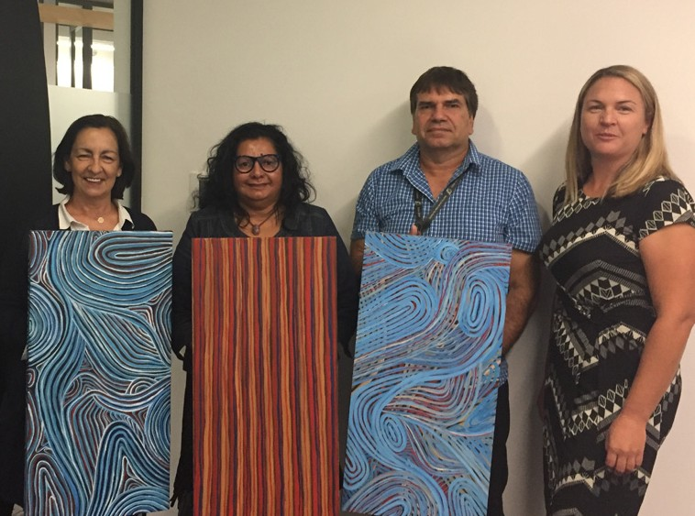
Finance’s Stephanie Black, artist Barbara Bynder, Max Jackson and Finance’s Kate Ingham.

This RAP aims to help Finance staff recognise their ability to drive change across government and understand that reconciliation is everyone’s responsibility. It aims to create a cultural shift towards embedding reconciliation into the everyday lives of staff.
It is important to recognise that healing is integral to reconciliation. Before we can reconcile, Aboriginal people must be given the time, and be made to feel empowered, to heal.
Reconciliation is a journey – everyone is at a different stage of that journey. Non-Aboriginal Australians may wish to try and reconcile – however our Aboriginal people may not be ready as they may need to grieve and heal over the past. They may be ready tomorrow or next week; they may be ready in many years’ time, or they may never be ready.
Finance will progress its reconciliation journey with an understanding of this concept and, where possible, implementing recommendations from the 2014 Forrest Review on creating parity between Aboriginal people and other Australians.
Finance is committed to working with its staff members, its fellow government agencies and the
community to make Western Australia a place of opportunity – for everybody.

3

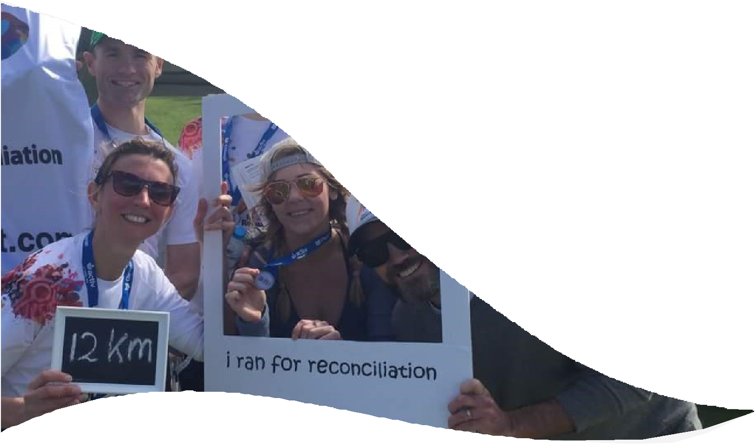

OUR BUSINESS
Finance’s objective is having efficient and effective systems and processes that build and harness our excellent relationships while continuing to build a strong, diverse and highly capable workforce. We have a vision of driving practical, cost-effective and quality outcomes across government to benefit all Western Australians.
This is achieved by taking a strong, collaborative and inclusive leadership approach, always having a whole-of-sector perspective, while implementing practical solutions based on deep insights and
understanding of issues. Finance places customers at the centre of service design and delivery ensuring innovative, affordable value-for-money outcomes, which promotes a culture of inspired, inquisitive and capable people.
Finance supports the delivery of government services to the community; administers revenue laws in a way that is equitable to the community, and leads a whole-of-government approach to the value-for-money procurement of goods, services and works.
Finance consists of six business units: Building Management and Works, State Revenue, Strategy and Coordination, Strategic Projects, Government Procurement and Corporate Services.
Finance is housed across five offices in the Perth metropolitan area and has a regional presence in Albany, Bunbury, Broome, Carnarvon, Kalgoorlie, Esperance, Geraldton, Narrogin, Northam, Merredin, Karratha, Kununurra and South Hedland.
As at 30 June 2017, Finance employed 980 Full Time Equivalents (FTE) and is looking at ways to increase
employment of Aboriginal people from its current 0.4 per cent of total FTE.

4

RECONCILIATION WITHIN OUR CORE BUSINESS

Aboriginal Business Initiative
In 2012, Finance enabled direct purchasing of goods, services and works from registered Aboriginal businesses through the Aboriginal Business Initiative and changes to the State Supply Commission policies.
At that time, a Social Procurement Initiatives team was established to further support, promote and build awareness of the Aboriginal Business Initiative to all government departments. This has resulted in an increase in purchases from registered Aboriginal businesses.
The 2016-17 financial year saw the State Government award approximately $94 million to Aboriginal businesses for a range of goods, services and works across Western Australia. This included contracts for housing construction, patrol services, cleaning, maintenance and consultancy services, among other contracts.
An example of the benefit of the initiative can be taken from the Western Australian Police Force (WAPF), which was looking to directly engage Wilco Electrical, an Aboriginal registered business from the Aboriginal Business Directory WA, for a solar installation project.
WAPF directly engaged Wilco Electrical to undertake the solar installation project, without having to seek other competitive quotes. Feedback from WAPF on Wilco Electrical’s performance was outstanding, noting their excellent workmanship and completion of the installation on-time whilst managing WAPF’s security protocols and other challenges associated with the project.
Finance arranged for Wilco Electrical to share with the Chief Procurement Officers (CPO) Forum the challenges they encountered as an Aboriginal business contracting with government, and the assistance they received from the Aboriginal Business Initiative.
Wilco Electrical have high regard for the Aboriginal Business Initiative, stating it is a “hand up, rather than a hand out”. This sparked a conversation among the CPO attendees about how to contract with Aboriginal businesses and play a role in future successes.

5

Aboriginal Procurement Policy
In 2017, the State Government committed to implementing an Aboriginal Procurement Policy to award three per cent of government contracts to Aboriginal businesses by 2020.
The Policy was developed by Finance and was announced by the Minister for Finance and Aboriginal Affairs on 19 December 2017. The Policy sets targets requiring government agencies to award one per cent of contracts to registered Aboriginal businesses from 1 July 2018, with this target increasing to two per cent from 1 July 2019 and three per cent from 1 July 2020.
Finance has built on its relationships with Aboriginal businesses and other relevant community stakeholders during the Policy development process. Finance has committed to providing education and training to Aboriginal businesses throughout the State to support their capacity to work with government and harness the opportunities this Policy presents.

Employment
Finance is committed to increasing Aboriginal representation as part of its strategy for a diverse and flexible workforce. Finance’s Workforce and Diversity Plan will assist in this through targeted recruitment strategies, traineeships and graduate programs. These initiatives will enable Finance to develop and build a more culturally secure and inclusive workforce to better service the Western Australian community.

6

Maintenance and Regional Programs
Building Management and Works’ Regional Programs took an innovative and progressive approach to regional maintenance, with an arrangement to deliver breakdown repair services to 12 remote communities using an Aboriginal business.
Ngaanyatjarra Repairs and Maintenance coordinates and delivers Building Management and Works’ breakdown maintenance – broken windows, plumbing problems, graffiti repair and other low value, high volume unplanned works typically under $1,500 – for the Ngaanyatjarra Lands region. This covers an area of some 500,000 square kilometres near the Northern Territory and South Australian border.
The value of the work is estimated to be between $750,000 and $1,000,000.
This arrangement has successfully delivered cost savings. Equally important was the Ngaanyatjarra Repairs and Maintenance’s commitment to a program of employing and developing the skills of Aboriginal employees, including apprentices in a range of trades to deliver maintenance services in the region. This arrangement
is closely aligned to government’s commitment to increase opportunities for local suppliers, Aboriginal businesses and apprentices.

7

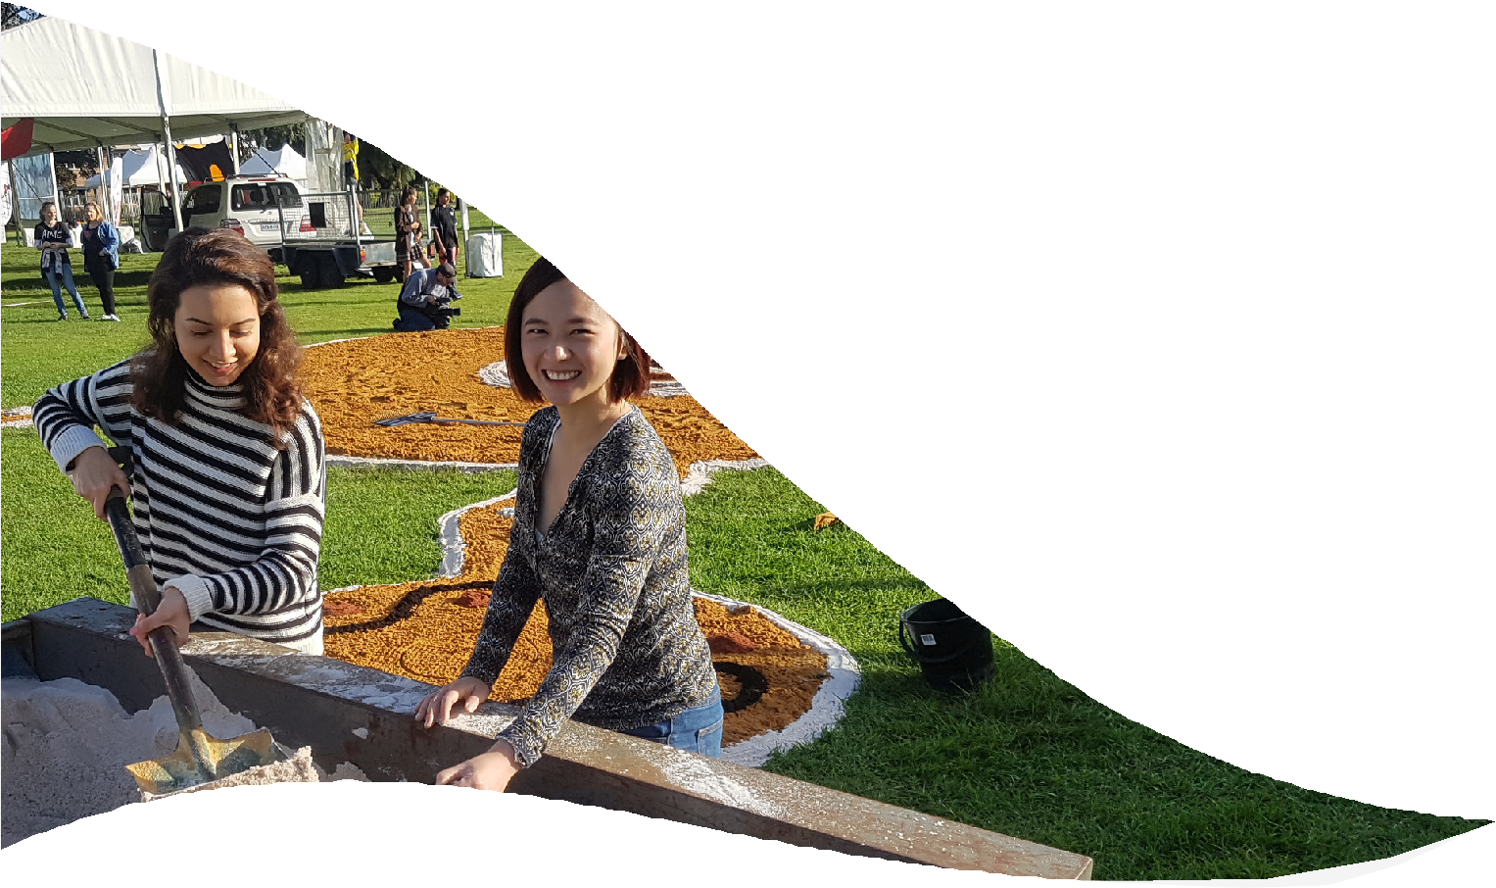OUR RECONCILIATION INITIATIVES AND ACTIVITIES

Building Management and Works’ Percent for Art Scheme
The Percent for Art Scheme commenced in 1989 and is jointly administered by Finance’s Building Management and Works and the Department of Local Government, Sport and Cultural Industries. The Scheme, which was developed, implemented and managed by both agencies, is part of a broad government strategy to encourage more art into Western Australia’s civic buildings and major infrastructure projects.
The Scheme sets aside one per cent of construction budgets to employ Western Australian artists to deliver bespoke artworks for major new public buildings such as schools, police stations and health services throughout Western Australia.
As part of the Percent for Art Scheme, Yawuru artists Maxine Charlie and Martha Lee were engaged under the Aboriginal Business Initiative to design, model and construct elements in Broome North Primary School, demonstrating its unique eco-system that represents the Yawuru culture, cultural heritage and way of life.
The school took on characteristics of the typical Broome mangrove environment, complete with
larger-than-life shells, model crocodiles and a series of connected knowledge circles designed to be both decorative and educative. The artworks also serve functional purposes such as seats, walkways, wall art and signage. School signs and interpretive material is in both English and the Yawuru language.
The involvement of Maxine Charlie and Martha Lee, both of Yawuru descent, was especially significant given
that the Yawuru are the traditional owners of Broome.

Sorry Day
In 2016 and 2017, Finance employees volunteered with the Bringing Them Home committee, assisting with their annual Sorry Day event. Both years, staff members helped to create a sand mural, while taking the opportunity to connect with Aboriginal culture and history. The ‘win’ was in the sharing of stories whilst shovelling away, and growing an understanding of the history surrounding Sorry Day.
Volunteering for the Bringing Them Home committee gave Finance a chance to show its support and progress its reconciliation journey.

8

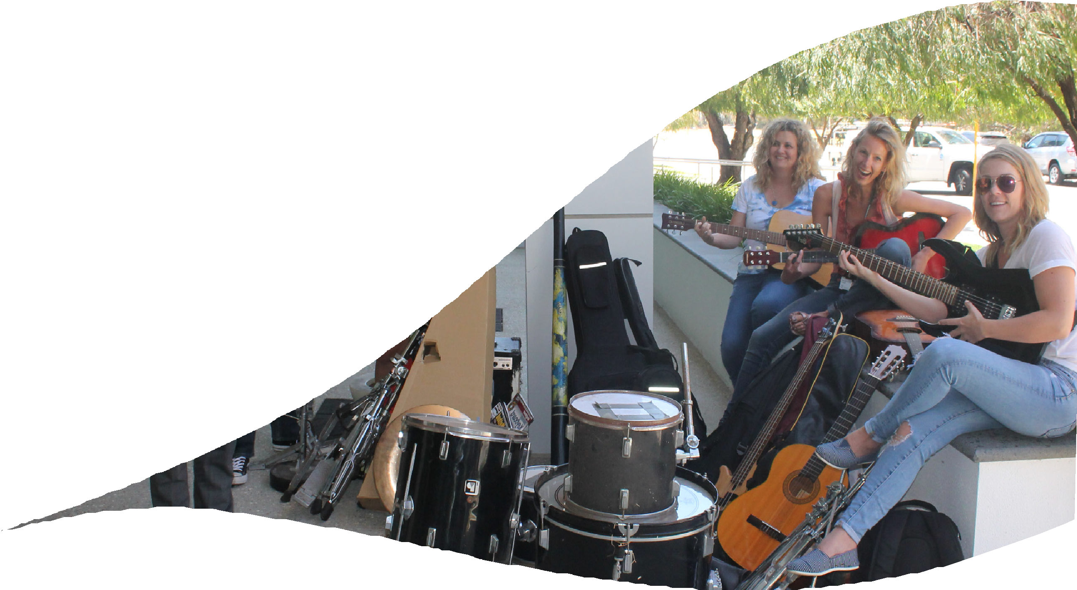Run for Reconciliation WA
Since 2016, Finance employees have participated in the Run for Reconciliation, a fun opportunity for Aboriginal and other Australians to run and walk together whilst promoting reconciliation, and raising awareness about creating new ways for all Australians to forge a new future.
Each year the event, organised by Reconciliation WA, is promoted as an avenue for Finance employees to show their support for reconciliation through running, walking, volunteering or donating.

Desert Feet
In October 2016, Finance staff collected money, and more importantly, pre-loved musical instruments to help
Desert Feet deliver opportunity through music, encouraging cultural expression and awareness.
Desert Feet is unique to WA. It uses the arts to create educational and musical opportunities for people in remote communities. At the heart of the organisation are regular music tours to Aboriginal communities which concentrate on tuition, recording and performing.
Thanks to the enthusiasm of Finance staff, Desert Feet gathered an eclectic collection of instruments, which included 13 acoustic and electric guitars, a cello, violin, flute, clarinet, trumpet, two amplifiers and much more.
Finance will continue to collect money throughout the year, and is aiming for another preloved instruments drive late in 2018.

9

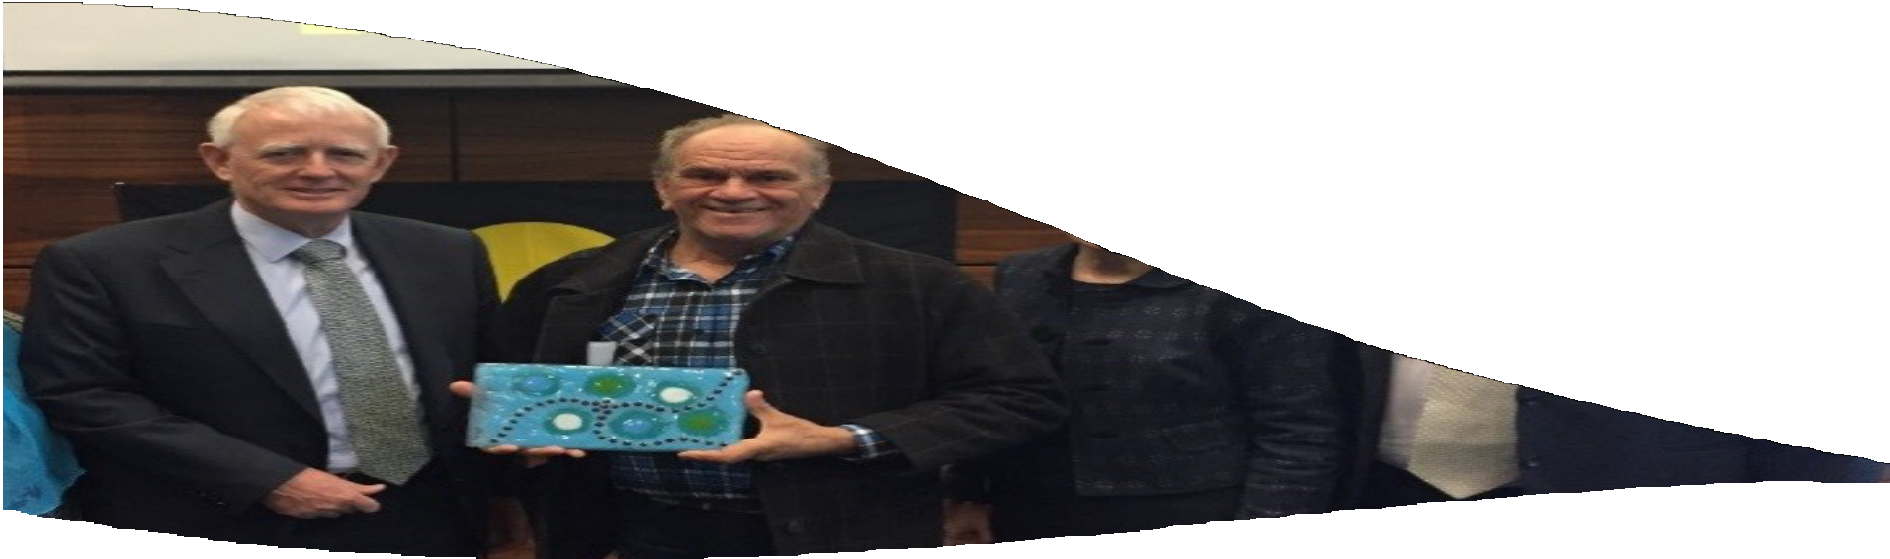

NAIDOC Celebrations
In 2016, the NAIDOC celebration saw the launch of an Acknowledgment of Country screen in the foyer of the
Optima Centre by local Elder Matthew Maguire.
The 2017 NAIDOC celebrations included renaming the Optima Centre’s ‘Town Hall’ meeting space.
Professor Len Collard translated and renamed the Town Hall to ‘meeting place near water’ or ‘Keirp Nyinalungup’, to represent the location and significance of the area surrounding the Optima Centre, located adjacent to Lake Monger.
Professor Collard also presented Finance and the Department of Training and Workforce Development with a beautiful glass artwork created at True Blue Australia by local Nyoongar Artist Neta Knapp. It shows the tracks of the people travelling to a meeting place surrounded by lakes and makes reference to the features of the land surrounding the Optima Centre. The morning teas at both events representing culture and flavours
were catered by Aboriginal businesses Grayz Catering and Kuditj Kitchen.

David Malcolm Justice Centre - Welcome to Country and Aboriginal Art Installation
The tower that forms part of the Cathedral Square Precinct was named the David Malcolm Justice Centre by the then Premier Colin Barnett. The opening of the building was planned and facilitated by Finance, in collaboration with the Department of Treasury, and included a moving Welcome to Country by respected Wadjuk Elder Mr Barry McGuire. Mr McGuire’s involvement in the opening of the tower was particularly moving in light of his earlier contribution to Cathedral Square’s projected Indigenous art installation, which carries a strong statement for reconciliation.

10

The Optus Stadium
The Optus Stadium is located on the Burswood Peninsula, in an area that was traditionally occupied by the Whadjuk people (sometimes written as ‘Wajuk’) prior to European settlement of Perth. The Stadium was designed and built by the private consortium Westadium, under a 28-year Design-Build-Finance-Maintain procurement model (a Public Private Partnership contract awarded by the State Government in 2014). The State requested bidders to include in their design various elements that acknowledge the Aboriginal cultural and historical significance of the site. The Stadium was completed in December 2017 and opened in early 2018.
Under the ‘Land.Mark.Art’ program developed by local cultrual organisation Form, several pieces of artwork created by local Aboriginal artists and construction teams have been installed in the parklands surrounding the Stadium.
Sharyn Egan’s ‘Maabiny Mia-Playhouse’ is located in the nature play area of the Stadium’s parklands, and is
designed to encourage children to climb on. Ms Egan is a Noongar painter, natural fibre weaver and sculptor.
The Stadium’s façade also includes the public art installation ‘Kaya’, a 17-verse poem created by the Miles Franklin Award winner Professor Kim Scott, in close collaboration with members of the Whadjuk Working Party. ‘Kaya’ means ‘Hello’ or ‘Yes’, and weaves 11 verses of Noongar prose with six verses of English text. The poem is etched into 68 pre-cast concrete panels that circle the podium level of the Stadium, welcoming all who enter.
Another significant piece was inspired by an Aboriginal message stick passed down through the generations. Barry McGuire is a Ballardong, Yued, Whadjuk, Pinjarreb Noongar and his sculptures, ‘Waanginy Boorna - Message Sticks’, can be found at each end of the Stadium’s boardwalk which runs along a lake fed by the Swan River.

11

OUR RAP CHAMPIONS
The Finance RAP Sponsor is the Executive Director Corporate Services.
The current chair of the RAP committee has responsibility for the Aboriginal Procurement Policy and Delivering Community Services in Partnership Policy, which have strong links to reconciliation.
There are currently representatives for each business unit on the RAP committee, which comprises a mix of
senior executive management and staff with a passion for embedding reconciliation within Finance.
Other committees within Finance have also been leveraged by members of the RAP committee and now act as channels to communicate and encourage reconciliation.
Our regional offices are also championing the use of Aboriginal businesses within their region and promoting
their successes.

12

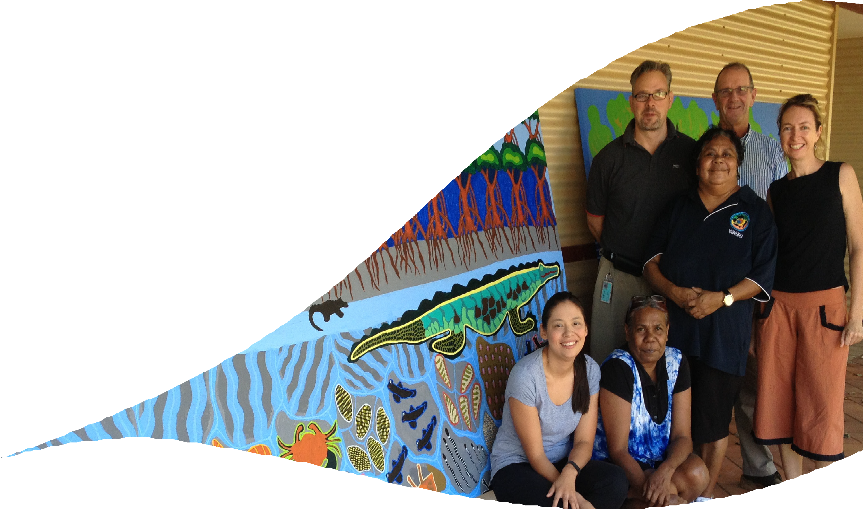OUR RECONCILIATION OPPORTUNITIES AND CHALLENGES
As a central agency, Finance has an opportunity to lead the way in sustainable and social procurement across government.
In addition, there is an opportunity and a need to increase the visibility of reconciliation within Finance, and embed reconciliation as part of ‘business as usual’, while tweaking our strategic directions to support it.
Because of the nature of our services, our primary clients are mainly other government agencies. As such, we have less opportunity to associate with Aboriginal communities and organisations at a service level. This creates a challenge in making sure Finance employees have the opportunity to connect.
Therefore, this RAP highlights the best avenue for employees to directly engage and build stronger relationships with Aboriginal communities and organisations through a variety of events, and increase knowledge and understanding of the importance of reconciliation.
The ongoing commitment is for Finance to focus on and build relationships and partnerships with key organisations and communities.
Another opportunity for Finance is to increase employment internally as this has been hindered by our ability to attract and retain Aboriginal employees. As at 30 June 2017, Aboriginal employees represent 0.4 per cent of our workforce.
Finance has developed a Workforce and Diversity plan to build a pathway for recruitment and provide a supportive structure for potential Aboriginal employees.

13

RECONCILIATION ACTIONS
Finance builds strong relationships and promotes teamwork allowing us to build mutually beneficial
relationships between Aboriginal and other Australians.

Relationships

Action | Deliverable | Timeline | Responsibility
Establish and maintain an  effective RAP Committee | The RAP Committee actively monitors RAP development and implementation of actions, tracking progress and reporting. | July 2018 | Project Officer
 | Establish Formal Terms of Reference for the Committee.
 | Meet at least three times per year to monitor and report on the RAP implementation. | July and October 2018,  January 2019
 | Ensure an Aboriginal staff member is  invited to participate in the RAP Committee. | July 2018
 | Each Finance Business Unit invited to nominate a representative to participate in the RAP Committee.
 | Establish a Budget for the RAP Committee.
Build internal and external relationships | Develop a listing of RAP organisations and other like-minded organisations whom Finance could approach to connect with on our reconciliation journey. | July 2018 | Project Officer
 | Develop a list of Aboriginal people, communities and organisations within our local area or sphere of influence that we could approach to connect with on our reconciliation journey. | December 2018
 | Provide a yearly presentation on RAP actions and progress, for delivery to the Tier 3 Group. | December 2018 | Executive Director Corporate Services

14

Action | Deliverable | Timeline | Responsibility
Participate in and celebrate National Reconciliation Week (NRW) | Encourage staff participation in NRW events (internally/externally), which are communicated via the intranet. | May-June 2018 | RAP Sponsor
 | Circulate and promote NRW events, resources and associated materials, to all staff through the intranet. | May 2018
 | RAP Committee representatives participate in an external event to recognise and celebrate NRW. | May 2018 | Project Officer
Build and maintain mutually beneficial relationships with Aboriginal communities and organisations to support positive outcomes | Develop a Departmental Strategy and/or Plan to raise awareness, support and promotion for existing business activities that contribute to Aboriginal economic development. | July 2018 | RAP Sponsor
 | Promote and publish Communication protocols with Aboriginal customers and stakeholders on the intranet.
Raise internal awareness of our RAP | Develop a Communication Strategy and/or Plan to raise awareness amongst staff about our RAP commitments. | July 2018 | Executive Director Corporate Services
Develop an Internal Stakeholder Strategy and/or Plan for staff engagement in our
RAP commitments.
 | Publish and communicate RAP commitments on the intranet.
 | Provide at least twice-yearly reporting to Corporate Executive on monitoring of RAP actions and progress.
 | Develop and implement a Stakeholder Strategy and/or Plan to engage and inform key internal stakeholders of their responsibilities within our RAP.

15

RECONCILIATION ACTIONS (continued)

Finance encourages staff to develop their awareness and understanding of Aboriginal cultures, lands and histories while fostering staff engagement in reconciliation. This creates a culture of fairness and respect, which aligns with Finance’s values of being ‘Honest and Respectful’ and ‘Passionate and Committed’.
Respect

Action | Deliverable | Timeline | Responsibility
Investigate Aboriginal cultural learning and development | Review Cultural Awareness Training needs across the organisation. | July 2018 | Executive Director Corporate Services
 | Implement Online Cultural Awareness Training across the organisation.
 | Information communicated to staff (via intranet) on Aboriginal cultural learning and development activities/ initiatives.
 | Establish a baseline of staff members’ level of knowledge and understanding of Aboriginal cultures, histories and achievements (to be ascertained through data capture).
Participate in and  celebrate NAIDOC Week | Information communicated to staff (via the intranet) on the meaning of NAIDOC Week including local Aboriginal communities. | July 2018 | Executive Director Corporate Services
 | Stage an internal event to promote and celebrate NAIDOC Week, to staff.
Promote local community events (via
intranet) during NAIDOC Week to staff.
 | RAP Committee representatives to participate in an external NAIDOC Week event. |  | Project Officer

16

Action | Deliverable | Timeline | Responsibility
Raise internal understanding of Aboriginal cultural protocols | Establish departmental protocols for application of Acknowledgement of Country and Welcome to Country. | July 2018 | Project Officer
 | Perform Acknowledgement of Country at RAP launch. |  | RAP Sponsor
 | Issue an invitation to a Traditional Owner of Lands and Waters to provide a Welcome to Country (as a minimum) at one significant event. | June 2018 | Project Officer
 | Develop and implement a plan to raise awareness and understanding of the meaning and significance behind Acknowledgement of Country and Welcome to Country protocols (including any local cultural protocols). |  | Executive Director Corporate Services
Celebrate and raise internal awareness of Aboriginal dates of significance | Stage an internal event (outside NAIDOC week) to celebrate and recognise at least one Aboriginal date of significance. | July 2018 | Executive Director Corporate Services

17

RECONCILIATION ACTIONS (continued)

Finance strives to actively pursue opportunities to improve the social, economic and health gap between Aboriginal and other Australians through the recruitment and retention of Aboriginal workers and inclusion of Aboriginal businesses in our procurement process, ensuring the sustainability of our communities.
Opportunities

Action | Deliverable | Timeline | Responsibility
Investigate Aboriginal employment | Scope and develop departmental employment and recruitment strategies for Aboriginal people. | July 2018 | Executive Director Corporate Services
 | Identify and inform Aboriginal staff of current and future employment and development opportunities.
Investigate Aboriginal supplier diversity | Promote Government Procurement Social Procurement Initiatives internally to increase awareness amongst business units and encourage procurement from Aboriginal businesses. | July 2018 | Executive Director Corporate Services
Develop and implement
(in conjunction with the Tier 3 group) a departmental procurement strategy to increase Aboriginal supplier diversity.

18

Governance and Tracking Progress

Action | Deliverable | Timeline | Responsibility
Build support for RAP | Develop and implement resource  requirements for RAP. | July 2018 | Chair RAP Committee
 | Define systems and capability requirements to track, measure and report on RAP activities. |  | Project Officer
 | Annual RAP Impact Measurement Questionnaire completed and submitted to Reconciliation Australia. | October 2018
Review and refresh RAP | Liaise with Reconciliation  Australia on development of a new RAP based on learnings, challenges and achievements. | July 2018 | Project Officer
 | Submit draft RAP to Reconciliation Australia. | October 2018
 | Submit draft RAP to Reconciliation Australia for formal endorsement. | January 2019

Contact details for public enquiries about our RAP:
Name: Kate Ingham
Position: Director Strategic Advisory Services and RAP Chairperson Phone: (08) 65511502
Email: kate.ingham@finance.wa.gov.au

Photo credits: All photos taken by Finance staff, with the exception of ‘Woven Playscape’ by
Gareth Andersen and Barbara Bynder’s three panels by Barbara Bynder.

19

20

