Registration of interest and expression of interest

Registration of interest
Registration of interest (ROI) is used:
- as an early identification strategy;
- when planning a new service or reviewing an existing service; or
- to seek contact information for service providers that might be interested in providing a service at a future time.
Once the ROI process has closed, the respondents can be contacted as necessary and in line with the purpose of the ROI process.
Conducting an ROI process will not result in any kind of evaluation or short-listing and is not a commitment or representation that a request will be issued at any time in the future.
The community services registration of interest template is available on the Finance website.
The ROI process is outlined in Figure 6:

Figure 6: Registration of interest (ROI)

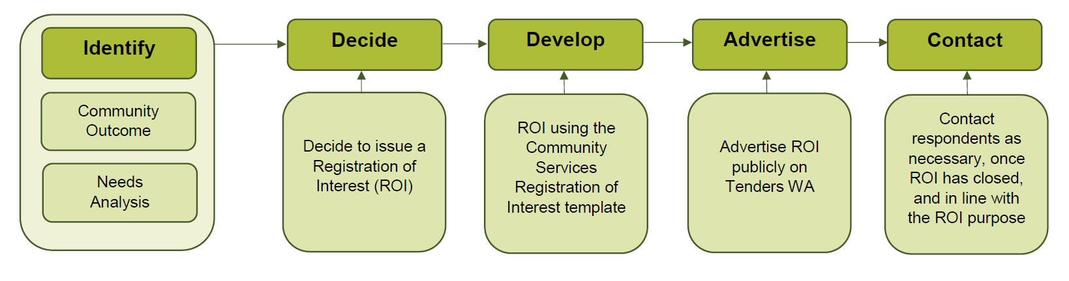

Expression of interest
An expression of interest (EOI) is a public process which you may use to establish preliminary interest, or shortlist potential service providers.
The EOI process is outlined in Figure 7:

Figure 7: Expression of interest (EOI)

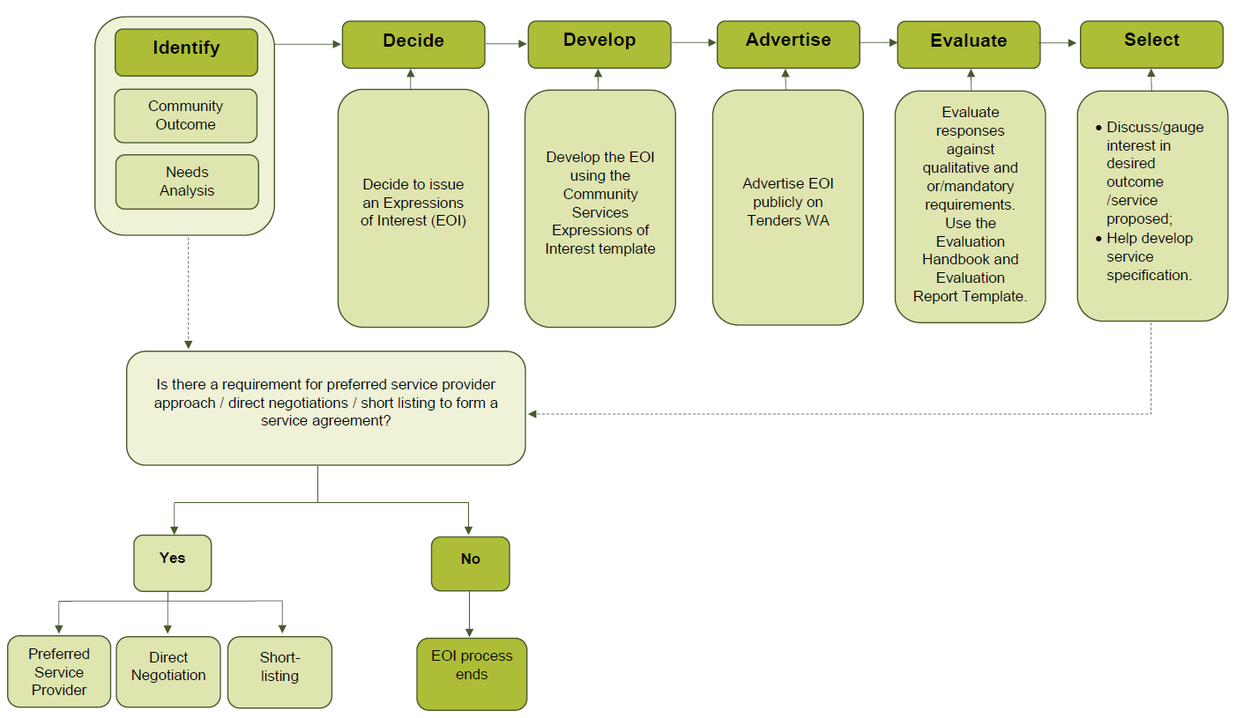

Guide notes (expression of interest):
- Use the community services EOI template available on the Finance website.
- Conducting an EOI process does not enable you to directly enter into a service agreement.
- Ensure that information and detail in the EOI is in line with the purpose and outcome required from the EOI process.
- EOIs must be publicly advertised on Tenders WA.
- Advertise EOIs for a period that will sufficiently enable potential service providers to submit a suitable response, and bear in mind the nature and complexity of the procurement.
- Evaluate responses against any mandatory requirements, qualitative criteria and disclosure requirements and record evaluation process and outcomes using the evaluation handbook and evaluation report template from the Finance website.

