Contract Number: CUAGAS2016
Last Updated: 28 Novemeber 2019

BOC Inhalo Medical Oxygen (400CD)
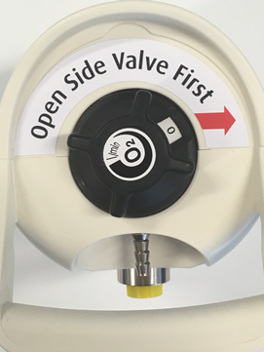
Integrated Valve Regulator
The Inhalo medical oxygen cylinder has been designed with an integrated valve to allow the cylinder pressure to be isolated from the regulator, as a result of this functionality, prior to use, customers are required to open the side valve first. The cylinders have been labelled, as shown, with a reminder for customers to open the side valve prior to use.
It is recommended that customers check that there is a flow of oxygen from the outlet prior to application on a patient, and to monitor a patient’s response to treatment.
Customers may benefit from familiarising themselves with the equipment prior to use. Instructions on how to operate the cylinder can be found here.
Figure 1: Labelling 400CD Inhalo Medical Oxygen Cylinder

Safety Notice Integrated Pressure Regulator/Flowmeter functionality
The manufacturer of the 400CD Inhalo product has issued a field safety notice for this medical device. The GCE device is supplied to BOC under the branding of Combilite part number 0710334 and in rare circumstances may have a broken pointer, as shown below, resulting in inaccurate readings of actual cylinder pressure.
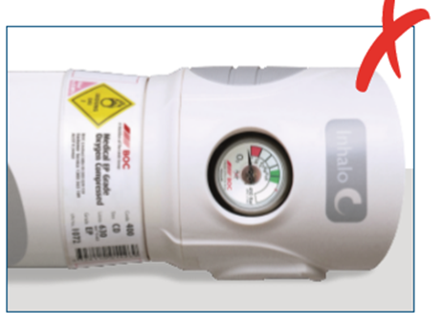
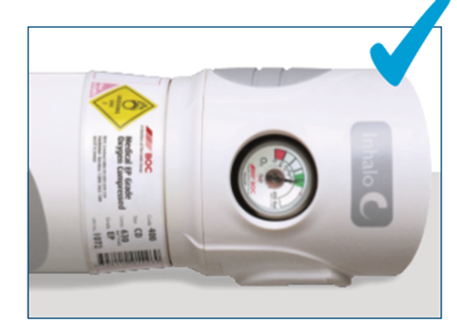
BOC has implemented additional product testing prior to release from their sites, however there is a remote possibility that a pressure gauge pointer may fail during transit/handling. To confirm the product is not faulty customers are asked to conduct a check prior to use. Instructions on how to conduct a check can be found here.
Figure 2 400CD Inhalo Medical Oxygen correct pressure gauge reading
Figure 3 400CD Inhalo Medical Oxygen incorrect pressure gauge reading

