CUA REM2017: Staff Relocations Service Zones
Services under the staff relocations category are provided to four (4) mainland geographical areas across the state and one (1) off-shore area - Christmas and Cocos Islands. These areas, known as Zones 1, 2, 3, 4, 5 and 6, are shown on the Maps below and are defined as follows:
Zone 1 | That area defined by the Buy Local Policy published by the State supply Commission of Western Australia. This is called the Perth Region and is delineated as shown on first Map below. This area is the To/From Perth reference area.
Zone 2 | That area defined by a line drawn West from PERTH CENTRAL to the COAST, then North following the COASTLINE to a point on the COAST determined by Latitude 20 deg 18 min South, and Longitude 118 deg 32 min East, then a line drawn back to PERTH CENTRAL.
Zone 3 | That area defined by a line drawn from PERTH CENTRAL to a point on the COAST determined by Latitude 20 deg 18 min South and Longitude 118 deg 32 min East, then North following the COASTLINE to a point on the COAST at 129 deg East Longitude, then South to a point determined by Latitude 19 deg South and Longitude 129 deg East, then a line drawn back to PERTH CENTRAL
Zone 4 | That area defined by a line drawn from PERTH CENTRAL to a point determined by Latitude 19 deg South, and Longitude 129 deg East, then South to a point on the COAST at 129 deg Longitude East, then following the COASTLINE West to a point on the COASTLINE determined by Latitude 33 deg 54 min South and Longitude 121 deg 39 min East, then a line drawn back to PERTH CENTRAL.
Zone 5 | That area defined by a line drawn from PERTH CENTRAL to a point on the COASTLINE determined by Latitude 33 deg 54 min South and Longitude 121 deg 39 min East, then following the COASTLINE West to a point on the COASTLINE due West of PERTH CENTRAL, then back to PERTH CENTRAL.
Zone 6 | Christmas and Cocos Islands.  Please note that suppliers would need to have arrangements in place with Zentnor Shipping in order to facilitate moves to and from Cocos and Christmas Islands in Zone 6.

Perth Metropolitan Region
Perth Region Boundary – to be used as the mandatory area for Category A – Office Relocation Services and Zone 1 Staff Relocations – Perth Metro Region.
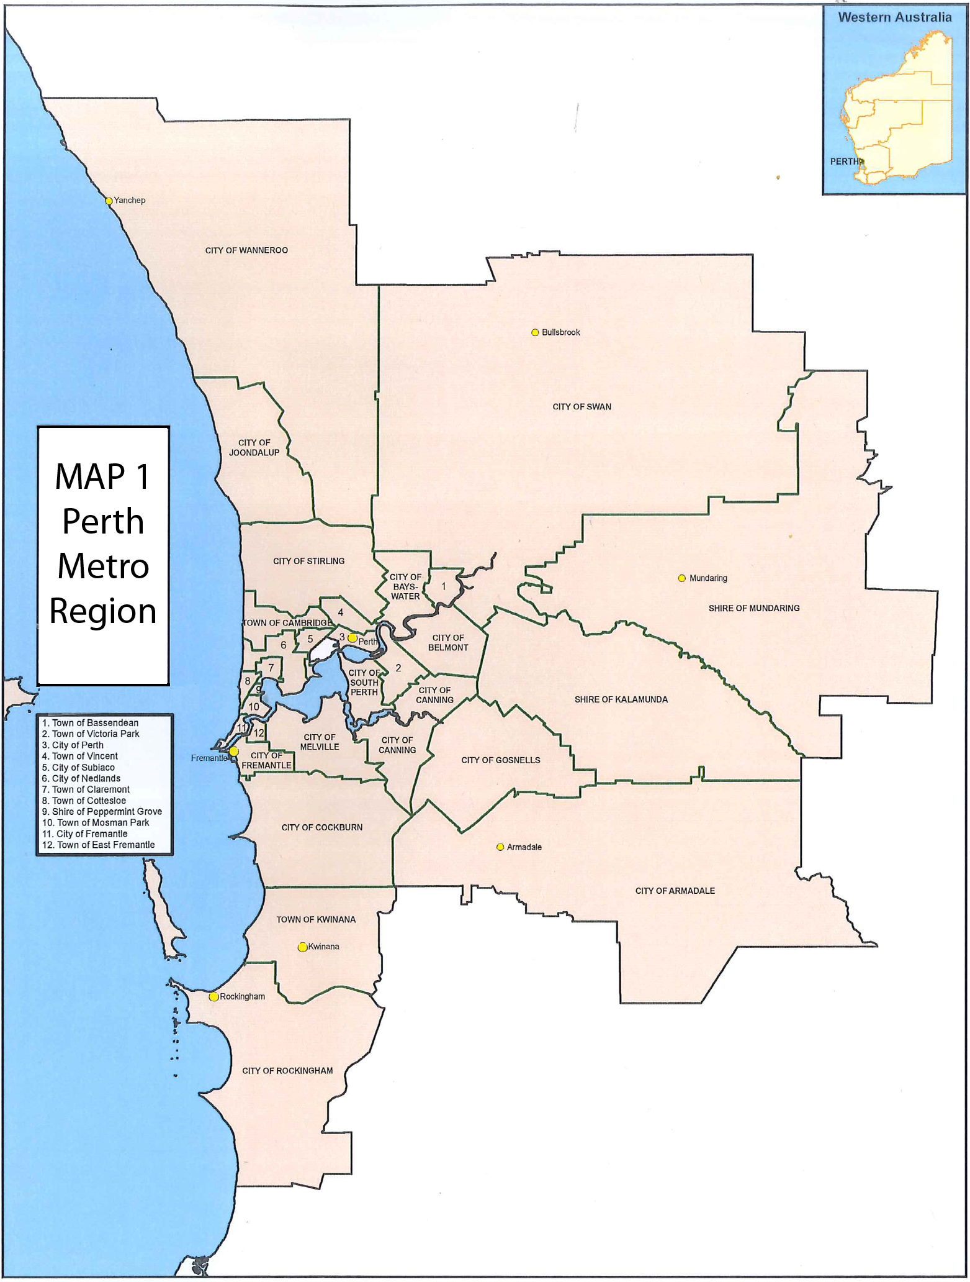

Staff Relocations: Contract Service Zones 2 - 5
Map 2 – Staff Relocations Service Zones 2-5
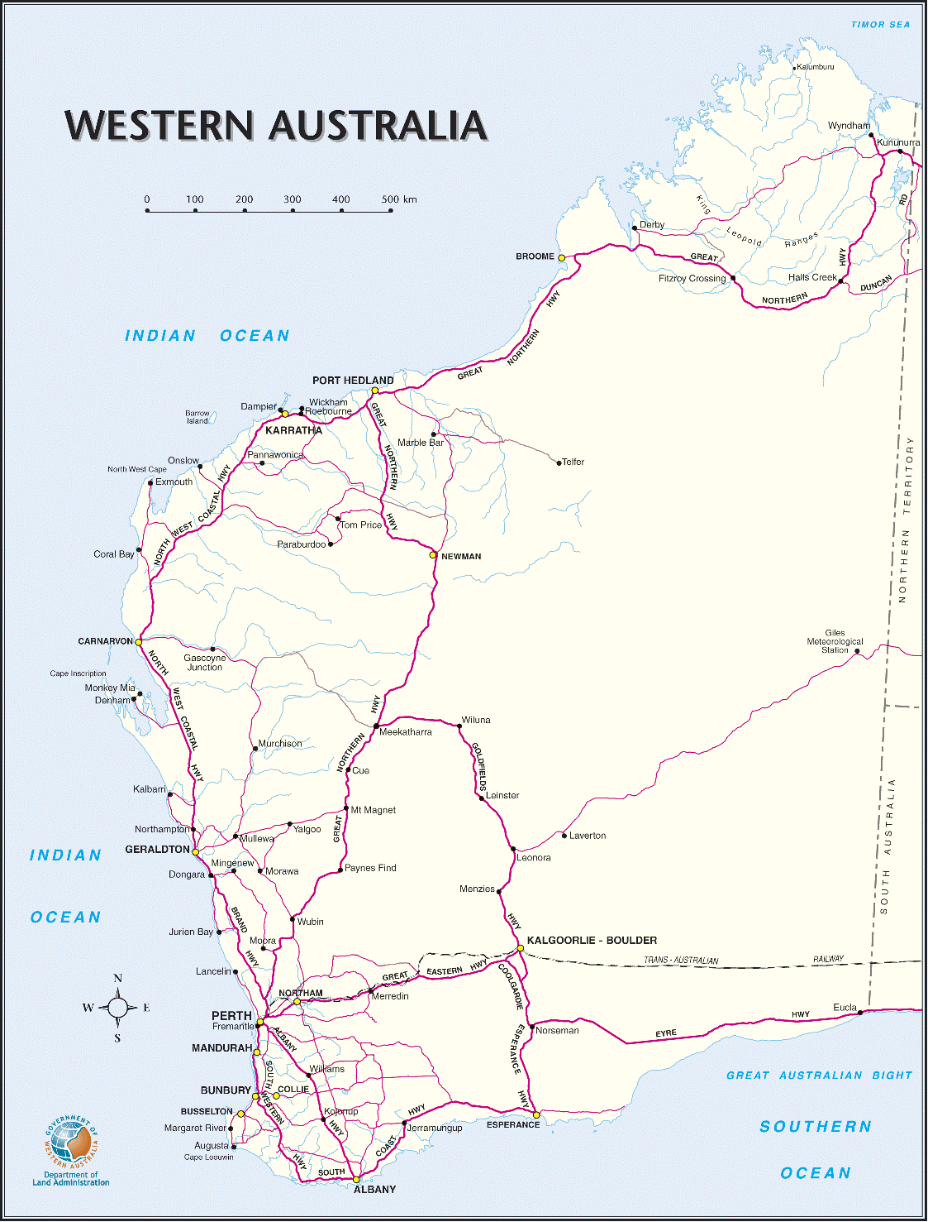
Zone 5
Zone 4
Zone 3
Zone 2

Staff Relocations: Contract Service Zone 6
