Elders Purchasing Card Payments
All Elders’ EFTPOS terminals Australia-wide automatically apply a 1% surcharge when processing credit card payments. As Elders have agreed to NOT apply surcharges for Government Purchasing Card payments, the following arrangement applies.
In order to offset the 1% surcharge, Elders branches should discount the total Tax Invoice by 1% when entering the sale through the EFTPOS terminal.
The process is as follows:
- Calculate the sale value under the Contract, as per the Tax Invoice (Example 1: $1173.35);
- Discount this amount by the Elders’ credit card surcharge (Example 1, a discount of 1% or $11.62).
- Enter the discounted amount (Example 1 $1161.73) into the EFTPOS terminal when processing the Government Purchasing Card payment.
The EFTPOS terminal will then add the Elders credit card surcharge back into the total charged to the card. The net result is that the total price charged through the EFTPOS terminal is correct as per the Customer’s Tax Invoice.
In Example 1, the Tax Invoice is for $1173.35 and the Total AUD charge on the EFTPOS receipt is $1173.35. The surcharge noted on the EFTPOS receipt is negated.
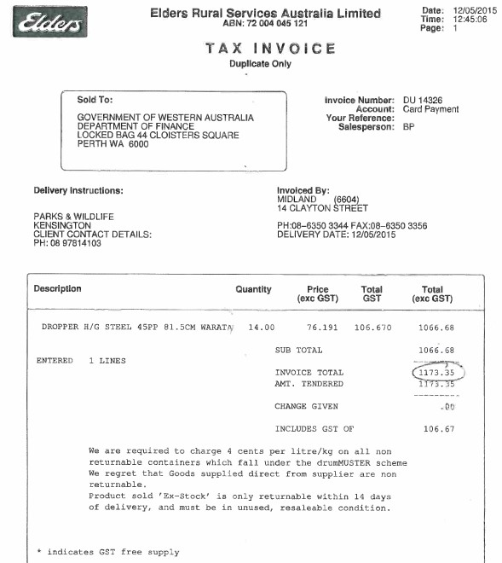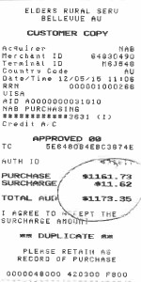
EXAMPLE 1: ELDERS’ TAX INVOICE AND EFTPOS RECEIPT

Invoice Total of
$1173.35 matches
EFTPOS Receipt
total of $1173.35,
despite the
EFTPOS ter
minal
applying the
automatic credit
card surcharge.

