Bin sizes
The below provides a snap-shot of the bins provided under the CUA. A full range of bin sizes is listed in the Price Schedule.
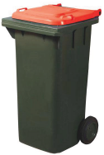  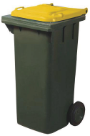  120L and 240L Mobile Garbage Bins | 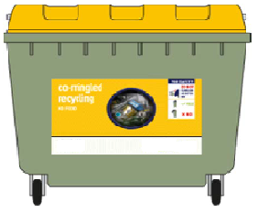660L / 1100L Mobile Garbage Bins
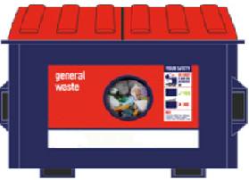Front Lift Bin (various sizes) in cubic metres | 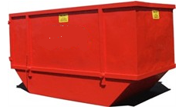  Bulk Bins (various sizes) in cubic metres
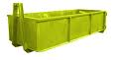  12.5m³ to 30m³ Bulk Bins | 23m³ to 32m³ Compactor Bins
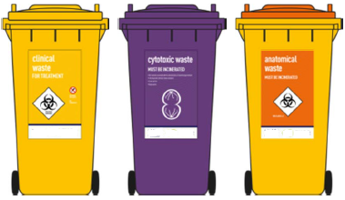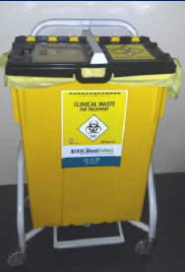  Medical Bins (various sizes) | 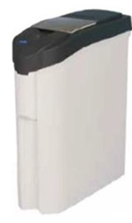  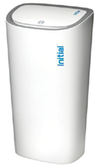  18 to 50 litre Sanitary Bins

Bin descriptions

General waste
Non-recyclable waste sent to landfill.
Mobile Garbage Bins, Front Lift, Bulk Bins and Compactors.


Comingled recycling
Plastics, paper, aluminium, steel, cardboard and glass.
Mobile Garbage Bins, Front Lift, Bulk Bins and Compactors.


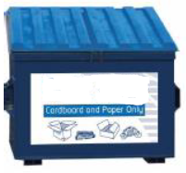
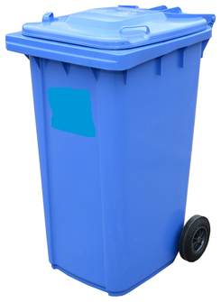Paper and cardboard recycling
Mixed Paper or mixed paper and cardboard
Mobile Garbage Bins, Front lift and Bulk Bins

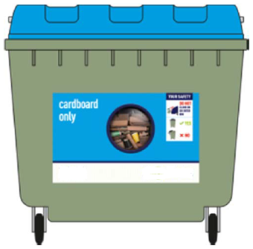
Cardboard recycling
Mixed cardboard.
Mobile Garbage Bins, Front Lift, Bulk Bins and Compactors.

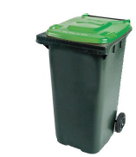
Green waste recycling
Grass, twigs, leaves, branches, flowers.
Clean green waste processed by the Contractor into compost and mulch.
Mobile Garbage Bins, Front Lift, Bulk Bins and Compactors.


Food organic waste recycling
Fruit, vegetables, fish, meat, food without any packaging (unless packaging is compostable)
Clean organic waste processed by the Contractor into compost and mulch.
Mobile Garbage Bins and Front Lift Bins


Medical/clinical waste
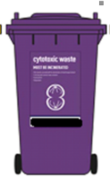
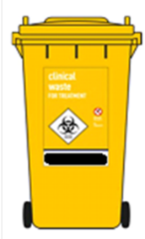
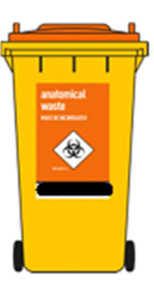
Clinical, pharmaceutical, anatomical and cytotoxic waste and operating plastics.
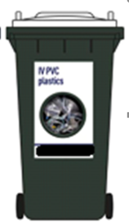
Small and Mobile Garbage Bins

Clinical Anatomical Cytotoxic Operating Plastics

Building and construction
Mixed inert building and construction waste sent to a recycling facility or landfill.
Bulk Bins

Scrap metal recycling
Mixed metals sent to various recyclers.
Bulk Bins

Timber recycling
Mixed timber sent for recycling, chipping or shredding
Bulk Bins



Batteries recycling
Mixed batteries including car batteries sent to a recycler.
Boxes, Pales, Buckets, Drums


Fluorescent tubes and bulbs recycling
Fluoro lights crushed and separated into components for recycling.
Box


Glass recycling
Glass crushed into roadbase or sent for recycling.
Mobile Garbage Bins

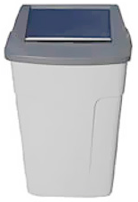Sanitary Waste
Sanitary and nappy waste, bins serviced and sanitised and waste disposed to landfill.
Include pictures.

ICT Equipment Disposal (E-Waste)
Computers, printers, tablets, monitors, keyboard, mice, phones, routers, cds, dvds, usbs, hard-drives, webcams, televisions, radios, cd players, hi-fis , projectors, electronic whiteboards, digital screens, multifunctional devices, photocopiers toners, scanners, fax machines and ICT batteries etc.
Bulk Bins, Truck Collection or self-drive option.


