Digital Services Policy Framework

Website Visual Design and Functional Standard

# Last updated: September 2019

# Document Control

**Website Visual Design and Functional Standard:** Version 1.1 – September 2019

**Produced and published by**: Office of Digital Government

**Acknowledgements:**

**Contact:**

Office of Digital Government  
2 Havelock Street  
WEST PERTH WA 6005

Telephone: 61 8 6552 5000

Email: [dgov-strategy@dpc.wa.gov.au](mailto:dgov-strategy@dpc.wa.gov.au)

**Document version history**

| **Date** | **Author** | **Version** | **Revision Notes** |
| --- | --- | --- | --- |
| March 2018 | Office of the GCIO | 1.0 | First Release |
| September 2019 | Office of Digital Government | 1.1 | Rebranded to Office of Digital Government |

[null](https://creativecommons.org/licenses/by/4.0/deed.us)

This document, the **Website Visual Design and Functional Standard, Version 1.1** is licensed under a **Creative Commons Attribution 4.0 International Licence**. You are free to re-use the work under that licence, on the condition that you attribute the Government of Western Australia (Office of Digital Government) as author, indicate if changes were made, and comply with the other licence terms. The licence does not apply to any branding or images.

**License URL:** <https://creativecommons.org/licenses/by/4.0/legalcode>

**Attribution:** © Government of Western Australia ([Office of Digital Government](https://wa.gov.au/organisation/office-of-digital-government)) 2018 to 2019

**Notice Identifying Other Material and/or Rights in this Publication:**

The Creative Commons licence does not apply to the Government of Western Australia Coat of Arms. Permission to reuse the Coat of Arms can be obtained from the [Department of the Premier and Cabinet](https://www.wa.gov.au/organisation/department-of-the-premier-and-cabinet/common-badging-use-of-the-state-coat-of-arms-and-the-wa-state-government-badge).

# Standards Statement

The Website Visual Design and Functional Standard (this document), together with the [WA Government Website Style Standard](https://www.wa.gov.au/government/publications/website-style-standard), describes the approved one government website user experience (UX) design, and is a mandatory component of the Digital Services Policy Framework.

The Website Visual Design and Functional Standard, together with the [WA Government Website Style Standard](https://www.wa.gov.au/government/publications/website-style-standard), replace the Common Website Element standards and will assist agencies to align to the one government website UX design.

# Scope

The Website Visual Design and Functional Standard is mandatory for all WA public sector agency websites under the Digital Services Policy. Agencies will be required to apply the standard to:

* all new public facing website projects;
* all significant redevelopment work including rebranding, restructure or major enhancements to websites; and
* all website projects involving transition to a new platform or new content management system.

This is to enable agencies to accommodate compliance with this standard within the normal planning or update cycle for their websites and web infrastructure.

Agencies seeking [exemption](http://www.wa.gov.au/government/publications/website-project-governance-process) from complying with this standard will require approval from the Directors General (DG) Information and Communications Technology (ICT) Council.

The Website Visual Design and Functional Standard is recommended but optional for Government advertising campaign and Government Trading Enterprise (GTE) websites.

# Objectives

* Assist agencies align to the one government user experience design.
* Ensure WA government websites look and operate consistently in order to improve usability and learnability, and enable a better user experience for users of WA Government websites.
* Simplify the user experience and make government digital services easier to use.

# Additional Requirements

All agencies should apply the [Western Australian Digital Service Design Principles](http://www.wa.gov.au/government/publications/digital-service-design-principles) when planning or updating websites to ensure services meet the needs of the community.

# Website Visual Design and Functional Standard

The Website Visual Design and Functional Standard establishes mandatory visual and functional requirements that must be adopted and fully complied with on all WA Government agency websites that fall within the scope.

This standard applies to the following main website elements:

1. Header
2. Navigation
3. Main Content Area
4. Footer

All WA Government agency websites that fall within the scope of this standard must comply with the details for each of the above elements.

## **Header**

The header banner contains the following mandatory elements:

1. Skip to main content
2. State Government Badge
3. Header links
   1. Link to Accessibility statement
   2. Link to Contact us
   3. Login (mandatory if applicable)
4. Search
5. WA Government search

The design of the header should be responsive, and adjust when displayed on a smaller mobile device.



Figure 1: Example of Header banner

### Skip to main content

The ‘Skip to main content’ link allows screen readers and keyboard users to go directly to the start of the main content on the page, bypassing all the other navigation elements.

The ‘Skip to main content’ link:

* must be the first interactive element on the webpage;
* does not have to be visible when it does not have focus;
* must be visible on focus;
* must have the link text ‘Skip to main content’;
* must take the user to the start of the main content on the current page;
* on hover has an ochre background colour; and
* on focus has an ochre background colour and dotted outline;



Figure 2: Skip to main content - focus state

### State Government Badge

The State Government Badge must:

* be displayed at the top left hand corner of the webpage;
* link to the homepage of your website;
* have an alternative text or alt tag message, for example: ‘Go to the <website / agency> website’; and
* on focus have an ochre dotted outline.

C:\67ceb747aa48770108a65b8fbfbeb5ca**

Figure 3: State Government Badge Figure 4: Example of State Government badge - focus state

Website name and approved co-badging logo (if applicable) are displayed next to the State Government Badge.  Font and text placement specifications are specified in the [Common Badging](https://www.wa.gov.au/organisation/department-of-the-premier-and-cabinet/common-badging-use-of-the-state-coat-of-arms-and-the-wa-state-government-badge) website under Co-badging.

Information on State Government Badge requirements are available on the [*WA State Government Badge Style Guide*](https://www.wa.gov.au/organisation/department-of-the-premier-and-cabinet/common-badging-use-of-the-state-coat-of-arms-and-the-wa-state-government-badge).  All State Government Badge queries should be referred to the Common Badging Committee, contact details listed on [Common Badging](https://www.wa.gov.au/organisation/department-of-the-premier-and-cabinet/common-badging-use-of-the-state-coat-of-arms-and-the-wa-state-government-badge) website.

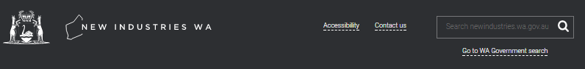

Figure 5: Example of State Government Badge and co-badging header

### Header links

All links located in the Header must:

* display in white with a dotted underline;
* on hover, have the dotted underline become a full underline;
* on focus, display an additional ochre dotted outline; and
* use the fonts, colours and styles specified in the WA Government Website Style Guide (link once published).

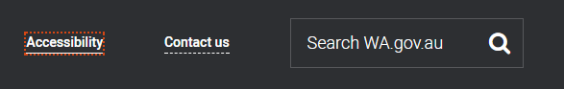

Figure 6: Header link - focus state

### Accessibility statement

The ‘Accessibility’ link is the first element in the top utility navigation.  It is located on the right hand side of the header banner, and takes the user to the 'Accessibility' content page.

The accessibility statement must be located on the ‘Accessibility’ content page, and provides information on how to enable the services’ accessibility features for users using assistive technology or who have different needs.  It should be written in clear and simple language.

The accessibility statement should include the following points:

* information on how users can customise their experience if they are using assistive technologies or have difficulties using the website;
  + for example, through installing assistive technologies or providing links to free third party reader and viewer software, using browser or operating system accessibility features, or accessibility tools on the website itself.
* any known accessibility issues or limitations and plans and timeframes to make improvements;
* technology or techniques employed that may assist users with assistive technology;
  + it’s important to not use jargon words or technical terms when describing these techniques.
* multiple ways to contact the agency to get help, if applicable (see WA.gov.au accessibility statement example);
* the agency’s commitment to accessibility, the website’s accessibility level, any legislation and standards the service is governed under;
* that the accessibility levels of external websites linked to from this website are not the responsibility of this agency; and
* date of when the accessibility statement was last updated.

Examples of accessibility statements:

* [WA.gov.au accessibility statement](https://www.wa.gov.au/accessibility)
* [Department of Communities Disability Services accessibility statement](http://www.disability.wa.gov.au/footer/website-accessibility/)
* [GOV.UK accessibility statement](http://www.gov.uk/help/accessibility)

### Contact us

The ‘Contact us’ link is the second element in the top utility navigation.  It is located on the right hand side of the header banner, and takes the user to the ‘Contact us’ content page.

The ‘Contact us’ page provides users with options for contacting the agency.  It should allow for different communication options, such as:

* feedback – for enquiries or to provide feedback about the website, compliments about the website, content on the website and information or services provided by the agency
* complaint – to capture complain about the website, content on the website and information or services provided by the agency

If you are providing these communication options using an online form, the form must be designed to be accessible.  WebAIM has suggestions on how to [create accessible forms](https://webaim.org/techniques/forms/).

If a response is required, the form must capture the user’s name, and their preferred method of contact (e.g. phone, email, mail).  When capturing user details, provide full disclosure of matters relating to the privacy and security of the submitted information.

The ‘Contact us’ page should also provide different contact methods for the agency responsible for the website.  It is recommended agencies provide as many contact options as possible or applicable, for example:

* building address
* mailing address
* contact numbers (e.g. telephone, fax)
* email address**\***[1] or a feedback or contact us form
* [National Relay Service](https://www.communications.gov.au/what-we-do/phone/services-people-disability/accesshub/national-relay-service) - a phone solution for people who are deaf or have a hearing or speech impairment
* interpreter services, and/or
* contact details for Media Liaison Officer.

### Login feature (mandatory if applicable)

If you offer a login feature, the login link is placed after the Contact us link in the top utility navigation.

### Search

The search box is located at the top right hand corner in the header banner.  It should default to searching the current website.

To increase usability, it is recommended that the text ‘search this website’ is displayed in the search box.  This search function allows users to perform a search from anywhere on the website.

On hover, the search button is ochre.

On focus, the search button also has an ochre dotted outline.



Figure 7: Search button - focus state

Where possible, the search results should display the following information:

* Title (links to the content page);
* Description;
* File format (to be provided if content is not in HTML format); and
* File size (to be provided if content is not in HTML format).

The search results page should be titled ‘Search results’ to assist those with visual impairments using assistive technology identify the page where their search results are listed.

### WA Government search

A link to the whole-of-WA Government search page sits beneath the search box.

The link should be displayed as text ‘Go to WA Government search’.  The link will go to <http://wa.gov.au/search>, and should open in the same browser window.

**

Figure 8: Example search box and link to whole of WA Government search

### Responsive design - header on a mobile device

When the browser screen size or orientation is changed, for example on mobile devices such as tablets and smartphones, the design should be responsive in adjusting to suit the screen.

When using responsive design, several website elements should change their appearance to remain clearly visible and provide a consistent, usable experience:

* The State Government Badge is centred;
* The Accessibility, Contact us and Login links are stored under a hamburger menu icon ( ) located at the top left hand corner; and
* The Search box becomes a magnifying glass icon ( ) which takes the user to a full search page. The search page should have the options to search the current website and a link to the whole-of-WA Government search.

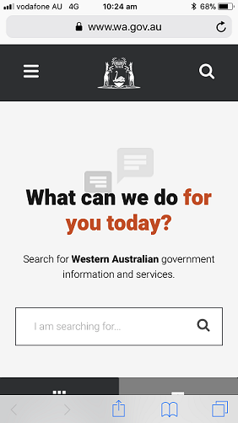

Figure 9: Header on a mobile device

## **Navigation**

All WA Government websites must have the following navigation components:

1. Global navigation
2. Utility navigation
3. Breadcrumbs

The design of the navigation should be responsive, and adjust when displayed mobile devices.

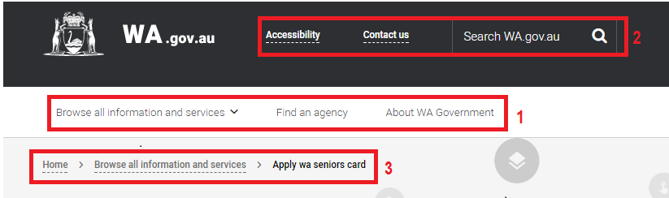

Figure 10: Example navigation: 1. Global navigation; 2. Utility navigation; 3. Breadcrumb navigation.

### Global navigation

The global navigation must be placed at the top of the page beneath the header banner.

The global navigation describes the website's top level navigation.  It must be visible and operate the same way on every page.  It should be structured based on user needs rather than the agency structure.

There is no need to include a 'Home' option in the global navigation, as the logo in the header and breadcrumb navigation provide sufficient options to get back to the homepage.

Use sentence case to display the navigation text.

On hover, the global navigation option displays an ochre top border.

On focus, the global navigation option also has an ochre dotted outline.



Figure 11: Global navigation option - focus state

### Drop-down menus

If a global navigation menu option has a drop-down menu it should have a downwards chevron (**v**) next to the option text to indicate this. For example, 'Browse all information and services **v**'.

The drop-down menu should display upon hovering on this option text of the global navigation menu or when it is reached in the tab-order of the page. Clicking on a global navigation menu option that has a drop-down menu will take you to the high-level page for that global navigation menu option.

* When tabbing through the page, once the drop-down menu is expanded the tab order should tab though all options in the drop-down menu;
* An ochre dotted outline should clearly identify which menu item is currently in focus in the tab order;
* The Esc key should close the menu; and
* Once all drop down menu options have been tabbed through, the drop down menu should close and the tab order can proceed to the next global navigation menu option on the right.

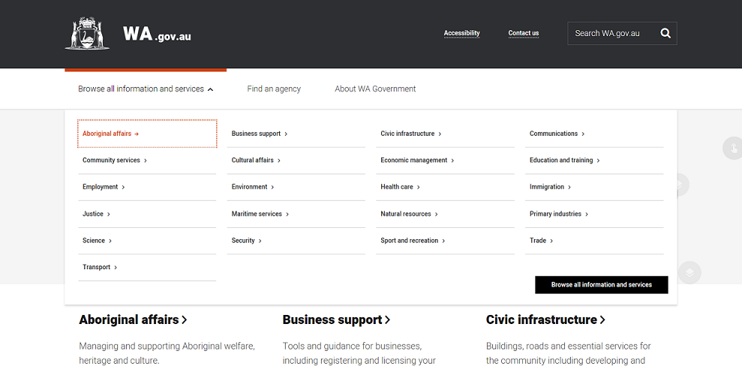

Figure 12: Drop-down menu option - focus state

### Utility navigation

Utility navigation contains secondary actions and tools such as print, share and subscribe. Outside of those elements already referenced in the header links, utility navigation is not mandatory. Social media, print and email this link are optional sharing and functional utility tools.  If these elements are included they are to be placed in the fat footer area.

### Breadcrumbs

The breadcrumb navigation shows the user’s current location in the website, helping them to understand where they are in relation to the rest of the website.  It allows the user to travel back up the hierarchy to any level without having to hit all the intermediate points.

The breadcrumb navigation is placed below the global navigation and must:

* progress from the highest to the lowest level from left to right;
  + that is, start with the homepage and end with the user’s current location within the website
* have active links for each of the levels shown, except for the lowest level (current page);
* on hover, the grey dotted underline on the active links becomes a full underline;
* on focus, the link displays an additional ochre dotted outline; and
* use the ‘**>**’ symbol as a separator between each link.

C:\b8cdc22478728f6addc7bd5e8e85fc7e

Figure 13: Breadcrumb - focus state

### Responsive design - global and utility navigation on a mobile device

When the browser screen size is reduced, for example, on mobile devices such as tablets and smartphones, the design should be responsive and adjust to suit the smaller screen.

The global navigation and all of the utility navigation menu options, with the exception of search, are stored in the left-hand hamburger menu. The search icon on the right-hand side of the header takes you to a full search page.

Global navigation menu options with a drop down are displayed with a rightwards chevron (>) that expand upon click. When viewing the drop down menu options a '< Return to previous menu' option is displayed at the top. The responsive mobile menu caters for three levels of menu:

1. Global navigation (e.g. Browse all information and services)
2. Global navigation drop-down level 1 (e.g. Aboriginal affairs)
3. Global navigation drop-down level 2 e.g. (Aboriginal cultural heritage)

 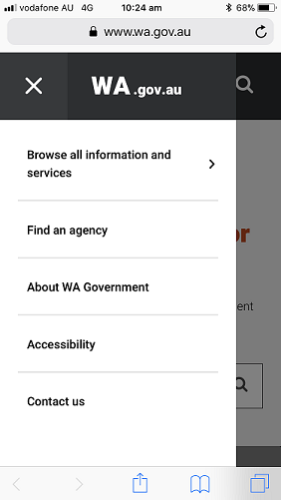

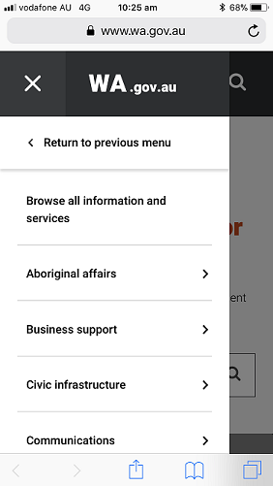 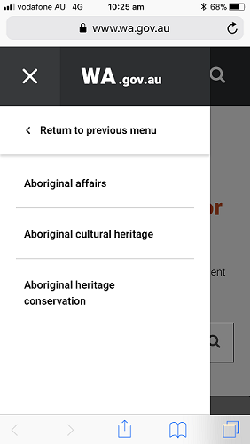

Figure 14: Header and global/utility navigation on a mobile device

There is no change to the styling or behaviour of the breadcrumb menu on a mobile device.

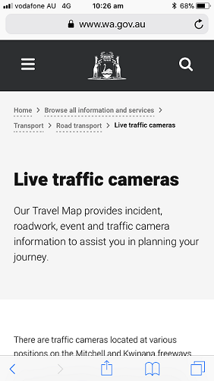

Figure 15: Breadcrumb on a mobile device

## **Content area**

The content area has five (5) sections.  Not all sections are required.

1. Heading and short description (mandatory)
2. Main content (mandatory), Page reviewed (mandatory), Call to action (optional)
3. Related services and information (optional)
4. Content feedback (recommended)
5. Additional related content (optional)

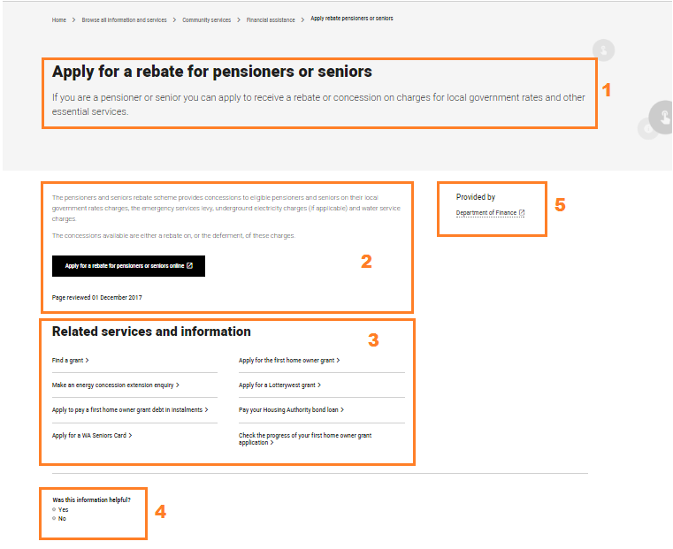

Figure 16: Example content area sections - 1: Heading and short description; 2: Main content, page reviewed date; 3: Related services and information; 4: Feedback box; 5: Additional related information.

### Heading and short description (mandatory)

Each content page must contain a heading and short description.

### Main content (mandatory)

Content should be designed to meet the user's needs.  Design content to lead the user to the information they need.

### Page layout

The content area can be displayed as two columns in a two thirds / one third layout or as a full width layout.



Figure 17: Example two thirds / one third page layout

### Links

Links in the main content and additional related content must:

* display in a heavier font weight with a dotted underline;
* on hover, the link is coloured ochre with a full underline; and
* on focus, the link also has an ochre dotted outline.

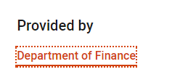

Figure 18: Example of a hyperlink in the main content -  focus state

### Page reviewed (mandatory)

Each content page must have a 'Page reviewed' date is displayed at the end of the content section.  The date must be formatted as day month year (eg. Page last reviewed 9 September 2017).

### Call to action (optional)

Ochre call to action panels can be used to highlight links to related content.

On hover, the call to action panel colour is dark grey. On focus, the call to action panel has an additional ochre dotted outline.



Figure 19: Call to action panel - normal state

**

Figure 20: Call to action panel - focus state

### Related services and information (optional)

This section displays links to other information and services relevant to the content.

Content can be tagged using extendable tagging and metadata, as relating to a particular topic, life event or type of user.  Using a consistent metadata schema for services and information will make it easier to find and present appropriate services and information in multiple places without duplicating content. Metadata schema standards will be documented. We are still working on the metadata standard and will provide a link as soon as it becomes available.

Links in the related services and information area display as:

* black with a rightwards facing chevron (**>**);
* on hover, the link is ochre and the chevron becomes a right-hand arrow; and
* on focus, the link also has an ochre dotted outline.

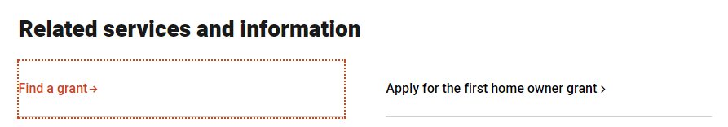

Figure 21: Related links - focus state

### Content feedback (recommended)

This section gives the user the opportunity to provide feedback on the content presented on the page.  This is useful to:

* measure and enhance customer satisfaction - determines if the service or information meets user needs and expectations;
* improve content of your information and services - captures missing information that users are looking for or improves how information is written and presented; and
* gather user input to add new or improve existing information and services - captures what users are looking for in a service or what users are searching for.

The feedback form should be placed below the content area, above the fat footer.

The feedback form should be simple and easy for the user to complete.

### Additional related content (optional)

Additional related content can be provided on the right column.  Content in the right column should communicate quick useful information that is relevant and helpful, for example contact details, opening hours, map or directions.

## **Footer**

The footer appears at the bottom of every page.

* Fat footer
* Standard footer
* Additional footer elements (optional)

The design of the footer should be responsive, and adjust when displayed on mobile devices.

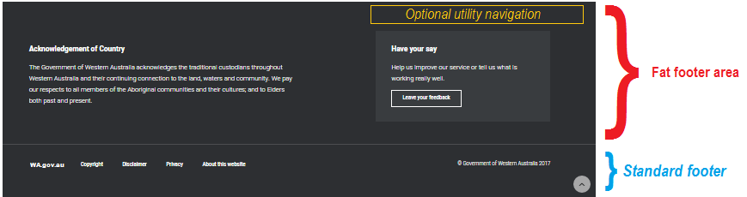

*Figure 22: Example of a footer*

### Fat footer

The fat footer is placed at the end of the content area.

If sharing and functional utility navigation is used, such as sharing via social media, emailing or printing content, these elements are to be placed at the top right of the fat footer area. For social media and other icons, the [IcoMoon icon libraries](https://icomoon.io/) are recommended.

The bottom right of the fat footer can be used for simple forms, such as a feedback form or subscribing for updates via email.

### Acknowledgement of Country

Every agency website must display an Acknowledgement of Country statement. The example statement for use on Western Australian public sector websites provided below was provided by the Aboriginal Affairs section from the Department of Planning, Lands and Heritage.

|  |
| --- |
| **The Government of Western Australia acknowledges the traditional custodians throughout Western Australia and their continuing connection to the land, waters and community.  We pay our respects to all members of the Aboriginal communities and their cultures; and to Elders both past and present.** |

### Standard footer

The standard footer appears at the bottom of every page after the fat footer.

The standard footer must provide the following mandatory elements in the order provided below from left to right:

* Link to whole of WA Government website. (i.e.: [WA.gov.au](http://wa.gov.au/) website);
* Copyright;
* Disclaimer;
* Privacy;
* About this website; and
* Back to top link.

Footer links display:

* in white with a dotted underline;
* on hover, the dotted underline becomes a full underline; and
* on focus, the footer links should display an additional ochre dotted outline.

C:\a5fabf97a5f090fd0cb9a5824b1f21ae

Figure 23: Footer links - focus state

### WA Government website ([WA.gov.au](http://wa.gov.au/))

The link to the WA Government website ([WA.gov.au](http://wa.gov.au/)) must:

* be the first element of the footer banner;
* be displayed as text – [WA.gov.au](http://wa.gov.au/);
* be left aligned and link to [www.wa.gov.au](http://www.wa.gov.au/);
* have the alt text – ‘Go to the [WA.gov.au](http://wa.gov.au/) website’; and
* have a contrast ratio of at least 4.5:1 between the text and background colour.

### Copyright statement

The copyright statement is the second element in the standard footer, and takes the user to the ‘Copyright’ content page.

A copyright statement describes what copyright issues apply and are relevant to the content contained within a website.

Traditional copyright statements are quite restrictive. However, agencies should consider whether their policy and business objectives are better served by a more liberal copyright statement which expressly allows users of a website to reproduce content for non-commercial use.  In some cases, an agency may even wish to allow materials on their website to be used for commercial purposes, for example where that agency provides best practice guidance for business. In such a case, agencies should seek their own advice on an appropriate statement.

If the entity responsible for the website is a body corporate that is capable of owning Intellectual Property in its own right, then the copyright statement needs to expressly identify that entity by substituting the body corporate’s name for ‘the State of Western Australia’ in each place where it appears.

A copyright stamp must also be placed at the bottom right of the standard footer, in the following format: © <agency> <year range> (note: avoid dash between dates, use YYYY to YYYY instead).

For example: © Government Western Australia 2017 to 2018

An example copyright statement for use on Western Australian public sector websites is provided below:

|  |
| --- |
| **Materials contained on this website, including website pages, documents, images, audio and video, [and any applications, if this is an appropriate reference to make] are protected by copyright law. Unless otherwise stated, copyright in those materials resides with the State of Western Australia [or the relevant statutory body corporate if appropriate].**  **You may copy, distribute, display, download or print the material on this website for your own personal use, for non-commercial educational purposes or for non-commercial use within your organisation, provided you attribute the source of the information and reference any copyright or licence conditions.**  **Apart from any fair dealing for the purposes of private study, research, criticism or review, as permitted under the provisions of the Copyright Act 1968, or where different copyright terms are expressly stated, no part may be reproduced or re-used for any commercial purposes whatsoever without prior written permission of the State of Western Australia.**  **Where the work is not owned by the department, please contact the original copyright holder.**  **Enquiries may be directed to:**  **<agency copyright contact details or online form>**  **Or email: <agency contact email address>** |

### Disclaimer statement

The disclaimer statement link is the third element in the standard footer, and takes the user to the ‘Disclaimer content page.

A disclaimer is a written statement that attempts to avoid or disclaim liability that could otherwise arise by operation of law.  To write an effective disclaimer statement, the words used in the disclaimer must:

* be clear; and
* have been brought to the attention of the individual concerned prior to that person engaging in the conduct the disclaimer is expressed to cover.

An example disclaimer statement for Western Australian public sector websites is provided below:

|  |
| --- |
| **The Western Australian Government is committed to quality service to its customers and seeks to ensure accuracy, currency and reliability of information and transactions provided over the Internet but this cannot be guaranteed.  Accordingly, to the fullest extent permitted by law, the State of Western Australia and its officers and employees are released from liability (including in respect of negligence) for any loss, damage, cost and expense (regardless of whether the loss is direct, indirect or consequential) caused by use of or reliance on this website and the information contained on it.**  **The Western Australia Government has no control over the content of material accessible on any non-Western Australian Government websites regardless of whether a link to that external website is provided on this website.  It is your responsibility to make your own decisions about the suitability, relevance, accuracy, currency, reliability and privacy practices of any external websites.**  **The Western Australian Government is not liable to you or anyone else if there is any interference with or damage to your computer systems arising out of your use of this website or an external site including but not limited to the transmission of any computer virus or malware.**  **The Western Australian Government accepts no liability if this website is temporarily or even permanently unavailable.** |

Some agencies should provide more specific or comprehensive disclaimers where particular circumstances give rise to additional risk.  An example of this is where an agency refers users to specific non-government service providers or where an agency delivers online services in conjunction with the private sector.

If the entity responsible for the website is a body corporate, the disclaimer would need to include reference to that entity.  An example is the Minister for Education, who is a body corporate under the School Education Act 1999.

### Privacy statement

The privacy statement link is the fourth element in the standard footer, and takes the user to the ‘Privacy’ content page.

Privacy continues to be a major concern for users of electronic services as advances in technology have dramatically changed the way personal information is collected and used.

Western Australia (WA) currently does not have comprehensive legislation dealing with privacy issues. The Commonwealth [*Privacy Act 1988*](https://www.legislation.gov.au/Details/C2017C00283) imposes various obligations on certain bodies to protect the privacy of individuals and certain information, but that legislation does not apply to Western Australian government departments and agencies.

However, the [Public Sector Commissioner's Circular 2014-02](https://publicsector.wa.gov.au/document/public-sector-commissioners-circular-2014-02-policy-framework-and-standards-information-sharing-between-government-agencies), issued under the [*Public Sector Management Act 1994*](https://www.slp.wa.gov.au/legislation/statutes.nsf/main_mrtitle_771_homepage.html), provides a policy framework and standards for information sharing between government agencies. The policy provides that such information sharing should be consistent with appropriate minimum privacy standards such as the National Privacy Principles, now replaced by the [Australian Privacy Principles](https://www.oaic.gov.au/privacy-law/privacy-act/australian-privacy-principles) (**APPs**) under the Privacy Act 1988 which govern the collection and disclosure of personal information.  Agencies may also wish to consider the APPs in circumstances where that policy does not apply (i.e. where the use or disclosure of information is other than between agencies).

Some agencies (e.g. in medical or judicial situations) may also be subject to more stringent privacy requirements by virtue of specific legislation applying to their operations.  This legislation may require that information be dealt with in a certain way notwithstanding whether the use of disclosure of the information may otherwise be permitted by the APPs. Such legislation needs to be taken into account, in addition to the privacy guidance provided here, by those agencies and by agencies who exchange information with those agencies.

All WA public sector websites require a privacy statement that accurately reflects the handling of personal information collected by that website.

A privacy statement must:

* identify the agency responsible for the website;
* provide contact details within the agency for issues relating to privacy or link to your agency's contact us page;
* describe any relevant law, for example applicable privacy legislation or any legislation which requires or authorises the particular information to be collected;
* detail why the information is collected;
* identify organisations, or types of organisations, to which the information would usually be disclosed, including any overseas recipients and the country where such overseas recipients are located;
* detail what consequences will flow if a user chooses not to provide any required personal information; and
* identify any further Privacy Policy of the agency (if available) which details how it managers the personal information it collects, and state that policy contains information about how users may access and seek the correction of any personal information held by the agency and how a user may complain about any breach of privacy.

Depending on the nature and functionality of the website, it is also good practice for the privacy statement to:

* describe whether cookies are used by the website and if so, provide the purpose for using it and whether the cookie will expire when the browser is closed or is persistent and maintains information that may be used the next time the user revisits the website in the future;
* make it clear the risks associated with using the web as the transmission medium and if other alternative options are available or if security measures such as encryption are provided; and
* state that the agency is not responsible for the privacy policies of any external links accessible from the website.

An example privacy statement for WA public sector website is provided below:

|  |
| --- |
| **This website privacy statement applies to <agency website>.**  **<agency> is not responsible for the content, policy or practices of websites operated by third parties that are linked to this website. Links to third party websites do not constitute sponsorship, endorsement or approval by <agency> of the content, policies or practices of those third party websites. When you follow a link from this website to another website, we recommend you read and consider the privacy statement of that website.**  **Collection of personal information**  **You can browse the general content of <agency website> anonymously, without disclosing your personal information. However, some functionality on this website may require you to provide personal information. Examples of this include:**  **where you wish to make an enquiry or undertake a transaction. We only collect personal information through <agency website> when it is knowingly and voluntarily provided by you.**  **If you choose not to provide personal information to <agency> through <agency website>, we may not be able to provide you with access to parts of the website or to certain content, products and services available on or from the website or generally from <agency>.**  **The retention and destruction of records of personal information held by <agency> is governed by legislation and policies including the State Records Act 2000.**  **Use and disclosure of personal information**  **Any personal information we collect through <agency website> may be used or disclosed for the primary purpose for which it was collected, for example to allow us to answer your enquiry or process your transaction. We may also use or disclose personal information for related purposes, for example, where you have consented to the use or disclosure for the related purpose or you would reasonably expect the personal information would be used for that related purpose.**  **Generally, personal information will only be used by staff or officers of <agency> but may also be used by or disclosed to <insert other persons e.g. contractors, project partners, suppliers third parties which have entered into legally authorised data sharing agreements with the agency, any overseas recipients (including the country where such overseas recipients are located), or any person to whom the agency is legally required to disclosure information>.**  **In some limited circumstances we may also need to use or disclose personal information for other specific purposes, including:**   * **where <agency> reasonably determines that the use or disclosure of the information is necessary for one or more enforcement related activities conduct by or behalf of an enforcement body** * **where required by or under a law of Western Australia, a law of the Commonwealth or a court or tribunal order, for example pursuant to the Freedom of Information Act 1992 or in response to a subpoena.**   **Personal information will be dealt with in accordance with the applicable legislation in Western Australia and consistent with any legal obligation.**  **Collection and use of website data**  **The following information may be automatically recorded by this website's web server for statistical and system administration purposes only:**   * **your server address** * **your top level domain name (e.g. .com, .au, .gov)** * **the date and the time of your visit to the site** * **the pages you accessed and downloaded** * **the address of the last site you visited** * **your operating system** * **the type of browser you are using**   **We will not attempt to identify individuals from the above information.   However, in the unlikely event of an investigation, a law enforcement agency or other government agency may exercise its legal authority to inspect our records of the above information.**  **Cookies (if used by the website)**  **A cookie is a block of data that is shared between a web server and a user's browser. Cookies, and the information collected through them, are used by <agency> to make this website more efficient.  The website statistics for this website are generated from the web logs.  <Identify cookie type, e.g. upon closing your browser the session cookie set by this website is destroyed and no personal information is maintained which might identify you should you visit our website at a later date.>**  **Contact us**  **<identify any further Privacy Policy of the agency e.g.: A copy of the <agency> Privacy Policy is available at <insert link to any further policy of the agency detailing how it managers the personal information it collects>. The Privacy Policy contains information about how you may access and seek the correction of any of your personal information held by <agency> and how you may complain about any breach of privacy.>**  **<provide a link to the contact us page>.** |

### About this website

The ‘About this website’ page provides information about the website.  It must also contain the website's service quality standards. This is a mandatory requirement as specified in the Digital Services Policy.  See the [WA.gov.au service quality standard](https://www.wa.gov.au/service-level-agreement)example.

### Back to top

Whilst not strictly in the footer, the 'Back to top' link is displayed as an icon ( ) in the bottom right-hand corner of the screen. It is displayed when the user scrolls past a certain point on the website and is styled to have a fixed position 1em from the bottom-right, meaning its positioning is unaffected by scrolling.

The 'Back to top' icon takes the users to the start of the page.

### Additional footer elements (optional)

Other footer elements can be added to the footer banner if required.  These elements can only be added to the right of the ‘Privacy’ element.  Examples of other elements that could go in this space include About Us and Site Map.

### About us (optional)

For agency websites, the ‘About us’ page provides information about the agency that owns the website.  This is not a mandatory element, however should agencies choose to provide this information, the placement of the ‘About us’ link should be in the footer area.

### Site map (optional)

The site map represents the structure of the website both textually and graphically in a single page.  It provides an excellent overview of the website and allows for quick access to pages and content of a website.  The site map is also useful to help search engines find and index the website.  This is an optional element.

You may opt for an XML sitemap instead of the traditional HTML sitemap.  XML sitemaps are only used by search engines, and include metadata which provides additional information about the content of each page, enabling search engines to better crawl your website.

### Responsive design - footer on a mobile device

When the browser screen size is reduced, for example, on mobile devices such as tablets and smartphones, the design should be responsive and adjust to suit the smaller screen. The order of the footer from top to bottom is:

1. Acknowledgement of Country;
2. Optional additional elements (if using) - such as sharing and functional utility tools (e.g. sharing via social media, emailing or printing content);
3. Have your sat feedback form;
4. Standard footer and any additional links; and
5. Copyright stamp.

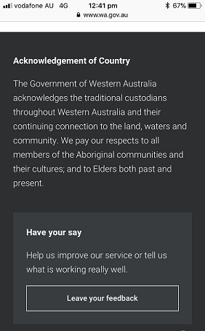  
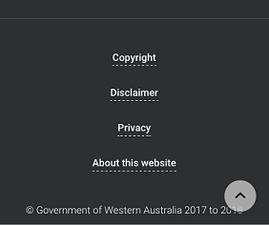

Figure 24: Footer on a mobile device

# Further Resources

* [Digital Services Policy](http://www.wa.gov.au/government/publications/digital-services-policy)
* [Western Australian Digital Service Design Principles](http://www.wa.gov.au/government/publications/digital-service-design-principles)
* [WA Government Website Style Standard](http://www.wa.gov.au/government/publications/website-style-standard) - details all the required style elements and associated CSS where applicable, for example: colours, typography, headings, links, icons and hover states.

# Further Information

Please email the Office of Digital Government: [dgov-strategy@dpc.wa.gov.au](mailto:dgov-strategy@dpc.wa.gov.au)

1. *If using email address, you may want to consider strategies for obscuring the email address so it is still legible and usable for users, but prevents email addresses from being automatically harvested for spamming.  Email obfuscation strategies include using JavaScript code, HTML encoding and email munging tools.*