Redeployment and redundancy
RAMS user guide

Contents
Introduction 3
1.0 Registrable Employee 4
1.1 Create a new Registrable Employee 4
1.2 Options for a Registrable Redeployee 4
1.2 Options for a Registrable Redeployee 5
1.3 Refer to Internal Position 5
1.4 Nominate for External Redeployment 6
1.5 Application for Voluntary Severance 7
1.6 Change Status to Inactive 9
1.7 Change Type to Internal Surplus Employee 9
2.0 Registered Employee 10
2.1 Options for a Registered Redeployee 10
2.2: Refer to Internal or External Position 10
2.3 Suspend Countdown Clock 11
2.4 Cancel/Amend Future Suspension 11
2.5 Recommence Countdown Clock 12
2.6: Severance (Redundancy) Process 12
2.7: Transition Payment 15
2.8: Deregister Registered Redeployee 16
3.0 Internal Surplus Employee 17
3.1 Create a new Internal Surplus Employee 17
3.2 Change type to Registrable Employee 17

Introduction

This user guide outlines the processes and functions that have been implemented into Recruitment Advertising Management System (RAMS) to meet the requirements of the Public Sector Management (Redeployment and Redundancy) Regulations 2014 and other associated documentation.
Detailed information regarding these regulations can be found on the Public Sector Commission website.
This user guide covers how to create and manage the following redeployee types with the RAMS system:
1.0 Registrable employee
2.0 Registered employee
3.0 Internal Surplus Employee
An employee can be identified and created as a Registrable Employee within the RAMS system at any time.
To create a Registered Employee an employee needs to first be created as a registrable redeployee, and then an application for external redeployment needs to be completed.
Once a redeployee becomes a Registered Employee, a six month countdown clock will be automatically initiated in the RAMS system. Agencies and Case Managers must manage a Registered Redeployee in accordance with redeployment and redundancy regulations.
The redeployee type Internal Surplus Employee is not covered under any redeployment and redundancy regulations. This option is provided for use by agencies where a requirement for additional classification exists for the transfer of internal employees, and internal guidelines or policies are in place to differentiate a registrable redeployee to an internal surplus employee.

1.0 Registrable Employee

1.1 Create a new Registrable Employee
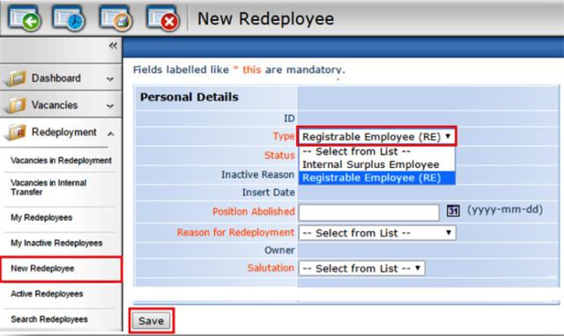 | - Log into RAMS using Case Manager user type  - Select ‘New Redeployee’ in Redeployment Menu  - Select Registrable Employee (RE) from the ‘Type’ field  - Populate ‘Personal Details’ page  - Click Save  - Populate ‘Previous Position’ page  - Click Save  - Populate ‘Matching Profile for Redeployee’ page  - Click Save  Note: Employee is now a Registrable Employee

1.2 Options for a Registrable Redeployee
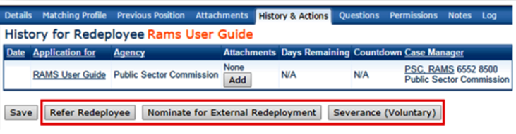 | The ‘History and Actions’ tab provides three options for managing a Registrable Employee:  1.3 Refer to Internal Position  1.4 Nominate for External Redeployment  1.5 Application for Voluntary Severance

1.2 Options for a Registrable Redeployee
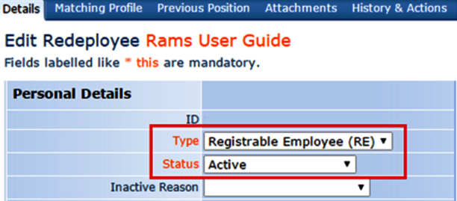 | The ‘Details’ tab provides two options for managing a Registrable Redeployee:  1.6 Change Status to Inactive  1.7 Change Type to Internal Surplus Employee

1.3 Refer to Internal Position
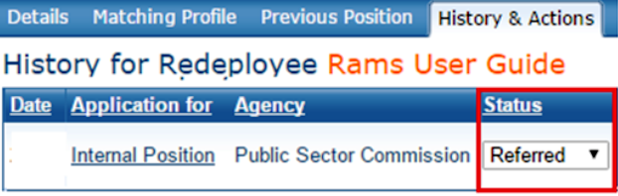 | 1. Go to the ‘History and Actions’ tab  2. Click Refer Redeployee  3. Select a position from drop down list  4. Click Continue  5. Review any existing attachments  6. Click Continue  7. Add new attachments if required  8. Click Save and Continue  Note: Redeployee is now referred to position. Monitor status via the ‘History and Actions’ tab

1.4 Nominate for External Redeployment
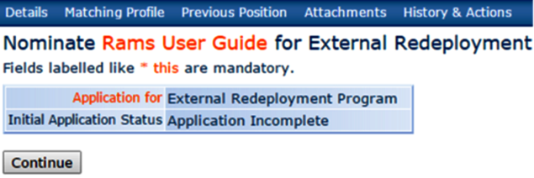 | - Go to the ‘History and Actions’ tab  - Click Nominate for External Redeployment  - Click Continue  - Review any existing attachments  - Click Continue  - Add new attachments if required  - Click Save and Continue
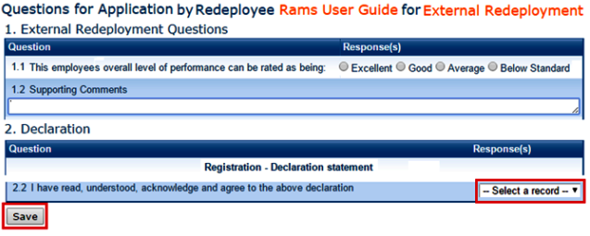 | - Populate ‘Questions for Application’ page  - Accept Declaration to proceed  - Click Save  Note: Application for external redeployment is recorded
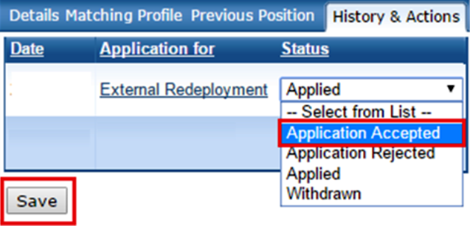 | - Go to ‘History and Actions’ tab  - Select a new status from drop down list:  - Application Accepted  - Application Rejected  - Withdrawn  - Click Save  Note: Employee is a Registered Employee upon acceptance

1.5 Application for Voluntary Severance
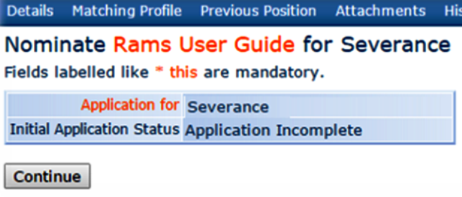 | - Go to the ‘History and Actions’ tab  - Click Severance (Voluntary)  - Click Continue  - Review any existing attachments  - Click Continue  - Add new attachments if required  - Click Save and Continue
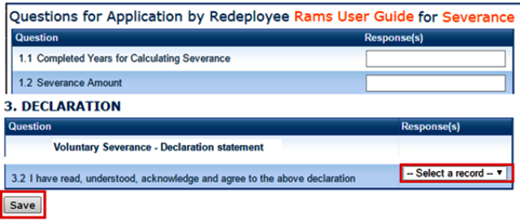 | - Populate ‘Questions for Application’ page  - Accept Declaration to proceed  - Click Save  Note: Application for severance is recorded
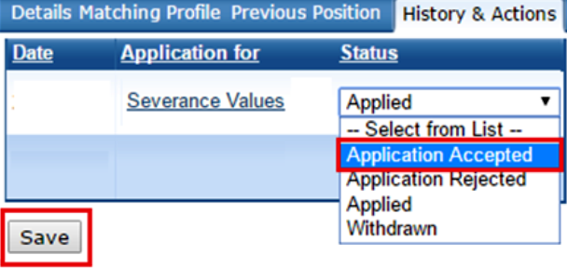 | - Go to ‘History and Actions’ tab  - Select a new status from drop down list:  - Application Accepted  - Application Rejected  - Withdrawn  - Click Save
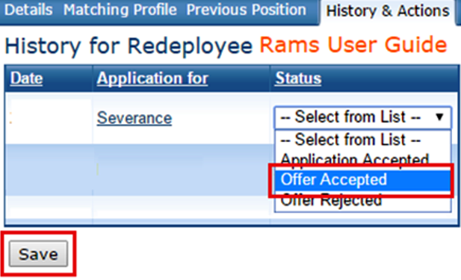 | - Go to ‘History and Actions’ tab  - Select a new status from drop down list:  - Offer Accepted  - Offer Rejected  - Click Save
- Go to ‘History and Actions’ tab
- Select Severed from drop down list
- Enter an effective date for the severance
- Click Save

Note: Employee is now severed

1.6 Change Status to Inactive
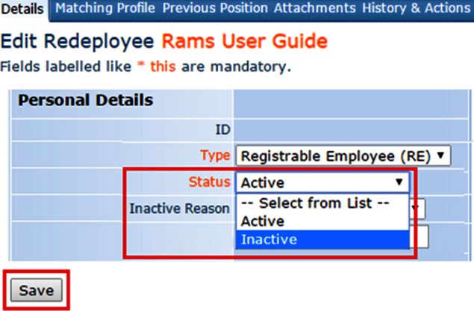 | - Go to the ‘Details’ tab  - Click the Status drop down list  - Select ‘Inactive’  - Click Save  Note: Redeployee is now Inactive

1.7 Change Type to Internal Surplus Employee
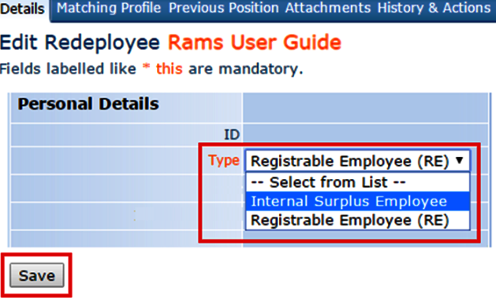 | - Go to the ‘Details’ tab  - Click the Type drop down list  - Select ‘Internal Surplus Employee’  - Click Save  Note: Redeployee is now an Internal Surplus Employee

2.0 Registered Employee
To become a registered employee, refer to 1.4 Nominate for External Redeployment of this document.

2.1 Options for a Registered Redeployee
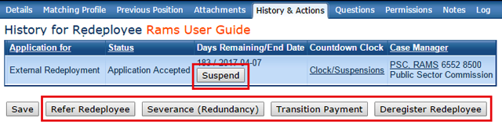 | The ‘History and Actions’ tab provides several options for managing a Registered Redeployee:  2.2 Refer to Internal or External Position  2.3 Suspend Countdown Clock  2.4 Cancel/Amend Future Suspension  2.5 Recommence Countdown Clock  2.6 Severance (Redundancy) Process  2.7 Transition Payment  2.8 Deregister Registered Redeployee

2.2: Refer to Internal or External Position
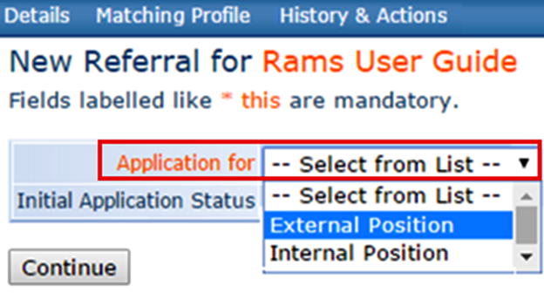 | - Go to the ‘History and Actions’ tab  - Click Refer Redeployee  - Select a position from drop down list  - Click Continue  - Review any existing attachments  - Click Continue  - Add new attachments if required  - Click Save and Continue  Note: Redeployee is now referred to position

2.3 Suspend Countdown Clock
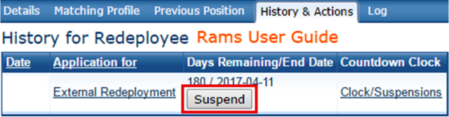  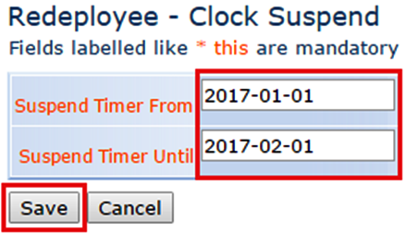 | - Go to the ‘History and Actions’ tab  - Click Suspend  - Select the suspend commencement date  - Select the suspend end date  - Click Save  Note: Immediate or future suspension dates can be entered

2.4 Cancel/Amend Future Suspension
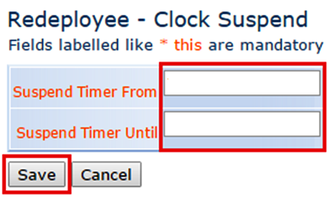 | - Go to the ‘History and Actions’ tab  - Click Suspend  - Delete both dates to cancel a future suspension  - Change any date to amend a future suspension  - Click Save  Note: Current and future dated suspensions can be viewed via the Log tab or by clicking ‘Clock/Suspensions’

2.5 Recommence Countdown Clock
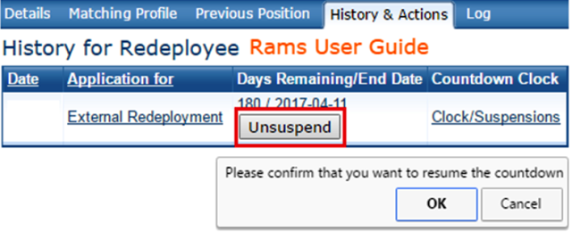 | - Go to the ‘History and Actions’ tab  - Click Unsuspend  - Click OK to recommence the countdown clock  Note: Countdown Clock is now active

2.6: Severance (Redundancy) Process
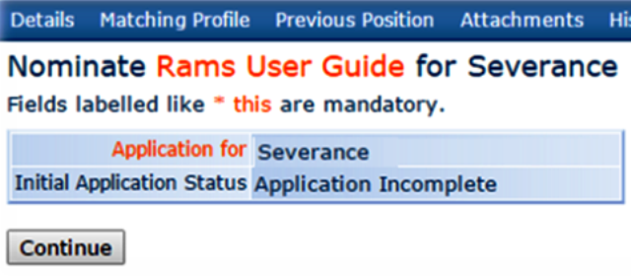 | - Go to the ‘History and Actions’ tab  - Click Severance (Redundancy)  - Click Continue  - Review any existing attachments  - Click Continue  - Add new attachments if required  - Click Save and Continue
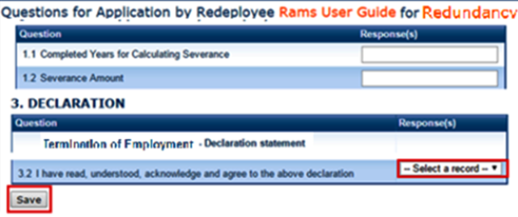 | - Populate ‘Questions for Application’ page  - Accept Declaration to proceed  - Click Save  Note: Application for Severance is recorded
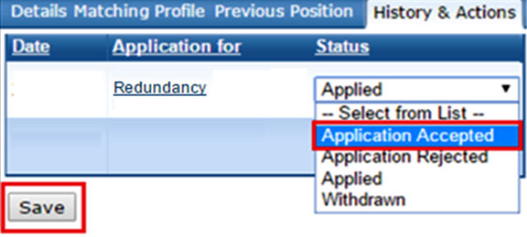 | - Go to ‘History and Actions’ tab  - Select a new status from drop down list:  - Application Accepted  - Application Rejected  - Withdrawn  - Click Save
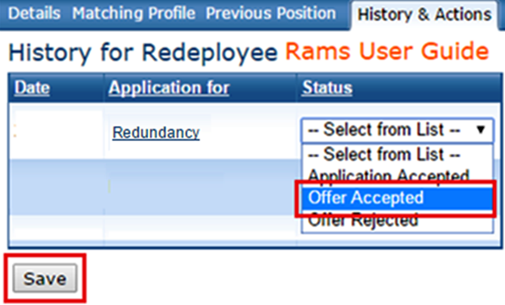 | - Go to ‘History and Actions’ tab  - Select a new status from drop down list:  - Offer Accepted  - Offer Rejected  - Click Save
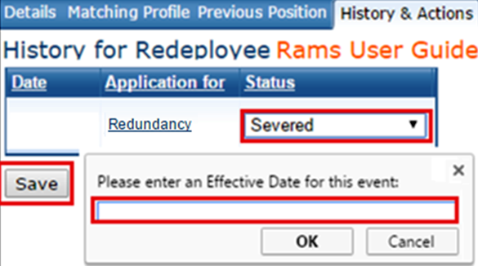 | - Go to ‘History and Actions’ tab  - Select Severed  - Enter an effective date for the severance  - Click Save  Note: Employee is now severed

2.7: Transition Payment
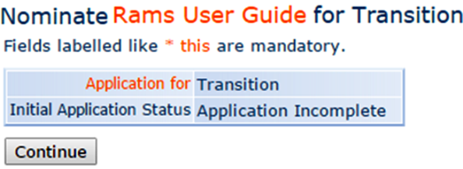 | - Go to the ‘History and Actions’ tab  - Click Transition Payment  - Click Continue  - Review any existing attachments  - Click Continue  - Add new attachments if required  - Click Save and Continue
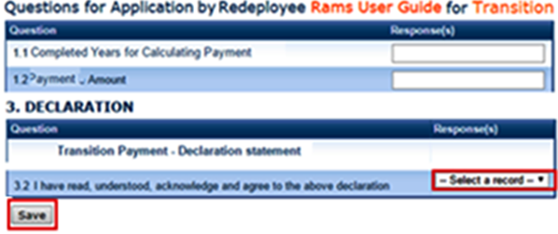 | - Populate ‘Questions for Application’ page  - Accept Declaration to proceed  - Click Save  Note: Application for Transition is recorded
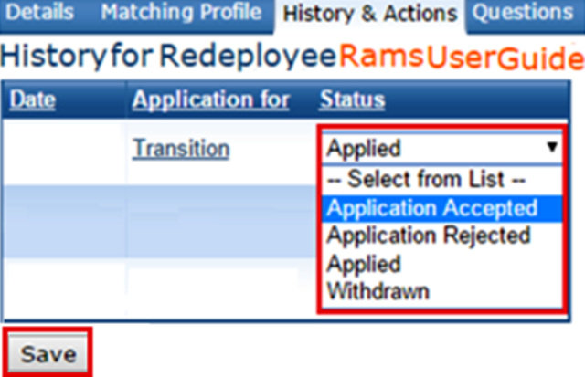 | - Go to ‘History and Actions’ tab  - Select a new status from drop down list:  - Application Accepted  - Application Rejected  - Withdrawn  - Click Save
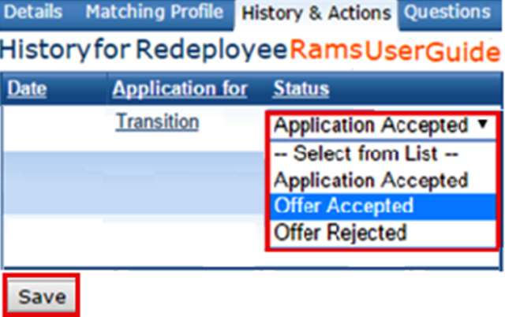 | - Go to ‘History and Actions’ tab  - Select a new status from drop down list:  - Offer Accepted  - Offer Rejected  - Click Save
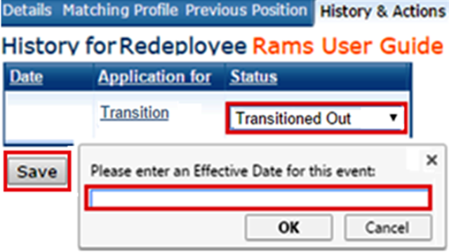 | - Go to ‘History and Actions’ tab  - Select Severed  - Enter an effective date for the severance  - Click Save  Note: Employee is now transitioned out

2.8: Deregister Registered Redeployee
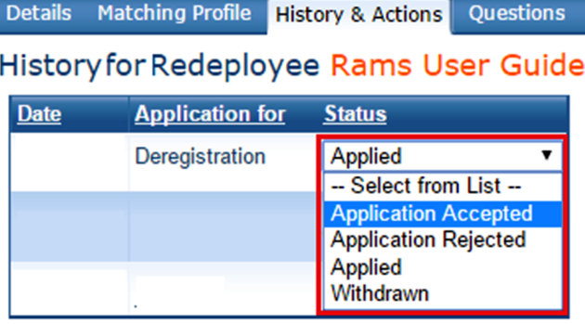 | 1. Go to the ‘History and Actions’ tab  2. Click Deregister Redeployee  3. Click Continue  4. Select a new status from drop down list:  - Application Accepted  - Application Rejected  - Withdrawn  5. Click Save  Note: Redeployee now a Registrable Redeployee

3.0 Internal Surplus Employee

3.1 Create a new Internal Surplus Employee
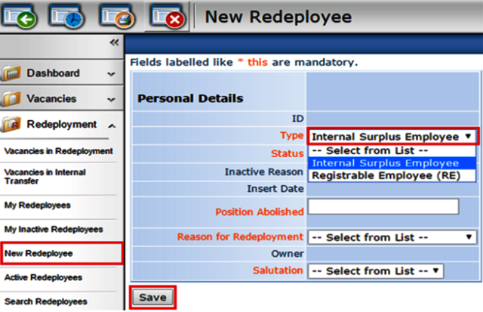 | - Log into RAMS using Case Manager user type  - Select ‘New Redeployee’ in Redeployment Menu  - Select Internal Surplus Employee from the ‘Type’ field  - Populate ‘Personal Details’ page  - Click Save  - Populate ‘Previous Position’ page  - Click Save  - Populate ‘Matching Profile for Redeployee’ page  - Click Save  Note: Employee is now an Internal Surplus Employee

3.2 Change type to Registrable Employee
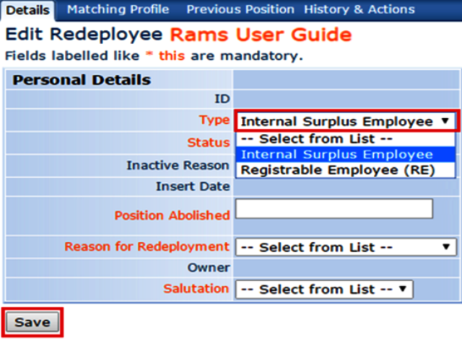 | - Go to the ‘Details’ tab  - Select the Type drop down list  - Select ‘Registrable Employee (RE)’  - Click Save  Note: Redeployee is now a Registrable Employee

