December 2018
Western Australian Public Sector Quarterly Workforce Report

Enquiries:
Data Analytics and Reporting
Public Sector Commission
Hale House, 1 Parliament Place, WEST PERTH WA 6005
Locked Bag 3002, WEST PERTH WA 6872
Telephone: (08) 6552 8500
Fax: (08) 6552 8710
Email: stateadministrator@psc.wa.gov.au
Website: www.publicsector.wa.gov.au

© State of Western Australia 2019
There is no objection to this publication being copied in whole or part, provided there is due acknowledgement of any material quoted or reproduced.
Published by the Public Sector Commission, May 2019.
This publication is available on the Public Sector Commission website at www.publicsector.wa.gov.au
Disclaimer
The Western Australian Government is committed to quality service to its customers and makes every attempt to ensure accuracy, currency and reliability of the information contained in this publication. However, changes in circumstances over time may impact on the veracity of this information.
Accessibility
Copies of this publication are available in alternative formats upon request.

WA public sector overview
December 2018
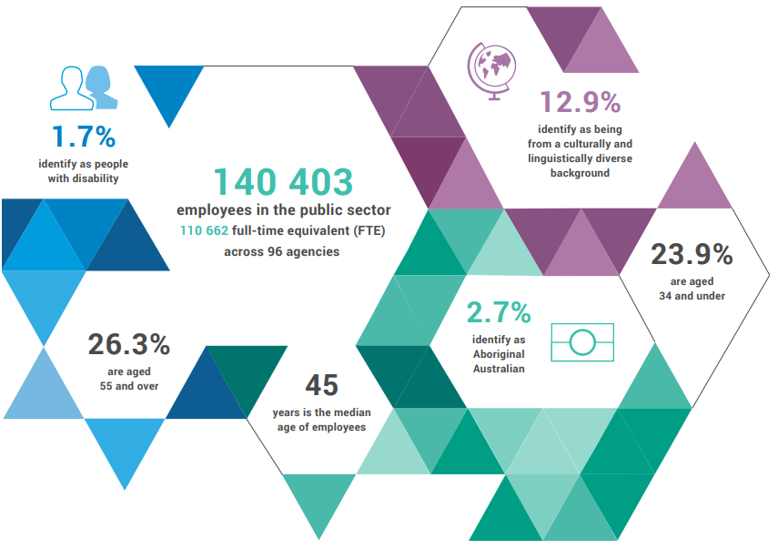
13.2%
identify as being from a culturally and linguistically diverse background

1.6%
identify as people with disability

138 678
employees
108 601
full-time equivalent (FTE) across
70 agencies

23.8%
aged 34 and under

2.7%
identify as
Aboriginal Australian

26.5%
aged 55
and over

46
median age

376
members of the SES
$7 583m
general government expenses
Top 3 occupation groups

245 males
131 females

$3 091m salaries
$4 492m other expenses

19.0% teachers
16.5% clerical workers
11.0% nurses and midwives
53.5% others

Staffing levels
In December 2018, the WA public sector employed 108 601 FTE reflecting:
- a quarterly decrease of 2654 FTE (-2.39%) since September 2018
- an annual increase of 230 FTE (+0.21%) since December 2017.
The end of the December quarter typically experiences a decrease in staffing levels, representing the normal seasonality impacts associated with the Christmas and holiday period. The decrease in FTE since September 2018 was due largely to the Department of Education requiring fewer casual teachers and education assistants (-1915 FTE) over the school holidays. This was similar across the five TAFEs with a collective decrease of 273 FTE across its workforces. An increase in FTE is expected for the March 2019 report when the academic year is back in full swing.
Between December 2017 and December 2018 the increase in FTE has been driven primarily by WA Health (+756 FTE), the Public Transport Authority (+166 FTE) and the Department of Education (+156 FTE).

Salaries expenditure
General government salaries increased by a total of $106 million (or 1.8%) during the six months to 31 December 2018, when compared to the same period in 2017-18. This was mainly due to increased health sector activity levels, growth in teaching staff numbers and the impact of voluntary separation costs for the Department of Education and the Western Australia Police Force.
Figure 1 Six months to 31 December salaries growth (general government)

Decade average = 6.3%

Source: Department of Treasury, Quarterly Financial Results Report – December 2018

Headcount, FTE and salaries expenditure from September 2013

Quarter | Headcount | FTE | Salaries expenditure ($M)
September 2013 | 139 642 | 109 883 | 2 657
December 2013 | 138 559 | 109 489 | 2 750
March 2014 | 138 610 | 109 423 | 2 636
June 2014 | 137 944 | 108 999 | 2 639
September 2014 | 138 353 | 109 379 | 2 707
December 2014 | 137 607 | 109 160 | 2 811
March 2015 | 138 307 | 108 979 | 2 722
June 2015 | 138 440 | 109 019 | 2 849
September 2015 | 139 277 | 109 919 | 2 837
December 2015 | 137 520 | 108 325 | 2 888
March 2016 | 137 371 | 108 722 | 2 801
June 2016 | 135 770 | 107 809 | 2 857
September 2016 | 137 746 | 109 295 | 2 887
December 2016 | 135 936 | 106 830 | 2 931
March 2017 | 139 144 | 109 895 | 2 880
June 2017 | 140 403 | 110 662 | 2 912
September 2017 | 141 609 | 111 472 | 2 980
December 2017 | 137 878 | 108 371 | 3 029
March 2018 | 140 799 | 110 404 | 3 049
June 2018 | 139 812 | 110 373 | 3 135
September 2018 | 141 744 | 111 255 | 3 023
December 2018 | 138 678 | 108 601 | 3 091

WA public sector entities
Agency | Dec-18 Headcount ¹ | Dec-18  FTE ² | FTE change from Sep-18 | FTE change from Dec-17
Department of Education | 51 280 | 37 804 | ▼ 2 225 | ▲ 156
WA Health  (North Metropolitan Health Service) | 11 815 | 8 775 | ▼ 189 | ▼ 1 673
WA Health  (WA Country Health Service) | 9 822 | 7 407 | ▼ 24 | ▲ 273
WA Health  (South Metropolitan Health Service) | 8 909 | 6 771 | ▼ 75 | ▲ 144
WA Health  (East Metropolitan Health Service) | 7 843 | 6 062 | ▼ 82 | ▲ 320
Department of Justice | 6 297 | 5 824 | ▲ 15 | ▼ 107
Department of Communities | 6 188 | 5 415 | ▲ 38 | ▼ 84
WA Health  (Child and Adolescent Health Service) | 4 369 | 3 040 | ▼ 39 | ▲ 39
Western Australia Police | 2 781 | 2 065 | ▲ 4 | ▼ 38
Department of Biodiversity, Conservation and Attractions | 2 203 | 1 856 | ▲ 133 | ▼ 10
WA Health (PathWest) ⁴ | 1 962 | 1 584 | ▲ 25 | N/A
Public Transport Authority | 1 962 | 1 884 | ▲ 59 | ▲ 166
WA Health (Health Support Services) | 1 929 | 1 299 | ▼ 90 | ▲ 29
Department of Primary Industries and Regional Development | 1 699 | 1 540 | ▼ 15 | ▼ 99
Department of Fire and Emergency Services | 1 679 | 1 599 | ▲ 26 | ▼ 42
Department of Mines, Industry Regulation and Safety | 1 451 | 1 362 | ▼ 9 | ▼ 154
Department of Transport | 1 422 | 1 307 | ▲ 12 | ▼ 6
North Metropolitan TAFE | 1 321 | 1 126 | ▼ 75 | ▲ 26
Main Roads Western Australia | 1 079 | 1 020 | ▼ 2 | ▼ 16
Department of Local Government, Sport and Cultural Industries | 1 078 | 817 | ▼ 36 | ▼ 103
South Metropolitan TAFE | 1 059 | 926 | ▼ 146 | ▼ 51
Department of Finance | 994 | 920 | ▼ 14 | ▼ 87
Department of Water and Environmental Regulation | 874 | 796 | ▲ 46 | ▲ 9
Department of Planning, Lands and Heritage | 818 | 697 | ▲ 7 | ▼ 46
WA Health (Department of Health) | 779 | 678 | ▲ 26 | ▲ 40
Department of the Premier and Cabinet | 548 | 477 | ▲ 4 | ▲ 12
VenuesWest | 506 | 249 | ▲ 8 | ▲ 15
Landgate | 502 | 455 | ▼ 6 | ▼ 33
Department of Training and Workforce Development | 476 | 427 | ▼ 6 | ▼ 50
South Regional TAFE | 421 | 336 | ▼ 25 | ▲ 16
Insurance Commission of Western Australia | 385 | 352 | 0 | ▲ 24
Central Regional TAFE | 365 | 306 | ▼ 16 | ▲ 22
Mental Health Commission | 347 | 276 | ▲ 3 | ▼ 15
Legal Aid Commission of Western Australia | 338 | 295 | ▲ 6 | ▲ 9
North Regional TAFE | 303 | 272 | ▼ 11 | ▲ 18
Department of Treasury | 287 | 266 | ▲ 7 | ▲ 13
Department of Jobs, Tourism, Science and Innovation | 274 | 251 | 0 | ▲ 1
Office of the Director of Public Prosecutions | 272 | 242 | ▲ 3 | ▲ 11
Lotterywest | 221 | 213 | ▲ 1 | ▼ 21
Forest Products Commission | 215 | 193 | ▲ 20 | ▲ 8
Metropolitan Cemeteries Board | 164 | 147 | ▼ 2 | ▼ 3
Office of the Auditor General | 153 | 137 | ▼ 9 | ▼ 8
ChemCentre | 148 | 140 | ▲ 4 | ▲ 2
Public Sector Commission | 130 | 98 | ▼ 1 | ▼ 13
WorkCover Western Australia | 129 | 117 | ▼ 2 | ▼ 9
Corruption and Crime Commission | 119 | 116 | 0 | ▼ 7
Metropolitan Redevelopment Authority | 112 | 103 | ▲ 1 | ▼ 15
Ombudsman Western Australia | 73 | 63 | 0 | ▼ 6
Animal Resources Centre | 65 | 59 | ▼ 1 | ▲ 2
Economic Regulation Authority | 61 | 58 | 0 | ▲ 5
Small Business Development Corporation | 54 | 48 | ▼ 2 | ▼ 2
GESB | 51 | 44 | ▲ 1 | ▲ 3
Legal Practice Board | 44 | 41 | ▼ 1 | ▲ 1
Western Australian Electoral Commission | 44 | 41 | ▲ 1 | ▼ 1
National Trust of Australia (W.A.) | 39 | 28 | ▲ 1 | ▼ 2
Department of the Registrar Western Australian Industrial Relations Commission | 37 | 34 | ▲ 1 | ▲ 1
Western Australian Meat Industry Authority | 31 | 15 | ▼ 6 | ▼ 6
Construction Training Fund | 23 | 22 | ▲ 1 | ▲ 6
Equal Opportunity Commission | 21 | 20 | 0 | ▼ 2
Health and Disability Services Complaints Office | 19 | 15 | ▲ 3 | ▼ 1
Office of the Inspector of Custodial Services | 17 | 16 | ▼ 1 | ▼ 1
Healthway | 16 | 15 | ▲ 1 | ▼ 2
Commissioner for Children and Young People | 14 | 12 | ▼ 1 | ▼ 3
Office of the Information Commissioner | 12 | 9 | ▼ 1 | ▼ 2
Keep Australia Beautiful WA | 9 | 5 | ▼ 4 | ▼ 6
Veterinary Surgeons’ Board | 6 | 4 | 0 | 0
Burswood Park Board | 5 | 4 | 0 | 0
Minerals Research Institute of Western Australia (MRIWA) | 4 | 4 | ▲ 1 | ▲ 1
Salaries and Allowances Tribunal | 3 | 3 | 0 | 0
Architects Board of Western Australia | 2 | 2 | 0 | 0
Western Australian public sector | 138 678 | 108 601 | ▼ 2 654 | ▲ 230

The ‘general government’ sector as defined by the Department of Treasury differs slightly from the ‘public sector’ as defined in the Public Sector Management Act 1994. However, for the purposes of indicative comparison of staffing levels and salaries expenditure, the difference is negligible.
Targeted voluntary separation programs under the Voluntary Targeted Separation Scheme (VTSS) were implemented between 1 July and 31 December 2018 in the education sector and the Western Australia Police Force. A total of 82 and 160 separations respectively were finalised by 31 December 2018, with ongoing savings reinvested back into service delivery in these two agencies. Together with 2,311 separations achieved across the sector to 30 June 2018 (detailed in the 2017-18 Annual Report on State Finances), the VTSS has achieved 2,553 separations to date. Further separations associated with the transition to the National Disability Insurance Scheme over the period to 30 June 2022 are expected to result in almost all of the 3,000 separations targeted for the scheme being achieved.
Headcount’ is a snapshot of employees as at the last pay period of the quarter, and includes all permanent, fixed term and paid casual employees during that pay period.
‘FTE’ is a snapshot of employees who were paid in the last pay period of the quarter. This methodology may differ from those used by public sector agencies in their own operational workforce management process. As the quality of agency data is regularly reviewed, some adjustments in FTE figures may occur.
‘Salaries expenditure’ covers the ‘general government sector’ as defined by the Department of Treasury differs slightly from the ‘public sector’ as defined in the Public Sector Management Act 1994.
Effective 1 July 2018, PathWest Laboratory Medicine WA (PathWest) was established as an independent Chief Executive Governed Health Service Provider under Section 32 of the Health Service Act 2016. PathWest was previously under the North Metropolitan Health Service.
The Department of Communities includes the Disability Services Commission and Housing Authority which remain statutory authorities.
Sworn officers are employed by the Police Force (a non-public sector entity as defined in the Public Sector Management Act 1994), separated from the Police Service.
The Department of Biodiversity, Conservation and Attractions includes the Botanic Gardens and Parks Authority, Zoological Parks Authority, and Rottnest Island Authority as part of administrative arrangements. However, these statutory authorities remain as separate entities and continue to employ their own staff.
While staff of regional development commissions are part of the Department of Primary Industries and Regional Development, regional development commissions and their respective chief executives and boards remain as separate entities under legislation. For the purposes of this report, the nine regional development commissions are included in the Department of Primary Industries and Regional Development.

