March 2019
Western Australian Public Sector Quarterly Workforce Report

Enquiries:
Data Analytics and Reporting
Public Sector Commission
Hale House, 1 Parliament Place, WEST PERTH WA 6005
Locked Bag 3002, WEST PERTH WA 6872
Telephone: (08) 6552 8500
Fax: (08) 6552 8710
Email: stateadministrator@psc.wa.gov.au
Website: www.publicsector.wa.gov.au

© State of Western Australia 2019
There is no objection to this publication being copied in whole or part, provided there is due acknowledgement of any material quoted or reproduced.
Published by the Public Sector Commission, September 2019.
This publication is available on the Public Sector Commission website at www.publicsector.wa.gov.au
Disclaimer
The Western Australian Government is committed to quality service to its customers and makes every attempt to ensure accuracy, currency and reliability of the information contained in this publication. However, changes in circumstances over time may impact on the veracity of this information.
Accessibility
Copies of this publication are available in alternative formats upon request.

WA public sector overview
March 2019
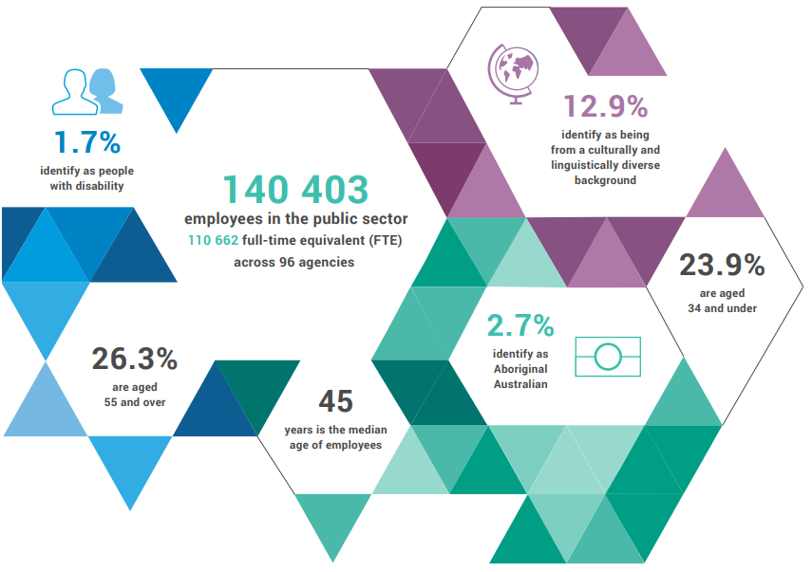
13.3%
identify as being from a culturally and linguistically diverse background

1.5%
identify as people with disability

142 278 employees
112 099
full-time equivalent (FTE) across
69 agencies

23.8%
aged 34 and under

2.7%
identify as
Aboriginal Australian

26.5%
aged 55
and over

46
median age

Top 3 occupation groups
$7 461m
general government expenses
375
members of the SES

$2 982m salaries
$4 479m other expenses

240 males
135 females

19.5% teachers
16.4% clerical workers
11.0% nurses and midwives
53.1% others

Sector profile
Western Australia’s public sector workforce profile continually changes. This report provides a snapshot of the public sector at a point in time (end of March 2019). Throughout the year, the profile of the workforce experiences seasonal variances, adapting to demands for services such as an increase in firefighters over the bushfire season, or a reduction in the education sector during school holidays. The December quarter typically reflects the lowest employment levels, before these rebound in the March quarter. Observations from the recent March quarter are summarised below.

Staffing levels
In March 2019, the WA public sector employed 112 099 full-time equivalent (FTE) staff, reflecting a quarterly increase of 3530 FTE since December 2018. This increase was due primarily to the resumption of the academic year and employees across the sector returning to work.
When compared to the public sector’s staffing level in March 2018, there has been an increase of 1695 FTE. This annual increase reflects:
- additional teachers and education aides in public schools across the State reflecting an increase in students in 2019 (about 356 additional FTE)
- additional nursing and medical staff across the health service providers (about 491 FTE)
- an increase in security officers and guards (about 58 FTE)
- an increase in other employees – primarily increases in allied health professionals and health support staff including technicians (110 FTE), business and corporate support (224 FTE), and engineers (50 FTE).

Employment trends
Additionally, the type of employment (permanent, fixed term and casual) has also been changing in recent years. Compared with March 2017, the number of people permanently employed (by FTE) has increased by 5.0 per cent, while fixed term and casual employment has decreased by 7.6 per cent. This likely reflects, in part, implementation of the Government’s commitment to provide job security to public sector employees through the conversion and permanent appointment of current fixed term contract and casual employees.

Salaries expenditure
General government salaries grew by just 0.4 per cent (up $39 million) during the first nine months of 2018/19, relative to the same period in 2017/18 (see Figure 1). Compared to the prior period, the lower net increase in salary costs is mainly due to savings realised through the Voluntary Targeted Separation Scheme which was completed for most agencies by 30 June 2018, and separation payments under the scheme paid in late 2017/18.

Figure 1 Nine months to 31 March salaries growth (general government)

Source: Department of Treasury, Quarterly Financial Results Report – March 2019

Headcount, FTE and salaries expenditure from September 2014
Quarter | Headcount | FTE | Salaries expenditure ($M)
September 2014 | 138 353 | 109 379 | 2 707
December 2014 | 137 607 | 109 160 | 2 811
March 2015 | 138 307 | 108 979 | 2 722
June 2015 | 138 440 | 109 019 | 2 849
September 2015 | 139 277 | 109 919 | 2 837
December 2015 | 137 520 | 108 325 | 2 888
March 2016 | 137 371 | 108 722 | 2 801
June 2016 | 135 770 | 107 809 | 2 857
September 2016 | 137 746 | 109 295 | 2 887
December 2016 | 135 936 | 106 830 | 2 931
March 2017 | 139 144 | 109 895 | 2 880
June 2017 | 140 403 | 110 662 | 2 912
September 2017 | 141 609 | 111 472 | 2 980
December 2017 | 137 878 | 108 371 | 3 029
March 2018 | 140 799 | 110 404 | 3 049
June 2018 | 139 812 | 110 373 | 3 135
September 2018 | 141 744 | 111 255 | 3 023
December 2018 | 138 678 | 108 569 | 3 091
March 2019 | 142 278 | 112 099 | 2 982

WA public sector entities staffing levels
Agency | Mar-19 Headcount ¹ | Mar-19  FTE ² | FTE change from Dec-18 | FTE change from Mar-18
Department of Education | 53 166 | 39 633 | ▲ 1 829 | ▲ 556
WA Health  (North Metropolitan Health Service) | 11 866 | 9 048 | ▲ 273 | ▼ 1 523
WA Health  (WA Country Health Service) | 9 986 | 7 500 | ▲ 94 | ▲ 266
WA Health  (South Metropolitan Health Service) | 8 937 | 6 855 | ▲ 84 | ▲ 89
WA Health  (East Metropolitan Health Service) | 7 955 | 6 269 | ▲ 208 | ▲ 302
Department of Justice | 6 440 | 5 884 | ▲ 60 | ▲ 78
Department of Communities | 6 239 | 5 386 | ▼ 28 | ▲ 37
WA Health  (Child and Adolescent Health Service) | 4 386 | 3 146 | ▲ 105 | ▼ 11
Western Australia Police | 2 807 | 2 077 | ▲ 12 | ▲ 40
Department of Biodiversity, Conservation and Attractions | 2 196 | 1 856 | 0 | ▲ 9
WA Health (Health Support Services) | 2 002 | 1 366 | ▲ 67 | ▼ 21
Public Transport Authority | 1 995 | 1 932 | ▲ 48 | ▲ 204
WA Health (PathWest) ⁴ | 1 975 | 1 589 | ▲ 4 | N/A
Department of Primary Industries and Regional Development | 1 732 | 1 569 | ▲ 29 | ▼ 10
Department of Fire and Emergency Services | 1 691 | 1 623 | ▲ 24 | ▼ 9
North Metropolitan TAFE | 1 503 | 1 230 | ▲ 104 | ▼ 3
Department of Mines, Industry Regulation and Safety | 1 497 | 1 404 | ▲ 41 | ▲ 30
Department of Transport | 1 445 | 1 329 | ▲ 23 | ▲ 21
South Metropolitan TAFE | 1 377 | 1 157 | ▲ 231 | ▲ 8
Department of Local Government, Sport and Cultural Industries | 1 092 | 862 | ▲ 45 | ▼ 79
Main Roads Western Australia | 1 080 | 1 024 | ▲ 4 | ▲ 6
Department of Finance | 983 | 920 | 0 | ▼ 60
Department of Water and Environmental Regulation | 893 | 796 | ▲ 32 | ▲ 35
WA Health (Department of Health) | 828 | 714 | ▲ 36 | ▲ 83
Department of Planning, Lands and Heritage | 825 | 677 | ▼ 20 | ▼ 42
South Regional TAFE | 576 | 422 | ▲ 86 | ▲ 18
Department of the Premier and Cabinet | 566 | 493 | ▲ 16 | ▲ 37
VenuesWest | 544 | 270 | ▲ 20 | ▲ 5
Landgate | 505 | 466 | ▲ 11 | ▼ 6
Department of Training and Workforce Development | 453 | 402 | ▼ 25 | ▼ 48
Central Regional TAFE | 424 | 349 | ▲ 44 | ▲ 6
Insurance Commission of Western Australia | 388 | 357 | ▲ 5 | ▲ 33
Mental Health Commission | 360 | 289 | ▲ 13 | ▲ 3
Legal Aid Commission of Western Australia | 341 | 297 | ▲ 3 | ▲ 15
North Regional TAFE | 312 | 284 | ▲ 12 | ▲ 2
Department of Treasury | 304 | 283 | ▲ 17 | ▲ 24
Department of Jobs, Tourism, Science and Innovation | 284 | 255 | ▲ 4 | ▲ 8
Office of the Director of Public Prosecutions | 278 | 248 | ▲ 6 | ▲ 6
Lotterywest | 246 | 235 | ▲ 22 | ▲ 20
Forest Products Commission | 192 | 170 | ▼ 23 | 0
Office of the Auditor General | 171 | 157 | ▲ 20 | ▲ 20
Metropolitan Cemeteries Board | 168 | 146 | ▼ 1 | 0
ChemCentre | 145 | 135 | ▼ 5 | ▲ 3
WorkCover Western Australia | 130 | 119 | ▲ 3 | ▼ 5
Public Sector Commission | 127 | 101 | ▲ 3 | ▼ 9
Corruption and Crime Commission | 123 | 119 | ▲ 4 | ▼ 8
Metropolitan Redevelopment Authority | 106 | 98 | ▼ 4 | ▼ 14
Ombudsman Western Australia | 70 | 58 | ▼ 5 | ▼ 7
Animal Resources Centre | 64 | 59 | 0 | ▲ 2
Economic Regulation Authority | 61 | 58 | ▲ 1 | ▲ 8
Small Business Development Corporation | 55 | 48 | 0 | ▲ 2
GESB | 52 | 45 | ▲ 1 | ▲ 3
Legal Practice Board | 46 | 42 | ▲ 1 | ▲ 3
Western Australian Electoral Commission | 44 | 41 | ▲ 1 | ▼ 1
National Trust of Australia (W.A.) | 39 | 28 | ▲ 1 | 0
Department of the Registrar Western Australian Industrial Relations Commission | 36 | 34 | 0 | ▲ 1
Western Australian Meat Industry Authority | 32 | 16 | ▲ 1 | ▼ 5
Construction Training Fund | 22 | 21 | ▼ 1 | 0
Equal Opportunity Commission | 21 | 20 | 0 | ▼ 2
Office of the Inspector of Custodial Services | 20 | 19 | ▲ 3 | ▲ 1
Commissioner for Children and Young People | 18 | 15 | ▲ 3 | ▲ 2
Health and Disability Services Complaints Office | 17 | 14 | ▼ 1 | 0
Office of the Information Commissioner | 13 | 11 | ▲ 2 | 0
Keep Australia Beautiful WA | 9 | 8 | ▲ 3 | 0
Veterinary Surgeons’ Board | 6 | 4 | 0 | 0
Burswood Park Board | 5 | 4 | 0 | ▲ 1
Minerals Research Institute of Western Australia (MRIWA) | 4 | 4 | 0 | ▲ 1
Salaries and Allowances Tribunal | 3 | 3 | 0 | 0
Architects Board of Western Australia | 2 | 2 | 0 | 0
Western Australian public sector | 142 278 | 112 099 | ▲ 3 530 | ▲ 1 695

Fixed term and casual employment has decreased by 7.6 per cent, not 9.8 per cent as originally published; Fixed Term FTE: -9.8 per cent; casual FTE: no significant change.
Headcount’ is a snapshot of employees as at the last pay period of the quarter, and includes all permanent, fixed term and paid casual employees during that pay period.
‘FTE’ is a snapshot of employees who were paid in the last pay period of the quarter. This methodology may differ from those used by public sector agencies in their own operational workforce management process. As the quality of agency data is regularly reviewed, some adjustments in FTE figures may occur.
‘Salaries expenditure’ covers the ‘general government sector’ as defined by the Department of Treasury which differs slightly from the ‘public sector’ as defined by the Public Sector Commission.
Effective 1 July 2018, PathWest Laboratory Medicine WA (PathWest) was established as an independent Chief Executive Governed Health Service Provider under Section 32 of the Health Service Act 2016. PathWest was previously under the North Metropolitan Health Service.
The Department of Communities supports the Disability Services Commission (Headcount: 1463; FTE: 1241) and Housing Authority (Headcount: 1848; FTE: 1657) which remain statutory authorities.
Sworn officers are employed by the Police Force (a non-public sector entity as defined in the Public Sector Management Act 1994), separated from the Police Service.
The Department of Biodiversity, Conservation and Attractions includes the Botanic Gardens and Parks Authority (Headcount: 146; FTE: 101), Zoological Parks Authority (Headcount: 194; FTE: 143), and Rottnest Island Authority (Headcount: 129; FTE: 115) as part of administrative arrangements. However, these statutory authorities remain as separate entities and continue to employ their own staff.
While staff of regional development commissions are part of the Department of Primary Industries and Regional Development, regional development commissions and their respective chief executives and boards remain as separate entities under legislation. For the purposes of this report, the nine regional development commissions are included in the Department of Primary Industries and Regional Development.
In January 2019, employees of Healthway were transferred to LotteryWest as part of the amalgamation of the two organisations.

