September 2018
Western Australian Public Sector Quarterly Workforce Report

Enquiries:
Data Analytics and Reporting
Public Sector Commission
Dumas House, 2 Havelock Street, WEST PERTH WA 6005
Locked Bag 3002, WEST PERTH WA 6872
Telephone: (08) 6552 8500
Fax: (08) 6552 8710
Email: stateadministrator@psc.wa.gov.au
Website: www.publicsector.wa.gov.au

© State of Western Australia 2018
There is no objection to this publication being copied in whole or part, provided there is due acknowledgement of any material quoted or reproduced.
Published by the Public Sector Commission, December 2018.
This publication is available on the Public Sector Commission website at www.publicsector.wa.gov.au
Disclaimer
The Western Australian Government is committed to quality service to its customers and makes every attempt to ensure accuracy, currency and reliability of the information contained in this publication. However, changes in circumstances over time may impact on the veracity of this information.
Accessibility
Copies of this publication are available in alternative formats upon request.

WA public sector overview
September 2018
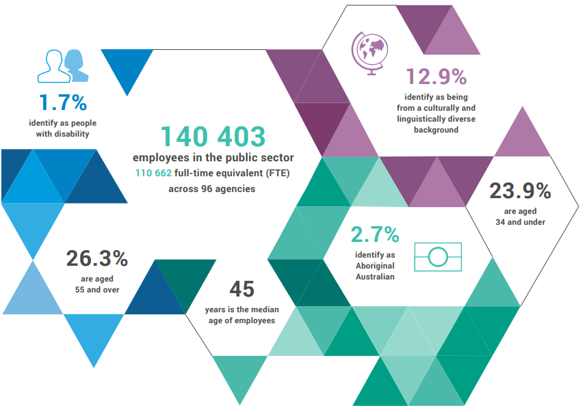
13.4%
identify as being from a culturally and linguistically diverse background

1.6%
identify as people with disability

141 744
employees
111 255
full-time equivalent (FTE) across
84 agencies

23.9%
aged 34 and under

2.7%
identify as
Aboriginal Australian

26.3%
aged 55
and over

45
median age

364
members of the SES
$7 438m
general government expenses
Top 3 occupation groups

243 males
121 females

$3 023m salaries
$4 415m other expenses

19.9% teachers
16.2% clerical workers
10.9% nurses and midwives
53.0% others

Employment levels
In September 2018, the WA public sector employed 111 255 FTE reflecting:
- a quarterly increase of 882 FTE (+0.80%) since June 2018
- an annual decrease of 217 FTE (-0.19%) since September 2017.
The 882 FTE increase over the quarter was due largely to a seasonal upswing in the Department of Education (+712 FTE). There were more casual teachers and education assistants (+441 FTE) in addition to permanent and fixed term teachers and education assistants (+232 FTE). A significant decrease is expected in December 2018 when the school year ends and fewer teaching and casual employees are required.
The next two largest increases are East Metropolitan Health Service (+63 FTE) and South Metropolitan Health Service (+69 FTE). Both experienced increases due to additional nursing and medical staff. The Child and Adolescent Health Service meanwhile had a net decrease of 78 FTE due to the majority of the Perth Children’s Hospital project positions ending on 30 June 2018.

Salaries expenditure
The Department of Treasury advises that general government salaries increased by a total of $43 million (or 1.4%) during the three months to 30 September 2018, when compared to the same period in 2017-18. This was primarily due to increased health sector activity (up $22 million) and the impact of separation costs for the Western Australia Police Force (up $14 million).
Figure 1 Three months to 30 September salaries growth (General Government)
Decade average = 6.5%

WA public sector headcount, FTE and salaries expenditure from September 2013

Quarter | Headcount | FTE | Salaries expenditure ($M)
September 2013 | 139 642 | 109 883 | 2 657
December 2013 | 138 559 | 109 489 | 2 750
March 2014 | 138 610 | 109 423 | 2 636
June 2014 | 137 944 | 108 999 | 2 639
September 2014 | 138 353 | 109 379 | 2 707
December 2014 | 137 607 | 109 160 | 2 811
March 2015 | 138 307 | 108 979 | 2 722
June 2015 | 138 440 | 109 019 | 2 849
September 2015 | 139 277 | 109 919 | 2 837
December 2015 | 137 520 | 108 325 | 2 888
March 2016 | 137 371 | 108 722 | 2 801
June 2016 | 135 770 | 107 809 | 2 857
September 2016 | 137 746 | 109 295 | 2 887
December 2016 | 135 936 | 106 830 | 2 931
March 2017 | 139 144 | 109 895 | 2 880
June 2017 | 140 403 | 110 662 | 2 912
September 2017 | 141 609 | 111 472 | 2 980
December 2017 | 137 878 | 108 371 | 3 029
March 2018 | 140 799 | 110 404 | 3 049
June 2018 | 139 812 | 110 373 | 3 135
September 2018 | 141 744 | 111 255 | 3 023

WA public sector entities
Agency | Sep-18 Headcount ¹ | Sep-18  FTE ² | FTE change from Jun-18 | FTE change from Sep-17
Department of Education | 53 845 | 40 029 | ▲ 712 | ▲ 135
WA Health  (North Metropolitan Health Service) | 11 948 | 8 965 | ▼ 1 532 | ▼ 1 475
WA Health  (WA Country Health Service) | 9 867 | 7 430 | ▼ 8 | ▲ 181
WA Health  (South Metropolitan Health Service) | 9 001 | 6 846 | ▲ 69 | ▲ 173
WA Health  (East Metropolitan Health Service) | 7 884 | 6 144 | ▲ 63 | ▲ 383
Department of Justice | 6 268 | 5 809 | ▲ 13 | ▼ 108
WA Health  (Child and Adolescent Health Service) | 4 384 | 3 079 | ▼ 78 | ▲ 39
Department of Communities | 2 854 | 2 444 | ▲ 7 | ▼ 69
Western Australia Police | 2 783 | 2 061 | ▲ 42 | ▼ 38
WA Health (Health Support Services) | 2 000 | 1 388 | ▲ 10 | ▲ 19
WA Health (PathWest) ⁴ | 1 937 | 1 559 | N/A | N/A
Public Transport Authority | 1 933 | 1 825 | ▼ 18 | ▲ 163
Housing Authority ⁵ | 1 752 | 1 574 | ▲ 23 | ▼ 69
Department of Primary Industries and Regional Development | 1 703 | 1 546 | ▼ 23 | ▼ 124
Department of Fire and Emergency Services | 1 665 | 1 573 | ▼ 14 | ▼ 78
Department of Biodiversity, Conservation and Attractions | 1 637 | 1 392 | ▲ 18 | ▼ 36
Disability Services Commission ⁵ | 1 525 | 1 358 | ▲ 47 | ▼ 50
North Metropolitan TAFE | 1 501 | 1 201 | ▲ 21 | ▼ 20
Department of Mines, Industry Regulation and Safety | 1 457 | 1 371 | ▲ 1 | ▼ 105
Department of Transport | 1 408 | 1 294 | ▲ 8 | ▼ 38
South Metropolitan TAFE | 1 314 | 1 072 | ▲ 21 | ▼ 106
Main Roads Western Australia | 1 081 | 1 022 | ▲ 2 | ▼ 10
Department of Finance | 1 002 | 934 | ▼ 11 | ▼ 82
Department of Local Government, Sport and Cultural Industries | 969 | 852 | ▼ 58 | ▼ 50
Department of Water and Environmental Regulation | 848 | 750 | ▲ 10 | ▼ 46
Department of Planning, Lands and Heritage | 801 | 690 | ▼ 3 | ▼ 74
WA Health (Department of Health) | 768 | 652 | ▲ 5 | ▲ 30
Department of the Premier and Cabinet | 545 | 473 | ▲ 22 | ▲ 17
South Regional TAFE | 518 | 361 | ▲ 6 | ▼ 24
Landgate | 505 | 461 | 0 | ▼ 68
VenuesWest | 488 | 242 | ▲ 4 | ▼ 2
Department of Training and Workforce Development | 480 | 433 | ▼ 7 | ▼ 57
Central Regional TAFE | 401 | 321 | ▲ 5 | ▼ 18
Insurance Commission of Western Australia | 382 | 352 | ▲ 14 | ▼ 15
Mental Health Commission | 341 | 273 | ▼ 9 | ▼ 24
Legal Aid Commission of Western Australia | 337 | 288 | ▲ 2 | ▲ 4
North Regional TAFE | 328 | 283 | ▲ 5 | ▼ 3
Department of Treasury | 282 | 258 | ▲ 1 | ▲ 1
Department of Jobs, Tourism, Science and Innovation | 275 | 251 | ▲ 7 | 0
Office of the Director of Public Prosecutions | 269 | 239 | ▼ 8 | ▲ 12
Lotterywest | 224 | 212 | ▼ 2 | ▼ 39
Zoological Parks Authority ⁸ | 192 | 143 | ▼ 11 | ▼ 25
Forest Products Commission | 189 | 173 | ▼ 11 | ▲ 5
Metropolitan Cemeteries Board | 165 | 149 | ▼ 1 | ▼ 9
Office of the Auditor General | 159 | 145 | ▲ 3 | ▼ 1
ChemCentre | 142 | 136 | 0 | ▲ 8
Botanic Gardens and Parks Authority ⁸ | 132 | 100 | ▼ 1 | ▼ 24
Public Sector Commission | 132 | 99 | ▼ 2 | ▼ 20
WorkCover Western Australia | 130 | 119 | ▼ 5 | ▼ 9
Corruption and Crime Commission | 118 | 116 | ▼ 4 | ▼ 3
Metropolitan Redevelopment Authority | 110 | 102 | ▼ 6 | ▼ 18
Rottnest Island Authority 8 | 103 | 89 | 0 | ▼ 4
Ombudsman Western Australia | 72 | 63 | ▼ 1 | ▼ 5
Animal Resources Centre | 64 | 60 | 0 | ▲ 5
Economic Regulation Authority | 61 | 58 | ▲ 1 | ▲ 7
Small Business Development Corporation | 55 | 50 | ▲ 2 | ▲ 1
GESB | 48 | 43 | 0 | ▲ 2
Legal Practice Board | 45 | 42 | ▲ 1 | ▲ 2
Western Australian Meat Industry Authority | 45 | 21 | 0 | ▲ 1
Western Australian Electoral Commission | 43 | 40 | 0 | ▼ 8
National Trust of Australia (W.A.) | 38 | 27 | ▼ 1 | ▼ 1
Department of the Registrar Western Australian Industrial Relations Commission | 36 | 34 | ▲ 2 | ▼ 1
Construction Training Fund | 22 | 21 | 0 | ▲ 5
Equal Opportunity Commission | 21 | 20 | 0 | ▼ 1
Office of the Inspector of Custodial Services | 18 | 17 | ▼ 1 | 0
Commissioner for Children and Young People | 15 | 13 | 0 | ▼ 4
Health and Disability Services Complaints Office | 15 | 13 | ▼ 2 | ▼ 4
Healthway | 15 | 14 | ▼ 3 | ▼ 6
Office of the Information Commissioner | 11 | 10 | 0 | ▼ 1
Keep Australia Beautiful WA | 10 | 8 | 0 | ▼ 2
Veterinary Surgeons' Board | 6 | 4 | 0 | 0
Burswood Park Board | 5 | 4 | 0 | 0
Minerals Research Institute of Western Australia (MRIWA) | 3 | 3 | 0 | 0
Salaries and Allowances Tribunal | 3 | 3 | 0 | 0
Architects Board of Western Australia | 2 | 2 | 0 | 0
Gascoyne Development Commission 7 | 1 | 1 | 0 | 0
Goldfields-Esperance Development Commission 7 | 1 | 1 | 0 | 0
Great Southern Development Commission 7 | 1 | 1 | 0 | 0
Kimberley Development Commission 7 | 1 | 1 | 0 | 0
Mid West Development Commission 7 | 1 | 1 | 0 | 0
Peel Development Commission 7 | 1 | 1 | 0 | 0
Pilbara Development Commission 7 | 1 | 1 | 0 | 0
South West Development Commission 7 | 1 | 1 | 0 | 0
Wheatbelt Development Commission 7 | 1 | 1 | 0 | 0
Western Australian public sector | 141 744 | 111 255 | ▲ 882 | ▼ 217

The Voluntary Targeted Separation Scheme closed for most agencies on 30 June 2018, with 2 311 separations finalised by the end of 2017-18. The Western Australia Police Force is currently conducting a voluntary separation program targeted at 150 police officers, with subsequent savings to be reinvested in front-line police services to maintain operational strength. A total of 113 police separations were finalised during the three months to 30 September 2018.
Headcount’ is a snapshot of employees as at the last pay period of the quarter, and includes all permanent, fixed term and paid casual employees during that pay period.
‘FTE’ is a snapshot of employees who were paid in the last pay period of the quarter. This methodology may differ from those used by public sector agencies in their own operational workforce management process. As the quality of agency data is regularly reviewed, some adjustments in FTE figures may occur.
‘Salaries expenditure’ covers the ‘general government sector’ as defined by the Department of Treasury which differs slightly from the ‘public sector’ as defined by the Public Sector Commission.
Effective from 1 July 2018, PathWest Laboratory Medicine WA (PathWest) was established as an independent Chief Executive Governed Health Service Provider under Section 32 of the Health Service Act 2016. PathWest was previously under the North Metropolitan Health Service.
The Department of Communities supports the Disability Services Commission and Housing Authority which remain statutory authorities. Reporting of FTE in this report reflects the allocation of employees supporting the different entities.
Sworn officers are employed by the Police Force (a non-public sector entity as defined in the Public Sector Management Act 1994), separated from the Police Service.
While staff of regional development commissions are part of the Department of Primary Industries and Regional Development, regional development commissions and their respective chief executives and boards remain as separate entities under legislation.
While the Botanic Gardens and Parks Authority, Zoological Parks Authority, and Rottnest Island Authority are part of the administrative arrangements for the Department of Biodiversity, Conservation and Attractions, these statutory authorities remain as separate entities and continue to employ their own staff.

