Suitability Lists and Shared Appointment Pools
RAMS User Guide
Introduction 2
Shared Appointment Pools and RAMS 4
The guidelines 5
A: Advertising as a Suitability List 6
B: Using a Suitability List to seek applicants 15
C: Advertising a Shared Appointment Pool 24
D: Appoint applicants from a Shared Appointment Pool 35
Further information/feedback 40
This publication can be copied in whole or part with due acknowledgement. It is on www.wa.gov.au. Copies are available in alternative formats on request.
Disclaimer: While every attempt is made to ensure the accuracy, currency and reliability of the information in this publication, changes in circumstances over time may impact on the veracity of the information.

Introduction
In February 2011, the Public Sector Commissioner released a Commissioner’s Instruction (CI). Commissioner’s Instruction: Filling a Public Sector Vacancy outlines how a vacancy may be filled in the public sector. The CI provides flexibilities to the sector within a compliance framework.
Flexibilities articulated within the CI include the use of Suitability Lists and Shared Appointment Pools.

Suitability Lists (Commissioner’s Instruction: Filling a Public Sector Vacancy; Part 5 Subsequent Appointments Following a Merit Process)
Suitability lists are the result of a single agency conducting a recruitment process that identifies more than one suitable applicant and maintaining these applicants, provided they consent to being on a Suitability List. The Suitability List can be accessed by other agencies to appoint to position/s at the same level with identical or similar job requirements to the original vacancy.
Suitability Lists provide greater opportunities for applicants to gain positions within a range of public sector agencies. Agencies accessing Suitability Lists can save time and costs associated with conducting their own recruitment processes.

Shared Appointment Pools (Commissioner’s Instruction: Filling a Public Sector Vacancy; Part 5 Subsequent Appointments Following a Merit Process)
Shared Appointment Pools occur when agencies combine to undertake a recruitment process. In this process applicants found suitable are placed into a pool from which they can be appointed to positions, at the same level, with identical or similar job requirements to the original vacancy.
Appointment Pools, including Shared Appointment Pools, are generally used where agencies anticipate they will have a number of vacancies arising in the future.
Using Shared Appointment Pools provides the opportunity for agencies to combine resources to recruit to the same or similar positions. Shared Appointment Pools can be useful for agencies who undertake similar functions and have similar roles, are based in regional or remote locations or who are recruiting from the same applicant field.

Advertising (Suitability Lists and Shared Appointment Pools)
Prior to advertising agencies should consider whether they wish to have a Suitability List or combine with other agencies to undertake a recruitment process and form a Shared Agency Pool.
Where agencies would like to have the option to appoint to similar vacancies the original advertisement should specify the possibility of appointment to a similar vacancy, as required by the Commissioner’s Instruction: Filling a Public Sector Vacancy.
Since the release of the CI, enhancements have been made in the Recruitment Advertising and Management System (RAMS) to allow both Suitability Lists and Shared Appointment Pools to be managed in a more consistent and effective manner, as well as allow accurate reporting to be generated on the use of these new forms of recruitment.

Note:
- Use of these new recruitment processes are not mandatory.
- Both these processes require that when advertising the position, agencies must provide clear instructions in their vacancy advert that these methods of recruitment will be used for that vacancy.
- Once advertised, a method of recruitment cannot be altered, therefore employers should take care when considering what method of recruitment to use in each circumstance.

Purpose
The purpose of this document is to provide RAMS users with a series of step by step guides that describe the new RAMS enhancements. This document is not intended to be an exhaustive resource that covers all aspects of RAMS and it is assumed that the audience already has a sound knowledge of RAMS.
The guidelines are broken down into four parts.
Part A – How to set up and manage a Suitability List
Part B - How to search Suitability Lists for suitable applicants
Part C – How to set up and manage a Shared Appointment Pool as the lead agency
Part D – How to set up and manage a Shared Appointment Pool as a collaborating agency
Should RAMS users require any assistance in navigating the system changes or to arrange a demonstration, contact the RAMS Contract Manager via rams@psc.wa.gov.au.
Further information regarding the application of the Commissioner’s Instruction: Filling a Public Sector Vacancy can be obtained by contacting the Public Sector Commission’s Workforce Practice team via agencysupport@psc.wa.gov.au.

Benefits
As already stated, advertising a vacancy via a Suitability List or Shared Appointment Pool is
a completely optional decision. However, it is important to note that significant benefit can be gained by both individual agencies and the public sector as a whole if these enhancements are used, since they were created and approved so that HR costs, timelines and effort could be reduced across agencies and the sector, particularly as more and more Suitability List and Shared Appointment Pool vacancies are completed.
Suitable applicants also benefit as they will be able to apply for similar positions across different
agencies with little (if any) additional effort.

Use of CMS
Agencies are strongly advised to implement CMS for their RAMS instance, as these and many other enhancements already in RAMS, work far more effectively with CMS enabled. These enhancements will work without RAMS CMS enabled, but not to their full potential.
Agencies can have CMS enabled in RAMS by emailing a request to rams@psc.wa.gov.au. CMS is free for all agencies and a demonstration of the functions available in CMS can be arranged by contacting the RAMS Contract Manager via rams@psc.wa.gov.au.

Suitability Lists and RAMS
Suitability Lists do not impose a financial cost to an agency’s recruitment process. The decision to use a Suitability List is at the discretion of the agency.
Agencies may choose to identify in RAMS their intent to have a Suitability List. RAMS will assist agencies to manage their Suitability Lists.
Applicants will be made aware of the vacancy being a Suitability List through content in the advert advising potential applicants.
Please Note: An applicant’s consent to be on a Suitability List must be obtained. Generally this is obtained at the application stage (see Part 5.9 of the Commissioner’s Instruction: Filling a Public Sector Vacancy).
A Suitability List is active for a defined period, or if no date is specified, no more than six months from the recruitment decision.
Shared Appointment Pools and RAMS
Shared Appointment Pools do not impose a financial cost to an agency’s recruitment process. The decision to use or collaborate in a Shared Appointment Pool is at the discretion of the agency.
Agencies may choose to identify in RAMS their intent to have a Shared Appointment Pool. RAMS will assist agencies to manage their shared appointment pool.
Applicants will be made aware of the Shared Appointment Pool through a co-branded advertisement and content in the advert advising potential applicants.
One agency must nominate as the lead agency for the recruitment process and be responsible for the management and execution of the process in RAMS.
Collaborating agencies work with the lead agency in all aspects of the recruitment and selection process, including participation in the selection panel. Collaborating agencies have the same level of authority and decision making ability as the lead agency.

The guidelines
A | Advertising intent to have a Suitability List  This section is for agencies that want to advertise a position and create a Suitability List to share with other agencies.
B | Accessing a Suitability List  This section is for agencies who want to search existing Suitability Lists to determine if suitable applicants are already available.
C | Advertising a Shared Appointment Pool  This section is for agencies that want to advertise a Shared Pool. The lead agency controls the process through RAMS. All agencies work together to manage the process.
D | Appointing applicants from a Shared Appointment Pool  This section is for collaborative agencies who are in a Shared Appointment Pool that wish to appoint a successful Shared Appointment Pool applicant to a position.

A: Advertising as a Suitability List

Step A1
Create a new vacancy by clicking on New Vacancy under the ‘Vacancies’ tab in the main menu.
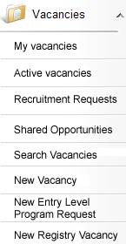
Complete the first few questions about the agency and the position as normal.
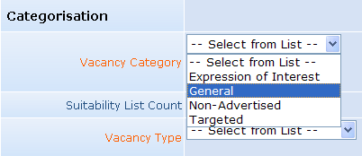
At the ‘Categorisation’ submenu, select General. This will generate a relevant selection list for the next drop down list.
Select Suitability List.
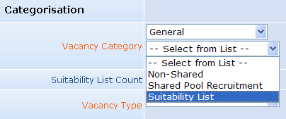
Complete creating the new vacancy as normal.

Step A2
Proceed with the agencies recruitment and selection process as normal:
- Obtain redeployment clearance
- Advertise the vacancy
- Run the selection process

Step A3
Applicants will be assessed as suitable or successful when the result of the recruitment process is known. If CMS is enabled, the status can be updated on RAMS for each applicant in this process.
Appoint the successful applicant to the vacancy as normal.
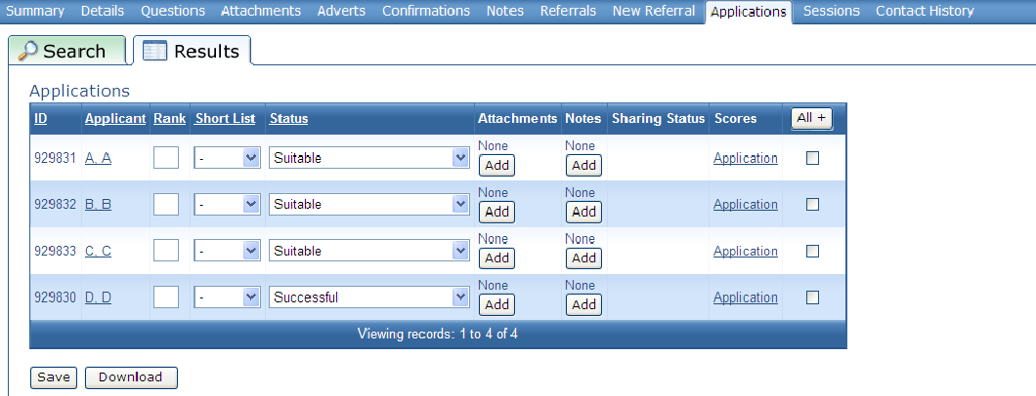
Important note: When applicants apply online for a position that is advertised as a Suitability List, and the vacancy is using CMS, an application question can be asked during the online application process where applicants can indicate their preference to be shared for other positions.
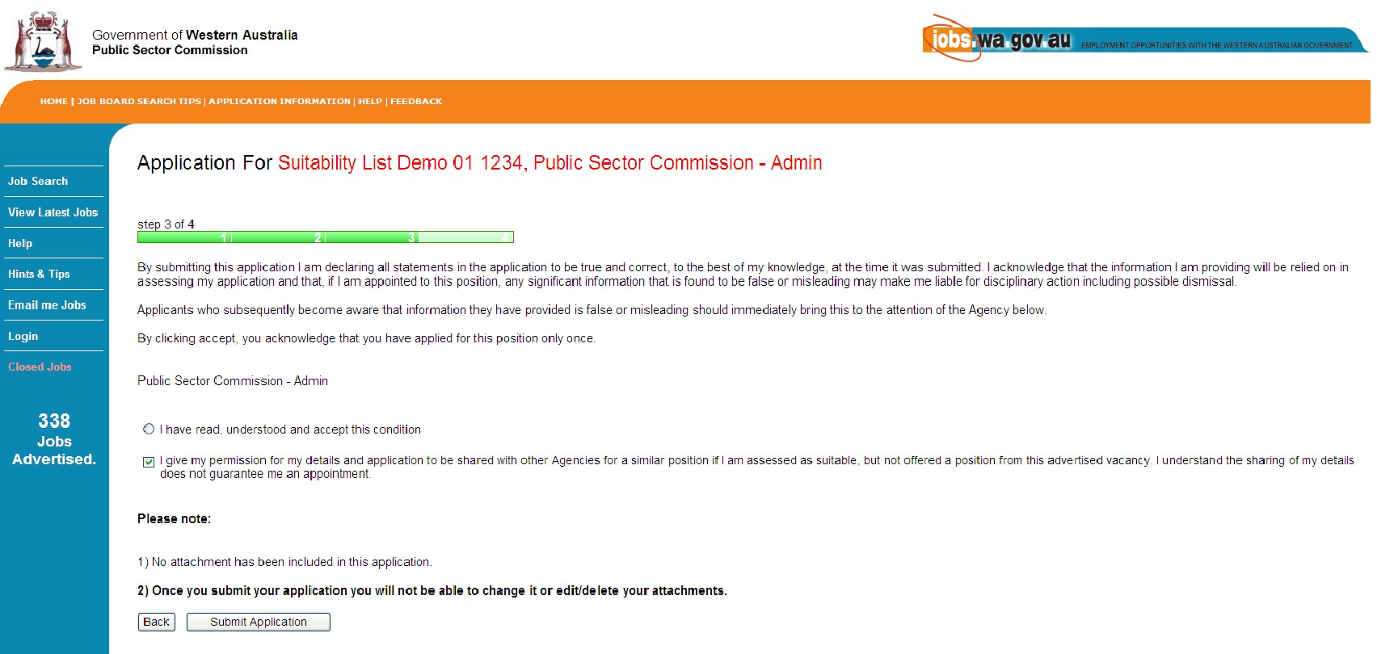
When viewing the list of applicants in RAMS, those that have ticked that box will have a green icon displayed in the Sharing Status column, indicating that they are willing to be shared via a Suitability list to other agencies.
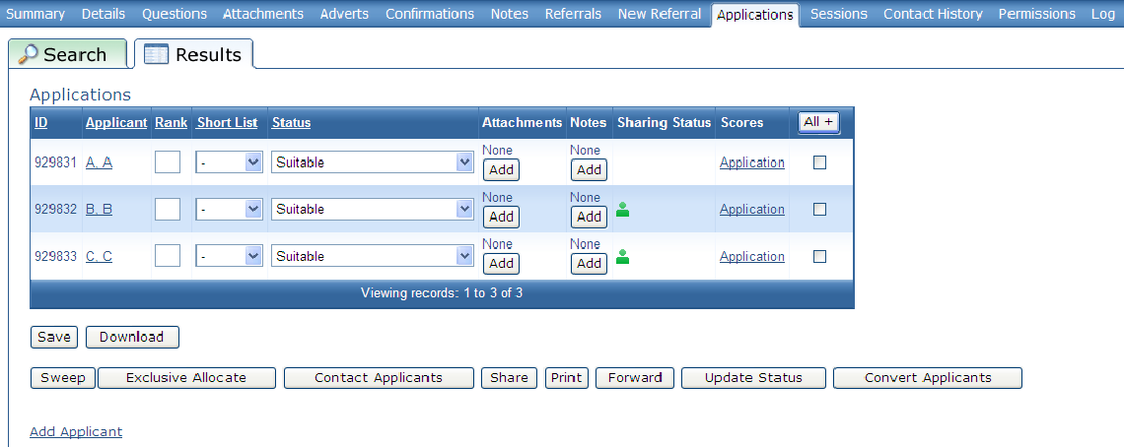
If the vacancy does not use CMS, or if the sharing status of an applicant needs to be changed at any time, then a manual process is available.
Select the tick box corresponding to the relevant applicants and click on the Share button. A new page will appear.
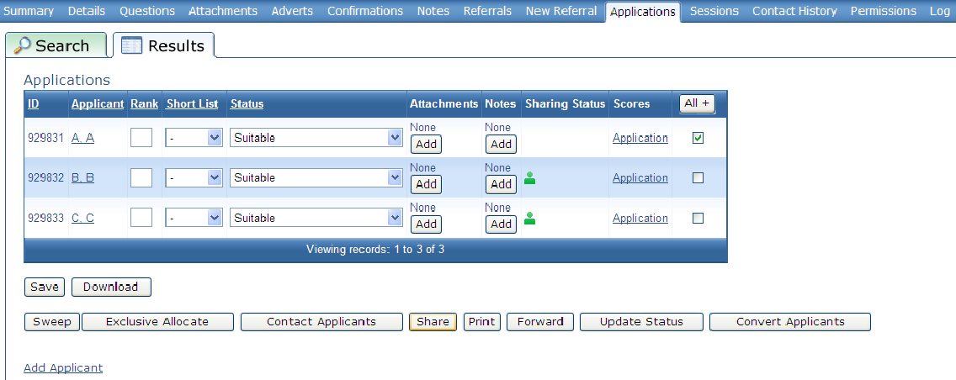

Select Grant or Withdraw in the ‘Applicants Approval to Share’ section as required. The page will return to the Applicants tab, with the Sharing Status updated per the selection.
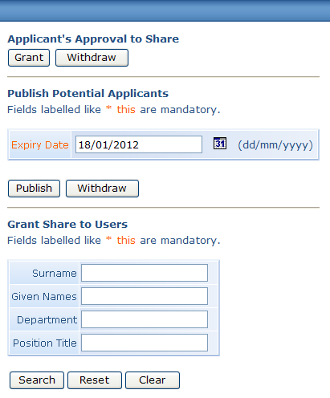
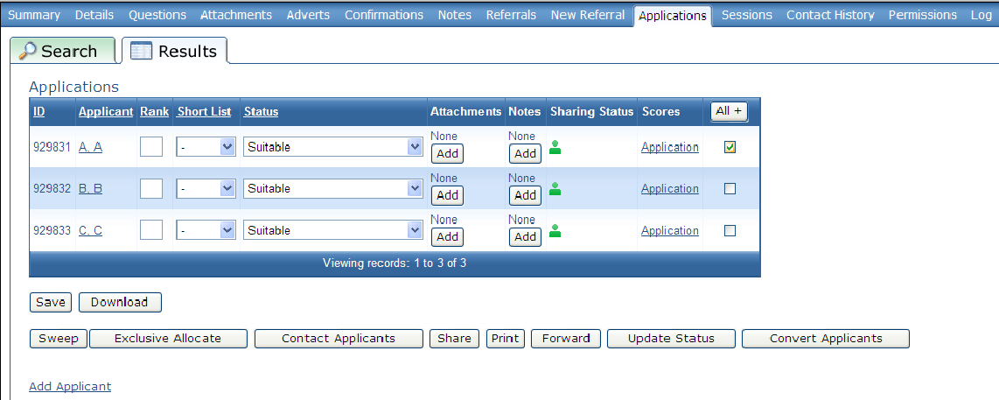

Step A4
Create a Suitability List by publishing any remaining suitable applicants.
Select each applicant to be shared via the tick box, then click the Share button.
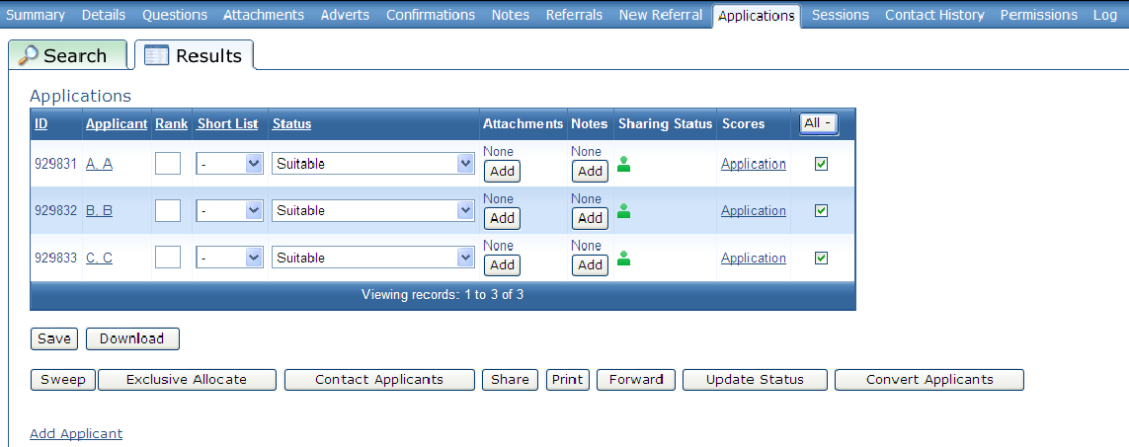
A new page will appear. If required, amend the expiry to reflect the end date of the Suitability List. A Suitability List is active for a defined period, or if no date is specified, no more than six months from the recruitment decision. Click on Publish.
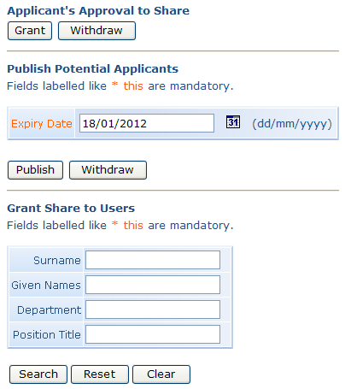
A Suitability List has been created. A blue icon will indicate which applicants are ‘published’, i.e., able to be viewed by other agencies searching Suitability Lists.
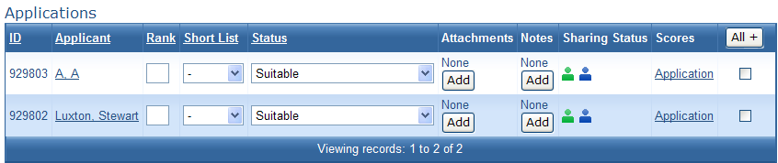

The recruitment process is now complete for the agency unless contacted by another agency that has viewed the Suitability List.
The Suitability List will display in RAMS via the Shared Opportunities page in the Vacancies section of RAMS for the period identified at the start of step A4. Once that period expires, the Suitability List will automatically remove itself from view.
If you are contacted by another agency seeking a applicant from the Suitability List, proceed to step A5.
Note: The lead agency is able to withdraw applicants from being ‘published’ at any time.
This will not change the applicants application status of ‘Suitable’ or their sharing status of ‘Shared’, but will ensure that their details are not able to be viewed by other agencies via the Suitability List.

In the ‘Applications’ tab, select the tick box corresponding to the user to withdraw then click on Share. The blue icon will disappear from that applicant in the ‘Applications’ tab.
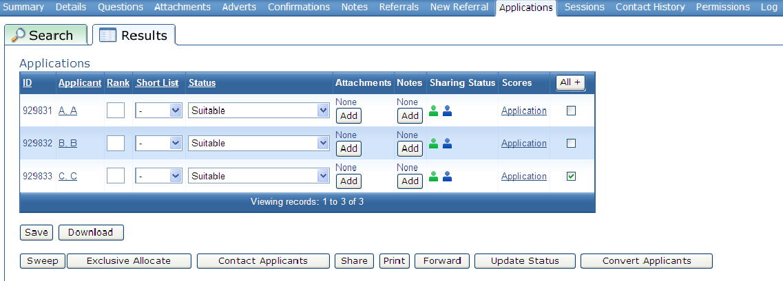
Click on Withdraw in the ‘Publish Potential Applicants’ section.
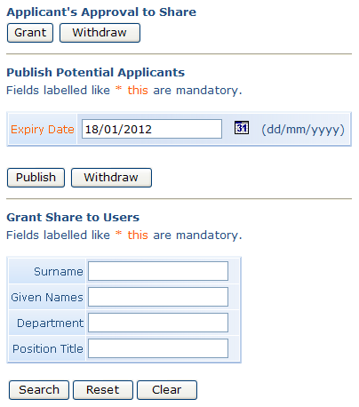
The blue icon is no longer displayed next to that applicant.
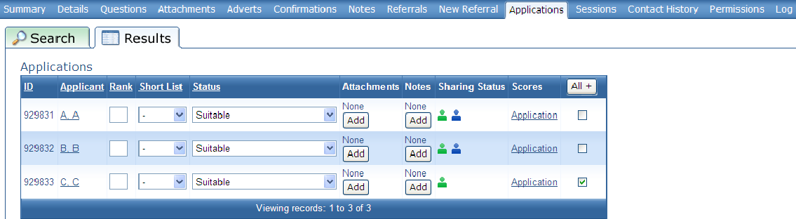

Step A5
In the event that the agency is contacted by another agency, discuss and decide if the Suitability List contains relevant applicants for their needs.
In RAMS, open the relevant vacancy and go to the ‘Applications’ tab.
- Select suitable applicants via the tick box.
- Click on the Share button. A new page will appear.
- 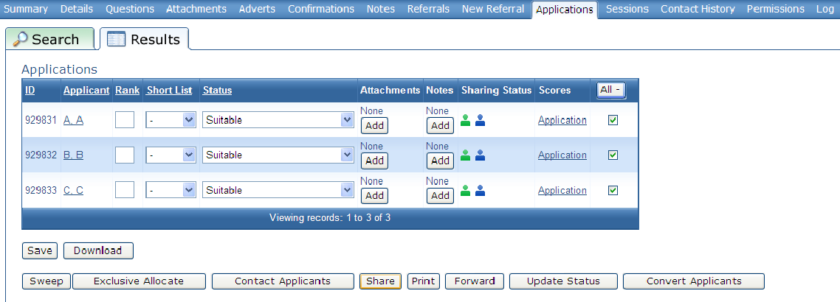
In the ‘Grant Share to Users’ section, search for the RAMS user from the querying agency.
- Enter their name details and click on Search.
- Select the correct user and click on Confirm.
- A pop-up box appears confirming what action has occurred. Click OK.
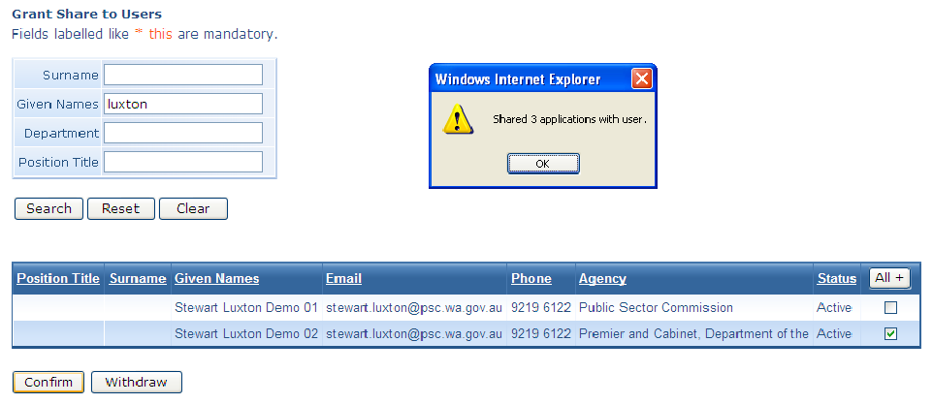

A ‘+’ icon is now displayed next to the blue icon, indicating that the applicant is shared with another agency. Applicants can be shared with many agencies at once. To withdraw the shared status from an applicant, repeat the steps above from the start of Step A5, and select Withdraw.
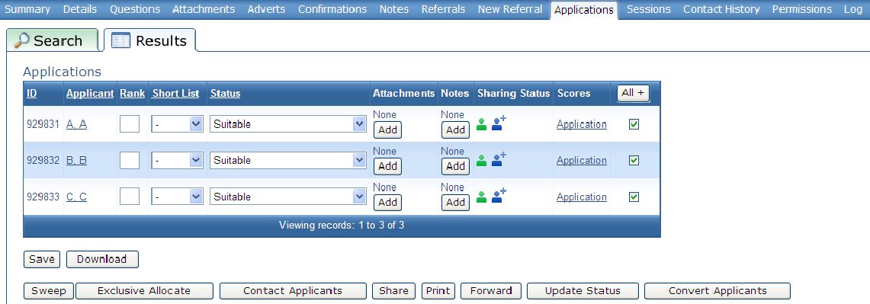
There are no further actions to take for the initiating agency. Further explanation of how an agency can view existing Suitability Lists can be found in Section B.
Note: Step A5 may be repeated by the lead agency as other agencies can view the Suitability List until the expiry date of the Suitability List is reached.

B: Using a Suitability List to seek applicants
Note: Before an agency begins this process, the agency must have a cleared vacancy in RAMS. This will enable shared applicants to be ‘nominated’ to that vacancy.

Step B1
Login to RAMS as normal and on the main menu page select Shared Opportunities.
A new page will appear, allowing agencies to perform a search of all Suitability Lists that have identical or similar job requirements to the agencies cleared vacancy. Enter the relevant search parameters and click Search.
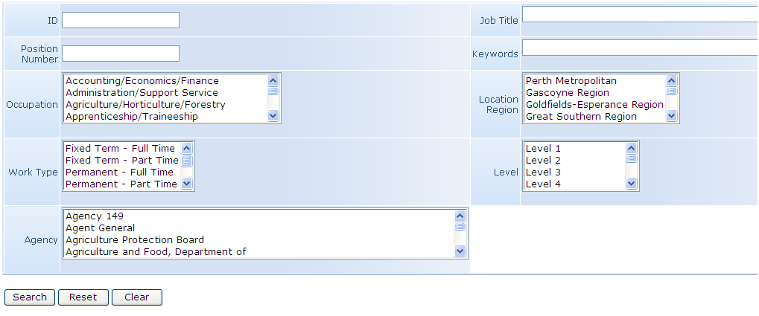

Step B2
A list of relevant Suitability Lists will be generated. The following information is provided:
- Date the Suitability List created
- Agency that created and has control of the Suitability List
- Job title
- Position number
- Classification
- The number of ‘Potential’ suitable applicants that are available, and the number of ‘Actual’ suitable applicants that have been assigned to the agency.
Potential:
- This is the number of suitable applicants that the initiating agency has shared and published for other agencies to view.
Actual:
- This is the number of applicants that have been shared by the lead agency to the querying agency representative. If this is the first time an agency has viewed a Suitability List or no contact has been made to the initiating agency, then there will be no number in the ‘Actual’ column.
More information about each Suitability List is available by selecting the Job Title. This will allow you to see the original vacancy advertisement.
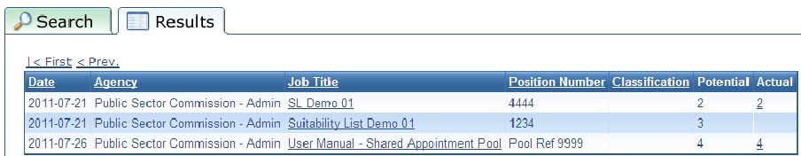

Step B2 continued
If the agency finds a Suitability List that meets its requirements, click on the Job Title. In addition
to the vacancy advert, the agency will find the following contact information:
- Vacancy ID
- Vacancy owner name
- Email and phone details for the vacancy owner.
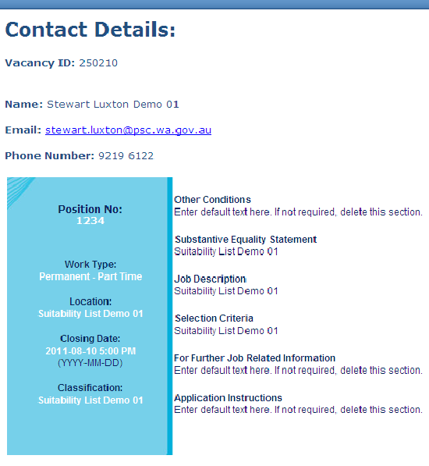

Step B3
Contact the nominated vacancy owner to discuss the available applicants.
If there are suitable applicants available, the lead agency will access RAMS (see Step A5) and grant permission to the querying agency representative to view the suitable applicants.
Once permissions have been granted, search the Shared Opportunities page again. A number will be seen in the ‘Actual’ column. This is the number of applicants the lead agency has assigned to the querying agency representative.
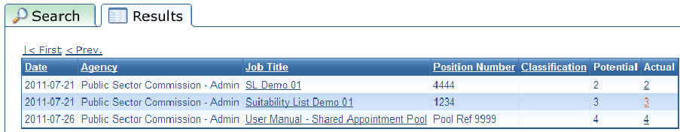
If there are no suitable applicants available, agencies can view other Suitability Lists to find a suitable applicant for their vacancy. If there are none to be found, then the agency should commence a recruitment process as normal. Agencies should determine at this time if they should advertise using a Suitability List (see Section A) or a Shared Appointment Pool process (see Section C).

Step B4
Click on the number in the ‘Actual’ column. This will display a list of the shared applicants.
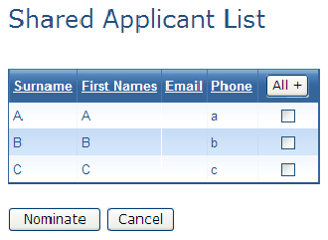
These applicants must be nominated into the vacancy before their details will be able to be viewed. Place a tick in the box against those applicants that will be nominated to the target vacancy. Click Nominate.
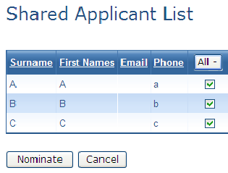

A search page will open. Enter the relevant parameters to identify the relevant vacancy for these that has been created. Click Search.
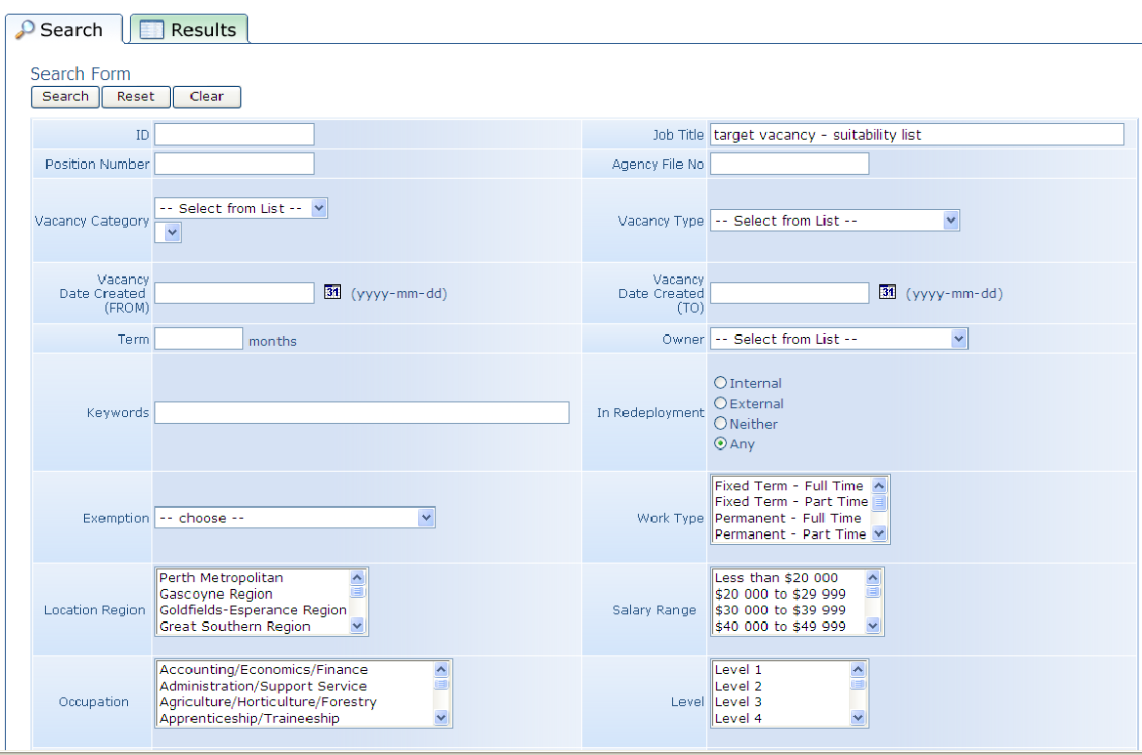
Select the relevant vacancy for the search results. Click Apply. Click OK.
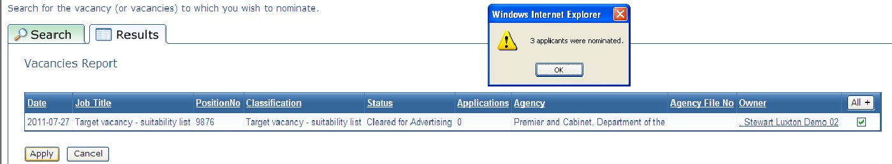
Go to My Vacancies and select the relevant vacancy that the applicants have been nominated to.
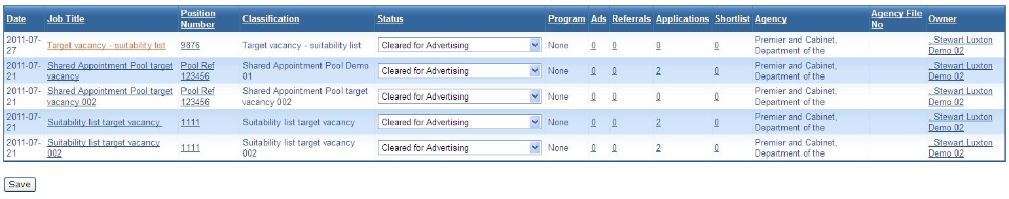

Check the ‘Summary’ tab of the vacancy. Note that the applications have been added, but at this time they will not yet display in the ‘Applications’ tab.
‘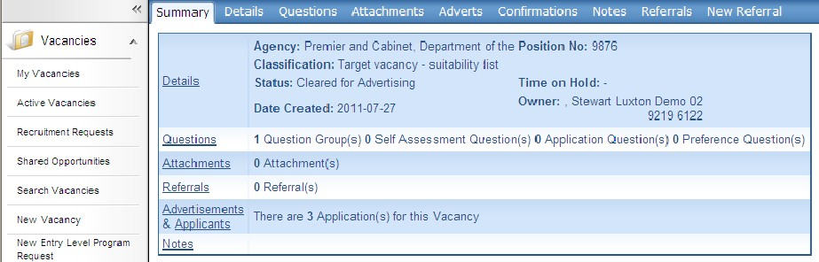

Step B5
Click on the ‘Applications’ tab, then in the ‘Search’ field.
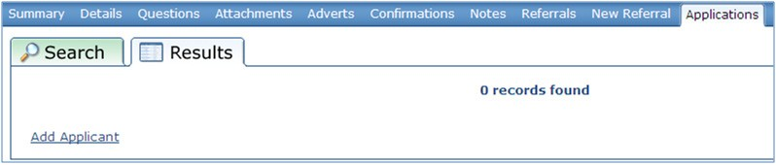

In the ‘Search Criteria’, enter the following search string:
- Division Hierarchy 1
- Application
- Status
- EQUALS TO
- Suitability Nomination.
Click on Generate.
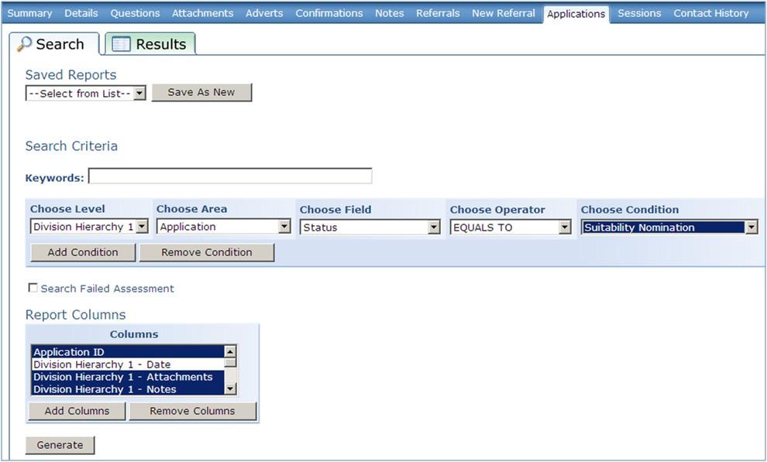

Step B5 continued
The applications will now display in the ‘Results’ tab with a status of ‘Suitability Nomination’. Note that ‘Application’ information is now available. If required, change the status of the nominated applicants in the Status column.
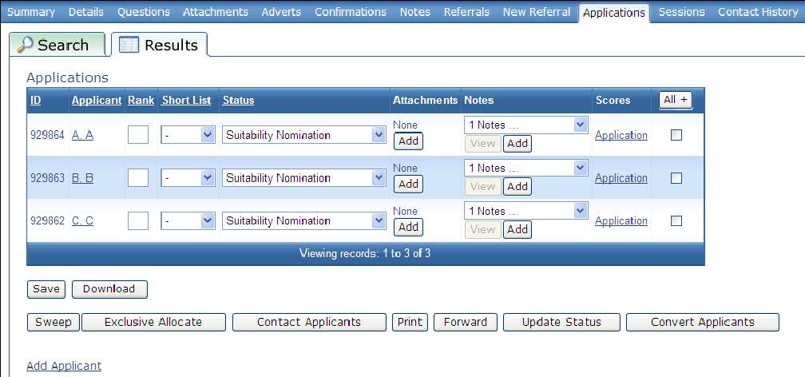
Agencies are able to view the information provided by the applicant as part of their application process by clicking on the Application link. It does not include any information generated by the initiating agency as part of their selection assessment process.
If applicable, appoint a successful applicant and complete the remainder of the recruitment process as normal.
If no appointment occurs, view other Suitability Lists or commence a recruitment process as normal. Agencies should determine at this time if they should advertise using a Suitability List (see Section A) or a Shared Appointment Pool process (see Section C).
Note: The ‘Suitability Nomination’ status is defined in RAMS to not display in the ‘Results’ tab unless the search string described above is used. This is because suitability applicants must not be included in the Application List with other applicants and must not be included in any subsequent report such as the selection report.
If/when an agency appoints an applicant from a Suitability List, the agency may wish to contact the initiating agency and advise them of this fact. However, the Suitability List cannot be changed unless the applicant themselves contacts the initiating agency and asks them to withdraw them from the Suitability List.
Accordingly, unless the applicant requests to be removed from the Suitability List, all applicants will remain on the Suitability List for its duration and may be contacted by other agencies and offered other opportunities.

C: Advertising a Shared Appointment Pool
Before you begin
A number of factors must be considered before commencing the Shared Appointment Pools recruitment process.
If the agency is using the Shared Appointment Pool Recruitment process for the first time, contact the RAMS Contract Manager via rams@psc.wa.gov.au, who will authorise enabling the agency as a Shared Appointment Pool user.
The agency will also need to provide a graphic of their logo for inclusion in the shared advert.
- Format: jpeg or gif
- Dimensions: 190 pixels wide, 130 pixels high
Collaborating agencies must determine the following at a minimum:
- Who is the lead agency (responsible for managing the vacancy in RAMS)?
- Who are the other agencies involved?
- Who is the delegated authority for this Shared Appointment Pool?
- How long will the Shared Appointment Pool operate for?
  - Must run for a defined period, and be determined by all collaborating agencies.
- Who are the representatives from each agency for the review panel?
  - Must be an existing RAMS user.
  - Each user must be created as an AU user in the Lead Agency
- What questions will be required to be answered by applicants?
  - Must be created in the shared question library.
- How will suitable applicants be appointed from the Shared Appointment Pool?
- Which JDF will be used in the advert?
- Will the default Shared Pool advert template be used or will a new advert template be required for the vacancy?
  - The default template is in place and provided for free for all Shared Appointment Pool recruitments. If a specific advert template is required, then a one-off cost will be incurred for its creation. Contact the RAMS Contract Manager via email (rams@psc.wa.gov.au) for further information.
- Who will the central contact be for queries by applicants regarding the vacancy?
- Reporting: Who will be responsible and how will it be done/presented?
Once these factors have been determined, the lead agency begins the process described below.
All agencies should have a cleared vacancy (or pool of cleared vacancies) ready to be filled at the commencement of this process.

Step C1
Create a new vacancy by clicking on New Vacancy under the ‘Vacancies’ tab in the main menu.
At the ‘Categorisation’ submenu, select General. This will generate a relevant selection list. Select Shared Pool Recruitment.
Note: the option to choose Shared Pool Recruitment will only appear in this drop down list if the agency has been enabled as a Shared Appointment Pool user.
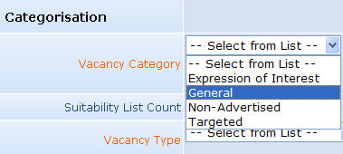

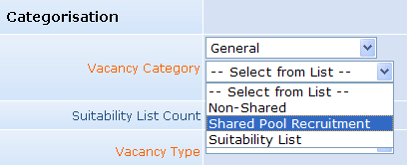
Complete the rest of the Shared Appointment Pool creation process as normal.

Step C2
Proceed with the Shared Appoinment Pool process, using the lead agencies existing process.
Shared Appointment Pool questions must be created in a shared library, rather than in the lead agencies library. This is to ensure that all agencies are able to view the questions throughout the process. All Shared Library questions and answers must be approved by all collaborating agencies.
A shared library will have been created as part of the initial set up of the Shared Appointment Pool. Access to the Shared Appoinment Pool will be granted to an agency at the same time the access to the Shared Advert Template is granted. These accesses will need to be approved by the RAMS Contract Manager at PSC.
To check that the Shared Library has been set up and that the lead agency has access to that Shared Library, click on Questions in the main menu then Question Library Groups.
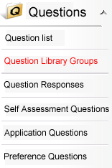

Select a Library from the first drop down menu and then find the Shared Pool Library in the second drop down menu. Go back to the main menu.
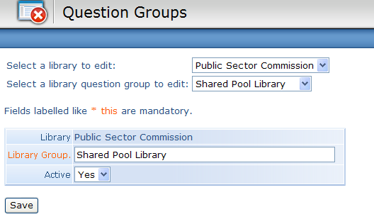
The process to create questions for the shared library is exactly the same as the question creation process in RAMS, except that the lead agency must select the Shared Library Question Group.
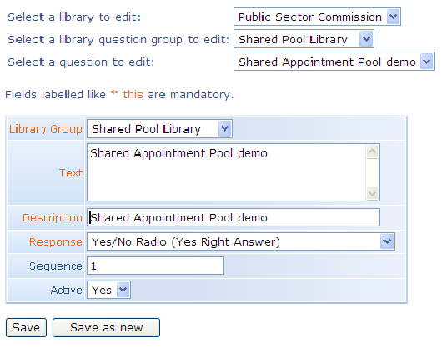
Note: Applicants may opt out of being shared with some of the agencies that are collaborating in the process. Agencies may wish to create a question in the Shared Library that allows applicants to make this choice.

Step C3
Continue with the Shared Appointment Pool per the lead agencies process. When creating the advertisement, some additional steps are required.
Ensure that a clear statement is included in the advert text alerting applicants that this vacancy is a Shared Appointment Pool and what this means.
The lead agency will note a change in the ‘Edit Advertisement’ page in RAMS. Select all the collaborating agencies from the list shown. Only agencies that have been approved as Shared Appointment Pool participants will be listed.
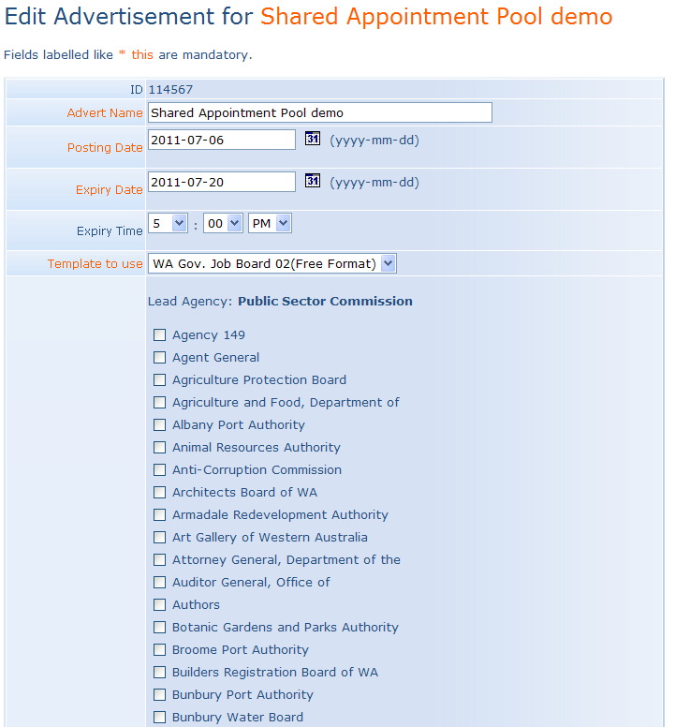

Step C4
Select permissions, then Add New User from the ‘User Permissions’ section.
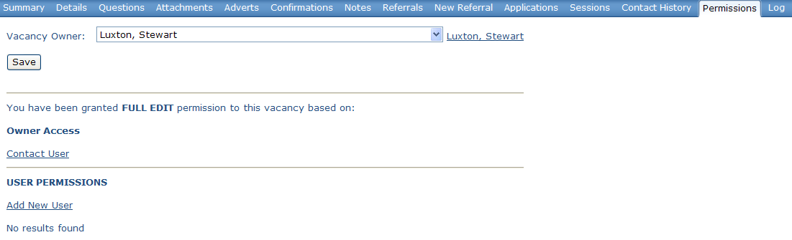
Enter user details of the AU users created at the start of the process and click Search. Select the correct user and add them to the vacancy.
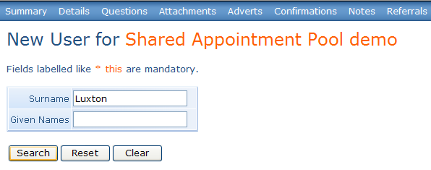

Step C5
When all apsects of the Shared Appoinment Pool vacancy are complete and all agencies are ready to proceed, publish the Shared Appoinment Pool vacancy and undertake the Shared Appoinment Pool selection process per the lead agenices normal procedures.
Ensure that all agencies participate in the pool recruitment process.
At the completion of the recruitment process a list of suitable applicants will be recommended by the panel and approved by the delegated authority. Update the RAMS status of these applicants to suitable.
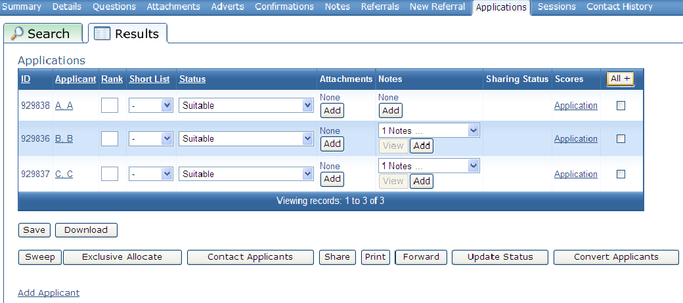
Select all Suitable Applicants, click on the Share button.
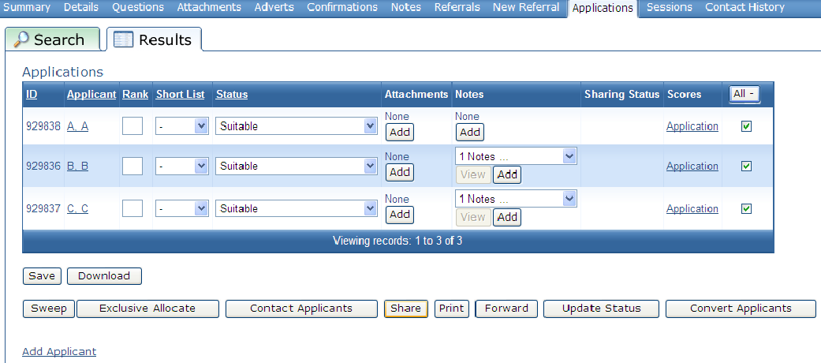

A new page will open. Click on the Grant button in the Applicants Approval to Share section. Click OK.
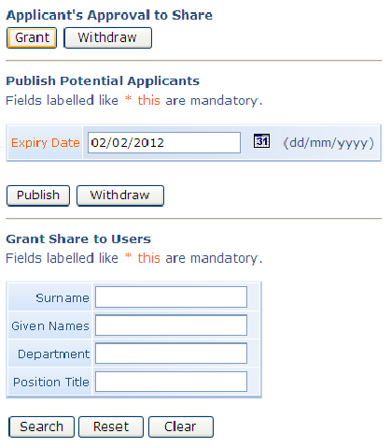
Green icons will appear in the Shared Status column, indicating that these applicants are willing to be shared. Click on the Share button again.
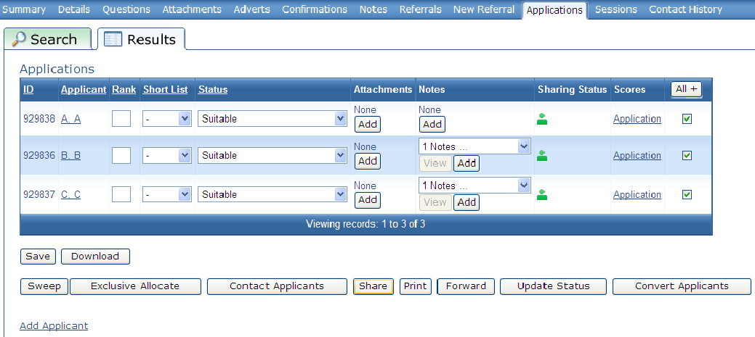

A new page will open. Review the expiry date and click on the Publish button in the Publish Potential Applicants section. Click OK.
Blue icons will appear in the Shared Status column, indicating that these applicants are willing to be published.
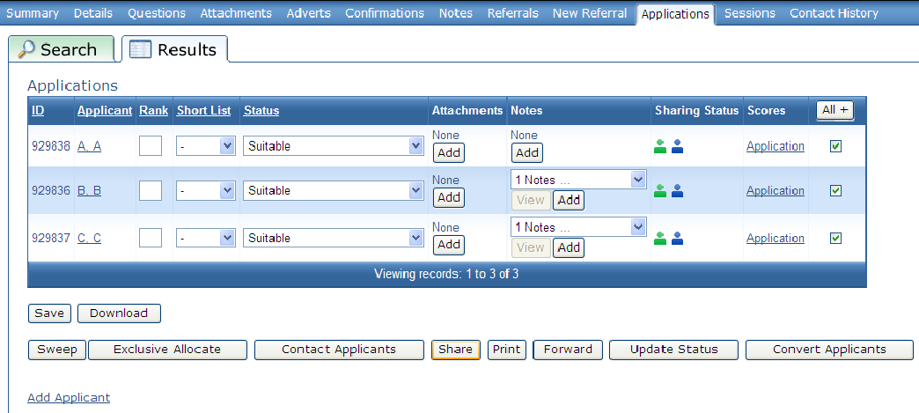

Step C6
Appoint successful applicants.
For the lead agency, the process is the same as a normal pool process. Appoint the applicant to the agency pool vacancy and change the Application Status accordingly.
For collaborative agencies, the Suitable Applicant must be nominated across to a representative of the collaborative agency by the lead agency. Section D explains the rest of the nomination process in more detail.
In the ‘Applications’ tab, select the suitable applicants via the tick box. Click the Share button.
Under the ‘Grant Share to Users’ section, add in the user details of the collaborating agency contact. Click Search.

Select the appropriate user and click Confirm.
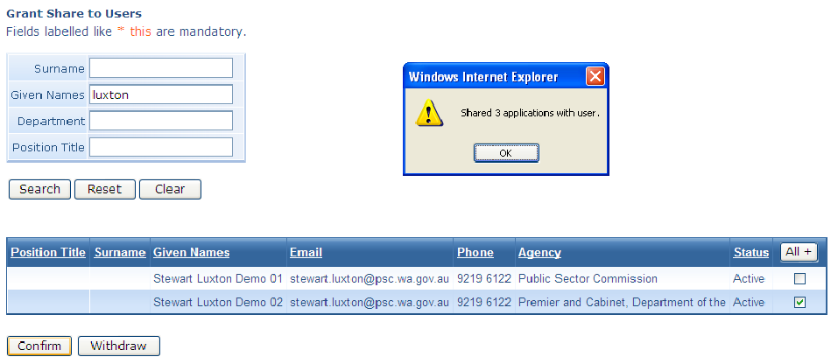
The ‘Applications’ tab displays icons in the ‘Sharing Status’ column.
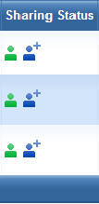
Note that the applicant shared with the collaborating agency shows the + sign next to it, indicating that that applicant has been shared with the collaborating agency contact.
This will allow the agency representative from the collaborating agency to nominate that applicant into their vacancy. Section D explains the rest of the nomination process in more detail.
The role of the lead agency in the Shared Appointment Pool is effectively complete, unless contacted by an applicant asking for a change to be made to their sharing status or one of the collaborating agencies has another vacancy position become available.
Note: Only collaborating agencies can appoint applicants from this process. Agencies cannot create a Suitability List from this process.
D: Appoint applicants from a Shared Appointment Pool
Before you begin
Ensure that a cleared vacancy is available.
Ensure that the person identified in Step C6 logs into RAMS to complete this process as the suitable Shared Applicant Pool applicant has been assigned to that user only.

Step D1
Login to RAMS, select Vacancies and then select Shared Opportunities.
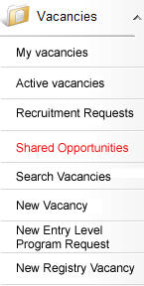
A new page will appear, allowing the agency to perform a search of all relevant Shared Appointment Pools.

Enter required search parameters and click on Search.
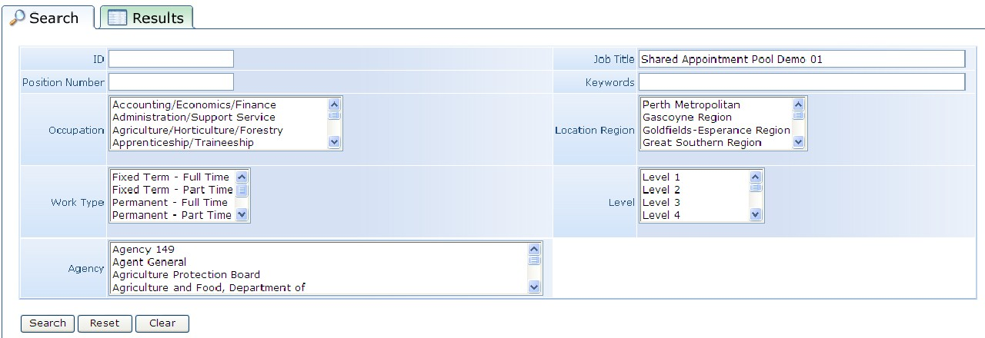

Step D2

The ‘Search Results’ tab will display any Shared Appointment Pools the agency is able to view.
Shared Appointment Pools will display the number of shared applicants in the ‘Actual’ column. Click on the relevant number in the ‘Actual’ column.
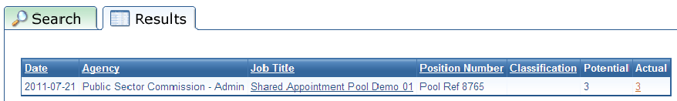
A list of shared applicants will be shown. Select applicants via the tick box and click the Nominate button.
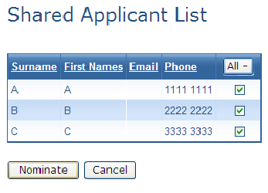

Step D2 continued
The following page appears, allowing the agency to seach for the correct vacancy that the selected applicant/s will be nominated to.
Enter required search parameters and click Search.
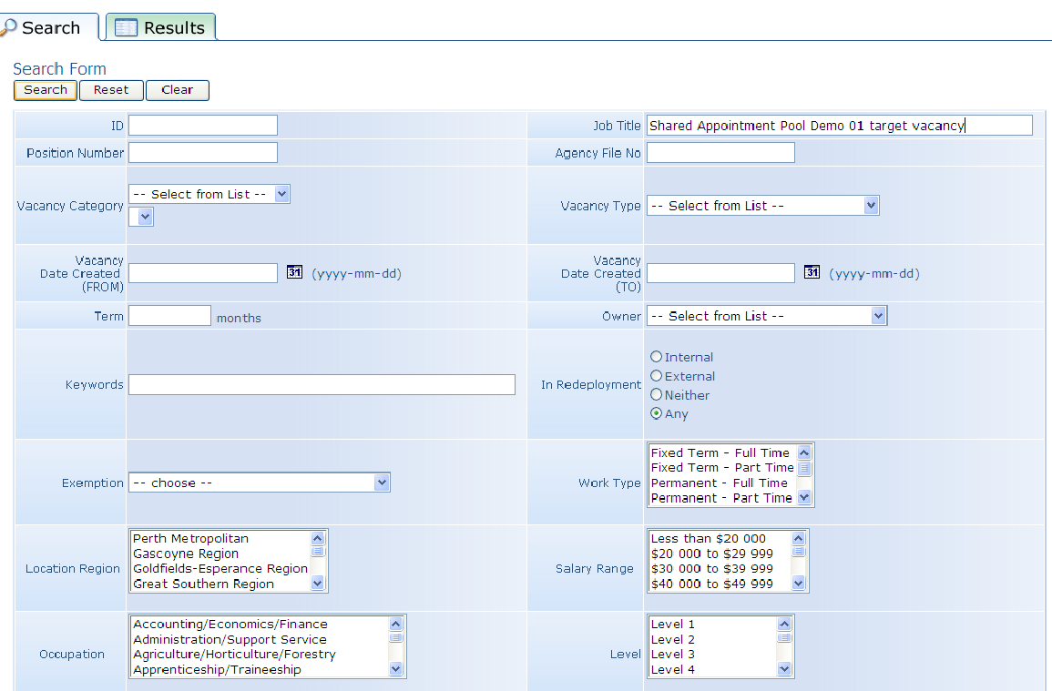

Select the correct vacancy via the tick box to attach the suitable applicant/s to and click the Apply button
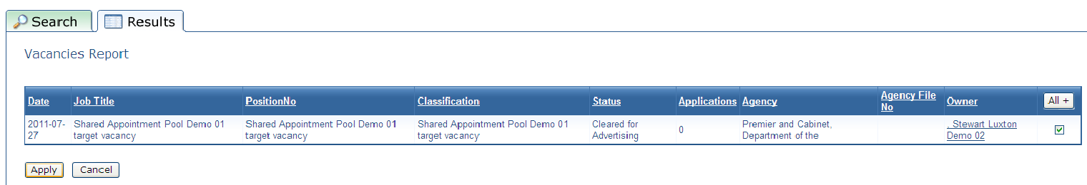

Step D3
In the ‘Applications’ tab, click Search.
In the ‘Search Criteria’, enter the following search string:
- Division Hierarchy1
- Application
- Status
- EQUALS TO
- Suitability Nomination.
Click on Generate.

Step D4
The suitable applicants are now nominated and visible in the collaborating agency vacancy.
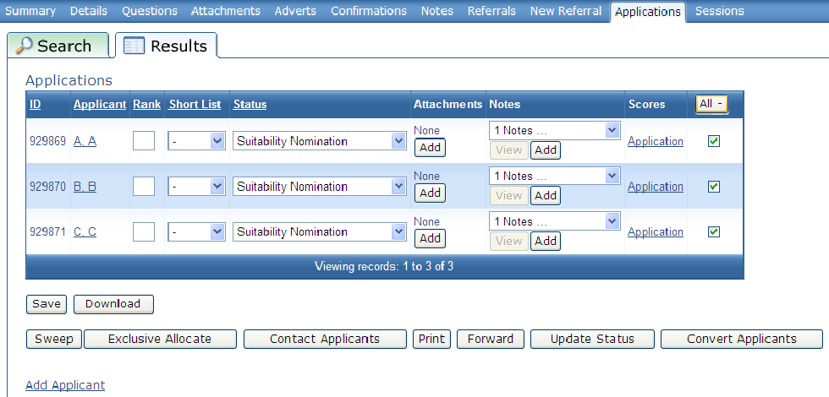
Appoint the candidate(s) to your position(s) per the agencies normal appointment process, remembering to ensure that the Status is changed from ‘Suitability Nomination’.
Click Save or the system will not recognise that your appointment is complete.
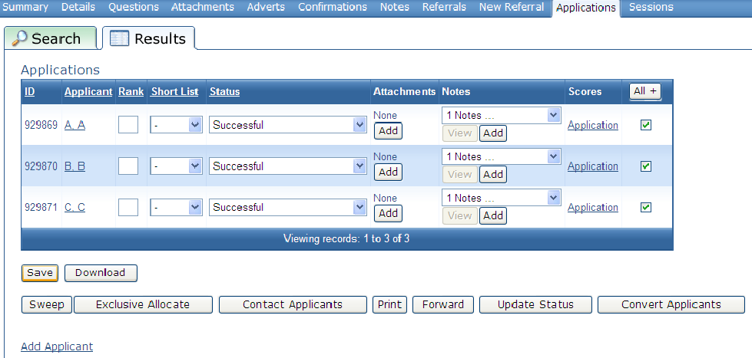
The process is complete.

Further information/feedback
Users of these guidelines are welcome to make suggestions or ask for more information on these enhancements or other matters relating to RAMS at any time.
Please contact the RAMS Contract Manager rams@psc.wa.gov.au

