Redeployment and Redundancy
Case Management Guidelines
Overview 2
Requirements to provide case management support 2
Role and responsibilities of agency case managers 3
Role and responsibilities of employees 3
Case management 4
Case management - registrable employee 4
Initial meeting with registrable employee 4
Internal job matching processes 4
Access to external public sector vacancies 4
Voluntary severance 5
Case management - registered employee 5
Redeployment case management activities 6
Identification and referral to suitable job opportunities
Access to job placement opportunities 8
Suitability assessment process 8
Retraining 10
Case management for impending termination 10

This publication can be copied in whole or part with due acknowledgement. It is on www.wa.gov.au. Copies are available in alternative formats on request.
Disclaimer: While every attempt is made to ensure the accuracy, currency and reliability of the information in this publication, changes in circumstances over time may impact on the veracity of the information.
Published by the Public Sector Commission (Western Australia) April 2015.
Overview
The provision of effective, transparent, and accountable case management services will assist agencies to meet their obligations under the redeployment and redundancy framework.
These guidelines are not intended to be prescriptive in nature but rather aims to provide a practical resource for agency redeployment case managers when providing case management support to employees.
It is intended this guide will also be used by agencies to develop internal policies relating to the provision of appropriate case management.
Information provided in this guide should be read in conjunction with Part 6 of the Public Sector Management Act 1994 (PSMA), the Public Sector Management (Redeployment and Redundancy) Regulations 2014 (the Regulations) and Commissioner’s instruction No.12 - Redeployment and Redundancy (CI No.12).

Requirements to provide case management support
Public sector employers are to adequately resource and provide case management support to their employees throughout the redeployment and redundancy process.
Regulation 21 and CI No.12 places specific case management obligations on employing authorities to support registered employees throughout the period of redeployment, but it is expected that case management will begin as soon as an employee is identified as a registrable employee.
An agency will determine the appropriate form of case management to be undertaken and may be guided by a number of factors such as the size of the agency, extent of any reform or change activity or the number of employees affected.
Case management arrangements may include situations where managers continue to maintain responsibility for the day to day management of their registrable/registered employees and are supported by human resource or case management services to assist redeployment outcomes. Alternatively, case management services may be sourced from existing agency employees, through established shared or other bureau services, or through external contract services providers.
Case management services may be provided by one person either on a dedicated basis or performed in conjunction with other duties, or when significant numbers of employees are involved may require the establishment of an appropriately resourced team with clearly assigned responsibilities to manage the redeployment process.

Role and responsibilities of agency case managers
Case managers assist in facilitating redeployment and redundancy activities and outcomes.
Case managers play an important role in supporting employees. While the extent of the required support will vary depending on the individual case, case management activities may involve advisory and practical services to help an employee understand their options and entitlements, assist them in preparing for change or potential placement opportunities and provide access to appropriate counselling.
It is important that case managers are identified in the early stages of any change process.
It is useful for case managers to become familiar with the employee’s background experience, qualifications, skills and interests to assist redeployment processes.
The contact details of support services, such as the Employee Assistance Program, may be provided to employees during initial meetings or discussions.
Case managers are encouraged to maintain robust and transparent record keeping practices.

Role and responsibilities of employees
Employees need to work actively and co-operatively with their case manager to give effect to job transition outcomes.
It is important that employees understand that they will need to:
- work positively with support services being offered to better equip them and assist their career transition efforts
- prepare a competitive resume
- be prepared for an interview when referred to positions, including familiarising themselves with the role and function of the agency and presenting in a positive manner
- actively pursue alternative employment opportunities and be willing to consider all possible job transition options.

Case management

Case management - registrable employee
It is expected that case management activities will begin once an employee is identified as a “registrable employee” and continue until such time the employee’s redeployment circumstances are resolved.
The following provides a suggested summary of case management activities and services that may be provided to registrable employees.

Initial meeting with registrable employee
As soon as practicable, the assigned case manager may wish to meet with the registrable employee to inform them of their options, relevant processes, and entitlements and support services.
Such a meeting may allow for the opportunity to gather information, confirm understandings and advise employees of such things as:
- their status and potential implications of being a registrable employee
- interim work arrangements
- relevant roles and responsibilities
The initial meeting may also provide the opportunity to identify the employee’s transferable skills and assess possible placement or retraining opportunities.
Case managers may also arrange appropriate support services that better equip and prepare employees for change and to be more competitive when applying and being considered for job placement opportunities.
External career transition services may be considered where in-house expertise may not available.

Internal job matching processes
Job placement opportunities may include placements that are currently available or likely to become available into which the employee may be retrained or placed.
It is expected that such opportunities be exhausted prior to giving consideration to registering the employee for redeployment.

Access to external public sector vacancies
The Recruitment Advertising Management System (RAMS) provides case managers with a daily listing of public sector job placement opportunities external to the agency.
Where the agency chooses to do so, informal approaches may be undertaken to liaise with an external agency to assess their willingness to consider the possible transfer of a registrable employee to a vacancy or an employment opportunity for retraining purposes.
Case managers may contact relevant managers in the external agency to sound out their willingness to consider the claims of any suitably qualified registrable employees for placement in the vacancy in the event no registered employees are to be, or have been, referred. In all instances, the claim of an available referred registered employee must be considered ahead of the registrable employee.
There is no obligation on the relevant line manager to agree to consider the registrable employee’s claims.
Retraining may involve secondment arrangements and the terms and conditions that apply are to be agreed between the employee, their employing authority and the agency with the vacancy.
Agreed arrangements, (i.e. transfers, secondments or retraining placements) and applicable terms and conditions need to be confirmed in writing in line with accepted human resource processes.

Voluntary severance
Case managers may also have a role in the voluntary severance process for registrable employees, including:
- discussions with employees concerning the option of voluntary severance and associated conditions
- preparing internal submissions for approval
- providing individual estimate payment details
- encouraging the employee to seek advice about taxation and superannuation relevant to their circumstances
- preparing and issuing severance offers and letters
- maintaining RAMS records

Case management - registered employee
The Regulations and CI No.12 provide a specific obligation for the employing authority to ensure that the employee is adequately and reasonably supported in identifying, being referred to, and given priority consideration for alternative suitable job or retraining opportunities in the public sector. Such support activities may include:
- priority access to public sector job vacancies
- entitlements to reasonable leave to attend job interviews and appropriate career and financial counselling
- receipt of 6 month pay maintenance when taking up a position which attracts a lesser rate of pay to the rate of their former position.
- In particular, case managers will have a significant role in assisting and managing the job matching and referral process for their registered employees. This may include:
- ensuring their registered employees are provided with access to public sector job opportunities made available through the daily emailed RAMS job listing
- facilitating discussions with their registered employees about the suitability for potential placement in those vacancies
- effecting referrals on their behalf through established processes
- working with the agency to reach agreement on the suitability of referred employee.

Redeployment case management activities
Redeployment case management actions will largely relate to vacancy identification and matching, redeployment referral actions and suitability assessments.
It is important that case managers consider processes that are appropriate to the individual registered employee and their circumstances. The below diagram has been developed to assist agencies in identifying appropriate processes. The diagram is not prescriptive and should be adapted to meet individual circumstances.
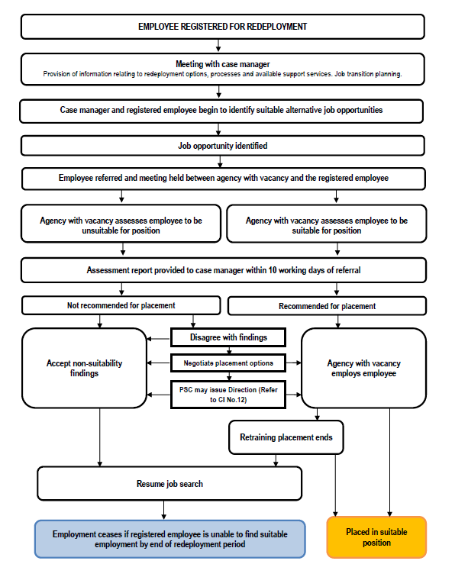

Identification and referral to suitable job opportunities Access to job placement opportunities
RAMS provides agency case managers with daily access to public sector job opportunities. Case managers have up to three working days to consider the suitability of their registered employees and to place a “hold” on a posted vacancy. From the end of the three day “hold” period case managers have a further two day period in which to refer any suitable registered employees to a job. Potential suitable job placement opportunities should be discussed with the registered employee.

Appropriate matching
When considering the appropriateness for a referral being made to a vacancy, case managers and registered employees need to ensure an appropriate match exists. Legislative provisions in regards to the definition of “suitable employment” should be kept in mind. In particular, regard is to be given for the responsibilities associated with the position compared to those held by the registered employee and their experience, skills, qualifications and competence.

Referral actions
Where it is identified that a registered employee is potentially suited to a particular vacancy, the case manager places a “referral” on RAMS and submits the registered employee’s résumé for the consideration of the advertising agency.

Competitive approaches
As more than one registered employee may be put forward for consideration, it is important referred employees ensure their interview skills are well developed and they approach assessment meetings competitively.

Suitability assessment process

Meeting held between agency with vacancy and registered employee
To assess suitability for placement in a position, it is expected that a meeting will be held between representatives from the agency with the vacancy and the registered employee. This may assist in an objective assessment to be undertaken of the employee’s suitability for appointment.
Where two or more registered employees are referred for consideration for the same position, selection will be made on merit.

Assessment criteria
In accessing the suitability of a registered employee for placement in a vacancy, an employing authority must give consideration to the employee’s ability to fulfil the requirements of the job within a reasonable period of time, with reasonable training.
The assessment also needs to have regard for the responsibilities of the position and to the experience, qualifications and competence of the employee.

Meeting format
While public sector employers have responsibility for determining applicable selection processes, the use of a formal selection interview may not always be appropriate in these circumstances. Particularly for generic type positions, a less formal meeting structured around the requirements of the job may be considered to elicit sufficient information for assessing the registered employee’s suitability.

Outcome report
CI No.12 requires the agency with the vacancy to provide a formal assessment report within 10 working days of the RAMS referral notice date unless otherwise agreed between the agency making the referral and the agency with the vacancy.
The report will need to provide sufficient information to demonstrate how the claims of the registered employee have been assessed in relation to job responsibilities along with a decision on suitability.

Formal offer when suitability confirmed
Where assessment outcomes confirm the suitability of a registered employee for appointment, the agency with the vacancy is required under regulation 22 to make an offer of employment in writing to the employee.
The offer needs to set out the terms and conditions (including pay details) subject to which the offer is being made. The registered employee needs to provide written confirmation of their acceptance or non-acceptance of the offer.

Refusal to accept employment offer
Where a registered employee receives but refuses to accept an offer of suitable employment or obstructs their redeployment to a suitable employment opportunity, the case manager should in the first instance attempt to work with the employee to bring about an appropriate resolution.
Where such attempts fail to address the situation, the employing authority may request the Public Sector Commissioner (or delegate) to direct the employee to accept that offer. If the Commissioner is satisfied that the offer of employment represents suitable employment, the Commissioner may direct the employee to accept the offer.
Refusal to accept the offer at this stage may be considered a breach of discipline under the PSMA and regulation 43.

Process when referred employee found unsuitable
Where a redeployment assessment finds a registered employee to be unsuited to the position the case manager should inform the registered employee. Following acceptance of the report, the case manager should make appropriate case notes and update RAMS.
The case manager will need to resume the redeployment search and continue to work with the registered employee to identify other potential suitable vacancies.

Retraining
The employing authority may arrange for the registered employee to be employed for retraining purposes inside or outside the public sector. This is set out in regulation 20(1).
Retraining requires the approval of the employing authority. Consideration of the appropriateness of retraining is likely to depend on an assessment of the realistic chances of an actual job being secured by the registered employee prior to the completion of their redeployment period.
All parties (i.e. the employee, their employing authority, and the employer providing the retraining opportunity) must agree to the retraining arrangements and the terms and conditions that are to apply. Retraining is not facilitated through an offer of employment.
CI No.12 confirms that any retraining arrangement given effect under regulation 20 must be made in writing and include a provision for terminating the arrangement.
Regulation 20 also confirms:
- the terms and conditions that apply to the retraining must be agreed to by the employee, their employing authority and the employer employing the employee for retraining
- the period of retraining cannot exceed a period greater than the employee’s redeployment period
- the period of retraining is disregarded for the purposes of calculating the six month pay maintenance period
Associated costs are to be met by the registered employee’s home agency unless otherwise negotiated.

Case management for impending termination
The employment of a registered employee who has not been successfully redeployed by the end of their redeployment period is terminated by the operation of the Regulations.
At the request of the registered employee, an employing authority may also agree to terminate the employee’s employment prior to the completion of the redeployment period.
Prior to termination, case managers may assist registered employees by:
- providing advice or responding to enquiries throughout the redeployment period concerning potential redundancy applications
- monitoring the redeployment status of registered employees to ensure sufficient time is provided to give effect to decision making
- ensuring that all legislative and other requirements have been met by the employing authority
- providing individual redundancy estimate payment details
- encouraging advice relating to taxation and superannuation to be sought
- maintaining and updating RAMS records.

