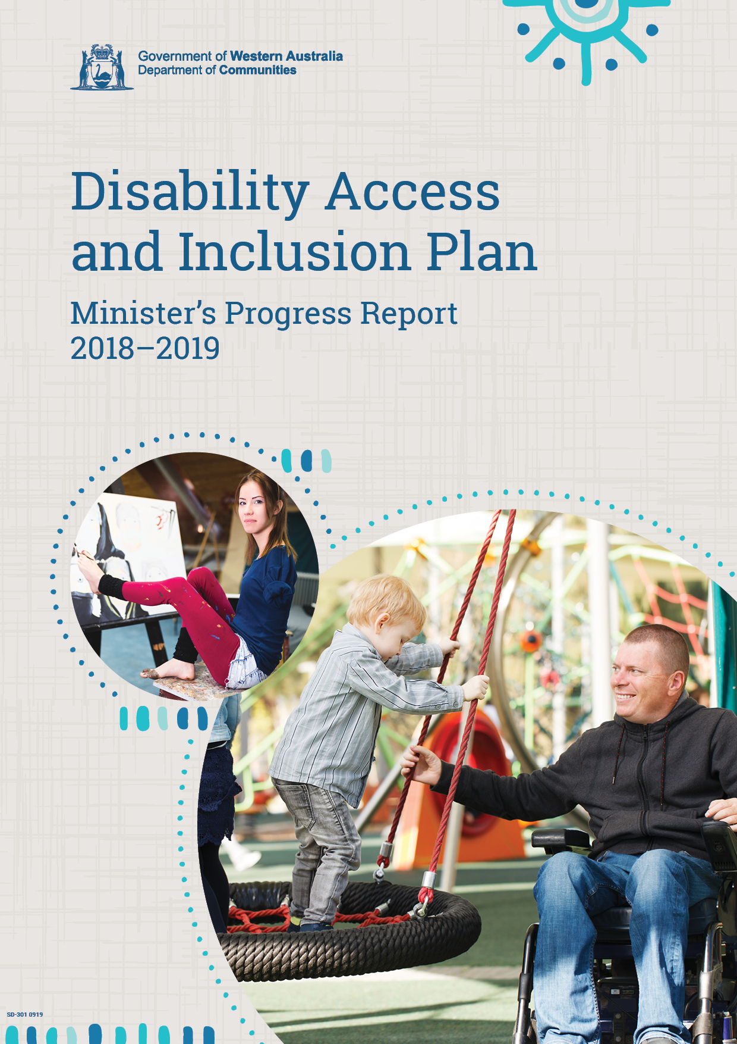

Disability Access and Inclusion Plan: Minister’s Progress Report 2018-2019
Table of contents
Message from the Minister for Disability Services 1
Introduction 2
Report format 3
The access and inclusion landscape in 2018-19 4
DAIP Outcomes at a glance 5
DAIP Progress Reports feature articles 6
Access and Inclusion Advisory Groups 6
Shire of Collie 6
Perth Airport 7
Western Australian Museum 7
City of Rockingham 7
City of Kalgoorlie-Boulder 7
South Metropolitan Health Service 8
City of Bunbury 8
City of Melville 8
Socially Inclusive Communities 9
Most Accessible Community in Western Australia (MACWA) Awards 11
Outcome 1 achievements – Services 14
Shire of Augusta-Margaret River 14
Shire of Broome 16
Town of Victoria Park 16
Shire of Denmark 17
Shire of Harvey 18
Western Australian Museum 19
City of Fremantle 20
City of Albany 20
Town of Cambridge 21
City of Wanneroo 23
Outcome 2 achievements – Facilities 25
Department of Biodiversity, Conservation and Attractions 25
Shire of Narrogin 26
City of Belmont 27
City of Armadale 28
Shire of Augusta-Margaret River 30
City of Stirling 30
City of Fremantle 31
Rottnest Island Authority 32
City of Mandurah 32
Outcome 3 achievements – Information 35
Town of Cambridge 35
City of Melville 35
City of Cockburn 36
Department of Finance 36
Central Regional TAFE 37
South Metropolitan Health Service 37
Department of Fire and Emergency Services 38
City of Fremantle 39
City of Mandurah 39
Outcome 4 achievements – Service quality 42
Department of Education 42
City of Melville 43
Shire of Lake Grace 43
Outcome 5 – Complaints 45
Main Roads 45
City of Armadale 45
City of Mandurah 45
Outcome 6 achievements – Consultation 48
City of Stirling 48
Synergy 49
Mental Health Commission 49
Main Roads 50
Shire of Broome 50
Shire of Narrogin 50
Shire of Cue 50
City of Fremantle 51
Western Australian Museum 51
Town of Victoria Park 52
Outcome 7 achievements – Employment 55
North Regional TAFE 55
Department of Mines, Industry Regulation and Safety 57
Department of Training and Workforce Development 58
City of Greater Geraldton 58
Shire of Augusta-Margaret River 58
Town of Victoria Park 59
City of Mandurah 60
City of Bayswater 60
Shire of Kojonup 61
Department of Communities 62
Department of Primary Industries and Regional Development 62
Department of Mines, Industry Regulation and Safety 62
Agents and contractors 63
South Metropolitan Health Service 64
City of Fremantle 64
City of Canning 65
Analysis of public authority DAIP Progress Reports 66
DAIP activities 66
Focus on the influence of DAIPS 66
Challenges experienced by public authorities 67
Changes in staffing/leadership 67
Budget constraints 67
Lack of support/feedback from the community 67
Support from the Department of Communities 68
Appendix One: Public authority submissions 69

Message from the Minister for Disability Services
In presenting the Disability Access and Inclusion Plan (DAIP) Progress Report for 2018-19, I will take the opportunity to highlight the endeavours and achievements of public authorities in improving the inclusion of people with disability, their families and carers.
Inclusion will be a key driver of Western Australia’s future prosperity and living standards. Inclusions’ capacity to harness the diversity of just over one in five Western Australians is dependent on addressing the barriers and restrictions faced by people with disability in reaching their full potential in social, economic and civil life.
The Progress Report shows the ongoing commitment of public authorities across the breadth of the state to using innovation and creativity to identify localised solutions to what is a global issue.
As we reach a new decade, it is critical that the economic imperative for inclusion gains equal footing with the long-held human rights and moral justifications. This will require leadership across business, government and broader society.
This year I have witnessed all aspects of society advocate for the inclusion of people with disability, including friends, families, carers and of course people with disability themselves. Without the essential role of advocacy, initiatives like the expansion of changing places and inclusive play areas across the state would not have occurred.
Access and inclusion requires an ongoing commitment to affording people with disability the best opportunity to thrive across education, health and employment, and enabling them to undertake valued roles in their communities.
The State Government’s obligation to co-designing the policies and services required by people with disability goes some way to ensuring people with disability can contribute their expertise and lived experience to improve the responsiveness and person-centred nature of the programs and supports they require. Co-design will play a key role in shaping the kind of welcoming community that we are all striving for.
The consultation that has occurred with stakeholders in the development of the State Disability Plan throughout 2019 will provide the insights to drive future improvements to the inclusion and empowerment of people with disability.
I would like to take the opportunity to thank the Western Australian public sector for its leadership, and its individual and collective insight across DAIP activities. The passion, skill and investment of local and state government authorities in creating a more inclusive community cannot be underestimated and I trust you will enjoy reading about their experiences.
Hon Stephen Dawson MLC
Minister for Disability Services


Introduction
The 2015 Australian Bureau of Statistics survey of Disability, Ageing and Carers estimates that there are 362,700 people with disability living in Western Australia (WA) (14.6 per cent of the total population). Of these, approximately 101,600 people have profound or severe core activity limitation. There are an estimated 201,700 carers for people with disability in WA; 68,000 of these are primary carers (people providing informal assistance, often around the clock, for people with disability). While this accounts for around one quarter of WA’s population, inclusive design and practice benefits everyone and has an ongoing impact on the diversity, cohesion and economy of the state.
Disability Access and Inclusion Plans (DAIPs) are the formal levers for identifying and addressing barriers to access and for protecting the rights of people with disability. In addition, DAIPs help to strengthen the independence of people with disability and to provide such people with greater opportunities for community participation. DAIPs are supported by a range of other legislative mechanisms including the Commonwealth Disability Discrimination Act 1992, Access to Premises Standards 2010 and the WA Equal Opportunity Act 1984. DAIPs effectively drive Western Australia’s commitment to national agreements which support people with disability and maximise their potential as equal citizens under the National Disability Strategy 2010-2020.
The Disability Services Act 1993 (the Act) requires Western Australian public authorities to implement a DAIP and to report on its implementation each year. DAIPs must be reviewed at least every five years.
Public authorities that are required to have a DAIP include:
- government departments established under the Public Sector Management Act 1994
- local governments
- universities
- public health services established under the Health Services Act 2016
- the Water Corporation
- corporations supplying electricity.
The process for developing a DAIP is set out in the Act and the Disability Services Regulations 2004. An authority is required to ensure:
- the community is notified and consulted
- the finished DAIP is published and lodged with the Department of Communities
- public authorities outline their DAIP activities in their own annual reports
- public authorities provide an annual progress report to the Department of Communities, including activities by agents and contractors who provide services to the public.
The annual progress report is designed to identify achievements, challenges and trends against the DAIP outcomes. The outcomes are designed to support people with disability to have the same rights as those without a disability and as such, to be valued and productive members of the community.
The seven DAIP Outcomes are listed below:
- Outcome 1
People with disability have the same opportunities as other people to access the services of, and any event organised by, a public authority.
- Outcome 2
People with disability have the same opportunities as other people to access the buildings and other facilities of a public authority.
- Outcome 3
People with disability receive information from a public authority in a format that will enable them to access the information as readily as other people are able to access it.
- Outcome 4
People with disability receive the same level and quality of service from the staff of a public authority as other people receive from the staff of that public authority.
- Outcome 5
People with disability have the same opportunities as other people to make complaints to a public authority.
- Outcome 6
People with disability have the same opportunities as other people to participate in any public consultation by a public authority.
- Outcome 7
People with disability have the same opportunities as other people to obtain and maintain employment with a public authority.
Following a review of the information provided by the individual public authorities, this DAIP Progress Report is prepared by the Department of Communities and tabled in both houses of Parliament in Western Australia by the Minister for Disability Services.

Report format
The objective of the report is to provide a valuable resource to public authorities and the community about the achievements and impacts of public authorities across each DAIP outcome area.
To complement the reinvigoration of the 2017-18 DAIP Progress Report, the reporting template for DAIPs was updated in consultation with public authorities. Historically, some public authorities viewed the DAIP reporting process as something outside of their normal scope of practice. While there are parameters to the reporting process as prescribed by the Disability Services Act 1993, the intent of the Act is for public authorities to take ownership and responsibility for their access and inclusion commitments as core business.
Forty-three per cent of local government authorities found that the changes better suited the way they managed access and inclusion, with seven per cent identifying that the changes did not suit their organisation. Among state government authorities the revised template had stronger support, with sixty-three per cent supporting the changes.
Given that several decades have passed since the DAIP Report parameters were set, understanding the evolution of DAIPs and the way in which they influence public authorities was another focus in making modifications to the template. This is particularly important in the context of the State Disability Plan and how this can best be implemented. While the development of the Plan included various consultation measures, the DAIP reporting template also offered another avenue for feedback.
The 2018-19 report highlights the key developments and learnings for public authorities across their DAIP commitments. An analysis of the annual progress reports submitted by each public authority, including a full list of these public authorities, is included.

The access and inclusion landscape in 2018-19
The National Disability Insurance Scheme (NDIS) continues to roll out across Western Australia, with the transfer of WA NDIS participants almost complete as of 30 June 2019. Eligible Western Australians who are currently receiving disability services from other WA Government or Commonwealth programs are also being progressively transitioned into the national NDIS scheme. Fulfilment of many of the goals and aspirations of NDIS participants will ultimately depend on how well access and inclusion is achieved throughout the community. This reinforces the importance of the ongoing efforts of public authorities working with their communities and clients for access and inclusion outcomes.
As part of the NDIS, $7 million in grant funding was announced in February 2019 under the Information, Linkages and Capacity Building Program. This program aims to help organisations in the community provide vital services in the disability sector to build capacity, boost social connections and improve employment and recreational opportunities for people living with disability.
Alongside the development of the State Disability Plan, the National Disability Strategy (NDS) 2010-2020 is in its final two years of implementation with an NDS Beyond 2020 strategy being developed. Consultation across all jurisdictions and states is taking place in 2019-2020 and continues to highlight the need for greater collaboration and coordination by all governments, industry and communities to build the NDS Beyond 2020.
In accordance with statutory requirements and in the context of WA’s transition to the NDIS, the Department of Communities is reviewing the state disability services legislation (the Disability Services Act 1993). The Review is currently in the preliminary planning stage.
The Review will align with the Functional Review of Disability Services that is currently being undertaken to help identify how the State Government can best support people with disability into the future. The Review will assess whether the policy objectives of the Act remain valid, and whether the Act’s provisions are still appropriate for securing those objectives. It is expected that disability sector stakeholders and public authorities will have an opportunity to provide submissions to the review through a consultation process to be announced in due course.

DAIP Outcomes at a glance
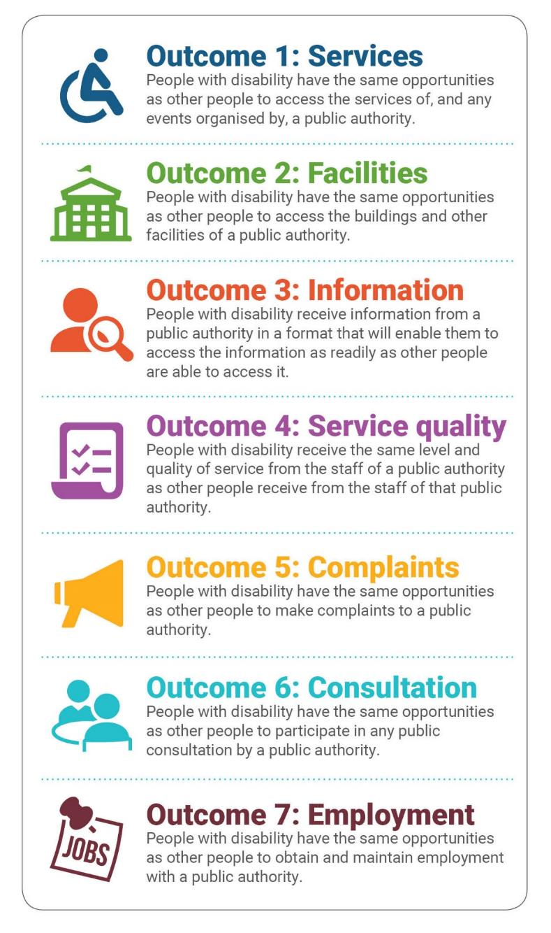

DAIP Progress Reports feature articles

Access and Inclusion Advisory Groups
The State Government is committed to achieving better co-design and collaboration between government agencies, service providers and the public.
Collaboration and co-design empowers stakeholders to be part of the decision-making process and to utilise their experience and insight. The City of Bunbury’s Most Accessible Regional City in Australia (MARCIA) Report highlights the role and key principles of co-design. Other useful resources include the WA Council of Social Services (WACOSS) Co-design Toolkit and the People with Disabilities Connect with Me initiative.
Thirty-five per cent of state government authorities and 61 per cent of local government authorities reported some form of ongoing community feedback and/or co-design mechanisms for access and inclusion. Around 20 per cent of all public authorities reported having an externally focused committee in place to provide oversight to their DAIP implementation. These advisory groups typically include people with lived experience of disability, senior staff and elected members for local governments. In some cases, these committees have a broader mix of members and apply collaboration and co-design principles across a range of community issues.
Establishing and maintaining such groups requires a level of ongoing commitment from public authorities and their members. Public authorities have reported that there is significant learning involved for members and the authority itself prior to the group reaching a state of effectiveness and empowerment.
The benefits of advisory groups are significant. Such groups offer innovative and contemporary mechanisms for working through difficult social, organisational or technical issues. This improves an authority’s ability to meet community or client needs, providing effective technical and experiential expertise, and mitigating future costs and issues through good service and infrastructure design.
Several public authorities have provided comment on their experiences with advisory groups:

Shire of Collie
Access and Inclusion Committee Chairperson Mr Joe Italiano
“Collie Shire Council's Access and Inclusion Committee recently got a better idea of what disabled people encountered when in the town centre. Members of the committee, which includes elected as well as community members, used wheelchairs to navigate the main streets of Collie.
This was a ‘walk in my shoes’ type activity which gave committee members an insight into just how hard some facilities and simple tasks, such as using an ATM, could be for the disabled.
We all came away from the experience better appreciating the challenges faced by disabled people in their everyday lives and how we as a council can play our part to help address these.”

Perth Airport
Chief Executive Officer Mr Kevin Brown
“Perth Airport is committed to delivering the airport Western Australians need and deserve – an airport which delivers the amenity, capacity and efficiency to deliver passengers a seamless, quality travel experience.
As Australia’s Western Hub, Perth Airport is continually improving access for people of all abilities to ensure we provide a great level of customer experience to passengers and visitors to the airport.
Perth Airport’s Access and Inclusion Advisory Group meets to discuss the barriers to inclusion and what can be done to improve access for people with disabilities.
The group provides feedback and advice on aspects of the travel experience and what improvements can be made to infrastructure and the operations at Perth Airport.”
Key organisations are represented on the Advisory Group, including:
- Department of Communities
- National Disability Services
- WA Deaf Society
- Council on the Ageing
- VisAbility
- Muscular Dystrophy WA
- People With disabilities (WA)
- Blind Citizens WA
- Autism WA.

Western Australian Museum
Chief Executive Officer Mr Alec Coles
“The WA Museum Access and Inclusion Panel has provided valuable input into the visitor experiences and exhibitions content for Western Australia’s New Museum. Panel members’ insight and feedback will ensure the New Museum is welcoming, inclusive and accessible for all visitors.”

City of Rockingham
“The City’s Disability Access and Inclusion Advisory Committee helps to ensure that the perspectives of people with disability are available to inform City projects and service provision, in line with the City’s DAIP/Strategy. The group is a valuable source of direct consultation for a range of projects and initiatives, particularly for infrastructure and open space developments being implemented by the City.”

City of Kalgoorlie-Boulder
“The Goldfields Disability Inclusion Group (GDIP) is a community-based committee designed to advocate, support, encourage, promote and build capacity to achieve the inclusion of all people in the Kalgoorlie-Boulder community, not just the City’s work.
Currently the GDIP Chairperson is Sue Nybo, Advocate for the Goldfields Region Individual Disability Advocacy Service, Sussex Street Community Law Service.
As part of the community consultation process for the 2016-2021 DAIP, the City’s DAIP became a standing agenda item at the GDIP meetings to facilitate discussion and feedback with suggestions or issues that were impacting on them within the community regarding access and inclusion to the City.
These meetings are attended by those organisations involved in the provision of services to those with disability. Meetings were held on a bi-monthly basis up until the beginning of 2019. Due to changes within the Department of Communities and the NDIS transition, these meetings have not been as regular as organisations have been navigating their way through the various changes, and as such the approach may change in response.
In general terms it is a good forum for collaboration and networking of the various providers offering services in this space.”

South Metropolitan Health Service
Executive Director Safety, Quality and Consumer Engagement Dr Maxine Wardrop
“At South Metropolitan Health Service (SMHS) we recognise that there are numerous benefits to creating and fostering effective partnerships with consumers and carers when planning, delivering and evaluating health services. These include better health outcomes, safer care, better consumer and staff satisfaction and the ability to provide healthcare that is respectful and responsive to the needs of all members of the community.
Consumers actively participate in numerous committees and advisory groups throughout the organisation including Consumer Advisory Councils and Mental Health and Emergency Department specific advisory groups. Each SMHS site also has a Disability Access and Inclusion Committee with consumer representation to ensure the consumer voice is heard when developing and implementing strategies to address the seven desired outcomes of DAIPs. Any issues identified at these committees that have area wide implications are also discussed at the SMHS Disability Advisory Network with a view to developing an area wide approach.”

City of Bunbury
“The City of Bunbury is progressing with its aspirations to be the most accessible regional city in Australia (the MARCIA initiative) and is establishing the Co-DAP panel which will become actively involved as partners in the design of City services, facilities and events.”

City of Melville
“The City of Melville’s Access Advisory Panel has around 20 members and includes community representatives who are deaf or have a hearing impairment, wheelchair users, older residents, people with Alzheimer’s and dementia, people with autism, and people who are blind or have a vision impairment.
The Panel provides feedback through the City on the accessibility of projects in the built environment such as large civic buildings, public realm improvements, apartment towers and park upgrades. Building planners and designers are asked to think beyond formal access standards and strive for more practical, user-friendly solutions. The Panel also provides feedback on the accessibility of other City projects such as civic events and the DAIP.
The Panel has no binding authority and convincing private developers to implement the recommendations can be challenging. Overall the feedback from stakeholders is that the Panel has had a positive influence on developers’ attitudes and practices. For example, the developers of a multi-unit aged care facility in Applecross now plan to install a public adult changing place, as per one of the Panel’s suggestions. The City’s staff, including planners, facility designers and landscape designers, also observe the Panel’s meetings, and apply learnings and perspectives from this to their other projects in the built environment.”

Socially Inclusive Communities
Inclusion consultancy organisations are supporting local governments to have a greater social impact throughout their communities. An example of this is the Socially Inclusive Communities WA Initiative (SICWA), facilitated by Inclusion Solutions.
The SICWA initiative is designed to provide tailored and intensive support to train and mentor authorities and their communities to address barriers to social inclusion. This initiative aims to:
- build the skills and capacity of Local Governments staff, access and inclusion advisory groups, community groups and community members to be more socially inclusive and to recognise the social and economic benefits of being inclusive.
- develop strong and sustainable relationships between community and local government.
- empower authorities and community members to create Champions of Inclusion.
- offer people from marginalised groups, including people with disability, the opportunity to be included and to contribute to the development of socially inclusive communities.
Now into its second year, the initiative is funded in partnership by participating authorities and the National Disability Insurance Scheme’s Information, Linkages and Capacity Building (ILC) grant funding scheme. In the first year of the SICWA (2018-19), eight local governments were successfully engaged in the initiative and have achieved inclusive outcomes throughout their communities. Year two of the project is funded by ILC Grants, Local Governments and a co-contribution from the Department of Local Government, Sport & Cultural Industries in the South West Region. Two additional local governments have since joined the initiative, taking the total number to thirteen.
In 2018-19, the following eight local governments participated:
- City of Wanneroo
- City of Joondalup
- City of Subiaco
- Town of Victoria Park
- Town of Bassendean
- City of Mandurah
- City of Bunbury
- Shire of Augusta Margaret River.
The outcomes to date have highlighted the effectiveness of building capacity to address challenges within an organisation and community. In addition to staff development and social inclusion workshops with staff and the community, the City of Mandurah has recruited four clubs to participate in the personalised mentoring process with Inclusion Solutions. Some of the City’s experiences with the program are detailed below.
The Mandurah Mustangs Football Club (MMFC) is one of the community groups that has achieved many inclusive outcomes within the Mandurah community, and developed a team to participate in the Integrated Football League. Prior to mentoring, no team representing Mandurah had been involved in the WA Amateur Football League’s (WAAFL) integrated competition. The club had identified that this was a priority area to provide more people with disability the opportunity to participate in football, and this has resulted in:
- increased membership
- increased participation of people with a disability
- increased volunteerism
- an improved club profile
- the club becoming a better representation of the Mandurah community.
MMFC are now champions in this space, liaising with the WACA Cricket Manager for the Peel Region and Mandurah Junior Cricket Club to support them to develop a team to participate in the Integrated Cricket League in the football off-season.
Read an article published by the Mandurah Mail on the MMFC’s achievements.
The Mandurah Surf Lifesaving Club’s Starfish Nippers Club has worked to strengthen their inclusion and accessibility. The SICWA program provided staff and volunteers with skills and tools to help children with disability participate, such as Cooper, who has established the confidence and trust to engage with lifeguard Anthony and become a passionate Starfish Nipper.
Cooper’s mum said: “This group has changed our world, we now have somewhere we belong and somewhere we can socialise, relax, and enjoy experiences and achievements together. Having a child with additional needs is hard, it takes a toll on your physical and mental health. Many parents have experienced the social isolation, the emotional or physical pain, lack of understanding when having a child with disability. The constant battle in social settings is exhausting and daily we are dodging the criticism, cruel comments and judgement.
Darren, Tash and Anthony have taken a vision and made it possible with Starfish Nippers. We all came with our own reservations on what to expect and how our kids would cope, but we have been blown away. Week by week we watched a stranger become a friend.”
This impact has been felt equally by Anthony and others at the club. City staff attended the club’s awards night earlier in the year and many speakers became emotional when retelling the experiences of Starfish Nippers and the Beach Access Day event which they heavily supported. The club has recently won a grant to purchase a beach wheelchair and has applied for another grant to purchase its own beach matting to roll to the water’s edge on Nippers’ days.

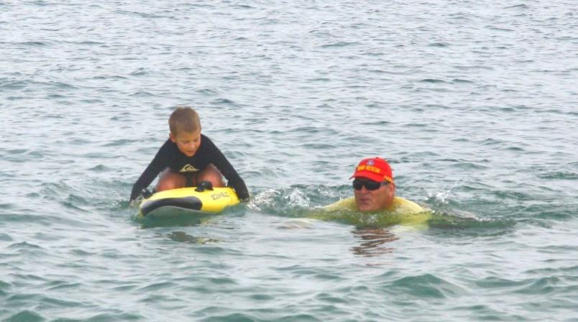
Figure 1 Building the confidence of clubs to be more inclusive has helped Cooper participate in the Mandurah Surf Lifesaving Club

Most Accessible Community in Western Australia (MACWA) Awards
Following the success of the inaugural MACWA awards for 2017-18, the Regional Capital Alliance of Western Australia (RCAWA), as stewards of the MACWA awards, once again invited nominations from local councils around the state. To retain consistency, the nominations were again assessed on the following criteria:
- Accessibility of council infrastructure and public open space
- Inclusive communication technology and information initiatives
- Accessible and inclusive council services, programs and events
- Exercises leadership and influences community attitudes and perceptions.
The awards were promoted by RCAWA, WA Local Government Association (WALGA), Ryan Campbell (City of Bunbury community partnerships officer, disability and seniors), Disability Services Commission Board and Melissa Northcott (MACWA ambassador, Disability Services Commission board member and disability access advocate).
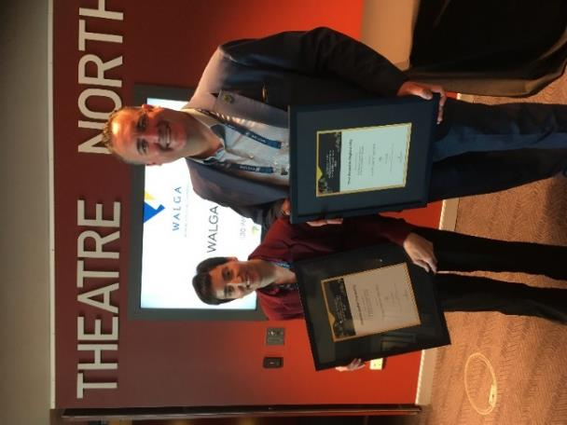
Figure 2 Shane Van Styn, Mayor City of Greater Geraldton and judge Melissa Northcott
The awards were judged by Waylen (State Manager NDIS), Bruce Langoulant (Chair Disability Services Commission Board), Kirstie Davis (WALGA) and Melissa Northcott. Comments made by the judges included:
- “Entries for 2018-2019 were 30 per cent up on last year, and the quality of nominations was high with some fantastic examples of ability access, programs and community collaborations.”
- “The physical access elements are to be commended but also anticipated in this modern world. When looking at nominations, judges were aware that buildings conforming to accessible infrastructure legislation is just biding by the rules and doing what is necessary.”
- “Examples of inclusion and inclusive activities and creative and enduring practices are a newer frontier and celebrate how we live together- with and without disability. There were some great examples of this in the nominations, and particular mention was made to activities, relationships and partnerships that were mutually beneficial in the community.”
List of winners:
- Overall winner: City of Greater Geraldton
- Most Accessible Metropolitan Council: City of Cockburn
- Most Accessible Regional City / Capital: City of Greater Geraldton
- Most Accessible Regional Shire / Town: Shire of Augusta Margaret River
- Judges Commendations: City of Wanneroo and City of Mandurah
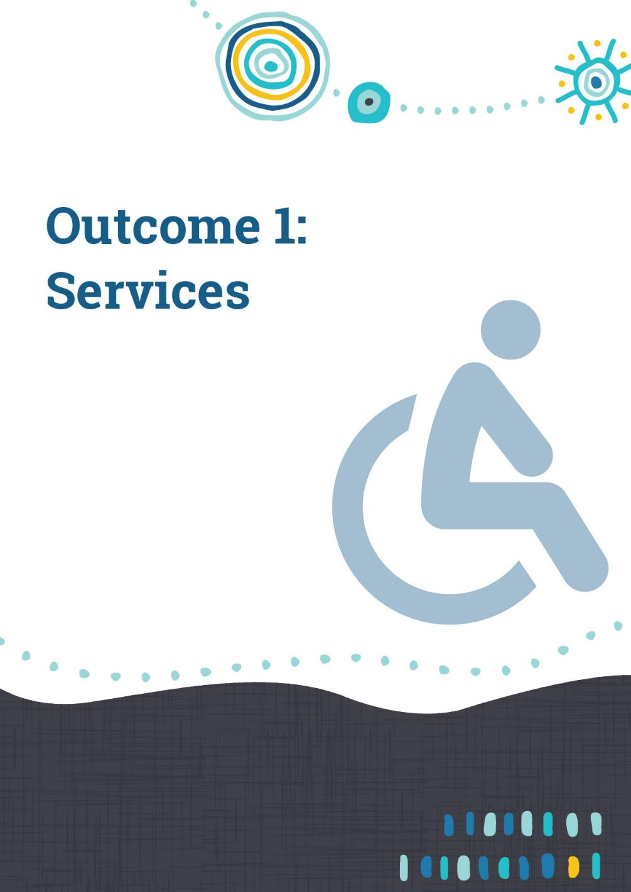

Outcome 1 achievements – Services
People with disability have the same opportunities as other people to access the services and events of a public authority.
Engagement with public events and services is a fundamental part of life for everyone. Unintentional discrimination can be caused by not providing appropriate access to a cinema or an event such as a concert. Challenges may include:
- signage lacking contrast on sign posts, or text size being too small
- lack of tactile ground surface indicators on footpaths
- no ramp access to entrances or exits
- lack of adequate and appropriate restrooms.
Difficulty in attending appointments or being unable to pay bills because of mobility or other access issues could also cause people with disability and other members of the community unnecessary angst.
The Disability Discrimination Act 1992 makes it unlawful to discriminate against a person because of disability with respect to; employment, education, getting or using services, renting or buying a house and accessing public places.
Public authorities have continued to focus on specific measures to increase participation by people with disability in community life as well as improving inclusion across events and services. This has helped to highlight where the unintended barriers exist and to promote equitable community engagement.

Shire of Augusta-Margaret River
In October 2018, two Shire of Augusta Margaret River library staff attended Sensory Story Time training at the Bunbury Regional Library. The training was run by Sensorium Theatre, who specialise in creating theatre productions as well as story time and rhyme time sessions for children with disabilities and sensory needs. The library staff learned the benefits of incorporating sensory elements into regular story time sessions and how this can be achieved in a practical manner. Participants were given the chance to experience how sensory activities can enhance a story or rhyme and had the opportunity to put their new skills into practice by developing a session outline they could use at a regular story time.
Sensorium Theatre then came to Margaret River Library on Wednesday 17 October and presented a show based on the book ‘Wombat Stew’ by Marcia K. Vaughan. The session was attended by eight children and seven adults, although about twelve children were booked in. The presentations entailed many sensory elements such as tactile props in the story, gentle music, food tasting and active rhymes. There were also Auslan signs incorporated into parts of the performance which was welcomed with joy from one of the participants. The two Sensorium Theatre actresses came in costume and children loved being very involved with the story by singing the Wombat Stew song and tasting and feeling some of the food in the “stew”, and a smaller sized audience made it less overwhelming for the children.
The library staff Sensory Story Time training was successful as the training made staff more aware of how sensory activities in story time could make it a more inclusive experience for children and caregivers. It also gave story time and rhyme time presenters practical examples of how sessions could be more sensory. They then had an opportunity to plan and present to the group a program that could be used at our regular library sessions.
The sensory storytelling performance at the library was successful because it gave library staff an opportunity to reach out, connect and network with organisations and individuals in our community that may have, or be involved with, clients with a disability. This was very beneficial for many reasons, as it made library staff more aware of how many organisations are in the community to help those with disability, what sort of needs the community had and how the library could best serve these people in the future. This event enabled library staff to view a full sensory story time presentation with ‘actual’ participants and learn from the reactions of the children attending. Parents attending said it was fantastic that their children had an opportunity to attend an event like this that was inclusive, and they felt welcomed.
Further impacts and outcomes for people with a disability included:
- At least one of the families had not been into the library before, because of the child’s autism and they feared the child could make too much noise. Now they are aware the library is an inclusive space and is for all community to use.
- Story time and rhyme time presenters are now more aware of things we can change in our sessions to make them more inclusive and we are doing our best to implement these changes.
- Library staff, in collaboration with community feedback, are researching ways to make the library space more inclusive for those with sensory needs, including a sensory kit with noise-reducing headphones and tactile objects.
Story time and rhyme time presenters are now learning Auslan sign language and there was an Auslan storytime held on 11 June 2019, with a huge turnout of 18 children and 20 adults. Local parent Sarah signed along with librarian Rachael who read “Where is the green sheep?” and she also taught the group simple signs such as hello, thank you and please. This event was well received; participants realised how simple and useful it is to learn Auslan. Since the event, some of the parents have joined the Auslan Conversation Group held fortnightly at the library.
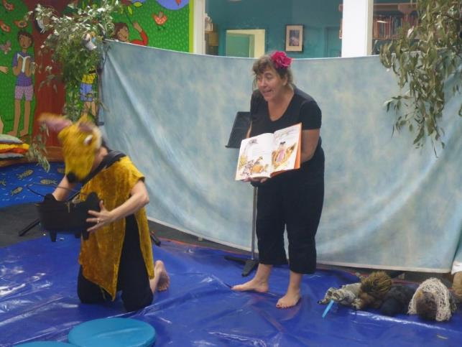
Figure 3 Sensorium Theatre’s Sensory Story Time Event at the Library

Shire of Broome
The Shire of Broome Librarian staff identified the need for Dyslexia resources and training to be made available to the community. A workshop was organised and was well received and attended by the community, service providers and teachers. The Library sourced 121 dyslexia-friendly resources (book collection) for the community to utilise.
Feedback from the training and resources has been positive from the community. The training was successful and resulted in resources being made available to people with dyslexia and to teachers, parents and the community. The essential training allowed for carers, teachers and community members to develop a stronger understanding and awareness of dyslexia and the resources available to assist with managing the condition.
To assess the ability of people with disability to have access to all public events at the Shire, the Community Development Directorate evaluated the way it provides information to external stakeholders on accessible and inclusive events, projects and services. The Community Development directorate identified the need for access and inclusion planning to be a requirement for applicants completing the Shire’s event application forms.
Event application forms have been designed to include a section on Accessible and Inclusive Events – “What actions have you taken to ensure your event is accessible to people with a disability?” In addition, the forms include a reference to the Disability Services Act 1993. This has led to improved outcomes for people with disability as there are now processes in place to ensure that Shire events are more inclusive. Moreover, to ensure that all applicants complete the section, it has been made mandatory and all applicants will be referred to the Disability Services Accessible Events Checklist.

Town of Victoria Park
The Town of Victoria Park celebrated International Day of People with Disability and Disability Awareness Week 2018 by delivering a flag raising ceremony, a Business Sundowner ‘Meet the Experts’ and the Wheel Life Program in the community. The Wheel Life Program is delivered by Rebound WA and offers a fun and practical way of understanding what it is like to live with a physical disability. The program includes a facilitated discussion about being active and inclusive, along with a supervised game of wheelchair basketball.
These events raised awareness in the local business community and non-education support schools. Comments from the support schools included that the students and staff were very happy to be included in the celebrations and for being recognised as valuable members of the community. The relationship with the local schools has been strengthened and the local business community have been made more aware of the benefits of employing a diverse workforce and accessing a diverse customer base. Visually, people with disability will be recognised in the community by a flag raising ceremony each year. The Town aims to continue to promote workplace diversity in the community via the business program.

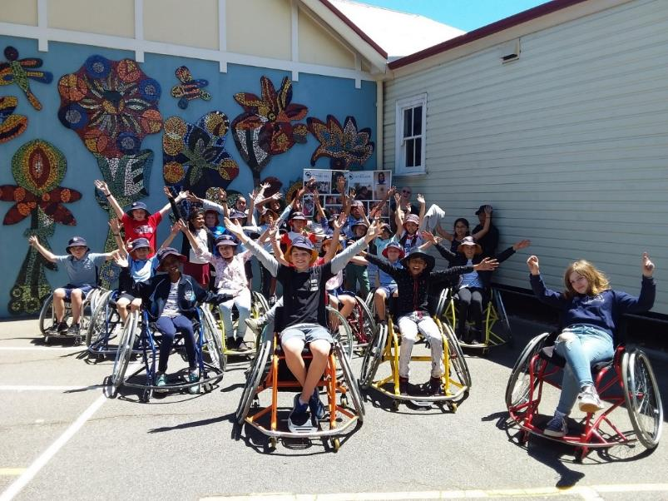
Figure 4 Wheel Life Program – Victoria Park Primary School

Shire of Denmark
To identify ways of making trails in the Denmark area more accessible for people with disability, the Shire of Denmark hosted an Adaptive Mountain Bike Trail development workshop in March 2019, facilitated by Break the Boundary consultants. The workshop included discussions on adaptive off-road/trail access in WA and other states, tourism opportunities, information about adaptive trail equipment for persons with leg, arm and full body impairments, and insights into the personal experiences of people with disability. This helped to improve awareness of the physical challenges faced by people with disability.
The Shire also hosted a community disability challenge in the town centre to raise awareness of barriers to access and inclusion. This event included people with disability, local community members, high school students, business and council representatives. The event challenged participants to complete a set of tasks around the town while being assigned an impairment. Because of the challenge, barriers were identified, and feedback was provided to local businesses. To conclude the event, a free community barbecue was held at a local accessible park. In response to the feedback received on the event, the Shire completed an upgrade of their main entrance doors to improve accessibility.

Figure 5 Presenters from Break the Boundary showcasing adaptive equipment

Shire of Harvey
The Shire of Harvey provides its facilities free of charge to disability organisations. For example, Shire facilities are used to host NDIS workshops and for the Grow.Cook.Eat.Create group. The Grow.Cook.Eat.Create group has two days per week free of charge to run cooking and art classes in the Leschenault Leisure Centre Function Room for community members with a disability. The Shire has also provided the group with the use of a small plot outside the function room to grow a vegetable garden and has recently installed a ramp to the garden to improve accessibility.
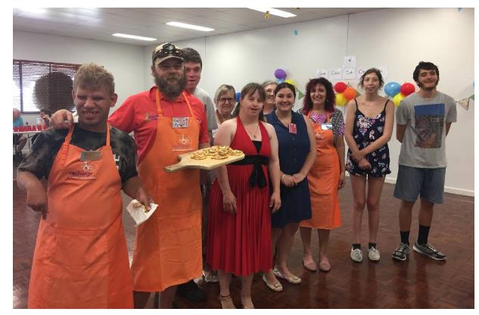
Figure 6 The Grow.Cook.Eat.Create group is helping connect community members at the Shire of Harvey

Western Australian Museum
Purchasing a 3D scanner has enabled the Western Australian Museum to introduce new tactile access opportunities for visitors this financial year. For example, tactile elements were made for the ‘French Explorers in Western Australia’ exhibition, making it more accessible and inclusive and enhancing visitor engagement, particularly for visitors with sensory impairment.
Specialised guided tours continued to be delivered at the WA Maritime Museum and the WA Shipwrecks Museum to meet the needs of people with disability and seniors’ groups with additional needs. The tours included an ‘Objects and Memories Tour’ designed for visitors with dementia and their carers, and a ‘Please Touch Tactile Tour’ for blind or vision impaired visitors. Both tours were regularly offered at each site. The tours were also provided as part of the Amana Living Arts Festival (March 2019) which provides opportunities for 2,500 Amana Living residents and home care clients over 55 years old to become involved in artistic and cultural experiences. In 2018-19, there were 747 visitors.
While hosting the LEGO exhibition ‘Brickman Cities at the Maritime Museum’, the Museum partnered with Kalparrin, an organisation supporting families raising children with disability, developmental delay, and genetic, chronic medical and/or health conditions. The Museum offered sensory sessions exclusively for Kalparrin families. The three sessions were fully booked, with approximately 240 visitors attending in total. Feedback from Kalparrin families during the sessions was positive, with many commenting that the atmosphere was welcoming and professional and the sessions appropriately facilitated.
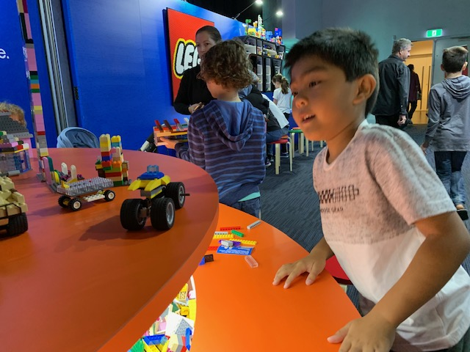
Figure 7 The sensory session at the LEGO ‘Brickman Cities’ event at the WA Maritime Museum, organised by the WA Museum and Kalparrin

City of Fremantle
At this year’s Fremantle International Street Arts Festival, the City of Fremantle committed to ensuring that festival information was fully accessible. Improvements were made to the festival map, online and in print, and information on accessible parking and accessible public toilet locations was added. Through its Access All Arts program, Disability in the Arts and Disadvantage in the Arts, the Festival also offered audio description for selected Festival shows (which was noted in the Festival program). While the cost of implementing audio description was significant, it enhanced live performances and visual art for people with impaired vision. The improvements to accessibility at the Festival were well received as it ensured that the event was inclusive and could be enjoyed by everyone in the community.

City of Albany
The National Anzac Centre is a major attraction in the Albany region. The City of Albany has taken several initiatives in 2018-19 to ensure it is inclusive for all, such as:
- Livestreaming the Anzac Day Dawn Service in 2019, enabling greater access to the event. Additionally, the livestream featured an Auslan interpreter, which was very well received.
- Interactive displays at the National Anzac Centre which required activation with an audio pen were replaced with an audio pod that is easier for people with arthritis or fine motor skill impairment to use. This improved access to the audio content for people with disability.
- Introduced ‘Vehicle friendly nights’ to facilitate improved access for wheelchair users and people with severe mobility impairment to access the Field of Light immersive light installation on Avenue of Honour.
Throughout its summer event schedule, the City identified an opportunity to build the confidence of people with disability and their families and friends to attend events by developing videos for each event. The videos helped people with disability by allowing them to get an idea of the venue, access features and any special arrangements for people with disability (e.g. vehicle drop off) prior to the event. This encouraged greater participation at the City’s events by people with disability. For example, the video for the Christmas pageant had specific vantage points to ensure wheelchair users a good view.
The videos were promoted through community networks and social media, and City received numerous compliments from event-goers on the initiative. An example of the videos can be found on the City of Albany’s Facebook page.
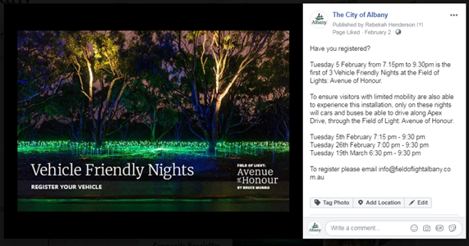
Figure 8 Vehicle Friendly nights at Albany’s Avenue of Honour helped people with mobility issues enjoy the experience

Town of Cambridge
The Town of Cambridge partnered with Activ Foundation to deliver a chill-out zone for children with autism at the Lake Monger Christmas festival. This initiative was in response to community feedback received via the Disability Access and Inclusion survey. Feedback indicated that parents of children with autism did not feel welcomed at community events. Parents observed that noise, lights and activities at festivals often caused children to become overstimulated resulting in behavioural issues. Such parents had felt compelled to leave due to the lack of understanding and adverse judgement from other event participants.
The aim of the chill-out zone was to provide a safe retreat for parents and their autistic children, as well as providing some information on autism and where to get support. The zone included a group activity area and a separate space where children could have quiet time on their own. The chill-out tent was equipped with cushions, headphones, books and other sensory toys. A staff member from Activ was on hand to provide expert advice on autism, to assist parents with managing their child's condition. The zone was highly successful as it enabled families with autistic children to safely enjoy the festival, without fear of judgment.
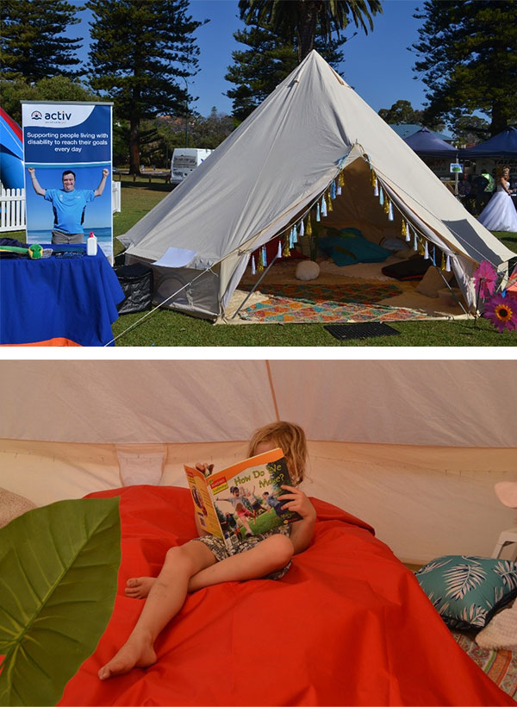
Figure 9 The Chill-Out zone at the Lake Monger Christmas festival helped families who have children with autism to have a more welcoming experience

City of Wanneroo
The City of Wanneroo’s Early Childhood and Youth team is responding to the diversity of its community to deliver several accessible and inclusive programs during 2018-19 including an NDIS information session with members of the Wanneroo and Surrounds Early Years (WASEY) Network.
A key accessible and inclusive program delivered by the City for young children is the ‘It’s All About Play’ (IAAP) program. This is an on-going program that provides a universal soft touch approach to child development and a stimulating multisensory environment that assist children with development delay. One mother commented on how welcoming and inclusive she and her son, who has cerebral palsy, felt after attending one term. She was able to connect with other parents, volunteers and staff thereby reducing her sense of isolation and fear of being judged. She was also able to observe her child being gently guided and supported to participate both physically and socially by a therapist assist while she could discuss her child's individual development plan.


Figure 10 Families and children aged under 5 years enjoying ‘It’s All About Play’ at Girrawheen Library
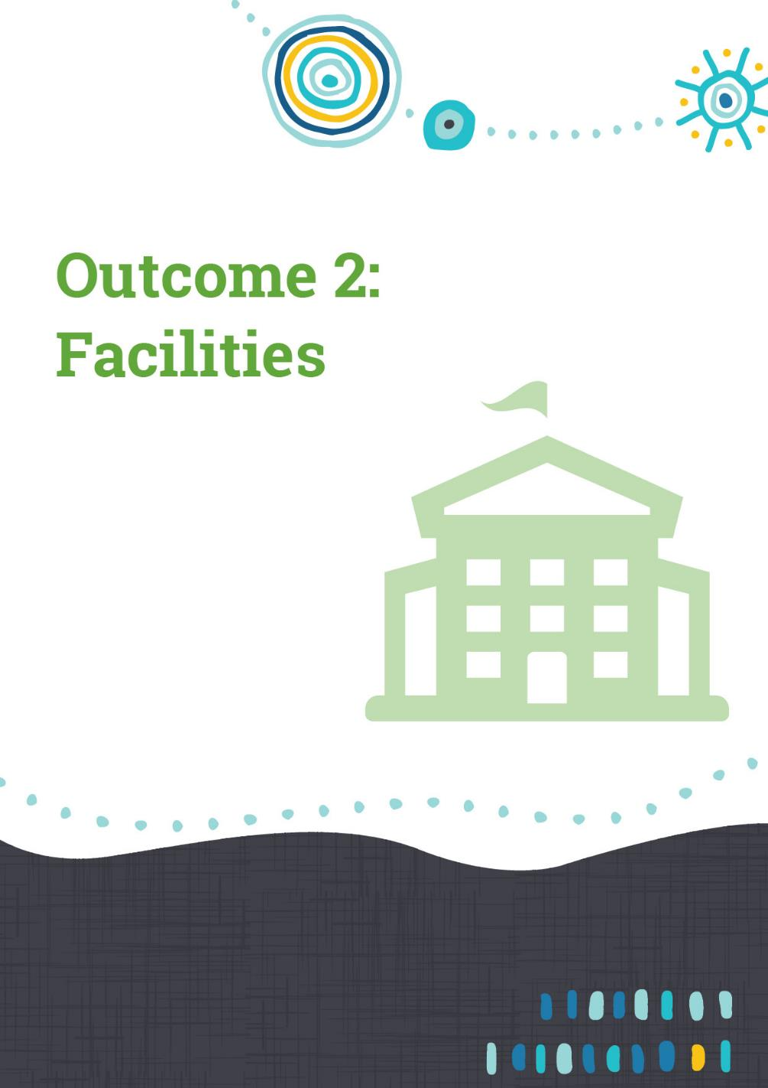

Outcome 2 achievements – Facilities
People with disability have the same opportunities as other people to access the buildings and facilities of a public authority.
This outcome area is focused on improving and ensuring that built infrastructure is accessible for everyone. Work towards achieving this outcome is occurring more consistently across public authorities and typically involves consultation with potential facility users and technical support to ensure an inclusive design process.
The Commonwealth Access to Premises Standards 2010 supports disability access and complements the commitments of public authorities to not only ensure that their own facilities are accessible but to also influence the accessibility of the broader built environment across communities.
For people with mobility needs, equitable access to built infrastructure across our community remains a significant barrier. For example, older or heritage listed buildings, which hold great value to communities, often do not meet contemporary community expectations about access. The costs and technical challenges in retrofitting these buildings are often prohibitive, for public authorities as well as businesses and community groups.
Effective measures to ensure greater access to buildings involve capital investment and wherever possible, ‘building in’ access and inclusion to new infrastructure and demonstrating agility in relocating or re-envisioning services to ensure access equitability.
As our built environment evolves over time, many public authorities prioritise regular access audits (which examine, for example, walkability or wayfaring) to monitor changes in accessibility and to identify priorities for improvement.

Department of Biodiversity, Conservation and Attractions
The Department of Biodiversity, Conservation and Attractions plans, designs and constructs recreation sites, facilities and buildings for universal access in all circumstances. Where budgets or site conditions in the natural environment constrain the ability to provide full universal access, alternative opportunities that enable a level of interaction with the location, experience or environment are planned for, including; assisted access, partial access, or the provision of opportunities in nearby locations.
Planning and design for new accessible facilities has commenced, with regional works including:
- Greens Pool and Madfish Bay in William Bay National Park with improvements to parking, toilets, gathering areas and future beach access
- Lake Kepwari in Collie including universal access to the proposed boat ramp and lake access for water skiing
- Expanded facilities at Dwaarlindjirraap catering for increased trail development, a river crossing and picnic facilities
- Construction has started on the Kalbarri Skywalks and associated visitor facilities in Kalbarri National Park, delivering two lookouts, shelters, kiosk and paths through interpretation of the area
- Completion of stage one of Fortescue Falls redevelopment in Karijini National Park, providing views over the gorge from a new lookout.

Metropolitan initiatives include:
- Redevelopment of the Olive Seymore boardwalk in Herdsman Lake Regional Park
- Continuation of the universal accessible promenade around Jane Brook Weir in John Forrest National Park
- Assisted access paths and a new accessible lookout on the northern tip of Cape Peron in Rockingham Lakes Regional Park
- A new Riverpark interpretation node at John Tonkin Reserve, completed in association with the Town of East Fremantle
- Completion of accessible toilets, showers and camp shelter with cooking facilities in the campground in Yanchep National Park.

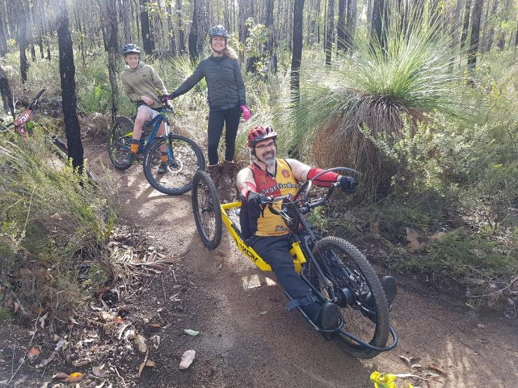
Figure 11 New handcycle friendly trails near Collie are enabling more people to enjoy active recreation in our natural environment

Shire of Narrogin
The ‘Library Landscape project’ evolved from the Shire of Narrogin local librarian’s vision to create an accessible and sensory garden adjacent to the library and is an example of ‘designing in accessibility’. This accessible rest and recreation place for the community aligns with the Shire’s intent to foster an inclusive community.
The project involved redesigning the original garden site to incorporate flat, level areas and a gazebo (with wide entry seating on three sides and room for wheelchairs). This means the gazebo has plenty of room for anyone with a wheelchair, walking frame or mobility scooter to enter and use the facilities. Handrails were installed to assist access from the library to the gazebo entry and the footpaths were upgraded with a non-slip finish. Another consideration was improving the tactile experience for visitors of all abilities.
The garden, which will be completed within the next six months, will provide all members of the community with an accessible and relaxing space to read in or to simply enjoy. Plants chosen for their scent, taste, flowers, tactile sensation and toughness (to withstand rough handling) are planted in the garden and along the street front, along with native plants to encourage birds and insects. Some of the trees have whispering bark and leaves for sound.
There is also plenty of space for children’s art activities and play. The garden is used extensively by all ages and although the plants are still quite small children and adults are already enjoying the scents and textures while relaxing in the gazebo.

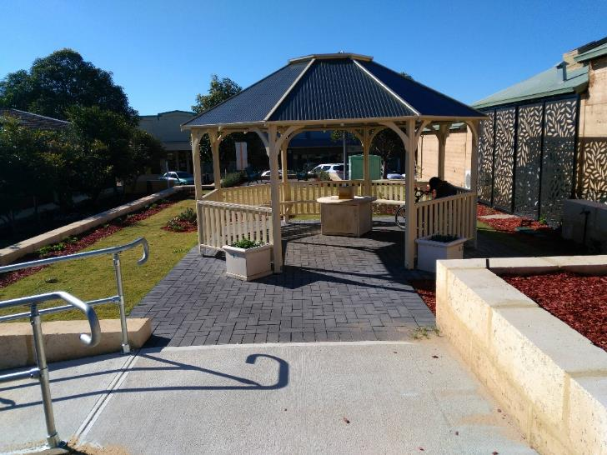
Figure 12 The Shire of Narrogin Library’s new sensory garden is nearing completion

City of Belmont
The City of Belmont has identified the need to incorporate triggers into the project management processes to ensure compliance and universal design principles are considered in the design and upgrades of the City’s built environment. The Design and Assets department have included a statement referring to access and inclusion in their checklist. This has resulted in several queries to the City’s Seniors and Disability Engagement Officer seeking advice on access and inclusion, including the design and placement of bollards on pathways.
Work continues to identify appropriate triggers in the broader project management system and is part of an overall review of the current process. The challenge continues to be the concern that inclusion of universal design principles and other building guidelines may put the organisation at risk of non-compliance. The need to engage with access consultants who can provide this expertise has been recognised in addition to capacity building.
The City has engaged the services of access consultants to provide guidance on both compliance and the opportunity to include universal design principles. In this reporting period, access consultants have been engaged to provide advice on street signage and the IT component of a new community centre. The process relating to the appropriateness of when to engage access consultants is under review and will continue to be developed.
In addition to the formal access audit process, the City has worked directly with people with lived experience of disability and local community members to undertake ‘experiential’ audits of the City’s facilities and spaces to assess their user friendliness.
This reporting period has included a ‘walk around’ the Belmont Civic Precinct to identify concerns with paving, signage and other elements. The findings of this walk were summarised in a report that was then distributed to relevant departments for appropriate action. This process provides the opportunity to meaningfully engage with community members while providing the opportunity for the City to be proactive and address access concerns prior to an incident or formal complaint.

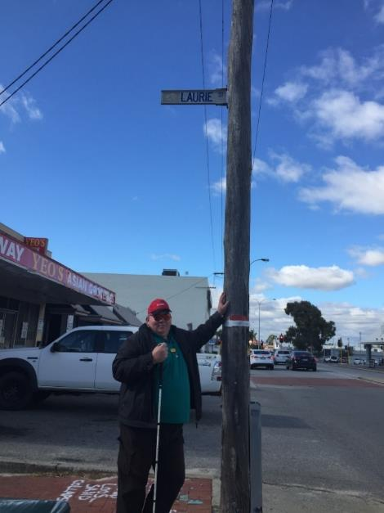
Figure 13 Experiential audits at the City of Belmont are part of a suite of strategies to strengthen accessibility

City of Armadale
The new Armadale Fitness and Aquatic Centre was opened in 2019 following a $26 million upgrade made possible through funding from the Federal Government’s Community Development Grants program, the Department of Local Government, Sport and Cultural Industries, and the City of Armadale. The City had prioritised the need for a fully accessible indoor pool and had actively sought external funding to ensure that the project came to fruition. The new accessible features of the centre have greatly increased opportunities for persons with disability to participate and improve their wellbeing. Some of the key upgrades include:
- Installed accessible ramp and handrail to existing 50m pool, ensuring all pools have ramp access and handrails
- Wheelchair viewing points cut into the grandstand
- Changing Places change room equipped with a full-size change table
- Aquatic Wheelchairs available for patrons’ use
- Centre can implement high level supervision plan for high risk aquatic users
- Facility is all on one level for easy accessibility around full facility, with consideration of access needs throughout, including how equipment is positioned in the Health Club
- An additional four ACROD bays surplus to compliance requirements.
The initial project design included the intention and scope for more people in the community, regardless of ability, to access and make use of the renovated facility. The City therefore anticipated an increase in the use of the facility by those with accessibility and/or mobility issues. Currently almost 25 per cent of recent memberships were sold to concession card holders, many of whom have mobility issues.
Another identified challenge associated with the increase in patrons with mobility issues (including older people) was the inability to get in and out of the lanes that were not located directly adjacent to the ramp entry points. To address this issue, the City has invested in a set of Platypus Aquatic Stairs and is tracking the use and effectiveness of these with a view to investing in a set for each pool over time if needed.
Since the upgrade, the Centre has received regular bookings from local physiotherapy groups and NDIS service providers. Information sought from one NDIS provider showed that their courtesy bus use is already at full capacity and that the provider is considering increasing the number of days on which the aquatic centre is part of their drop-off schedule.
The Centre recently won the Parks & Leisure Australia ‘Community Facility of the Year’ award, with the submission highlighting the Centre as being inclusive and accessible to every member of the local community.

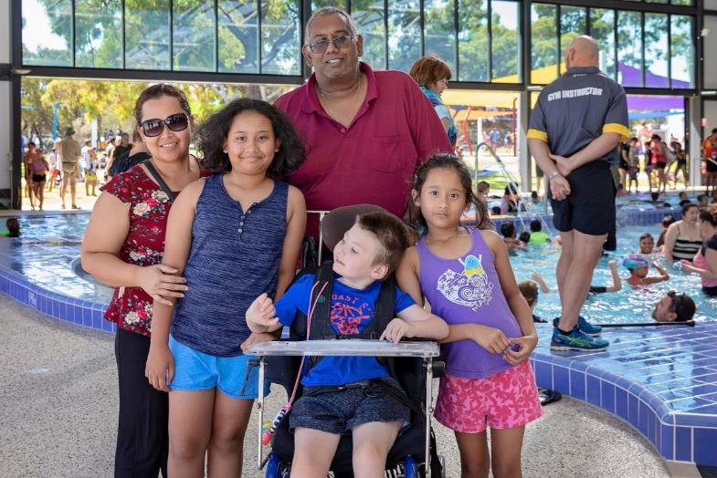
Figure 14 The Armadale Fitness and Aquatic Centre redevelopment prioritised accessibility to ensure it met the needs of its changing population

Shire of Augusta-Margaret River
This year, the Shire of Augusta-Margaret River has been working with Alzheimer’s WA to become a dementia-friendly community. The eight-month project, led by Alzheimer’s WA, has involved a local coordinator and working group and aims to:
- engage with people living with dementia to shape the community around their needs and aspirations
- increase social participation and volunteering opportunities for people living with dementia
- support local businesses to provide accessible services for people living with dementia, including the employment of staff who understand and can communicate effectively
- create environments that are enabling and easy to navigate.
The project was funded by Margaret River Lions, Margaret River Rotary and the Shire and supported by the WA State Government through the WA Country Health Service.
Members of the working group include Alzheimer’s WA, Rotary, Lions, Silver Chain, BaptistCare, Community Home Care, Library, a local GP, ANZ bank, Post Office, Woolworths and community members. A work plan was developed covering volunteering, education, communication, community engagement, sustainability, lack of transport, enabling environments, respite services and support, and timely diagnosis. The main projects have included: a GP Info Pack reviewing current referral and diagnosis pathways, establishing a memory café, establishing regular inclusive walks, training in the community and training for local businesses.
As part of the project, Alzheimer’s WA met with the Shire to provide some specific training with internal staff. A dementia enabling expert met with the project manager for our Main St upgrade to discuss some ideas to make our Main St more accessible for people living with dementia, such as advice around signage, footpaths, lighting, seating and toilets. Additionally, training was held for internal staff on Dementia Enabling Environments. This was attended by staff from Community Development, Infrastructure, Works, Library and the Recreation Centre. The training was very useful in educating staff about the needs of people with dementia and providing information on how the Shire’s buildings and facilities should cater for the needs of those with a cognitive disability, as well as people with physical disability, to enable people living with dementia to live meaningful and active lives.
The project will result in real improvements to assist locals living with dementia, as the Shire has committed to undertaking several actions (as listed in the Shire’s current Access and Inclusion Implementation Plan) to ensure that buildings, facilities and services are more dementia friendly.

City of Stirling
An accessible triple swing comprising a ‘You and Me’ swing seat, bird’s nest and toddler swing has been installed on rubber soft fall at the Whale Playground at Scarborough Beach.
The upgrade to the playground was undertaken by the City of Stirling and the Metropolitan Redevelopment Authority to provide access for people with disability. Dianella Grandmother, ‘Lea’, thanked the City and said it is the first time she has been able to play with her grandson on a swing. Her grandson ‘Matthew’ is five years old and has Autism. They sat on the You and Me swing together and when Lea stopped swinging, Matthew indicated, using his communication board, that he wanted to continue.
Matthew also enjoyed swinging with his twin sister ‘Charlotte’. Lea said that it was a very special experience for the family. Lea also provided feedback for the company who designed the swing. She hopes that they can design a bigger seat so that her older grandchild with disability can also enjoy using it with the family.

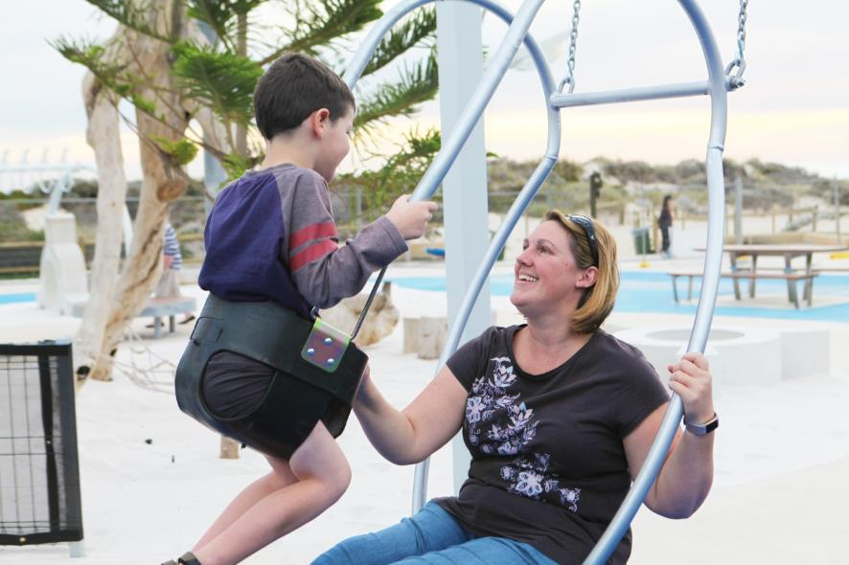
Figure 15 Matthew and his mother Jessica share the innovative You and Me Swing set at Scarborough Beach

City of Fremantle
During the year, the City of Fremantle became aware of a negative comment posted on social media by a wheelchair user who had been unable to access the water’s edge due to the presence of bollards and therefore could not benefit from the ocean view. The City subsequently contacted the Department of Transport to discuss the bollards (the bollards were located on land managed by the Department of Transport). The Department of Transport’s Harbour Manager of Coastal Infrastructure and City of Fremantle staff confirmed that the bollards were most likely installed in the mid to late 1980s (during the America’s Cup Challenge) to keep vehicles away from the path.
The City and the Department of Transport acknowledged that the presence of the bollards no longer met the accessibility code and committed to investigating further to determine what could be done to improve accessibility.
Because of the investigation, the Department of Transport removed one bollard and repaved the area, ensuring that the paving edge adjacent to the rock wall was safe to use. While one bollard remained to prevent vehicle access (consistent with the historic purpose of the bollards) the removal of the other bollard allowed clear access to the ocean by wheelchair users. City staff responded to the original comment on social media to advise that the issue had now been resolved. Due to the City’s good working relationship with the Department of Transport and its commitment to staying abreast of community feedback on all platforms, the City successfully addressed the barrier to accessibility in a timely and appropriate manner, allowing all wheelchair users to benefit from access to the ocean.

Rottnest Island Authority
Given that Rottnest Island is a key tourist destination, the Rottnest Island Authority (RIA) recognises the importance of providing accessible services and facilities to meet the growing demand for accessible tourism.
Wheelchairs, mobility scooters and a beach wheelchair are available for hire on the island. These items are available through the Pedal and Flipper bike hire shop (for the scooters and the beach wheelchair) or through the Visitor Centre (for the wheelchairs). There are also accessible bike options available including tricycles and a Wike Trailer which, once connected to a bicycle, can transport an adult around the island. A buggy is available for hire that allows a carer to transport a visitor with disability from the ferry to their accommodation.
Opportunities to upgrade accessible accommodation units have been utilised, and adaptations have been made, including; wider hallways and doors, bathroom floors which are level and without obstacles, adjusted bed heights and a kitchen with an open design that allows wheelchair access underneath the benchtop (in some units).
RIA has now completed construction of a ‘Changing Places’ facility. This new building is located near the main bus stop in Thomson Bay.
An audit was undertaken of the promotional material available to prospective visitors about the accessible units and this information has been refreshed with new photographs and updated information. This information pack explains, for example, which beaches and restaurants are most accessible and what activities are suitable for visitors with disabilities. It also includes information on how to get around the island.

City of Mandurah
The City of Mandurah continued its goal of improving access to its beaches and other waterways to help to ensure that all community members benefit from enjoying water-based activities and to improve social inclusion. The following initiatives demonstrate key improvements in this regard:
- A two-month trial of matting to the water’s edge at the Keith Holmes ‘Lido’ man-made beach at Dolphin Quay. The sheltered location was considered perfect for such a trial as the matting would not be exposed to tidal and sand movements to the same degree as in other locations. The trial was such a success that the matting stayed in place for five months over the summer period and experienced high use and a positive response from the community. Accessible beach matting continues to be used at seven beaches across the City over the summer months.
- Two all-terrain wheelchairs were made available for free community use, seven days a week. The chairs are located and managed by the Mandurah Visitors Centre. The second all-terrain wheelchair, which was purchased in late 2018, has different features to the existing chair, enabling a greater number of residents and visitors to access Mandurah beaches. The chairs can be booked by individuals or local community groups; either at the visitor’s centre, over the phone or online.
- The City co-hosted a Beach Access Day event, with accessible beach matting and equipment provided by the supplier Push Mobility. The event celebrated International Day of People with Disability, created community awareness around beach access, and gave people with mobility restrictions access to Mandurah’s Town Beach for the day. Most importantly, this event provided people in the community with the opportunity to learn about how to use available equipment to access local beaches and waterways
While the above initiatives have all received positive feedback, members of the community, through the Access and Inclusion Advisory Group, have raised the issue that the accessible matting in not a permanent structure. The City has acknowledged that the Keith Holmes Reserve/Swimmers Beach is a popular space for the local community and is working towards incorporating additional universally accessible features to the space. In line with this, the City has contracted a landscape architect to develop a concept design for the Keith Holmes Reserve with a strong focus on universal design. This will provide the City with innovative ways to further improve access to the beach/beach reserves.

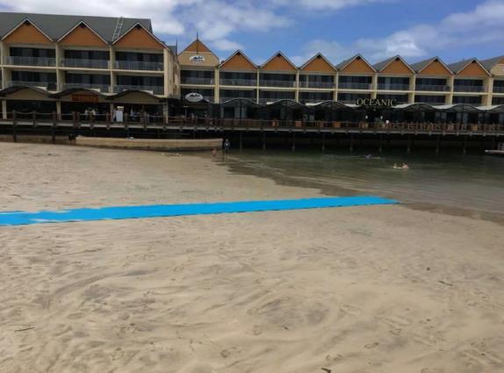
Figure 16 Access improvements at Swimmer’s Beach, Keith Holmes Reserve, Mandurah

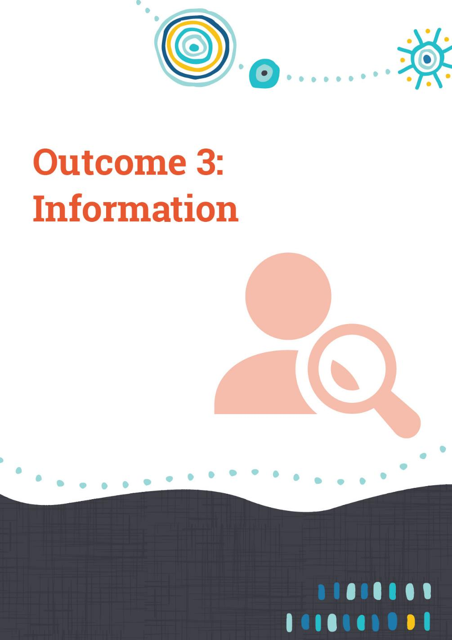

Outcome 3 achievements – Information
People with disability receive information from a public authority in a format that will enable them to access the information as readily as other people are able to access it.
People with disability may have difficulties accessing public information. The types of disability that frequently impact a person’s ability to access information include hearing loss or deafness, impaired vision or blindness, or intellectual, psychiatric, cognitive or neurological impairment that substantially reduces the capacity to learn or communicate.
Many communication difficulties can be avoided with informed planning and procedures including:
- using clear and concise language
- using appropriate font style and size
- providing information in alternative formats
- providing audio loops
- using Auslan sign language interpreters
- captioning videos
- designing accessible websites
- displaying information in an accessible location.
The broader community can also benefit from these considerations.
Public authorities continue to monitor the way in which they communicate with people, while building capacity and awareness of contemporary practice on providing accessible information.

Town of Cambridge
An audio description was installed in the gazebo at the West Leederville Memorial Gardens, which narrates the stories of some of the local soldiers who died in World War 1. The motion activated audio-track is operational between 7am to 7pm each day and has the option to be paused or forwarded through. This has been highly successful with young children and people with visual impairment, dyslexia or illiterate.

City of Melville
The City of Melville provides information in alternate technologies and formats. In 2018-19, the City’s Social Justice Advocate and Marketing & Communications team oversaw the development of a publication in the format of ‘Easy English’ for the Active Link community program (voucher program which promotes participation and inclusion in community initiatives for residents with low income).
As a result, the City’s staff are now aware of the process for developing an Easy English publication. With the distribution of the brochure, there is also increased community awareness of Easy English (Easy Read) as an alternative format.

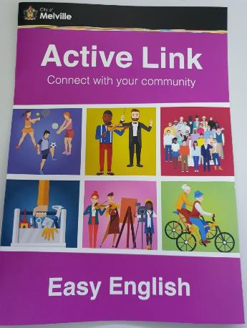
Figure 17 The City of Melville developed an Easy English document for a key community program to improve accessibility

City of Cockburn
The Cockburn Aquatic and Recreation Centre (ARC), Youth Services and Seniors Centre reviewed 'Companion Card' procedures to ensure that the 'two for one' objective of the scheme is appropriately understood and implemented by staff. To reduce the number of complaints, City of Cockburn staff were instructed on the correct application of the companion card with further discussions held during disability awareness training sessions. Staff across all divisions of the City are confident that their services are meeting the needs of the local and surrounding community, including people with a disability. This has resulted in a reduction in the number of complaints relating to access and inclusion.

Department of Finance
In September 2018, the Department of Finance’s DAIP Committee hosted a ‘Supporting Access and Inclusion’ awareness event at Optima, with approximately 30 people including senior management and external stakeholders in attendance. Three guest speakers presented on their background and experiences during the 1.5-hour event, including:
- a guest from local government who presented on their organisation's successes and lessons learnt on progressing access and inclusion
- a sight impaired guest presenter speaking on her experiences working with disability in government
- a Finance hearing impaired employee presented an educational and entertaining session that included communicating using Auslan sign language.
The entire event received positive feedback for supporting awareness and education and communicating the access and inclusion message across the Department. Following the success of this event, another event is being planned for 2019-20 that will be open to all staff.
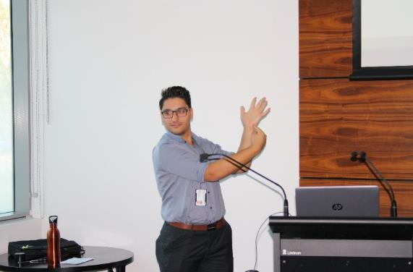
Figure 18 Adam from the Department of Finance presenting an educational and entertaining session that included communicating using Auslan sign language

Central Regional TAFE
Albert EFTPOS has been installed in the Northam and Geraldton bookshops. Albert has the accessibility feature of text-to-speech for blind and vision impaired customers, making it easier to complete transactions.
Dyslexia overlays are now available at our campuses to assist clients with dyslexia and other issues to more easily access hard copies of forms, worksheets, handouts and assessments.
Central Regional TAFE ensured campuses have access to electronic colour overlays for our students with dyslexia, light sensitivity, sensory processing disorders and other issues. Central Regional TAFE also provided electronic colour overlays for its computers, allowing users to turn the filter off and on, and choose colours and brightness to suit their individual needs. This application has had great feedback from students and staff who have trialled it. Some users have had issues with learning this system, but Student Services ensure that support is available until the user is confident with the technology, including being able to change the colours and brightness throughout the day to accommodate for eyestrain and tiredness.
Students are provided access to assistive technology to support them with their studies. Some of these technologies are available for computers, laptops, tablets and mobile phones (in the form of apps). Many of these apps are suitable for multiple disabilities - for example; sight impairment and dyslexia can both be assisted with some of these tools. Examples of the apps utilised include Google Speech to Text, Microsoft Ease of Access features, Seeing AI, Ava, and Claro ScanPen (trialling this app). As these apps are easy to use and portable, it allows the student to work in different areas in the college as well as at home. Support is provided to students while learning to use these new technologies.

South Metropolitan Health Service
At the end of 2018, a Community Link Booth was installed near the main entrance to Fiona Stanley Hospital. The booth, a collaboration between Connect Groups, the Health Consumers Council WA and Fiona Stanley Hospital, is a one-stop-shop for patients, families and carers to connect with community-based services and organisations. The first of its kind, the booth is staffed by volunteers who assist individuals, families and carers requiring emotional and physical support upon discharge from the hospital, providing information and resources about their condition and locating local support groups.

Figure 19 The Community Link Booth at Fiona Stanley Hospital provides an easy to use and accessible way for patients and families to find information

Department of Fire and Emergency Services
To comply with State Government accessibility guidelines and to ensure that people of all abilities can access important information, the Department of Fire and Emergency Services (DFES) captions and transcripts its videos. Melanie, the DFES Media and Corporate Communications Video and Data Assistant, is integral to this process and initiated this work four years ago. The work undertaken by Melanie includes:
- Captioning the majority of the DFES Facebook and YouTube videos in a relevant, consistent way. Thirty-nine new videos were captioned within the last 12 months.
- Producing videos with open captions on the silent screen in the reception area of the DFES Emergency Services Complex in Cockburn and ensuring accessibility of seasonally relevant information on bushfires or storms for visitors.
- Developing transcripts for the video captions, which are stored on a publicly accessible website. Each PDF’s transcript has a unique URL which is published with the YouTube video or Facebook link.
- Melanie says that “captioning and writing transcripts can be challenging and time consuming. But I enjoy it (most of the time!). I like the satisfaction of knowing that I have made the information in the video more accessible to our viewers.”

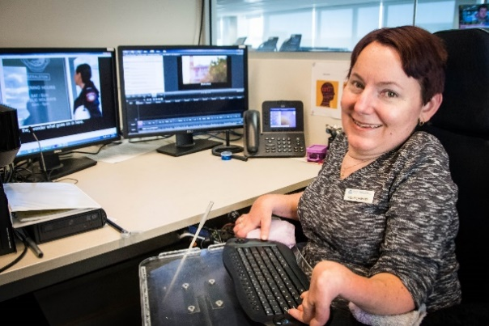
Figure 20 The Department of Fire and Emergency’s employee, Melanie, is dedicated to ensuring information is accessible as captions or transcripts

City of Fremantle
An Access, Inclusion and Community Connection Facebook Group, ‘Fair Go Freo’, was established in 2019. Fair Go Freo is a place for local organisations, agencies, people with disabilities, their carers, parents, friends and the City of Fremantle to share events, news, grant information and positive stories that may be of relevance/interest to each other. The new group currently has around 100 members and expands on the City’s existing Facebook Group – ‘Volunteer Fremantle’ – which has almost 500 members. Both groups provide an easy and effective way to raise awareness of events, news and activities in the disability sector. Feedback on the Fair Go Freo group has been extremely positive and the group continues to grow rapidly. The group is helping people to feel connected and informed in their local community.

City of Mandurah
The Inclusive Mandurah group is an extension of the Access and Inclusion Advisory Group and includes a collection of people who are champions for the importance of access and inclusion in the Mandurah community. The group aims to create awareness in the community around disability, access and inclusion, and acts as an information source for the community, and a conduit between the City and community. The group also supports the local community with inclusive projects throughout the year, including a chill-out zone for people with sensory needs at the Children’s Festival, events for International Day for People with Disability and the City’s Christmas Pageant.
The City of Mandurah acknowledges the positive impact that the group has in promoting access and inclusion and as such the group continues to be supported throughout the year by the dedicated Access and Inclusion officer. However, the City is currently supporting the Inclusive Mandurah group to develop their independence from the City and to plan for a way forward. The group is currently developing a terms of reference document and diversifying the group membership. Meetings are hosted at community organizations and venues across the City.
With support from the City and mentoring from the Socially Inclusive Communities WA (SICWA) project, the Inclusive Mandurah group has developed a logo, values, vision, flyer and a Facebook page. Members of the group recently interacted with members of the public at a local Disability Awareness Expo to raise awareness about the values of inclusion and to gather ideas about how to improve access and inclusion for all people within the local community.
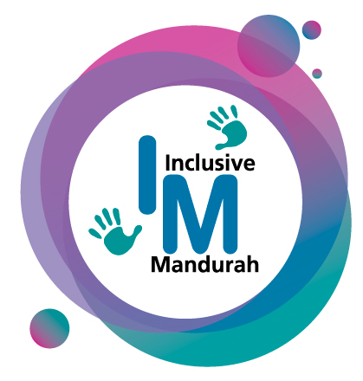

- 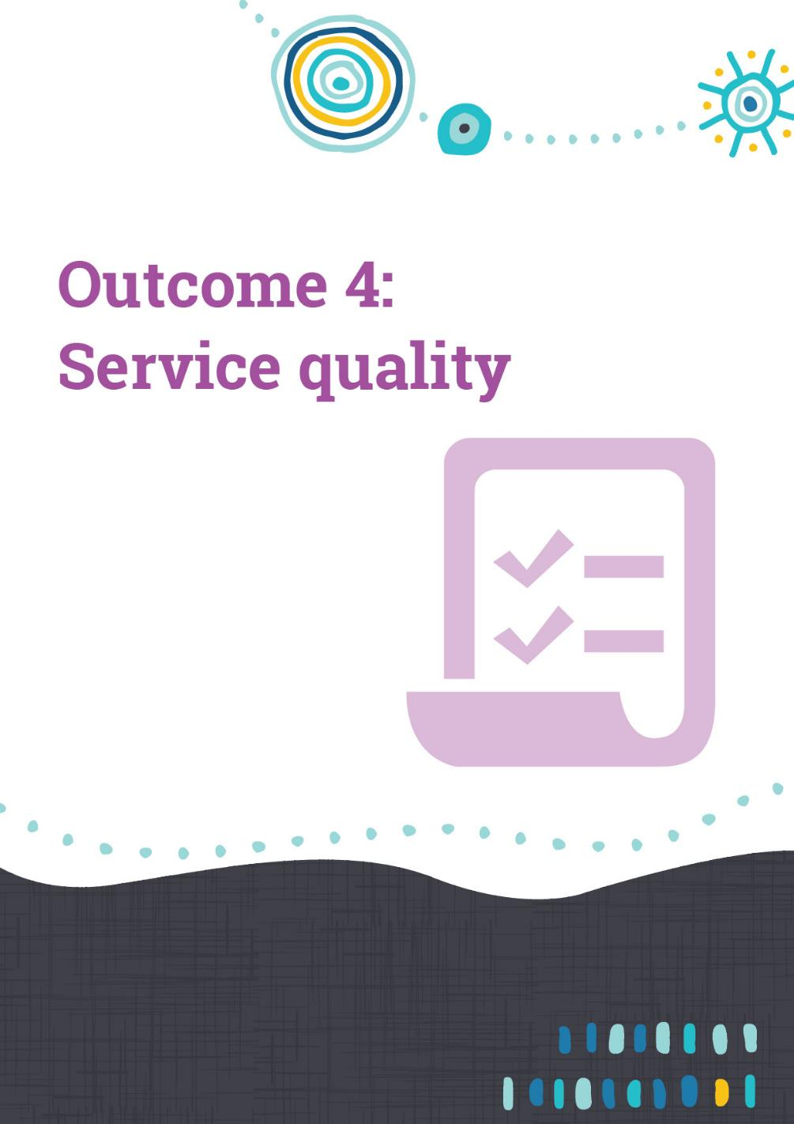

Outcome 4 achievements – Service quality
People with disability receive the same level and quality of service from the staff of a public authority as other people receive from the staff of that public authority.
This outcome area refines the focus on the quality and equitability of service arrangements. It is built on the principle that an individual should not be disadvantaged in the level of service they receive due to their disability.
Public authorities have approached this outcome in several ways. Some have focused initiatives and monitoring on customer services processes and procedures. Good customer service involves understanding customer needs and providing adequate responses to all service inquiries. Customer service staff should be provided with training on how to communicate effectively with all people, including people with disability.
Other authorities have the view that what is needed is capacity, knowledge and technical expertise and they have focused on improving disability awareness through their organisation and community. Some have developed training packages that illustrate the appropriate way of assisting people with disability to access the services they provide.

Department of Education
The Department of Education is supporting a national trial of telepresence robots in partnership with the not-for-profit organisation MissingSchool.
In 2018-19, MissingSchool’s See-Be robot initiative included two students in Western Australia with serious medical conditions that prevent them attending school for extended periods. This initiative has potential to benefit all children, particularly children with certain forms of disability, who are more likely to experience associated medical conditions which require extended absences from school.
The student, in the hospital or at home, can use their computer, phone or tablet to connect through See-Be to their classroom at the school. The robots provide a two-way video and audio connection enabling the absent student, students in the classroom and the teacher, to see and hear each other in real time. From their remote location, the absent student can also move the robot in the classroom and around the school, for example, to attend assembly or go to the library.
Megan Gilmour, Chief Executive Officer and co-founder of MissingSchool describes the “absolute look of joy”’ on children’s faces as they are connected with their teachers and peers.
MissingSchool recognises that school is a child’s community and an important source of support. It can alleviate the stress and anxiety of illness, promote resilience and optimism, and encourage seriously ill children to remain positively engaged in all aspects of their present and future.
A parent commented, “As my daughter was only commencing Kindy at the time of her extended illness, contact with her enrolled school and kids was extremely limited. Introducing her to the class through See-Be gave a personal, face-to-face experience which cemented her as part of the class group. Without being able to attend she was only a name, but the robot connection gave a physical embodiment and belonging to the class. This made her return to school, socially and academically, so much easier with the support of her school and the hospital school.”
Caleb Jones, principal of School of Special Educational Needs: Medical and Mental Health at Perth’s Children’s Hospital, commented that: “this new and emerging technology to connect students is very exciting. Evidence shows that social and academic disconnection affects a successful return to school. The See-Be robots are another tool to overcome these factors and improve student success. Thanks to MissingSchool for the national robot initiative and the partnership to make this a reality in WA.”

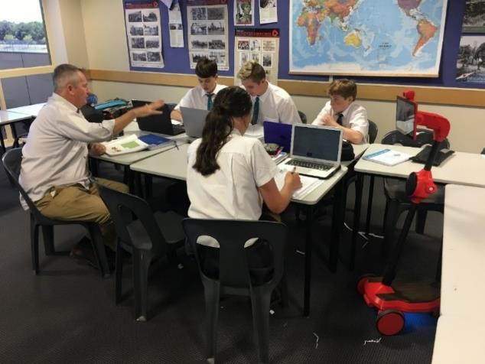
Figure 21 The Department of Education's robot enabling students who are not physically present in the classroom to engage in school activities

City of Melville
The City of Melville is committed to developing and deploying an all staff Disability Awareness Training package as part of the Corporate Training Calendar. As part of this, a staff lunchtime Disability Awareness and Social Justice presentation was delivered by Greens Senator Jordon Steele-John. Jordon presented on his own lived experience with disability and facilitated a discussion session on how the City of Melville can ensure people with disability are included and engaged in our Council, political processes and community. Additionally, in May 2019, organisational Disability and Dementia Awareness Training (two sessions) were provided by Equal Disability Consultants and Alzheimer’s WA.

Shire of Lake Grace
A stylus (a small pen-shaped instrument that is used to input commands to assist customers) has been adopted for the touch screen EFTPOS machine. Some customers were finding the touch screen difficult to use, causing them concern and frustration. There have been no difficulties experienced since the implementation of the stylus.

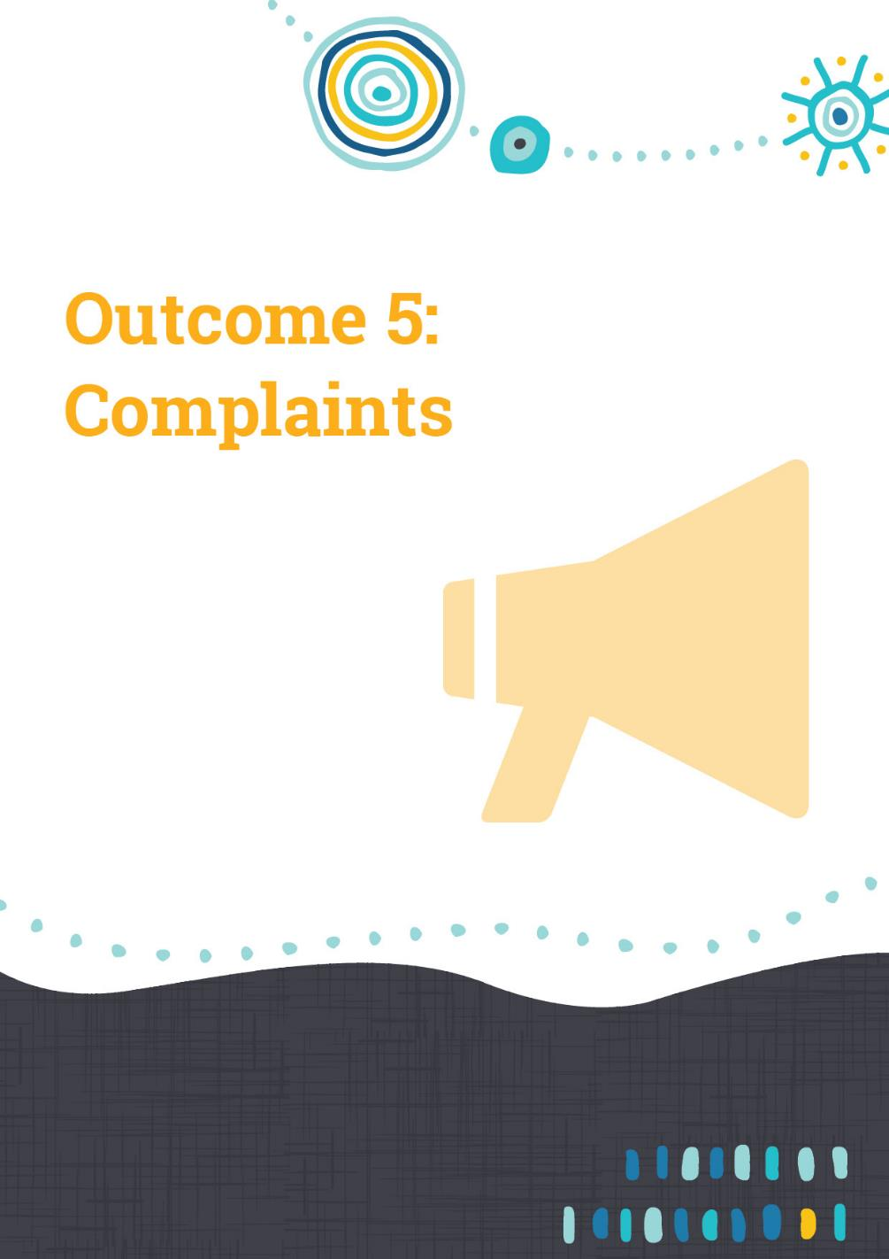

Outcome 5 – Complaints
People with disability have the same opportunities as other people to make complaints to a public authority.
Complaints systems play a fundamental role in ensuring that services meet the needs of the intended consumers and are also an important mechanism for achieving continuous improvement. The community has the right to let a public authority know if they are unhappy with the services provided. Equitable complaints mechanisms effectively receive and address complaints from all members of the community.
It can be more difficult for people with disability to make complaints. Information about how to make a complaint may be in a format that is inaccessible and the processes themselves may create barriers, by, for example, requiring all complaints to be made in writing. Alternatives to paper-based complaint processes could include internet complaint systems or a face-to-face service that assists not only people with disability but people from a non-English speaking background and older people.
This outcome reinforces the importance of accessible complaints mechanisms. Feedback from public authorities indicates that procedures and policies to ensure fair and equitable treatment are widespread, that complaints are valued as a source of information which improves access and inclusion, and that contemporary practice uses a variety of formats and mechanisms to ensure all people can voice their concerns in a way that suits them.

Main Roads
Main Roads has established a reporting tool that identifies DAIP related complaints and allows them to be categorised into key themes for analysis. The key themes are reported to Corporate Executive on a quarterly basis. This ensures issues around access and inclusion are identified and reviewed, thus allowing Main Roads to identify systemic issues in a timely fashion.

City of Armadale
Complaints can be made/received across all the City of Armadale’s buildings and departments and the City’s Feedback Protocol clearly defines the way in which complaints are handled and addressed. The Feedback Protocol to date is proving to be successful. For example, the City received a verbal complaint from a non-City of Armadale resident who was utilising a service in Armadale that was not available in her local area and was affected by the lack of accessible parking options for visitors to the premises (151 Jull Street, Armadale – which is also a building City staff occupy). Upon further investigation it was found that the City was not meeting legislative requirements (i.e. the Disability (Access to Premises – Buildings) Standards 2010). Accordingly, immediate action was taken to complete work at the adjacent carpark (145 Jull St) to include an Accessible Parking bay that is compliant with the specifications in the Standards (including signage, size/width of bay, distance to front door and surfacing materials).

City of Mandurah
Complaints to the City of Mandurah are made either in person, by telephone or by email. Staff from across the City have received disability awareness and social inclusion training which continues to enable staff to respond to feedback and complaints. In 2019, a community member informed the City of some access concerns in the City’s centre. The feedback provided an opportunity for the City to explore the accessibility of the City’s centre in greater detail. The City views feedback and complaints as an opportunity to increase universal access for all members of the community. A key benefit from the feedback and complaint process is that personnel from various business units now engage the Community Capacity Building team for input regarding a range of access and inclusion issues.
Because of the complaint process, several site visits were arranged with the Senior Development Compliance Officer, Community Development Officer and a community member with a vision impairment to gather data to guide a strategy to improve access in the City’s centre.

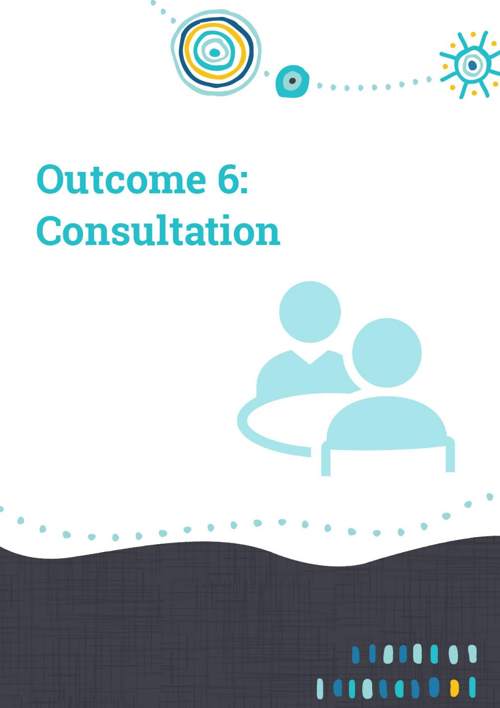

Outcome 6 achievements – Consultation
People with disability have the same opportunities as other people to participate in any public consultation by a public authority.
Consultation with residents, clients or service users brings benefits to all parties, including increased trust, transparency, a better understanding of experiences and technical expertise which can lead to better quality services and/or facilities.
This outcome area is aimed at driving and safeguarding the ability of people with disability to participate in the decision-making processes of a public authority. Some people with disability find it more difficult to communicate their opinions and experiences (for example, some may lack the confidence to voice their opinions). Conversely, many people without disability may lack sufficient understanding of disability related experiences and without consultation, a less effective or efficient result is more likely. Co-design, involving a consultation group throughout all stages of a project, has become increasingly popular in designing and implementing government projects.
Many public authorities, particularly local governments, have harnessed various forms of advisory groups to influence access and inclusion decisions.

City of Stirling
The City of Stirling is developing its DAIP 2020-25 and is currently engaging the community to help inform the future direction and actions of the plan to implement positive changes for people with disability.
The City’s Joe Camilleri Adult Day Club is a vibrant centre for people aged 18 to 65 years with intellectual disability. Programs offered to members include; music, drama, wellness, life skills, educational activities and opportunities that support clients in maintaining their independence. In alignment with Outcome Six of the City’s DAIP, Joe Camilleri Day Club members were asked if they would like to participate in the community consultation process. There were approximately 20 people who responded which resulted in four sessions being scheduled through May 2019.
The City’s Access and Inclusion Officer and a Curtin University Social Work student initially took participants in a small group through an interactive guide of what access and inclusion may mean for people. This was done via a whiteboard, with visual representation of different modes of transport, roads and footpaths, activities, clubs, Civic and community events, local facilities such as leisure centres and services including libraries and waste collection in the City of Stirling.
Participants shared stories of any barriers they may have encountered or positive experiences they have had in relation to access and inclusion. After these initial conversations, participants took part in a survey conducted one on one with a facilitator. Communication styles were adapted to meet the needs of the participant. Surveys were available in different formats including large print; some were completed by participants using iPads, populating hard copies or through verbal communication with facilitators. The facilitators found that the sessions took longer than originally anticipated with participants completing at their own pace. The Club Coordinator adjusted the daily timetable accordingly so there was no pressure to finish the sessions prematurely.
People’s different experiences provided valuable insights which may be used to inform positive change within the City of Stirling. An important part of the engagement process will be to meet again with the participants when the new DAIP is in draft format. The City will demonstrate to members how their information has been used in developing actions and seek feedback on the draft document from members, their families and networks.

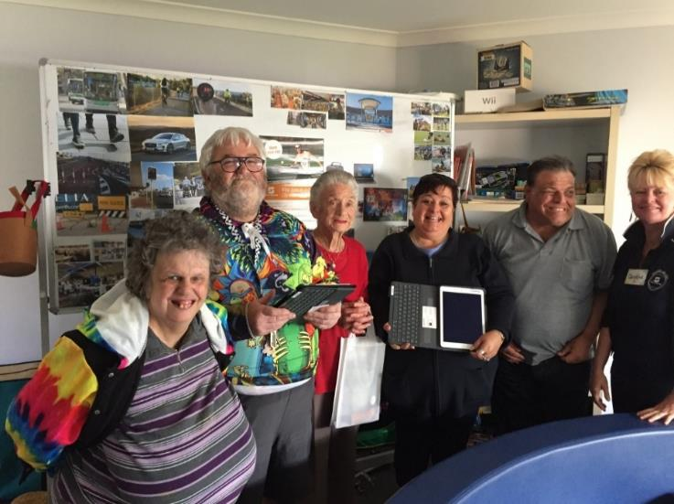
Figure 22 Access and Inclusion consultation at the Joe Camilleri Adult Day Club in the City of Stirling

Synergy
Synergy Diversity Committee ran an online customer survey on Diversity and Inclusion. The purpose of the survey was to gain insights on customer perceptions and expectations of Synergy and Synergy’s diversity and inclusion initiatives.
The results of this research have informed Synergy's strategic direction for diversity and inclusion for employees, customers and the community.

Mental Health Commission
In September and October 2018, the Mental Health Commission (MHC) provided the draft Western Australian Mental Health, Alcohol and Other Drug Accommodation and Support Strategy 2018-2025 (Accommodation and Support Strategy) for stakeholder feedback.
The public consultation process for the Accommodation and Support Strategy recognised the need to ensure and encourage people of all abilities to participate and provided a variety of options for people to provide feedback and submissions, including an online survey, via telephone, in writing via mail, through email or in person at the MHC office.
All the consultation material was available on the MHC Website and individuals were able to request Word versions of the consultation materials, so they could manipulate the size/colour of the font.
Where requested, MHC staff spoke with people individually to obtain their feedback and clarify any questions.

Main Roads
Main Roads is extending its consultation approach by leveraging from established regular and relevant communication with Local and State Government Authorities who have active disability reference committees as part of their community engagement strategies.
Main Roads actively participates in the State Government Access and Inclusion Network meeting, which includes numerous representatives from state government agencies.
Main Roads also actively participates in a Transport Access and Inclusion working group, with their portfolio partners Department of Transport and the Public Transport Authority. This Group have extended an invite to local government agencies to present key topics for consideration at their meetings.

Shire of Broome
The Shire of Broome’s Youth Community Development Officer recognised the need to attend regular community disability access and inclusion meetings to consult with stakeholders and community members within the disability sector. The meetings provide ongoing advice, recommendations, insights and knowledge to support disability needs within the community. Such meetings include the National Disability Strategy Review, Disability Pathways Working Group, State Disability Plan Consultation Workshop and general stakeholder committee meetings.

Shire of Narrogin
The Manager of the Community Leisure & Culture at the Shire of Narrogin requested that Council allocate a budget for disability awareness training for all organisational staff. Key staff in the Department of Development and Regulatory Services and Technical and Rural Services attended the training. This training gave staff a new perspective on the concept of inclusiveness and barriers to inclusion. Excellent feedback was received from the participants and a budget request has been progressed to allow for further training of this nature in 2019-20.
The Shire developed a Community Engagement Policy which will be presented to Council for endorsement on 26 June 2018. This included the following clause which sets out the principle that the Shire will carefully consider how to engage with the community and ensure its processes, venues and information are accessible:
“We recognise people engage with civic life in different ways depending on a number of factors, such as age, background and ability. We aim to be responsive to this broad spectrum of needs and ensure there are multiple engagement methods in various settings, to achieve appropriate community participation.
We ensure our engagement is accessible by providing information in clear and easy to understand formats or is available in alternative formats on request. Our engagement events and venues are designed to be accessible whenever practical and achievable.”

Shire of Cue
The Shire of Cue is working to ensure that its governance and formal engagement with community is accessible. The Shire administration building has been outfitted with an electric chair and access has been improved to allow all members of the community to access the Chambers and the building. Larger town meetings are now held in a facility that can accommodate all accessibility requirements.

City of Fremantle
As part of the City of Fremantle’s playground works schedule, the combination play unit, swings and basketball hoops and backboards at Grigg Park were due for replacement. Instead of a like-for-like replacement, the City wanted to examine the suitability of the surrounding area. Accordingly, the City undertook community engagement to understand the most popular types of activities for the local community, the facilities used/required, and the appropriate style of replacement play equipment for this space. To better connect with the community, the City letterboxed the catchment area, held a drop-in at the park, undertook school visits and had an online engagement strategy.
The City’s parks team researched basket swings to understand how they enable wider participation of people with disability/mobility issues. The team concluded that a basket swing was more inclusive than the existing swing and would generate a social benefit. The City’s approach was to integrate accessible elements into the overall design rather than providing separate pieces. Because of the feedback provided by the community, additional benches were installed in various locations in the park to provide for a range of uses.
After completion of the upgrades to Grigg Park, the City worked with locals to hold an event as part of ‘Neighbour Day’ to encourage people to connect with and look out for their neighbours. Members of the City’s community safety team also attended and handed out giveaways to help people with practical ideas to improve the security of their homes.

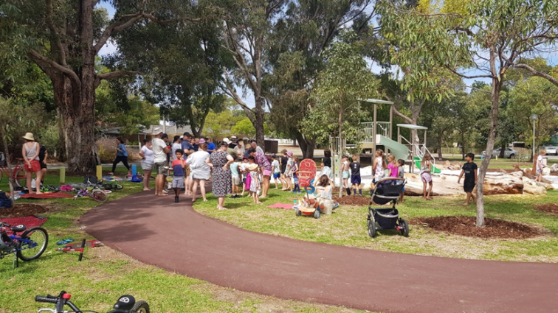
Figure 23 Grigg Park Community consultation session

Western Australian Museum
To support Outcome 6, the Western Australian Museum actively consulted with a representative panel of people with disability, advocates and carers, to ensure universal access requirements are central to the development of the New Museum, located in the Perth Cultural Centre and due to open to the public in 2020.
The Access and Inclusion panel have met on four occasions, providing input into content development and visitor experiences for the New Museum, including proposed exhibition themes, ways of presenting information for diverse audiences, accessible tours and proposed site interpretation. During the year, the Museum developed its new DAIP
2018-22.
DADAA (an arts and health organisation that creates access to cultural activities for people with disability or a mental illness) was engaged by the Department of Culture and the Arts to review the DAIP, the department and its portfolio agencies, including the WA Museum, and to consult with the disability sector. The Museum incorporated some of the findings from DADAA’s report, Embedding Access: An Opportunity for the Arts Sector, into the new DAIP. An advertisement was placed in ‘The West Australian’ newspaper inviting the public to provide feedback on its draft DAIP 2018-22.

Town of Victoria Park
The Town of Victoria Park hosted the ‘55+ in the Park’ event which included a community directory, seniors’ network and celebration launch events. The project was supported by the Department of Communities, in partnership with Connect Victoria Park, Harold Hawthorne Community Centre and SwanCare. The aim was to connect seniors to their community through active participation and to promote local community groups and service providers. Five events were held over the course of the project. Information was gathered about seniors, their aspirations, concerns and barriers towards achieving a good quality of life, resulting in 89 responses. A community directory, which includes over 120 entries on community groups, activities and services is now available and has been distributed to Town of Victoria Park centres and partners. The community directory was launched at the following three events in June:
- Family Fun Day – SwanCare
- Rock Around the Park – Connect Victoria Park
- Ballroom Blitz – Harold Hawthorne Community Centre.
These events were designed to engage a diverse range of seniors, including older people with disability, to actively participate in a range of activities that utilised all senses. The events incorporated various entertainment options:
- Live Music
- Silent Disco
- WA Disability Aid Dogs
- Guide Dogs WA
- Ballroom Dancing and display
- Rock and Roll Dancing and display
- Roving magician
- Petting Farm
- Board Games
- Giant Games, with Trophies & participation Medallions awarded
- Roving Community Development Students
- Digital help desk
- Free Door Prizes/Raffles
- Food and refreshments
- ‘55+ in the Park’ Banner ‘set’ for fun personal Facebook photos.
Because of the above events, local community groups and service providers have been widely promoted to the community and the City is more engaged with its elderly residents and those with disability. In addition, the Town has information about people’s aspirations and concerns at different stages of ageing and mobility and its partnership with seniors’ groups has strengthened. A seniors’ network group, which includes disability and culturally diverse service providers, held its first meeting and plans for future activities in the seniors’ space.

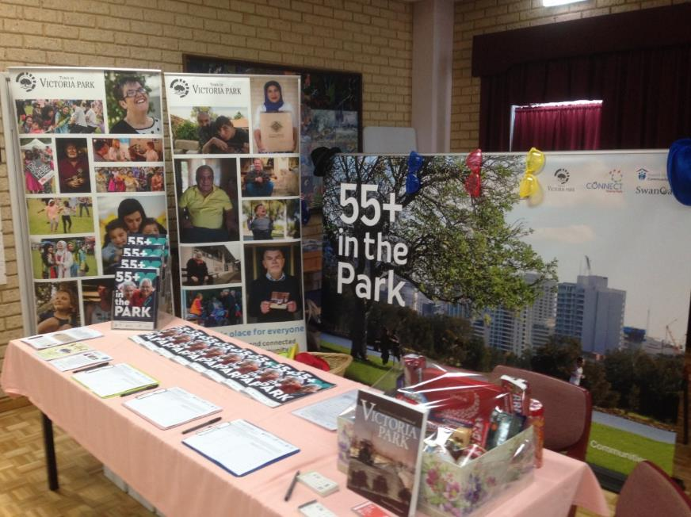
Figure 24 The ‘55+ in the Park’ event helped bring together seniors and older people with disability to provide and receive information from the Town of Victoria Park



Outcome 7 achievements – Employment
Meaningful employment is essential to an individual’s economic security and is important to achieving social inclusion and independence.
Employment contributes to physical and mental health, personal wellbeing and a sense of identity. People with disability or mental illness can experience restrictions in their daily lives when taking part in family, community, recreation and work activities. For them, a job means much more than an income – it is a doorway to engagement in community life and an enhanced feeling of self-worth.
Finding employment is something many Western Australians take for granted. For people with disability, finding, securing and retaining employment can be challenging. People with disability are often overlooked by employers for a variety of reasons and are only half as likely to be employed as people with no disability.
Some public authorities have improved employment opportunities for people with disability by using inclusive recruitment practices, such as advertising job opportunities in an accessible format, including an Equal Opportunity statement in the advertisement and conducting interviews in accessible venues.
To promote and retain inclusive employment, many authorities have modified their employment processes. For example, job descriptions and work practices have become more flexible (e.g. by allowing working from home and adopting flexible working hours).
It should be noted that some public authorities’ roles in building the capacity of people with disability to gain employment may not be linked to employment with the authority, but elsewhere in the community. These roles are still reflected as DAIP activities.

North Regional TAFE
North Regional TAFE has experienced significant growth in the number of students with disability who are provided with face-to-face training support, both across its courses and its open learning program. This support enables students to build skills to improve their employability, independence, skills and leadership. The number of students with disability has increased by over 60 per cent in the last year. Part of this this growth has been attributed to the implementation of the National Disability Insurance Scheme (NDIS) and the supports available to help people achieve their goals.
Because of this spike in demand, it has been a significant challenge planning and implementing strategies to ensure physical access, access to information and support for students with disability. However, this has also created opportunities for new learning programs, innovation and community engagement. For example, Fitzroy Crossing Open Learning Centre has established a partnership with community organisations Far North and the Men’s Shed and programs are being developed with the local Women’s Centre.
At the Broome campus, one student, Rana, is studying Community Services and receiving training support to complete her course. Due to the increasing number of students and Rana’s skills and attitude, she has been invited to complete her work experience placement by assisting another student, with the objective of Rana securing paid work as a North Regional TAFE Support Worker on completion of her course. Rana said: “I wasn’t expecting this! I hadn’t been able to find employment so have been undertaking these courses in the hope of eventually gaining employment, so this is very exciting and a wonderful opportunity for me.”

The situation has highlighted the capacity of effective classroom technology to enable more inclusive and adaptable learning opportunities which support individual learning goals. There has been increased demand for Electronic Smart Boards that allow staff and support workers to download and or build appropriate programs for improved learning delivery. Supporting students with significant disability involves identifying their talents and improving their independence. For example, student Richard has leveraged his new skills in technology and social media to establish a small business for art and game boards.

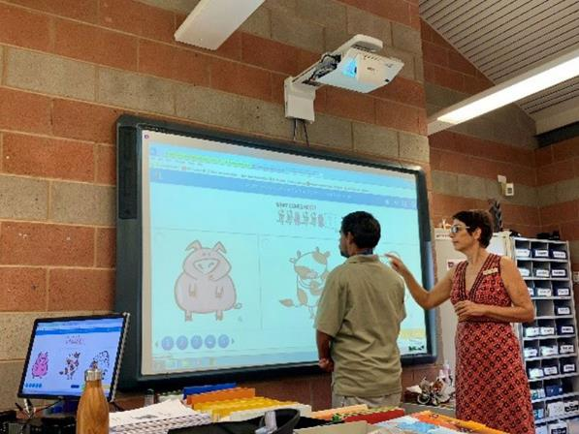
Figure 25 Students at the Kununurra Open Learning Centre used interactive whiteboards to improve numeracy and literacy skills

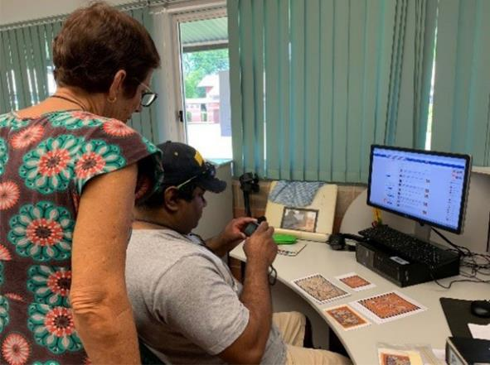
Figure 26 Richard’s economic independence has grown through learning new technology skills to complement his creativity

Department of Mines, Industry Regulation and Safety
The Department of Mines, Industry Regulation and Safety (DMIRS) participated in the Public Sector Commission’s Adult People with Disability (PWD) trainee pilot program. Through this program the department hosted Anthony, a trainee working towards his Certificate III in Government (Public Administration).
Hosting Anthony has raised awareness and increased our employees’ understanding of autism. It has also demonstrated that an inclusive work environment fosters people’s skills and abilities so that they can thrive in the workplace.
Being on the autism spectrum, Anthony described experiencing intense levels of discrimination from past employers. Since commencing at DMIRS Anthony has felt welcomed and supported by his colleagues.
“The main goal of diversity and inclusion is to focus on breaking down barriers all together and my lived experience motivates my work to help others with disabilities,” said Anthony.
General Manager of Information and Development, Su Ho, said that trainees like Anthony learn and develop a range of administrative and office skills within a public sector context. Successful completion awards students with the nationally recognised qualification, Certificate III in Government (Public Administration).
“DMIRS worked with the Public Sector Commission, the Autism Association of WA, Aspire Performance Training and AIM Employment. The collaboration was paramount to the success of the program,” said Su.
“Anthony has already made a significant work contribution and the benefits of hosting him go beyond what he has done workwise. He has assisted with destigmatising disability at DMIRS and highlighted the contributions that people will make when given the opportunity.”

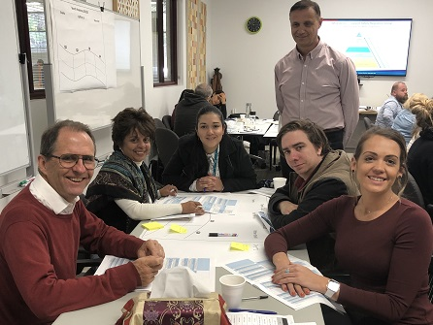
Figure 27 Welcoming Anthony (seated second from right) to DMIRS has been successful experience for both Anthony and his colleagues

Department of Training and Workforce Development
The Department of Training and Workforce Development has developed an Employer Incentive Scheme that will encourage employers to take on apprentices and trainees. Under the scheme, the Department recognises a range of target groups including apprentices and trainees with disability.

Employers who hire a person with disability will receive an additional payment loading of 10 per cent. Further information is available on the Jobs and Skills WA Employer Incentive page.

City of Greater Geraldton
Public authorities are increasingly aware that the challenge of improving diversity in the workforce can require rethinking the way positions are advertised and ensuring inclusive recruitment and retention practices.
The City of Greater Geraldton includes a diversity statement in its advertising material that encourages all groups of people to apply. “The City of Greater Geraldton actively welcomes, includes and values the unique contributions of all people in its workplace. The City welcomes applications from all age groups, people with a disability, and those from diverse ethnic and cultural backgrounds. We are proud to be an equal opportunity employer with strong commitment to fitness for work and safety in the workplace.” This statement clearly demonstrates to prospective employees the City’s stance on diversity and inclusivity.
Further progress in 2018-19 included reviewing the selection criteria of each position to determine if it was necessary to include a requirement to have a driver's licence. Removing this criteria from positions that don't require it broadens the potential applicant pool and ensures that people with disability that are unable to drive are not excluded from applying for these roles.
The City's recruitment pages have been designed to be intuitive with their audience by including a function that reads the information on the page aloud to the viewer. This function is a positive step forward in making the information about vacancies accessible to more groups of people.

Shire of Augusta-Margaret River
As part of providing opportunities for local youth with disability, Brooke was employed as a Recreation Administration officer for a 12-month contract at the Shire of Augusta Margaret-River. Brooke’s role includes front counter customer service, café and various administration duties. During Brooke’s placement, the management team worked diligently with Brooke and her family to develop Brooke’s strengths in the workplace, to increase her confidence in undertaking the role and to broaden her skills in readiness for other potential employment opportunities in the future.
When Brooke commenced in the role, she was readily accepted into the team and her confidence grew daily. Her skills in the café and front counter are now well established and her customer service ability has improved significantly. Brooke has attracted positive feedback from all patrons attending the centre. Management and other Shire staff now realise the importance of diversifying and becoming a more inclusive team.
Dylan, Recreation Centre Manager: “Brooke has walked (or danced) directly into our team. Her role at the centre has created a more diverse workforce – one in which many views are represented, and everyone’s talents are valued. Having an inclusive work environment has also allowed the recreation team to grow and diversify with Brooke. I believe through Brooke’s time at the Recreation Centre people see through her disability and she is just another team member.”
Tegan, Aquatic Operator: “The Artzability group love coming in and seeing Brooke at work on Tuesdays and Thursdays at lunch times. She serves them coffee and lunch regularly and is a shining and vibrant personality in our community. The Rec Centre patrons enjoy seeing Brooke when they come in for a work out.”
Brooke: “I love my job and it’s the best I’ve ever had, I love making coffees and being nice to customers. Brian helps me do pool tests and teaches me about the pool.”

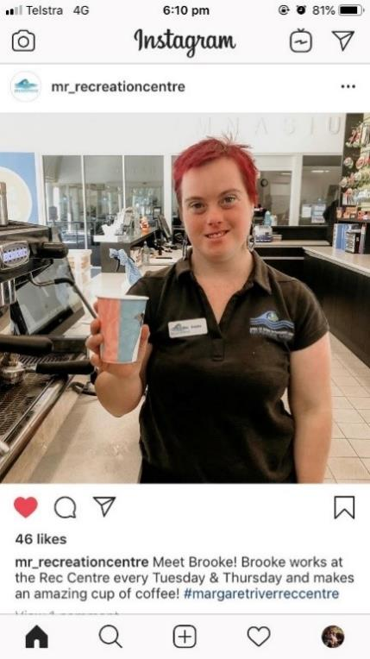
Figure 28 Brooke is The Shire of Augusta-Margaret River’s popular new employee

Town of Victoria Park
Multi-disciplinary conceptual artist Bruno Booth painted a mural on the Victoria Park Community Centre wall. The design has been informed by those who use the centre. Bruno was contracted for his ability to deliver a community artwork and the installation process was captured on video. Bruno’s experience, as captured in the video, provides a great example of the fact that disability is not a barrier for people who wish to pursue a career in the arts industry.

Figure 29 Conceptual Artist Bruno Booth

City of Mandurah
In 2018-19, Mandurah Libraries successfully partnered with the Peel Volunteer and Resource Centre to host an inclusive volunteer initiative called the Sociability Program. Mandurah Libraries provided a six-week volunteer opportunity to a group of five volunteers (who identified as people with disability) across three library branches. Volunteers at the libraries received on-the-job support from a Peel Volunteer and Resource Centre staff member to build skills, knowledge and confidence, and to develop working relationships with the library staff. Staff from one of the libraries received an orientation session from Peel Volunteer and Resource Centre regarding the Sociability Program, with some staff from the City of Mandurah’s events team also attending inclusion training with the Centre.
The Sociability Program highlighted to the City the importance of community participation, inclusion, relationships/friendships, valued roles and lifelong learning for all people. This program also enabled the City to explore creative ways of providing valued roles for people with disability, with scope for an ongoing partnership.

City of Bayswater
In 2018, the City of Bayswater was contacted by a family who were seeking work experience for their son at one of its recreation facilities. The young man identified as having an intellectual disability and indicated that he was keen to work at a gymnasium or similar recreational sporting facility. The City’s Recreation team was keen to give the young man an opportunity to participate in a work placement, and proactively worked with the family, his school, and the City's Human Resources team to overcome several barriers to arrange the work placement opportunity.
A work placement program was set up, and the young man undertook work experience at Bayswater Waves Health Club from October to November 2018. The Recreation team reported that the placement was a success.
City staff are currently investigating opportunities and pathways to create a paid employment opportunity for the young man, if feasible. A meeting with a Disability Employment Service provider has been booked for mid-2019 to determine what assistance they can offer to the City and how the City might progress with a placement. This action is consistent with the City’s DAIP strategies that seek to improve workplace flexibility and diversity.

Shire of Kojonup
The Shire of Kojonup provides work experience, volunteering and employment opportunities within the organisation for people with disability. This information is relayed through service providers, schools and through the Shire’s E-News newsletter. In 2018-19, the Shire (through The Kodja Place and Kojonup Visitor Centre) took on two volunteers. One was a student with a mild intellectual disability, Participant A, and the other was an older student with dwarfism, Participant B, who was preparing for university and lacked confidence in dealing with members outside of her family and friends. Using a buddy program, work tasks were modified to help build the confidence of both participants and to provide them with essential skills to assist in obtaining future employment opportunities. These skills included customer service, telephone technique, handling money (e.g. how to use the point of sale within the retail shop), communication skills and tourism knowledge through visitor servicing, preparing stock and stock control, and computer skills. A step was provided for participant B to assist with counter enquiries and the Shire was looking at ways to utilise Participant B’s skills and interest in film making within the Story Place of The Kodja Place attraction (co-located with the visitor centre).
The Shire continues to provide training, through The Kodja Place and Kojonup Visitor Centre’s volunteer/mentoring program, to a mature indigenous person, Participant C, who suffers from physical disability and health issues. Participant C has been unemployed for a considerable length of time and wanted assistance to become more employable. The training has been ongoing for four years and although progress has been hampered due to Participant C dropping in and out of the program (sometimes for lengthy periods of time), he has managed to create several indigenous products (message sticks, paintings, tapping and walking sticks) for sale, either directly or through the visitor centre retail store, providing him with some additional income. Participant C’s self-confidence has dramatically improved through his participation in media and community events. Participant C has also had training in the visitor centre which involved handling point of sale and visitor enquiries and is currently developing his tour guiding skills.

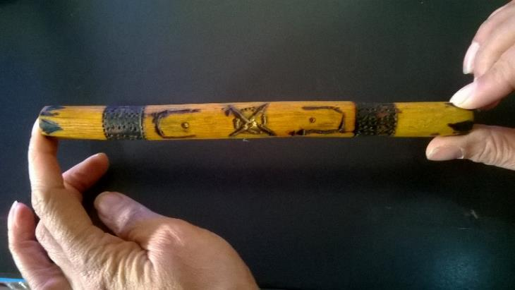
Figure 30 The Shire of Kojonup is using volunteer and mentor programs to support people with disability to gain economic independence through the development and sale of their products

Department of Communities
The Department of Communities is currently completing an assessment process to be recognised as a Disability Confident Recruiter (DCR). The program is being undertaken via the Australian Network on Disability and the Department of Communities is scheduled to complete this over the next year. This work is being driven internally by consultation with a working group that includes employees with disability and will be informed by their lived experiences.
Once recognised, the Department of Communities will be able to use the DCR logo on its recruitment advertisements, identifying that it has fair, equitable, accessible and barrier-free recruitment processes.
This initiative is part of the Department of Communities’ Equity and Diversity Plan, developed in consultation with stakeholders during the first half of 2019, which identifies people with disability as a key priority for inclusion in the Department of Communities’ workforce. The plan sets targets and identifies initiatives to create and sustain a diverse and inclusive workplace and disability confident culture, where people with disability have equal access to employment and development opportunities. Achieving targets will hinge on the support of senior leadership, and commitment to implementing the strategies and equity targets will form part of senior executive performance development plans.

Department of Primary Industries and Regional Development
The Department of Primary Industries and Regional Development made a commitment to fund staff with a disability to attend a bespoke program, LeadAbility, offered by Leadership WA.
LeadAbility is provides training to people with disability and those in the disability sector, who have the potential to lead and generate change. It is an experience-based initiative designed to equip these people with new frameworks and tools to become stronger leaders. Specifically, LeadAbility builds leadership skills to enable people to become more influential, confident and to lead effectively. The LeadAbility Program includes dynamic activities focusing on understanding leadership, effective communication, teamwork, and community.

Department of Mines, Industry Regulation and Safety
Several Department of Mines, Industry Regulation and Safety’s (DMIRS) specialised vehicles have been modified to be multi-use and suitable for remote work. The vehicles are equipped with several extra safety features to protect staff and to carry the equipment needed for the work.
One vehicle was further modified to enable Environmental Officer, Adam, to drive the car and use his expertise in carrying out fieldwork and inspections. Adam has a physical disability limiting access to the accelerator pedal and to the stored field equipment. When this specific car was due for replacement, Adam thought he might not be able to continue his remote fieldwork and his role as an Environmental Officer.
“Fortunately, DMIRS had recently established the Reasonable Adjustment and Modification Policy”, said Adam. “Also DMIRS practices a ‘like for like’ vehicle replacement agreement to ensure new vehicles continue to meet the organisational needs as well as considering staff. This resulted in the new vehicle being configured in the same way as the previous vehicle to allow me to drive it. Cost was not the barrier I thought it might be. Costs were kept to a minimum because DMIRS was able to reuse the previous recovery and field equipment. I am looking forward to continuing my contribution to DMIRS and doing the job I value.”

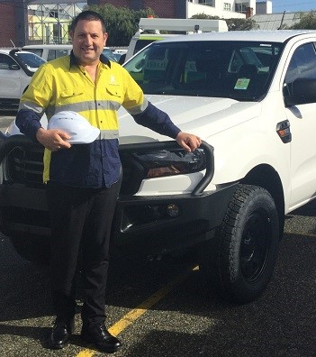
Figure 31 Effective workplace modification policies at DMIRS have supported Adam’s expertise in the field

Agents and contractors
This section is included to highlight the role agents and contractors play in supporting and enhancing a public authority’s DAIP values. An agent or contractor is an individual or organisation that undertakes work or provides a service on behalf of a state government agency or local government authority.
Under the Disability Services Act 1993, public authorities are required to take all practicable measures to ensure that their DAIP is implemented by the public authority and its officers, employees, agents or contractors. Services provided to the public by agents and contractors need to be consistent with the contracting public authority’s DAIP. This addresses the expectation that services, or facilities provided through public funds are accessible to everyone.
The objective is to help to ensure that contractors operate with shared values towards access and inclusion, and to stimulate greater disability awareness and innovation across the private and community sector. Ensuring agent and contractor awareness of an employer’s DAIP commitments is good risk management to help avoid poor inclusion practices from an agent or contractor.
In 2018-19, 71 per cent of local government, and 56 per cent of state government authorities used contracts or agreements which included DAIP clauses with agents and contractors. Around 20 per cent of all authorities required an annual report on DAIP related activities from their agents and contractors.
For state government authorities, a special condition of contract applies under the Department of Treasury and Finance’s framework and the State Supply Commission’s Funding and Purchasing Community Services Policy.
The special condition:
- applies to new and varied contracts for providing services to the public
- is compulsory for state government agencies and recommended for use by local governments
- outlines the Act’s requirements for contractors, stating that they must:
- undertake services to the public in a manner consistent with the contracting public authority’s DAIP
- report once a year to the public authority about which DAIP outcome areas they have progressed.
Following consultation with the Western Australian Local Government Association, this special condition is a suggested approach for local government authorities to ensure that contracted services are accessible to people with disability.

South Metropolitan Health Service
South Metropolitan Health Service contracts key services to Avivo Live Life Incorporated. Avivo Live Life have initiated the following activities to make their services more accessible and inclusive to people with disability:
- Outcome 3 - People with disability receive information in a format that will enable them to access information as readily as other people are able to access it.
Avivo’s website was reviewed in late 2018 and work is currently underway to update the site. An external website developer that specialises in accessibility and inclusive design has been engaged.
- Outcome 4 – People with disability receive the same level and quality of service from staff as other people receive.
Avivo have established a network of ‘experts by experience’ who meet bi-monthly and are involved in various aspects of operational and strategic activities.
- Outcome 7 – People with disability have the same opportunities as other people to obtain and maintain employment.
Avivo is currently involved in the Disability Employment Initiative. The project is focused on identifying how the organisation can better support people with disability to work at Avivo and increase the number of people with disability employed by the service.

City of Fremantle
In March 2019, the City of Fremantle adopted a new community engagement policy which applies to all staff and contractors. The policy stipulates that the City will carefully consider how to ensure that its processes, venues and information are accessible. Training contractors, including Alzheimer’s WA and VisAbility, presented Disability Awareness training sessions to all staff and volunteers. Dr Scott Hollier presented to the Executive team about online accessibility, in preparation for the new website development. The City has also created a new Sustainability and Accessibility checklist policy. Event contractors are provided with a copy of this policy when applying for a contract.

City of Canning
The City of Canning’s Procurement of Goods and Services Policy requires at least one quotation from a WA Disability Enterprise, Aboriginal Owned Business or local supplier. This Policy has led to 236 Purchase Orders being raised on Disability Enterprises over 2018-19, for a total spend of $147,077.

Analysis of public authority DAIP Progress Reports
All 208 public authorities completed their DAIP Progress Reporting between April and July 2019, achieving 100 per cent compliance. During the 2017-18 period the compliance rate was 92 per cent.

DAIP activities
Public authorities reported 5,475 new and ongoing (progressed) activities for 2018-19. Ongoing activities were those pre-existing initiatives which were advanced and or developed during the reporting period.
As awareness of anti-discrimination and disability access and inclusion standards has been embedded within public authorities over the last few decades, this year’s DAIP progress report has focused on capturing the innovation and creativity used to create localised responses to the needs of people with disability.
Emphasis was on sharing the story of the activity. The intent of sharing the stories is to develop a shared purpose for stakeholders, in supporting the inclusion of people with disability, their families and carers in Western Australia.

Focus on the influence of DAIPS
Many public authorities now report that access and inclusion has been integrated into their broader community planning and consultation processes.
Approaches to the coordination and leadership of DAIPs varies across public authorities, with local government authorities, in line with their role and proximity to community, utilising Community Services and Community Development (35 per cent), Corporate Services (14 per cent) and Service Delivery (8 per cent).
Most of state government agencies coordinated their DAIP via Corporate Services (52 per cent) as it aligned with human resources, workforce planning, communications and building and facility management.
Internal working groups, participation of external stakeholders and feedback from the community are also used to support DAIP activities. Internal working groups were reported by over 70 per cent of state government authorities. One-in-five local government authorities reported and external working group, with 60 per cent having established consultation or co-design mechanisms.
Most public authorities (83 per cent and 71 per cent of state and local governments respectively) support and operationalise their agency’s five-year DAIP via an implementation plan.
Public authorities also support staff awareness of their DAIP and access and inclusion practices, through inclusion of DAIP in internal policies and procedures, other planning processes and staff orientation.
Over 70 per cent of authorities referenced the DAIP in other internal policies and procedures, and over 60 per cent integrated DAIP values or commitments into other organisational planning, such as their strategic plan. Around 40 per cent of authorities ensured that new staff received a copy of the DAIP.

Challenges experienced by public authorities
Consistent with previous years, public authorities have reported challenges to implementing DAIP initiatives; including changes in staffing and leadership, budget constraints, conflicting and changing priorities, and loss of engagement with stakeholders.

Changes in staffing/leadership
In 2018-19, changes in staffing and leadership were reported as the most significant challenges to DAIP implementation across authorities. These challenges may be experienced for a range of reasons, often inherent to the way each organisation is resourced and supported. They impact people with disability by impeding the effective completion of planned initiatives.
Public authorities can mitigate the risk of losing key staff by prioritising a systems-based approach which doesn’t rely on any individual or function to drive the DAIP. This includes:
- ensuring decision makers are involved in all DAIP initiatives to support resourcing and funding decisions
- ensuring clear roles and responsibilities when working with partners
- working to agreed governance and project management models
- the agility to manage barriers as they occur.

Budget constraints
These challenges predominantly impact efforts to improve the accessibility of built infrastructure. Local government authorities point to a limited revenue base and significant costs associated with retrofitting existing infrastructure. As a result, even though the scope for improvements is often identifiable, there is significant time lag in funding these initiatives.
While the costs for building works are likely to reduce over time as infrastructure is renovated or replaced, currently, people with mobility restrictions continue to face considerable challenges in gaining equal and equitable access to infrastructure. Public authorities undertake strategies to address these challenges, which include:
- ensuring inclusive infrastructure in the costing, design and planning stage to mitigate future costs and poor accessibility
- ensuring expertise in assessing social and economic return on investment into accessible infrastructure, to support funding decisions
- relocating services to more accessible buildings and facilities, or reconfiguring services to improve access
- working with people with disability, the commercial sector and the community to use co-design and innovation to ensure initiatives are effective and minimise cost and
- dedicating an ongoing budget towards improving built infrastructure priorities.

Lack of support/feedback from the community
Public authorities continue to report difficulties in establishing a comprehensive picture of access and inclusion needs of the community. While many have established highly effective consultation methods, others report that momentum for driving DAIP initiatives can be stymied by a lack of community input and advocacy. While in some cases this may be a sign that customers or residents with disability are comfortable with current arrangements, it should be noted that many people with disability find it difficult to communicate their experiences. They may experience social isolation and a lack of direct contact with an authority or they may lack confidence.
Strategies undertaken by public authorities to address these issues include:
- identifying disability representatives via formal or informal consultation mechanisms
- valuing and seeking the input of carers, friends and family to help identify community or customer issues
- providing support and development opportunities to improve the quality of feedback
- valuing and promoting complaints mechanisms, including anonymity, as a means of understanding issues. Where a complaint is made, engaging with the complainant as a potential source of broader disability feedback
- offering a variety of options, including social media, to make it as easy as possible to provide feedback
- communicating with other public authorities to share engagement strategies and learn from each other.

Support from the Department of Communities
The Department of Communities supported public authorities to develop their DAIPs and to build inclusive communities during 2018-19. Activities included:
- maintaining a suite of resources online to assist public authorities to develop and implement DAIPs, including guidelines on agents and contractors
- providing disability awareness presentations for public authorities to build staff knowledge and confidence
- providing one-on-one support to officers across the public sector to help them to improve accessibility
- participating in consultation and advisory groups on significant projects, including the Perth Stadium, Perth Airport and on several local government advisory groups
- liaising with public authorities to assist with the extension and expansion of the NDIS in WA
- providing regular workshops and training opportunities, with a focus on regional authorities as well as agencies impacted by Machinery of Government reforms
- leading and supporting the WA local government access and inclusion group forums, and state government access and inclusion network meetings
- providing a ‘DAIP Development’ workshop aimed at assisting public authorities who were reviewing DAIPs
- providing a dedicated access and inclusion enquiry service to authorities and the public
- ensuring public access and inclusion concerns and queries are effectively addressed through team knowledge and liaison with DAIP contacts in public authorities.
Public authorities indicated that they were 100 per cent satisfied with support for access and inclusion offered by the staff of the Department of Communities. Out of 164 responses to this question, 84 respondents indicated that they were very satisfied, while 80 reported that they were satisfied.

Appendix One: Public authority submissions
The following State Government authorities provided progress reports to the Department of Communities:
Art Gallery of Western Australia
Botanic Gardens and Parks Authority
Central Regional TAFE
ChemCentre
Child and Adolescent Health Service
Curtin University of Technology
Department of Biodiversity, Conservation and Attractions
Department of Communities
Department of Education
Department of Finance
Department of Fire and Emergency Services
Department of Health
Department of Jobs, Tourism, Science and Innovation
Department of Justice
Department of Local Government, Sport and Cultural Industries
Department of Mines, Industry Regulation and Safety
Department of Planning, Lands and Heritage
Department of the Premier and Cabinet
Department of Primary Industries and Regional Development
Department of the Registrar, Western Australian Industrial Relations Commission
Department of Training and Workforce Development
Department of Transport
Department of Treasury
Department of Water and Environmental Regulation
East Metropolitan Health Service
Economic Regulation Authority
Edith Cowan University
Forest Products Commission
GESB
Gold Corporation
Horizon Power
Insurance Commission of Western Australia
Landgate
Legal Aid Commission of Western Australia
Lotterywest
Main Roads Western Australia
Mental Health Commission
Metropolitan Cemeteries Board
Metropolitan Redevelopment Authority
Murdoch University
North Metropolitan Health Service
North Metropolitan TAFE
North Regional TAFE
Office of the Auditor General
Office of the Director of Public Prosecutions
Office of the Information Commissioner
Office of the Inspector of Custodial Services
Ombudsman Western Australia
Perth Theatre Trust
Public Sector Commission
Public Transport Authority
Rottnest Island Authority
School Curriculum and Standards Authority
Small Business Development Corporation
South Metropolitan Health Service
South Metropolitan TAFE
South Regional TAFE
State Library of Western Australia
Synergy
Tourism Western Australia
University of Western Australia
WA Country Health Service
Water Corporation
Western Australian Electoral Commission
Western Australian Museum
Western Australia Police
Western Power
Workcover
Zoological Parks Authority

The following Local Government authorities provided progress reports to the Department of Communities:
City of Albany
City of Armadale
City of Bayswater
City of Belmont
City of Bunbury
City of Busselton
City of Canning
City of Cockburn
City of Fremantle
City of Gosnells
City of Greater Geraldton
City of Joondalup
City of Kalamunda
City of Kalgoorlie-Boulder
City of Karratha
City of Kwinana
City of Mandurah
City of Melville
City of Nedlands
City of Perth
City of Rockingham
City of South Perth
City of Stirling
City of Subiaco
City of Swan
City of Vincent
City of Wanneroo
Shire of Ashburton
Shire of Augusta-Margaret River
Shire of Beverley
Shire of Boddington
Shire of Boyup Brook
Shire of Bridgetown-Greenbushes
Shire of Broomehill-Tambellup
Shire of Brookton
Shire of Broome
Shire of Bruce Rock
Shire of Capel
Shire of Carnamah
Shire of Carnarvon
Shire of Chapman Valley
Shire of Chittering
Shire of Collie
Shire of Coolgardie
Shire of Coorow
Shire of Corrigin
Shire of Cranbrook
Shire of Cuballing
Shire of Cue
Shire of Cunderdin
Shire of Dalwallinu
Shire of Dandaragan
Shire of Dardanup
Shire of Denmark
Shire of Derby-West Kimberley
Shire of Donnybrook-Balingup
Shire of Dowerin
Shire of Dumbleyung
Shire of Dundas
Shire of East Pilbara
Shire of Esperance
Shire of Exmouth
Shire of Gingin
Shire of Gnowangerup
Shire of Goomalling
Shire of Halls Creek
Shire of Harvey
Shire of Irwin
Shire of Jerramungup
Shire of Katanning
Shire of Kellerberrin
Shire of Kent
Shire of Kojonup
Shire of Kondinin
Shire of Koorda
Shire of Kulin
Shire of Lake Grace
Shire of Laverton
Shire of Leonora
Shire of Manjimup
Shire of Meekatharra
Shire of Menzies
Shire of Merredin
Shire of Mingenew
Shire of Moora
Shire of Morawa
Shire of Mount Magnet
Shire of Mount Marshall
Shire of Mukinbudin
Shire of Mundaring
Shire of Murchison
Shire of Murray
Shire of Nannup
Shire of Narembeen
Shire of Narrogin
Shire of Northam
Shire of Northampton
Shire of Nungarin
Shire of Peppermint Grove
Shire of Perenjori
Shire of Pingelly
Shire of Plantagenet
Shire of Quairading
Shire of Ravensthorpe
Shire of Sandstone
Shire of Serpentine-Jarrahdale
Shire of Shark Bay
Shire of Tammin
Shire of Three Springs
Shire of Toodyay
Shire of Trayning
Shire of Upper Gascoyne
Shire of Victoria Plains
Shire of Wagin
Shire of Wandering
Shire of Waroona
Shire of West Arthur
Shire of Westonia
Shire of Wickepin
Shire of Williams
Shire of Wiluna
Shire of Wongan-Ballidu
Shire of Woodanilling
Shire of Wyalkatchem
Shire of Wyndham-East Kimberley
Shire of Yalgoo
Shire of Yilgarn
Shire of York
Town of Bassendean
Town of Cambridge
Town of Claremont
Town of Cottesloe
Town of East Fremantle
Town of Mosman Park
Town of Port Hedland
Town of Victoria Park
Eastern Metropolitan Regional Council
Mindarie Regional Council
Western Metropolitan Regional Council

