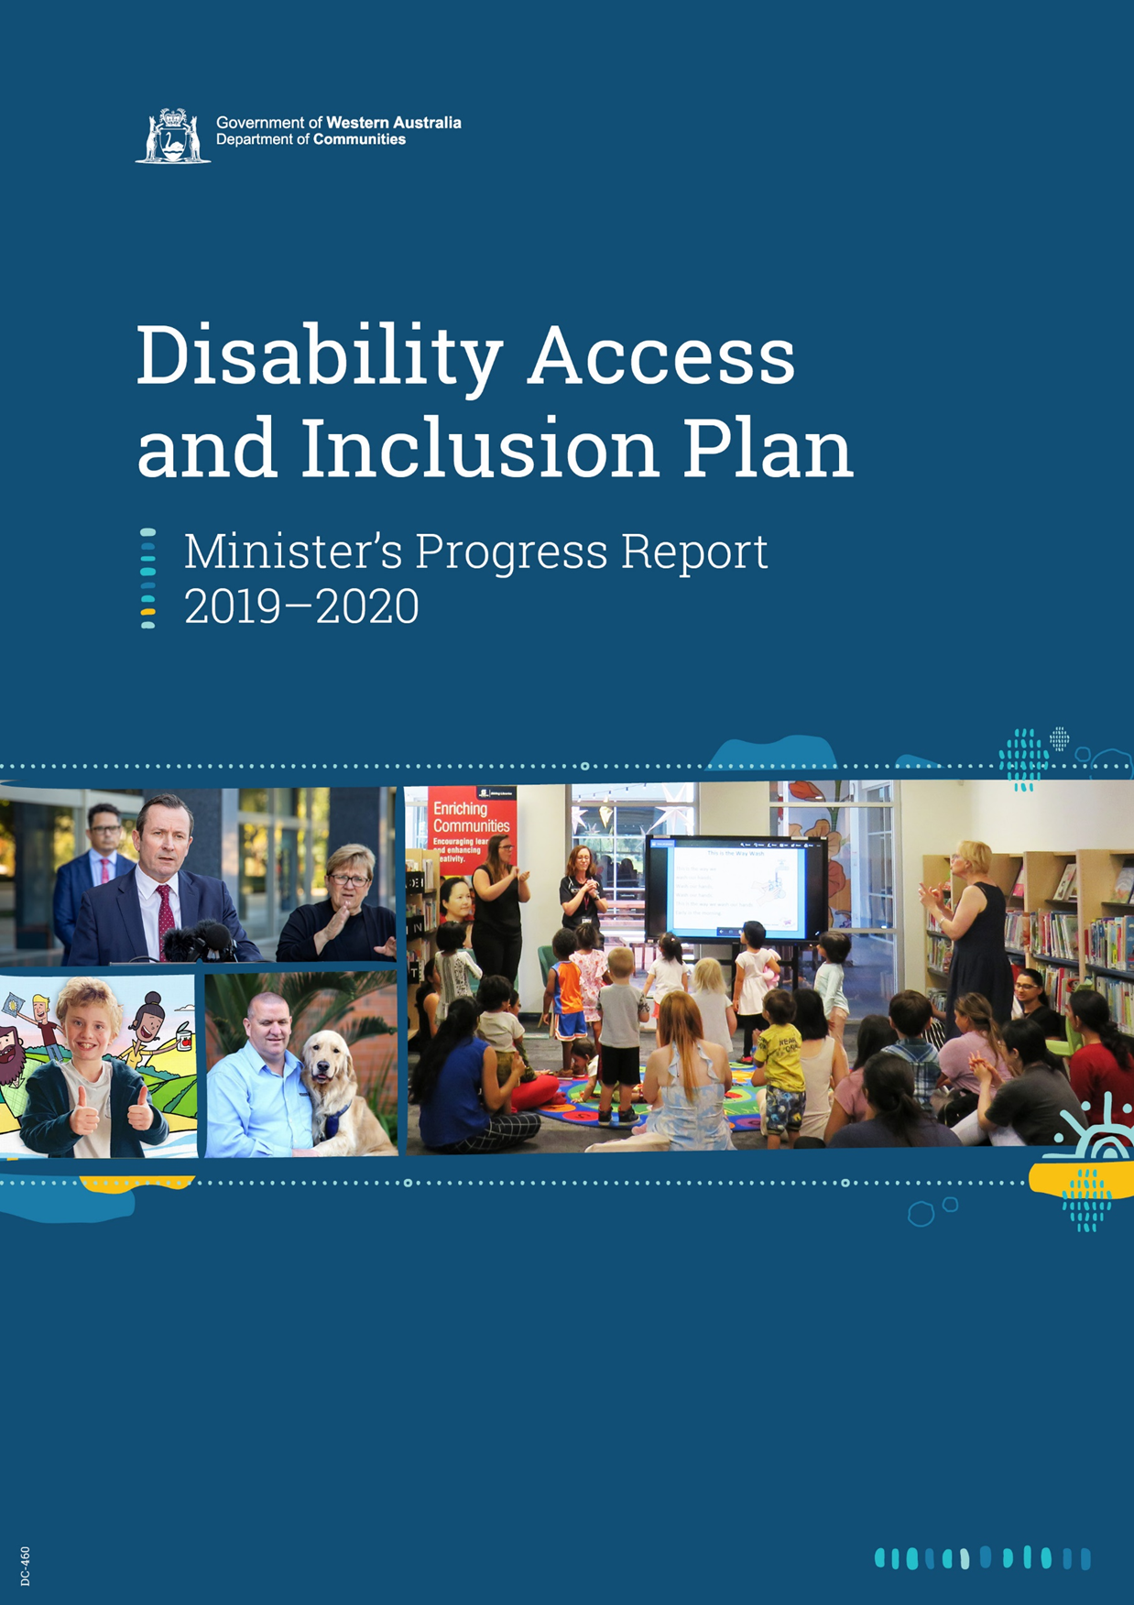

Disability Access and Inclusion Plan: Minister’s Progress Report 2019-2020
Table of contents
Message from the Minister for Disability Services 1
Introduction 2
DAIP outcome areas at a glance 6
Outcome 1 achievements – Services 8
City of Subiaco 8
City of Cockburn 8
City of Karratha 8
City of Kalgoorlie-Boulder 8
City of Fremantle/Western Australian Museum 9
Shire of Ashburton 9
Town of Victoria Park 10
City of Canning 10
Department of Justice 10
Legal Aid Commission 11
GESB (Government Employees Superannuation Board) 11
Edith Cowan University 12
Curtin University 12
Outcome 2 achievements – Facilities 14
Department of Planning, Lands and Heritage 14
City of Kalamunda 15
City of Canning 16
City of Karratha 16
Town of Cambridge 16
City of Rockingham 17
City of Kalgoorlie-Boulder 17
Child and Adolescent Health Service (CAHS) 17
Shire of Augusta-Margaret River 17
South Metropolitan TAFE 18
Shire of Irwin 18
Outcome 3 achievements – Information 20
City of Cockburn 21
Curtin University 21
North Metropolitan Health Service 22
City of Melville 23
Small Business Development Corporation (SBDC) 24
Murdoch University 24
Mindarie Regional Council (MRC) 25
City of Fremantle 25
Reviewing Corporate Documents 25
Outcome 4 achievements – Service quality 28
South Metropolitan Health Service (SMHS) 28
Department of Water and Environmental Regulation (DWER) 28
Department of Education 29
East Metropolitan Health Service (EMHS) 29
Department of Fire and Emergency Services (DFES) 29
Western Australia Police 30
City of Melville 31
Outcome 5 – Complaints 33
East Metropolitan Health Service 33
Department of Mines, Industry Regulation and Safety (DMIRS) 33
City of Fremantle 33
Outcome 6 achievements – Consultation 36
Cities of Mandurah, Kwinana and Rockingham 36
Shire of Mundaring 36
City of Belmont 37
Shire of Augusta-Margaret River 37
Landgate 38
Main Roads 38
Department of Communities 39
City of Stirling 40
Child and Adolescent Health Service 42
Outcome 7 achievements – Employment 44
Town of Victoria Park 44
Department of Biodiversity, Conservation and Attractions (DBCA) 44
Western Power 44
Department of Communities 45
City of Greater Geraldton 45
City of Rockingham 46
South Metropolitan TAFE 47
South Regional TAFE 47
Curtin University 48
Department of Education 49
Department of Mines, Industry Regulation and Safety (DMIRS) 50
Shire of Augusta-Margaret River 50
Agents and contractors 51
City of Belmont 52
City of Swan 52
North Metropolitan Health Service 52
Appendix One: Public authority submissions 53

Message from the Minister for Disability Services
The role of inclusion in thriving communities ensures that everyone has a part in making sure people with disability are not only welcomed but valued and included in all aspects of life.
This year has been one of change for us all with the impacts of COVID-19 felt throughout our community. For people with disability, their carers and families, we have also seen the continuation of people transitioning to the National Disability Insurance Scheme; the commencement of a Royal Commission into Violence, Abuse, Neglect and Exploitation of People with Disability; the consultation about the State Disability Strategy, our next ten-year roadmap for the sector; and engagement about the establishment of a new office of disability for the State.
Disability access and inclusion plans (DAIPs) provide a legislative prerequisite for public authorities to identify and address the restrictions faced by people with disability, whether they are physical or social.
I am further encouraged by the leadership and sophisticated approaches many public authorities are taking to advance inclusion for all people as they review their DAIPs. They show that a successful plan doesn’t need to be a complex document, but that it should evolve and inspire new ideas and paradigms, while embedding and safeguarding the efforts made to date. Most importantly, it needs to be owned by an organisation and the people within it.
Ultimately, being fully inclusive is not something that can be imposed or achieved by an organisation simply by setting prerequisites or targets; context is fundamental. Understanding what inclusion looks like for an organisation involves working with stakeholders and not for stakeholders.
I am pleased to present the 2019-2020 DAIP Progress Report and thank the Western Australian public sector for its ongoing commitment to becoming a more inclusive society. The stories and examples in this report show that positive change is often driven at a local level, by local people and I commend them for their actions.

Hon Stephen Dawson MLC
Minister for Disability Services


Introduction
Under the Disability Services Act 1993, public authorities are required to develop and implement a disability access and inclusion plan (DAIP), and report on their progress annually. The Minister for Disability Services is required to table a report to Parliament each year on their progress.
This report provides an overview of public authority progress, including a selection of initiatives shared by WA public authorities. The report is designed to help focus on common themes, and best practice.
As a result of the restricted operating environments for many public authorities this year, the Progress Report template for public authorities had been scaled back. Public authorities were asked to report on whether new activities, or significant developments to ongoing initiatives, occurred during the 2019-2020 reporting period. The Department of Communities requested reports from 207 state and local authorities and achieved a 100 percent response rate.
Many of the initiatives described in the report should be considered in the context of some significant developments across the access and inclusion landscape.
National Disability Strategy
The new National Disability Strategy is currently under development with the aim for Ministers to endorse it in June or July 2021.
It sets out how the Australian, state, territory and local governments are working together to make things better for people with disability and to help drive real and practical improvements in their lives. This includes commitments to better public reporting to show whether outcomes for people with disability are improving, and a strengthened approach to implementation through targeted plans for action.
It will emphasise the continuing need for a whole of society approach to implementing disability inclusive policies. Collaboration and engagement with people with disability, their families and carers, and advocacy organisations will be at the heart of the new National Disability Strategy.
People with Disability: Action Plan to Improve WA Public Sector Employment Outcomes 2020-2025
The Public Sector Commission led the State Government’s response to ongoing underrepresentation of people with disability employed in the public sector.
State Government public authorities will be responsible for increasing the representation of people with disability employed in the public sector to 5 percent by the end of 2025.
For more information please visit the WA Government website at https://www.wa.gov.au/government/publications/people-disability-action-plan-improve-wa-public-sector-employment-outcomes-2020-2025
Disability Royal Commission
On 4 April 2019, a Royal Commission into Violence, Abuse, Neglect and Exploitation of People with Disability (Disability Royal Commission) was established by the Governor-General of the Commonwealth of Australia. The Disability Royal Commission’s terms of reference charge it with inquiring into matters including:
- what governments, institutions and the community should do to prevent, and better protect, people with disability from experiencing violence, abuse, neglect and exploitation
- how to achieve best practice in the reporting, effective investigation and response to violence, abuse, neglect and exploitation of people with disability
- what should be done to promote a more inclusive society that supports the independence of people with disability and their right to live free from violence, abuse, neglect and exploitation.
The Disability Royal Commission has a broad scope with the capacity to inquire into violence, abuse, neglect and exploitation of people with disability in all settings and contexts including schools, workplaces, family homes, health services and specialist disability settings.
The inquiry is gathering information through a range of avenues including research, public hearings, and hearing the personal experiences of people with disability and their families through submissions, private sessions, and other forums. The Disability Royal Commission held its ceremonial opening sitting on 16 September 2019, with additional hearings conducted in 2019-2020 on matters including inclusive education and the experiences of people with disability living in group homes.
The inquiry is scheduled delivered its interim report on 30 October 2020.
People with disability in Australia report
The Australian Institute of Health and Welfare published this report in September 2019. The report brings together information from a range of national data sources to contribute to a greater understanding about disability in Australia.
It shows that some people with disability face challenges routinely and actively participating in everyday life areas (such as employment) and are more likely to experience poor health, discrimination and violence. The report can be read at https://www.aihw.gov.au/reports/disability/people-with-disability-in-australia/summary
United Nations' International Day of People with Disability (IDPwD)
IDPwD is a worldwide celebration of people with disability, and across Western Australia public authorities marked the day with events to reflect on the challenges and achievements for people with disability. The State Government, through the Department of Communities, supported 84 community-based events in 2019 through a grant program with a focus on striving for inclusivity through the removal of physical, technological and attitudinal barriers.
The theme for the 2020 IDPwD, to be held on December 3, is ‘Not all Disabilities are Visible’, with a focus on spreading awareness and understanding of disabilities and disabling long term conditions that are not immediately apparent, such as mental illness, chronic pain or fatigue, sight or hearing impairments, diabetes, brain injuries, neurological disorders, learning differences and cognitive dysfunctions, among others.
The World Health Organisation estimates that over 1 billion people globally are living with disability. Of this number, it’s estimated 450 million are living with a mental or neurological condition— and two-thirds of these people will not seek professional medical help, largely due to stigma, discrimination and neglect.
Access and Inclusion Awards
Awards related to outstanding access and inclusion support the promotion of good practice and help facilitate perspective on the work of public authorities.
The Australian Access Awards is an initiative of the Centre for Accessibility Australia, based in Fremantle. This was a national celebration of organisations, designers, developers and content creators who are making efforts to implement accessibility in their digital resources.
The event was considered very successful and will return as a biennial event, with a call for nominations to be opened on 20 May 2021, coinciding with Global Accessibility Awareness Day. Several Western Australian public authorities were recognised, with Jane Ots announced as a finalist for her work leading the implementation of the GESB website and online retirement planning calculator, developing accessibility training for staff and other initiatives to help embed accessibility into everyday practices and organisational culture.
The MACWA (Most Accessible Community in WA) Awards, facilitated by the Regional Capitals Alliance of WA, will return in early 2021.
ACROD Review
The ACROD Parking Program currently supports people with mobility restrictions to access the community by providing permits for accessible parking bays. Communities is leading a review of the ACROD Parking Program, with a focus on exploring the potential to expand the eligibility criteria.
Considerable progress has been made on the project, with extensive public consultation undertaken to understand how the ACROD Parking Program is working across the community and where changes might be needed.
A report with the final recommendations, including a new proposed eligibility criterion, will be completed in late 2020.
Benchmarking
During reviews of disability access and inclusion plans, public authorities will seek to understand whether the measures they have put into place have been effective in achieving access and inclusion outcomes, whether some existing strategies have moved to a monitoring phase, and whether further targeted actions are needed.
Organisational plans should be established with some form of outcomes or indicators so that the question of effectiveness is not subjective.
Benchmarking helps an organisation understand its progress in comparison to other organisations or to an accepted standard. While disability access and inclusion plans should work to achieve the seven outcomes described in this report, there has been advocacy from some public authorities to consider establishing an agreed form of benchmarking to reflect the evolution of access and inclusion planning. The Most Accessible Regional City in Australia (MARCIA) Research Report produced with Edith Cowan University and the City of Bunbury in 2018 also considered the issue.
The Australian Network on Disability published its latest round of results for organisations who have undertaken the Access and Inclusion Index (see https://www.and.org.au/pages/access-inclusion-index.html ). The Index provides an example of how a benchmarking approach could be progressed.

The impacts of COVID-19
Many authorities reported challenges in progressing DAIP strategies over the course for 2019-20. The impacts included staffing resources, prioritisation of COVID-19 related initiatives and challenges in the way consultations and events could be held. The DAIP Progress Report template was streamlined this year to enable more efficient reporting, cognisant of these challenges.
Especially during the most critical phases of COVID-19, many public authorities worked in partnership with their communities and volunteers to inform and support their clients and customers, including outreach information, alternative formats of information and direct humanitarian and social supports. From an access and inclusion perspective, some of these initiatives are included within the report.

DAIP outcome areas at a glance
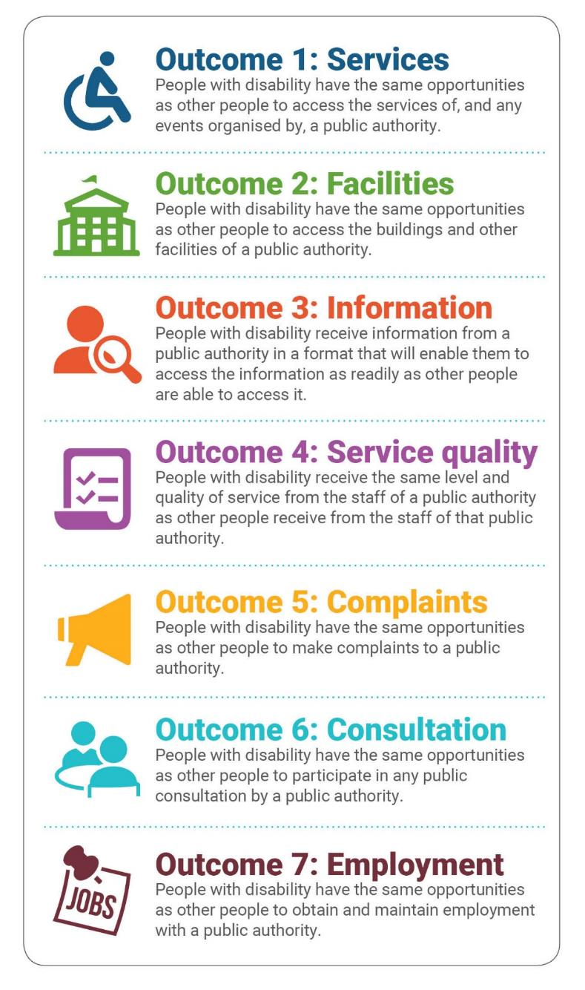
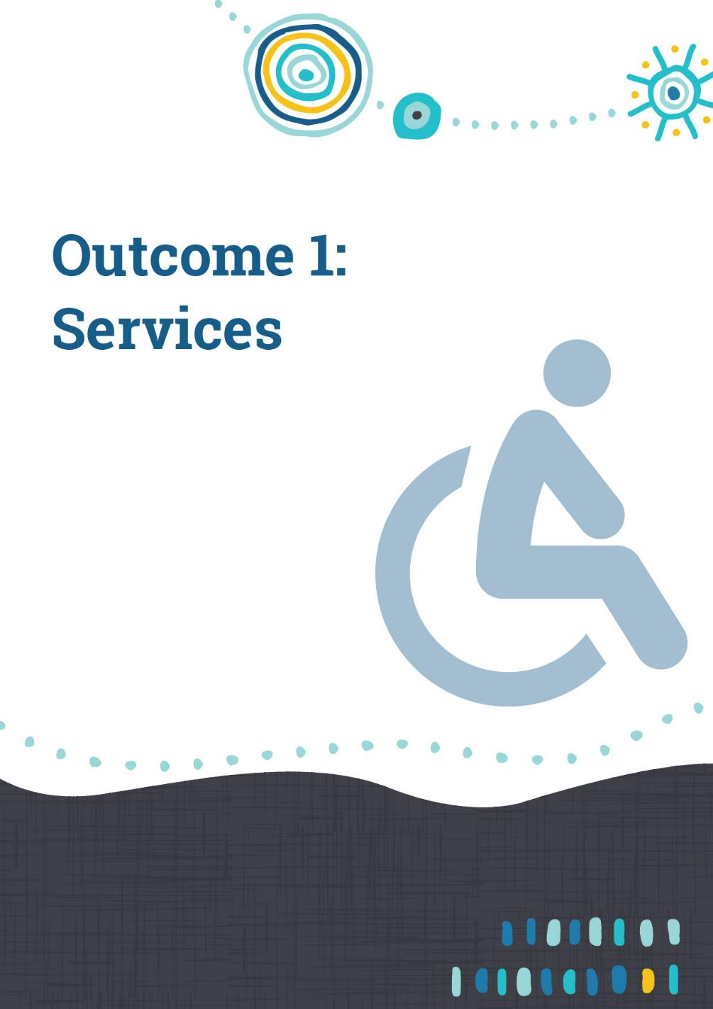

Outcome 1 achievements – Services
People with disability have the same opportunities as other people to access the services and events of a public authority.
Public authorities continue to report the most activity in progressing DAIP strategies in this outcome area, with 90 percent of state authorities and 78 percent of local authorities reporting new or significantly progressed activity. This is likely due to the wide variety of measures which would fall under this outcome, as well as the impact of technology and evolving expectations about inclusion.
Several authorities reported innovative developments in the way public events are managed, and others were focused on how they are working to embed good practices and establish targets and standards across services.
There were several narratives about the role of local government grants in driving community access and inclusion

City of Subiaco
The City renewed its partnership agreement to support the Vocal Ensemble Voiceworks, a local community choir, with 22 of its 90 members identifying as having disability. The group includes Voiceworks PLUS which has an emphasis on people with disability to develop their musical talents and confidence to perform in mainstream settings. A highlight for 2019-2020 was a musical showcase, a collaboration with the main Voiceworks ensemble, a guest choir and Voiceworks PLUS who delivered a production at the Subiaco Arts Centre to an audience in excess of 900 patrons over three performances.

City of Cockburn
Treeby Community Association (TCA) and the City worked collaboratively to complete the first accessible community garden in Cockburn. The Treeby Community garden design has incorporated low raised garden beds to accommodate children and people with disability. Currently there are nine garden beds that are fully inclusive. The TCA has workshops and event opportunities planned that are inclusive for all.

City of Karratha
The City delivered grant funding to Empowering People in Communities (EPIC), a local disability sector organisation, to deliver support groups for families of children with disability. In collaboration with other local disability service providers the City of Karratha also provided $150,000 to EPIC for the fit-out of the newly constructed EPiCentre. The funding is to support the provision of accessible resources, furniture and technology for the centrally located, fully accessible office and community hub.

City of Kalgoorlie-Boulder
The City updated its Annual Grant Program to include requirements for applying organisations to outline how their project facilitates inclusive practices. This resulted in a $13,000 contribution towards the establishment of a canteen at a local Family Centre to provide barista and customer service training for people with disability, giving opportunities to gain employment in the workforce.

City of Fremantle/Western Australian Museum
The City of Fremantle in partnership with the WA Maritime Museum held the first Wide Angle Film Festival Children’s Program in Western Australia in October 2019. The screening of award winning Australian and international films reflected the lived experience of people with disability. A curated selection of both children’s and adult short films were screened in the NWS Shipping Theatre at the WA Maritime Museum.
Free accessible parking was arranged to ensure enough ACROD spaces were also available for the event. The Film Festival was promoted to the wider community, schools, community groups and disability organisations.
The screenings were designed for maximum disability access and inclusion, including open captions, audio description, flashing-light-free guarantee, and a screening kit for the needs of people with anxiety and post-traumatic stress disorder which was available on request from the City of Fremantle.
Free popcorn and free entry into the WA Maritime Museum were also offered. Lights were dim but not dark. Visitors were informed that they could move around as needed and explained the accessibility features of the films. A quiet space outside the cinema was made available and space for wheelchair access was also available at the front of the seating area.
A ‘Welcome to Country’ video with an Auslan interpreter and captions was produced for the event and screened prior to each film session. This video is now used for internal training sessions. A scrolling ‘holding message’ was screened prior to all films. Flyers and messaging about other inclusive resources and community groups were also available for people to take home.
The event was well received and feedback was very positive with one participant commenting to the whole audience, “I just want to thank the City of Fremantle, Maritime Museum and WA Film Festival for going to the effort to put this type of event on”. After the screening a young boy mentioned that “it was great how the boy in the wheelchair and his friend who were jealous of each other, worked it all out”.
The Festival will be held again in late 2020 in an online format and will be extended to schools and shown in classes.

Shire of Ashburton
Each year the Shire of Ashburton holds Have a Go Day, a free and inclusive event promoting access and inclusion, physical activity, services and programs available within Tom Price and Paraburdoo. The 2019 event received attendance of 500 in Tom Price, and 350 in Paraburdoo, making the day’s festivities a huge success. A free barbecue lunch provided everyone with the chance to spend time meeting new residents, talking to clubs and registering their participation in the upcoming sport season.
The initiative was made possible through a partnership between the Shire of Ashburton, Rio Tinto, the Department of Local Government, Sport and Cultural Industries and Inclusion WA, the Have a Go day event aimed to raise awareness of, and encourage participation in, local sport and activity for people of all abilities.
The Shire of Ashburton also held its biennial Passion of the Pilbara festival in 2019. The event was an opportunity to celebrate Onslow’s diverse community by promoting access and inclusion, physical activity and services available locally. Over 850 people attended the event and enjoyed a range of programs and activities for all ages and abilities, such as cooking demonstrations, market stalls, information kiosk, live music, entertainment, children’s activities and amusement rides.

Town of Victoria Park
In October 2019 the Town of Victoria Park’s Swim School became the first in Western Australia to gain National Disability Insurance Scheme (NDIS) accreditation. The accreditation means the Town is the leading provider of inclusive swim programs that cater for all abilities through specially designed programs to provide swimming lessons on a one-to-one, two-to-one and four-to-one ratio.
The Swim School programs provide swimming lessons for participants with a range of developmental, behavioural, physical or learning difficulties. Being NDIS accredited makes the Swim School programs more financially accessible, easing the financial pressures on families attending the programs.

City of Canning
The City’s two Leisureplex sites continue to develop all abilities exercise programs for adults with disability. The Canning Leisureplex won the WA Disabled Sports Association (WADSA) Community Service Provider of the Year Award in October 2019 for their continued work in this area, namely for the new Fit4all program, which is designed for people living with intellectual disability. These classes utilise modified and adaptive equipment as well as mainstream sporting equipment’s. The Fit4All program is a result of Leisureplex staff participating in the WADSA Opening Mainstream Doors project. The project looked at how those living with an intellectual disability could enjoy and participate in physical activity. The Fit4all program was offered free during December 2019 to celebrate International Day for People with Disability (IDPwD), raising awareness and creating opportunity for participation.
The Leisureplex continues to promote and build upon existing accessible swimming programs and to date has provided swimming lessons for 1,226 people with a disability, allowing access to the pool and participation in the programs. Once participants gain confidence in their water safety skills they can begin to participate in other water-based activities on offer, such as pool walking and water aerobics. The City continues to build upon their ‘female only swimming and wellness sessions’ which caters for multicultural females living with disability, as they are able to participate in a private, safe and enjoyable environment.
The City’s Leisureplex features include portable hoists for entry to leisure and lap pools, ramps for court and gym access, pool chairs, braille and tactile signage in change rooms, and accessible car parking bays close to entrances.

Department of Justice
In March 2020, as requested by the Attorney General (AG) Hon. John Quigley MLA, the Department of Justice commenced the process of considering amendments to the Juries Act 1957 (WA) in order to ensure that people with disability are able to participate, as jurors, in court proceedings.
This is in response to recommendations from the Committee on the Rights of Persons with Disabilities, the Australian Law Reform Commission, the Law Reform Commission of Western Australia, the New South Wales Law Reform Commission and the Queensland Law Reform Commission over the past few years, suggesting amendments to existing legislation be made to enable the participation of people with disability, as jurors, in court proceedings.
As such, a discussion paper was released regarding Participation of People with a Disability in Jury Service, to provide stakeholders with an overview of the relevant legislation in WA and other Australian jurisdictions. Questions were posed to elicit discussion with stakeholders, assist the Department to form a position and make recommendations to the AG as to whether it is appropriate to make any changes to the current legislation.
At the time of writing, the final report is progressing to the Attorney General.

Legal Aid Commission
In April 2020, Legal Aid WA implemented the Coordinator position for the Your Story Disability Legal Support (YSDLS) in Western Australia. The YSDLS is a national service funded by the Australian Government and delivered through National Legal Aid and the National Aboriginal and Torres Strait Islander Legal Services.
The YSDLS is independent and separate from the Royal Commission into Violence, Abuse, Neglect and Exploitation of People with Disability. The YSDLS supports people with disability, their families, carers, supporters and advocates to safely share their story.
In Western Australia, both Legal Aid WA and the Aboriginal Legal Service WA are collaborating to offer a state-wide legal service for all people with disability who require legal support for things like what to do if there is a confidentiality agreement that stops the person from sharing their story or the person is concerned about payback if they share their story.
The service is also working to increase individual and community engagement with the Royal Commission through the delivery of community legal education and stakeholder engagement, the provision of legal advice to individuals, families and carers who wish to make submissions to the Royal Commission and by working with disability advocates and counsellors to ensure people can share their story in a safe way.
To date, the program has completed 26 activities of community legal education and engagement with stakeholders; assisted ten clients by providing initial legal advice about engaging with the Royal Commission and a further nine legal advices on other matters. This demonstrates the important of this new service for people with disability to obtain meaningful access to justice.
It is hoped that in the next twelve months the service will be able to travel throughout Western Australia and engage with the community and with clients on a deeper level.

GESB (Government Employees Superannuation Board)
The focus of GESB’s Progress Report was on the extent to which access and inclusion has been effectively integrated into policies and practices and the influence of access and inclusion measures on customers and communities. GESB’s DAIP is now nearing the end of its five-year cycle and during that time it has proven an excellent platform from which to promote and educate access and inclusion initiatives. It has become clear that the DAIP is not a stand-alone document but a key element of how business is done, and that it works best when included from the planning and research stages of any project.
Having it endorsed and implemented from senior management has meant that the DAIP is embedded well into the GESB culture. Outcomes have been met, with some far exceeding original expectations. Disability awareness has been built into GESB policy and processes, considered and incorporated into other business plans and strategies in many areas of the GESB business. This has included a business partner, the Link Group, which provide the superannuation administration services for GESB. Their continued support to improve disability access has kept pace with the GESB initiative.

Edith Cowan University
Edith Cowan University engaged YDAN (Youth Disability Advocacy Network) to conduct an ‘experiential audit’ from the perspective of young people with disability before its 2019 International Day of People with Disability event, which featured sports champion and television and radio host Dylan Alcott OAM. YDAN’s report stated that “ECU is on track to host a wonderful and inclusive event” and provided recommendations to further improve physical accessibility. These recommendations were implemented as thoroughly as possible, and the report continues to guide future actions.
ECU is updating its events checklist to incorporate items from the Department of Communities’ accessible events checklist, with the full checklist included as an appendix. In addition, the University plans to establish an accessible facilities taskforce to improve universal access across its campuses. ECU will also make system changes to record the number of enquiries regarding accessibility concerns and continue to follow these up in a timely manner.

Curtin University
Curtin’s ‘One Curtin’ agenda includes a Global Diversity Taskforce. Approaches have been made to incorporate DAIP considerations to ensure the recognition and importance of disability access across its international campuses, despite differences in international legislation and levels of understanding and awareness.
General equivalence has been established for Malaysia under their Persons with Disabilities Act (2008) with respect to participation in education, provision of ‘reasonable adjustments’ to support education participation and equal access to employment.
Mauritius’ Equal Opportunities Act (2008) and Employment Rights Act (2008, amended 2015) offer equivalence with respect to employment of people with disability, but do not cover education opportunity and participation. Curtin will continue to seek consistency in the ‘Curtin experience’ for staff and students, regardless of the physical location for their work or study.
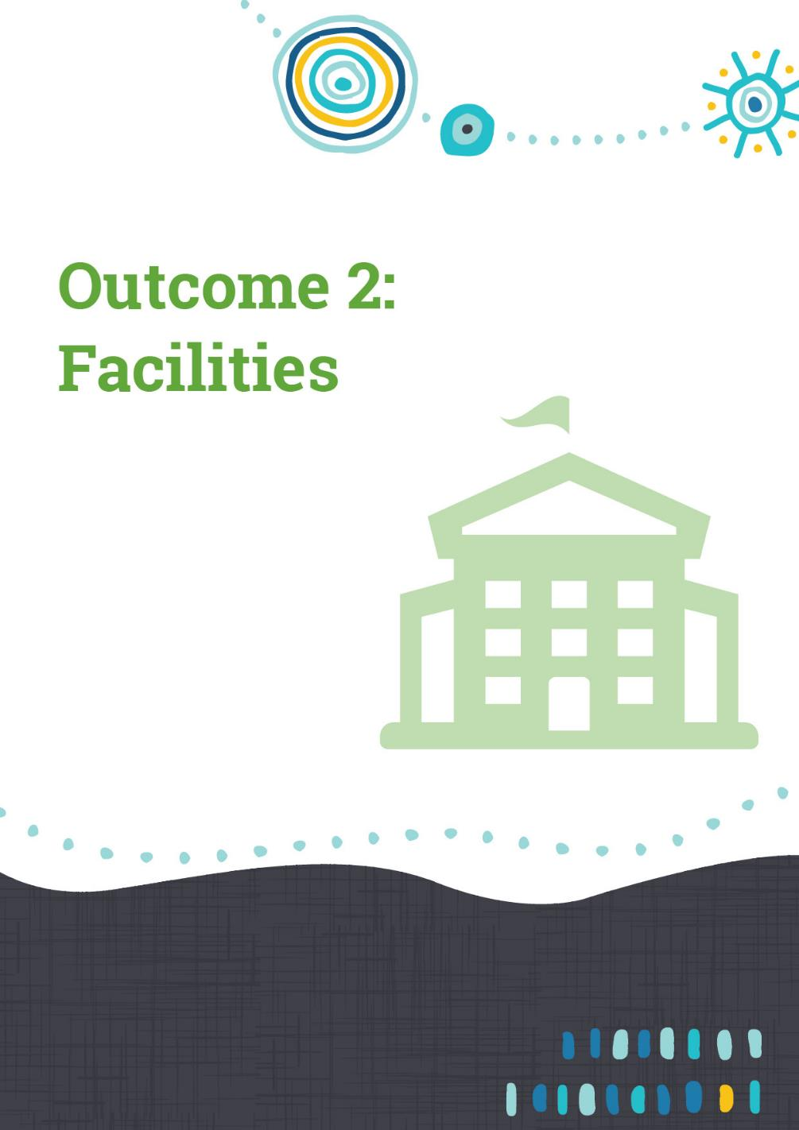

Outcome 2 achievements – Facilities
People with disability have the same opportunities as other people to access the buildings and facilities of a public authority.
This outcome area is focused on improving and ensuring that built infrastructure is accessible for everyone.
The Access to Premises Standards 2010, the Building Code of Australia and several of the Australian Standards help ensure basic accessibility for new and redeveloped facilities. Improving access is a consistent activity across public authorities, with 82 percent of local authorities and 91 percent of state authorities reporting significant progress or new initiatives. The costs involved with redeveloping older infrastructure, and particularly with historic buildings, continue to delay progress to creating a fully accessible public sector and community.
Good practice demonstrated by public authorities includes a systematic and embedded approach to identifying accessibility issues and the unmet or under-met needs of facility users of existing infrastructure, and ensuring that they are addressed either through allocated budget provisions over time, or by transferring services to alternative venues which deliver better access. A further step to best practice beyond compliance is to engage and co-design facilities in partnership with the people who would use them. This practice helps ensure full accessibility for everyone and helps mitigate the risk of unexpected accessibility issues not picked up through the design and operational phases.
Particularly for local government authorities seeking to develop communities which are accessible and inclusive to both residents and visitors, strengthening and promoting a region’s credentials in inclusive tourism can unlock significant economic benefits. For example, the Shires of Wagin, Kent and Augusta-Margaret River shared narratives about constructing accessible accommodation and leisure facilities at local caravan parks and facilities which they expect to improve the inclusive experience and encourage more visitors.

Department of Planning, Lands and Heritage
An 8,000 square metre nature-based all-abilities playground, Pia’s Place in Whiteman Park, was officially opened in December 2019 by the Hon Rita Saffioti MLA, Minister for Planning. Pia’s Place is a joint project driven by the Touched by Olivia Foundation and the Rudd family in memory of their baby, Pia Maeve.
The innovative play space is accessible to children of all abilities, including children with mobility issues and wheelchair users, and those with cognitive, sensory or social-emotional challenges. The playground features customised play equipment including an elevated lighthouse, polished concrete slides, a basket swing, an all-abilities carousel, a sensory garden and family-friendly shelters. The play space also features a barbeque area that is accessible to wheelchair users.
In addition, an accessible ‘Changing Places’ facility equipped with a shower, toilets and lifting equipment to cater for children with severe disability has been constructed adjacent to the playground.
The $2.2 million play space and the ‘Changing Places’ amenities building were funded primarily by the Western Australian Planning Commission (WAPC) and will be managed by the Touched by Olivia Foundation.
Whiteman Park has also benefitted from a range of infrastructure works including widening dual use pathways, increasing accessible parking, accessible shelters and food kiosk access, and ramp access to the historic tram features.
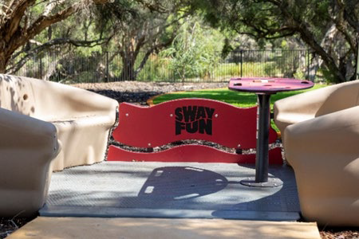
The Pia’s Place launch including inclusive play equipment was complemented by accessibility improvements including for the iconic tram at Whiteman Park

City of Kalamunda
The concept design for the new Stirk Park Playground was guided by the involvement of a young community member who advocated to the City of Kalamunda for more local park equipment to be accessible for her sister and friends who have disability. This insight and passion from lived experience led the community member and her family to play an influential role in identifying practical ways to reflect the City’s commitment to inclusive design. A consultant was engaged to facilitate a fun, interactive and empowering community-building process with young people and families in Kalamunda targeted to get their ideas and inspire a creative and uniquely ‘Kalamunda’ Play Space at Stirk Park.
As a result, the City was able to engage approximately 600 local young people and families throughout the consultation process, with inclusion being a central theme. Their aspirations and comments helped provide a clear direction in the concept design and helped confirm the City’s values that the best play spaces are ones in which all members of the community can be a part of. The process empowered the young people involved and has given them a sense of ownership.
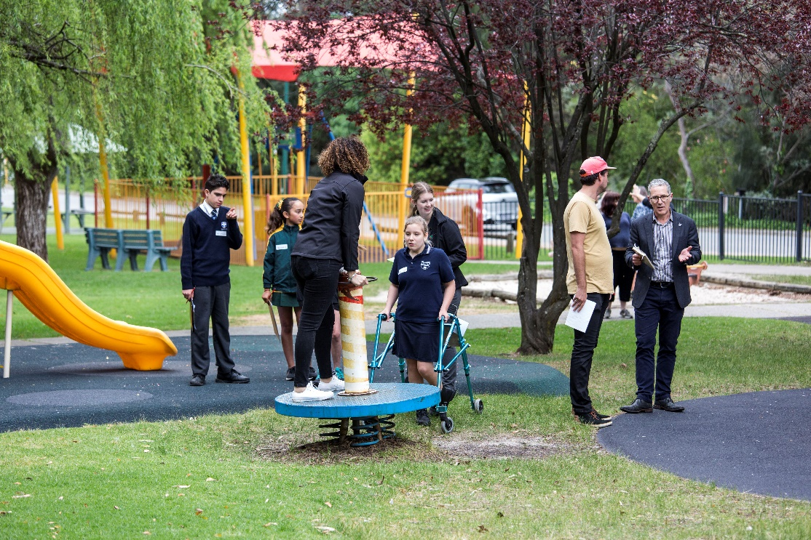
Community co-design at work in planning improvements to the City of Kalamunda’s Stirk Park

City of Canning
The City of Canning's first Changing Places facility is now complete, providing a secure, clean facility for people with complex disability and their carers to use when they are out and about in Canning. The Changing Place includes an adult sized change table, ceiling hoist, a peninsular toilet, privacy screen and additional circulation space. The project reaffirmed the City’s commitment to facilitating the inclusion of people with disability through improving access to services, facilities, programs and events.
The City’s Changing Places facility sits alongside new additional accessible toilets, which are located close to the City’s Civic and Administration Centre, and is readily available for park goers, visitors to the Centre and attendees at major events which are held at the City’s amphitheatre, such as ANZAC Day, the annual Christmas Carols concert and the other numerous celebrations throughout the year. The City reports receiving encouraging and appreciative community feedback for this new facility and expects high frequency use by the community.

City of Karratha
City staff are developing a Facilities Matrix. This matrix will collate the accessibility information of all City facilities and hireable spaces and will be available on the City of Karratha’s website. The matrix will include information on wheelchair accessibility, number of ACROD parking bays, number of accessible bathrooms and more.

Town of Cambridge
The Town has embedded commitments to disability access by compiling a provisional ten-year Facilities Capital Works Programme.
The aim of the programme is to drive improvements to disability access across the Town’s public buildings and address the non-compliance matters identified.
45 disability access audits were undertaken as part of the process, priorities were identified, and the proposed works have been cost estimated.
The plan will be delivered in stages with an amount of $450,000 for stage 1 included in the budget for the 2020-2021 financial year.

City of Rockingham
In 2018 the City implemented a program of accessibility audits on 42 of its facilities and reserves. During 2019/2020 significant progress has been made to prioritise and plan for the implementation of the associated recommendations. Ten sites have been identified as having the highest priority and by the end of 2019-2020, 3 percent of actions for these sites were completed. Funding for a further 63percent has been built into the business plan and maintenance plans for implementation within five years. The recommendations from the audits have been incorporated into the City’s asset management and planning systems, enabling the Assets team to take the lead with ongoing implementation and reporting of these actions. Improvements at the top ten sites will take priority initially, but opportunities to address recommendations at other sites will be sought and optimised.

City of Kalgoorlie-Boulder
The City endorsed a major paving project for its Central Business District to transition from broken, tired and outdated pavers to a new exposed concrete surface to support increased safety for shoppers and improve disability access interfaces at shops. The project will be delivered in late 2020.The City also updated 27 ACROD parking bays across Kalgoorlie-Boulder and has a program to update 23 more before the end of this financial year to ensure compliance with Australian Standards. The upgrades included new line marking, access spaces for wheelchairs and bollard installation.

Child and Adolescent Health Service (CAHS)
The CAHS Strategic Asset Plan (SAP) was endorsed by the CAHS Board in November 2019. The CAHS SAP outlines the capital investment required to be made in infrastructure by CAHS over the next 10 years in order to support the service delivery needs of the organisation.
The CAHS SAP identifies disability access gaps at existing facilities and provides a way to address these gaps through investment in infrastructure. The CAHS Midland Community Health Hub and other proposed infrastructure projects offer an opportunity to ensure accessibility planning in new facilities for CAHS.

Shire of Augusta-Margaret River
The Shire’s community development team and infrastructure services team have worked on ACROD awareness projects.
The infrastructure services team are in the process of developing a database of all Shire managed ACROD bays. Once complete, this database will be harnessed to develop a location map of all available ACROD bays in the Shire. This will assist the Shire in ensuring ACROD bays remain compliant over time and will create an easy to use map for community members wanting to understand the location of all ACROD bays in the shire.
ACROD bays across the Shire are continuously being monitored for compliance, with upgrades being made where possible, within budgetary and site limits. For example, a bay near the Shire’s administration building in Margaret River has been designed this financial year and is in the budget for construction next financial year. This project was discussed with the Shire’s Community Access and Inclusion Reference Group (CAIRG) in May 2020 and the group communicated support for the project.
In addition, infrastructure services and the community development team worked closely with National Disability Services WA (NDS WA) to develop and implement this year’s ACROD Bay Awareness Raising Campaign in June 2020. The Shire was happy to work with NDS WA to incorporate themes of their state-wide campaign, while also tailoring the message to suit local needs.

South Metropolitan TAFE
Student requests to bring Assistance Animals into education and training environments are increasing and in order to be able to manage these requests South Metropolitan TAFE (SMT) has developed and implemented a suite of guiding documentation. Information and a fact sheet are available on the College website for prospective students to view. A significant amount of time and research has been devoted to understanding the ramifications of the current Federal legislation as it pertains to adult learning environments with the aim of implementing a contemporary best practice approach. SMT is confident that its approach offers access to students wishing to bring an Assistance Animal onto campus whilst simultaneously balancing Duty of Care considerations for all students, staff and visitors to our campuses.
Student Support Services has compiled a professional development session to increase staff awareness and provide essential information and pointers on Assistance Animal etiquette to staff and this is made available each semester. SMT has also shared its protocols and Professional Development with The Australian Tertiary Education Network on Disability (ATEND) and colleagues at North Metropolitan TAFE and South Regional TAFE.

Shire of Irwin
With a quarter of its population aged over 65 years, accommodating senior residents comfortably and enabling ageing residents to stay in the community is a priority for the Shire.
The Shire has been working with the Department of Primary Industries and Regional Development to build six Independent living units in Port Denison. The units have been designed to accommodate seniors with disability and dementia and have been awarded Liveable Housing Australia’s highest level of ‘Platinum Certification’ for the design. Some of the design aspects include level, step-free entrance ways and easy, independent access to hobless bathrooms installed with grab-rails.
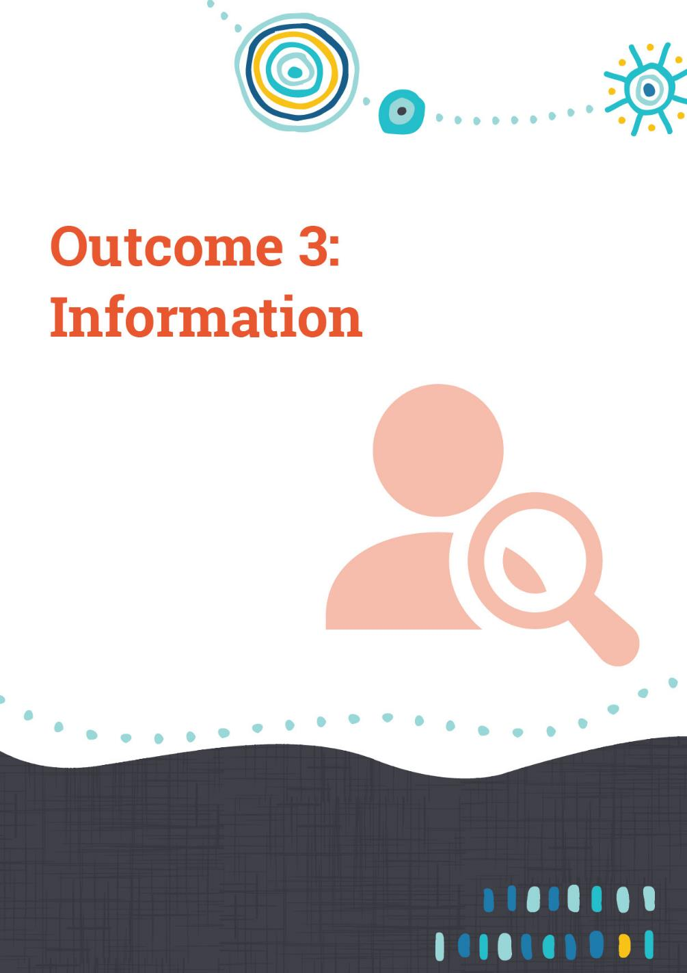

Outcome 3 achievements – Information
People with disability receive information from a public authority in a format that will enable them to access the information as readily as other people are able to access it.
Reports from public authorities reflected a continuing evolutionary process including embedding accessible and inclusive digital practices and considering the best ways to reach the broadest range of target audiences through information, communications and marketing. There was some variation between state and local authorities, with 85 percent and 69percent respectively reporting new or significantly progressed initiatives.
Across State authorities, embedding accessibility across digital products is well served by the development of the WA.gov.au website, managed by the Department of the Premier and Cabinet’s Office of Digital Government.
The Accessibility and Inclusivity Standard under the Digital Services Policy Framework sets the minimum standard when designing, developing and delivering digital products, services and content. The current standard is WCAG 2.0 AA and agencies are expected to achieve this minimum level. Meeting the success criteria associated with WCAG 2.0 AA includes that content can be accessed by a number of means such as audio, text and visual cues; that content is distinguishable for example considering contrast and text sizes; navigable and easy to follow, and able to be interfaced by a keyboard or other devices.
Agencies that migrate onto WA.gov.au accelerate government’s ability to provide a consistent approach in the delivery of information and services so that:
- information and services are easy to find and access
- information is easy to read and understand
- information and services are relevant and current
- services are easy to use; and
- information and services are available to as many people as possible.
All templates on WA.gov.au have been designed to exceed WCAG 2.0 AA. The Office of Digital Government performs an accessibility check over WA.gov.au on a weekly basis against the highest current level of WCAG 2.1 AAA. Agencies who have migrated are informed of these results to ensure compliance. The Business and Technology Advisory Committee and the Director General’s Information and Communication Technology (ICT) Council provide oversight. As at 30 June 2020, 26 agencies and government initiatives had migrated to WA.gov.au, with more to come.
Evidence of an increased use of Auslan and Easy Read documents is a positive outcome. Some libraries (such as in the City of Stirling library cover photo) are adopting Auslan story time sessions.
The impact of COVID-19 has led to many authorities taking extraordinary actions to support their staff, clients and community. The need to ensure that each person was effectively engaged in understanding the situation helped progress the case for consistent use of alternative formats of communication. For example, the Department of Communities, working with WA Individualised Services, published a range of Easy Read information brochures.
Other examples related to COVID-19 included the City of Mandurah, which made use of its existing Mandurah Matters website, a community hub for information, by adding a dedicated page to COVID-19. This page has also provided an Easy Read document about COVID-19 to support access information about the virus. The City of Bunbury designed social media campaigns targeted towards vulnerable groups, including people with a disability, to assist in response and recovery to COVID-19. A COVID-19 information portal was created on the City’s website. All the Premier of Western Australia’s key media exchanges included Auslan interpretation (see cover page photo).

City of Cockburn
The City places great importance on inclusivity and accessibility, being named the Most Accessible Community in WA by the Regional Capitals Alliance of WA in 2018, and in 2019 winning the Most Accessible Metropolitan Local Government Award for the second time. The City was recently nominated for the Centre for Accessibility Australian Access Awards.
The City’s Communications team acknowledge that website accessibility is not just people with disability benefitting. It helps older readers, people of different cultural and linguistic backgrounds, residents living in areas of lower bandwidth and even those just wanting to tab through on their mobile or tablet with one hand instead of using a mouse and cursor.
The City is believed to be the only local government to have now achieved Website Content Accessibility Guidelines (WCAG) 2.1 AA Accreditation, the highest level of website accessibility compliance in WA. The website is regularly tested by a team of experienced web analysts at Web Key IT, all of whom have a disability. The test team includes individuals who are blind, have low vision, are dyslexic, colour blind, mobility impaired, have a learning difficulty and deaf. All this testing is carried out in accordance with the WCAG Evaluation Methodology, and this accreditation confirms that the page sample has been tested and passes compliance with WCAG 2.1 to Level AA. Over the past twelve months the City has met the seventeen additional criteria set to achieve the WCAG 2.1 accreditation. The City’s webpages are tested against all 78 success criteria in WCAG 2.1.
The achievement badge is displayed proudly on the City’s website. With more people using mobile phones the communications team are increasingly laying out information in more accessible forms.

Curtin University
Curtin is facilitating a resolution towards a national approach to ensure future collective ICT procurement agreements require adoption of AS/EN 031 549:2016 (Australian Standard) as a minimum requirement. This is being conducted through CAUDIT (the Council of Australasian University Directors of Information Technology)
This follows release of Vision Australia’s 2018 report `Online, but Off Track – Barriers to Online Learning Experienced by University Students who are Blind or have Low Vision’. The intent is around ensuring compatibility of higher education systems with screen reading technology to improve consistent application across the whole tertiary education sector to implement accessibility standards.
Students enrolled at Curtin can self-identify when requiring reasonable adjustment on basis of disability or other grounds. Some students however elect not to self-identify, and consequently do not access support services. Barriers to learning, such as the timely access to accessible content, may be a contributing factor to poor retention for students with these needs. Explicit alternative format requests often exclude many students and can result in long delays in the learning process. Throughout the term of their current DAIP, Curtin has been committed to embedding Universal Design principles into delivery of all teaching and learning practices, thereby moving away from an ‘accommodation’ approach towards students with specific access requirements.
The University’s Learning Management Systems (LMS) and integrated technologies need to comply with standards ISO/IEC 40500:2012 [Web Content Accessibility Guidelines (WCAG) 2.1], as part of due diligence. However, very few academic staff have previously had the time, awareness or experience to develop accessible content when using the LMS.
A twelve-month licence for BlackBoard Ally was implemented from February 2020, with the intent being to enhance Curtin’s ability to provide accessible content via the LMS and embedding the principle teaching value that accessible content is ‘good’ content. The system can provide students with access to more accessible alternatives such as Semantic HTML, ePub, Audio and Electronic Braille. The anticipated outcomes include:
- improved engagement with unit content for students with accessibility requirements
- streamlined way for academics and teaching support staff to receive continuous feedback on improving the accessibility of their teaching content
- decreased manual conversion of content into alternate formats by teachers, teaching support staff and Accessibility Services team with associated reduced cost to the University
- enterprise overview of the state of content accessibility within the University in relation to use within the LMS.

North Metropolitan Health Service
Two significant information initiatives strengthened the capacity of North Metropolitan Health Service to ensure its communications are effective to all people.
The Special Needs Dental Clinic at Dental Health Services have developed ‘Maggie goes to the dentist’, a ‘Social Story’ tool for patients with Autism Spectrum Disorder who are attending a dental appointment for the first time. The visuals in the social story depict `Maggie’ attending her appointment at the clinic from entering the clinic’s waiting room and waiting for her appointment, all the way through to sitting in the dental chair and the instruments used for her treatment.
The aim of the ‘Social Story’ is to reduce a patient’s anxiety and to prepare them for what will happen at their dental appointment. This is achieved by explicitly pointing out details about the setting and what typically happens in that setting, including sounds made by the various pieces of dental equipment. These details help the patient pick up on cues they normally wouldn’t notice. The delivery method of the Social Story learning varies to accommodate for individual needs prior to arriving at the clinic and includes hardcopy handouts, online with printing enabled and copies provided to Disability Health Network, Carers WA and Developmental Disability WA.
BreastScreen WA reviewed and updated information for women with disability and their carers. The ‘Women with Disabilities’ brochure used in community engagement activities has been updated and is now available online and in hardcopy. A second resource, ‘What will happen at my mammography’ has been developed to assist carers and clinic staff to explain the mammography process. A review of the existing pictorial resource ‘A Guide to Breast Health’, which was developed in partnership with the Department of Communities, is underway.
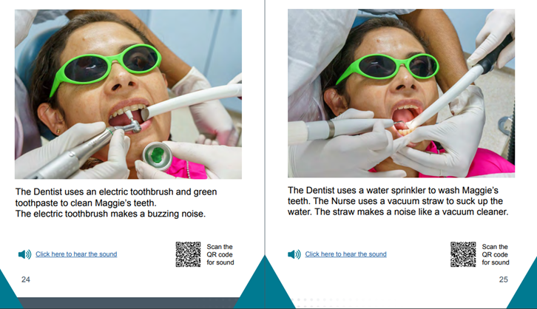

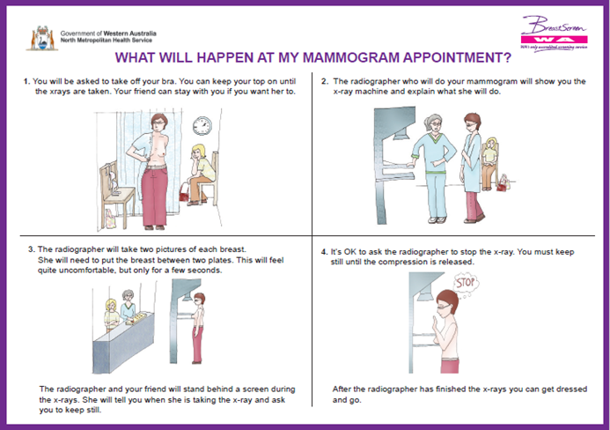
New brochures produced through the North Metropolitan Health Service are helping people feel confident by improving their understanding of what will happen during a service.

City of Melville
The City is committed to supporting the development of accessible online content. Working alongside local community member and children’s book author Tracey Hicks, an Auslan interpreted video of her book ‘Don’t Guffaw at a Dinosaur’ was produced and published with the assistance of the City’s Digital Communications Advisor and Social Justice Advocate to coincide with International Day of People with Disability. The video aims to raise awareness of alternative formats and acknowledge International Day of People with Disability, as well as celebrate the achievements of a local resident on the launch of her most recent publication.
With the support of the City, Tracey’s video has been entered into the ‘Focus on Ability’ short film festival, with the outcome of judging anticipated later in 2020.

Small Business Development Corporation (SBDC)
In Australia, people with disability have traditionally had a higher rate of entrepreneurship and self-employment than employed people without disability. Being self-employed can offer greater freedom and independence, and for some people it enables working at their own pace, undertaking work that may not be available in traditional jobs, in an environment that suits their needs.
SBDC partnered with Western Australia Individualised Services (WAiS) on a project to develop Easy Read resources to help support people to start and run a small business, following WAiS’s successful grant application in 2018. The project was funded through the Department of Communities under the National Disability Insurance Scheme’s Information Linkages and Capacity Building (ILC) grant round with the priority of building the capacity of people with disability to engage in meaningful employment.

Murdoch University
Murdoch University’s Strategic Plan 2017-2027 makes a commitment to equity and social justice as a core principal upon which Murdoch University was founded and this is reflected in a range of work and committees across the University.
As an outcome of the LGBTIQA+ Advisory Group, an Inclusive Curriculum Working Party (ICWP) was developed in October 2019. The focus of this group covers a range of diversity issues including disability and works to encourage academic staff within the university to consider equity, diversity and inclusion factors in the design and delivery of curriculum. The ICWP consists of staff and students from a wide range of backgrounds and abilities, and strongly aligns with Murdoch University’s Reconciliation Action Plan 2019-2021 and Strategic Plan 2017-2027.
Activities to date have focussed on four principal areas:
- Identifying existing internal, national and international inclusion resources and consolidating, updating and promoting them across the university.
- Designing and implementing workshops to share, troubleshoot and revise curriculum (both explicit and hidden) to ensure it follows principles of inclusive design, including resources for teaching staff with regards to integrating Universal Design Principles in online learning environments.
- Identifying, promoting and participating in workshops, seminars, conferences, networking events and webinars of interest to equity cohorts, including the sharing best-practice inclusive curriculum initiatives and strategies amongst WA universities.
- Implementing students-as-partners initiative – working with students from diverse backgrounds and experiences – to ensure inclusivity practices are student-led and endorsed. Murdoch is in the process of accrediting student-led projects focused on inclusive curriculum design, as part of the central curriculum spine units.
Members of the ICWP are active in research, publication, grant applications, improving teaching and learning experiences, and shaping community behaviours that support greater inclusion, diversity and visibility with involvement in major research projects on Aboriginal Youth, LGBTIQA+, people with disability, and, of course, intersectionality. Members also network with other university curriculum groups in WA and nationally.

Mindarie Regional Council (MRC)
Inclusive signage is an essential part of any organisation’s ability to communicate to people, and MRC’s review of existing signage across its site provided the opportunity to develop new signs to improve its overall communication.
The new signage provided for larger lettering and picture icons to assist the visually impaired, and overall improved communication.
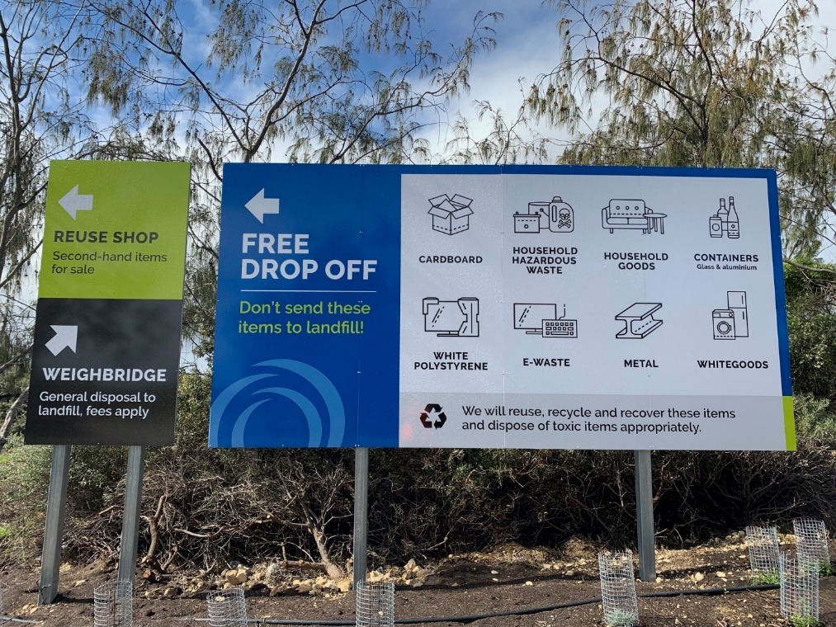
Easy to follow signage has helped improve accessibility for all at Mindarie Regional Council’s operations

City of Fremantle
The City adopted several changes to its staff business cards. All business cards increased their font size, with Braille Business Cards introduced for the Access and Inclusion Officer. It was identified that the text and font on the City of Fremantle Business Cards was very small and difficult for a lot of people to read. The Access and Inclusion Officer worked with the Communications and Graphic Design team to redesign them to make it easier for all people to read and to keep the ‘style’ they wanted.
As part of the development of the City’s new Access and Inclusion Plan many community consultation sessions took place. The new business cards were used during this process where the likelihood of meeting people with vision impairment was much higher. The challenge was to get designers to put practicality and ease of use over design or look. All staff business cards are now considered much easier to read for the City’s clients and networks in the community.

Reviewing Corporate Documents
Several authorities reported changes to their policy templates and corporate publications as a result of investigating accessibility improvements. The Shire of Pingelly, for example, is one of local governments continuing to benefit from the Lighthouse Project, provided by Local Government Professionals WA and administered by the Department of Communities. The Shire completed training through Forrest Personnel and updated a suite of corporate documents, included ensuring awareness that they could be made available in alternative formats upon request.
The Botanic Gardens and Parks Authority, part of the Department of Biodiversity, Conservation and Attractions continued to move away from .pdf toward .html which can be more accessible to people using assistive technologies on mobile devices. GESB contracted an accessibility consultant, Dr Scott Hollier, to review and test all digital initiatives for accessibility. The University of Western Australia (UWA) formed a dedicated Web Accessibility Policy Working Group with responsibility to evaluate and implement plans that inform actions and reporting at UWA. These actions will ensure availability of skilled support and continuous improvement of their Web Accessibility Policy. Landgate has implemented the use of OTTER, a platform for voice-to-text translation, where an AUSLAN interpreter cannot be reached. This enables Landgate to release both edited video and transcripts of events for the benefit of customers and employees.

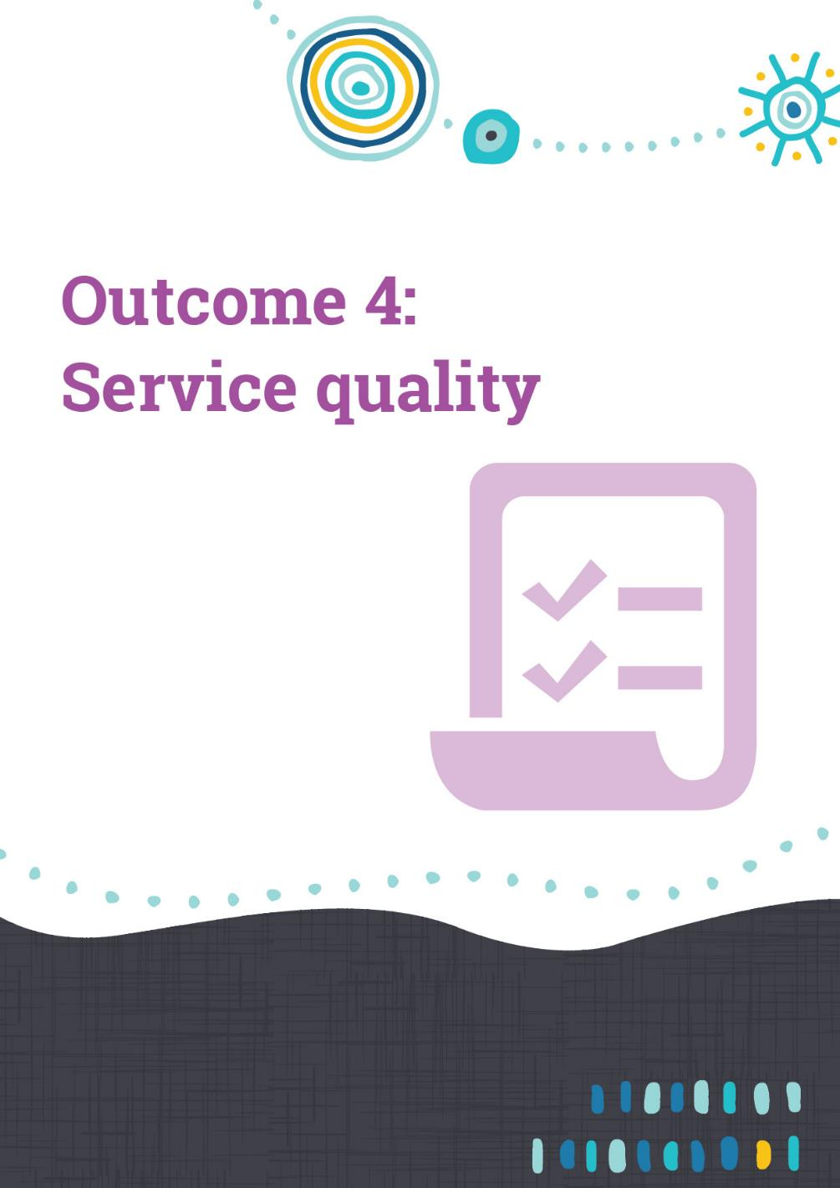

Outcome 4 achievements – Service quality
People with disability receive the same level and quality of service from the staff of a public authority as other people receive from the staff of that public authority.
This outcome area refines the focus on the quality and equitability of service arrangements. It is built on the principle that an individual should not be disadvantaged in the level of service they receive due to their disability.
This could be considered a very specific outcome area, and one which is often intertwined with other DAIP Progress Reporting areas. A major theme throughout authority reports as to how quality is progressed and safeguarded are through improving and reinforcing awareness. Progress reports indicated 84 percent of state authorities and 67percent of local governments significantly progressed or commenced initiatives towards this outcome.

South Metropolitan Health Service (SMHS)
An objective of the SMHS Consumer and Carer Engagement Strategy is to review patient/consumer literature to ensure its accessibility to all members of the community using SMHS services, including those with disability.
Several health documents presented in different formats are now available to patients with disability and the staff caring for them. The resources are accessed via links to the Health Consumers Council WA website and the SMHS intranet sites. The booklets provide essential information to assist people with disability navigate the health system, prepare for a hospital admission including outlining their rights, where to go for help and key considerations across the entire hospital journey.
The resources were developed as a result of a project partnership between the Health Consumers Council WA and People with Disability WA in collaboration with a working group of people with disability. Other resources produced include videos on:
- advocacy in the health system
- where to go when accessing health care
- ideas for better health care
- health care rights; and
- medical Records.

Department of Water and Environmental Regulation (DWER)
As part of DWER’s commitment to improving disability access and inclusion, their Corporate Executive approved a pilot corporate volunteering activity for a group of 14 staff to spend a day volunteering in the disability sector. Fourteen staff completed gardening, car wash and art activities at Rocky Bay in Mosman Park.
DWER is considering adopting a ‘Corporate Volunteering Policy’ that provides staff with access to one paid day per annum to participate in an approved volunteer activity in the disability sector. The purpose of the program is to provide an opportunity for staff to increase their awareness and understanding of employing and working with people with disability. This will also allow staff to positively contribute through further ways that ‘we serve to make a difference’ to the broader community.

Department of Education
The Department strengthened the quality of service to students with disability through an agreement between the Victorian and Western Australian curriculum authorities enabling teachers to use the Victorian Personal and Social Capability curriculum in Reporting to Parents Special Education Needs. It assists teachers to plan for students on a modified curriculum, particularly students with Autism Spectrum Disorder and students requiring support in social and emotional learning, behaviour and self-management skills.
A service agreement was also confirmed between the School of Special Education Needs (SSEN): Disability and the Dyslexia SPELD Foundation of WA Inc to support students with specific literacy and learning difficulties, including dyslexia. This involves:
- advocacy, resources, assessments and tutoring for students
- development of new online Specific Learning Difficulties Modules. The Understanding Learning Difficulties Module was completed by 89 staff; and
- information, resources, research and professional learning for staff, including:
  - workshops at Dyslexia SPELD Foundation for 360 public school staff and 113 staff from regional areas; and
  - off-site workshops for staff from 92 public schools.

East Metropolitan Health Service (EMHS)
In January 2020, in partnership with WA Primary Health Alliance and the Non-Government Sector, EMHS initiated a program to assist consumers living in the EMHS area with psychosocial disabilities achieve transition to NDIS supports. It is an innovative service model that enables comprehensive assessment and collection of evidence (especially including implications of diagnoses on function and physical health) for consumers currently linked to community supports with non-government organisations. A high success rate has been achieved to request access to NDIS supports.
The Commonwealth will cease its Transition Support Services as NDIS and My Aged Care systems mature, this initiative is an important step in ensuring people with psychosocial and physical disability can engage with and have access to NDIS.

Department of Fire and Emergency Services (DFES)
To support the International Day of People with Disability 2019, DFES held an event to honour and highlight positively people with disability. It was an opportunity to bring staff and community together. Titled `The Future is Accessible’, this important DFES event celebrated and acknowledged the achievements of people with disability with the explicit focus on raising awareness and understanding. Introduced by our Executive Sponsor, Mr Mal Cronstedt AFSM, Deputy Commissioner Strategy and Emergency Management; DFES, Mr Bruce Langoulant, Chairperson Disability Services Commission was a keynote speaker. Another highlight was Mr Michael Hatfield, Senior Firefighter, Metropolitan Operations who shared his insights on becoming Australia's first Auslan fire safety presenter. Mr Mackinley Asplin who identifies as a person with disability was an outstanding Master of Ceremonies for this exciting event.
DFES personnel were given the opportunity to attend Deafness Awareness Training by Access Plus where they were given the opportunity learn about Auslan, to be mindful of deaf culture and understand the experiences of people with hearing impairment. Edge Employment Solutions (Cockburn Office) was invited to bring along clients who have a lived experience of hearing impairment so that staff could learn their experiences firsthand. The two-hour session was so well received by DFES personnel that those who missed out asked for more training to be offered. Consequently, DFES organised two more sessions for March 2020 which were fully booked but unfortunately COVID-19 put a brake on these sessions.
Feedback from Edge Employment Solutions for our first session stated “Just wanted to say thank you once again for another most enlightening event held by DFES this week. Even though we do have some experience with Deaf and Hard of Hearing clients, there is always more to learn. We all found the session most educational and interesting. That our clients also were so engaged and gave some insights was a bonus. They too enjoyed the event immensely”.
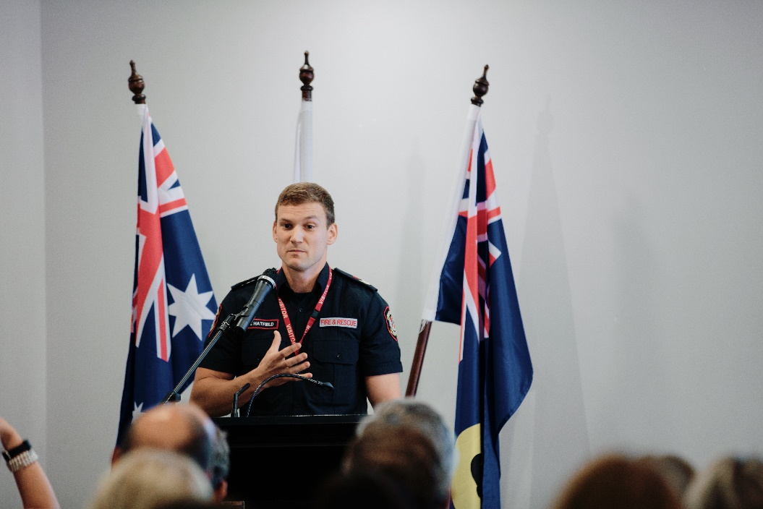
Australia's first Auslan fire safety presenter Mr Michael Hadfield speaking at the Department of Fire and Emergency Services International Day of People with Disability event

Western Australia Police
In 2019, the Professional Development portfolio hosted a joint learning event featuring presentations on Foetal Alcohol Spectrum Disorder (FASD) by experts from Alaska and PATCHES Paediatrics.
The team from Alaska comprised a superior court judge, psychologist, doctor, midwife and a behavioural expert and the PATCHES team provided a local WA perspective including their experiences in prevention, detection and early intervention. Attendees learned that police officers and frontline staff who meet individuals with FASD (offenders, witnesses and victims) may misinterpret the behaviour exhibited when it is likely to be a symptom of their condition. Having a better understanding and awareness of FASD is vital for every WA Police Force employee who may be the first point of contact.
In 2020, Training Design and Standards introduced Vulnerable People and Effective Communications training as part of a suite of existing training delivered to educate and encourage awareness of disability and access issues. Many of these initiatives were auspiced under the International Day of People with Disability.
In partnership with Autism Australia, the WA Police Force received funding to produce three five-minute videos to create greater understanding of Autism and its impacts – Understanding Autism; Responding in a Crisis; and Interviewing. The first video is completed and the scheduled production of videos 2 and 3 have been delayed due to COVID 19.

City of Melville
The City of Melville obtained a Lighthouse Grant to support delivery of six invisible disability awareness sessions. Each workshop was delivered to staff members from multiple directorates within the organisation (approximately 60 staff in total). The series, entitled Invisibilia (Latin for ‘the invisible things’), had an emphasis on increasing staff awareness about invisible disabilities, encouraging an examination of staff perceptions and understandings of the nature of disability. Invisible disabilities explored through the series included Dementia, Autism and Intellectual Disability, with sessions delivered by external facilitators including Alzheimer’s WA, Autism Association of Western Australia, and Developmental Disability Western Australia.
Training functioned to increase staff confidence in communicating, interacting with and supporting their colleagues and community members who may have an invisible and/or undisclosed disability. Staff comments about their learnings included:
- “Permission – Being bold and not debilitated by not wanting to offend/make mistakes.”
- “Customer service, focus on the customer not the carer.” “More accessible language.”
- “Be more inclusive with everyone.” “Don’t be scared to approach me.”
- “Hopefully be more open-minded and ensure I’m responding with empathy not pity. Being mindful everyone has their struggles but also gifts that they bring.”
- “Consider that some of the kids in the library, who may appear to be ‘misbehaving’, may actually have autism or another disability.”
The City also played a role in supporting quality of service within the community. In a first for a Western Australian shopping centre, Hawaiian’s Melville commenced a ‘Quiet Hour’ initiative, aimed at providing a low-sensory shopping experience for those who need it.
Occurring every Tuesday in August from 10.30am – 11.30am, Hawaiian’s Melville provides an age and autism-friendly shopping experience aligning with the ‘Quiet Hour’ initiative originally commenced within the centre’s Coles tenancy.
The original pilot program was developed in consultation with the City of Melville Age Friendly Melville Team through the Melville Age Friendly Accessible Business (MAFAB) network and Alzheimer’s WA, following a deepening commitment from Hawaiian to provide better age-friendly services, and support those with health concerns that might make a regular shopping experience difficult.
In implementing the Quiet Hour as a permanent initiative, Hawaiian’s General Manager of Shopping Centres (Suburban) Scott Greenwood said “There are many noises and distractions in an ordinary shopping experience that many of us are not aware of, but that can be challenging or prohibitive for individuals with noise or light sensitivity,” said Mr Greenwood.
“As part of our commitment to providing an inclusive environment for the local community, we are continually seeking new ways to adapt our centre amenities and surrounds to better serve our patrons.”
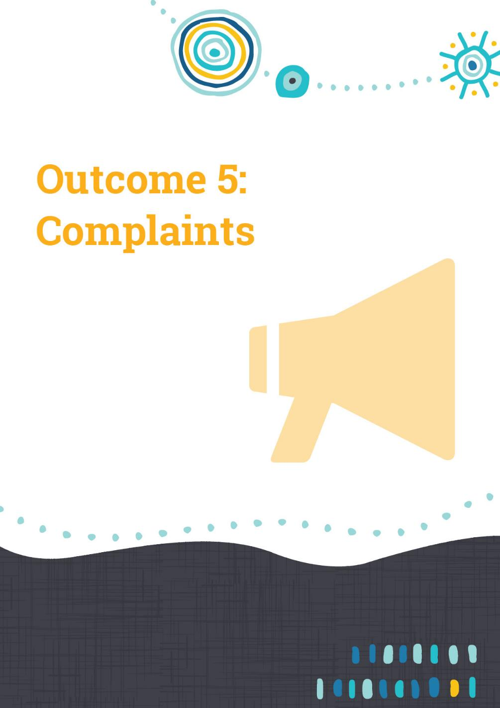

Outcome 5 – Complaints
People with disability have the same opportunities as other people to make complaints to a public authority.
Most Western Australian public authorities are required to have a complaints management system in place, as directed by the Public Sector Commissioner’s Circular 2009-27. The WA Ombudsman provides guidance on the importance of an accessible complaints management process.
This outcome area is typically the least reported of all seven outcome areas, with 71 percent of state authorities and 49 percent of local authorities reporting new or significantly progressed initiatives. As systems are generally already in place, DAIP strategies are more likely to be in a maintenance and safeguarding status. However, authorities are encouraged to be vigilant to any emerging issues in this space.

East Metropolitan Health Service
East Metropolitan Health Service described their approach to consumer feedback specifically relating to disability issues at Royal Perth Hospital. These are monitored and considered at the Royal Perth DAIP Committee every two months, and while the number of complaints has reduced in 2019-2020 the process provides valuable information which helps inform new accessibility actions
For example, providing directions on where to find an alternate lift during periods of maintenance or if lifts are locked out for catering; recommending provision of extra wheelchairs at main entrances; and trialling a variety of additional seating types as rest stations.

Department of Mines, Industry Regulation and Safety (DMIRS)
DMIRS has published simple to understand information about consumer rights. On the DMIRS website ‘Consumer rights for people with Disability’ available at https://www.commerce.wa.gov.au/consumer-protection/consumer-rights-people-disability there is a section ‘Know your rights’ providing details about your rights when a person buys something or enters into a contract. Information on lodging a formal complaint through Consumer Protection is also available if a person has had no success with trying to resolve a problem with a business or trader.
A video was developed in Auslan to assist people who live with hearing loss or impairment in our community. The Auslan content was been tailored for a WA audience, with information about ‘Scams against people with disabilities’ and other videos outlining topics on ‘Understanding scams’, ‘Hiring a service’ and ‘Entering a contract’ can be found on the DMIRS website.

City of Fremantle
The City of Fremantle provided an example of an access related complaint and the benefits of a proactive approach. An email was received from a person with vision impairment who had been refused entry to a local restaurant because she was accompanied by a Guide Dog. The person was called and thanked for her feedback and asked about her experience. A clear plan of action was agreed to and City staff investigated the incident with the restaurant owners, who acknowledged responsibility and agreed to display a ‘Welcome Guide Dogs Sticker’ in their window, as well as read printed resources prepared by VisAbility. The City also placed an informative blurb in the `Business Matters’ newsletter that goes out to all business owners. The complainant was informed of the actions and thanked for her role in helping safeguard access to premises for Guide Dogs.
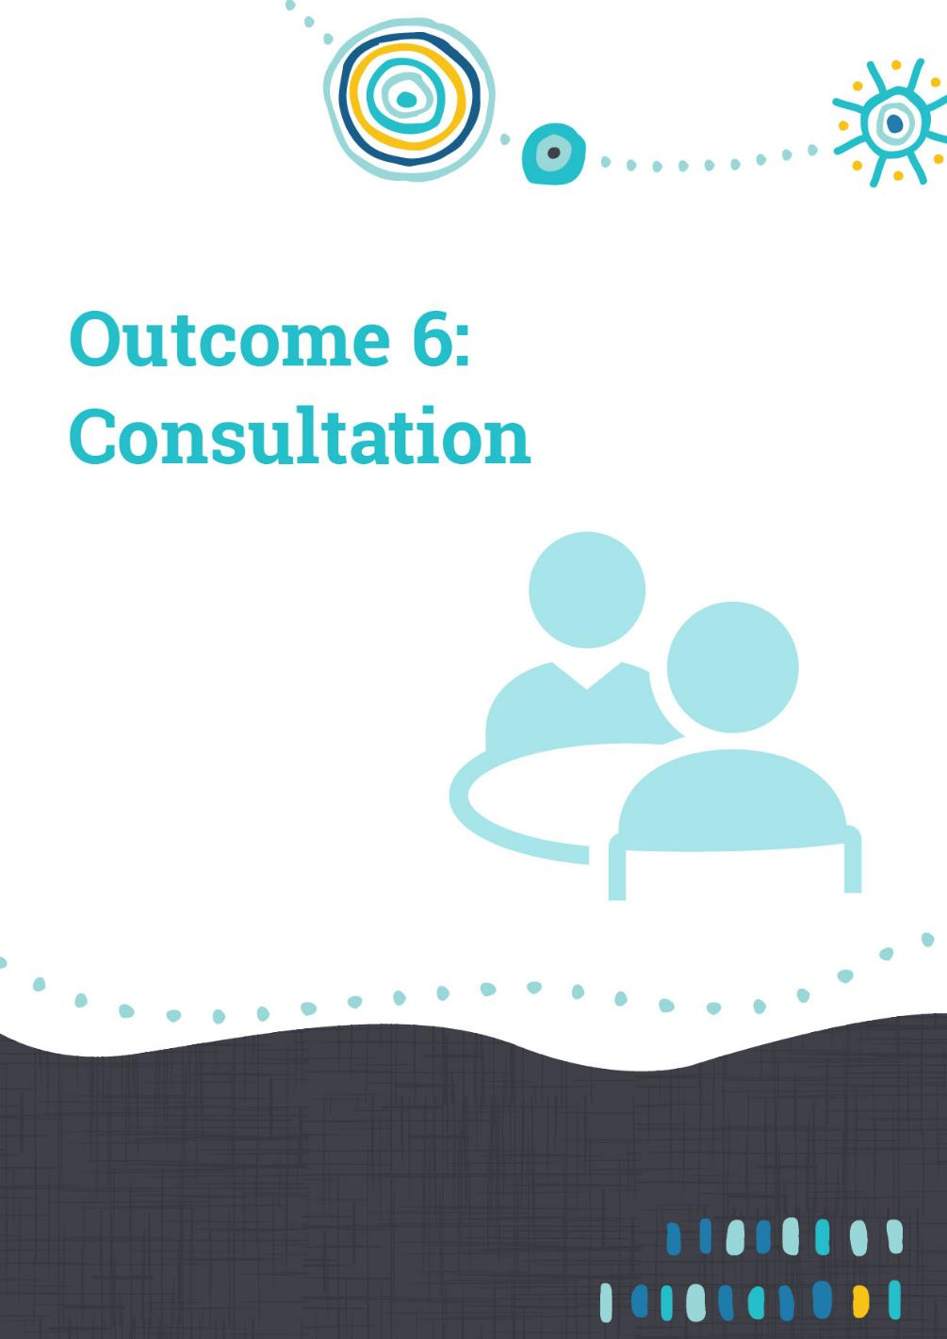

Outcome 6 achievements – Consultation
People with disability have the same opportunities as other people to participate in any public consultation by a public authority.
Consultation with residents, clients or service users brings benefits to all parties, including increased trust, transparency, a better understanding of experiences and technical expertise which can lead to better quality services and/or facilities.
Most authorities reported progress in this outcome area, at 84 percent for state authorities and 67 percent for local authorities. Progress areas included:
- ensuring consultation processes are inclusive and accessible to all people
- targeting people with disability, their families and carers or the disability sector to either provide their perspectives or help design a solution improves the outcome of a project
- implementing access and inclusion advisory groups for major projects or as an ongoing mechanism to safeguard access and inclusion
- enabling opportunities for people with disability to demonstrate and develop leadership and confidence to engage on matters affecting them.

Cities of Mandurah, Kwinana and Rockingham
MKRain (Mandurah, Kwinana & Rockingham Access and Inclusion Network) is an example of effective collaboration between neighbouring local governments. The network brings together stakeholders working across all three local government areas to support people with disability and their families. MKRain came about through a meeting between the Access and Inclusion Officers at each of the respective local governments who identified that many organisations are supporting people and families across a broader region that is not confined by local government boundaries.
Rockingham already had a well-established Rockingham Access and Inclusion Network attended by disability and community organisations across Rockingham and other local areas to share information and resources to the benefit of the community. It was decided to broaden the existing Rockingham network and in early 2020 the first MKRain meeting was held. As a result of the COVID-19 restrictions the meetings were moved to an online platform and this resulted in healthy meeting participation throughout the year.
As part of this initiative the City of Rockingham facilitates a regular e-newsletter which the City of Kwinana and the City of Mandurah support with providing content. This e-newsletter is distributed to hundreds of disability and community support organisations across the three local governments.
MKRain provides a valuable avenue for service providers to access relevant and timely information to share with people with disability and their support networks. The network also supports engagement of key stakeholders in consultation processes implemented by each of the local authorities, while also providing a platform to promote networking and collaboration between community organisations. A Terms of Reference is in place to support the ongoing operations and sustainability of the network.

Shire of Mundaring
Consultation with the Shire’s ongoing Inclusion and disAbility Access Advisory Group (IDAAG) continues to help embed, inform and co-design access and inclusion across the Shire’s activities. The IDAAG is a volunteer Committee of Council with a strong focus on leadership by members with disability.
The IDAAG was specifically consulted as part of the development of the Shire Community Health and Wellbeing Informing Strategy 2020-2025, resulting in an Access and Inclusion objective and commitments listed in the Strategy.
The IDAAG was also consulted for the Shire’s Age Friendly Informing Strategy 2020-2025, and through the IDAAG people with disability were represented on the Shire COVID-19 Community Relief and Recovery Sub-committee.

City of Belmont
The City has committed to developing an Accessible Business Program to raise awareness within the businesses and wider community. This has been developed through a co-design method which encourages people with lived experience of disability to participate in the development and implementation of initiatives.
In this instance, an engagement process was undertaken to identify challenges experienced by people living with disability when accessing businesses. This included members of the City’s Access and Inclusion Advisory Group; organisations working in the area of disability and their clients; and social media.
The purpose of this activity is to ensure that the accessible business program and relevant materials are developed collaboratively with people with lived experience and familiar with the sector. The early feedback from those who have been involved in the process has resulted in a greater feeling of being heard and their opinions being valued. Members of the co-design group have participated in the creation of a set of videos to complement the program, this has included participating in interviews and acting in the videos. They have been regularly asked to give feedback during this process to ensure the content and messaging is clear. The next phase is to engage with the business sector to develop the implementation method of the program and will again involve members of the co-design group.

Shire of Augusta-Margaret River
Shire Officers, members of the Shire’s Community Access and Inclusion Advisory Group (CAIRG) and other stakeholders worked in collaboration to develop a business brochure titled: ‘Smart Business - how your business can attract customers by providing better access for everyone’. It details what businesses can do to create better access for all and includes dementia information as part of the Shire’s current commitment to become a dementia friendly community. Featuring CAIRG members, it outlines positive statistics and information on subsidies for employing people with disability in local businesses. The Shire’s Community Development Officer, Katie Taylor, acknowledged the input of local employees with disability, stating, “Many of the tips have actually come from local people with disability and you can spot some recognisable local faces in the booklet.”
Several local authorities continued to strengthen access and inclusion with the private sector- pictured is the Shire of Augusta-Margaret River’s `Smart Business’ brochure

Landgate
During 2019, Landgate engaged in public consultation on the Strata Titles (General) Regulations 2019, and special care was taken to ensure that people with disability in both regional and metropolitan communities had the opportunity to engage in this process. Multiple entities who provide advocacy services for people with disability were provided with discussion papers and invited to comment as part of the process of developing the regulations.
There were seventeen community information sessions held across metropolitan and regional WA in accessible venues to ensure all people could attend. Video/audio recordings from the community information sessions were made available to the public via Landgate‘s strata website, if they were unable to attend the sessions in person.
Resources in relation to the strata reforms were included on the strata.wa.gov.au website, including online video presentations which were also available as a transcript. Other resources on the website included the Guide to Strata Titles and frequently asked questions. Visitors to the website were invited to subscribe to Landgate’s strata reform email updates. Further, a strata titles email address was made available, so that any questions in relation to strata reforms could be asked and answered. Customer Service employees were trained to provide information verbally via phone contacts.

Main Roads
Main Roads is managing the design and construction of a pedestrian bridge over Winthrop Avenue in Nedlands to connect the lawn area located between Perth Children’s Hospital (PCH) and the multi-story carpark on the Queen Elizabeth II Medical Centre grounds to Kings Park.
To be known as ‘The Kids' Bridge’, the facility will provide families and children using facilities on the Queen Elizabeth II Medical Centre campus with the opportunity to escape the rigours of their hospital journey by safely visiting Kings Park. Clinicians strongly agree that providing the opportunity to visit places like Kings Park is positive for the overall wellbeing of unwell children and their families.
Prior to construction, Main Roads consulted and sought feedback from the Department of Communities and the Child and Adolescent Health Service Disability Advisory Committee on the design of the bridge. In addition, Main Roads has gathered feedback and comments on specific design aspects (such as signage and surface coverings) from the Main Roads Disability Advisory Group, who consists of people with disability and their family members, carers and individuals who represent people with disability on a professional level. The outcomes of this consultation will form part of the final design of ‘The Kids Bridge’ and put access and inclusion as an integral part of the bridge design.
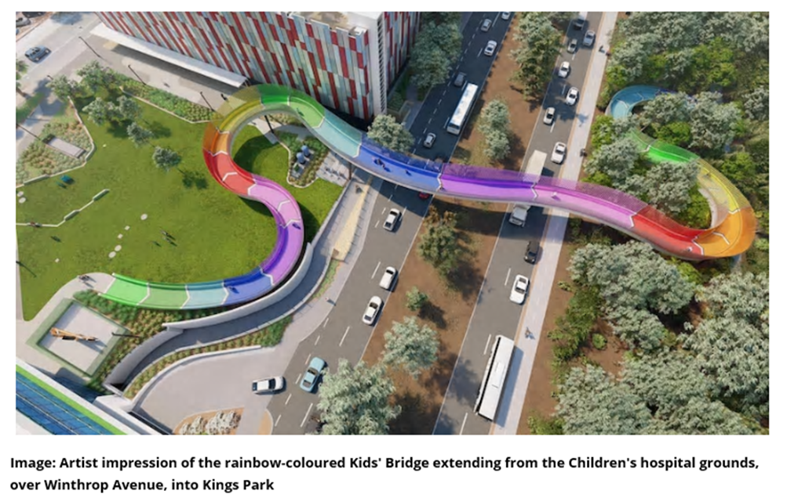
Artists impression of the `Kids Bridge’ linking Perth Children’s Hospital to Kings Park, designed for access to all people

Department of Communities
The Department undertakes public consultations using a variety of methods and forums to ensure they are as accessible and inclusive as possible. For the recent consultation on the establishment of an office of disability, various alternative formats were produced including accessible Word versions and Easy English/Easy Read versions. Accessible and inclusive community engagement sessions will be held across the State in 2020-21.
Additional consultation on the State Disability Strategy took place during 2019-2020 and included:
- workshops and an online survey around the priority areas, targeting government agencies, advocacy groups, the disability sector and service providers, business and private sector
- a community drop-in session and online survey around what the outcome areas mean for individuals
- videoconference workshop with people in regional locations
- conversations, focus groups and yarns with harder-to-reach people, including people of Aboriginal and Torres Strait Islander backgrounds, people of Culturally and Linguistically Diverse backgrounds, people with complex needs and their families, people with disability who are also homeless, and people living in remote areas of Western Australia.
Community engagement workshops on a range of issues are held throughout the year. Staff are available to cater for people with intellectual and physical disability and seniors. This ensures that a staff member is available to provide a one–on–one consultation experience.

City of Stirling
The City of Stirling recently formed a Social Planning Team to ensure greater coordination and consistency in the development, reporting, monitoring and implementation of the City’s social plans. The team committed to embedding inclusive practice across the City’s business units supported by the development of a Diversity and Inclusion Self-Assessment Tool. This tool will investigate barriers to participation and opportunities for promoting diversity and inclusion. It will assess the way the City responds to the changing needs of our diverse community and underpin how we engage with, support and build the capacity of specific groups, including people with disability.
To assist with development of the tool, the City hosted a community consultation workshop in December 2019. The aim was to help identify areas with the potential for improvement through the promotion of diversity across the City’s policies and procedures. Community members representing each of the City’s social plans were invited with over fifty people participating. Each table was facilitated by a staff member with a diverse group of up to ten people. The workshop resulted in the development of five prototypes to help inform social plan activity. Feedback from attendees was extremely informative and many positive comments were also received about the connection and communication between the diverse participants. Due to COVID-19, on-going development and implementation of the tool has been delayed but moving forward, the City acknowledges that it is vital that this level of community engagement is maintained as the process of design, roll out and review continues.
The City’s Access and Inclusion Advisory Group (AIAG) continues to influence best practice approaches to access and inclusion. Membership is drawn from staff, Stirling residents and representatives of disability service organisations or support groups operating within the City. The group provides a wealth of expertise and advice on the City’s Access and Inclusion Plan, as well as making recommendations for the improved access and inclusion of people with disability. Meetings cover a range of topics from the roll out of the National Disability Insurance Scheme (NDIS) in Stirling to presentations such as those by developers for Westfield Innaloo and the Karrinyup Shopping Centre. The City of Stirling acknowledges the AIAG as a valued source of guidance and support to City officers and encourages Business Units to consult with the group on their projects at the planning stage to ensure they have considered the many access elements that impact on the community.
In developing its Access and Inclusion Plan (AIP) 2020-2025 the City made a conscious decision to consult over a long period of time to ensure a detailed review through a range of methods, reaching out to people in the community that may not have been previously engaged. One of the new methods utilised was the use of the City’s ‘Chatter That Matters’ Teardrop Caravan. The caravan visits locations across Stirling including shopping centres, parks and at scheduled events. Its uniqueness and friendly staff encourage people to stop and chat about the things that are important to them. There has been an overwhelming response to this method of connecting with the community. Participants had the opportunity to speak individually and privately and City staff could provide relevant and in-depth information to the individual. Information was available in alternative formats including the provision of interpreters, on request. This resulted in ‘Easy Read’/large print/pictorials and electronic form.

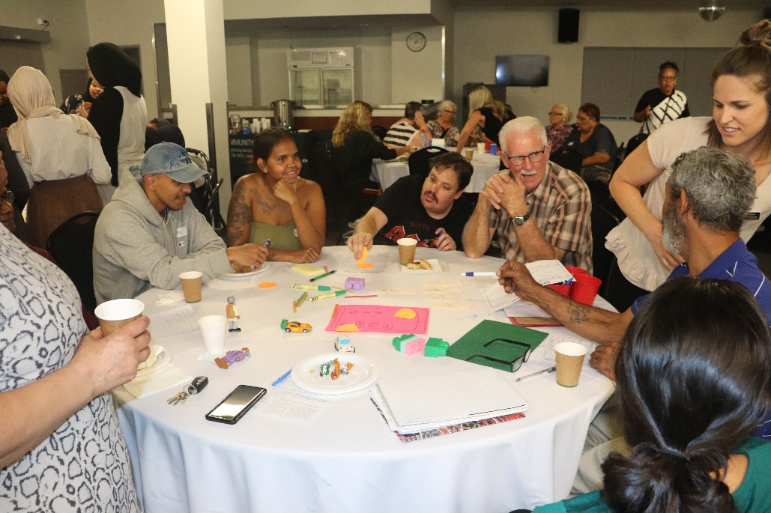
City of Stirling’s community workshop helped develop a social plan for all residents
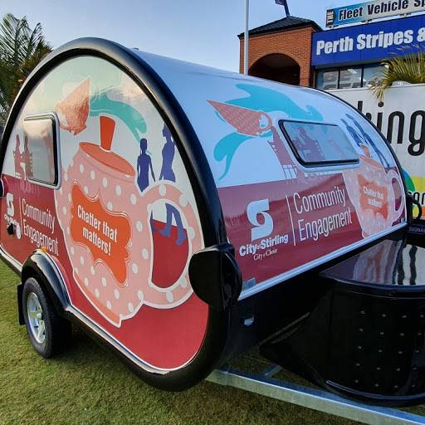
The City of Stirling’s Chatter that Matters caravan proved an effective way of connecting with all residents

Child and Adolescent Health Service
Perth Children’s Hospital works in partnership with Kalparrin, a member organisation that represents families raising children with disability, developmental delay, genetic, chronic medical and/or health conditions. Kalparrin provides next steps guidance, information and resources, peer mentoring and support, in-hospital support and inclusive events for members.
Kalparrin’s presence helps to support access and inclusion and awareness of disability and run education sessions to staff about how to create an inclusive culture. For International Day of people with Disability, Kalparrin and Perth Children’s Hospital ran an event to celebrate, and Kalparrin showcased their book ‘Super Power Kids’, with stories about the strengths and unique abilities of Kalparrin members children with the aim of creating a community that is more supportive and understand about children with disability. The book is available at www.kalparrin.org.au

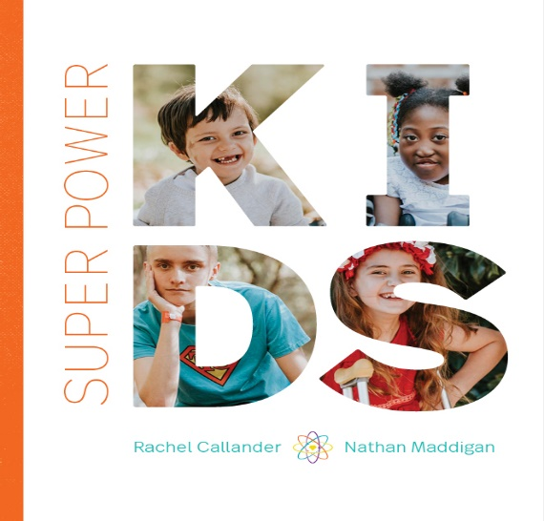
Kalparrin’s Super Power Kids book contains inspiring stories which increase people’s understanding of the talents of children with disability


Outcome 7 achievements – Employment
People with disability have the same opportunities as other people to obtain and maintain employment with a public authority.
The Public Sector Commission’s People with Disability: Action Plan to Improve WA Public Sector Employment Outcomes 2020-2025 were referenced in some authority reports, many of these plans will be in the early stages. Most authorities continue to report initiatives which will help prepare the environment for meeting targets, with 85 percent of state authorities and 60 percent of local authorities reporting new or progressed initiatives.

Town of Victoria Park
While local government authorities are not currently required to adopt the State Government’s revised target of 5 percent employment of people with disability by
31 December 2025, the Town has made a strong statement of support. In December 2019 the Town’s Council adopted the State Government targets. The Town currently has a disability employment percentage of 0.9percent.
The decision also approved the Town’s proposed project strategies and initiatives to meet the 5 percent Disability Employment Target across the total workforce, including a further initiative in the Project Proposal associated with Strategy 29 of the Town’s Disability Access and Inclusion Plan to work with Curtin University to develop a student and graduate employment program for people with disability to work in the Town.
The Town is also working with local providers such as Edge Employment and Mission Australia to explore ways to meet the target.

Department of Biodiversity, Conservation and Attractions (DBCA)
DBCA’s People Services Branch has worked with the Australian Network on Disability to identify and remove unintended barriers to inclusive recruitment practices, and to build on the Department’s confidence and capability to attract, support and retain skilled candidates with disability. DBCA achieved Disability Confident Recruiter status which recognises the Department’s commitment to inclusive recruitment and selection processes, and demonstrates that processes fulfil the following:
- Recruits from the entire talent pool by enabling skilled jobseekers with disability to compete for positions on a level playing field.
- Appropriate adjustments are made to the recruitment process for candidates who have disability.
- Provides an excellent candidate experience to all applicants.
Over 40 DBCA staff also recently participated in an online forum to help identify ways to develop the Department’s capacity to be a confident employer of people with disability.
DBCA also began working with National Disability Services on their ‘Building the Talent Pool Project’ to develop disability employment confidence in the WA State Public Sector to improve employment outcomes for people with disability.

Western Power
Western Power undertook several initiatives as part of building a disability confident workplace and were proud to receive a Disability Employer Award from Edge Employment in 2019. Initiatives included:
- Creating a quick user guide for Formal Leaders – Guideline to a Disability Confident workplace to assist them to address barriers to employment, performance, and promotion for people with disability. The guidelines contain more resources on how they can create a supportive work environment.
- Sending out emails every three months to HR Business Partners to remind them about accessing JobAccess for support for employees and managers.
- Establishing a mailroom and building services contract with InteLife. This contract provides work for eight people with disability.
- Establishing a direct contract with Activ to provide depot landscaping services.

Department of Communities
The Department progressed several disability employment initiatives across 2019-2020. The 2020 graduate program included a People with Disability Pathway, with dedicated positions for graduates with disability. The pathway offered additional support tailored to the applicant/graduate, such as advice on applications, reasonable adjustments to the selection process, access to workplace adjustments and flexible work options. Through this process, employment was offered to six graduates with disability, with five of these offers accepted.
As part of a larger project to increase the representation of people with disability, Communities has been working towards achieving the Disability Confident Recruiter endorsement from the Australian Network on Disability, expecting endorsement in 2020-21. This has involved identifying and implementing improvements to ensure practices are accessible to people with disability, such as providing information in alternative formats; that applicants can nominate their preferred method of communication at each stage of the process; a video interview option and an accessible recruitment factsheet.

City of Greater Geraldton
The City delivered its first Disability Employment Mobile Outreach (DEMO) program. Working in partnership with the Midwest Chamber of Commerce and Industry, local Disability Employment Service providers, Central Regional TAFE, and local industries and businesses. The aim was to break down barriers associated with negative opinions and misinformation around employing those with disability and to introduce participants to prospective employers. This was achieved by taking participants into pre-arranged workplaces over a one-week period where they enjoyed a lunch together and were given the opportunity to tell their story.
Businesses and participants were able to connect personally on site, rather than anonymously via online job applications where their experience was universally negative. This proved incredibly valuable and resulted in encouragement and invitations from prospective employers for participants to apply for current vacancies, bring in their resumes and attend formal interviews. Disability Employment Service providers were also able to further expand their client base.
The City was the primary partner in the National Disability Coordinators Office Passport 2 Employment program. Geraldton was chosen to pilot a specialised seven week program to prepare, support and assist fourteen students with supported needs for the transition into life after school, and to provide participants with skills and knowledge that will assist them in seeking, finding, obtaining and retaining employment and/or further education training opportunities. The City’s Community Development Officer facilitated and mentored the program. The City also provided the venue, transport and driver. Students also attended a variety of workplaces including several departments at the City, culminating in a question and answer session in the Council Chambers with the Mayor and the CEO. The program proved to be a great exercise in collaborative practices and sustainable outcomes. This year will see the program extended over a nine-week period due to its success.
The City was honoured to receive the award for Most Accessible Community in Western Australia for both Regional City and overall, in 2019. The City continues to strengthen its already established relationship with Access to Leisure and Sport (ATLAS) whose focus is firmly on being a leader in inclusive tourism, recreation and participation in the Mid-West. The City and ATLAS have been developing strategies in areas such as how to upskill and build capacity of stakeholders, and how to increase awareness of potential opportunities for local businesses, organisations and agencies. The City remains committed go beyond legislative obligations in seeking and exploring progressive and innovative ways to ensure the whole community has equal opportunities in all aspects of access and inclusion.

City of Rockingham
The City delivered two business engagement events focused on increasing awareness and knowledge relating to employment of people with disability: The Disability Employment Business Breakfast was held in November 2019; and the Disability Employment Business Expo and Sundowner was held in February 2020. The event series was partly funded through the Lighthouse Project with funding made available under the National Disability Insurance Scheme Information Linkages and Capacity Building stream.
The breakfast event aimed to provide the local business community with an opportunity to learn more about the benefits of increasing inclusion in the workplace through disability employment. Mayor Barry Sammels opened the event, followed by presentations from a series of keynote speakers.
Over 140 people attended this event and feedback from participants indicated that: 75 percent reported an increase in their confidence to employ people with disability, 82 percent planned to take action to improve employment opportunities for people with disability, 96 percent either agreed or strongly agreed that the event increased their awareness of the importance of employment for people with disability, 97 percent either agreed or strongly agreed that the event gave them a better understanding of the resources and supports available to assist the employment of people with disability.
The expo and sundowner sought to build on the foundations and increased awareness achieved by the breakfast, providing businesses with an opportunity to connect directly with local Disability Employment Services. The event was well attended by local Disability Employment Services (DES) who each provided an information stall at the event. The event was attended by 123 guests, with eleven DES providers represented. Representatives from People with Disability WA also attended the event and provided an information stall. The City engaged Sue Robertson as the guest speaker for the event. Sue presented about alternative approaches to creating employment for people with disability, highlighting the opportunities available to people and businesses through job customisation. Following the guest speakers, attendees were encouraged to spend the remainder of the event networking with one another and visiting each of the information booths provided by the DES providers.
Despite the disruptions caused by COVID-19 on the ability to evaluate the events, the City is confident positive outcomes will be generated over time as a result of the engagement.
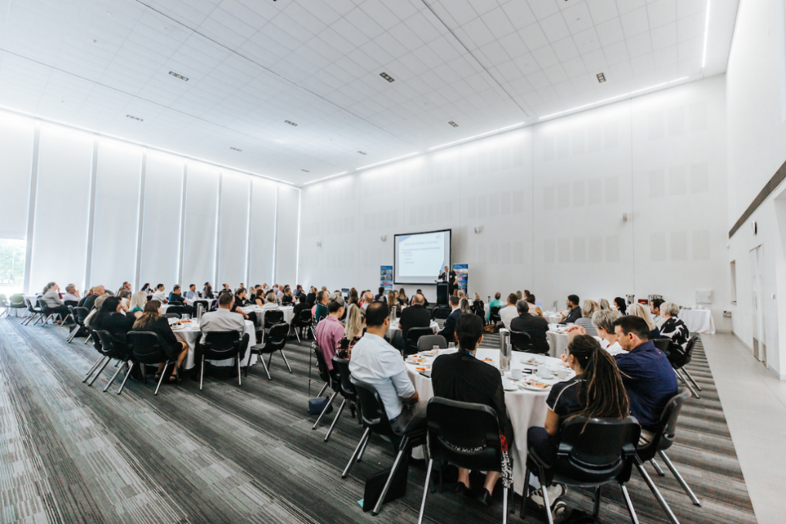
The City of Rockingham supported disability employment in the local community through a business breakfast

South Metropolitan TAFE
In conjunction with the National Disability Co-Ordination Officer (NDCO) Program and BIZLINK (Disability Employment Service), a 12-month pilot program called the TAFE Specialist Employment Partnership (TSEP) was launched in February 2020. This program is the first of its kind in WA. It is a free employment service based on campus and its purpose is to support students and Jobs and Skills Centre (JSC) clients with a disability or medical condition to find employment. The program also offers on the job support if required.
With Department of Training & Workforce Development (DTWD) data indicating that the rate of unemployment amongst graduates with a disability is 23.5 percent compared to those without disability at 11.3 percent South Metropolitan TAFE believes there is a real need to support students and clients with meaningful transitions and linkages into employment.
A specialist employment consultant from BIZLINK is based at the Thornlie JSC one day a week and is also available to meet with students on other campuses or off campus as required. The specialist consultant works with students to identify their skills, abilities and interests, supports them to plan and apply for jobs, prepares them for transition into work and later provides on the job support if necessary. Co-location of the TSEP consultant on campus also promotes cross-training, heightened awareness and natural upskilling of staff in the types of disability supports available within an employment environment.
The arrival of COVID-19 resulted in a modified and flexible delivery mode of telephone consultation for a time. There has been keen interest in the pilot from students and JSC clients seeking support with specialist career and employment assistance and the first student participant will be successfully commencing employment in two weeks.

South Regional TAFE
In Semester 2 2019 South Regional TAFE collaborated with Activ to develop and deliver a part-time training program at Albany campus, Certificate II in Furniture Making, targeted at meeting the specific learning and employment skill needs of Activ clients with disability. Elective units were identified to develop the skills required for employment within the furniture making and carpentry industry. Developing these skills will assist the students to transition to employment. The training was delivered to meet the learning needs of the students, and additional lecturer support was provided through enrolling the students in the Underpinning Skills for Industry Qualifications (USIQ) course. The students developed both woodworking and employability skills.

Curtin University
Curtin has entered into partnership agreements with three Disability Employment Service (DES) providers – Ability Centre, VisAbility and Autism Association - to facilitate recruitment of candidates with disability through our Talent Acquisition (TA) team, and to support upcoming graduates with disability through to employment upon completion of their qualification. The TA team feature prospective candidates on a flyer which goes out to the Human Resources community across Curtin who then use it as a point of reference when discussing prospective opportunities on campus to hiring managers to consider when recruiting to any vacant positions. Four flyers have been produced to date, with one candidate being interviewed for current vacancies. Whilst Curtin has not yet secured any new staff through this platform to date (due to disruptions following the COVID-19 pandemic), Curtin hopes it will be successful in appointing new staff through this initiative in the second half of 2020. Current representation of staff with disability sits at 143 of a total 7,553 continuing/ fixed term/casual and sessional staff employed at Curtin (1.89 percent).
Curtin is enormously proud that staff member Paul was awarded the Quarter 3 2020 Customer Servicing Benchmark Australia (CSBA) Most Customer Focused Agent Award for his dedication to the student experience and continually going above and beyond for his customers. Paul and his Seeing Eye dog Hercules work in the Student Services Contact Centre at Curtin University.
As Paul is legally blind, he uses a text to speech system on his laptop called JAWS, which reads text to him. The system integration with Curtin’s software platforms isn’t perfect and it can’t read everything, but Paul doesn’t let this slow him down. His ability to multitask, having a customer speaking to him in one ear, and JAWS in the other of his headphones, is phenomenal.
During the COVID-19 crisis, Paul overcame the struggles of working from home, with his dedication to the student experience shining through more than ever.
Paul is an invaluable member of the team. He strives for excellence in every interaction he has and always looks to create a better experience for the students he supports. On many occasions graduating students have called to say goodbye to Paul and to thank him for being a source of knowledge and steady support throughout their studies.
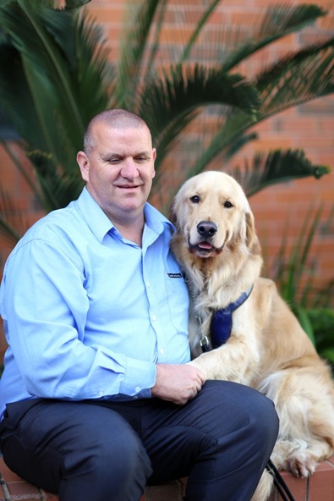
Curtin University’s popular staff member Paul was recognised for his performance in customer service (also appears on cover page)

Department of Education
To improve employment outcomes for people with disability through strengthening inclusive recruitment and employment practices in schools and workplaces, Education developed and published comprehensive information to enhance the capacity of principals, line managers and selection panel members to use exceptions (sections 66R and 66S) in the Equal Opportunity Act 1984 to recruit, employ and support people with disability. This aligns with the Public Sector Commissioner’s Circular: 2018-02 Measures to achieve equality in human resource management.
Consultancy was provided to assist schools use the exceptions (66R and 66S) to prioritise employment of people with disability and adapt the recruitment process to attract and support applicants with disability.
For example, Warwick Senior High School advertised a gardening traineeship position using section 66R of the Equal Opportunity Act 1984. The written application process was simplified, asking applicants to complete a short application form. There were twelve applications for the position, including two from people with disability. The successful applicant was a person with disability who was experienced and had completed a Certificate II in Horticulture.
Warren now works two days a week at the school as a gardener and is completing his Certificate III in Horticulture with North Metropolitan TAFE. Edge Employment and the Apprenticeship Community also supported Warren to commence his Certificate with TAFE.
The Principal and the Manager Corporate Services at Warwick Senior High School agreed: “Warren has become a great asset to our gardening team. He participates in all of our social events and has become a popular member of our school.”

Department of Mines, Industry Regulation and Safety (DMIRS)
DMIRS established the DMIRS Diversity and Inclusion (D&I) Excellence Award, aligned to the department’s Diversity and Inclusion (D&I) Plan. The award recognises and celebrates DMIRS employees who have demonstrated a commitment to diversity and inclusion; have contributed to strengthening the diversity of our workforce; and worked to build and maintain an inclusive workplace culture where all employees feel valued, respected and connected.
Nominations were open to all DMIRS employees with the option to self-nominate or nominate others. To nominate, an application form needed to be completed. Providing some form of evidence was encouraged.
The application form requested nominators to provide a story or examples demonstrating the nominees contribution to the two D&I Plan goals: strengthening the diversity of our workforce; and building and maintaining an inclusive workplace culture where all employees feel valued, respected and connected.

Shire of Augusta-Margaret River
The Shire recognises the importance of promoting achievements regarding access and inclusion to staff and the community. This is achieved through all staff emails, internal staff meetings, Council inductions/updates, Community Access and Inclusion Reference Group (CAIRG) network emails, media releases, the Shire Facebook page and the Shire website. This promotion builds awareness around the initiatives that the Shire is undertaking, while also encouraging staff to strive to ensure that services and processes are consistent, inclusive and can readily adjust to people’s needs.
This financial year the Shire has also been awarded the Lighthouse Regional CEO Leadership Award, recognising the achievements of WA local governments in seeking to increase the employment of people with disability in WA local government. Presented at the Local Government Professional WA’s Annual State Conference Gala Dinner and Awards Night, the award recognises CEO leadership within a local government that has resulted in a demonstrable increase in employment of people with disability.
“We acknowledge that as one of the largest providers of employment in the community we have an important role to help upskill community members experiencing access barriers to employment,” said Shire CEO Stephanie Addison-Brown.
“Through the Shire’s Access and Inclusion Plan we aim to improve opportunities for all people with diverse abilities and backgrounds to obtain and maintain employment with the Shire”.
In October 2019 twelve-year-old Margaret River Primary School student Willem was announced as the Shire’s official ambassador for the new waste campaign: Best We've Ever Bin. The program aimed to support community to adapt to the Shire’s new three-bin kerbside collection service.
The Shire sought to work with a volunteer community ambassador to help lead a cultural change about effective waste management. The Shire’s former Waste Education and Project Officer Jackie said, “We had been brainstorming as to who might make a great ambassador since the project's inception. We thought about which local identities would work, plus had a short list of celebrities we wanted to approach. Then by pure chance I had the good fortune of meeting Willem at a school presentation and was absolutely convinced on the spot I had found the right ambassador. He has a fascinating knowledge of all things to do with the Shire's bins, recycling and waste management systems. His curiosity and interest in the subject are just incredible and he clearly has so much to offer to his local community as a bin campaign ambassador.”
Willem’s volunteer ambassador role so far has included appearances at the Shire’s Waste Education stand at the Margaret River and Districts Agriculture Show, visits to the Shire’s waste facilities to find out about the processes and machinery used in landfilling and the creation of online videos to assist residents in using their bins correctly through COVID-19.
Willem’s parents have said this role has empowered their son, who has autism, to be able to utilise his knowledge and passion in a constructive way.
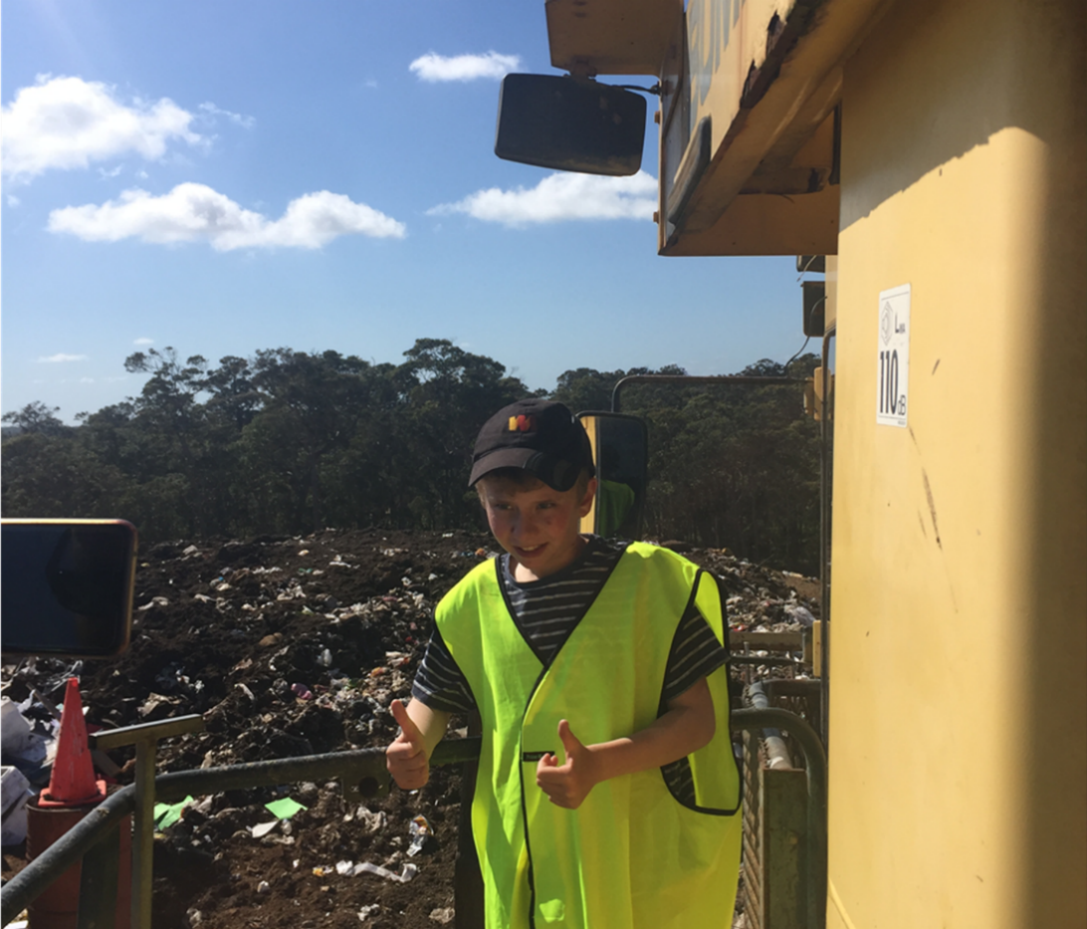
William’s role as the Shire of Augusta-Margaret River’s Waste Ambassador has empowered his passion and knowledge (Willem also features on cover page)

Agents and contractors
An agent or contractor is an individual or organisation that undertakes work or provides a service on behalf of a state government agency or local government authority. The Disability Services Act 1993 requires public authorities take all public authorities are required to take all practicable measures to ensure that their DAIP is implemented by the public authority and its officers, employees, agents or contractors. This addresses the expectation that services, or facilities provided through public funds are accessible to everyone.
Public authorities are responsible for deciding on how to implement this measure within their organisation. Some authorities report that they don’t use agents or contractors, or don’t have any which are appropriate for tracking (fifteen percent state authorities and 35 percent of local authorities).Others may target certain agents and contractors over others because of the level of interface they have with the general public, the significant investment or a recognised risk to the authority if access and inclusion is not prioritised.
Procurement templates developed by the Department of Finance for use by agencies across the sector have a ‘Disability Access and Inclusion Plan’ clause. When used it requires contractors completing work on behalf of an agency to ensure a DAIP is implemented by the contractor. The Department of Finance will prompt any contractors engaged by the Department to act in accordance with its DAIP Plan where it is required.

City of Belmont
The City has listed accessibility in the Request to Quote for open space design which is set at ten percent of the assessment criteria of the procurement process.

City of Swan
To increase the use of online forms and ensure that all externally used or viewed materials are accessible, the City’s Customer Care Services included in Request for Quote and Request for Tender considerations that contractors will need to ensure their staff have the capacity to communicate and to interact effectively with people from diverse backgrounds, dementia and/or disability. The City's Library and Customer Services changed surveys to Culture Counts, where customers can access the survey online from home or mobile device and/or the library with assistance from staff.

North Metropolitan Health Service
NMHS has over 30 contracts with organisations that reference DAIP in the contract, with contractors required to provide a DAIP report to NMHS every year. These reports give NMHS confidence that contractors are acting in accordance with their access and inclusion values. For example, the Goldfields Women’s Health Care Centre successfully advocated to the local council to install two accessible parking bays to the front of their building, increasing access to all services in their street. They are also creating a Diversity Policy and have been involved in the development of the City of Kalgoorlie-Boulders’ AIP 2020-2025.
Bethesda Health Care have recently published their DAIP 2020-2022 and their Consumer Partnership Group has conducted a way finding audit across their organisation. Midland Women’s Health Care Place were able to respond to the individual needs of clients with disability during COVID, allowing clients who did not respond to video conferencing and who were feeling socially isolated to attend the clinic for their appointment (with COVID-Safe practices in place). Waratah Support Centre conducted an audit on all their buildings to ensure that access ways are clear and trip hazards are removed. Counsellors at Waratah also completed four Medibank Disability e-learning modules.

Appendix One: Public authority submissions
The following State Government authorities provided progress reports to the Department of Communities:
- Art Gallery of Western Australia
- Central Regional TAFE
- ChemCentre
- Child and Adolescent Health Service
- Curtin University
- Department of Biodiversity, Conservation and Attractions (including independent reports from the Botanic Gardens and Parks Authority, Perth Zoo and Rottnest Island Authority)
- Department of Communities
- Department of Education
- Department of Finance
- Department of Fire and Emergency Services
- Department of Health
- Department of Jobs, Tourism, Science and Innovation
- Department of Justice
- Department of Local Government, Sport and Cultural Industries
- Department of Mines, Industry Regulation and Safety
- Department of Planning, Lands and Heritage
- Department of the Premier and Cabinet
- Department of Primary Industries and Regional Development (including an independent report from the Kimberley Development Commission).
- Department of the Registrar, Western Australian Industrial Relations Commission
- Department of Training and Workforce Development
- Department of Transport
- Department of Treasury
- Department of Water and Environmental Regulation
- East Metropolitan Health Service
- Economic Regulation Authority
- Edith Cowan University
- Forest Products Commission
- GESB
- Gold Corporation (the Perth Mint)
- Horizon Power
- Insurance Commission of Western Australia
- Landgate
- Legal Aid Commission of Western Australia
- Lotterywest/Healthway
- Main Roads Western Australia
- Mental Health Commission
- Metropolitan Cemeteries Board
- Metropolitan Redevelopment Authority
- Murdoch University
- North Metropolitan Health Service
- North Metropolitan TAFE
- North Regional TAFE
- Office of the Auditor General
- Office of the Director of Public Prosecutions
- Office of the Information Commissioner
- Office of the Inspector of Custodial Services
- Ombudsman Western Australia
- Public Sector Commission
- Public Transport Authority
- School Curriculum and Standards Authority
- Small Business Development Corporation
- South Metropolitan Health Service
- South Metropolitan TAFE
- South Regional TAFE
- State Library of Western Australia/State Records Office
- Synergy
- Tourism Western Australia
- University of Western Australia
- WA Country Health Service
- Western Australian Electoral Commission
- Western Australian Museum
- Western Australia Police
- Water Corporation
- Western Power
- Workcover
The following Local Government authorities provided progress reports to the Department of Communities:
- Bunbury Harvey Regional Council
- City of Albany
- City of Armadale
- City of Bayswater
- City of Belmont
- City of Bunbury
- City of Busselton
- City of Canning
- City of Cockburn
- City of Fremantle
- City of Gosnells
- City of Greater Geraldton
- City of Joondalup
- City of Kalamunda
- City of Kalgoorlie-Boulder
- City of Karratha
- City of Kwinana
- City of Mandurah
- City of Melville
- City of Nedlands
- City of Perth
- City of Rockingham
- City of South Perth
- City of Stirling
- City of Subiaco
- City of Swan
- City of Vincent
- City of Wanneroo
- Eastern Metropolitan Regional Council
- Rivers Regional Council
- Shire of Ashburton
- Shire of Augusta-Margaret River
- Shire of Beverley
- Shire of Boddington
- Shire of Boyup Brook
- Shire of Bridgetown-Greenbushes
- Shire of Brookton
- Shire of Broome
- Shire of Broomehill-Tambellup
- Shire of Bruce Rock
- Shire of Capel
- Shire of Carnamah
- Shire of Carnarvon
- Shire of Chapman Valley
- Shire of Chittering
- Shire of Collie
- Shire of Coolgardie
- Shire of Coorow
- Shire of Corrigin
- Shire of Cranbrook
- Shire of Cuballing
- Shire of Cue
- Shire of Cunderdin
- Shire of Dalwallinu
- Shire of Dandaragan
- Shire of Dardanup
- Shire of Denmark
- Shire of Derby-West Kimberley
- Shire of Donnybrook-Balingup
- Shire of Dowerin
- Shire of Dumbleyung
- Shire of Dundas
- Shire of East Pilbara
- Shire of Esperance
- Shire of Exmouth
- Shire of Gingin
- Shire of Gnowangerup
- Shire of Goomalling
- Shire of Halls Creek
- Shire of Harvey
- Shire of Irwin
- Shire of Jerramungup
- Shire of Katanning
- Shire of Kellerberrin
- Shire of Kent
- Shire of Kojonup
- Shire of Kondinin
- Shire of Koorda
- Shire of Kulin
- Shire of Lake Grace
- Shire of Laverton
- Shire of Leonora
- Shire of Manjimup
- Shire of Meekatharra
- Shire of Menzies
- Shire of Merredin
- Shire of Mingenew
- Shire of Moora
- Shire of Morawa
- Shire of Mount Magnet
- Shire of Mount Marshall
- Shire of Mukinbudin
- Shire of Mundaring
- Shire of Murchison
- Shire of Murray
- Shire of Nannup
- Shire of Narembeen
- Shire of Narrogin
- Shire of Ngaanyatjarraku
- Shire of Northam
- Shire of Northampton
- Shire of Nungarin
- Shire of Peppermint Grove
- Shire of Perenjori
- Shire of Pingelly
- Shire of Plantagenet
- Shire of Quairading
- Shire of Ravensthorpe
- Shire of Sandstone
- Shire of Serpentine-Jarrahdale
- Shire of Shark Bay
- Shire of Tammin
- Shire of Three Springs
- Shire of Toodyay
- Shire of Trayning
- Shire of Upper Gascoyne
- Shire of Victoria Plains
- Shire of Wagin
- Shire of Wandering
- Shire of Waroona
- Shire of West Arthur
- Shire of Westonia
- Shire of Wickepin
- Shire of Williams
- Shire of Wiluna
- Shire of Wongan-Ballidu
- Shire of Woodanilling
- Shire of Wyalkatchem
- Shire of Wyndham-East Kimberley
- Shire of Yalgoo
- Shire of Yilgarn
- Shire of York
- Town of Bassendean
- Town of Cambridge
- Town of Claremont
- Town of Cottesloe
- Town of East Fremantle
- Town of Mosman Park
- Town of Port Hedland
- Town of Victoria Park
- Mindarie Regional Council
- Western Metropolitan Regional Council

