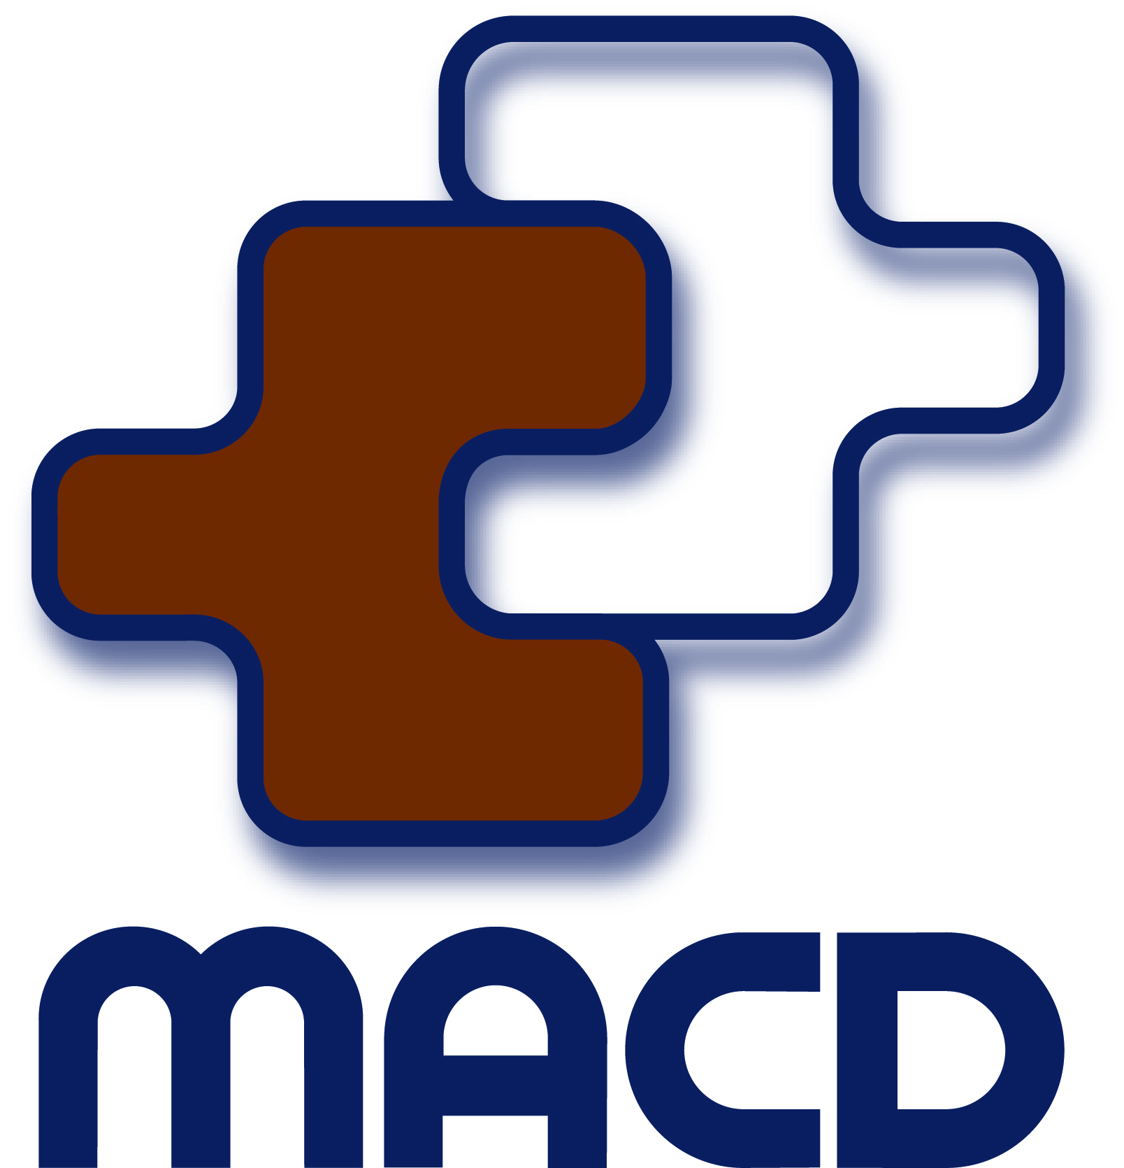
Independent advisor to the Western Australian Minister for Disability Services
Keeping government informed

Ministerial Advisory Council on Disability

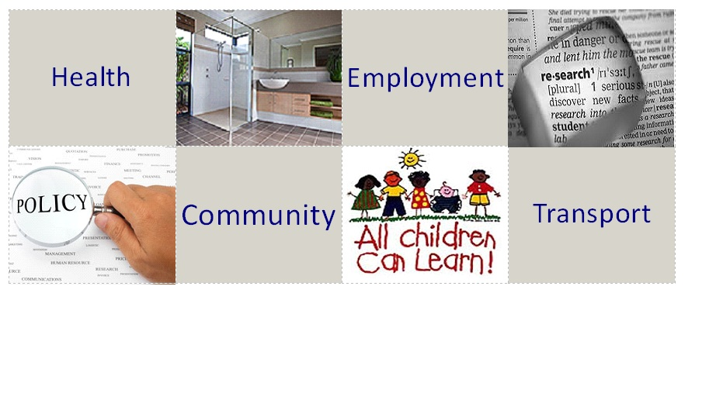

Annual Work Report
2019

Contact Details

Address: 146-160 Colin Street
West Perth
Western Australia 6005

Postal Address: PO Box 494
West Perth
Western Australia 6872

Telephone: (08) 6167 8237
(08) 6167 8236

Freecall: 1800 629 269

TTY: (08) 9426 9321

Facsimile: (08) 9226 2316

Email: advisory@dsc.wa.gov.au

Website: www.macd.wa.gov.au

Published by the Ministerial Advisory Council on Disability, Western Australia.

May 2019
© Copyright Ministerial Advisory Council on Disability, Western Australia, 2017.

This publication is copyright. No part may be reproduced by any process except in accordance with the provisions of the Copyright Act 1968.

Authorised by the Ministerial Advisory Council on Disability (Western Australia).
146 – 160 Colin Street, West Perth, Western Australia 6005.

This report covers the 2019 calendar year, following a decision by Council to align its planning and reporting timelines.

The terms Council or MACD have been used interchangeably throughout this report and refer to the Ministerial Advisory Council on Disability (Western Australia).
This Report is available in alternative formats upon request - please contact the Council office.

Contents
Executive Report 1
About Us 3
Report on Council Activities in 2018 5
Annual Work Plan 2018 5
Priorities 5
Watching Briefs 5
External Committee Representation 6
Meetings 7
Ministerial Advisory Council on Disability 7
State Minister for Disability Services 8
Disability Services Board 8
Networking Events and Other Meetings 8
Council Membership and Staff 10
Council Members 10
Council Staff 10

Executive Report

The role of the Ministerial Advisory Council on Disability (MACD) is to keep government informed about major issues affecting the lives of Western Australians with disabilities, their families and carers. There are many such issues, so each year we decide on our priority areas and plan how to address them. These priority areas are worked through systematically throughout the year and in addition, Council also addresses other issues that arise regularly and require action. In this Executive Report, I will highlight some aspects of our work during the year; however, the Annual Work Report provides more detail of the work of Council, both planned and reactive.

Hello! My name is Kerry Allan-Zinner. I was born with Cerebral Palsy which has led me down an immensely rewarding career path in disability advocacy and supporting people’s human rights. My appointment to the role of Chairperson to the Ministerial Advisory Council on Disability (MACD) in January 2019 was very humbling yet exciting. It is a great opportunity to represent everyone with a disability, their families and carers in the advice Council provides to the Minister for Disability Services in WA. I was with the Council from 2003 and served as Chair from 2006 to 2008. Minister Stephen Dawson kindly invited me back this year to again, Chair the Council. I find that the key issues we talk about may be the same but the conversations around those issues are different conversations than we had last time I was on the MACD, before the NDIS. I also represent Western Australia on the National Independent Advisory Council for the NDIA, so I get to see and hear about so many issues that people are faced with daily, from all sides.

Before I talk about the work that the Council has achieved this year, I must thank Andrew Thompson. Andrew is the immediate past Chairperson. He graciously agreed to step aside to the Deputy Chair role in order to allow a person with lived experience of disability to take the helm. Andrew is a true professional and has much experience in the world of disability. He raised a successful young man who has a disability and is the prime support and advocate for an older man with a disability. In his professional life, Andrew played a very integral high-level role in the management of the Education Support Centres in schools. He has been a rock-solid support to me coming straight into the hot seat of the Council. Thank you Andrew, you have really helped to smooth the road for me.

All people who come onto Council do so because they are very passionate about improving the lives of people with disabilities and their support crews. Their strong network connections are vital links that help us hear about what’s working and what’s not working both in the NDIS and the WA NDIS.

We are advisors to the Minister for Disability Services. We’re not advocates. We’re not activists. It’s not easy to take off our advocates’ and activists’ hats when we meet, but this we must do to provide researched and balanced information with which, the Minister can work without fear or favour. We won’t necessarily see the results of our work overnight, next week or next month. While this can be frustrating because we’re so keen to make a difference, we trust that our independent advice is useful and a valued addition to the big melting pot of information that reaches the Minister’s office.

Apart from ensuring the National Disability Insurance Scheme is the best that it can be for all Western Australian’s affected by disability, Minister Dawson is keen to improve three aspects of life for people with disabilities: Employment, Housing and Transport. To examine these topics in greater detail, in 2019 Council provided considered advice about:

- Barriers that people with disabilities face when seeking employment.
- Employment in the Public Service for people with disabilities.
- The amount of available social housing classed as universally accessible and ways of increasing housing choices for people with disabilities within the public housing system.
- Accessibility of public transport infrastructure within the Perth metropolitan area.
- On-demand passenger transport levy.
Every year we farewell some members and welcome aboard new members. For continuity of knowledge and experience on Council, we stagger members’ terms so there is never a complete change of members.

I commenced in January and, Mary Butterworth and Jasmyn Allen joined us in October. Carole Kagi, David Carrington, Justin Mortley, Nita Spedding and Peter Batini retired, and Justine Colyer commenced her second term of two years.

Finally, I would like to thank our dedicated staff, Executive Support Officer Peta Kenworthy and Executive Assistant Roslyn (Lyn) Creed who provide professional executive support, keeping me and my fellow Council members on track with current tasks and issues. Thanks to both for the administrative support as well as the vital assistance provided at Council meetings.

Kerry Allan-Zinner
Chairperson
MINISTERIAL ADVISORY COUNCIL ON DISABILITY

29 January 2020

About Us

The Ministerial Advisory Council on Disability is an independent body constituted under the Disability Services Act 1993 to provide advice to the State Minister for Disability Services on matters affecting or likely to affect people with disability, their families and carers. The Council was established in accordance with Part 3 and Schedule 5 of the Act.

Council is comprised of 14 members selected and appointed by the Minister. Membership must reflect the spectrum of people with a disability and includes people with disability, family members, carers, advocates and service providers.

The Council’s Strategic Framework assists the Council to deliver a strategic approach when providing valuable information and advice to the Minister. The framework includes the five Focus Areas:

- Focus Area 1 - Getting Everyone’s Input
This focus area describes how the Council will consult with people with disability, their families and carers, advocates and the wider community of Western Australia as required by the State Disability Services Act 1993.

- Focus Area 2 - Connecting with Government and the Community
This focus area describes how the Council will connect with Government and the community of Western Australia to create positive changes for people with disability, their families and carers.

- Focus Area 3 - Increasing Awareness
This focus area describes how the Council will work to increase community awareness regarding people with disability, their families and carers.

- Focus Area 4 - Working together with the Minister
This focus area describes how the Council works together with the State Minister for Disability Services and Ministerial staff.

- Focus Area 5 - How the Council works
This focus area describes how the Council manages its role.

For further details visit our website and go to ‘Publications’ www.macd.wa.gov.au
The Council undertakes its work through consultation with the community through the members’ community networks and linkages and through formal consultation processes. The diagram below shows the links and flow of information gathering:

Disability Sector Organisations and Peak Bodies

Disability Services Commission
(Department of Communities)

WA State Minister for Disability Services

Disability Services Commission Board
Local Government / State / Territory Disability Advisory Councils

People with disability, their families and carers

Ministerial Advisory Council on Disability (WA)

Description of diagram for screen readers:

The diagram above includes three circles in a central vertical position and four other circles (two to either side). The top circle represents people with disability, their families and carers with an arrow to the Council in the centre, followed by a downwards pointing arrow to the WA State Minister for Disability Services. This represents the flow of information and advice coming from the community through the Council and onto the Minister. The other four shapes depict secondary links to Local Government, State and Territory Disability Advisory Councils, Disability Sector Organisations and Peak Bodies, the Disability Services Commission Board and the Department of Communities, Disability Services.

Report on Council Activities in 2019

Annual Work Plan 2019
Every year, members focus on topics or issues that are current and relevant to the broader community of people with disabilities, their families and their Carers. Council members become aware of issues via connections with their personal and professional networks within the disability sector.

Some topics that we address are requests from the Minister and this year, Minister Dawson was very clear that he wished Council to focus on Employment, Housing and Transport for people with disabilities, while at the same time bringing to him immediate notice of any issues with the NDIS in Western Australia. He is extremely keen to rectify problems with the NDIS to ensure it works well in WA. Members worked tirelessly in sub-committees to provide several briefing notes to Minister Dawson on various aspects of these topics as follows:

- Barriers that people with disabilities face when seeking employment
- Employment in the Public Service for people with disabilities
- The amount of available social housing classed as universally accessible and ways of increasing housing choices for people with disabilities within the public housing system
- Accessibility of public transport infrastructure within the Perth metropolitan area
- On-demand passenger transport levy

Priorities in 2019
- Employment for people with disabilities
- Housing for people with disabilities
- Transport for people with disabilities
- National Disability Insurance Scheme in WA

Watching Briefs
The following items were listed as Watching Briefs. The Council received updates on the activities for each area below and monitored the impacts that these activities had on people with disability, their families and carers.
- NDS WA Accommodation and Housing Subcommittee
- NDS WA Access and Inclusion Subcommittee
- NDS WA Disability Employment Services Subcommittee
- NDS WA Finance and Sustainability Subcommittee
- NDS WA Workforce Subcommittee
- Supported Accommodation for those with disabilities over 65 years and not eligible for NDIS
- Mental health
- State Disability Plan
- Support Coordination within NDIS plans
- On-demand passenger transport levy
- Department of Communities’ Homeless Strategy

External Committee Representation
Council’s representation on various committees/working parties in 2019 included the following:
- The Department of Human Services’ Community Advisory Forum
- The Department of Human Services’ Multicultural Advisory Forum
- The Department of Human Services’ Indigenous Advisory Forum
- Curtin University DAIP Implementation Committee
- MetroNet Working Group
- Optus Stadium Access User Group
- All States and Territories Disability Advisory Councils
- Transitional Governance Advisory Group to NDIA
- State Disability Plan Reference Group

The Council is an Associate Member of the National Disability Service and may be invited to attend as observers, these sub-committees:
- Accommodation and Housing
- WA Access and Inclusion
- Disability Employment Services
- Clinical and Allied Health
- Finance and Sustainability
- Workforce

Meetings
Council members participate in a range of meetings within the sector. Several are standing meetings and meetings that provide an opportunity for Council to have input into a range of strategies and initiatives. It also allows the members to network and raise awareness of the Council within the community.

Ministerial Advisory Council on Disability

The Council meets on the last Thursday of each month, except December. Items of discussion at the Council meetings are outlined throughout this report.

Below is an overview of those who attend regular Council meetings:
- Council members and support staff.
- The Minister, the Minister’s Chief of Staff and the Minister’s Policy Adviser are invited to attend throughout the year.
- NDIA representatives attend in Observer capacity and provide a substantial connection to the NDIA.
- The Council Executive meets with the Minister for Disability Services on a regular basis.
- The Department of Communities, Disability Services Assistant Director General and staff provide briefings to Council on specific matters when requested.
- The Council’s Chairperson meets on a regular basis with the Chair of the Disability Services Commission Board and is a member of the Board.
- Two joint meetings were held with the DSC Board and the Council.

Guest Speakers at Council meetings

The Council Executive invites subject experts to meetings to inform members on priority areas, current and emerging issues or new initiatives and/or policy. This also provides an opportunity for Council to provide comment on the subject area.

The Department of Communities consults with Council to obtain feedback on emerging issues and projects.

Our visitors this year were:
- Professor Tele Tan, Curtin University Autism Academy
- Alison Blake, Director Strategic Support
- Ben O’Rourke, Executive Director Inclusion, Department of Communities
- Marion Hailes-MacDonald, Assistant Director General, Department of Communities, Disability Services

State Minister for Disability Services

The Council advises the Minister on strategic issues as well as issues as they arise. Identification of issues, in accordance with the Council’s legislative mandate, is carried out by close and continuous liaison with the disability community whose opinion is sought, where appropriate, on issues under consideration.

The Council provides advice to the State Minister for Disability Services through written briefings and at regular meetings with the Council Executive and the whole Council.

Disability Services Commission Board

Although the Council’s mandate extends beyond the Department of Communities (Disability Services) we have a strong working relationship with the Board and staff. The Chair of the Council is also a member of the Disability Services Commission Board and brings a consumer representative viewpoint.

The Council Chairperson meets regularly with the Board’s Chairperson, Bruce Langoulant to discuss topics relevant to both the Council and the Board.

The Council Chairperson attends visits to rural and regional areas with the Board to meet with service providers, families and carers.

Two joint meetings of Council and the DSC Board were held in 2019.

Networking Events and Other Meetings

Throughout the year the Council members and staff attended various events including public forums, consultations, launches and awards. These events provided opportunities for members to network, gather information, participate in discussion and increase the profile of the Council.

Council members and staff attended the following events throughout 2019:
- Information, Linkages and Capacity Building (ILC) Showcase
- Launch of the WA Individualised Services’ Shared Management Resources for Providers Individualised Living and Supports
- Launch of the Future Thinking Project, Ability Centre
- Disability Health Network Executive Advisory Council meetings
- First Nations People Consultation Workshop – an informal process to gather information for the Royal Commission into Violence, Abuse, Neglect and Exploitation of People with Disability
- WA Disability Support Awards 2019
- Ability Centre Annual General Meeting
- Disability Employment Conference (WA)
- National Disability Services WA State Conference 2019, What Matters Most
- National Disability Services WA Pre-Budget Submission Launch
- Kings Park and Botanic Garden Management Plan Workshop
- National Disability Service WA, International Day of People with a Disability Lunch
- WA Individualised Services International Day of People with a Disability Gala Ball
- Public Sector Commission’s Workforce Diversification Strategy and Action Plan consultation workshop (Disability)

Council Membership and Staff

Council Members

Membership of the Council is drawn from interested persons who have experience, skills or knowledge of disability. For member profiles visit the Council website: www.macd.wa.gov.au.

Ms Kerry Allan-Zinner (Chair) | 1st Term: 01/01/2019 – 31/12/2020
Mr Andrew Thompson (Deputy Chair) | 3rd Term: 01/01/2019 – 31/12/2020
Ms Carol Franklin | 1st Term: 01/01/2019 – 31/12/2020
Ms Carole Kagi (retired) | 2nd Term: 01/01/2018 – 31/12/2019
Mr David Carrington (retired) | 2nd Term: 01/01/2018 – 31/12/2019
Ms Grace Mills | 1st Term: 01/01/2018 – 31/12/2019
Ms Jasmyn Allen | 1st Term: 26/08/2019 – 25/08/2021
Ms Joan Foley | 1st Term: 01/01/2018 – 31/12/2019
Mr Justin Mortley (retired) | 1st Term: 01/07/2017 - 30/06/2019
Ms Justine Colyer | 1st Term: 01/07/2017 - 30/06/2019  2nd Term: 25/07/2019 – 25/08/2020
Mr Kane Moyle | 1st Term: 01/01/2018 – 31/12/2019
Ms Mary Butterworth | 1st Term: 26/08/2019 – 25/08/2021
Ms Nita Spedding (retired) | 1st Term: 01/07/2017 - 30/06/2019
Mr Peter Batini (retired) | 1st Term: 01/01/2018 – 31/12/2019
Mrs Piper Marsh | 2nd Term: 01/07/2018 - 30/6/2020
Mr Tony Vardaro | 1st Term: 01/01/2018 – 31/12/2019

Council Staff
Peta Kenworthy Executive Support Officer
Roslyn (Lyn) Creed Executive Assistant
Rita Reid/Judy Ambrocio Supports to a member with special needs

