Disability Justice Service Portal

User Manual

  - May 2021
  - Version 0.1

Department of Communities

Contents
Requests for Disability Justice Service 3
Training Requests 14
Training Feedback 20
General Enquiry / General Feedback / All Other Requests 25

Requests for Disability Justice Service
Requests for Disability Justice Service assistance (referrals) can be made via the Disability Justice Service Portal.
Please consult with a Justice Coordinator before submitting Requests for Disability Justice Service. Justice Coordinators can be contacted on 0478 405 481 or 0401 695 671.
Submit Request for Disability Justice Service (Referral)
Request for Disability Justice Service can be made by the Disability Justice Service Portal. | 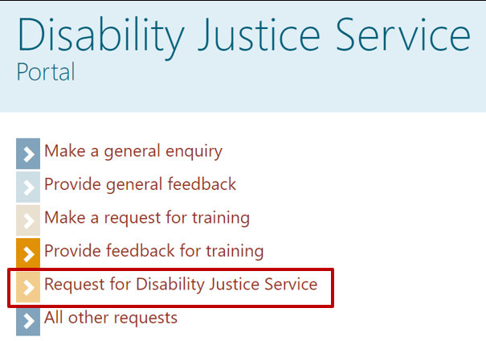
You will be asked to complete the client’s general details.  At least one phone number must be provided.  An accurate File Number is important as it allows the request to be matched with a person record. The Justice Coordinator will provide you with the File Number.  *NDIS Participant Number is not a required field. However, if a number is entered it must be the correct format – i.e. ten digits, generally beginning with a zero. | 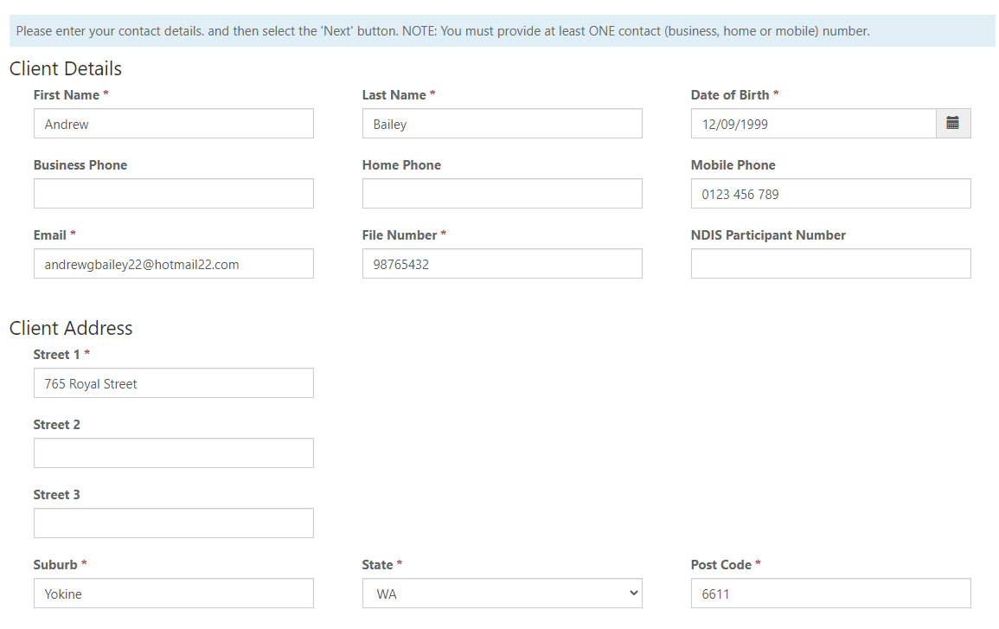
At least one Family Member/Care Giver or Guardian details must be entered.  Enter the code displayed and click Next.  Details of Languages, Communication needs and cultural background can be provided. | 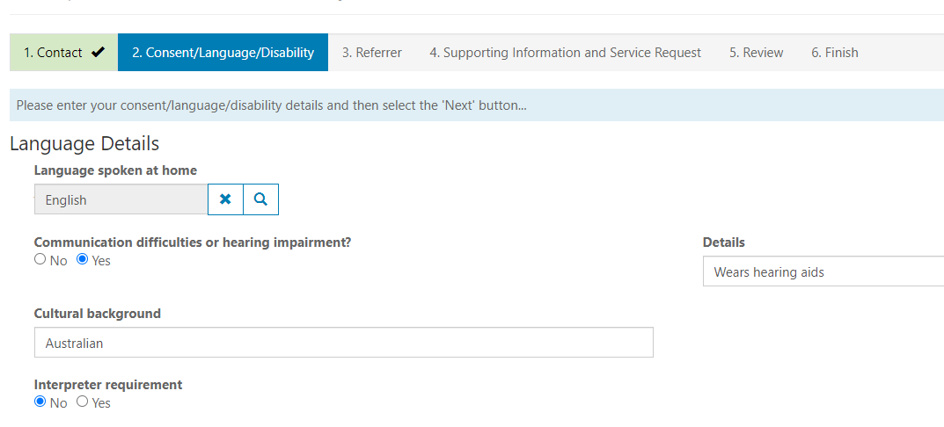  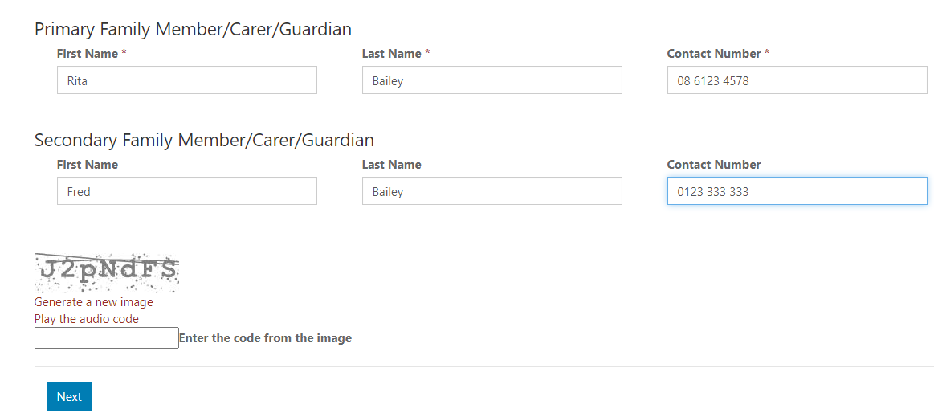
Details of Consent given are provided.  Only one option is required to be a ‘Yes’ – others should be marked as ‘No’. Consent Details must also be added. | 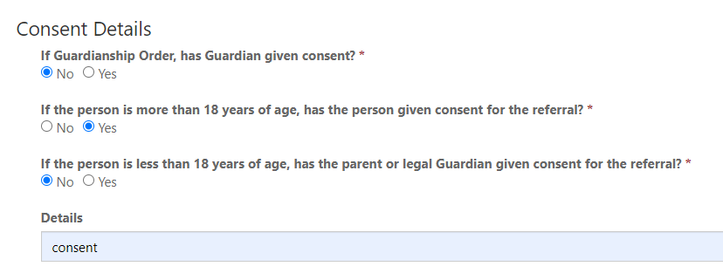
Nature of Disability outlined including details of any other disability the individual has.

Click Next at the bottom of the page.
Details of the person submitting the referral must be supplied. | 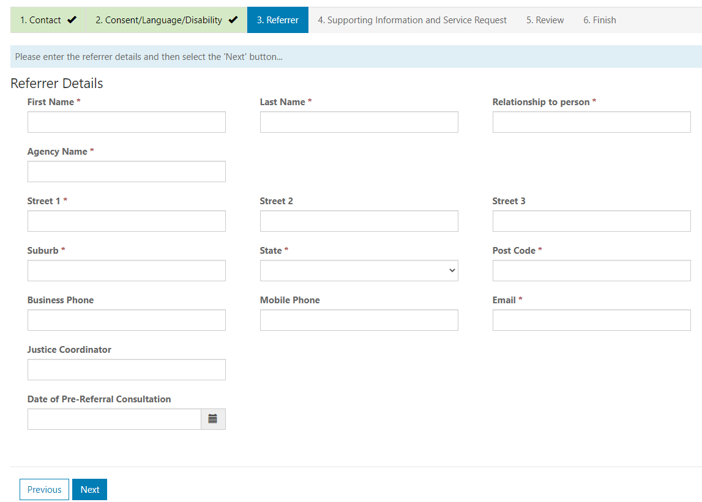

You will then be prompted to provide as much detail as you can in the following fields:
- Background - e.g. family situation, trauma details, substance use
- Description of Behaviour - e.g. what does it look like, where does it happen, how often, with whom, and severity
- Individual’s current interface with the justice system – e.g. any interface with WA Police, Department of Justice, Court appearances occurred/upcoming, description of charges, any conditions the person is subject to (e.g. bail, orders in place).
- Strengths for the client and the client system - e.g. social skills, level of independence, family support
- What has been tried before during the previous 12 months? - Provide details such as: By Whom? When? Outcome?
- Is the behaviour likely to result in serious harm to self, staff or others? - If yes, please describe
- What processes are in place to manage these issues? - e.g. reporting /safeguarding /development of safety plans.
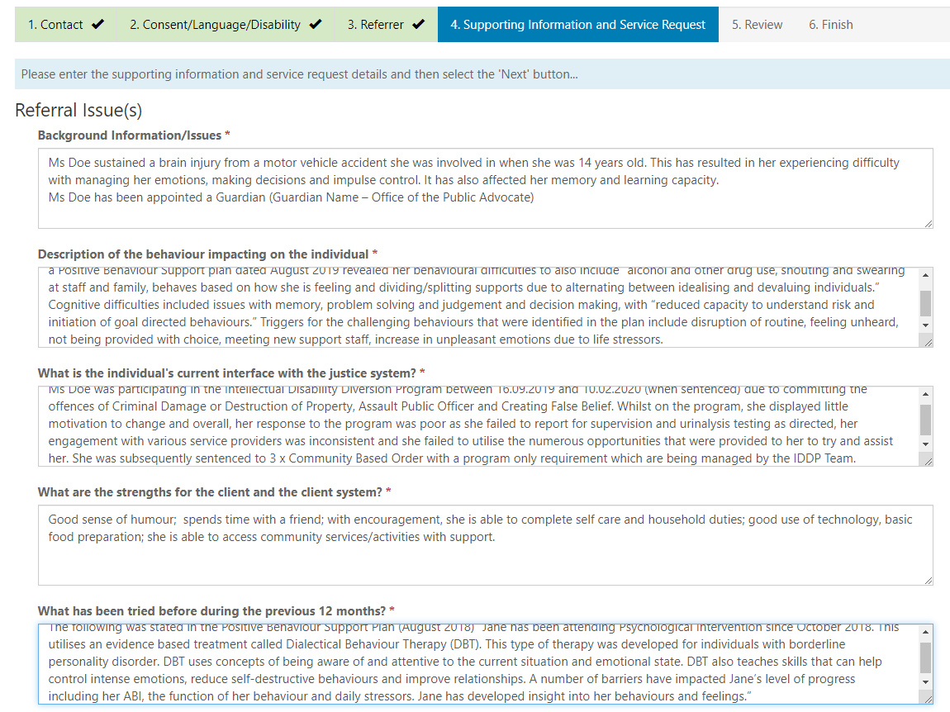

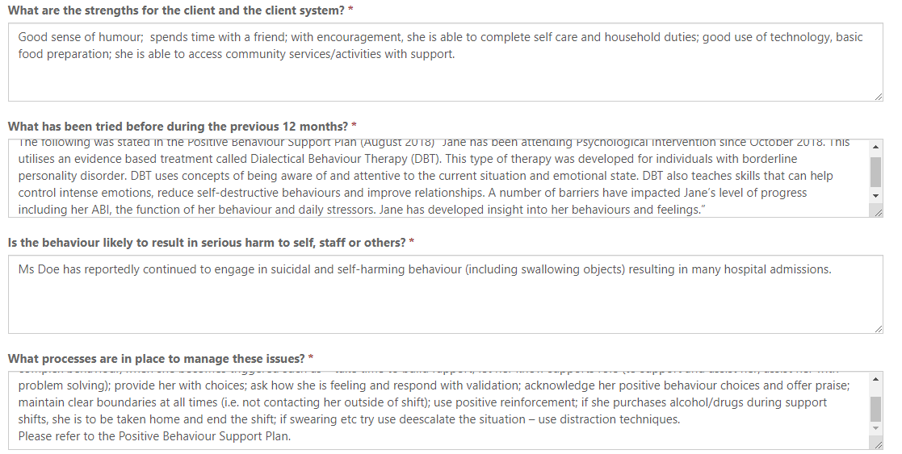
The Current Services Involved should be indicated. | 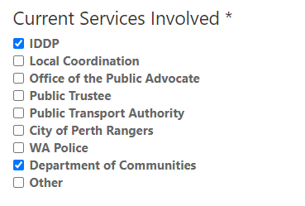
Additional details should be provided that relate to:
- Where does the person live?
- Is the person/family/support system consenting to the referral and likely to have the capacity to implement intervention strategies effectively with support?
- Service Request – outline the types of assistance and support being sought for the individual.
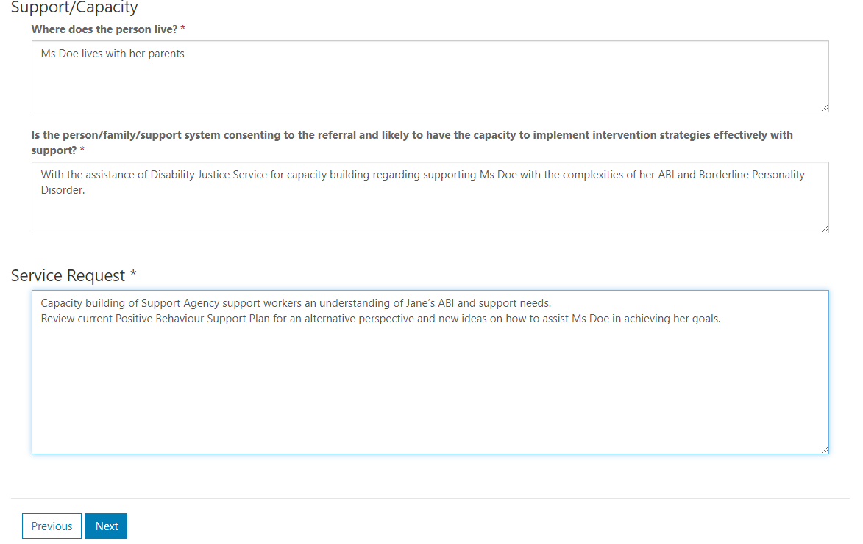
After clicking Next, you will be asked to review the details that you have entered. | 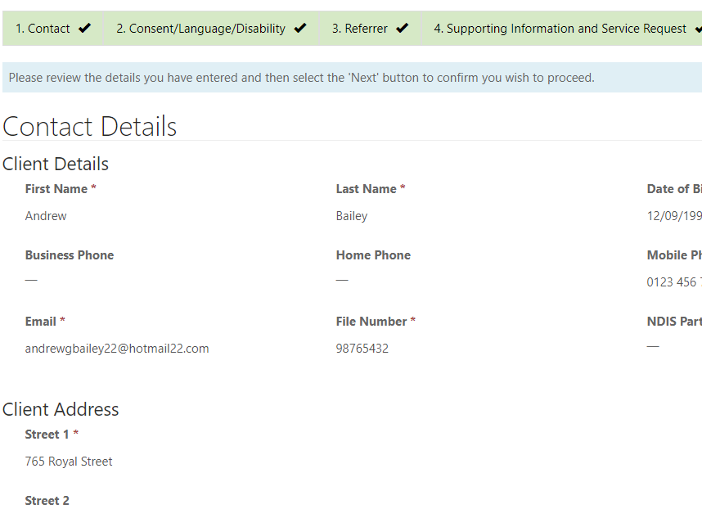
If you need to change anything, you can click on Previous at the bottom of the screen.
If you are happy with what you have entered, click Next at the bottom of the screen.
A receipt number will be provided for the request. | 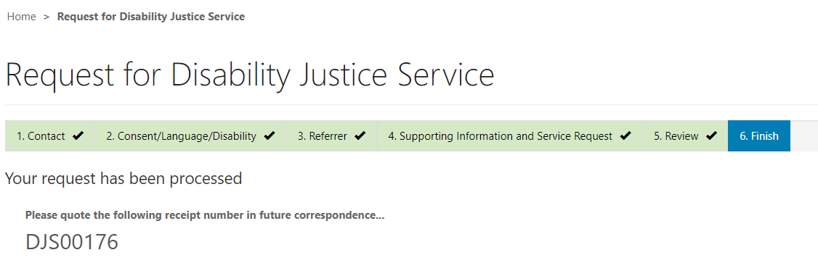

Training Requests
Requests for training can be submitted via the External Portal. When these requests are created and submitted, they will be accessible within JIMS for allocation and action.
Submit Training Requests
Requests for Training can be submitted via the Disability Justice Service Portal |  | 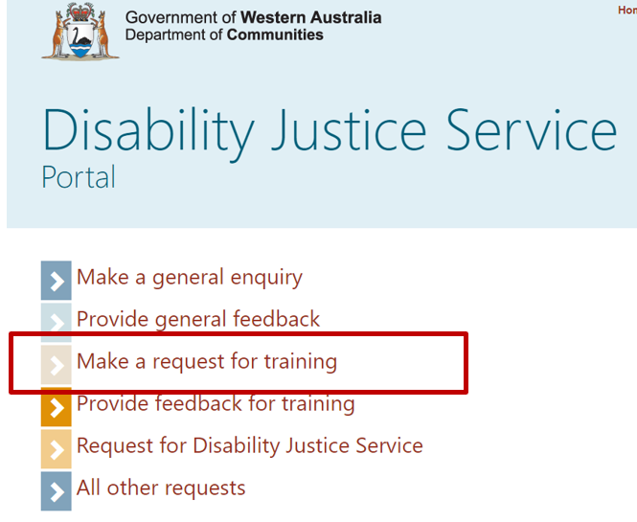
You will be asked to enter your details. | 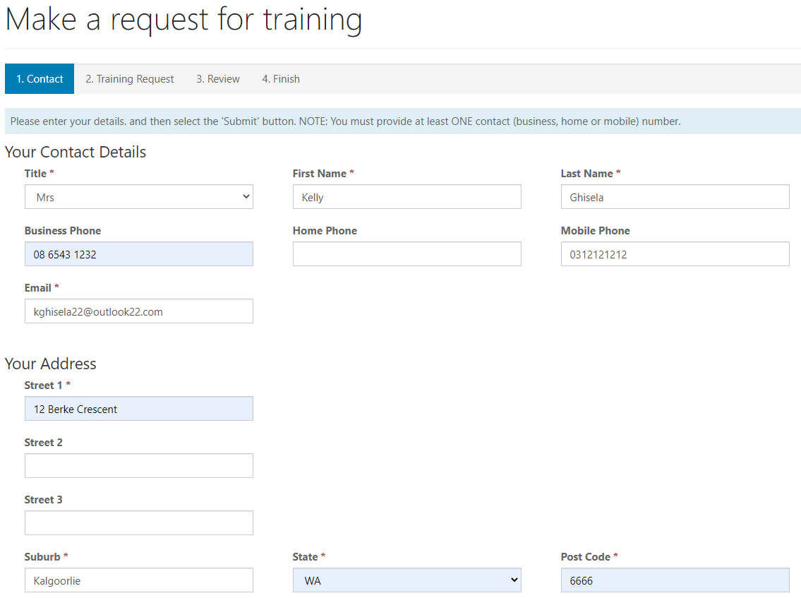
Please indicate your role or membership details and some brief details about your training request.  You will need to enter the code before clicking Next. | 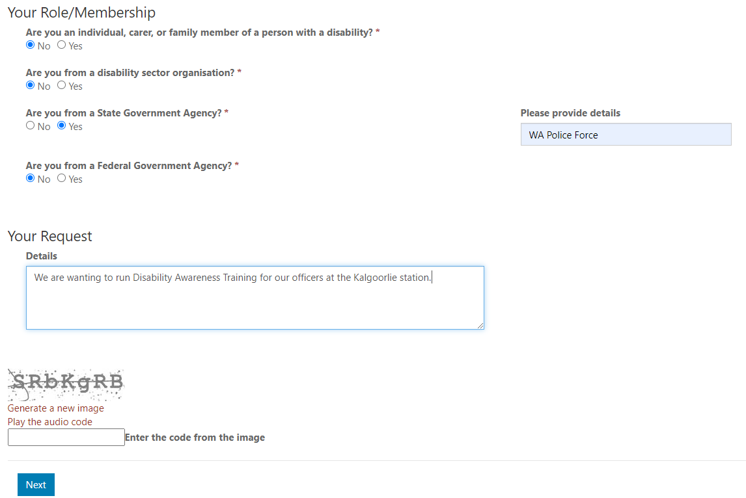
Please enter the details of the training you are requesting. | 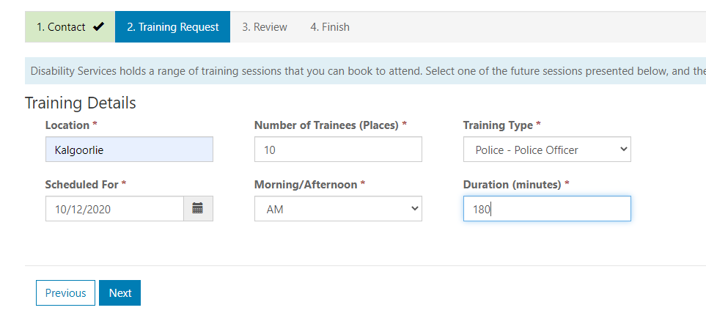
You will then be asked to review the information you have entered.  If you need to change anything, please click on the Previous button on the bottom of the page.  If no changes are needed, click Next. | 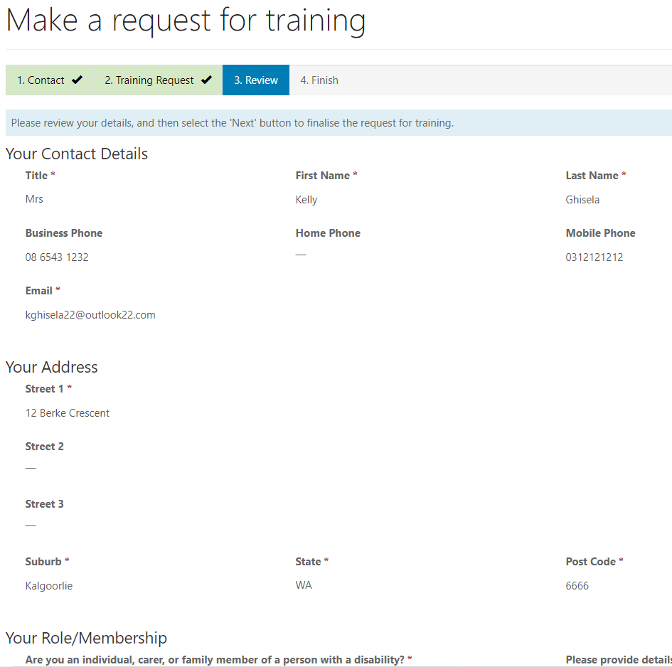
Upon submission of the training request, you will receive a receipt number. | 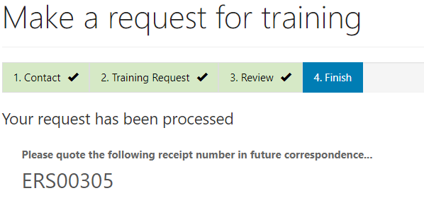

Training Feedback
Feedback on training conducted by Disability Justice Service can be submitted by attendees via the Disability Justice Service Portal.
Training Feedback Submission
Feedback regarding the Training your agency received can be made by participants via the Disability Justice Service Portal | 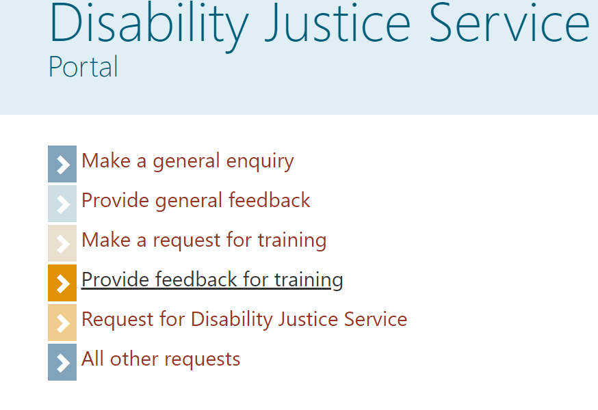
You will be asked to select the Training Event you received. | 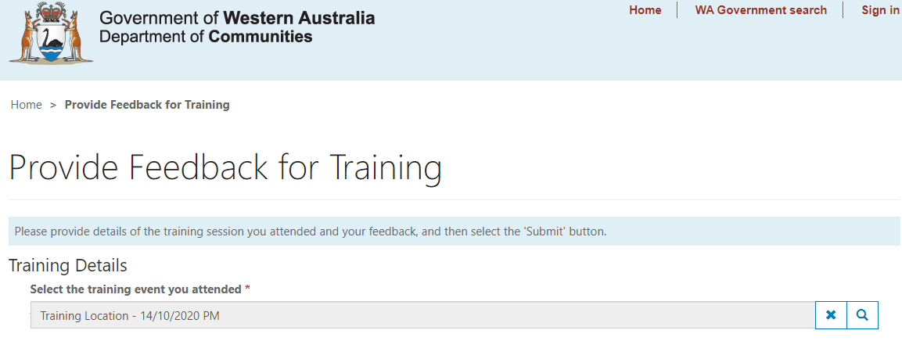
Your feedback can be provided. You can add further comments next. | 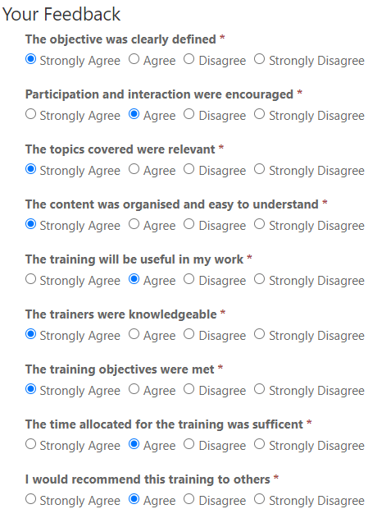
You will then be asked to provide comments.  Before submitting you feedback, you will be asked to enter the code displayed.  Click Submit. | 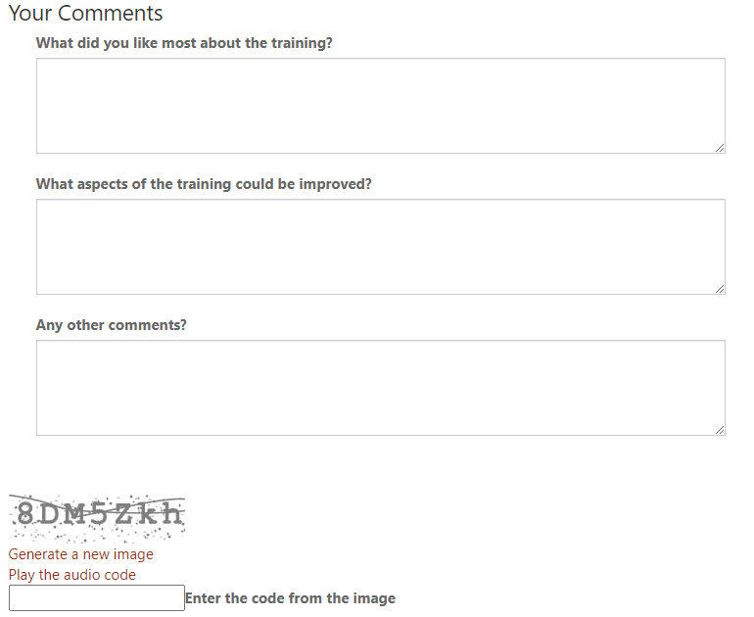
Upon submitted the feedback, you will receive a receipt number. | 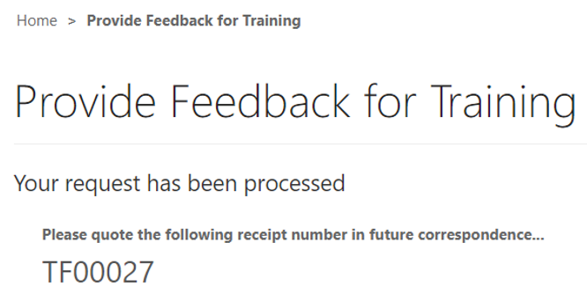

General Enquiry / General Feedback / All Other Requests
General Enquiries, General Feedback and All Other Requests can be submitted via the Disability Justice Service Portal.
Submit General Enquiries, Feedback and other Requests
These requests can be made by the Disability Justice Service Portal. |  | 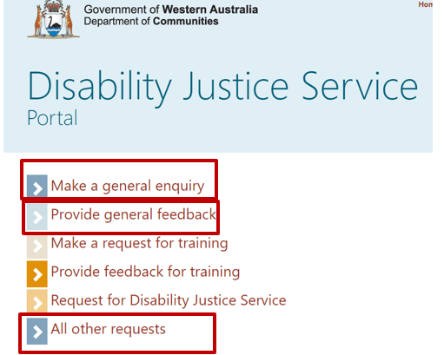
The form that is provided for all three of these types of submissions is made up of the same components:  - Contact Details for the person making the submission. | 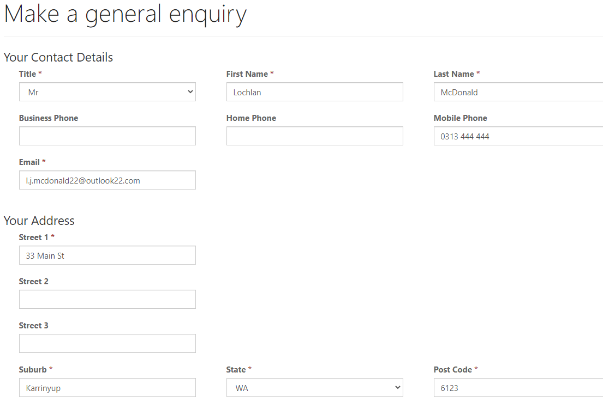
- Details about your role and specific Feedback or Request details.  You will then be asked to input the code and before you can click Next. | 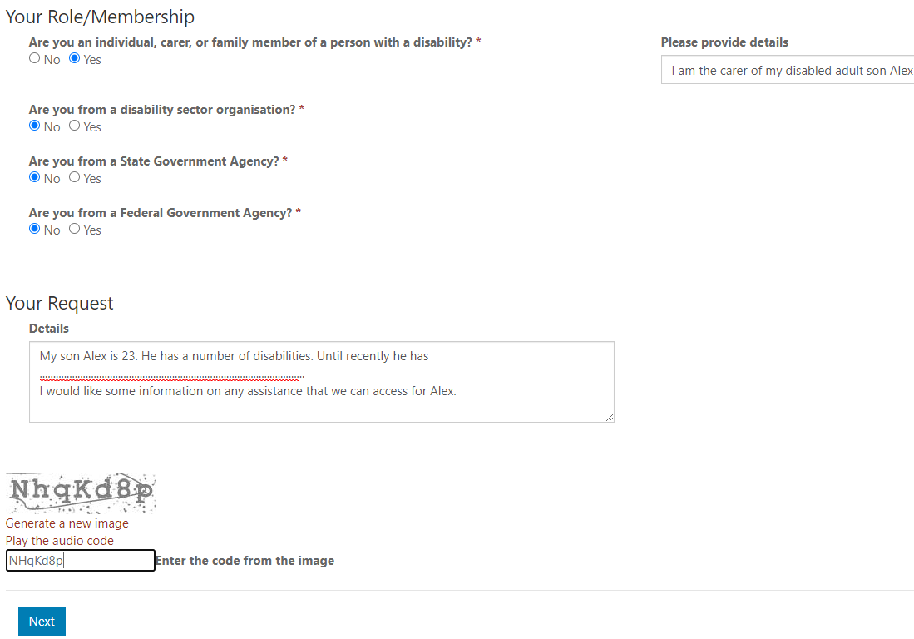
Upon submitting, you will receive a receipt number for future reference. | 