Table of contents

Executive summary (optional)
1: Proposal details
2: Environmental considerations
2.1: Native vegetation – modification and clearing
2.2: Revegetation/ Landscape plans
3: Bushfire assessment results
3.1: Assessment inputs
3.2: Assessment outputs
4: Identification of bushfire hazard issues
5. Assessment against the bushfire protection criteria
5.1: Compliance table
5.2: Additional management strategies
6: Responsibilities for implementation and management of the bushfire measures

List of figures
Figure 1: Copy of planning proposal
Figure 2: Location plan
Figure 3: Map of bushfire prone areas for the subject site
Figure 4: Vegetation classification map
Figure 5: BAL contour map
Figure 5: Spatial representation of the bushfire management strategies

List of Appendices

Full content detail
Coversheet
- Insert a Bushfire Management Plan (BMP) coversheet at the front of the BMP. This is available online at www.planning.wa.gov.au under Bushfire planning reform>Bushfire planning publications (Forms).
- Complete all relevant details on the coversheet.

Cover page – Content determined by report author.

Document control
Client: Insert client name
Report version | Purpose | Author/reviewer and accreditation details | Date submitted

Disclaimer

Executive summary (optional)
- This section is optional, but can be useful in providing a short summary of the following information, particularly for more complex planning proposals:
  - overview of the planning proposal
  - results of bushfire assessment
  - bushfire management strategies that will be incorporated into the development design in order to demonstrate compliance with bushfire protection criteria
  - key implementation and management responsibilities going forward.

Section 1: Proposal details

Do not: paraphrase or repeat sections of State Planning Policy 3.7 or the Guidelines for Planning in Bushfire Prone Areas

Do not include: details on climate, bushfire history, prevailing winds
- Explain the planning proposal and resulting intensification of land use.
- Acknowledge any known reports or plans prepared for previous planning stages that refer to the subject area and may or will impact the assessment of bushfire risk and/or the implementation of bushfire risk management measures, and will be referenced in the BMP (e.g. structure plan, environmental report, landscaping plan or any relevant bushfire risk assessments).

FIGURE 1: Copy of planning proposal
Include a copy of the subdivision, structure plan or strategic planning proposal.

FIGURE 2: Location plan
Include a map that depicts a spatial overview of existing site conditions such as cadastral detail and an outline of the site boundary; and label any areas of significance to the BMP (e.g. existing local reserves, State forest, National park, wetlands, Bush Forever sites, etc.). The map should be overlaid on an up-to-date aerial image. The map extent should be appropriate to the size of the development and depict the full site boundary plus the broader spatial context surrounding the site. This will ensure consideration is given to the wider road network, proximity of settlements to the subject site and the broader vegetation extent.

FIGURE 3: Map of Bushfire Prone Areas for the subject site
Include a screen shot of the Map of Bushfire Prone Areas for the subject site and surrounds.

Section 2: Environmental considerations

Some bushfire prone areas have high biodiversity values. State Planning Policy 3.7 (SPP3.7) policy objective 5.4 recognises the need to consider bushfire risk management measures alongside environmental, biodiversity and conservation values.

- Identify any environmental, biodiversity or conservation values on the subject site (or adjoining, if relevant).
This information can be provided by the environmental/planning consultant or alternatively, obtained through publicly available databases (SLIP database www.data.wa.gov.au or WA map database http//nationalmap.gov.au) and/or a local government’s local biodiversity strategy or local planning strategy). If any of these values exist, an environmental or planning consultant will be required to undertake necessary environmental reports, and the BMP will need to respond to this report. This may trigger potential environmental impact/referral requirements under State and Federal environmental legislation.
Relevant datasets include:
- Department of Biodiversity, Conservation and Attractions (DBCA)
- Conservation category wetlands and buffer (geomorphic wetlands, then the area of interest i.e. Swan Coastal Plain DBCA-019, Augusta to Walpole DBCA-017 etc.)
- RAMSAR wetlands (DBCA-010)
- Threatened and priority flora (DBCA-036)
- Threatened Ecological Communities (DBCA-038)

- Department of Planning, Lands and Heritage
- Bush Forever areas 2000 (DOP-071)

- Department of Water and Environmental Resources (DWER)
- Clearing regulations – Environmentally Sensitive Areas (DWER-046)
- Swan Bioplan Regionally Significant Natural Areas 2010 (DWER-070)

- Department of Primary Industries and Regional Development (DPIRD) dataset
- Conservation Covenants Western Australia (DPIRD-023) – This data needs to be requested through the DAFWA Geographic Information Services team, and requires permission from the Commissioner for Soil and Land before they can be supplied.

Sub-section 2.1: Native vegetation – modification and clearing
- Identify whether onsite clearing of native vegetation is required.
- Generally, if the subject site does not contain those values mentioned above and is not identified in a local planning strategy or local biodiversity strategy, clearing requirements will be in accordance with the Environmental Protection (Clearing of Native Vegetation) Regulations 2004.
- Confirmation should be included from the relevant agencies that the proposed clearing is acceptable.

- Identify alternative bushfire management design solutions that may reduce the extent of vegetation clearing. These include:
- reduction of lot yield;
- clustering of buildings in one area to contain development and reduce clearing requirements;
- construction of the building to a higher standard as per BCA and AS3959; and/or
- modification to the development location.

Sub-section 2.2: Revegetation/landscape plans
- Identify those areas required or intended to be revegetated or retained as part of the proposal.
- These may include riparian zones and wetland or foreshore buffers, as well as areas of public open space.

- Provide written evidence and/or an approved landscape plan to demonstrate that agencies responsible for the ongoing management (i.e. local government and/or Department of Biodiversity, Conservation and Attractions) understand and support the vegetation classification assigned to the subject area.

Section 3: Bushfire assessment results

- For most subdivision applications and structure plans where lot layout is known, a BAL Contour Map is required, in accordance with Appendix 2 of the Guidelines.
- For small subdivision proposals (2–3 lots); or where building envelopes have been identified, a BAL assessment may be more appropriate to this level of detail.

Sub-section 3.1: Assessment inputs

- Provide results of a site assessment in accordance with Appendix 3 of the Guidelines.

- Insert site photos to support the vegetation classification.

Photo ID  Plot number  Vegetation classification or exclusion clause  Description / justification for classification | Insert photo

Vegetation area/plot | Applied vegetation classification | Effective slope under the classified vegetation  (degrees)
1
2

FIGURE 4: Vegetation classification map
Include a vegetation class and effective slope map as per Appendix 3 of the Guidelines.

- Present any additional site data for BAL determination using Method 2
- Present verification of all variables used in Method 2 BAL determination calculations
- If a performance based modification to any inputs required for Method 2 BAL determination has been used, present the justification to the extent that it clearly demonstrates the author understands the methodology being used and a decision-maker/advisor is able to verify the outcome.

Sub-section 3.2: Assessment outputs

- Undertake a BAL Contour in accordance with Appendix 3 of the Guidelines.

- Provide a results table showing:
- the results of the site assessment
    - the separation distances assessed as being achievable and that apply to each indicative BAL presented
- whether Method 1 or Method 2 has been applied in the calculation of each BAL rating.

Method 1 or 2 BAL determination
Lot | Applied vegetation classification | Effective slope under the classified vegetation  (degrees) | Separation distance to the classified vegetation  (metres) | Highest BAL contour | Modified BAL contour
1
2

FIGURE 5: BAL contour map
Include a BAL contour map in accordance with Appendix 3 of the Guidelines.

Section 4: Identification of bushfire hazard issues

- Identify any bushfire hazard issues identified through examination of the environmental considerations and the bushfire risk assessment. This will assist in the understanding of whether the proposal is likely to be able to comply with the Bushfire Protection Criteria.

Section 5: Assessment against the Bushfire Protection Criteria
Sub-section 5.1: Compliance table

- For each of the elements listed within Appendix 4 of these Guidelines, the ‘intent’ must be demonstrated by either addressing the relevant acceptable solutions; or where these acceptable solutions cannot be fully met, performance based solutions can be developed to achieve the ‘intent’.

- Acceptable solutions should be provided within a table (example provided below) and not duplicated in the body of the BMP.
Acceptable solutions
Present justification statements/discussion for the proposal’s compliance or non-compliance with the relevant acceptable solutions.
In every case include all elements and their acceptable solutions but mark as N/A, where appropriate.
Performance based solutions
Explanation and evidence based justification of how the performance based solution achieves the intent of the element. This must be presented to the extent that it clearly demonstrates the author understands the methodology being used to create the performance based solution, and a decision-maker/advisor is able to verify the outcome.

Bushfire protection criteria | Method of compliance | Proposed bushfire management strategies
 | Acceptable solutions
Element 1: Location | A1.1 Development location | Summarise the strategies proposed to meet compliance with this solution/ stage when they will be addressed
Element 2: Siting and design | A2.1 Asset Protection Zone
Element 3: Vehicular access | A3.1 Two access routes.
 | A3.2 Public road
 | A3.3 Cul-de-sac (including a dead-end-road)
 | A3.4 Battle-axe
 | A3.5 Private driveway longer than 50 metres
 | A3.6 Emergency access way
 | A3.7 Fire service access routes/ perimeter roads
 | A3.8 Firebreak width
Element 4: Water | A4.1 Reticulated areas
 | A4.2 Non-reticulated areas
 | A4.3 Individual lots within non-reticulated areas

Subsection 5.2: Additional management strategies

- Discuss any additional bushfire management strategies that may be useful in guiding future planning and development stages, such as:
- consideration of any potential Vulnerable or High risk land uses and the necessary requirements under SPP3.7 and the Guidelines that may apply to future planning applications
- consideration of landscape planning in Public open space areas and consistency between bushfire management, landscaping objectives and environmental objectives
- any specific requirements of the local government’s annual firebreak notice
- preparation of BMPs to accompany future planning applications.
FIGURE 6: Spatial representation of the bushfire management strategies (where relevant)
Example Figure 6 provided on following page

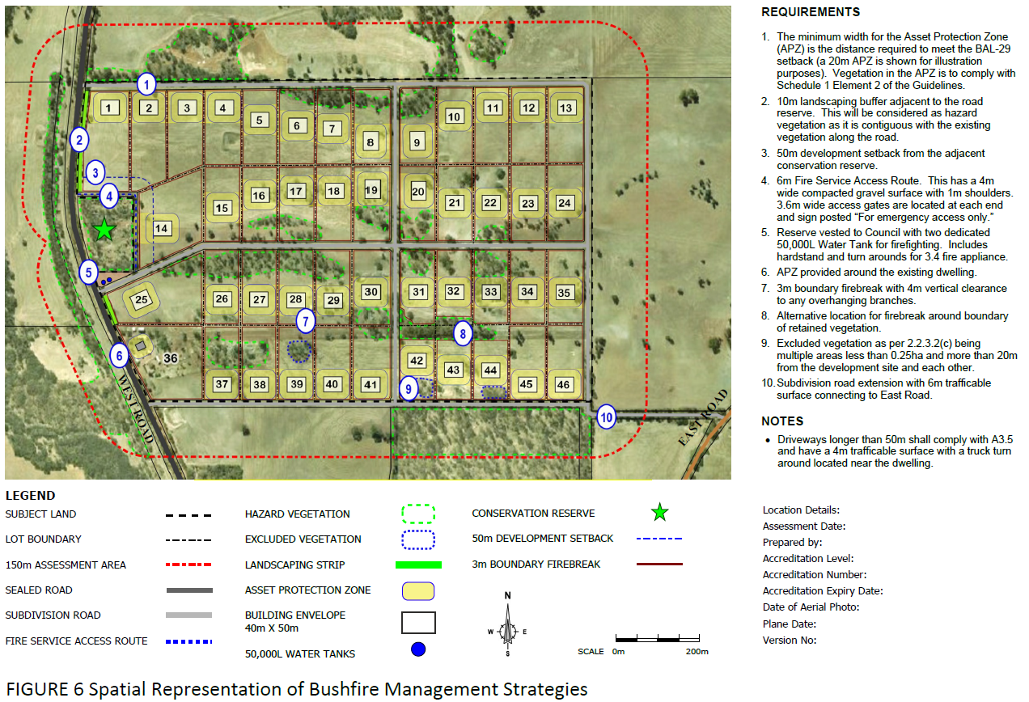

Section 6: Responsibilities for implementation and management of the bushfire measures

This section should set out the responsibilities of the developer/s, landowner/s and local government for the initial implementation and ongoing maintenance of the required actions. Actions will be different depending on the stage of the planning process.
- The requirements are to be set out in a table/s and provide the following:
- the required initial and ongoing actions and any associated works that need to be undertaken
- provision for those proposals that will be staged
- responsibilities – separately identified and assigned to the developer/s, landowner and local government, as applicable
- for each responsible entity, the actions are to be assigned a number
- the required timing of the actions.

For subdivision applications, the following table should be included to assist the local government in providing a subdivision ‘clearance’ to certify that all relevant conditions of the subdivision approval have been satisfactorily undertaken. The local government should determine which, if any, of these bushfire mitigation strategies they wish to certify and which (if any) they wish the planning practitioner to certify. Some may require certification by both practitioner and local government. Through completion of the necessary implementation actions, the bushfire planning practitioner is certifying the BAL ratings (derived from the BAL assessment) are correct.
(Following is a format example with content to be deleted or added as applicable, to the specific proposal.)
DEVELOPER – PRIOR TO ISSUE OF CERTIFICATE OF TITLES FOR NEW LOTS
No. | Implementation action | Local government clearance | Bushfire consultant clearance
1 | Construct the public roads and culs-de-sac to the standards stated in the BMP
2 | Install the emergency access ways and associated signs and gates to the standards stated in the BMP
3 | Identify a separate lot for the strategic water tank on the deposited plan and cede free of cost to the local government
4 | Establish the Public open space in a ‘low threat’ state as stated in the BMP
5 | Clearing and/or vegetation modification to be undertaken in accordance with the BMP

Certification by bushfire consultant
I ___________________________, certify that at the time of inspection, the BAL ratings contained within this BMP are correct; and implementation actions 1–6 have been undertaken in accordance with the BMP.

Clearance by local government is recommended.

Signature: ____________________ Date: _______________
Bushfire consultant details to be provided.

 | LANDOWNER/DEVELOPER – PRIOR TO SALE OR OCCUPANCY
 | No. |  | Implementation action
 | 1 |  | Establish the Asset Protection Zone (APZ) to the dimensions and standard stated in the BMP (this can be the responsibility of the developer or the landowner – should be determined by the local government).
 | 2 |  | Install the required 10,000 litre water supply (tank within the lot) that meets construction and vehicle access specifications.
 | LANDOWNER/OCCUPIER – ONGOING
 | No. |  | Management action
 | 1 |  | Maintain the Asset Protection Zone (APZ) to the dimensions and standard stated in the BMP and the Bushfire Lot Management Statement.
 | 2 |  | Comply with the relevant local government annual firebreak notice issued under s33 of the Bush Fires Act 1954.
 | 3 |  | Maintain vehicular access routes within the lot to the required surface condition and clearances.
 | 4 |  | Maintain the emergency water supply tank and its associated fittings and vehicular access in good working condition.
 | 5 |  | For the emergency water supply tank/s that have been installed to service multiple lots, be aware of the arrangement that is in place regarding who has the responsibility for maintaining the emergency water supply tank at or above designated capacity at all times (this may be in the form of an agreement with the local government and the local fire service. Check that this is being complied with.
LOCAL GOVERNMENT – ONGOING MANAGEMENT
No. |  | Management action
1 |  | The adjoining reserve to be managed in accordance with the written agreement, to ensure the vegetation remains as low threat vegetation, in accordance with AS3959–2009.

Appendices
- Include documentation to support the BMP and assist with demonstration of bushfire management criteria.
- Exerts from SPP3.7 and the Guidelines (or other), should not be included within the BMP and if deemed necessary, can be provided as a separate document to the landowner.

