Table of contents

Executive summary (optional)
1: Proposal details
2: Environmental considerations
2.1: Native vegetation – modification and clearing
2.2: Revegetation/ Landscape plans
3: Bushfire assessment results
3.1: Assessment inputs
3.2: Assessment outputs
4: Identification of bushfire hazard issues
5. Assessment against the bushfire protection criteria
5.1: Compliance table
5.2: Additional management strategies
6: Responsibilities for implementation and management of the bushfire measures

List of figures
Figure 1: Copy of the planning proposal
Figure 2: Map of bushfire prone areas for the subject site (if a partial designation)
Figure 3: Vegetation classification map
Figure 4: Spatial representation of the bushfire management strategies

List of appendices

Full content detail
Coversheet
- Insert a Bushfire Management Plan (BMP) coversheet at the front of the BMP. This is available online at www.planning.wa.gov.au under Bushfire planning reform>Bushfire planning publications (Forms).
- Complete all relevant details on the coversheet.

Cover page – Content determined by report author.

Document control
Client: Insert client name
Report version | Purpose | Author/reviewer and accreditation details | Date submitted

Disclaimer

Executive summary (optional)
- This section is optional, but can be useful in providing a short summary of the following information, particularly for more complex planning proposals:
- overview of the planning proposal
- results of bushfire assessment
- bushfire management strategies that will be incorporated into the development design in order to demonstrate compliance with bushfire protection criteria
- key implementation and management responsibilities going forward.

Section 1: Proposal details

Do not: paraphrase or repeat sections State Planning Policy 3.7 or the Guidelines for Planning in Bushfire Prone Areas
Do not include: details on climate, bushfire history, prevailing winds

- Explain the type of development proposed and resulting intensification of land use.
- Acknowledge any known reports or plans prepared for previous planning stages that refer to the subject area and may or will impact the assessment of bushfire risk and/or the implementation of bushfire risk management measures, and will be referenced in the BMP (e.g. structure plan, environmental report, landscaping plan or any relevant bushfire risk assessments).

FIGURE 1: The copy of the planning proposal

FIGURE 2: Screen shot of Map of Bushfire Prone Areas for the subject site (if a partial designation).

Section 2: Environmental considerations

Some bushfire prone areas also have high biodiversity values. State Planning Policy 3.7 (SPP3.7) policy objective 5.4 recognises the need to consider bushfire risk management measures alongside environmental, biodiversity and conservation values.

- Identify any environmental, biodiversity or conservation values on the subject site (or adjoining if relevant).

This information can be provided by the environmental/planning consultant or alternatively, obtained through publicly available databases (SLIP database www.data.wa.gov.au or WA map database http//nationalmap.gov.au) and/or a local government’s local biodiversity strategy or local planning strategy). If any of these values exist, an environmental or planning consultant will be required to undertake necessary environmental reports, and the BMP will need to respond to this report. This may trigger potential environmental impact/referral requirements under State and Federal environmental legislation.
Relevant datasets include:
- Department of Biodiversity, Conservation and Attractions (DBCA)
- Conservation category wetlands and buffer (geomorphic wetlands, then the area of interest i.e. Swan Coastal Plain DBCA-019, Augusta to Walpole DBCA-017 etc.)
- RAMSAR wetlands (DBCA-010)
- Threatened and priority flora (DBCA-036)
- Threatened Ecological Communities (DBCA-038)

- Department of Planning, Lands and Heritage
- Bush Forever areas 2000 (DOP-071)

- Department of Water and Environmental Resources (DWER)
- Clearing regulations – Environmentally Sensitive Areas (DWER-046)
- Swan Bioplan Regionally Significant Natural Areas 2010 (DWER-070)

- Department of Primary Industries and Regional Development (DPIRD)
- Conservation Covenants Western Australia (DPIRD-023) – This data needs to be requested through the DAFWA Geographic Information Services team, and requires permission from the Commissioner for Soil and Land before they can be supplied.

Sub-section 2.1: Native vegetation – modification and clearing
- Identify whether on-site clearing of native vegetation will be required.
- Generally if the subject site does not contain those values mentioned above and is not identified in a local planning strategy or local biodiversity strategy, clearing requirements will be in accordance with the Environmental Protection (Clearing of Native Vegetation) Regulations 2004.
- Confirmation should be included from the relevant agencies that the proposed clearing is acceptable.
- Identify alternative bushfire management design solutions that may reduce the extent of vegetation clearing. These include:
  - construction of the building to a higher standard as per BCA and AS3959; and/or
  - modification to the development location.

Sub-section 2.2: Revegetation/Landscape plans
- Identify those areas required or intended to be revegetated or retained as part of the proposal.
- These may include riparian zones and wetland or foreshore buffers.

- Provide written evidence and/or an approved landscape plan to demonstrate that agencies responsible for the ongoing management (i.e. local government and/or Department of Biodiversity, Conservation and Attractions) understand and support the vegetation classification assigned to the subject area.

Section 3: Bushfire assessment results

A BAL assessment is required, in accordance with clause 6.5 of SPP3.7.

Sub-section 3.1: Assessment inputs
- Provide results of a site assessment in accordance with Australian Standard 3959.
- Insert site photos to support the vegetation classification.
- Accredited practitioners should use the Fire Protection Association template.

Photo ID  Plot number  Vegetation classification or exclusion clause  Description/justification for classification | Insert photo

FIGURE 3: Include a vegetation class and effective slope map as per Appendix 3 of the Guidelines.

- Present any additional site data for BAL determination using Method 2.
- Present verification of all variables used in Method 2 BAL determination calculations.
- If a performance-based modification to any inputs required for Method 2 BAL determination has been used, present the justification to the extent that it clearly demonstrates the author understands the methodology being used and a decision-maker/advisor is able to verify the outcome.

Sub-section 3.2: Assessment outputs

- Undertake a BAL Assessment in accordance with Australian Standard 3959.

- Provide results in a table showing:
- the results of the site assessment
- the separation distances assessed as being achievable and that apply to each indicative BAL presented
- whether Method 1 or Method 2 has been applied in the calculation of each BAL rating.

Method 1 or 2 BAL determination
Vegetation area/plot | Applied vegetation classification | Effective slope under the classified vegetation  (degrees) | Separation distance to the classified vegetation  (metres) | Bushfire Attack Level
1
2
Determined Bushfire Attack Level

Section 4: Identification of bushfire hazard issues

- Identify any bushfire hazard issues identified through examination of the environmental considerations and the bushfire risk assessment. This will assist in the understanding of whether the proposal is likely to be able to comply with the bushfire protection criteria.
Note: It is likely this section will not be necessary for this assessment

Section 5: Assessment against the bushfire protection criteria
Sub-section 5.1: Compliance table
- For each of the elements listed within Appendix 4 of these Guidelines, the ‘intent’ must be demonstrated by either addressing the relevant acceptable solutions; or where these acceptable solutions cannot be fully met, performance-based solutions can be developed to achieve the ‘intent’.

- Acceptable solutions should be provided within a table (example provided below) and not duplicated in the body of the BMP.
Acceptable solutions:
Present justification statements/discussion for the proposal’s compliance or non-compliance with the relevant acceptable solutions. In every case, include all elements and their acceptable solutions but mark as N/A, where appropriate.
Performance based solutions
Explanation and evidence based justification of how the performance based solution achieves the intent of the element. This must be presented to the extent that it clearly demonstrates the author understands the methodology being used to create the performance based solution, and a decision-maker/advisor is able to verify the outcome.

Bushfire protection criteria | Method of compliance | Proposed bushfire management strategies
 | Acceptable solutions
Element 1: Location | A1.1 Development location | Summarise the strategies proposed to meet compliance with this solution/stage when they will be addressed
Element 2: Siting and design | A2.1 Asset Protection Zone
Element 3: Vehicular access | A3.1 Two access routes.
 | A3.2 Public road
 | A3.3 Cul-de-sac (including a dead-end-road)
 | A3.4 Battle-axe
 | A3.5 Private driveway longer than 50 metres
 | A3.6 Emergency accessway
 | A3.7 Fire service access routes (perimeter roads)
 | A3.8 Firebreak width
Element 4: Water | A4.1 Reticulated areas
 | A4.2 Non-reticulated areas
 | A4.3 Individual lots within non-reticulated areas

Sub-section 5.2: Additional management strategies

- Discuss any additional bushfire management strategies that may be useful in guiding future planning and development stages, such as:
- consideration of any potential Vulnerable or High risk land uses and the necessary requirements under SPP3.7 and the Guidelines that may apply to future planning applications
- consideration of landscape planning in Public open space areas and consistency between bushfire management, landscaping objectives and environmental objectives
- any specific requirements of the local government annual firebreak notice
- preparation of BMPs to accompany future planning applications.
The required bushfire risk management measures that must be implemented and maintained on the specific lot (which include relevant bushfire protection criteria and the firebreak notice) should be represented spatially. This will form an easy reference guide for the local government and the landowner.

FIGURE 4: Spatial representation of the bushfire management strategies

For a Development Application, provide:
- Spatial representation of the lot, identifying the:
- lot boundary, any existing buildings and the proposed building footprint
- required APZ with annotated dimensions
- position of required internal access requirements (if applicable)
- position of required onsite water supply and associated access (if applicable)
- nearest water hydrant or direction and distance to hydrant (if applicable).
- A short summary stating:
- details of location, local government, proposed building description and BAL, assessment date, bushfire consultant and signature
- the dimensions of the required APZ
- the standard to which the APZ must be maintained (this will be determined by either Element 2 – Schedule 1 of the bushfire protection criteria; or a variation imposed by the relevant local government)
- the requirement to comply with the applicable local government firebreak and fuel load notice
- construction specifications of the required internal access (i.e. private driveway)
- how the firefighting water requirements of bushfire protection criteria Element 4 will be met (including access, if applicable).

FIGURE 4 Complex Development Application
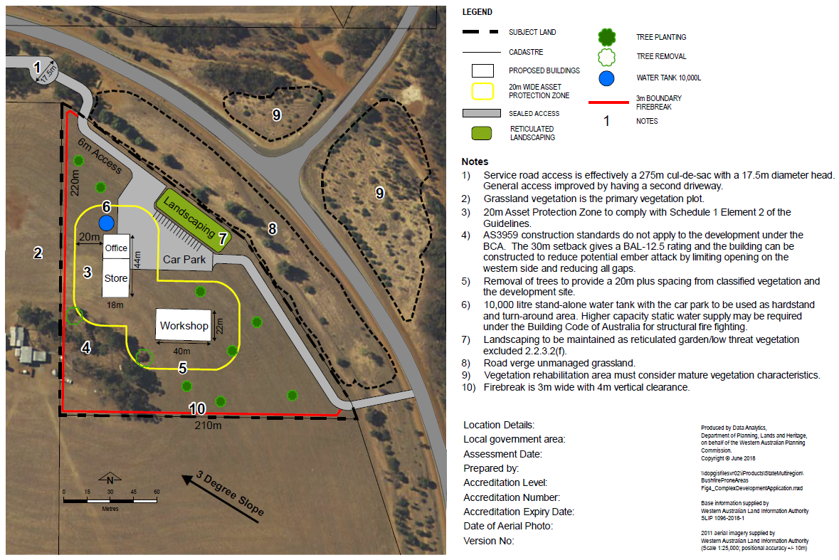

Section 6: Responsibilities for implementation and management of the bushfire measures

This section should set out the responsibilities of the developer/s, landowner/s and local government for the initial implementation and ongoing maintenance of the required actions. The requirements are to be set out in a table/s and provide the following:

- the required initial and ongoing actions and any associated works that needs to be undertaken
- responsibilities separately identified and assigned to the developer/s, landowner, local government, as applicable to the development
- for each responsible entity, the actions are to be assigned a number
- the required timing of the actions.

(Following is a format example with content to be deleted/added as applicable to the specific proposal.)

DEVELOPER/LANDOWNER – PRIOR TO SALE OR OCCUPANCY
No. | Implementation action
1 | Install the emergency access ways, fire service access routes and associated signs and gates to the standards stated in the BMP
2 | Install the private driveways and battle-axes to the standards stated in the BMP
3 | Establish the Asset Protection Zone to the dimensions and standard stated in the BMP
4 | Install the required 10,000 litre emergency water supply (tank within the lot) that meets construction and vehicle access specifications

LANDOWNER/OCCUPIER – ONGOING MANAGEMENT
No. | Management action
1 | Maintain the Asset Protection Zone to the dimensions and standard stated in the BMP
2 | Comply with the relevant local government annual firebreak notice issued under s33 of the Bush Fires Act 1954
3 | Maintain vehicular access routes within the lot to the required surface condition and clearances
4 | Maintain the emergency water supply tank and its associated fittings and vehicular access in good working condition

Appendices
- Include documentation to support the BMP and assist with demonstration of bushfire management criteria.
- Include Schedule 1: Standards for Asset Protection Zones, Appendix 4 of the Guidelines and the Fire Break Notice.
- Do not include additional information for the landowner in the appendices. It can however, be included as a standalone document, if necessary.

