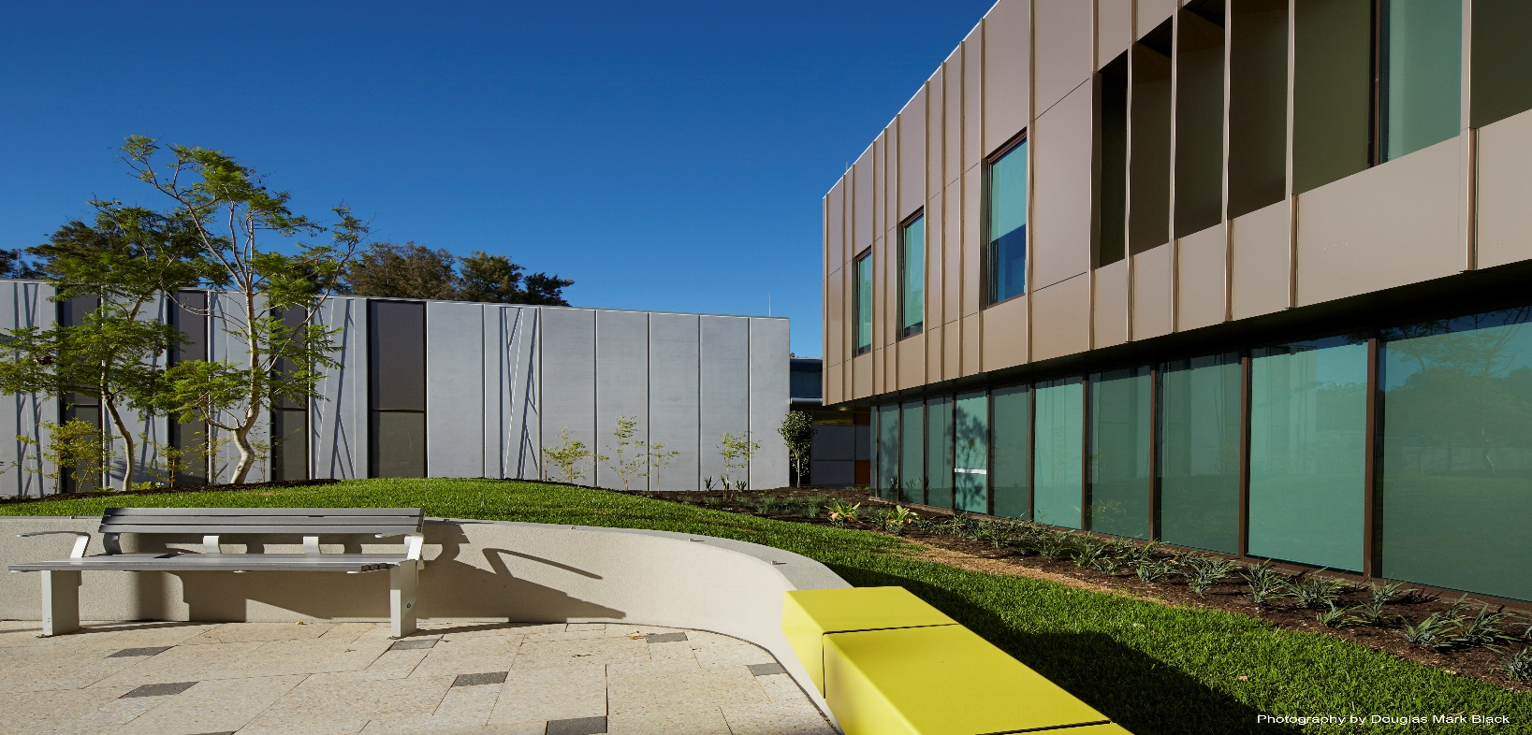

pROJECT BANK ACCOUNTS
CONTRACTOR GUIDE
This document provides a summary of the processes that contractors need to follow for Department of Finance (the Department) contracts that use a project bank account (PBA).
This guide is not legal advice and must be read in conjunction with the PBA pack included in the tender documents for the contract. If you have concerns you should obtain your own legal advice.

TABLE OF CONTENTS

1. OVERVIEW OF PROJECT BANK ACCOUNTS 3
1.1. HOW DO THEY WORK? 3

2. HOW TO CREATE THE ACCOUNT 4
2.1. WEEK ONE OF THE CONTRACT 5
2.2. WEEK TWO OF THE CONTRACT 6
2.3. WEEK THREE OF THE CONTRACT 6
2.4. WEEK FOUR OF THE CONTRACT 7
2.5. WEEK FIVE OF THE CONTRACT 8
2.6. HOW TO FACILITATE THE $1 PAYMENT 8

3. HOW MONTHLY PAYMENTS WORK 9
3.1. SUMMARY 9
3.2. THE MONTHLY PAYMENT PROCESS - IN DETAIL 10
WHERE 20 DAY PAYMENT TERMS APPLY:
- DAY 0: 10
- BY DAY 10 OF THE CLAIM 10
- BY DAY 15 OF THE CLAIM 10
- BY DAY 20 OF THE CLAIM 10

4. HOW TO MAKE PAYMENTS AT ANOTHER TIME VIA A CDI 11

5. MORE INFORMATION 12

APPENDIX 1: THE PAYMENT REPORT, PPI & STAT DEC - IN DETAIL: 13
PBA STATUTORY DECLARATION 14
THE PROGRESS PAYMENT INSTRUCTION (PPI) 14
EXAMPLE PPI: 15
COMPLETING THE PAYMENT REPORT - IN DETAIL: 16
EXAMPLE PAYMENT REPORT: 19

OVERVIEW OF PROJECT BANK ACCOUNTS
A project bank account (PBA) is a bank account that operates under a trust for a Department of Finance construction contract. Rather than monthly payments being made from the Department directly to the contractor’s regular account, monthly payments are paid into the PBA and funds are directed to the contractor’s regular account and participating subcontractors and suppliers at the same time.
PBAs are intended to:
- provide a degree of insolvency protection;
- speed up the payment process for parties lower down in the supply chain; and
- increase transparency and accountability in the payment process.
They do not affect the contractor’s contractual rights and responsibilities to subcontractors and suppliers.
This payment system applies to Department of Finance construction contracts where the tender sum is at or above $1.5 million (including GST), and the contractor will engage one or more subcontractors.
More information is available at www.finance.wa.gov.au/cms/pba.

HOW DO THEY WORK?
- The head contractor is the single trustee of the PBA.
- The Department has visibility of the PBA account but not of the contractor-subcontractor commercial relationship.
- All subcontractors that have a contract with the contractor valued at $20,000 (GST inclusive) or above, will be automatically joined to the PBA trust.
  - If a subcontract reaches this value through variations the subcontractor will be automatically joined to the PBA. All payments from that point on must be performed through the PBA.
- Subcontractors undertaking work valued at less than $20,000 (GST inclusive) and suppliers undertaking work of any value may choose to opt-in but are not required to do so.
- All retentions held for subcontractors and suppliers joined to the PBA trust are held in the PBA.
- The model only applies to first tier subcontractors, not second tier subcontractors.

Need help?
Please contact the Department’s project manager. We’d prefer you contact us with any questions so you can get it right the first time.

HOW TO CREATE THE ACCOUNT
Within 28 calendar days of being awarded the contract, you need to have completed:
Opened the account with the bank
Deed of release/priority deed poll
Trust deed poll
PBA agreement

The PBA agreement, trust deed poll, deed of release and priority deed poll are documents that you will find in an email sent to you at contract award. Keep reading for more information about these requirements.
Depending on your contract, you may receive the PBA documents via DocuSign to complete. Docusign is an online program which facilitates electronic signing of documents. PBAs going through the Docusign process will be more streamlined and automated. The Docusign Workflow is shown on the following page.

DocuSign Workflow:
# | Recipient | Tasks to complete
1 | Finance Project Manager | Enters contact details for authorised contractor & finance signatories
 |  | Reviews & confirms information entered automatically from PowerApps is correct.
 |  | PM will receive an email that gives them access to change any recipient at any time.
2 | Contractor’s contact | Is advised to follow up with company director(s) to ensure they have the bank account details and are aware to sign the documents.
3 | Contractor - Director 1 | Advised to enter bank account details & sign PBA Agreement & Trust Deed Poll
4 | Contractor - Director 2 / Company secretary | Advised to sign PBA Agreement & Trust Deed Poll  (Note: does not apply if company is run by Sole Director)
5 | Bank’s contact | Enters contact for bank attorney that will be signing PBA Agreement
6 | Bank – Attorney | Enters contact for person who will be witnessing their signature  Signs PBA Agreement
7 | Bank – Witness | Witnesses bank attorney signature
8 | Finance L9+ Executioner | Executes the PBA Agreement and Trust Deed Poll
9 | Finance Project Manager | Witnesses Finance executioner signature
10 | Contractor’s contact | Receives copy of executed documents and is advised DoF PM will contact them to organise $1 payment.
11 | FirstPoint | Receives a copy of the signed documents for their records.
It is critical you complete these steps on time to meet the requirements of the contract, so use this guide as a checklist to help you manage your time.

WHAT DOES THE ACCOUNT LOOK LIKE?
The account has two sub-accounts, one for general transactions and one for subcontractor retention deposits. This means there will be two account numbers for the one PBA.
The account cannot have an overdraft facility. All interest must be credited to a non-PBA account. Fees and charges must be debited from a non-PBA account.
There are minimal fees associated with the account the contractor will need to pay. The contractor can contact the bank for details of fees, charges and interest accrued on the account.

WEEK ONE OF THE CONTRACT
- Contact the Commonwealth Bank of Australia (the bank) immediately to open the PBA as it can take up to two weeks for the account to be created. Contact details are in the bank information pack provided within a day of contract award.
- Provide authorised signatories with a copy of the PBA agreement and trust deed poll to familiarise themselves with how the PBA will operate and help avoid delays when requesting to sign these documents.
- Contact the Department’s project manager for your contract to agree to a date when your payment claim will be submitted each month.
- Notify subcontractors of the date they’ll submit their payment claim each month. If you have multiple contracts with the Department you may want to consider staggering the dates to spread the workload.
- If your company has not had a contract with the Department in the past two years you will need to complete a supplier creation/maintenance form and provide this to the Department’s project manager within 14 days of contract award. Include details of your regular bank account, not your PBA.
If you are in the process of engaging subcontractors:
- Notify subcontractors with a contract value at $20,000 (GST inclusive) or more of the existence of the PBA trust and start updating these subcontractor contracts to cover PBA requirements. Suggested clauses are in your PBA pack.
- Notify subcontractors with a contract value under $20,000 (GST inclusive) and suppliers with a contract value of $20,000 or more (GST inclusive) of their right to opt-in to the PBA. You don’t need to notify suppliers with a contract value less than $20,000 of the PBA, although they are still able to opt-in. If these subcontractors or suppliers notify you that they want to join the PBA trust you will need to provide them with a Form of Opt-in Notice within seven calendar days. (found in the trust deed poll as Schedule 7). You must also provide a copy of all signed opt-in forms to the Department’s project manager.
There is no requirement for you to engage subcontractors earlier than normal.
The PBA page on the Finance website also contains a range of brochures on PBAs specifically targeted at Subcontractors so refer them to the link below for further information:
https://www.wa.gov.au/organisation/department-of-finance/subcontracting-government-projects

WEEK TWO OF THE CONTRACT

ARE THERE FEES?
There are minimal fees associated with the account that you will need to pay. Contact the bank for details of the fees, charges and interest accrued on the account.
- Contact any entities and financial institutions that hold a security interest over your assets to request they complete a deed of release. If they decline, request they complete a priority deed poll. Note that if the Commonwealth Bank of Australia holds a security interest over your company, they are not required to provide either of these documents.
- If required, contact the bank to arrange training to make sure you’re fully across how to operate the account. This training should take place in week three.

WEEK THREE OF THE CONTRACT
- You should receive BSBs and two account numbers (one for your general sub-account and one for your retention sub-account) from the bank. Follow up with the bank immediately if this has not occurred by the middle of the week. You need to have the account numbers in order to continue the process of finalising PBA Agreement.
- Ensure a deed of release or priority deed poll is signed by any entities that hold a security interest over your company. Follow up immediately if this has not occurred.
- Enter the two PBA account numbers and BSBs into the PBA agreement.
- Ensure the completed PBA agreement and trust deed poll are signed by authorised signatories in your company.

THE TRUST DEED POLL
This document sets out how the contractor holds money on trust for the benefit of beneficiaries (subcontractors).
This establishes the trust and who the beneficiaries of the trust are.

THE PBA AGREEMENT
Is an agreement made between the contractor, the bank, and the Minister for Works. It outlines how money will flow in and out of the account.

THE DEED OF RELEASE AND PRIORITY DEED POLL
If a creditor holds a security interest over your company, they will be required to sign a deed of release or a priority deed poll. (We’d prefer they sign a deed of release).
By signing a deed of release, a creditor agrees to release the PBA (and the money in the account) from any security interests it holds.
By signing a priority deed poll, creditors agree that beneficiaries have priority should an insolvency event occur.
- Provide the bank with the signed PBA agreement and trust deed poll. The bank will sign the PBA agreement and sight the trust deed poll. If you are processing the PBA agreement via Docusign, the bank will receive copies automatically after you have finished signing the documents.
- You should have now received tokens (electronic devices that generate a random number) from the bank which will allow you to operate the PBA. Follow up with the bank immediately if this has not occurred.

WEEK FOUR OF THE CONTRACT
- Within 28 days of contract award, you must email the Department’s project manager the:
  - completed the Trust Deed Poll (Annexure A) signed by your company;
  - completed the PBA Agreement (Annexure B) signed by your company and the bank; and
  - completed a Deed of Release or Priority Deed Poll (Annexure C) signed by any financial entities that hold a security interest over your company. If no financial entities hold a security interest over your company, email the Department’s project manager to notify them.
If you are processing the PBA agreement via Docusign, the Department’s project manager will receive copies automatically after you and the bank have finished signing the documents.
- Provide the Department of Finance project manager with viewing access to the account. Project Managers require access that enables them to drill into transactions. The bank should have taken you through this process in your training with them. If you’re already a Commonwealth Bank of Australia customer, the bank can add the viewing access once the accounts have been created.

WEEK FIVE OF THE CONTRACT
- The Department will sign the PBA agreement and the trust deed poll ASAP. The Department will provide the documents back to you then you will need to provide your subcontractors with a copy of the trust deed poll.
- Within 10 business days of the trust deed poll being signed by the Department, you will need to make sure the account is ‘established’. This means that the bank is fully satisfied with the documents and customer details you’ve provided, and that the accounts have been set up as a trust account and can be used for payments. As part of this process you will need to facilitate a payment of $1 through the PBA.

HOW TO FACILITATE THE $1 PAYMENT
The $1 payment serves to create the trust. It also has the effect of testing that the payment system functions correctly before the Department makes the first payment.
- You will need to log into your PBA in Commbiz (the online banking system) and make a payment instruction for $1 to be transferred from your general PBA sub-account to your non-PBA account. The transfer needs to occur 5 calendar days after you create the instruction (the bank should have already provided you with training on how to do this) on a working day.
- Provide a PDF copy of the instruction to the Department’s project manager as soon as it is authorised and scheduled. Feel free to provide the Department’s project manager with a draft so we can make sure the document is correct before you authorise and schedule it. There’s no need for a statutory declaration or payment report to be provided with this instruction.
- The Department will pay $1 into your general PBA sub-account and then according to your instruction, the bank will pay this $1 to your non-PBA account. Notify the Department’s project manager once you receive this $1.
Assuming your other contractual obligations are met, you can now submit your first payment claim.

HOW DOES THE ACCOUNT OPERATE?
The account balance of the general sub-account is kept at $0.
The Department will make monthly payments into the general PBA sub-account, and the contractor will instruct the bank to disburse the payment to its subcontractors’ accounts, the retention PBA sub-account which holds the subcontractors’ retention, and the contractor’s regular account.
Payment from the Department will go into the general PBA sub-account and the entire amount will flow out of the sub-account around half an hour later.

HOW MONTHLY PAYMENTS WORK

SUMMARY
- Just like the standard AS 2124 process, you will submit a payment claim, and depending on the payment timeframes specified for your contract, the Superintendent’s Representative will have a set number of days to provide a payment certificate.
- If your payment is subject to 20 Day payment terms under the contract, then the SR will need to issue a payment certificate within 10 calendar days;
- If your payment is subject to 28 Day payment terms under the contract, then the SR will need to issue a payment certificate within 14 calendar days.
- Within 5 calendar days of the SR issuing the payment certificate, you will need to create an instruction through the bank as to how the money will be disbursed to you and subcontractors. This is called a progress payment instruction (PPI) which, together with the payment report and statutory declaration, forms the PBA specific documentation you need will to submit to us by within this timeframe.
- Provided the documents you’ve submitted are correct and timely, then the Department will make payment into the PBA on the scheduled payment date, and the funds deposited to your account will be disbursed to you and your subcontractors according to your instruction. Any retention you’re holding over your subcontractors enters the retention PBA sub-account.
Use this guide as a checklist to help manage your time.

WHAT ABOUT SUPPLIERS?
You’re required to notify suppliers with a contract value of $20,000 or more (GST inclusive) that they can opt to join the PBA trust.
There’s an opt-in notice in your PBA pack that you need to provide to your supplier within seven calendar days of them expressing a wish to be joined to the trust. Once the supplier signs an opt-in notice you will need to provide a copy to us as soon as possible.

HOW ARE SUBCONTRACTORS $20K OR MORE JOINED?
Any subcontractor that has a contract valued at $20,000 (GST inclusive) or more will be automatically joined to the trust. This happens through the operation of the PBA trust deed poll.
If a contract value is increased through variations, the subcontractor will become joined once the value reaches $20,000 (GST inclusive). Payments made prior to a subcontractor becoming a beneficiary to the PBA trust must not be made through the PBA.
Joined subcontractors must be paid solely through the PBA, and they cannot opt out of the PBA.

THE MONTHLY PAYMENT PROCESS - IN DETAIL
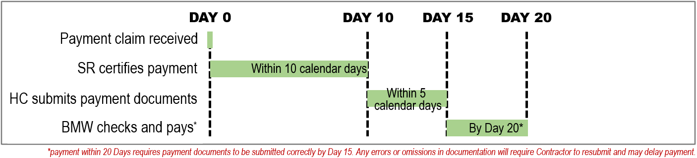
This section is for 20-day payment terms. If your contract is on 28-day payment terms, please contact your Department Project Manager for a process guideline for 28-day payments.

DAY 0:
- Submit your payment claim to the Superintendent’s Representative on the day you agreed. The way that you claim each monthly payment is no different from a standard AS 2124 process.

BY DAY 10 OF THE CLAIM
- The Superintendent’s Representative will provide a payment certificate within 14 calendar days of your payment claim, just like they would in a standard AS 2124 payment process.

BY DAY 15 OF THE CLAIM
- Within 5 calendar days of receiving the Payment Certificate (and no later than 15 calendar days from submission of the payment claim) you will need to email the Department’s project manager:
  - Progress Payment Instruction(s) (PPI);
  - Payment Report; and
  - PBA Statutory Declaration.
Make sure you read about these documents on this page and through Appendix 1 of this guide as it is critical to provide them correctly. Also remember to factor in public holidays and weekends into this time.
- Ensure the statutory declaration is dated and signed on the same day or after the PPI(s) have been authorised and scheduled. If possible, prepare the statutory declaration last.
- On the same day you create your PPIs, inform your subcontractors of how much they will be paid.
Note: While the Department will perform a general check of these documents, it is the Contractor’s responsibility to ensure they are correct. Any errors or mistakes identified will require the Contractor resubmit the PBA documents and may lead to delays in payment within 20 days.

BY DAY 20 OF THE CLAIM
- The Department will make payment by the 20th calendar day from the date of your payment claim. Should the payment date fall on a weekend, be affected by any Western Australian public holiday, or if there is a specific requirement for earlier payment, discuss and agree an alternative payment date with the Department’s Project Manager.

HOW TO MAKE PAYMENTS AT ANOTHER TIME VIA A CDI
You can make payments to subcontractors at any time⁽¹⁾ throughout each month. This is referred to as a Contractor Deposit Instruction (CDI). To perform this you will provide an instruction to the bank to disburse an amount from the general PBA sub-account to the subcontractor’s account and the retention PBA sub-account, and then deposit that amount into the general PBA sub-account.
⁽¹⁾ CDIs cannot be made on the day before, day of, or day after that a PPI is scheduled to occur.
Check that:
- Retention amounts are listed individually and refer to the subcontractor’s ABN.
- Make sure that the payment instruction doesn’t have a processing date two days before, or the day before the Department is due to pay you.
- If you make a payment to a subcontractor on a day other than when we pay you, you will need to notify us in your next payment report. Make sure to note the date the CDI was made in the ‘Description’ column.

WHAT HAPPENS TO THE SUBCONTRACTOR RETENTION MONEY?
If retention is being held over subcontractors, the balance of the retention PBA sub-account will increase throughout the contract.
When you decide to release the retention, you will create an instruction (Retention Release Instruction) to the bank for the money to be paid ⁽²⁾ from the Retention PBA sub-account directly to the Subcontractor.
You must provide a copy of this instruction to the Project Manager.
⁽²⁾ payment is from the Retention PBA sub-account directly to the Subcontractor’s account, without going through the General PBA sub-account).

MORE INFORMATION

WHAT DOES ‘ESTABLISHING’ AND ‘OPENING’ THE ACCOUNT MEAN?
‘Opened’ means the account numbers are available and the contractor can pay money into the account. It doesn’t mean that money can leave the account.
‘Established’ means the bank has received all the required paperwork and is fully satisfied with the customer details. At this point the contractor can pay money out of the account.

HOW DO I DEAL WITH LIFT SUPPLIERS?
If a lift supplier is supplying a lift and also undertaking work or services (such as installation), they are classified as a subcontractor. If the contractor needs to pay a lift supplier before the Department makes the first payment, the contractor will need to provide the bank with an instruction to pay to the lift supplier then deposit that amount of money into the PBA general sub-account. Refer to ‘How to payments are made at another time via a CDI’ on the previous page for more information.

CAN I MAKE SUBCONTRACTORS WITH CONTRACTS UNDER $20,000 AND SUPPLIERS JOIN THE PBA TRUST?
It’s entirely up to these subcontractors to decide whether they are paid through the PBA. These two groups can’t be paid through the PBA without completing an opt-in notice.

WHAT IF THE CONTRACTOR NEEDS TO PAY SUBCONTRACTORS MORE THAN THE AMOUNT THE DEPARTMENT IS PAYING THIS MONTH, OR IN TOTAL?
The contractor will need to pay any subcontractors the difference through a CDI. The payment will need to go through the PBA and be made no less than two days before the Department is due to pay the contractor.
The contractor will need to submit an instruction to the bank to have the funds paid out, then deposit that amount into the general PBA sub-account. Refer to ‘How to make payments at another time’ on the previous page for more information.

CAN ONE PBA BE USED FOR MULTIPLE CONTRACTS?
No. Each PBA is specific to one contract.

WHAT HAPPENS TO THE PBA AFTER THE CONTRACT IS COMPLETE?
The contractor can close the Project Bank Account for a contract once:
- the Final Certificate has been issued and the last payment has been made has been;
- all retention money has been paid out of the account and all subcontracts paid in full;
- the General and Retention sub-accounts both have a balance of $0.

CAN I MAKE PAYMENTS TO UNJOINED SUBCONTRACTORS OR SUPPLIERS THROUGH THE PBA?
Unjoined subcontractors and suppliers cannot be paid through the PBA, as the contract requires payments made through the PBA to be allocated to the contractor or joined subcontractors/suppliers only.

APPENDIX 1: THE PAYMENT REPORT, PPI & STAT DEC - IN DETAIL:

THE PAYMENT REPORT
The payment report provides a running tally of payments and explains why an amount that was certified to be paid to a trade is not reflected in the PPIs. It is to be provided to the Department in excel format, who will then review this document alongside your PPIs to check that the allocation of funds is accepted.
Ensure to fill out the ‘Description’ column to include any information into this document that will help explain the payment breakdown including:
- Reason (to the extent it is lawfully able to do so) for any dispute and/or any rights set off;
- Reason that a subcontractor has failed to claim;
- The date that a CDI was made through the PBA; and
- Any other relevant information.
Check the following:
- The contract and company details, payment certificate date and report date have been filled out;
- Check that the all Subcontractor details (legal name, ABN, BSB, account no etc.) have been listed.
- Check that the total payment shown matches exactly the Payment Certificate amount.
- Confirm that all the PBA Subcontractors are listed, and the amounts being paid to each are correct:
  - the payment amounts for each subcontractor must match the amounts shown in the PPI(s);
  - if any expected payments to subcontractors have not been made or are in dispute a reason must be provided in the Description column.
- Ensure the ‘Description’ column has been filled out to include any information to explain the payment breakdown including:
- reasons (to the extent you are lawfully able to do so) for disputes⁽¹⁾ and rights set off;
- the date that CDIs⁽²⁾ were made through the PBA; and
- any other relevant information.
- All CDI⁽²⁾ payments that were made since the last report must be listed.
- If payments have been paid out of the Retention PBA sub-account you must also submit copies of these instructions.

⁽¹⁾ The $ amounts disputed must also be included (these are often incorrectly omitted).
⁽²⁾ CDIs (Contractor Deposit Instructions) allow the contractor to pay at any time of the month except on the day prior, day of, or day after the scheduled PPI date. To perform a CDI the Contractor deposits money into the PBA and disburses it to subcontractors & to the retention sub-account as required.

PBA STATUTORY DECLARATION
The Statutory Declaration must not be declared or dated before the PPIs and the payment report are provided. It must also correctly reference the date that the PPI was authorised. Once you complete the declaration email a copy to the Project Manager (there is no requirement to provide the original nor to provide a copy to the Superintendent’s Representative).
Remember that if you submit an incorrect PPI or payment report, they will need to be resubmitted together with a new Statutory Declaration (as the old one will no longer be valid).

THE PROGRESS PAYMENT INSTRUCTION (PPI)
A PPI instructs the bank how disbursements will be made. You’ll create the PPI in the bank’s online banking system in ABA file format, then provide us with a PDF copy. It’s likely your accounting team will be familiar with this system. The bank can also provide your company with training on how to create a PPI.
There are two ways you can provide this instruction (select the option suitable for your system):
- a single consolidated PPI which covers all disbursements, or
- up to three PPIs:
  - one for your payment to yourself
  - one for your payments to subcontractors and
  - one for subcontractor retention payments.
Check the following:
- The total amount of the PPIs must equal exactly the amount certified for the month.
- The processing date is within:
20 calendar days from the date of the claim if subject to 20 day payment terms; If the processing date is affected by a weekend or WA public holiday, or if there is a requirement for earlier payment, discuss an earlier processing date with the Department’s Project Manager.
- The PPI must be authorised and scheduled before it is provided to the Department.
- The money must be instructed to come out of the contract’s General PBA sub-account.
- Retention amounts must be directed to the retention PBA sub-account, listed individually and accompanied by the ABN for each subcontractor. Retention payments must be inclusive of GST at the time they are paid into the PBA Retention account.
An example of a consolidated PPI is on the next page.

EXAMPLE PPI:
This is what a PDF of a consolidated PPI looks like:
All PPIs must be authorised & scheduled before they are provided to us.
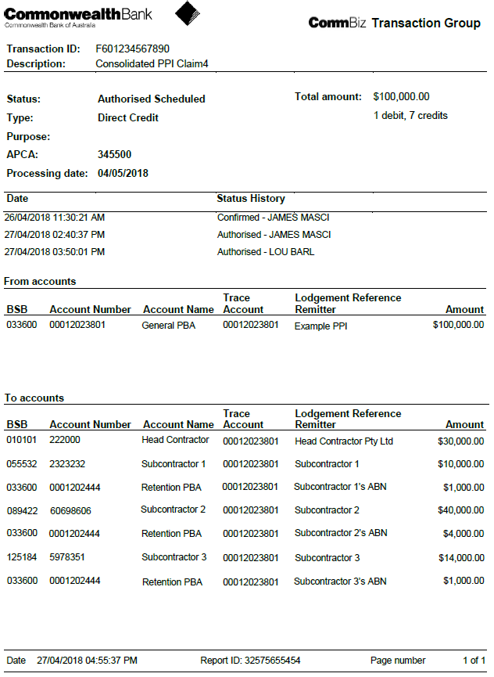
The processing date must be as per the payment terms of the contract (typically no later than 20 calendar days from the date the payment claim was lodged)
The Trace Account must be the general PBA for this contract.
Each retention amount must be listed individually and include GST.
Retention amounts must be directed to the retention PBA sub-account and include the ABN of the subcontractor under the ‘Lodgement Reference Remitter’
The money must be instructed to come out of your general PBA sub-account.

All PPIs must total the exact amount that is certified to be paid to you that month.

COMPLETING THE PAYMENT REPORT - IN DETAIL:
- Enter the relevant process dates
Date of payment claim: | Enter the date you submitted the payment claim (DAY 0)
Date of payment certificate: | Enter the date the SR issued the payment certificate
Date of this report: | Enter the date you’re issuing the payment report
Scheduled payment date: | Enter the scheduled payment date (listed on the PPI as Processing Date)

- Enter Subcontractor details
Subcontractor name  (list all engaged PBA subcontractors) | List the legal entities of all Subcontractors joined to the PBA on the contract (and not just the ones being paid this month)
ABN | Enter the ABN of the subcontractor.
BSB | Enter the Subcontractor's BSB account number that they will be paid to.
Account Number | Enter the Subcontractor's bank account number that they will be paid to.

- Enter the payment amounts for this payment cycle (as shown in the PPI):
PPI payment this cycle  ($) | Enter the amount (including GST) you are paying directly to the subcontractor in this PPI for this payment cycle.
PPI retention this cycle  ($) | Subcontractor retention amount (inc GST) allocated to the PBA retention sub-account in this PPI for this payment cycle.

- Enter any CDI payments (Contractor Deposit Instructions) made since the last report.
CDI payments this cycle  ($) | Enter the amount (including GST) that you have paid a subcontractor via a CDI since the date of the last payment report.  Provide a copy of the CDI to the Department whenever they are executed.
CDI retention this cycle  ($) | Amount (inc GST) you have disbursed to the retention sub-account this payment cycle via a CDI since the date of the last payment report.  Provide a copy of the CDI to the Department whenever they are executed.

Common mistakes:
- Not listing all joined PBA subcontractors.
- Not listing all subcontractor details (Correct legal entity, ABN, Account numbers).
- Not including GST when making a payment into the retention sub-account. (GST must be included for all payments being made in the retention sub-account).
- Not providing the date that a CDI was executed under the ‘description’ column (step 9).
- Not providing a copy of the CDI to the Department for records.
- Enter the total payments made from the General PBA sub-account to the Subcontractor accounts to date including in the PPI for the current payment cycle.
Total subcontractor payments to Date inc this PPI ($) | Total Payments made to the subcontractor's account to date through the General PBA sub-account, including the amount being paid in this PPI.  *note: do not include retention payments nor retention released in this calculation.

Common mistakes:
- Not including the amount scheduled to be paid in the current PPI.
- Including retention payments made into the retention sub-account.
- Including released to the Subcontractor.

- Enter the total retention currently held in the Retention sub-account for the subcontractor, and the total retention released from the Retention sub-account to date.
Current retention sub-account balance inc this PPI ($) | This must match the total retention for the subcontractor currently held in the retention PBA sub-account.
Total retention released to Subcontractor to date  ($) | Total retention released to the Subcontractor from the Retention PBA sub-account to date.
Total retention paid to head contractor for liabilities to date ($) | Total retention released from the retention PBA sub-account to the head contractor due to subcontractor liabilities or other cause.  A Description must be provided (step 8).

Common mistakes:
- Not emailing a copy of the Retention Release Instruction to the Project Manager when retention is released from the retention sub-account.
- Not providing details as to why retention has been paid to the head contractor from the PBA sub-account (to be included in the Description/Comments column).

- Confirm that the Cumulative Retention calculated matches your records.
Cumulative Retention paid into the PBA to date  (J + K + L) | Cumulative total retention (including any amounts already released) that has been paid into the PBA sub-account to date for the subcontractor over the course of the contract.  *note: this field is automatically calculated.

Common mistakes:
- Manually amending this amount (if it doesn’t match then check that the retention amounts have been entered correctly in step 5).

- Note any Subcontractors have failed to claim this cycle, and if there have been any disputes or Rights set off.
Failed to claim this cycle? (Y/N) | If a subcontractor has failed to claim but was entitled to do so (where work undertaken is being paid this month) input "Yes"; otherwise leave blank.
Disputes / Rights set off  ($) | Any amounts that the head contractor and subcontractor are in dispute over.  Any amounts of any rights set off by the head contractor.

- Provide relevant descriptions / comments (DO NOT SKIP THIS STEP).
Description / Comments  (Describe any payment anomalies, outstanding payments, status of issues & disputes, etc) | Items you will need to provide a description for:  - Date that a CDI was paid  - Rights of set off (to the extent you are lawfully able to do so, describe the reasons for the exercise of the set-off rights).  - If the head contractor has reduced a subcontractor claim.  - Disputes (both new or ongoing disputes. Provide a description of the matter that is in dispute).  - Resolution of a previous dispute.  - Why any retention was released to the head contractor due to liabilities.  - Any Subcontractor liquidations, insolvencies, administration etc.  - Any other information, issue, or comment relevant to this payment.

Common mistakes:
- Not providing the date that a CDI was made.
- Not providing a description of the outcome/resolution of a previous dispute.
- Not providing/withholding information relating to disputes and issues.
  - Note: The Contractor is required to provide this information as part of their reporting requirements. Failure to provide this information is evident if a complaint or issue relating to subcontractor payments arises but nothing is recorded in the payment report history. This would also indicate that the Contractor may not be meeting their contract requirements.

EXAMPLE PAYMENT REPORT:

