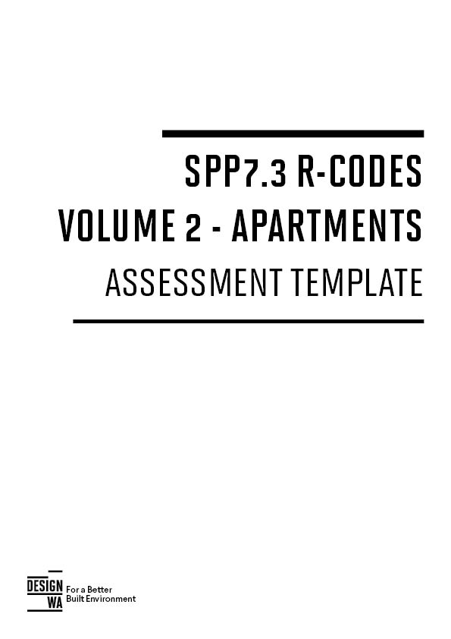
Disclaimer: This assessment template is not intended to replace R-Codes Volume 2. Applicants and assessors should refer to the R-Codes Volume 2 for information on the relevant provisions that are applicable to a development.

ABOUT THIS TEMPLATE
State Planning Policy 7.3 Residential Design Codes Volume 2 – Apartments (R-Codes Vol. 2) has brought about changes to the way that multiple dwellings will be designed, assessed, constructed and – ultimately – lived in.
This assessment template is based on work conducted by the Inner City Councils Planning Working Group¹, and adapted by the Department of Planning, Lands and Heritage for broader distribution.
Responsible Authorities are encouraged to adapt this template to best suit their needs. This template is designed to be used in conjunction with, not as a replacement for, the R Codes Vol. 2.

This template comprises of 2 parts:
PART 1 Recommended information to be submitted by applicant as part of a development application.
PART 2 Template for assessment under the R-Codes Vol. 2 (including any local planning framework that amends or replaces the R-Codes Vol. 2). It is recommended that this template is completed by:
(a) the applicant and submitted as part of the development application; and
(b) the Responsible Authority for the purposes of assessment.

R-Codes Vol. 2 is a performance-based policy. While addressing the Acceptable Outcomes is likely to achieve the relevant Element Objectives, they are not a deemed-to-comply pathway and the proposal will be assessed in context of the entire design solution to ensure the Element Objectives are achieved.
Assessing officers are encouraged to firstly consider the proposal under the Element Objectives, delve into details provided by the applicant (whether these be the Acceptable Outcome or alternate performance solution approach using the relevant Design Guidance) before returning to the principles outlined in the Element Objectives.
The onus is on the Applicant to demonstrate that the Element Objectives have been achieved. Responsible Authorities may consider refusal of an application on the basis that insufficient information/materials have been provided to satisfy an Element Objective to the satisfaction of the Responsible Authority. The burden of proof is not on the Responsible Authority but the applicant to demonstrate – by way of example – adequate solar access is achieved if the applicant has not provided the relevant diagrams and calculations to address this subject matter.
Please be advised that this assessment template is not intended to replace R-Codes Vol. 2 in terms of being a point of reference for both designers and assessors. Amongst other things, the source document contains Design Guidance, diagrams and example images that are not featured within this template.
¹Inner City Councils Planning Working Group – Town of Victoria Park, City of Perth, City of South Perth, City of Subiaco, City of Vincent
PART 1 - INFORMATION FOR THE APPLICANT
It is recommended that the following information is provided by the applicant when lodging a development application.
A5 – Development application guidance (1/2)
This guidance assists proponents in formulating the appropriate materials when submitting a development application. Check with the relevant local authority if there are any additional materials required.
Documentation | Required Information | Provided?
Development details | A summary document that provides the key details of the development proposal. It contains information such as the:  - plot ratio of the development  - number, mix, size and accessibility of apartments  - number of car parking spaces for use (residential, retail, accessible, visitor etc.)  - percentage of apartments meeting cross ventilation and daylight requirements.
Site analysis | [Prepared at earlier stage of design development in A3 Site analysis and design response guidance]
Design statements | An explanation of how the design relates to the Design Principles in State Planning Policy 7 .0 Design of the Built Environment.  An explanation of how the proposed development achieves the relevant objectives of this policy in A6 Objectives summary.  For adaptive reuse projects which affect heritage places, provide a Heritage Impact Statement prepared in accordance with the State Heritage Office’s Heritage Impact Statement Guide available at www.stateheritage.wa.gov.au (for state registered places) or the relevant local government guidelines (for other places).
Site plan | A scale drawing showing:  - any proposed site amalgamation or subdivision  - location of any proposed buildings or works in relation to setbacks, building envelope  controls and building separation dimensions  - proposed finished levels of land in relation to existing and proposed buildings and roads  - pedestrian and vehicular site entries and access  - interface of the ground floor plan with the public domain and open spaces within the site  - areas of communal open space and private open space  - indicative locations of planting and deep soil areas including retained or proposed significant trees.  - overshadowing over neighbouring sites  - location of adjacent solar collectors.
Landscape plan | A scale drawing showing:  - the building footprint of the proposal including pedestrian, vehicle and service access  - trees to be removed shown dotted  - trees to remain with their tree protection areas (relative to the proposed development)  - deep soil areas and associated tree planting  - areas of planting on structure and soil depth  - proposed planting including species and size  - details of public space, communal open space and private open space  - external ramps, stairs and retaining wall levels  - security features and access points  - built landscape elements (fences, pergolas, walls, planters and water features)  - ground surface treatment with indicative materials and finishes  - site lighting  - stormwater management and irrigation concept design.
Other plans and reports | Acoustic Report (or equivalent)  Waste Management Plan (or equivalent)

A5 – Development application guidance (2/2)
Documentation | Required information | Provided?
Floor plans | A scale drawing showing:  - all levels of the building including roof plan  - layout of entries, circulation areas, lifts and stairs, communal spaces, and service rooms with key dimensions and Real Level (RL) heights shown  - apartment plans with apartment numbers and areas, all fenestration, typical furniture layouts for each apartment type, room dimensions and intended use and private open space dimensions  - accessibility clearance templates for accessible units and common spaces  - visual privacy separation shown and dimensions where necessary  - vehicle and service access, circulation and parking  - storage areas.
Elevations | A scale drawing showing:  - proposed building height and RL lines  - building height control  - setbacks or envelope outline  - building length and articulation  - the detail and features of the façade and roof design  - any existing buildings on the site  - building entries (pedestrian, vehicular and service)  - profile of buildings on adjacent properties or for 50m in each direction, whichever is most appropriate.  Samples or images of proposed external materials, finishes and colours of the proposal, keyed to elevations.
Sections | A scale drawing showing:  - proposed building height and RL lines  - building height control  - setbacks or envelope outline  - adjacent buildings  - building circulation  - the relationship of the proposal to the ground plane, the street and open spaces  particularly at thresholds  - the location and treatment of car parking  - the location of deep soil and soil depth allowance for planting on structure (where applicable)  - building separation within the development and between neighbouring buildings  - ceiling heights throughout the development  - detailed sections of the proposed façades.
Building performance diagrams | A solar diagram (where required) at the winter solstice (21 June) at a minimum of hourly intervals showing:  - number of hours of solar access to the principal communal open space  - number of hours of solar access to units within the proposal and tabulation of results  - overshadowing of existing adjacent properties and overshadowing of future potential  development where neighbouring sites are planned for higher density  - elevation shadows if likely to fall on neighbouring windows, openings or solar panels. A ventilation diagram (where required) showing unobstructed path of air movements through  dual aspect apartments and tabulation of results.
Illustrative views | Photomontages or similar rendering or perspective drawings illustrating the proposal in the context of surrounding development. Note: Illustrative views need to be prepared using a perspective that relates to the human eye. Where a photomontage is prepared, it should use a photo taken by a full frame camera with a 50mm lens and 46 degree angle of view.
Models | A three dimensional computer generated model showing views of the development from adjacent  streets and buildings.  A physical model for a large or contentious development (if required by the consent authority).

PART 2 - TEMPLATE FOR ASSESSMENT UNDER THE R-CODES VOL. 2

It is recommended that the template is used as follows -
Applicants
- This document is intended to provide a structure to organise and arrange the supporting material and documentation for preparing and submitting a Development Application, with the onus being on the applicant to demonstrate that an Element Objective has been achieved.
- Applicants are encouraged to complete the ‘applicant sections’ of this document, outlining how the Element Objectives are satisfied. In many (if not most) instances it is expected that written response will be supported by associated drawings or documentation provided by the applicant ‘e.g. – refer to Overshadowing Diagrams page 25 of submission package’.
- The template can then be included in the application to the Responsible Authority.
Responsible Authority
- This document is intended to provide a structure to systematically and holistically undertake a planning assessment against the performance-based approach of R-Codes Vol. 2.
- The Responsible Authority will review the applicant’s comments provided in this template and undertake an assessment of the materials provided against the relevant Element Objectives.

Section 1.2 of R-Codes Vol. 2 provides that certain sections of the policy may be amended or replaced by local planning frameworks. Where such local planning frameworks may have effect, this template provides an additional section where the applicable requirements may be stated.
ELEMENT 2.2 | BUILDING HEIGHT
ELEMENT OBJECTIVES  Development is to achieve the following Element Objectives |  | applIcant comment | ASSESSOR COMMENT
 |  | Outline the rationale demonstrating that the proposal has met the Element Objectives, through either a performance based solution or using the Acceptable Outcomes. The Design Guidance provided in the policy may be of assistance.
O2.2.1 – The height of development responds to the desired future scale and character of the street and local area, including existing buildings that are unlikely to change.
O2.2.2 – The height of buildings within a development responds to changes in topography.
O2.2.3 – Development incorporates articulated roof design and/or roof top communal open space where appropriate.
O2.2.4 – The height of development recognises the need for daylight and solar access to adjoining and nearby residential development, communal open space and in some cases, public spaces.
ACCEPTABLE OUTCOMES
Acceptable Outcome pathway may not be applicable where a performance solution is provided
A2.2.1 – Development complies with the building height limit (storeys) set out in Table 2.1, except where modified by the local planning framework, in which case development complies with the building height limit set out in the applicable local planning instrument.
(Excerpt from table 2.1)
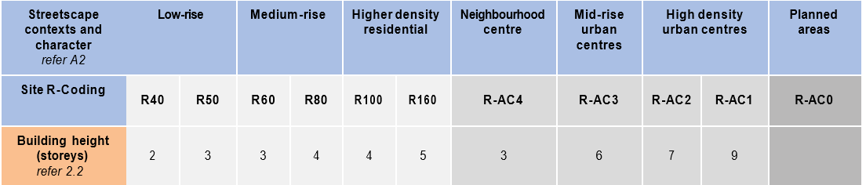
LOCAL PLANNING FRAMEWORK |  | REQUIREMENT
Does the local planning framework amend or replace the above stated controls? If yes, state the applicable requirement:

ELEMENT 2.3 | STREET SETBACKS
ELEMENT OBJECTIVES  Development is to achieve the following Element Objectives |  | applIcant comment | ASSESSOR COMMENT
 |  | Outline the rationale demonstrating that the proposal has met the Element Objectives, through either a performance based solution or using the Acceptable Outcomes. The Design Guidance provided in the policy may be of assistance.
O2.3.1 – The setback of the development from the street reinforces and/or complements the existing or proposed landscape character of the street.
O2.3.2 – The street setback provides a clear transition between the public and private realm.
O2.3.3 – The street setback assists in achieving visual privacy to apartments from the street.
O2.3.4 – The setback of the development enables passive surveillance and outlook to the street.
ACCEPTABLE OUTCOMES
Acceptable Outcome pathway may not be applicable where a performance solution is provided
A3.2.1 – Development complies with the street setback set out in Table 2.1, except where modified by the local planning framework, in which case development complies with the street setback set out in the applicable local planning instrument
(Excerpt from table 2.1)
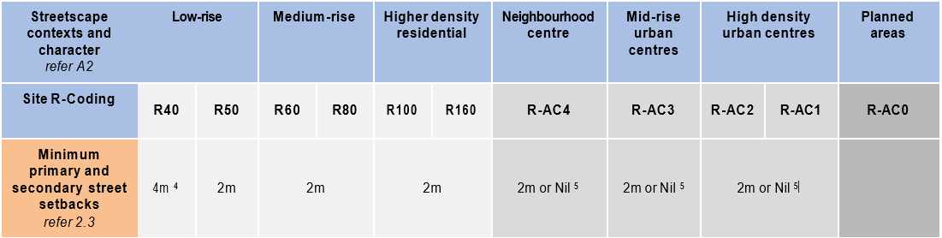

(4) Minimum secondary street setback 1.5m
(5) Nil setback applicable if commercial use at ground floor
LOCAL PLANNING FRAMEWORK |  | REQUIREMENT
Does the local planning framework amend or replace the above stated controls? If yes, state the applicable requirement:

ELEMENT 2.4 | SIDE AND REAR SETBACKS
ELEMENT OBJECTIVES  Development is to achieve the following Element Objectives |  | applIcant comment | ASSESSOR COMMENT
 |  | Outline the rationale demonstrating that the proposal has met the Element Objectives, through either a performance based solution or using the Acceptable Outcomes. The Design Guidance provided in the policy may be of assistance.
O2.4.1 – Building boundary setbacks provide for adequate separation between neighbouring properties.
O2.4.2 – Building boundary setbacks are consistent with the existing streetscape pattern or the desired streetscape character.
O2.4.3 – The setback of development from side and rear boundaries enables retention of existing trees and provision of deep soil areas that reinforce the landscape character of the area, support tree canopy and assist with stormwater management.
O2.4.4 –The setback of development from side and rear boundaries provides a transition between sites with different land uses or intensity of development.
ACCEPTABLE OUTCOMES
Acceptable Outcome pathway may not be applicable where a performance solution is provided
A2.4.1 - Development complies with the side and rear setbacks set out in Table 2.1, except where:
- modified by the local planning framework, in which case development complies with the side and rear setbacks set out in the applicable local planning instrument
AND /OR
b) a greater setback is required to address 3.5 Visual privacy.
(Excerpt from table 2.1)
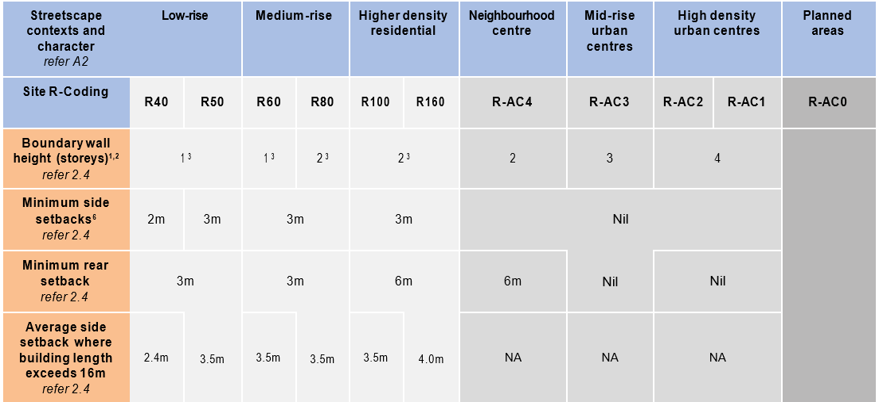
- Wall may be built up to a lot boundary, where it abuts an existing or simultaneously constructed wall of equal or greater proportions
- Where the subject site and an affected adjoining site are subject to different density codes, the length and height of any boundary wall on the boundary between them is determined by reference to the lower density code
- Boundary wall only permitted on one boundary, and shall not exceed 2/3 length.
- Boundary setbacks will also be determined by provisions for building separation and visual privacy within this SPP and building separation provisions of the NCC.
A2.4.2 – Development is setback from the boundary in order to achieve the Objectives outlined in 2.7 Building separation, 3.3 Tree canopy and deep soil areas, 3.5 Visual privacy and 4.1 Solar and daylight access.
LOCAL PLANNING FRAMEWORK |  | REQUIREMENT
Does the local planning framework amend or replace the above stated controls? If yes, state the applicable requirement:

ELEMENT 2.5 | PLOT RATIO
ELEMENT OBJECTIVES  Development is to achieve the following Element Objectives |  | applIcant comment | ASSESSOR COMMENT
 |  | Outline the rationale demonstrating that the proposal has met the Element Objectives, through either a performance based solution or using the Acceptable Outcomes. The Design Guidance provided in the policy may be of assistance.
O2.5.1 – The overall bulk and scale of development is appropriate for the existing or planned character of the area.
ACCEPTABLE OUTCOMES
Acceptable Outcome pathway may not be applicable where a performance solution is provided
A2.5.1 – Development complies with the plot ratio requirements set out in Table 2.1, except where modified by the local planning framework, in which case development complies with the plot ratio set out in the applicable local planning instrument.
(Excerpt from table 2.1)
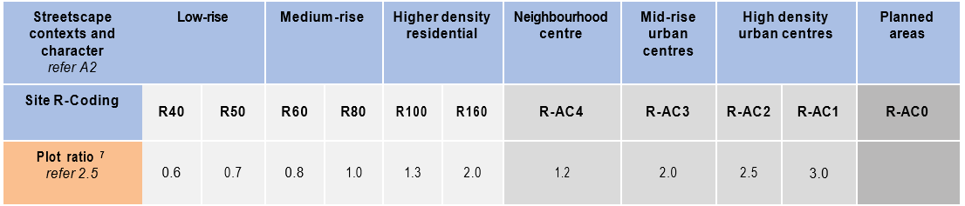
- Refer to Definitions for calculation of plot ratio
LOCAL PLANNING FRAMEWORK |  | REQUIREMENT
Does the local planning framework amend or replace the above stated controls? If yes, state the applicable requirement:

ELEMENT 2.6 | BUILDING DEPTH
ELEMENT OBJECTIVES  Development is to achieve the following Element Objectives |  | applIcant comment | ASSESSOR COMMENT
 |  | Outline the rationale demonstrating that the proposal has met the Element Objectives, through either a performance based solution or using the Acceptable Outcomes. The Design Guidance provided in the policy may be of assistance.
O2.6.1 – Building depth supports apartment layouts that optimise daylight and solar access and natural ventilation.
O2.6.2 – Articulation of building form to allow adequate access to daylight and natural ventilation where greater building depths are proposed.
O2.6.3 – Room depths and / or ceiling heights optimise daylight and solar access and natural ventilation.
ACCEPTABLE OUTCOMES
Acceptable Outcome pathway may not be applicable where a performance solution is provided
A2.6.1 – Developments that comprise single aspect apartments on each side of a central circulation corridor shall have a maximum building depth of 20m. All other proposals will be assessed on their merits with particular consideration to 4.1 Solar and daylight access and 4.2 Natural ventilation.
LOCAL PLANNING FRAMEWORK |  | REQUIREMENT
Does the local planning framework amend or replace the above stated controls? If yes, state the applicable requirement:

ELEMENT 2.7 | BUILDING SEPARATION
ELEMENT OBJECTIVES  Development is to achieve the following Element Objectives |  | applIcant comment | ASSESSOR COMMENT
 |  | Outline the rationale demonstrating that the proposal has met the Element Objectives, through either a performance based solution or using the Acceptable Outcomes. The Design Guidance provided in the policy may be of assistance.
O2.7.1 – New development supports the desired future streetscape character with spaces between buildings.
O2.7.2 – Building separation is in proportion to building height.
O2.7.3 – Buildings are separated sufficiently to provide for residential amenity including visual and acoustic privacy, natural ventilation, sunlight and daylight access and outlook.
O2.7.4 – Suitable areas are provided for communal and private open space, deep soil areas and landscaping between buildings
ACCEPTABLE OUTCOMES
Acceptable Outcome pathway may not be applicable where a performance solution is provided
A2.7.1 – Development complies with the separation requirements set out in Table 2.7.
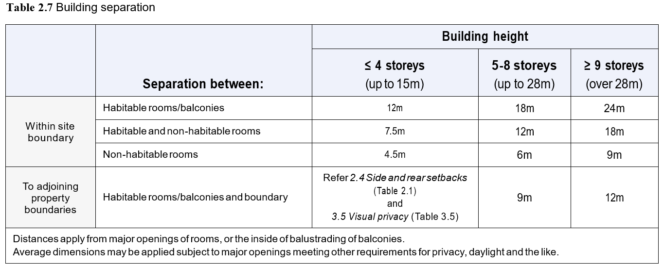
LOCAL PLANNING FRAMEWORK |  | REQUIREMENT
Does the local planning framework amend or replace the above stated controls? If yes, state the applicable requirement:

ELEMENT 3.2 | ORIENTATION
ELEMENT OBJECTIVES  Development is to achieve the following Element Objectives |  | applIcant comment | ASSESSOR COMMENT
 |  | Outline the rationale demonstrating that the proposal has met the Element Objectives, through either a performance based solution or using the Acceptable Outcomes. The Design Guidance provided in the policy may be of assistance.
O3.2.1 – Building layouts respond to the streetscape, topography and site attributes while optimising solar and daylight access within the development.
O3.2.2 – Building form and orientation minimises overshadowing of the habitable rooms, open space and solar collectors of neighbouring properties during mid-winter.
ACCEPTABLE OUTCOMES
Acceptable Outcome pathway may not be applicable where a performance solution is provided
A3.2.1 – Buildings on street or public realm frontages are oriented to face the public realm and incorporate direct access from the street.
A3.2.2 – Buildings that do not have frontages to streets or public realm are oriented to maximise northern solar access to living areas.
A3.2.3 – Development in climate zones 4, 5 and 6 shall be designed such that the shadow cast at midday on 21st June onto any adjoining property does not exceed:
  - adjoining properties coded R25 and lower – 25% of the site area¹
  - adjoining properties coded R30 – R40 - 35% of the site area¹
  - adjoining properties coded R50 – R60 – 50% of the site area¹
  - adjoining properties coded R80 or higher – Nil requirements.
(1) Where a development site shares its southern boundary with a lot, and that lot is bound to the north by other lot(s), the limit of shading at A3.2.3 shall be reduced proportionally to the percentage of the affected properties northern boundary that abuts the development site. (Refer to Figure A7.2 in Appendix 7)
A3.2.4– Where adjoining sites are coded R40 or less, buildings are oriented to maintain 4 hours per day solar access on 21 June for existing solar collectors on neighbouring sites.
LOCAL PLANNING FRAMEWORK |  | REQUIREMENT
Does the local planning framework amend or replace the above stated controls? If yes, state the applicable requirement:

ELEMENT 3.3 | TREE CANOPY AND DEEP SOIL AREAS
ELEMENT OBJECTIVES  Development is to achieve the following Element Objectives |  | applIcant comment | ASSESSOR COMMENT
 |  | Outline the rationale demonstrating that the proposal has met the Element Objectives, through either a performance based solution or using the Acceptable Outcomes. The Design Guidance provided in the policy may be of assistance.
O3.3.1 – Site planning maximises retention of existing healthy and appropriate and protects the viability of adjoining trees.
O3.3.2 – Adequate measures are taken to improve tree canopy (long term) or to offset reduction of tree canopy from pre-development condition.
O3.3.3 – Development includes deep soil areas, or other infrastructure to support planting on structures, with sufficient area and volume to sustain healthy plant and tree growth.
ACCEPTABLE OUTCOMES
Acceptable Outcome pathway may not be applicable where a performance solution is provided
A3.3.1 – Retention of existing trees on the site that meet the following criteria:
- healthy specimens with ongoing viability AND
- species is not included on a State or local area weed register AND
- height of at least 4m AND/OR
- trunk diameter of at least 160mm, measured 1m from the ground AND/OR
- average canopy diameter of at least 4m.
A3.3.2 – The removal of existing trees that meet any of the criteria at A3.3.1 is supported by an arboriculture report.
A3.3.3 – The development is sited and planned to have no detrimental impacts on, and to minimise canopy loss of adjoining trees.
A3.3.4 – Deep soil areas are provided in accordance with Table 3.3a. Deep soil areas are to be co-located with existing trees for retention and/or adjoining trees, or alternatively provided in a location that is conducive to tree growth and suitable for communal open space.
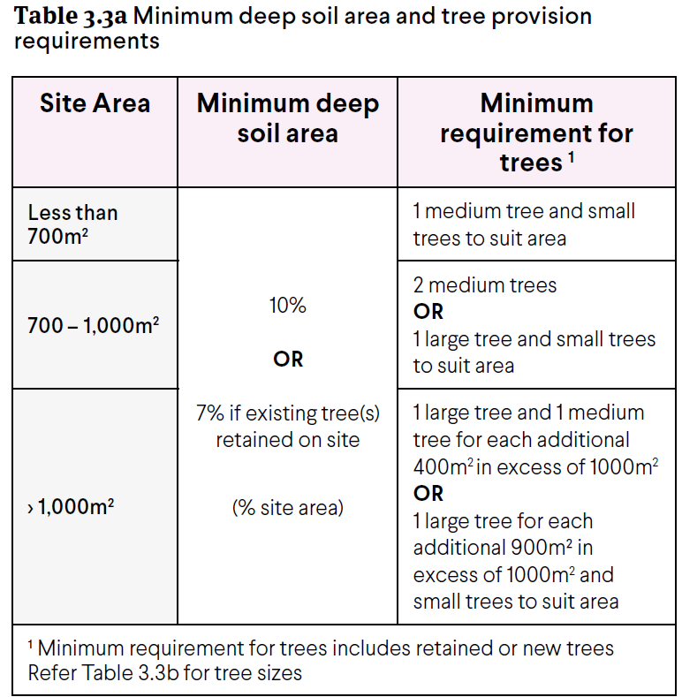
A3.3.5 – Landscaping includes existing and new trees with shade producing canopies in accordance with Tables 3.3a and 3.3b.
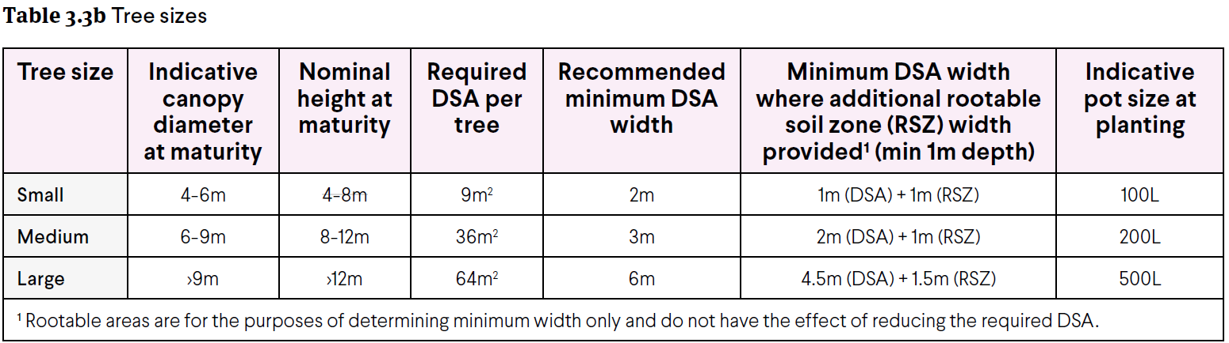
A3.3.6 – The extent of permeable paving or decking within a deep soil area does not exceed 20 per cent of its area and does not inhibit the planting and growth of trees.
A3.3.7 – Where the required deep soil areas cannot be provided due to site restrictions, planting on structure with an area equivalent to two times the shortfall in deep soil area provision is provided.
LOCAL PLANNING FRAMEWORK |  | REQUIREMENT
Does the local planning framework amend or replace the above stated controls? If yes, state the applicable requirement:

ELEMENT 3.4 | COMMUNAL OPEN SPACE
ELEMENT OBJECTIVES  Development is to achieve the following Element Objectives |  | applIcant comment | ASSESSOR COMMENT
 |  | Outline the rationale demonstrating that the proposal has met the Element Objectives, through either a performance based solution or using the Acceptable Outcomes. The Design Guidance provided in the policy may be of assistance.
O3.4.1 – Provision of quality communal open space that enhances resident amenity and provides opportunities for landscaping, tree retention and deep soil areas.
O3.4.2 – Communal open space is safe, universally accessible and provides a high level of amenity for residents.
O3.4.3 – Communal open space is designed and oriented to minimise impacts on the habitable rooms and private open space within the site and of neighbouring properties.
ACCEPTABLE OUTCOMES
Acceptable Outcome pathway may not be applicable where a performance solution is provided
A3.4.1 – Developments include communal open space in accordance with Table 3.4
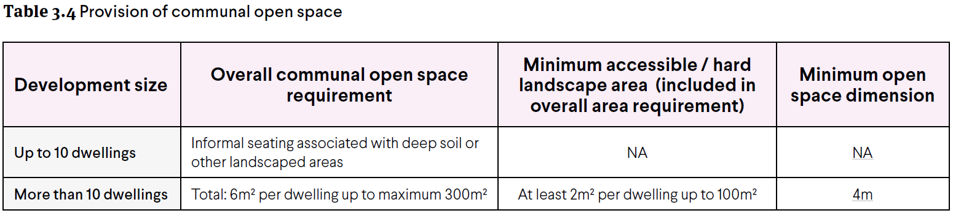
A3.4.2 – Communal open space located on the ground floor or on floors serviced by lifts must be accessible from the primary street entry of the development.
A3.4.3 – There is 50 per cent direct sunlight to at least one communal open space area for a minimum of two hours between 9am and 3pm on 21 June.
A3.4.4– Communal open space is co-located with deep soil areas and/or planting on structure areas and/ or co-indoor communal spaces.
A3.4.5 – Communal open space is separated or screened from adverse amenity impacts such as bins, vents, condenser units, noise sources and vehicle circulation areas.
A3.4.6 – Communal open space is well-lit, minimises places for concealment and is open to passive surveillance from adjoining dwellings and/or the public realm.
A3.4.7 – Communal open space is designed and oriented to minimise the impacts of noise, odour, light-spill and overlooking on the habitable rooms and private open spaces within the site and of neighbouring properties.
LOCAL PLANNING FRAMEWORK |  | REQUIREMENT
Does the local planning framework amend or replace the above stated controls? If yes, state the applicable requirement:

ELEMENT 3.5 | VISUAL PRIVACY
ELEMENT OBJECTIVES  Development is to achieve the following Element Objectives |  | applIcant comment | ASSESSOR COMMENT
 |  | Outline the rationale demonstrating that the proposal has met the Element Objectives, through either a performance based solution or using the Acceptable Outcomes. The Design Guidance provided in the policy may be of assistance.
O3.5.1 – The orientation and design of buildings, windows and balconies minimises direct overlooking of habitable rooms and private outdoor living areas within the site and of neighbouring properties, while maintaining daylight and solar access, ventilation and the external outlook of habitable rooms.
ACCEPTABLE OUTCOMES
Acceptable Outcome pathway may not be applicable where a performance solution is provided
A3.5.1 – Visual privacy setbacks to side and rear boundaries are provided in accordance with Table 3.5.
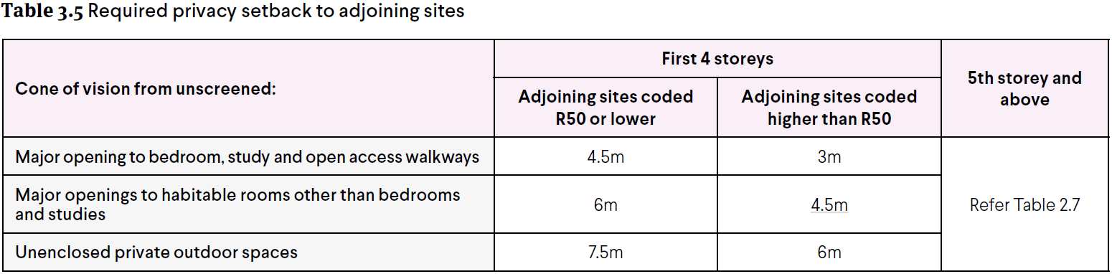
A3.5.2 – Balconies are unscreened for at least 25 per cent of their perimeter (including edges abutting a building).
A3.5.3 - Living rooms have an external outlook from at least one major opening that is not obscured by a screen.
A3.5.4 – Windows and balconies are sited, oriented, offset or articulated to restrict direct overlooking, without excessive reliance on high sill levels or permanent screening of windows and balconies.
LOCAL PLANNING FRAMEWORK |  | REQUIREMENT
Does the local planning framework amend or replace the above stated controls? If yes, state the applicable requirement:

ELEMENT 3.6 | PUBLIC DOMAIN INTERFACE
ELEMENT OBJECTIVES  Development is to achieve the following Element Objectives |  | applIcant comment | ASSESSOR COMMENT
 |  | Outline the rationale demonstrating that the proposal has met the Element Objectives, through either a performance based solution or using the Acceptable Outcomes. The Design Guidance provided in the policy may be of assistance.
O3.6.1 – The transition between the private and public domain enhances the privacy and safety of residents.
O3.6.2 – Street facing development and landscape design retains and enhances the amenity and safety of the adjoining public domain, including the provision of shade.
ACCEPTABLE OUTCOMES
Acceptable Outcome pathway may not be applicable where a performance solution is provided
A3.6.1 – The majority of ground floor dwellings fronting onto a street or public open space have direct access by way of a private terrace, balcony or courtyard.
A3.6.2 – Car-parking is not located within the primary street setback; and where car parking is located at ground level behind the street setback it is designed to integrate with landscaping and the building façade (where part of the building).
A3.6.3 – Upper level balconies and/or windows overlook the street and public domain areas.
A3.6.4 – Balustrading includes a mix of visually opaque and visually permeable materials to provide residents with privacy while maintaining casual surveillance of adjoining public domain areas.
A3.6.5 – Changes in level between private terraces, front gardens and the ground floor level of the building and the street level average less than 1m and do not exceed 1.2m.
A3.6.6 – Front fencing includes visually permeable materials above 1.2m and the average height of solid walls or fences to the street does not exceed 1.2m.
A3.6.7 – Fencing, landscaping and other elements on the frontage are designed to eliminate opportunities for concealment.
A3.6.8 – Bins are not located within the primary street setback or in locations visible from the primary street.
A3.6.9 – Services and utilities that are located in the primary street setback are integrated into the design of the development and do not detract from the amenity and visual appearance of the street frontage.¹
(1) Firefighting and access to services such as power and water meters require careful consideration in the design of the front façade. Consult early with relevant authorities to resolve functional requirements in an integrated design solution.
LOCAL PLANNING FRAMEWORK |  | REQUIREMENT
Does the local planning framework amend or replace the above stated controls? If yes, state the applicable requirement:

ELEMENT 3.7 | PEDESTRIAN ACCESS AND ENTRIES
ELEMENT OBJECTIVES  Development is to achieve the following Element Objectives |  | applIcant comment | ASSESSOR COMMENT
 |  | Outline the rationale demonstrating that the proposal has met the Element Objectives, through either a performance based solution or using the Acceptable Outcomes. The Design Guidance provided in the policy may be of assistance.
O3.7.1 – Entries and pathways are universally accessible, easy to identify and safe for residents and visitors.
O3.7.2 – Entries to the development connect to and address the public domain with an attractive street presence.
ACCEPTABLE OUTCOMES
Acceptable Outcome pathway may not be applicable where a performance solution is provided
A3.7.1 – Pedestrian entries are connected via a legible, well-defined, continuous path of travel to building access areas such as lift lobbies, stairs, accessways and individual dwelling entries.
A3.7.2 – Pedestrian entries are protected from the weather.
A3.7.3 – Pedestrian entries are well-lit for safety and amenity, visible from the public domain without opportunity for concealment, and designed to enable casual surveillance of the entry from within the site.
A3.7.4 – Where pedestrian access is via a shared zone with vehicles, the pedestrian path is clearly delineated and/or measures are incorporated to prioritise the pedestrian and constrain vehicle speed.
A3.7.5 – Services and utilities that are located at the pedestrian entry are integrated into the design and do not detract from the amenity of the entry.
A3.7.6 – Bins are not located at the primary pedestrian entry.
LOCAL PLANNING FRAMEWORK |  | REQUIREMENT
Does the local planning framework amend or replace the above stated controls? If yes, state the applicable requirement:

ELEMENT 3.8 | VEHICLE ACCESS
ELEMENT OBJECTIVES  Development is to achieve the following Element Objectives |  | applIcant comment | ASSESSOR COMMENT
 |  | Outline the rationale demonstrating that the proposal has met the Element Objectives, through either a performance based solution or using the Acceptable Outcomes. The Design Guidance provided in the policy may be of assistance.
O3.8.1 – Vehicle access points are designed and located to provide safe access and egress for vehicles and to avoid conflict with pedestrians, cyclists and other vehicles.
O3.8.2 – Vehicle access points are designed and located to reduce visual impact on the streetscape.
ACCEPTABLE OUTCOMES
Acceptable Outcome pathway may not be applicable where a performance solution is provided
A3.8.1 – Vehicle access is limited to one opening per 20m street frontage that is visible from the street.
A3.8.2 – Vehicle entries are identifiable from the street, while being integrated with the overall façade design and/ or located behind the primary building line.
A3.8.3 – Vehicle entries have adequate separation from street intersections.
A3.8.4 – Vehicle circulation areas avoid headlights shining into habitable rooms within the development and adjoining properties.
A3.8.5 – Driveway width is kept to a functional minimum, relative to the traffic volumes and entry/egress requirements.
A3.8.6 – Driveways designed for two way access to allow for vehicles to enter the street in forward gear where:
  - the driveway serves more than 10 dwellings
  - the distance from an on-site car parking to the street is 15m or more OR
  - the public street to which it connects is designated as a primary distributor, district distributor or integrated arterial road.
A3.8.7 – Walls, fences and other structures truncated or reduced to no higher than 0.75m within 1.5m of where walls, fences, other structures adjoin vehicle access points where a driveway meets a public street and where two streets intersect (refer Figure 3.8a).
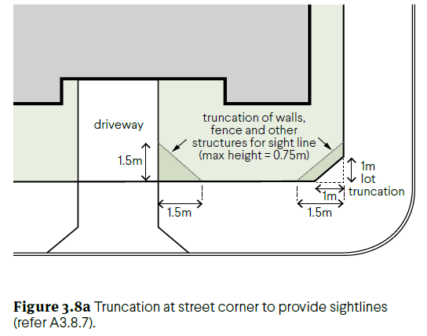
LOCAL PLANNING FRAMEWORK |  | REQUIREMENT
Does the local planning framework amend or replace the above stated controls? If yes, state the applicable requirement:

ELEMENT 3.9 | CAR AND BICYCLE PARKING
ELEMENT OBJECTIVES  Development is to achieve the following Element Objectives |  | applIcant comment | ASSESSOR COMMENT
 |  | Outline the rationale demonstrating that the proposal has met the Element Objectives, through either a performance based solution or using the Acceptable Outcomes. The Design Guidance provided in the policy may be of assistance.
O3.9.1 – Parking and facilities are provided for cyclists and other modes of transport.
O3.9.2 – Car parking provision is appropriate to the location, with reduced provision possible in areas that are highly walkable and/or have good public transport or cycle networks and/or are close to employment centres.
O3.9.3 – Car parking is designed to be safe and accessible.
O3.9.4 – The design and location of car parking minimises negative visual and environmental impacts on amenity and the streetscape.
ACCEPTABLE OUTCOMES
Acceptable Outcome pathway may not be applicable where a performance solution is provided
A3.9.1 – Secure, undercover bicycle parking is provided in accordance with Table 3.9 and accessed via a continuous path of travel from the vehicle or cycle entry point.
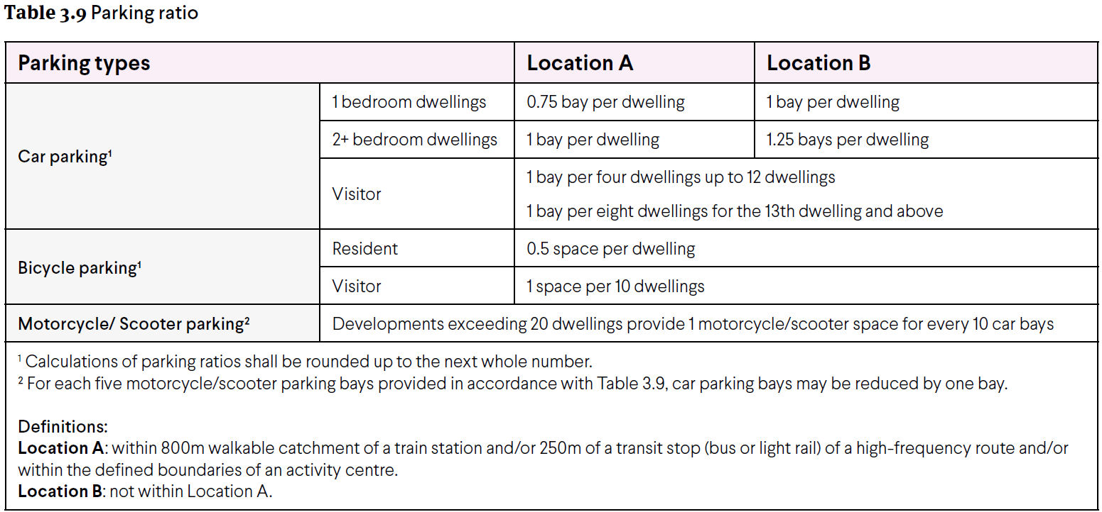
A3.9.2 – Parking is provided for cars and motorcycles in accordance with Table 3.9.
A3.9.3 – Maximum parking provision does not exceed double the minimum number of bays specified in Table 3.9
A3.9.4 – Car parking and vehicle circulation areas are designed in accordance with AS2890.1 (as amended) or the requirements of applicable local planning instruments.
A3.9.5 – Car parking areas are not located within the street setback and are not visually prominent from the street.
A3.9.6 – Car parking is designed, landscaped or screened to mitigate visual impacts when viewed from dwellings and private outdoor spaces.
A3.9.7 – Visitor parking is clearly visible from the driveway, is signed ‘Visitor Parking’ and is accessible from the primary entry or entries.
A3.9.8 – Parking shade structures, where used, integrate with and complement the overall building design and site aesthetics and have a low reflectance to avoid glare into apartments.
A3.9.9 – Uncovered at-grade parking is planted with trees at a minimum rate of one tree per four bays.
A3.9.10 – Basement parking does not protrude more than 1m above ground, and where it protrudes above ground is designed or screened to prevent negative visual impact on the streetscape.
LOCAL PLANNING FRAMEWORK |  | REQUIREMENT
Does the local planning framework amend or replace the above stated controls? If yes, state the applicable requirement:

ELEMENT 4.1 | SOLAR AND DAYLIGHT ACCESS
ELEMENT OBJECTIVES  Development is to achieve the following Element Objectives |  | applIcant comment | ASSESSOR COMMENT
 |  | Outline the rationale demonstrating that the proposal has met the Element Objectives, through either a performance based solution or using the Acceptable Outcomes. The Design Guidance provided in the policy may be of assistance.
O4.1.1 – In climate zones 4, 5 and 6: the development is sited and designed to optimise the number of dwellings receiving winter sunlight to private open space and via windows to habitable rooms.
O4.1.2 – Windows are designed and positioned to optimise daylight access for habitable rooms.
O4.1.3 – The development incorporates shading and glare control to minimise heat gain and glare:
- from mid-spring to autumn in climate zones 4, 5 and 6 AND
- year-round in climate zones 1 and 3.
ACCEPTABLE OUTCOMES
Acceptable Outcome pathway may not be applicable where a performance solution is provided
A4.1.1 – In climate zones 4, 5 and 6 only:
- Dwellings with a northern aspect are maximised, with a minimum of 70 per cent of dwellings having living rooms and private open space that obtain at least 2 hours direct sunlight between 9am and 3pm on 21 June AND
- A maximum of 15 per cent of dwellings in a building receiving no direct sunlight between 9am and 3pm on 21 June.
A4.1.2 – Every habitable room has at least one window in an external wall, visible from all parts of the room, with a glazed area not less than 10 per cent of the floor area and comprising a minimum of 50 per cent of clear glazing.
A4.1.3 – Lightwells and/or skylights do not form the primary source of daylight to any habitable room.
A4.1.4 – The building is oriented and incorporates external shading devices in order to:
  - minimise direct sunlight to habitable rooms:
    - between late September and early March in climate zones 4, 5 and 6 only AND
    - in all seasons in climate zones 1 and 3
  - permit winter sun to habitable rooms in accordance with A 4.1.1 (a).
LOCAL PLANNING FRAMEWORK |  | REQUIREMENT
Does the local planning framework amend or replace the above stated controls? If yes, state the applicable requirement:

ELEMENT 4.2 | NATURAL VENTILATION
ELEMENT OBJECTIVES  Development is to achieve the following Element Objectives |  | applIcant comment | ASSESSOR COMMENT
 |  | Outline the rationale demonstrating that the proposal has met the Element Objectives, through either a performance based solution or using the Acceptable Outcomes. The Design Guidance provided in the policy may be of assistance.
O4.2.1 – Development maximises the number of apartments with natural ventilation.
O4.2.2 – Individual dwellings are designed to optimise natural ventilation of habitable rooms.
O4.2.3 – Single aspect apartments are designed to maximise and benefit from natural ventilation.
ACCEPTABLE OUTCOMES
Acceptable Outcome pathway may not be applicable where a performance solution is provided
A4.2.1 – Habitable rooms have openings on at least two walls with a straight line distance between the centre of the openings of at least 2.1m.
A4.2.2 –
- A minimum 60 per cent of dwellings are, or are capable of, being naturally cross ventilated in the first nine storeys of the building
- Single aspect apartments included within the 60 per cent minimum at (a) above must have:
- ventilation openings oriented between 45º – 90º of the prevailing cooling wind direction AND
- room depth no greater than 3 × ceiling height
- For dwellings located at the 10th storey or above, balconies incorporate high and low level ventilation openings.
A4.2.3 – The depth of cross-over and cross-through apartments with openings at either end and no openings on side walls does not exceed 20m.
A4.2.4 – No habitable room relies on lightwells as the primary source of fresh-air.
LOCAL PLANNING FRAMEWORK |  | REQUIREMENT
Does the local planning framework amend or replace the above stated controls? If yes, state the applicable requirement:

ELEMENT 4.3 | SIZE AND LAYOUT OF DWELLINGS
ELEMENT OBJECTIVES  Development is to achieve the following Element Objectives |  | applIcant comment | ASSESSOR COMMENT
 |  | Outline the rationale demonstrating that the proposal has met the Element Objectives, through either a performance based solution or using the Acceptable Outcomes. The Design Guidance provided in the policy may be of assistance.
O4.3.1 – The internal size and layout of dwellings is functional with the ability to flexibly accommodate furniture settings and personal goods, appropriate to the expected household size.
O4.3.2 – Ceiling heights and room dimensions provide for well-proportioned spaces that facilitate good natural ventilation and daylight access.
ACCEPTABLE OUTCOMES
Acceptable Outcome pathway may not be applicable where a performance solution is provided
A4.3.1 – Dwellings have a minimum internal floor area in accordance with Table 4.3a.
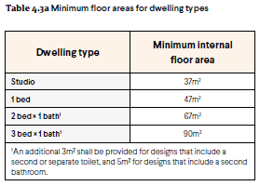
A4.3.2 – Habitable rooms have minimum floor areas and dimensions in accordance with Table 4.3b.
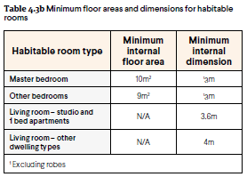
A4.3.3 – Measured from the finished floor level to finished ceiling level, minimum ceiling heights are:
- Habitable rooms – 2.7m
- Non-habitable rooms – 2.4m
- All other ceilings meet or exceed the requirements of the NCC.
A4.3.4 – The length of a single aspect open plan living area is equal to or less than 3 x the ceiling height. An additional 1.8m length may be provided for a kitchen, where the kitchen is the furthest point from the window in an open plan living area provided that the maximum length does not exceed 9m.
LOCAL PLANNING FRAMEWORK |  | REQUIREMENT
Does the local planning framework amend or replace the above stated controls? If yes, state the applicable requirement:

ELEMENT 4.4 | PRIVATE OPEN SPACE AND BALCONIES
ELEMENT OBJECTIVES  Development is to achieve the following Element Objectives |  | applIcant comment | ASSESSOR COMMENT
 |  | Outline the rationale demonstrating that the proposal has met the Element Objectives, through either a performance based solution or using the Acceptable Outcomes. The Design Guidance provided in the policy may be of assistance.
O4.4.1 – Dwellings have good access to appropriately sized private open space that enhances residential amenity.
O4.4.2 – Private open space is sited, oriented and designed to enhance liveability for residents.
O4.4.3 – Private open space and balconies are integrated into the overall architectural form and detail of the building.
ACCEPTABLE OUTCOMES
Acceptable Outcome pathway may not be applicable where a performance solution is provided
A4.4.1 – Each dwelling has private open space accessed directly from a habitable room with dimensions in accordance with Table 4.4.
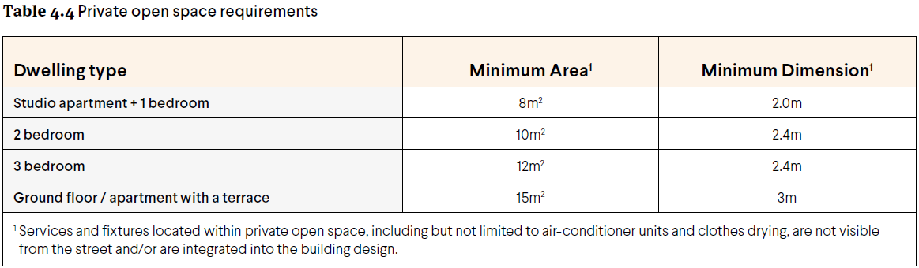
A4.4.2 – Where private open space requires screening to achieve visual privacy requirements, the entire open space is not screened and any screening is designed such that it does not obscure the outlook from adjacent living rooms.
A4.4.3 – Design detailing, materiality and landscaping of the private open space is integrated with or complements the overall building design.
A4.4.4 – Services and fixtures located within private open space, including but not limited to air-conditioner units and clothes drying, are not visible from the street and/or are integrated into the building design.
LOCAL PLANNING FRAMEWORK |  | REQUIREMENT
Does the local planning framework amend or replace the above stated controls? If yes, state the applicable requirement:

ELEMENT 4.5 | CIRCULATION AND COMMON SPACES
ELEMENT OBJECTIVES  Development is to achieve the following Element Objectives |  | applIcant comment | ASSESSOR COMMENT
 |  | Outline the rationale demonstrating that the proposal has met the Element Objectives, through either a performance based solution or using the Acceptable Outcomes. The Design Guidance provided in the policy may be of assistance.
O4.5.1 – Circulation spaces have adequate size and capacity to provide safe and convenient access for all residents and visitors.
O4.5.2 – Circulation and common spaces are attractive, have good amenity and support opportunities for social interaction between residents.
ACCEPTABLE OUTCOMES
Acceptable Outcome pathway may not be applicable where a performance solution is provided
A4.5.1 – Circulation corridors are a minimum 1.5m in width.
A4.5.2 – Circulation and common spaces are designed for universal access.
A4.5.3 – Circulation and common spaces are capable of passive surveillance, include good sightlines and avoid opportunities for concealment.
A4.5.4 – Circulation and common spaces can be illuminated at night without creating light spill into the habitable rooms of adjacent dwellings.
A4.5.5 – Bedroom windows and major openings to living rooms do not open directly onto circulation or common spaces and are designed to ensure visual privacy and manage noise intrusion.
LOCAL PLANNING FRAMEWORK |  | REQUIREMENT
Does the local planning framework amend or replace the above stated controls? If yes, state the applicable requirement:

ELEMENT 4.6 | STORAGE
ELEMENT OBJECTIVES  Development is to achieve the following Element Objectives |  | applIcant comment | ASSESSOR COMMENT
 |  | Outline the rationale demonstrating that the proposal has met the Element Objectives, through either a performance based solution or using the Acceptable Outcomes. The Design Guidance provided in the policy may be of assistance.
O4.6.1 – Well-designed, functional and conveniently located storage is provided for each dwelling.
ACCEPTABLE OUTCOMES
Acceptable Outcome pathway may not be applicable where a performance solution is provided
A4.6.1 – Each dwelling has exclusive use of a separate, ventilated, weatherproof, bulky goods storage area. This can be located either internally or externally to the dwelling with dimensions in accordance with Table 4.6.
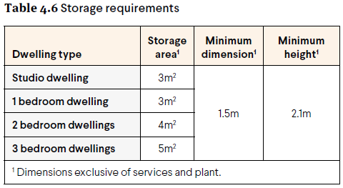
A4.6.2 – Bulky good stores that are not directly accessible from the dwelling/private open space are located in areas that are convenient, safe, well-lit, secure and subject to passive surveillance.
A4.6.3 – Storage provided separately from dwellings or within or adjacent to private open space¹, is integrated into the design of the building or open space and is not readily visible from the public domain.
- Storage on/adjacent to private open space is additional to required open space area and dimensions.
LOCAL PLANNING FRAMEWORK |  | REQUIREMENT
Does the local planning framework amend or replace the above stated controls? If yes, state the applicable requirement:

ELEMENT 4.7 | MANAGING THE IMPACT OF NOISE
ELEMENT OBJECTIVES  Development is to achieve the following Element Objectives |  | applIcant comment | ASSESSOR COMMENT
 |  | Outline the rationale demonstrating that the proposal has met the Element Objectives, through either a performance based solution or using the Acceptable Outcomes. The Design Guidance provided in the policy may be of assistance.
O4.7.1 – The siting and layout of development minimises the impact of external noise sources and provides appropriate acoustic privacy to dwellings and on-site open space.
O4.7.2 – Acoustic treatments are used to reduce sound transfer within and between dwellings and to reduce noise transmission from external noise sources.
ACCEPTABLE OUTCOMES
Acceptable Outcome pathway may not be applicable where a performance solution is provided
A4.7.1 – Dwellings exceed the minimum requirements of the NCC, such as a rating under the AAAC Guideline for Apartment and Townhouse Acoustic Rating (or equivalent).
A4.7.2 – Potential noise sources such as garage doors, driveways, service areas, plant rooms, building services, mechanical equipment, active communal open space and refuse bins are not located adjacent to the external wall of habitable rooms or within 3m of a window to a bedroom.
A4.7.3 – Major openings to habitable rooms are oriented away or shielded from external noise sources.
LOCAL PLANNING FRAMEWORK |  | REQUIREMENT
Does the local planning framework amend or replace the above stated controls? If yes, state the applicable requirement:

ELEMENT 4.8 | DWELLING MIX
ELEMENT OBJECTIVES  Development is to achieve the following Element Objectives |  | applIcant comment | ASSESSOR COMMENT
 |  | Outline the rationale demonstrating that the proposal has met the Element Objectives, through either a performance based solution or using the Acceptable Outcomes. The Design Guidance provided in the policy may be of assistance.
O4.8.1 – A range of dwelling types, sizes and configurations is provided that caters for diverse household types and changing community demographics.
ACCEPTABLE OUTCOMES
Acceptable Outcome pathway may not be applicable where a performance solution is provided
A4.8.1 –
- Dwelling mix is provided in accordance with the objectives, proportions or targets specified in a local housing strategy or relevant local planning instrument OR
- Where there is no local housing strategy, developments of greater than 10 dwellings include at least 20 per cent of apartments of differing bedroom numbers.
A4.8.2 – Different dwelling types are well distributed throughout the development, including a mix of dwelling types on each floor.
LOCAL PLANNING FRAMEWORK |  | REQUIREMENT
Does the local planning framework amend or replace the above stated controls? If yes, state the applicable requirement:

ELEMENT 4.9 | UNIVERSAL DESIGN
ELEMENT OBJECTIVES  Development is to achieve the following Element Objectives |  | applIcant comment | ASSESSOR COMMENT
 |  | Outline the rationale demonstrating that the proposal has met the Element Objectives, through either a performance based solution or using the Acceptable Outcomes. The Design Guidance provided in the policy may be of assistance.
O4.9.1 – Development includes dwellings with universal design features providing dwelling options for people living with disabilities or limited mobility and/or to facilitate ageing in place.
ACCEPTABLE OUTCOMES
Acceptable Outcome pathway may not be applicable where a performance solution is provided
A4.9.1 –
- 20 per cent of all dwellings, across a range of dwelling sizes, meet Silver Level requirements as defined in the Liveable Housing Design Guidelines (Liveable Housing Australia) OR
- 5 per cent of dwellings are designed to Platinum Level as defined in the Liveable Housing Design Guidelines (Liveable Housing Australia).
LOCAL PLANNING FRAMEWORK |  | REQUIREMENT
Does the local planning framework amend or replace the above stated controls? If yes, state the applicable requirement:

ELEMENT 4.10 | FAÇADE DESIGN
ELEMENT OBJECTIVES  Development is to achieve the following Element Objectives |  | applIcant comment | ASSESSOR COMMENT
 |  | Outline the rationale demonstrating that the proposal has met the Element Objectives, through either a performance based solution or using the Acceptable Outcomes. The Design Guidance provided in the policy may be of assistance.
O4.10.1 – Building façades incorporate proportions, materials and design elements that respect and reference the character of the local area.
O4.10.2 – Building façades express internal functions and provide visual interest when viewed from the public realm.
ACCEPTABLE OUTCOMES
Acceptable Outcome pathway may not be applicable where a performance solution is provided
A4.10.1 – Façade design includes:
  - scaling, articulation, materiality and detailing at lower levels that reflect the scale, character and function of the public realm
  - rhythm and visual interest achieved by a combination of building articulation, the composition of different elements and changes in texture, material and colour.
A4.10.2 – In buildings with height greater than four storeys, façades include a defined base, middle and top for the building.
A4.10.3 – The façade includes design elements that relate to key datum lines of adjacent buildings through upper level setbacks, parapets, cornices, awnings or colonnade heights.
A4.10.4 – Building services fixtures are integrated in the design of the façade and are not visually intrusive from the public realm.
A4.10.5 – Development with a primary setback of 1m or less to the street includes awnings that:
  - define and provide weather protection to entries
  - are integrated into the façade design
  - are consistent with the streetscape character.
A4.10.6 – Where provided, signage is integrated into the façade design and is consistent with the desired streetscape character.
LOCAL PLANNING FRAMEWORK |  | REQUIREMENT
Does the local planning framework amend or replace the above stated controls? If yes, state the applicable requirement:

ELEMENT 4.11 | ROOF DESIGN
ELEMENT OBJECTIVES  Development is to achieve the following Element Objectives |  | applIcant comment | ASSESSOR COMMENT
 |  | Outline the rationale demonstrating that the proposal has met the Element Objectives, through either a performance based solution or using the Acceptable Outcomes. The Design Guidance provided in the policy may be of assistance.
O4.11.1 – Roof forms are well integrated into the building design and respond positively to the street.
O4.11.2 – Where possible, roof spaces are utilised to add open space, amenity, solar energy generation or other benefits to the development.
ACCEPTABLE OUTCOMES
Acceptable Outcome pathway may not be applicable where a performance solution is provided
A4.11.1 – The roof form or top of building complements the façade design and desired streetscape character.
A4.11.2 – Building services located on the roof are not visually obtrusive when viewed from the street.
A4.11.3 – Useable roof space is safe for users and minimises overlooking and noise impacts on private open space and habitable rooms within the development and on adjoining sites.
LOCAL PLANNING FRAMEWORK |  | REQUIREMENT
Does the local planning framework amend or replace the above stated controls? If yes, state the applicable requirement:

ELEMENT 4.12 | LANDSCAPE DESIGN
ELEMENT OBJECTIVES  Development is to achieve the following Element Objectives |  | applIcant comment | ASSESSOR COMMENT
 |  | Outline the rationale demonstrating that the proposal has met the Element Objectives, through either a performance based solution or using the Acceptable Outcomes. The Design Guidance provided in the policy may be of assistance.
O4.12.1 – Landscape design enhances streetscape and pedestrian amenity; improves the visual appeal and comfort of open space areas; and provides an attractive outlook for habitable rooms.
O4.12.2 – Plant selection is appropriate to the orientation, exposure and site conditions and is suitable for the adjoining uses.
O4.12.3 – Landscape design includes water efficient irrigation systems and where appropriate incorporates water harvesting or water re-use technologies.
O4.12.4 – Landscape design is integrated with the design intent of the architecture including its built form, materiality, key functional areas and sustainability strategies.
ACCEPTABLE OUTCOMES
Acceptable Outcome pathway may not be applicable where a performance solution is provided
A4.12.1 – Submission of a landscape plan prepared by a competent landscape designer. This is to include a species list and irrigation plan demonstrating achievement of Waterwise design principles.
A4.12.2 – Landscaped areas are located and designed to support mature, shade-providing trees to open space and the public realm, and to improve the outlook and amenity to habitable rooms and open space areas.
A4.12.3 – Planting on building structures meets the requirements of Table 4.12.
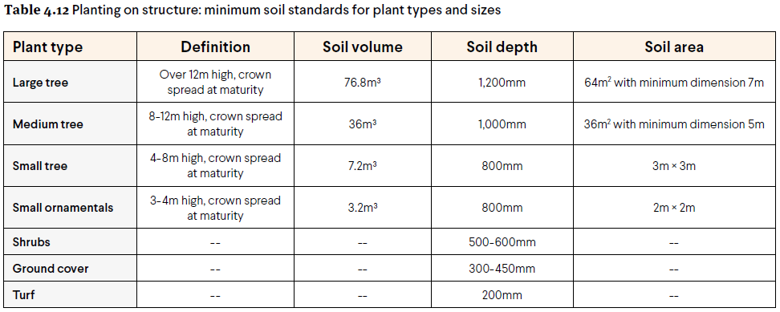
A4.12.4 – Building services fixtures are integrated in the design of the landscaping and are not visually intrusive.
LOCAL PLANNING FRAMEWORK |  | REQUIREMENT
Does the local planning framework amend or replace the above stated controls? If yes, state the applicable requirement:

ELEMENT 4.13 | ADAPTIVE REUSE
ELEMENT OBJECTIVES  Development is to achieve the following Element Objectives |  | applIcant comment | ASSESSOR COMMENT
 |  | Outline the rationale demonstrating that the proposal has met the Element Objectives, through either a performance based solution or using the Acceptable Outcomes. The Design Guidance provided in the policy may be of assistance.
O4.13.1 – New additions to existing buildings are contemporary and complementary and do not detract from the character and scale of the existing building.
O4.13.2 – Residential dwellings within an adapted building provide good amenity for residents, generally in accordance with the requirements of this policy.
ACCEPTABLE OUTCOMES
Acceptable Outcome pathway may not be applicable where a performance solution is provided
A4.13.1 – New additions to buildings that have heritage value do not mimic the existing form and are clearly identifiable from the original building.
A4.13.2 – New additions complement the existing building by referencing and interpreting the scale, rhythm and materiality of the building.
LOCAL PLANNING FRAMEWORK |  | REQUIREMENT
Does the local planning framework amend or replace the above stated controls? If yes, state the applicable requirement:

ELEMENT 4.14 | MIXED USE
ELEMENT OBJECTIVES  Development is to achieve the following Element Objectives |  | applIcant comment | ASSESSOR COMMENT
 |  | Outline the rationale demonstrating that the proposal has met the Element Objectives, through either a performance based solution or using the Acceptable Outcomes. The Design Guidance provided in the policy may be of assistance.
O4.14.1 – Mixed use development enhances the streetscape and activates the street.
O4.14.2 – A safe and secure living environment for residents is maintained through the design and management of the impacts of non-residential uses such as noise, light, odour, traffic and waste.
ACCEPTABLE OUTCOMES
Acceptable Outcome pathway may not be applicable where a performance solution is provided
A4.14.1 – Where development is located within a mixed use area designated within the local planning framework, ground floor units are designed for future adaption to non-residential uses.
A4.14.2 – Ground floor uses including non-commercial uses, such as communal open space, habitable rooms, verandahs and courtyards associated with ground floor dwellings, address, enhance and activate the street.
A4.14.3 – Non-residential space in mixed use development is accessed via the street frontage and/or primary entry as applicable.
A4.14.4 – Non-residential floor areas provided in mixed use development has sufficient provision for parking, waste management, and amenities to accommodate a range of retail and commercial uses in accordance with the requirements
A4.14.5 – Mixed use development is designed to mitigate the impacts of non-residential uses on residential dwellings, and to maintain a secure environment for residents.
LOCAL PLANNING FRAMEWORK |  | REQUIREMENT
Does the local planning framework amend or replace the above stated controls? If yes, state the applicable requirement:

ELEMENT 4.15 | ENERGY EFFICIENCY
ELEMENT OBJECTIVES  Development is to achieve the following Element Objectives |  | applIcant comment | ASSESSOR COMMENT
 |  | Outline the rationale demonstrating that the proposal has met the Element Objectives, through either a performance based solution or using the Acceptable Outcomes. The Design Guidance provided in the policy may be of assistance.
O4.15.1 – Reduce energy consumption and greenhouse gas emissions from the development.
ACCEPTABLE OUTCOMES
Acceptable Outcome pathway may not be applicable where a performance solution is provided
A4.15.1 –
- Incorporate at least one significant energy efficiency initiative within the development that exceeds minimum practice (refer Design Guidance) OR
- All dwellings exceed the minimum NATHERS requirement for apartments by 0.5 stars.¹

Compliance with the NCC requires that development shall achieve an average star-rating across all dwellings that meets or exceeds a nominated benchmark, and that each unit meets or exceeds a slightly lower benchmark. Compliance with this Acceptable Outcome requires that each unit exceeds that lower benchmark by at least half a star.
LOCAL PLANNING FRAMEWORK |  | REQUIREMENT
Does the local planning framework amend or replace the above stated controls? If yes, state the applicable requirement:

ELEMENT 4.16 | WATER MANAGEMENT AND CONSERVATION
ELEMENT OBJECTIVES  Development is to achieve the following Element Objectives |  | applIcant comment | ASSESSOR COMMENT
 |  | Outline the rationale demonstrating that the proposal has met the Element Objectives, through either a performance based solution or using the Acceptable Outcomes. The Design Guidance provided in the policy may be of assistance.
O4.16.1 – Minimise potable water consumption throughout the development.
O4.16.2 – Stormwater runoff from small rainfall events is managed on-site, wherever practical.
O4.16.3 – Reduce the risk of flooding so that the likely impacts of major rainfall events will be minimal.
ACCEPTABLE OUTCOMES
Acceptable Outcome pathway may not be applicable where a performance solution is provided
A4.16.1 – Dwellings are individually metered for water usage.
A4.16.2 – Stormwater runoff generated from small rainfall events is managed on-site.
A4.16.3 – Provision of an overland flow path for safe conveyance of runoff from major rainfall events to the local stormwater drainage system.
LOCAL PLANNING FRAMEWORK |  | REQUIREMENT
Does the local planning framework amend or replace the above stated controls? If yes, state the applicable requirement:

ELEMENT 4.17 | WASTE MANAGEMENT
ELEMENT OBJECTIVES  Development is to achieve the following Element Objectives |  | applIcant comment | ASSESSOR COMMENT
 |  | Outline the rationale demonstrating that the proposal has met the Element Objectives, through either a performance based solution or using the Acceptable Outcomes. The Design Guidance provided in the policy may be of assistance.
O4.17.1 – Waste storage facilities minimise negative impacts on the streetscape, building entries and the amenity of residents.
O4.17.2 – Waste to landfill is minimised by providing safe and convenient bins and information for the separation and recycling of waste.
ACCEPTABLE OUTCOMES
Acceptable Outcome pathway may not be applicable where a performance solution is provided
A4.17.1 – Waste storage facilities are provided in accordance with the Better Practice considerations of the WALGA Multiple Dwelling Waste Management Plan Guidelines (or local government requirements where applicable).
A4.17.2 – A Level 1 Waste Management Plan (Design Phase) is provided in accordance with the WALGA Multiple Dwelling Waste Management Plan Guidelines - Appendix 4A (or equivalent local government requirements).
A4.17.3 – Sufficient area is provided to accommodate the required number of bins for the separate storage of green waste, recycling and general waste in accordance with the WALGA Multiple Dwelling Waste Management Plan Guidelines - Level 1 Waste Management Plan (Design Phase) (or local government requirements where applicable).
A4.17.4 – Communal waste storage is sited and designed to be screened from view from the street, open space and private dwellings.
LOCAL PLANNING FRAMEWORK |  | REQUIREMENT
Does the local planning framework amend or replace the above stated controls? If yes, state the applicable requirement:

ELEMENT 4.17 | WASTE MANAGEMENT
ELEMENT OBJECTIVES  Development is to achieve the following Element Objectives |  | applIcant comment | ASSESSOR COMMENT
 |  | Outline the rationale demonstrating that the proposal has met the Element Objectives, through either a performance based solution or using the Acceptable Outcomes. The Design Guidance provided in the policy may be of assistance.
O4.18.1 –The site is serviced with power, water, gas (where available), wastewater, fire services and telecommunications/broadband services that are fit for purpose and meet current performance and access requirements of service providers.
O4.18.2 – All utilities are located such that they are accessible for maintenance and do not restrict safe movement of vehicles or pedestrians.
O4.18.3 – Utilities, such as distribution boxes, power and water meters are integrated into design of buildings and landscape so that they are not visually obtrusive from the street or open space within the development.
O4.18.4 – Utilities within individual dwellings are of a functional size and layout and located to minimise noise or air quality impacts on habitable rooms and balconies.
ACCEPTABLE OUTCOMES
Acceptable Outcome pathway may not be applicable where a performance solution is provided
A4.18.1 – Utilities that must be located within the front setback, adjacent to the building entry or on visible parts of the roof are integrated into the design of the building, landscape and/or fencing such that they are accessible for servicing requirements but not visually obtrusive.
A4.18.2 – Developments are fibre-to-premises ready, including provision for installation of fibre throughout the site and to every dwelling.
A4.18.3 – Hot water units, air-conditioning condenser units and clotheslines are located such that they can be safely maintained, are not visually obtrusive from the street and do not impact on functionality of outdoor living areas or internal storage.
A4.18.4 – Laundries are designed and located to be convenient to use, secure, weather-protected and well-vented; and are of an overall size and dimension that is appropriate to the size of the dwelling.
LOCAL PLANNING FRAMEWORK |  | REQUIREMENT
Does the local planning framework amend or replace the above stated controls? If yes, state the applicable requirement:

