Template 1: DCE + TC survey instrument

Welcome to the Cottesloe Beach survey

We would like to start with a few questions about yourself:

S1) What is your gender?
- Male
- Female
- Non-binary/other

S2) Which age group applies to you?
- Under 18 years
- 18-30 years
- 31-45 years
- 46-60 years
- 61-75 years
- Over 75

S3) Where do you live?
- [insert name of LGA here if targeting a local sample, otherwise delete this option]
- Perth metropolitan area
- Regional Western Australia
- Other part of Australia
- International visitor

Preferences for managing coastal hazards at Cottesloe Beach
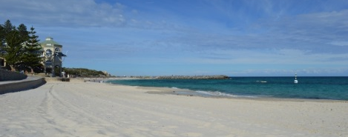

Dear Sir/Madam,
Thank you for reading this introduction screen which outlines a research project being conducted by [insert relevant affiliations for the study here].
This survey aims to understand your preferences for managing the coastal environment and infrastructure at Cottesloe Beach from coastal hazards.
You have been selected at random from the Western Australian population to participate in this research.
Your opinion is important – we will be surveying a large number of people to obtain a representative view of the community.
Participation involves completing a survey that will take approximately 20 minutes of your time. Your involvement is voluntary, and you may withdraw from the survey at any time. You must be at least 18 years of age to participate.
If you consent to participate in this study, please complete the survey that follows. If you have any questions feel free to contact me on the details below.
You can download a copy of this information sheet here.
Kind regards,
INSERT CONTACT DETAILS

Approval to conduct this research has been provided by …. [Insert any relevant ethics approval information here if relevant, otherwise delete].
What this survey is about
Coastal environments and infrastructure, including Cottesloe Beach, are exposed to many threatening processes. Threats might include coastal hazards, the spread of weeds, urban development, or others.
This survey focuses on the impacts caused by coastal hazards.
This survey aims to understand your preferences for protecting the coast at Cottesloe Beach from these hazards.
In Western Australia, the main hazards that affect our coast are erosion and inundation.
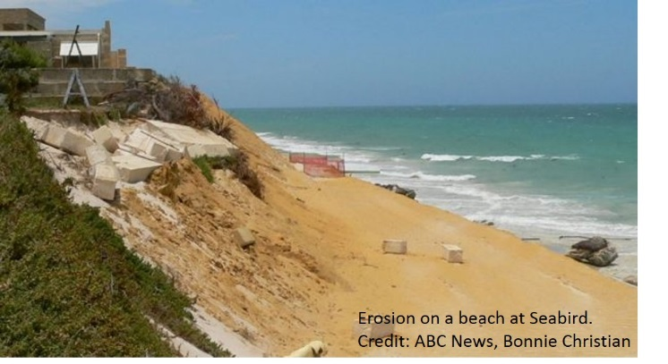
Erosion is a process where parts of the shoreline are worn away due to waves, tides, wind or human activities. It can change the shape and form of the coast, reducing the area between the ocean and features on the land, and even allowing inundation.

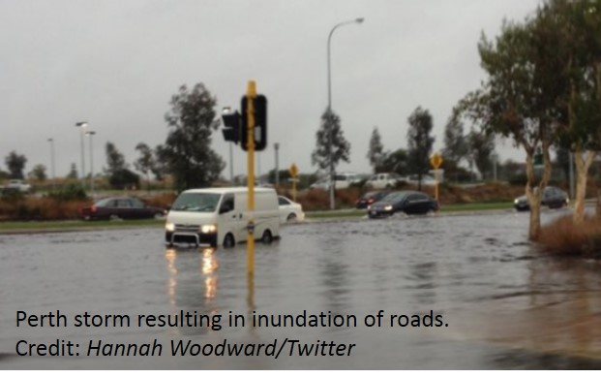
Inundation is when water occupies previously dry land. It can be temporary or permanent:
- Permanent inundation refers to the loss of land due to sea level rise.
- Temporary inundation is the flooding of an area due to storm surge, high tides or large waves.

Storm events and rising sea levels are likely to result in a greater impact of erosion and inundation on our coast in future years.
Coastal features, such as sandy beaches, grassed foreshore reserves, natural reserves containing animals and plants, beach access points, and retail, dining and club facilities can be impacted by the erosion and inundation.
Different management actions can be used to avoid or reduce the impacts of coastal hazards. These actions are usually funded by Local Government and/or State Government agencies.

The survey has 4 main parts:
PART 1: Some questions about your experiences with Cottesloe Beach.
PART 2: A description of how some coastal features will be impacted by coastal hazards in the next 10 years. This information is needed for Part 3.
PART 3: A series of hypothetical management scenarios. You will be asked to choose one of 3 options for each scenario. Each option involves different outcomes for a few important features of the coast.
PART 4: Some questions about you, to make sure the group of people that respond to this survey are representative of the broader community.

PART 1 - Your experiences with Cottesloe Beach
Cottesloe Beach includes the stretch of sandy beach and associated foreshore areas starting at the groyne at the southern end of the main beach and spanning 1.5km up towards North Street.

NORTH STREET
FORREST STREET
COTTESLOE BEACH

The following questions relate to your experience with Cottesloe Beach.
Q1.1) Have you visited Cottesloe Beach in the last year?
- Yes [answer the questions below]
- No [skip to Q1.11 on page 9]

Q1.2) Thinking about a typical trip to Cottesloe Beach first in the hotter months, and then in the colder months, what activities do you usually undertake?
Select all that apply
 | Hot months  (Nov-April) | Cold months  (May-Oct)
Swimming
Snorkelling
Scuba diving
Surfing
Windsurfing
Kitesurfing
Stand up paddle boarding
Kayaking
Water skiing
Jet skiing
Sailing
Boating (private motorised vessel)
Boating (chartered/hired motorised vessel)
Fishing – shore based
Fishing – boat based
Four wheel driving
Off-road biking
Walking
Running
Dog walking
Sandboarding
Relaxing
Socialising with friends or family
Picnicking or barbecuing
Visiting playgrounds
Visiting Aboriginal heritage sites
Visiting European heritage sites
Watching wildlife
Beach combing – e.g. shell collecting
Replanting native plants & removing weeds
Dining at restaurants, cafes, kiosks, pubs etc.
Attending events – e.g. concerts, sporting, arts events
Other activity 1 (specify)
Other activity 2 (specify)

Q1.3) How often on average would you visit Cottesloe Beach per month during the hotter months (November to April)?
- Nearly every day (5-7 times a week)
- A few times a week (2-4 times a week)
- About once a week
- About once a fortnight
- About once a month
- Less than once a month
- Never

Q1.4) How often on average would you visit Cottesloe Beach per month during the colder months (May to October)?
- Nearly every day (5-7 times a week)
- A few times a week (2-4 times a week)
- About once a week
- About once a fortnight
- About once a month
- Less than once a month
- Never

Q1.5) How many people usually come with you to the beach?
_____ adults _____ children

Q1.6) Thinking about a typical trip to Cottesloe Beach, please identify the distance you travel, and the time you take in the table below (one-way).
If a single trip involves more than one mode of transport (e.g. bus, followed by walking) please indicate distance and time for BOTH means of transport for a single trip.
For reference: Perth City to Cottesloe Beach = 12km

 | Distance (km) | Time (minutes)
Walk
Bicycle
Motorcycle
Small car
Large car, ute, 4WD, small truck
Bus [answer Q1.7 below]
Train [answer Q1.7 below]
Other (please specify)

Q1.7) If you take the bus or train as part of the trip, how much do you typically pay:
One way? $________
or
Round trip $________

Q1.8) On a typical trip to Cottesloe Beach, do you normally combine the trip with other activities unrelated to the beach (e.g. visiting the beach while going to/from work)?
- No – visiting Cottesloe Beach is typically the only stop I make on the trip
- Yes – I typically make multiple stops when I visit Cottesloe Beach

Q1.9) What do you think about the public transport services available to access Cottesloe Beach?
Insufficient public transport |  |  |  | Sufficient public transport
1 | 2 | 3 | 4 | 5

Q1.10) What do you think about the availability of parking at Cottesloe Beach?
Insufficient parking available |  |  |  | Sufficient parking available
1 | 2 | 3 | 4 | 5

Q1.11) Aside from Cottesloe Beach, there are other places that you could visit around the Perth metropolitan region to enjoy outdoor recreation activities, including other beaches, lakes, wetlands, rivers or parks.
When you want to do outdoor recreation activities, do you usually visit Cottesloe Beach or one of these other areas?
- Use Cottesloe Beach most of the time [skip to Q1.12 on page 11]
- Use other locations most of the time [answer questions Q1.11a, Q1.11b (if relevant) and Q1.11c below]
- I usually don’t visit any outdoor recreation areas in the Perth metropolitan region [skip to Q1.12 on page 11]

Q1.11a) If you prefer other locations, what is the main reason?
- Closer to where you live than Cottesloe Beach
- Better suited to the type of outdoor activity than Cottesloe Beach [Answer Q1.11b below]
- Better accessibility than Cottesloe Beach (e.g. car parking, boat ramps, walkways and stairs)
- Better facilities/amenities than Cottesloe Beach (e.g. bbq’s, playground equipment, toilets)
- There are fewer people using it than Cottesloe Beach
- Nicer environment than Cottesloe Beach (e.g. cleaner, more natural)
- Safer environment than Cottesloe Beach (e.g. calmer water, more sheltered, more secure)
- Other (please specify): ...........................
Q1.11b) Which types of outdoor recreation activities do you prefer to do at other sites rather than at Cottesloe Beach?
Select all that apply
- Swimming | - Walking
- Snorkelling | - Running
- Scuba diving | - Dog walking
- Surfing | - Sandboarding
- Windsurfing | - Relaxing
- Kitesurfing | - Socialising with friends or family
- Stand up paddle boarding | - Picnicking or barbecuing
- Kayaking | - Visiting playgrounds
- Water skiing | - Visiting Aboriginal heritage sites
- Jet skiing | - Visiting European heritage sites
- Sailing | - Watching wildlife
- Boating (private motorised vessel) | - Beach combing – e.g. shell collecting
- Boating (chartered/hired motorised vessel) | - Replanting native plants & removing weeds
- Fishing – shore based | - Dining at restaurants, cafes, kiosks, pubs etc.
- Fishing – boat based | - Attending events – e.g. concerts, sporting, arts events
- Four wheel driving
- Off-road biking
- Other (specify): ……………………….

Q1.11c) Of the other outdoor recreation areas that you prefer relative to Cottesloe Beach, what are the main ones?
Please list
...............................................
...............................................
...............................................
...............................................

Q1.12) State how much you agree that it is important to protect, manage, and maintain Cottesloe Beach in its current state for the following reasons (tick the relevant boxes in the table below):
It is important to maintain Cottesloe Beach in its current state: | Strongly disagree | Disagree | Neutral | Agree | Strongly agree
For my own recreational use

For other people’s recreational use

For the option that I can use it for recreation at some time in the future
For future generations to use for recreation
For people to be able to live nearby

For environmental health, including flora and fauna habitat
For cultural significance, including Aboriginal and European heritage
For commercial use

For tourism

Q1.13) Do you have any other comments you would like to add about how you use Cottesloe Beach or other beaches in the Perth metropolitan region, or why you think these beaches are important?
(you may skip this question if you prefer)
________________________________________________________________________________________________________________________________________________________________________________________________________________________________________________________________________________________________________________________________

PART 2 – The state of coastal features at Cottesloe Beach

You will need to read this information to be able to answer the management scenarios in Part 3.

Over the next 10 years coastal hazards will cause damage to Cottesloe Beach.
Coastal features that are affected by the hazards include sandy beaches; foreshore reserves; natural reserves; beach access; and retail, dining and club facilities.
Different management actions can be used to address the hazards and control their impact on the coastal features. Management actions include:
- Sand replacement
- Dune stabilisation and sand management
- Dune construction
- Reef construction or restoration
- Offshore breakwaters
- Seawalls
- Groynes
- Relocating facilities
*Hover mouse over for more information

Different management actions can have positive impacts on some coastal features while having negative impacts, or no influence at all, on others. For example, a seawall might protect the foreshore reserve, but lead to a decrease in the area of sandy beach available.
There is a degree of uncertainty about the precise impact that the hazards and their management will have on the coastal features in the 10 year timeframe, but the information that follows is based on the best available information, including modelling of global trends in coastal hazards.

Q2.1) Do you have any opinions about the management actions listed above and how appropriate they are for coastal hazard management at Cottesloe Beach?
You may skip this question if you prefer
________________________________________________________________________________________________________________________________________________________________________________________________________________________________________________________________________________________________________________________________

In the questions that follow in Part 3:
- We will focus on the outcomes of management actions on coastal features. These varying outcomes may have an effect on your enjoyment of the beach.

- It doesn’t matter what management action was used, we are focussing on the condition of the coastal features themselves.

- What we want to know is how you would value different outcomes if the condition of the coastal features was to change.

Now we will describe our 5 coastal features

1. Sandy Beach

This is the area of sandy beach available for recreational use at high tide.

Currently, there are about 30,000 square metres of sandy beach available for use: an area roughly 20 metres wide along the 1.5km stretch of beach (or, about 1 ½ times the size of Subiaco Oval).

In 10 years time, without any management action, it is expected that the area of beach available for use will be only 50% (half) of what is currently available.

Different hazard management actions could lead to increases or decreases in the amount of sandy beach, ranging from:
  - 25% of the current beach (7,500m²)
  - 50% of the current beach (15,000m²) – i.e. the expected area in 10 years time
  - 75% of the current beach (22,500m²)
  - 100% of the current beach (30,000m²) – i.e. there is no change from today

2. Foreshore reserve

This is the land reserve adjacent to the sandy beach that is available for recreational use. It includes recreational facilities such as change rooms, open grassy areas, shelter, play equipment, barbeques and picnic tables.

Currently, there are about 12,000 square metres of foreshore reserve available for use (or, about ½ the size of Subiaco Oval).

In 10 years time, without any management action, it is expected that the area of foreshore reserve available for use will be only 50% (half) of the current area.

Different hazard management actions could lead to increases or decreases in the amount of foreshore reserve, ranging from:
  - 25% of the current foreshore reserve (3,000m²)
  - 50% of the current foreshore reserve (6,000m²) – the expected area in 10 years time
  - 75% of the current foreshore reserve (9,000m²)
  - 100% of the current foreshore reserve (12,000m²) – i.e. there is no change from today

3. Natural reserve

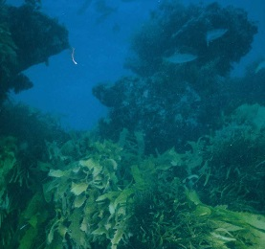

This is the area of natural reserves next to the coast, including marine ecosystems in the water near the shore and native dune vegetation.

Currently, there are about 20,000 square metres of natural reserve (or, about the same sized area as Subiaco Oval).

In 10 years time, without any management action, it is expected that the area of natural reserves will be only 25% (a quarter) of the current area.

Different hazard management actions could lead to increases or decreases in the amount of foreshore reserve, ranging from:

  - 25% of the current natural reserve (5,000m²) – the expected area in 10 years time
  - 50% of the current natural reserve (10,000m²)
  - 75% of the current natural reserve (15,000m²)
  - 100% of the current natural reserve (20,000m²) – i.e. there is no change from today

4. Beach access

This includes the provision of pathways and stairs that service the beach, as well as ramps for disability access.

Currently beach access is good, with there being pathways, stairs and ramps leading down to the beach about every 50 metres.

In 10 years time, without any management action, it is expected that accessibility will be average, with some pathways, stairs and ramps no longer connecting to the beach, meaning the distance between access points will be 200 metres.

Different hazard management actions could change the accessibility to either:
  - Poor, with only one access point to the beach
  - Average, with access points every 200m – i.e. the expected amount in 10 years time
  - Good, with access points every 50m – i.e. there is no change from today

5. Retail, dining & club facilities
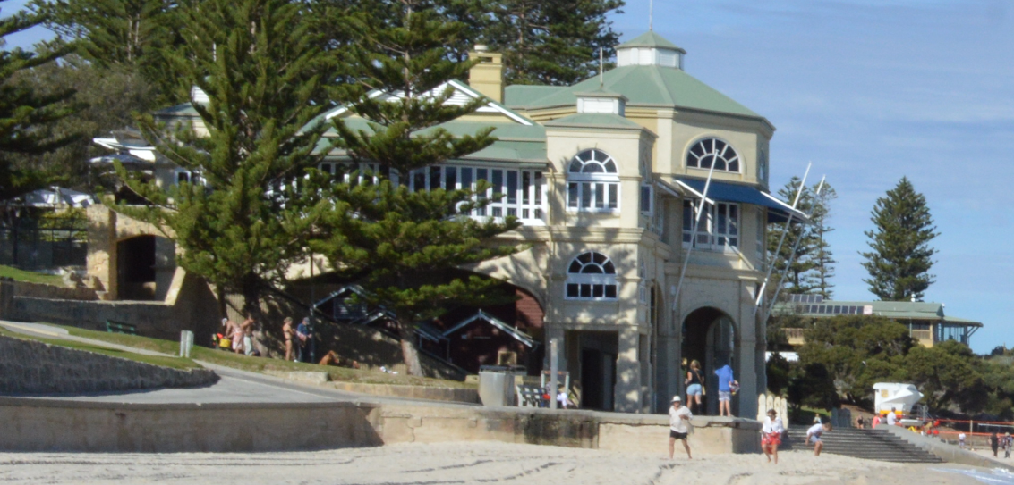

This includes the provision of retail, food outlets and other public services along the foreshore reserve.

Currently, the services provided include cafés, restaurants and surf club facilities.

In 10 years time, with no management action, it is expected that foreshore space will not be able to support any of these facilities.

Different hazard management actions could mean that these facilities are either:

  - Absent, where current facilities deteriorate and are removed – i.e. the expected situation in 10 years time
  - Present, where current facilities are maintained – i.e. there is no change from today

Q2.2) Do you have any opinions about the state of the coastal features we have described, in terms of the way they could change in size, amount or presence, due to impacts from coastal hazards and their management?
(you may skip this question if you prefer)
________________________________________________________________________________________________________________________________________________________________________________________________________________________________________________________________________________________________________________________________

What can we do?
To maintain the current condition of the coastal features described above, additional funds are required to increase the budget that Western Australian Local and State Government agencies have available to manage our coastal environments.
Sourcing additional funds to invest in coastal hazard management at Cottesloe Beach could be achieved through a special State Fund, where payments are collected from all Western Australian households.

PART 3 – Management scenarios
In this part, you will be asked a number of questions about the outcomes of management for the coastal features described in Part 2.
Note that while the questions are hypothetical, and the specific management actions are not described, the outcomes in each question have been deemed feasible by experts and can be achieved through combinations of different management actions.
The management costs associated with improving outcomes of these features will be raised through a State Fund, with payments collected from Western Australian households. The funds collected would be used specifically for managing the impacts of coastal hazards.
These payments will apply for a period of 10 years, with the management outcomes achieved by the end of this period.

Please read the following guidelines before proceeding further:
- You will be presented with 5 hypothetical management scenarios. Each question should be treated independently.
- In each scenario, you will be presented with 3 options. Each option offers a different combination of outcomes for the coastal features. The combinations are different according to the size, amount or presence of each feature offered in 10 years time. They also differ according to the management cost. The increased cost to you is presented as an annual figure to be paid for a period of 10 years.
- In each scenario, you will be asked to choose the option that is most appealing to you. You need to be mindful of your own financial circumstances, i.e. consider the limit of how much you can realistically afford given your current household income and personal expenses.
- We will be surveying a large number of people to work out the values held across the WA community.

The findings that emerge from this study may be used to inform future investment decisions for managing the impact of coastal hazards at Cottesloe Beach.

Here is an example of the type of question you will have to answer.
When answering the management scenarios, don’t forget to:
- Consider each option (looking down each column)
- Keep in mind what you can afford when weighing up the cost of each option
- Choose your most preferred option based on the assumption that these are the only options available to you
- Treat each management scenario independently. You don’t need to remember or anticipate the choices you make across the series of scenarios.
You can make your selection by clicking on the box containing the option.
Once you have selected it the box will turn green. You should only select one.
In the example below, the respondent has decided that they are prepared to pay $50 a year for the next 10 years to ensure greater protection of the Foreshore reserve and retail, dining and club facilities, even though the area of Sandy beach will be reduced further.
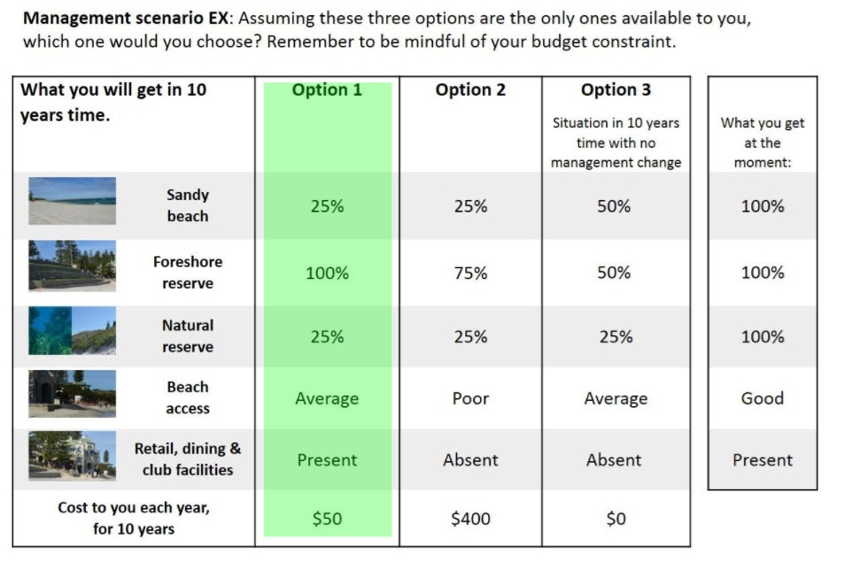
Now we would like you to answer 5 of these questions

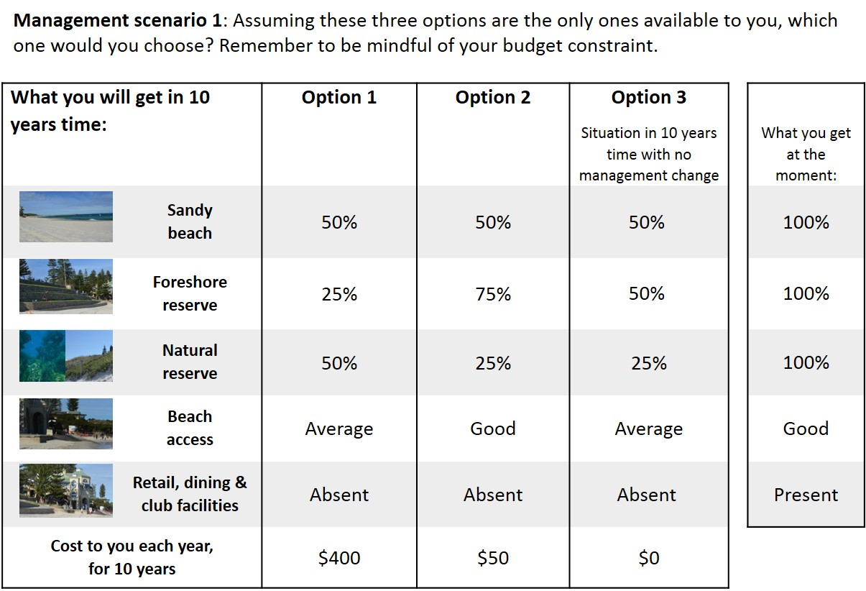

A reminder of what is meant by each term is available here:
Sandy beach
Foreshore reserve
Natural reserve
Beach access
Retail, dining & club facilities
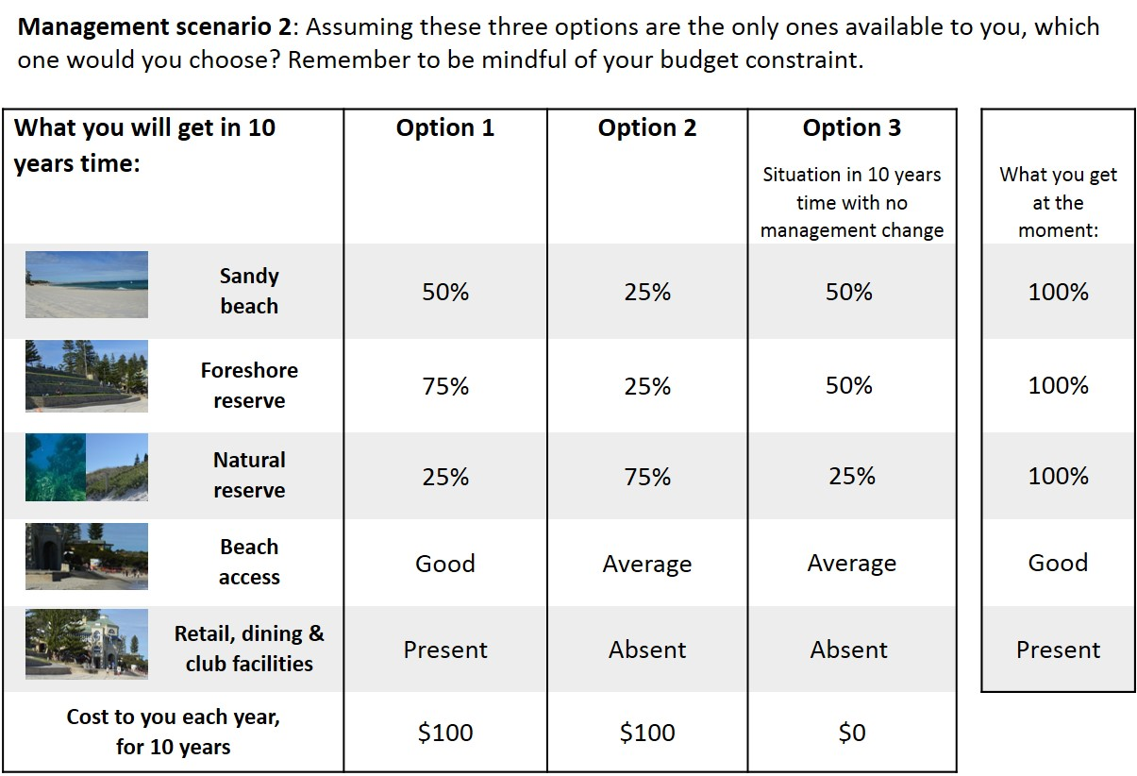

A reminder of what is meant by each term is available here:
Sandy beach
Foreshore reserve
Natural reserve
Beach access
Retail, dining & club facilities

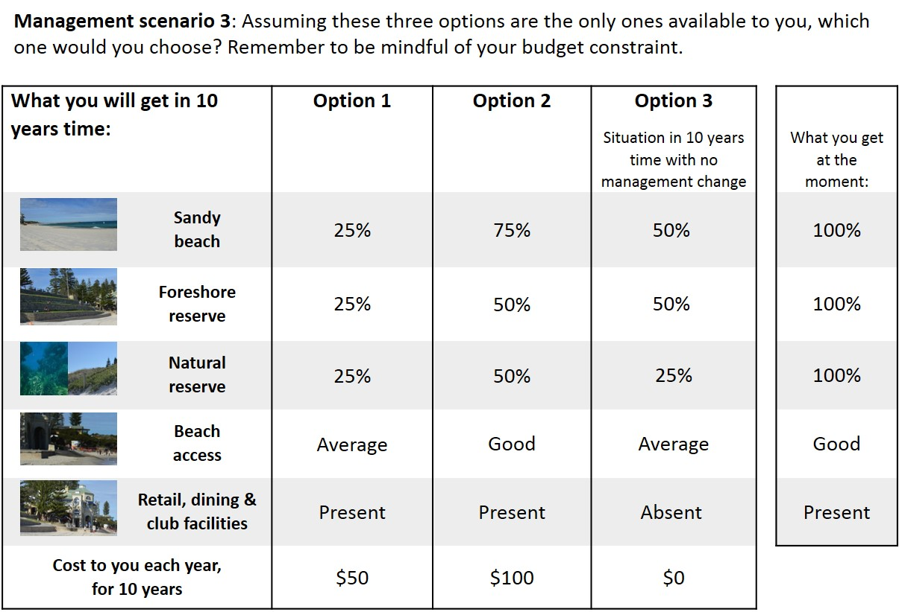

A reminder of what is meant by each term is available here:
Sandy beach
Foreshore reserve
Natural reserve
Beach access
Retail, dining & club facilities
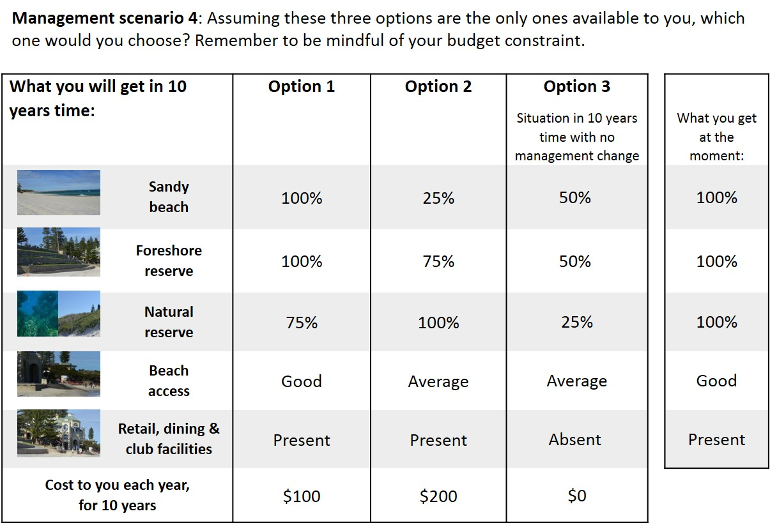

A reminder of what is meant by each term is available here:
Sandy beach
Foreshore reserve
Natural reserve
Beach access
Retail, dining & club facilities
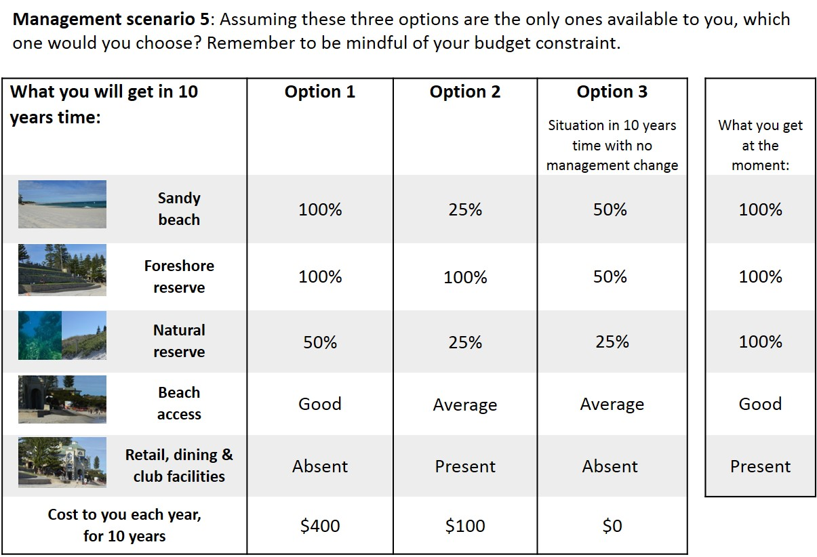

A reminder of what is meant by each term is available here:
Sandy beach
Foreshore reserve
Natural reserve
Beach access
Retail, dining & club facilities
[Question answered if respondent always selected Option 3]
Q3.SQ) You selected Option 3 (the situation in 10 years time with no management change) for ALL 5 management scenarios.
Please provide your reason why, choosing from the list below:
- I preferred this option to all others
- I could not afford the other options
- I believe funding to manage the impacts of coastal hazards should come from somewhere other than my own pocket
- I believe funding to manage the impacts of coastal hazards should be collected by some other means than a State Fund
- I don’t trust that the funds would be used to manage the impacts of coastal hazards at Cottesloe Beach
- I don’t believe that there will be impacts from coastal hazards (i.e. erosion and/or inundation) during this time period
- I don’t believe I should have to make these choices
- Other (please specify): ............................................................

PART 3 continued
You are now more than 80% of the way through the survey.
There are 9 follow-up questions about the management scenarios and survey in general.

Q3.1) In each management scenario, was the amount of the extra payment required for the different options (i.e. the ‘cost to you each year, for 10 years’) important to you when making your choices?
- Yes
- No

Q3.2) Thinking about the coastal features described in the scenarios, could you rank which were the most important when making your choices?
Rank 1 as most important, 5 as least important.
If you did not care whether the amount of the feature(s) increased/decreased/stayed the same, do not rank the feature.

Coastal Feature: | Rank:
Sandy beach
Foreshore reserve
Natural reserve
Beach access
Retail, dining & club facilities

Q3.3) Did you think about your household budget, and how much you could afford, while making your choices for the scenarios?
- Yes
- No

Q3.4) Did you find the scenarios confusing or particularly difficult to answer?
- Yes
- No

Q3.5) Please indicate on the following scale how certain you were of the answers you gave in the scenarios:
Very uncertain |  |  |  |  |  |  |  |  | Very certain
1 | 2 | 3 | 4 | 5 | 6 | 7 | 8 | 9 | 10

Q3.6) What did you think about the information that was provided to describe the coastal features of Cottesloe Beach?
- I thought it was an informative and accurate description
- I would have liked more information
- I thought the descriptions were inaccurate
- I thought there was too much information
- I though the information was confusing

Q3.7) How useful do you think the results of this study would be to inform future investment decisions about the coastal features at Cottesloe Beach:
Not very useful |  |  |  |  |  |  |  |  | Very useful
1 | 2 | 3 | 4 | 5 | 6 | 7 | 8 | 9 | 10

Q3.8) How likely do you think it is that the results of this study will be used by decision makers to inform future investment decisions about the coastal features at Cottesloe Beach:
Very unlikely |  |  |  |  |  |  |  |  | Very likely
1 | 2 | 3 | 4 | 5 | 6 | 7 | 8 | 9 | 10

Q3.9) Do you have any other comments about the coastal features described for Cottesloe Beach that you would like to add?
You may skip this question if you prefer

________________________________________________________________________________________________________________________________________________________________________________________________________________________________________________________________
PART 4 – Questions about you
You are almost at the end of the survey.
These final questions are to make sure that the group of people that respond to this survey are representative of the general community.
Rest assured that your individual responses will remain confidential and we will only use the collected data in aggregate form.

Q4.1) Which Local Government Area do you live in?
- Armadale, City of  - Bassendean, Town of  - Bayswater, City of  - Belmont, City of  - Cambridge, Town of  - Canning, City of  - Claremont, Town of  - Cockburn, City of  - Cottesloe, Town of [Answer Q4.1a]  - East Fremantle, Town of  - Fremantle, City of  - Gosnells, City of  - Joondalup, City of  - Kalamunda, Shire of  - Kwinana, Town of | - Melville, City of  - Mosman Park, Town of  - Mundaring, Shire of  - Nedlands, City of  - Peppermint Grove, Shire of  - Perth, City of  - Serpentine-Jarrahdale, Shire of  - South Perth, City of  - Stirling, City of  - Subiaco, City of  - Swan, City of  - Victoria Park, Town of  - Vincent, City of  - Wanneroo, City of  - Regional local government area  - Not listed / Unsure

Q4.1a) Do you live within —what you would consider to be— a reasonable walking distance of Cottesloe Beach?
- Yes
- No

Q4.2) What are the streets that form the nearest intersection to where you live?
E.g. Stirling Highway and Bruce Street
We don’t want to know your exact address, but we would like to identify roughly how far it is between your house and Cottesloe Beach.

___________ and ___________

Q4.3) Do you have a view of the ocean or coastal dunes (of any part of the coast, not just Cottesloe) from your usual place of residence and/or employment?
- Yes
- No

Q4.4) Do you belong to any conservation groups?
- Yes – coastal conservation groups; list if you would like to:____________________________
- Yes – other environmental conservation groups; list if you would like to: ________________
- No

Q4.5) Do you belong to any recreational groups associated with the coast? Select all relevant options
- Surf lifesaving club
- Swimming club
- Sailing club
- Recreational fishing club
- Diving club
- Beach fitness/exercise club
- Other (please specify): ........................
- None of these groups

Q4.6) Are you employed or do you volunteer in any of the following fields?
- Coastal management/research/consulting
- Government agencies tasked with coastal responsibilities
- Tourism venture specifically associated with the coast
- Hospitality in a business specifically associated with, or located on, the coast
- Boating industry
- Fishing industry
- Other field associated with the coast (please specify): ..................
- None of these fields

Q4.7) Which of the following household descriptions best fits you?
- Single without children
- Single with children – at least some of the children are still dependent
- Single with children – with all children having left home
- Couple without children
- Couple with children – at least some of the children are still dependent
- Couple with children – with all children having left home
- Other (please specify): ………………………….

Q4.8) What is your highest level of education?
- Schooling up to Year 10
- Schooling up to Year 12
- Trade or technical certificate
- University degree (Bachelor, Master, PhD)

Q4.9) What is your gross annual income (i.e. before tax)? Please provide your shared household income if you have joint management of household finances: otherwise provide your personal income.
- Under $13,000 (under $250/week)
- $13,000-$25,999 ($250-$500/week)
- $26,000 - $41,599 ($500-$800/week)
- $41,600 - $62,399 ($800-$1200/week)
- $62,400 - $88,399 ($1200-$1700/week)
- $88,400 - $129,999 ($1700-$2500/week)
- $130,000 - $181,999 ($2500-$3500/week)
- $182,000 and over ($3000+/week)
- I would rather not say

Q4.10) If you have any further comments, please note them in the box below:

Thank you for completing this survey – your time is greatly appreciated!

