Positive behaviour support
This information sheet provides an overview of the key elements of positive behaviour support and is part of a series of information sheets that have been developed to help everyone understand the ‘Authorisation of Restrictive Practices in Funded Disability Services Policy’ (the Policy) that applies in Western Australia from 1 December 2020.
For further detailed information please refer to the authorisation of restrictive practices website.

Positive Behaviour Support (PSB) and the Policy
The principles outlined in the Policy are aligned with contemporary application of PBS. Positive behaviour support is an evidence-based framework consisting of four main elements:
- Developing an understanding about why challenging behaviours occur by assessing the impact of the social environment, physical environment and broader context on the person with disability.
- Involving stakeholders and capturing their perspectives.
- Using the emerging understanding from assessment to implement and evaluate a person-centred sustainable support system around the person with disability.
- Focusing on enhancing quality of life outcomes for the person with disability and those around them.
Under the Policy, regulated restrictive practices are used in the context of safeguarding a person with disability and/or those around them due to that person engaging in challenging behaviour. Challenging behaviour is understood to be a symptom of unmet needs. A person may show these behaviours when their key needs are not met.
The functional impact of disability often means that people with disability rely heavily on the people around them to understand what they need, and support those needs to be met. In the case of complex disability and/or complex circumstances around a person’s life, it can be difficult for key stakeholders to recognise and meet important needs for the person with disability.
The intent of the Policy is to support the reduction and elimination of the use of restrictive practices for people with disability in WA. The following section describes important elements of PBS that can assist NDIS Behaviour Support Practitioners and Implementing Providers in the process of supporting people with a view to finding alternatives to restrictive practice.

PBS and behaviour support plans
Under the NDIS Commission Positive Behaviour Support Capability Framework (2019) and the Policy, NDIS Behaviour Support Practitioners are required to practice consistently with the guiding principles of PBS in the provision of behaviour support services. Under the Policy, NDIS Behaviour Support Practitioners are required to develop a behaviour support plan (BSP), which captures information about a person and how to support their needs, and also provides details of the proposed restrictive practices to support the Quality Assurance Panel process.
Following is an overview of some key elements of PBS informed behaviour support planning that are important for practitioners to hold in mind in the delivery of behaviour support interventions, including in the development of a BSP for authorisation of restrictive practice under the Policy.

Focusing on unmet needs and not just behaviour
NDIS Behaviour Support Practitioners are often engaged to develop BSPs in the context of often challenging and sometimes confronting behaviours, which may be impacting significantly on the person with disability and/or those who love them and interact with them.
The natural tendency when faced with behaviour is to turn the focus to the behaviour. PBS recognises that behaviour happens in a broader environment and is often a sign that much more is going on for the person than just the behaviour that can be seen. In this way, behaviour is often referred to as just the “tip of the iceberg”.
Using a PBS lens, we turn our attention to the multiple factors that can influence what a person may experience.
The diagram on page 3 (figure 1) highlights some of the factors that can influence what a person needs and experiences. Contemporary approaches to PBS recognise that unmet needs can significantly impact on our ability to feel calm, regulated and connected to others. When this occurs, challenging behaviour may result as an expression of those unmet needs.
Figure 1: Factors that influence needs and behaviour
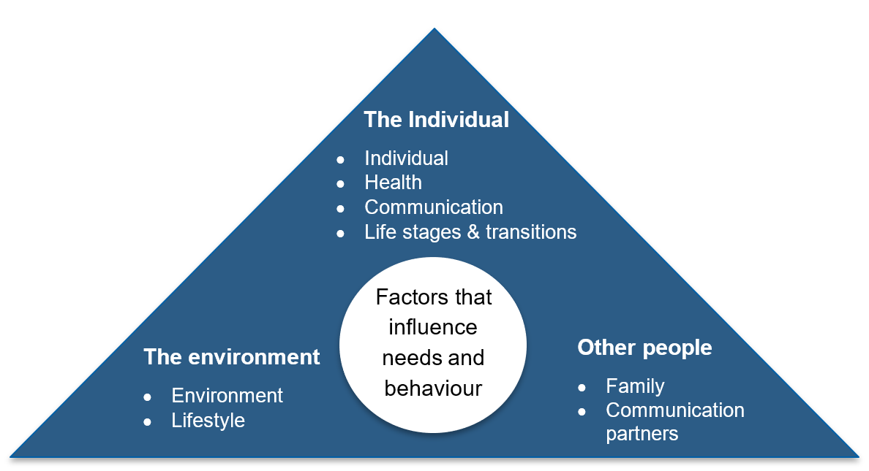
Factors that influence what a person experiences
It is recognised that there are some core, or foundational, needs that we all have, including the following:
- The need for predictability, choice and control.
- The need to be able to process and make sense of information.
- The need to communicate with others.
- Social interaction and sense of belonging needs.
- Sensory regulation needs.
- The need to experience pleasurable meaningful engagement and to have a sense of purpose.
It can be helpful to visualise these needs as the foundation upon which a house is built, where the house represents living our best life.
Supporting a good life requires careful attention to understanding and meeting foundational needs that we all have
It is therefore very important that NDIS Behaviour Support Practitioners consider a range of individual needs, regulation needs, and needs related to the functional impact of the disability as well as environmental factors that are very likely influencing the behaviour that can be seen, and ensure these are described within the BSP. It is not adequate or appropriate to only explore and describe the behaviour that is observed when developing a BSP.

Engaging with the person and key stakeholders
Exploration of unmet needs and the impact of environment in meeting those needs requires working in partnership with key people or stakeholders in the life of the person. This may include close family members, support workers, as well as other professionals in the person’s life.
Some of the principles for NDIS Behaviour Support Practitioners to hold in mind when engaging a person and the stakeholders around them when developing a BSP include:
- A person-centred approach: holding the person at the centre of the process.
- Develop empathy for the person by engaging with those around them to better understand what the person may be experiencing and how their behaviour is likely an indicator of distress and significant unmet needs.
- Systematic collaboration and participation: the person, family and support system are involved and contributing.
- The NDIS Behaviour Support Practitioner adopts a ‘non-expert’ approach: recognising that the experts about the person are the person themselves and those closest to them, and drawing on the expertise and knowledge of the people around the person, including family members. The practitioner adopts a facilitative approach when working with others.
- Listen and validate the experience of people impacted by behaviour.
- Empower, encourage and support system knowledge and change, as well as self-determination for the person and those who support them.
- Use respectful, clear and appropriate communication.
- Adopt an inclusive, non-discriminatory approach and be sensitive to and considerate of other cultures and experiences.
- Identify and work with people within the system who take on the role of champions or advocates for the needs and rights of the person as well as those who support them.
- A strengths-based approach in relation to the person as well as those around them: aiming to identify and work from strengths supports recognition of what is working and also supports empowerment of others.
Exploration mindset
In the process of engaging with the person and stakeholders, it is also important that the NDIS Behaviour Support Practitioner adopts what can be viewed as an exploration mindset. An exploration mindset refers to the practitioner being neutral and willing to accommodate a range of views and information, and not jumping too quickly to making assumptions or adopting a common narrative or view as to why the behaviour is occurring.
To be neutral, the practitioner must be curious and willing to explore different perspectives and accommodate and consider potentially conflicting information. It is important that the NDIS Behaviour Support Practitioner develops hypotheses or potential explanations for what factors may be influencing or driving a behaviour.
This ensures that curiosity is intentional, not aimless, and guided by clues about unmet needs for the person and/or the system around them that emerge through the process of engaging with others. It is important that the NDIS Behaviour Support Practitioner remain flexible and tentative in the hypotheses they develop and be prepared to discard them if the emerging information no longer supports them.
The final element of an exploration mindset is to be solution-focused and explore exceptions to problems. Much can be learned by exploring what happens when challenging behaviours are not present and by being curious about what needs may be met for a person when the challenging behaviour does not occur. Indeed, this is often a very powerful way of drawing on strengths of the person and the system to better match supports to needs, with a result of less presence of challenging behaviour and better quality of life outcomes for all involved.

Functional Behaviour Assessment
Functional Behaviour Assessment (FBA) through a PBS lens can best be understood as the process of establishing an understanding of the needs of the person and the system around them in partnership or collaboration with the key people involved. Therefore, the goal of FBA is to collaboratively develop a shared understanding of the needs of the person with the system/stakeholders around them. This shared understanding of needs facilitates the development of supports which can result in:
- improved quality of life for the person and those around them
- reduced challenging behaviour and resultant reduction in or elimination of the use of restrictive practices.
See the ‘Behaviour Support Plan requirements’ information sheet (listed on the restrictive practices resources page under ‘Providers and Behaviour Support Practitioners) for further details about components of an FBA for inclusion as part of a BSP.

PBS and Quality Assurance Panels
Quality Assurance Panels play an important safeguarding and quality assurance role under the Policy.
It is important that the decision-making Panel members have a working understanding of PBS in order to provide a considered critique as to whether the requirements outlined in the Policy and ‘Procedure guidelines for authorisation of restrictive practices in NDIS funded disability services – Stage two’ (Procedure Guidelines) have been sufficiently addressed as documented in the BSP. The independent external NDIS Behaviour Support Practitioner is expected to have an applied understanding of the application of PBS in clinical practice.
Specific considerations in addressing each of the principles as outlined in section 4.1.2. of the Procedure Guidelines (BSP is evidence-based) are detailed in the ‘Principles guiding the use of regulated restrictive practices’ information sheet (listed on the restrictive practices resources page under ‘Providers and Behaviour Support Practitioners’).
Also see the Quality Assurance Panel information sheets listed on the restrictive practices resources page for more information about the Quality Assurance Panel process and roles of decision-making Panel members.

PBS and requirements for justification of restrictive practice(s)
The Policy notes that Implementing Providers need to have explored and applied alternative evidence-based person-centred and proactive strategies to address challenging behaviours before resorting to the use of restrictive practices.
In the context of a PBS framework, a range of evidence-based and person-centred approaches can be accommodated.
The function of the behaviour as a means of communicating a need or unmet needs within environment(s) should be considered and documented within the BSP. In addition, supports to meet those needs should be identified, even if those supports are under development.
Proactive strategies refer to both environmental and skill supports being designed and implemented to assist the person and the people around them to support their needs.
It is important that information is available to demonstrate that supports have been considered and/or are under development as part of satisfying the Quality Assurance Panel that the restrictive practice(s) is the least restrictive and most appropriate means of supporting a person safely at that point in time.

Contact information
For enquiries about the Policy, please contact the Department of Communities – authorisation of restrictive practices team:
Email: ARP@communities.wa.gov.au
Phone: 08 6217 6888 or free call 1800 176 888
Voice relay: 1300 555 727
Teletypewriter (TTY): 133 677
SMS relay: 0423 677 767

References
- Gore, NJ, McGill, P, Toogood, S, Allen, D, Hughes, JC, Baker, P, Hastings, RP, Noone, SJ, and Denne, LD (2013), “Definition and scope for positive behaviour support”, International Journal of Positive Behavioural Support, 3,2.
https://www.bild.org.uk/positive-behaviour-support-pbs/
- NDIS Quality and Safeguards Commission Capability Framework (2019) https://www.ndiscommission.gov.au/pbscapabilityframework
[Last updated June 2021]

Gore, McGill, Toogood, Allen, Hughes, Baker, Hastings, Noone and Denne, 2013

