Premier’s Circular
Number: 2021/10
Issue Date: 04/11/2021
Review Date: 30/06/2025

TITLE

MAKING WRITTEN SUBMISSIONS TO NATIONAL INQUIRIES

POLICY
This policy, including the process for making written submissions to national inquiries as outlined in the attached guidelines (Attachment 1), applies to all Western Australian public sector bodies.
The Western Australian Government receives numerous requests to make written submissions to national inquiries. Requests are generally issued to the Premier, directly to public sector bodies, or through general public invitation. The Government will only submit responses in areas of high priority or strategic value to the State. Written submissions must represent a whole of Government view. The process is detailed in Attachment 1.
A Western Australian public sector body may also receive requests to:
- make written submissions from international inquiries, other State and Territories, and local government authorities. In this event, please inform the Department of the Premier and Cabinet (DPC) by email to national.inquiries@dpc.wa.gov.au; and/or
- attend Parliamentary Committee inquiries (State or Commonwealth) or for officers to appear as witnesses. In this event, the principles and obligations outlined in the Public Sector Commissioner’s Policy for Public Sector Witnesses Appearing Before Parliamentary Committees (Public Sector Commissioner’s Circular 2010/03) will apply.

This policy does not apply to government trading enterprises and other entities listed in Schedule 1 of the Public Sector Management Act 1994. If such organisations intend to make a written submission to a national inquiry, please email DPC at national.inquiries@dpc.wa.gov.au for guidance on whether the submission should indicate that the views represented are not those of the Western Australian Government.

BACKGROUND
Committees of the Commonwealth Parliament (Senate Committees, House of Representative Committees or Joint Committees), various Commissions (e.g. Productivity Commission), and agencies of the Commonwealth Government and other States and Territories regularly conduct inquiries into matters of policy, government administration and public significance. In the course of its investigations, an inquiry may seek the input of interested parties through written submissions, surveys, roundtables, workshops and public hearings.

Mark McGowan MLA

PREMIER

For enquiries contact: Department of the Premier and Cabinet
national.inquiries@dpc.wa.gov.au
6552 5000
Other relevant Circulars: Public Sector Commissioner’s Circular 2010/03
Circular/s replaced by this Circular: 2010/03, 2017/06

ATTACHMENT 1 - GUIDELINES FOR MAKING WRITTEN SUBMISSIONS TO NATIONAL INQUIRIES

PRINCIPLES
The Western Australian Government receives numerous requests to make written submissions to national inquiries. In some instances making a submission provides an important opportunity to influence policy in areas of high priority or strategic value to Western Australia. In others, making a submission may be of limited value to the State.
Public sector bodies should take early action to decide whether to prepare a response, and consider the following:
- State public sector resources should only be dedicated to making a submission in areas of high priority or strategic value to the State; and
- Other inter-governmental mechanisms between the Commonwealth and the State may more effectively communicate the State’s point of view.
The preparation of responses must represent a consolidated Western Australian Government view.

PROCESS
The process below applies to all public sector bodies making a written submission to a national inquiry.
- Receiving a request
If the Chairperson of a national inquiry writes to the Premier inviting the Western Australian Government to make a written submission, DPC liaises with the relevant Minister’s Office to initiate and facilitate the approvals, development and lodgment processes for the submission.
If a public sector body receives a direct request to make a written submission to a national inquiry, they inform DPC as soon as possible, by email to national.inquiries@dpc.wa.gov.au.
- Obtaining approval to develop a submission
Before developing a submission to a national inquiry, public sector bodies obtain approval from the relevant Minister. They also seek approval from DPC by completing and emailing Attachment 2 to national.inquiries@dpc.wa.gov.au.

- Coordinating the development of a written submission
Once approval to develop a submission has been given, the following applies:
- If the subject of the inquiry affects a single department or agency – the department or agency develops the submission; or
- If the subject of the inquiry affects two or more departments or agencies – a lead agency, or DPC where relevant, coordinates a whole of Government submission.
- Consulting when developing a submission
To ensure that responses represent a consolidated Western Australian Government view, agencies consult with DPC when developing a written submission.
If the submission covers Commonwealth-State financial relations or raises issues with resourcing implications, public sector bodies consult with the Department of Treasury when developing the submission.
If the submission covers legal issues, including constitutional issues, or Western Australia’s obligations under Commonwealth legislation, public sector bodies consult with the State Solicitor’s Office, other than in straightforward cases.
DPC can help public sector bodies determine whether consultation with the Department of Treasury and/or the State Solicitor’s Office will be necessary. Please contact national.inquiries@dpc.wa.gov.au.
- Obtaining approval to lodge submissions
Non-contentious submissions
If the initial request was sent to the Premier, and the submission is not contentious, the public sector body developing or coordinating the submission forwards the final submission to DPC. DPC arranges for the submission to be approved by the Premier and lodged by DPC on behalf of the Premier.
If the initial request was received directly by a public sector body or by general public invitation, and the submission is not contentious, the public sector body developing or coordinating the submission obtains the approval of the relevant Minister to lodge the submission. Prior to lodging the submission, the public sector body provides a copy of the submission to DPC.
Contentious submissions
If a submission covers significant, contentious and/or emerging policy issues, the public sector body obtains approval from Cabinet to lodge the submission. If Cabinet approves, DPC lodges the final submission to the inquiry on behalf of the Premier.
DPC can help public sector bodies determine what is a significant, controversial or emerging issue. Please contact national.inquiries@dpc.wa.gov.au.
The process for making a written submission to a national inquiry is illustrated in Attachment 3.

Name/subject matter of the inquiry
Name of the body conducting the inquiry
(e.g. the Productivity Commission; the Commonwealth House of Representatives Standing Committee on Employment, Education and Training)
Due date for submission or response
Brief outline of proposed content of submission
How does the proposed submission relate to areas of high priority or strategic value to Western Australia?
Other portfolios and agencies affected
The proposed submission will: (please select all that apply)
- cover Commonwealth-State financial relations or raise issues with resourcing implications
- cover legal issues, including constitutional issues, or Western Australia’s obligations under Commonwealth legislation
- cover non-contentious issues only
- contain mainly factual or technical information
- relate to a contentious topic (please provide details below)
- relate to a new or emerging policy position of the Western Australian Government (please provide details below)
Details
Other jurisdictions expected to make a submission, and any details (if known)

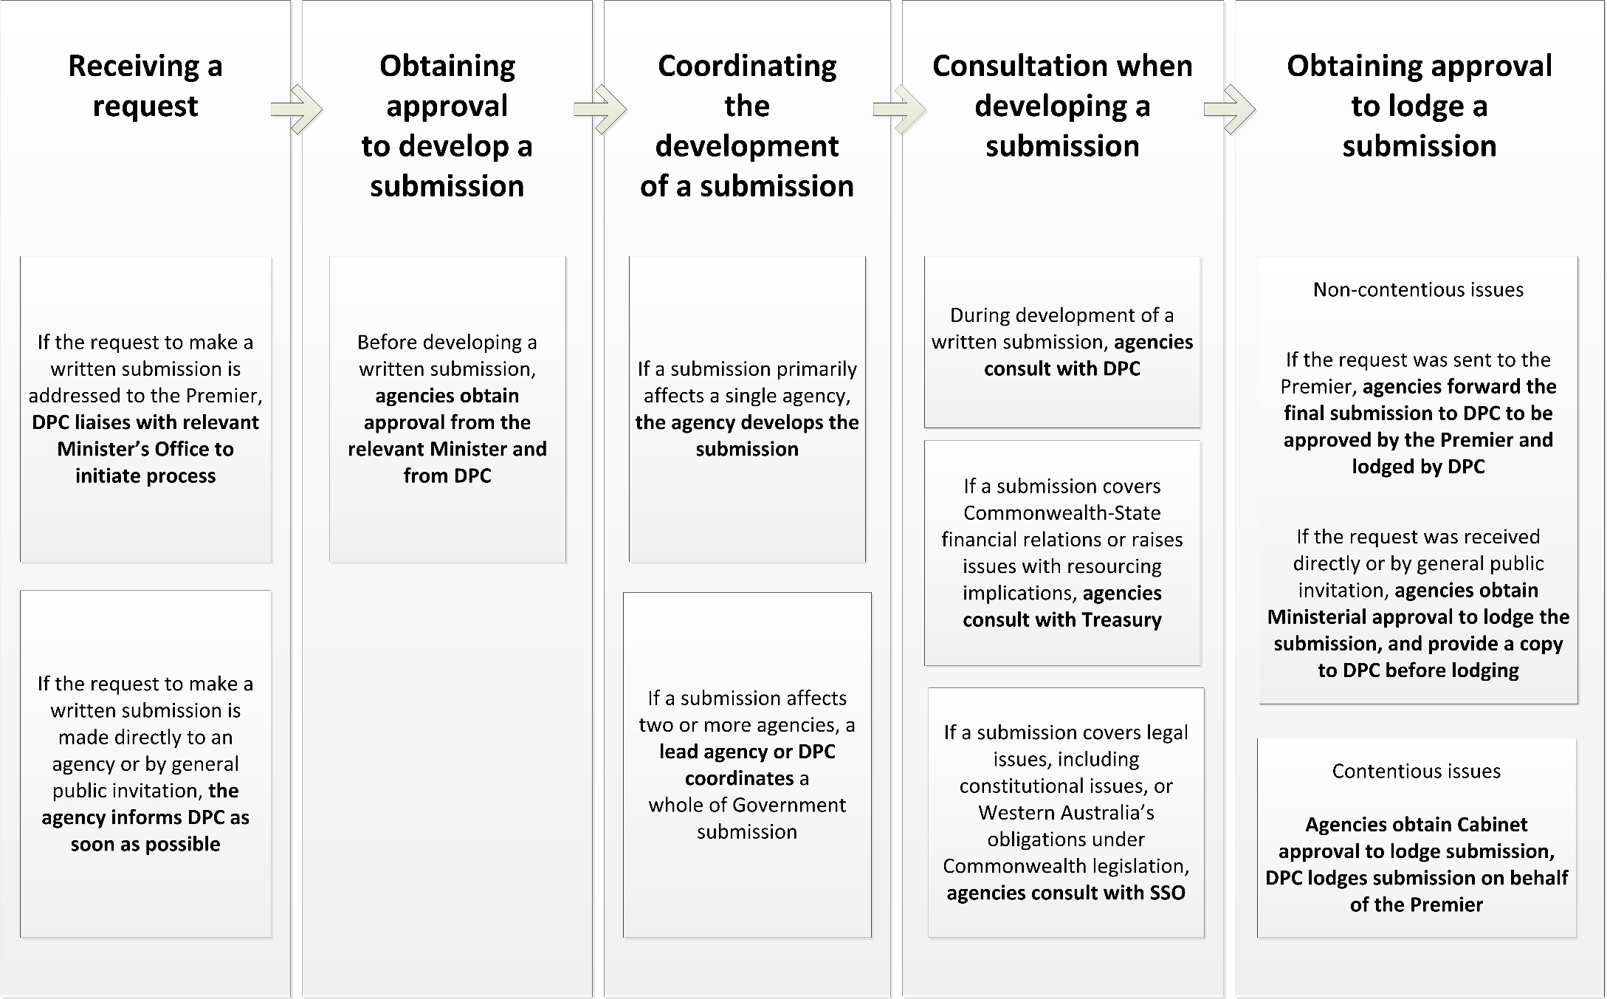

“Public sector body” is defined in section 3 of the Public Sector Management Act 1994 (the Act) to mean “agency, ministerial office or non-SES organisation”.

