X-TEND WA
Round 3 Guidelines
2021 New Industries Fund

Contents
1. Introduction 2
2. The objectives of the NIF 2
3. Overview and objective: X-TEND WA Program 3
4. Scope of activities 3
5. Eligibility criteria 4
6. Evaluation criteria 5
7. Co-investment 6
8. Follow on funding 6
9. How the application process works 6
9.1. Stage 1: Develop and submit your application 7
9.2. Stage 2: Eligibility checks 7
9.3. Stage 3: Evaluation 7
9.4. Stage 4: Notification of Outcome 8
10. How the funding works 10
11. Other terms and conditions 10
11.1. Reporting 10
11.2. Freedom of Information Act 1992 11
11.3. Conflict of Interest 11
11.4. Tax Information for Applicants 11

Introduction
The Western Australian Government has reinvested another $16.7 million in the New Industries Fund (NIF) over four years (2021-25) that will continue to support and accelerate new and emerging businesses to diversify the Western Australian economy and create new WA jobs and industries.
Building jobs and new industries requires an industry-led approach to innovation and business competitiveness. The NIF was initially established in 2017 to support a self-sustaining innovation environment that encourages collaboration and private sector investment. This is helping grow State and regionally significant competitive advantages, and helping to create the required levels of skills for the jobs of the future.
The NIF is run by the Western Australian Department of Jobs, Tourism, Science and Innovation (JTSI). The NIF provides funding for a number of initiatives to foster an innovative and diversified Western Australian that is competitive, sustainable and attractive to investors, industry and entrepreneurs.
This document is written for organisations who wish to apply for the X-TEND WA Program. If you have any questions about the NIF or the program please contact the innovation staff at innovation@jtsi.wa.gov.au.

The objectives of the NIF
To support and accelerate new and emerging businesses in order to diversify the Western Australian economy and create new jobs and industries. This will be achieved through a focus on four pillars of work:
• Talent, Skills and Entrepreneurship
A sustainable innovation environment requires the right people with the right skills. Western Australia needs to develop, attract and retain the right people.
• Investment and Infrastructure
Infrastructure and capital are important to innovation to enable the collaboration necessary for startups, emerging businesses and SME’s to grow, commercialise and create jobs.
• Culture and Collaboration
Western Australia has significant human, natural and infrastructure assets. By fostering the right culture, and facilitating collaboration, Government can maximise their value.
• Marketing and Promotion
Raising the State’s profile on the global stage is essential. Leveraging the State brand will allow WA’s strengths to become synonymous with innovation, and critical global networks to be forged.

Overview and objective: X-TEND WA Program
Ensuring the NIF supports those industries where there is potential for job growth is critical to the future of Western Australia. WA is fortunate to have talented people and many competitive advantages. The State Government is leveraging and building on these competitive advantages and focusing on growing industries that enrich lives, create jobs and diversify the economy.
In order to create new jobs and industries there is a recognised need for services to expand the capability of entrepreneurs and support their innovation journey.
There is also a need to expand the educational opportunities of investors and corporates to deliver better access to investment capital to coincide with the journey of entrepreneurs and innovative business owners in Western Australia.
The X-TEND WA Program is a competitive co-investment grants program that will invest in organisations that deliver programs that assist Western Australian entrepreneurs, startups, emerging businesses and small to medium sized enterprises to grow their capability to better navigate their commercialisation journey. It will also fund organisations that run programs that enhance investor education, engendering confidence for investment in innovative projects in Western Australia.
Funding for the X-TEND WA Program is subject to available funds. All funding decisions are final and at JTSI’s absolute discretion.
Funding may be available up to, but will not exceed, $100,000 (+GST) per entity.
A valid application does not automatically entitle an applicant to funding under the X-TEND WA Program.

Scope of activities
JTSI is seeking applications which support the development of entrepreneurs and investors and may take the form of educational forums, mentoring, ideation, incubator, accelerator, scale up and investor ready programs. Programs are to be delivered over 12 months. JTSI will accept applications from entities, with a proven track record of success and deliver activities in one or two of the following two streams:
- Entrepreneurial education – programs which equip entrepreneurs with the understanding and skills to successfully navigate the commercialisation process. Examples includes business mentoring, ideation, incubator, accelerators, scale up and investor ready programs where there is a strong market need. High valued programs which provide entrepreneurs, startups or SME’s with high impact potential to build successful, sustainable and scalable businesses are strongly encouraged.
- Investor education – programs which educate and activate current and potential investors, through providing best practice tools to make more successful investment decisions for investing in local innovation ventures. By doing so this will encourage the availability of more private capital for emerging industries, improving overall outcomes for Western Australian enterprises.
A focus on diversity and inclusion is strongly encouraged in all applications.
X-TEND is open to all investor markets and industry sectors (including growing sectors such as technology accessibility, circular economy, decarbonisation and indigenous entrepreneurship) that clearly demonstrates a strong market need.
The program must be delivered in Western Australia and contribute towards the growth of the innovation community. Applications that strengthen innovation ecosystem collaboration and improve access to, or participation in, the Western Australian innovation community are encouraged.

Eligibility criteria
The X-TEND WA Program supports activities that have strategic merit consistent with the current WA Science and Innovation Framework and initiatives contained within the NIF.
In order to be considered eligible, and to be included in the evaluation process, an application must be received via the X-TEND WA online grant platform by the due date and time, 11am AWST Wednesday 1 December 2021. Applications will not be accepted after this time and will not be accepted outside of the X-TEND WA online grant platform.
Applications must also meet the following criteria:
- Have an Australian Business Number (ABN) and/or Australian Company Number (ACN);
- Have your business/organisation’s (including not-for-profits) registered business address in the State of Western Australia; or
  - be an Australian business/organisation not located in the State of Western Australia, that agrees to register a business address in the State of Western Australia.
- Be made by a valid legal entity that can enter into a funding agreement with the Western Australian Government;
- Be a solvent Western Australian based non-government organisation (business or not-for-profit);
- Put forward a program proposal that aligns with one or two of the streams within the Scope of Activities, as indicated at Item 4 above;
- Clearly explain how the proposal will contribute to job creation in Western Australian; and
- Includes a project plan that includes a timeline, deliverables, a clear and reasonable budget, resources, risks, IP management, stakeholder engagement and how impact/success will be measured.
Employees and Officers of JTSI, and their immediate families, are not elegible to apply.
Previous X-TEND Progam recipients may apply for the same program but must demonstrate a strong market need.

Evaluation criteria
Eligible applications are required to address the following Evaluation Criteria via the X-TEND WA online grant platform that includes a word count for each section. The applications will be scored against the Evaluation Criteria to determine the extent to which the application meets the investment requirements of Government and whether they offer value for money as an investment and against other applications. The New Industries Fund will invest up to, but not exceeding, $100,000 (+GST) per successful application. Applications seeking funding in excess of $100,000 will not be considered.
The six, equally weighted Evaluation Criteria used to assess application are as follows:
- The extent to which the program provides a comprehensive solution to a market need within the Western Australian innovation community.
- Uniqueness – applications will need to demonstrate how the program is unique in the innovation space. Uniqueness may be supported by verification of ownership of the program.
- Contribution to one or more of the NIF pillars (building talent and skills, culture and collaboration, investment and attraction, marketing and promotion).
- Return on investment to the State, including job creation and economic diversification.
- Capability and capacity of proponent to deliver the program, including track record.
- Feasibility of the proposed program, including risk, affordability and a project plan which includes how the program will be promoted to attract the maximum number of people within the target audience and how you will measure the success of the program.

Co-investment
A 1:1 co-investment is preferred in this process. However, it is recognised that some vital programs may not be able to attract this level of co-investment. As such partial or non-matched co-funding applications may be considered and evaluated on a case by case basis where a demonstrated market need is shown and at JTSI’s absolute discretion.
Recipient’s are required to provide evidence to JTSI of their co-investment before any funding is paid. The co-investment cannot comprise or include funds, sponsorship or otherwise from the Western Australian State Government.

Follow on funding
Applicants are invited to identify if their program will run for 1 or 2 years in the application process. Successful X-TEND recipients will be funded for an initial 12 months. Additional follow on funding for the second year, (not exceeding $100,000) may be considered based on the proven outcomes from the program so far; a demonstrated strong market need; and is subject to available government funding and at JTSI’s absolute discretion.

How the application process works
Timeline for Round 3 funding
Closing date | Applications lodged no later than 11:00am (AWST) Wednesday 1 December 2021
Eligibility checks | December 2021
Evaluation | December 2021
Funding offers | January 2022
Funding agreements in place | February 2022
Programs funded completed | February 2023

To be considered for funding for the X-TEND WA Program, your application must be received by 11:00AM (AWST) Wednesday 1 December 2021. Successful applicants will be required to be available to sign documentation throughout January 2022.
The application evaluation comprises four stages and each stafe is described below.

Stage 1: Develop and submit your application
Applicants should consider New Industries Fund - Guidelines for Applicants X-TEND WA Program prior to completing their written application. Applications can be completed online via the X-TEND online grant platform.
To be considered for funding for the X-TEND WA Program your application must be received by 11:00am (AWST) Wednesday 1 December, 2021.
JTSI officers cannot review and quality check your application. However, you should feel free to ask questions, especially if you would like to clarify the requirements.

Stage 2: Eligibility checks
Once you complete your application it will be assessed by JTSI to make sure that it has all the required information and meets the basic criteria for the program.
If your application does not meet these basic requirements it will not be assessed further. You will be notified via email at the end of the process.
In some circumstances (for example, if a simple point needs to be clarified) JTSI officers may contact you to request additional information to assist with progressing your application. See Item 5 for eligibility criteria.

Stage 3: Evaluation
Your application will be evaluated to determine the extent to which the application meets the investment requirements of Government and whether they offer value for money as an investment.
There will be multiple applications competing for a finite pool of funds and so there will be a competitive assessment to identify the strongest applications.
JTSI will draw on a range of information to understand and assess your application. The application form, and its supporting documentation, will be the first piece of information JTSI considers.
The panel may also draw on information that it gathers from referees and financial due diligence checks conducted by the panel and JTSI officers.
Evaluation panel members will be required to complete a conflict of interest declaration and any conflicts will be managed.
All applications will be evaluated using the same six criteria which are weighted equally:
- The extent to which the program provides a comprehensive solution to a market need within the Western Australian innovation community.
- Uniqueness – applications will need to demonstrate unique ability of the proponent to deliver the program. Uniqueness may be supported by verification of ownership of the program.
- Contribution to one or more of the NIF investment pillars (building talent and skills, culture and collaboration, investment and attraction, marketing and promotion).
- Return on investment to the State, including job creation and economic diversification.
- Capability and capacity of proponent to deliver the program, including track record.
- Feasibility of the proposed program, including risk, affordability and a project plan including how the program will be promoted to attract the maximum number of people within the target audience and how you will measure the success of the program
As mentioned above, applications will be scored against the evaluation criteria to determine whether they offer value for money as an investment and against other applications. This scoring will be used to make a recommendation to JTSI along with advice on the strengths and weaknesses of each application. JTSI makes the final decision on awarding funding.
JTSI reserves the right to subject any application to a competitive process, or not proceed at all, should the proposal fail to meet any of the above criteria to JTSI’s satisfaction at any point during the assessment process outlined in this document.

Stage 4: Notification of Outcome
You will be advised of the outcome of your application by emailed letter once JTSI has made a decision. JTSI’s decision is final and no further correspondence will be entered into.
If your application is successful the letter will include an offer of funding and you will be asked to enter into a Financial Assistance Agreement (FAA).

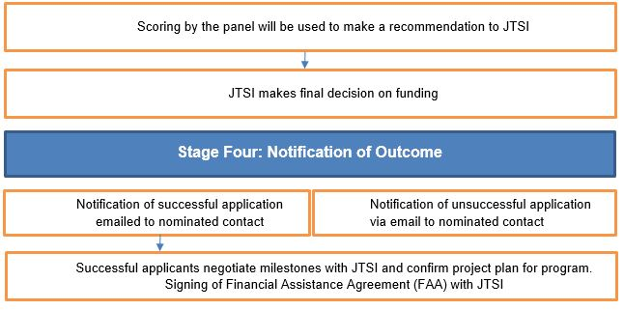
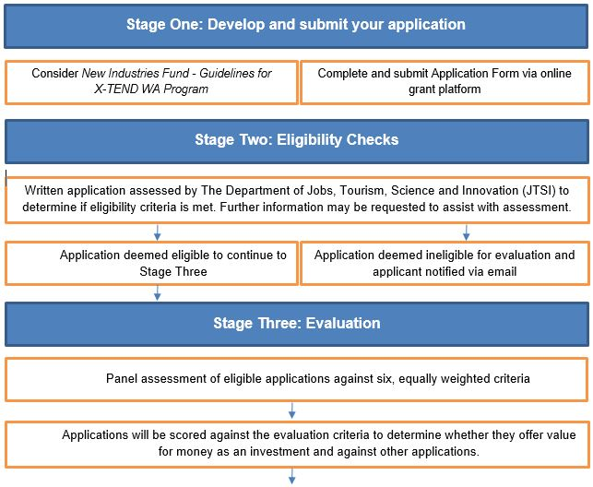
New Industries Fund – X-TEND Program Process

How the funding works
Your funding will be managed under a Financial Assistance Agreement (FAA), which will link payments to agreed milestones and key performance indicators.
Programs will be funded for a set value (not exceeding $100,000) and specified purpose and duration. Your project plan needs to clearly identify the components of your program that the funding from the X-TEND Program will be applied. X-TEND Program funding cannot be spent on salaries of existing staff.
JTSI reserves the right to check the financial stability of all selected applicants before funding agreements are finalised. Successful applicants without a registered business address in the State of Western Australia will be required to show proof of their Western Australian business address before funding is released.
No rights to financial assistance accrue until such time as the FAA has been executed by JTSI.
Any follow on funding will be subject to:
- achievement of deliverables and key performance indicators that are agreed in the funding agreement;
- evaluation of outcomes;
- available funds; and
- at JTSI’s absolute discretion.
The provision of financial support under this program shall be at the absolute discretion of JTSI and is subject to the availability of funds.

Other terms and conditions

Reporting
If you receive funding from this program, you will be required to undertake reporting against your Key Performance Indicators, including financial statements, as part of milestone payments.
You will also be requested to provide JTSI impact measurements, on an annual basis, outside of the term of your agreement to determine the effectiveness of the State’s investment in the X-TEND WA Program.

Freedom of Information Act 1992
JTSI is subject to the Freedom of Information Act 1992, which provides a general right of access to records held by Western Australian State and Local Government agencies.

Information that relates to the receipt of State Government financial support may be tabled in the Western Australian Parliament. This information could include names of recipients, the amounts of financial support, the name of the project/activity and, possibly, a brief description of the project/s funded. This could result in requests for more detail to be released publicly.
Further information on the operation of the Freedom of Information Act 1992 can be obtained from JTSI’s website.

Conflict of Interest
You will be required to complete a conflict of interest form that discloses any information that might be relevant to an actual, perceived or potential conflict of interest.

Tax Information for Applicants
JTSI regards this grant program as having sufficient nexus for supply, and as such grant funds will be inclusive of GST.
Grant Recipients must provide JTSI with a tax invoice inclusive of GST.

