[Insert local government logo]

[Insert location]

Coastal Hazard Risk Management and Adaptation Plan

Consultant Scope of Works

I. PURPOSE
The purpose of this project is to prepare a Coastal Hazard Risk Management and Adaptation Plan (CHRMAP) for [insert location].
The CHRMAP will set the framework for the assessment, by identifying coastal hazards, analysing vulnerability for specific assets, identifying and prioritising management and adaptation responses, and providing an implementation plan. It will also inform the community and stakeholders about potential coastal hazard risks; identify community and stakeholders’ values as well as key coastal infrastructure and assets at risk; and provide a clear pathway for the [insert local government] to address coastal hazard risks over time. Ultimately, the CHRMAP will provide strategic guidance for coordinated, integrated and sustainable land use planning and management decision-making by the [insert local government]. The CHRMAP will also guide necessary changes to the [insert local government] Local Planning Strategy, Local Planning Scheme and other relevant strategies and local planning policies.
The CHRMAP will be prepared in accordance with the CHRMAP Guidelines and State Planning Policy 2.6 – State Coastal Planning Policy (SPP2.6).

2. OBJECTIVES
The objectives of the CHRMAP are to:
- improve understanding of coastal features, processes and hazards in the study area
- identify significant vulnerability trigger points and respective timeframes for the relevant sediment cells to mark the need for immediate or medium-term risk management measures
- identify assets (natural and man-made) and the services and functions they provide situated in the coastal zone
- gain an understanding of assets vulnerability
- identify the value of the assets that are vulnerable to adverse impacts from coastal hazards
- determine the consequence and likelihood of coastal hazards on the assets, and assign a level of risk
- identify possible (effective) risk management measures (or ‘actions’) and how these can be incorporated into short and longer-term decision-making
- engage stakeholders and the community in the planning and decision-making process.
The project objectives will be achieved through appointment of a suitably qualified consultant who will produce a CHRMAP for the study area in accordance with the CHRMAP Guidelines and SPP2.6, which is adopted by the [insert local government] and used to guide future decision making for vulnerable assets in its coastal zone.

3. STUDY AREA
The CHRMAP shall cover the section of shoreline highlighted in Figure 1. The study area shall include the entire sediment cell and extend to adjacent coastal areas required to define the coastal physical processes (Figure 1).

Figure 1: Study area

[INSERT AERIAL PHOTOS OF STUDY AREA AND INCLUDE EXTENT OF PROJECT]

4. PROJECT TASKS
All work shall take into account and be consistent with the requirements of SPP 2.6 and the CHRMAP Guidelines.
Each Chapter Report is required to be reviewed by the Steering Committee. The consultant should allow up to two weeks for this to occur. Meetings may be required to discuss the outcomes of each stage.

Stage | Task | Deliverable
1. Establish the context  Purpose, Objectives, Scope, Study area, Community and Stakeholder engagement, Values, Existing controls and Success criteria | Delineate Purpose, Objectives, Scope, Study area, Community and Stakeholder engagement, Values, Existing controls and Success criteria.  Develop Community and Stakeholder Consultation and Engagement Plan.  Collection of Community and Stakeholder coastal values (social, environmental, infrastructure, and economic). | - Establish the context report chapter.  - Stakeholder and Community Engagement Plan.  - Identify community coastal values and aspirations.
2. Risk identification  Planning timeframe, hazard and asset identification, and hazard mapping | Hazard Assessment to identify 100-year ARI erosion and 500-year ARI inundation extents for various planning timeframes (up to and including 100 years from time of assessment).  Identification of coastal assets both man-made and natural (social, economic, environment), public and private impacted by coastal hazards at each project planning timeframe | - Coastal hazard assessment and mapping for the selected planning timeframes. For example, current year, and the years 2030, 2050, 2070, 2090 and 100 years from year of assessment may be used.  - Detailed description of each asset/asset grouping.
3. Vulnerability analysis  Consequences, likelihood, level of risk, adaptive capacity and asset vulnerability | Preparing consequence and likelihood scales for the selected planning timeframes.  Establish the risk level matrix to consider the potential impact of coastal hazards on an asset.  Identify risk tolerance scale and establish erosion and inundation risk matrix for assets.  Establish adaptive capacity scale to identify assets ability to adjust to coastal hazard.  Establish vulnerability tolerance scales to identify asset adaptive capacity in conjunction with risk level from coastal hazards.  Prepare vulnerability of assets at risk matrix, indicating vulnerability of assets (and their service, function and values). | - Consequence and likelihood scales.  - Level of risk matrix and risk tolerance scale and risk matrix.  - Adaptive capacity of assets scale and vulnerability matrix and tolerance scales, and vulnerability of assets at risk table.
4. Risk evaluation  Existing controls and priorities for risk treatment | Review of existing controls and measures already in place to manage risk.  Identification of any alteration to level of risk, any subsequent change to asset vulnerability.  Identify assets for which residual risk remains and treatment is required to reduce risks to an acceptable level as a priority. | - Identification of existing controls that alter level of risk.  - Reassessment of asset vulnerability in light of existing controls.  - Assets requiring risk treatment as a priority.
5. Risk treatment  Identify and evaluate risk treatment options, multi-criteria analysis, cost benefit analysis, long-term adaptation pathway, decision-making triggers and planning horizon | Establish through Risk Management and Adaptation Hierarchy risk treatment options for assessment of assets requiring risk treatment as a priority.  Undertake multi-criteria assessment of risk treatment options, to establish preferred options for further assessment in cost benefit analysis.  Undertake cost benefit analysis of preferred risk treatment options.  Identify adaptation pathway(s) and associated triggers for risk management measures for preferred risk treatment options across short, medium and long-term planning horizons. | - Identification of risk treatment options.  - Results of multi-criteria assessment (including community values and success criteria).  - Cost benefit analysis of suitable risk treatment options for addressing short term, medium and long-term risk (including community values and success criteria).  - Adaptation pathway(s) for the establishment of a decision- making strategy that is made up of a sequence of decision- points over time, and identification of triggers for implementation of the management measures for short, medium and long-term planning horizons.
6. Implementation plan  Plan for short-term management measures, medium and long-term strategic management measures, land use planning instruments, and funding proposal | Develop implementation plan for short term, including responsibilities, and costs and funding arrangements (e.g. differential rating, beneficiary pays).  Undertake a Benefit Distribution Analysis to inform funding arrangements/beneficiaries of chosen risk management measures.  Develop medium and long-term strategic management measures.  Identify land use planning instrument(s), provide details for any required changes, updates or amendments, details on proposed wording, implementation method/ processes. | - Detailed short-term implementation plan (present - 25 years) including Gantt chart.  - Medium and long-term strategic implementation plan (25 – 50 and 50 – 100 years).  - Detailed land use planning instrument requirements for implementation of chosen management measures.  - Detailed funding proposal, based on the Benefit Distribution Analysis, for implementation of chosen risk management measures.
7. Monitor and review | Detail any monitoring and review that may be needed to ensure management measures identified in the implementation plan remain current. | - Monitoring plan.
8. Final CHRMAP | Preparation of Draft CHRMAP. | - Draft CHRMAP.
 | Steering Committee Review of Draft CHRMAP. | - Excel document addressing Steering Committee review comments.
 | Preparation of Final Draft CHRMAP and Public Comment. | - Final Draft CHRMAP.
 | Finalisation of CHRMAP. | - Final CHRMAP presented to Council for Endorsement.

5. PROJECT METHODOLOGY

STAGE 1 – ESTABLISH THE CONTEXT

Task 1 – Establish the Context report chapter
The consultant will prepare the Establish the context chapter and include, as a minimum, sections on purpose; objectives; scope; study area; community and stakeholder consultation (including internal engagement); values; existing controls; and success criteria.

Task 2 – Develop Stakeholder and Community Engagement Plan
The consultant will prepare a Community and Stakeholder Engagement Plan to guide how community and stakeholders will be involved in the preparation of the CHRMAP. It is expected that the Plan includes, as a minimum, the following:
- the collection and collation of community and stakeholders’ social, environment, infrastructure and economic values and aspirations for the coastal area; this information will inform the remainder of the process, in particular the vulnerability analysis and multi-criteria assessment of adaptation options
- an understanding of the level of tolerance and acceptability of specific risks within the community for specific assets, or groups of assets
- involving the community in identifying suitable adaptation options (can be undertaken with collection of community values above)
- educating the community and stakeholders of the planning framework requirements for beneficiaries pays requirements.
- advising the community and stakeholders about the inclusion of a Benefit Distribution Analysis to assist with apportioning the costs (capital and recurrent) of chosen risk management measures, based on the beneficiary pays principle
- wide distribution of the Draft CHRMAP to seek feedback on the proposed adaptation options, pathways and implementation plan.
The Community Engagement Strategy will be based on principles of the International Association for Public Participation (IAP2) Public Participation Spectrum. The Community and Stakeholder Engagement Plan should determine the appropriate level of engagement for each initiative, and recommends tools and activities for each level. The levels of engagement include ‘Inform’, ‘Consult’, ‘Involve’, ‘Collaborate’.
The Stakeholder and Community Engagement Plan will establish the objectives of the community engagement; determine primary, secondary and tertiary stakeholders; set out the level of engagement; and detail the actions proposed to achieve the desired level of engagement and the timeframe for carrying out the engagement. The Plan will be submitted to the Local government for consideration and approved by the Steering Committee.
It is anticipated that different levels of engagement may be appropriate for different components of the CHRMAP, for example:
- Inform the community and stakeholders about the outcomes of the hazard assessment and the risks identified through the project
- Collaborate with the community to determine the level of risk tolerance, community and stakeholder values attributed to coastal assets and to identify potential adaptation options
- Involve the community and stakeholders in assessing the adaptation options presented
- Consult with the community and stakeholders on the draft CHRMAP through a public advertising process.
While not an exhaustive list, it is considered that key community and stakeholders for the project will include, at a minimum:
  - organisation staff and councillors
  - Department of Planning, Lands and Heritage
  - Department of Transport
  - [Add] other relevant State Government Department(s)
  - [Add] relevant Natural Resource Management group(s)
  - [Add] relevant Local group(s) e.g. Friends of groups etc.
  - landowners shown in the coastal hazard areas predicted to be affected over the planning timeframe
  - the broader community.
It should be noted that during community and stakeholder consultation, consideration should be given to residents who reside outside of the local government area, or to those who live inland and visit the coastal area for recreation. Therefore, the use of stratified random sampling with an emphasis on the coastal area should be demonstrated.

Task 3 – Collection of Community and Stakeholder Coastal Values
As specified in the Stakeholder and Community Engagement Plan, collation and collection of community and stakeholder values and aspirations attributed to coastal assets is to be undertaken. This should include the use of workshop(s) and survey(s) to collect the social, environmental, infrastructure and economic values associated with each built and natural asset, including environmental and cultural assets within the coastal zone. The proposed survey(s) is to be reviewed by the Steering Committee prior to use.

Stage 1 Deliverables
A chapter report detailing the Establish the Context including:
- delineate purpose; objectives; scope; study area; community and stakeholder engagement (including internal engagement); values; existing controls; and success criteria
- Community and Stakeholder Engagement Plan
- identify community and stakeholder coastal values and aspirations
- chapter report – first chapter for the Draft CHRMAP is to include the requirements as specified in the CHRMAP Guidelines.

STAGE 2 – RISK IDENTIFICATION

Task 4 – Coastal Hazard Assessment
The consultant will undertake a review of available coastal data, reports and studies for the area. As part of this review, the consultant will visit the site and provide a brief assessment of the site condition. The consultant shall be responsible for obtaining and researching information relevant to this project, including data from other organisations. A list of currently-known coastal data and reports is provided below:
- [To be populated by the local government, Department of Transport and Department of Planning, Lands and Heritage]
- XX
- XX
- XX
The consultant is expected to complete a coastal hazard assessment and mapping to meet the requirements of Schedule One in SPP2.6 for a 100-year planning timeframe. The assessment is also expected to include possible future sea level rise and storm events and associated storm surge for a number of timeframes. For example, current year, and projections for 10, 25, 50 and 100 years from the year of assessment may be used. It is expected to include, but not limited to, the following:
- description of current coastal processes, which takes into consideration coastal sediment cells of the study area
- assessment of the environmental variables impacting the study area (e.g. water level, wind climate, geomorphological change, etc)
- assessment S1, S2, S3 and S4 components, taking into account available information, key environmental variables and predicted future change, including sea level rise; two assessments need to be completed, (1) excluding any existing controls and (2) including existing controls; the consultant is expected to produce the topography information to complete the assessment and the hazard maps (the consultant will include this methodology in their response to the Request for Tender).
  - an assessment is required for the medium (25 – 50 years) to long-term (50 – 100 years) planning timeframe excluding any existing controls; an additional set of maps should also be provided where there are existing controls for use in Stage 4 Task 9
  - the short-term planning timeframe (<25 years) consideration of coastal processes should be in accordance with the methodology outlined in Appendix 3 Scope of Works Local Coastal Hazard Assessment of the CHRMAP Guidelines
- descriptions of the study’s limitation and recommendations to address this in the future (e.g. data collection, coastal monitoring, record keeping etc.).

Coastal Hazard Maps
Coastal hazard maps will be produced: one for erosion without existing controls, one for erosion with existing controls and one for inundation for the identified timeframes for the 100-year planning timeframe.

Task 5 – Asset Identification
The consultant is to identify all the assets together with their function, services and value. Where appropriate, assets sharing similar values or management requirements, or where adaptation is likely to consider a group of assets as a whole, can be grouped together. Where assets are grouped together, the consultant should provide a rationale for the groupings.

Stage 2 Deliverables
A chapter report detailing the methodology and outcomes of the risk identification including:
- a coastal hazard and coastal assets chapter report that includes, but not limited to:
  - Introduction and Scope
  - Methodology
  - Assumptions made and their basis
  - Conclusions
  - Recommendations and rationale behind these
- coastal hazard maps for erosion and inundation
- coastal asset type and grouping.

STAGE 3 – VULNERABILITY ANALYSIS
Using the hazard assessment and coastal asset type and grouping identified in Stage 2, the consultant is required to undertake an assessment of vulnerability of each asset including the consequence, likelihood, adaptive capacity of a coastal asset, and asset vulnerability. The CHRMAP Guidelines provides further information on the vulnerability assessment.

Task 6 – Develop Consequence and Likelihood and Scales
The consultant is to prepare consequence and likelihood scales for each planning timeframe, for the coastal hazards identified in Stage 2 (to be completed separately for erosion and inundation). Formulation of the consequence scale should incorporate community and stakeholder values.

Task 7 – Develop Level of Risk Matrix and Risk Tolerance Scale
The consultant is to prepare a risk level matrix to consider the potential impact of coastal hazards. The risk level matrix should include each planning timeframe.
The consultant is to identify a risk tolerance scale and establish an erosion and inundation risk matrix for assets for each planning timeframe.

Task 8 – Adaptive Capacity and Asset Vulnerability
The consultant is to establish an adaptive capacity scale to identify assets ability to adjust to coastal hazards. Once the adaptive capacity scale has been established, adaptive capacity should be associated with the assets, their function, services and values for each planning timeframe.
The consultant is to establish vulnerability tolerance scales, to identify asset adaptive capacity in conjunction with risk level from coastal hazards.
Finally, the consultant is to prepare an asset vulnerability risk matrix, indicating vulnerability of assets, their function, services and values for each planning timeframe.

Stage 3 Deliverables
A chapter report detailing the methodology and outcomes of the vulnerability analysis including:
- likelihood and consequence scales including risk matrix
- risk tolerance scale and risk matrix
- adaptive capacity, and vulnerability tolerance scales
- vulnerability of assets at risk matrix.

STAGE 4 – RISK EVALUATION

Task 9 – Existing Controls
The combination of the consequence and likelihood and adaptive capacity identified above in Stage 3 identifies the unmitigated risk, however there maybe existing controls and measures already in place that have the potential to mitigate the risk by decreasing the consequence and/or likelihood or risk level. Upon completion, remaining is the residual risk and vulnerability requiring management.
The consultant is to identify the existing controls and measures identified in Stage 1 that may reduce the consequence and/or likelihood and risk level.

Task 10 – Priorities for Risk Treatment
Where existing controls are identified in Task 9 that may reduce the consequence and/or likelihood and risk level, the consultant is to reassess risk tolerance of asset vulnerability.
The tasks in Stage 3 should be modified accordingly, and the risks, locations, assets, priority for risk treatment required for different levels of risk, and asset vulnerability to be addressed as a priority, are to be outlined.

Stage 4 Deliverables
A chapter report detailing the methodology and outcomes of the risk evaluation including:
- identification of existing controls that alter tolerability and risk level
- reassessment of asset vulnerability in light of existing controls
- assets requiring risk treatment as a priority.

STAGE 5 – RISK TREATMENT

Task 11 – Identify Risk Treatment Options
The consultant is to list and describe all available risk treatment options that could treat existing and future vulnerable development. The risk treatment options are to be separated in accordance with the Risk Management and Adaptation Hierarchy (refer to CHRMAP Guidelines) and ensure that future risk treatment options can also follow the hierarchy.

Task 12 – Multi-Criteria Analysis
The multi‐criteria analysis is to be undertaken on proposed risk treatment options, as identified in Task 11.
The multi-criteria analysis is to include (but not be limited to) economic, social and environmental impact, considering the community values as identified in Stage 1.
A list of risk treatment options resulting from the multi-criteria analysis is to be produced. Only those risk treatment options with a positive assessment should proceed to cost benefit analysis, unless the option specifically addresses a highly-valued asset. Explanation should be provided for these cases within the report.

Task 13 – Cost Benefit Analysis
A cost benefit analysis of all risk treatment options identified for further analysis through the multi-criteria analysis is to be undertaken.
The report should include details on the cost benefit methodology and provide a table of suitable risk treatment options.

Task 14 – Adaptation Pathway
The consultant is to identify adaptation pathway(s) that establish a decision-making strategy made up of a sequence of decision points over time, avoiding commitment to any specific risk treatment option (and associated management measures), which may not be appropriate for dealing with the long-term problem. The intent is for decision-making to be responsive to changing circumstances over time.
Using the community values and aspirations collected in Stage 1, the adaptation pathways for each highly-valued coastal asset is to be determined over the planning timeframe (for example, current year, and projections for 10, 25, 50 and 100 years from the year of assessment).
The adaptation pathways must maintain the ability over time to select risk treatment options from the risk management and adaptation hierarchy.
An example of potential future adaptation pathways is provided below in Figure 2.
Figure 2: Identification of Long Term Pathways
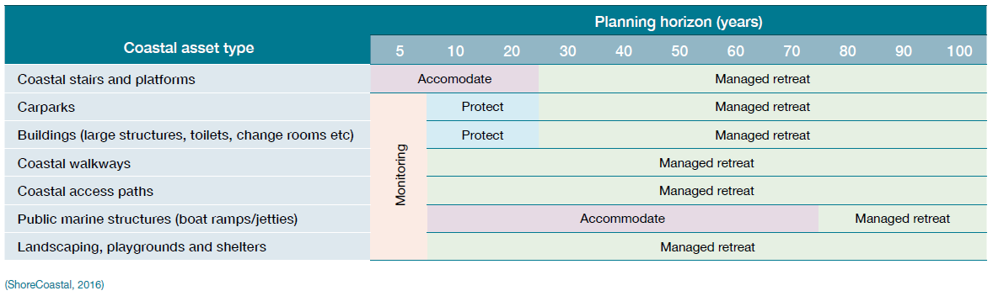
An example of potential future adaptation pathways including decision-making trigger points is provided below in Figures 3.
Figure 3: Example adaptation pathway including decision-making trigger points
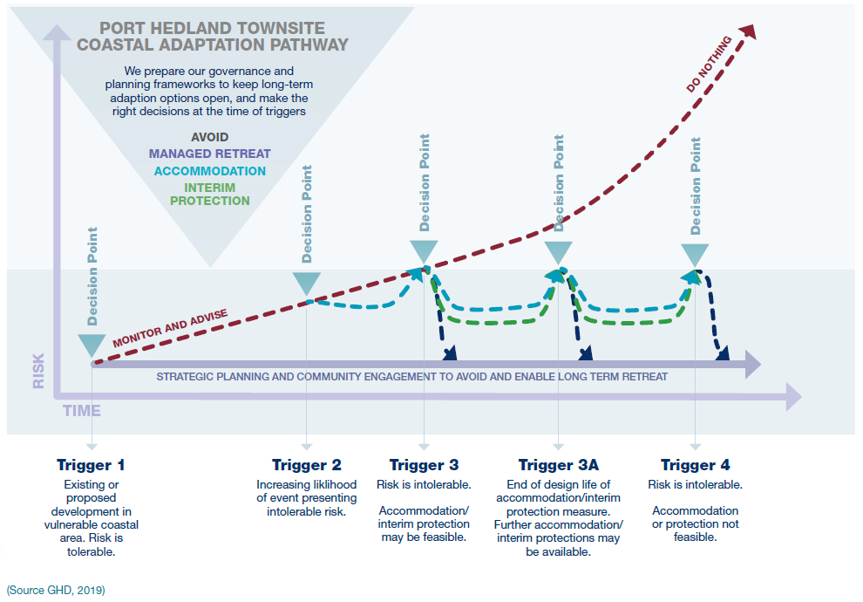

Triggers
Triggers are decision points which define or alter the adaptation pathway for a specific asset in response to future conditions. Triggers are to be used as the basis for decision-making and risk management measures, and need to be formulated using a combination of factors identified above in Stages 3 - 5 Vulnerability analysis, Risk evaluation, and Risk treatment respectively.
The consultant is to identify short, medium and long-term triggers for implementing risk management measures.

Planning Horizons
Stage 2 Risk identification identified the need to establish planning horizons as part of the CHRMAP hazard identification assessment process. The planning horizons need to be translated to the risk management pathways, to establish short, medium and long-term planning horizons for risk management measures to be implemented at the decision-making trigger points (as mentioned above).
The consultant is to ensure medium to long-term planning horizons focus on strategic planning measures, maintaining the ability over time to be able to select risk treatment options from the risk management and adaptation hierarchy at any given future decision-making trigger point.
The consultant is to ensure the short-term horizon planning focuses on identifying the decision points that will arise from increasing
risk, identifying the appropriate risk treatment option prioritised through Tasks 12 multi criteria analysis and 13 cost benefit analysis respectively. Of particular importance in the short-term is the establishment of the necessary controls in local planning schemes and other planning instruments, and commencement of budgeting for required risk management measures.

Stage 5 Deliverables
A chapter report detailing the methodology and outcomes of the risk treatment including:
- identification of risk treatment options
- results of multi-criteria assessment (including community values and success criteria)
- results of cost benefit analysis of suitable risk treatment options for addressing short, medium and long-term risk (including community values and success criteria)
- adaptation pathway(s) for a decision-making strategy comprising a sequence of decision-points over time, and identification of triggers for implementation of the risk treatment options for short, medium and long-term planning horizons

STAGE 6 – IMPLEMENTATION PLAN

Task 15 – Short Term Implementation Plan
A 25-year implementation plan is to be developed for each asset, groups of assets or sector, in accordance with the CHRMAP Guidelines. The assets can be grouped, but the same grouping as identified in the medium and long-term pathways is to be used.
The short-term implementation plan is to detail the following (as a minimum):
- Description – what is the selected risk treatment option? What is the required risk management measure to implement the risk treatment option? The reasons for selection, including expected benefits to be gained.
- Resource requirements – what is required to implement the risk management measure?
- Responsibility – who will be responsible for the implementation (risk management owner)?
- Planning framework – planning instrument requirements and amendments.
- Approval agencies – processes and requirements.
- Trigger – points for implementing risk management measures? Monitoring framework to determine if trigger occurs.
- Costs – associated with implementing selected risk management measures (capital and recurrent costs)? Provide a detailed funding proposal, based on the Benefit Distribution Analysis, for implementation of chosen risk management measures.
- Performance measures – what will be the indicators that demonstrate progress of implementation and effectiveness of the risk management measures?
- Communications and monitoring – who will need to be informed during and at completion of implementation of the risk management measures and how will the implementation be monitored and how frequently?
The short-term implementation plan should not prevent the medium and long-term pathway from being implementable.
As part of the short-term implementation plan, it can be helpful to formulate a Gantt chart that can clearly identify the priority order in which individual adaptation actions should be implemented and their timing, and can be seen in Figure 4 below.
Of particular importance in the short-term is the establishment of the necessary controls in local planning schemes and other planning instruments, and commencement of budgeting for required risk management measures.

Figure 4: Example Gantt chart
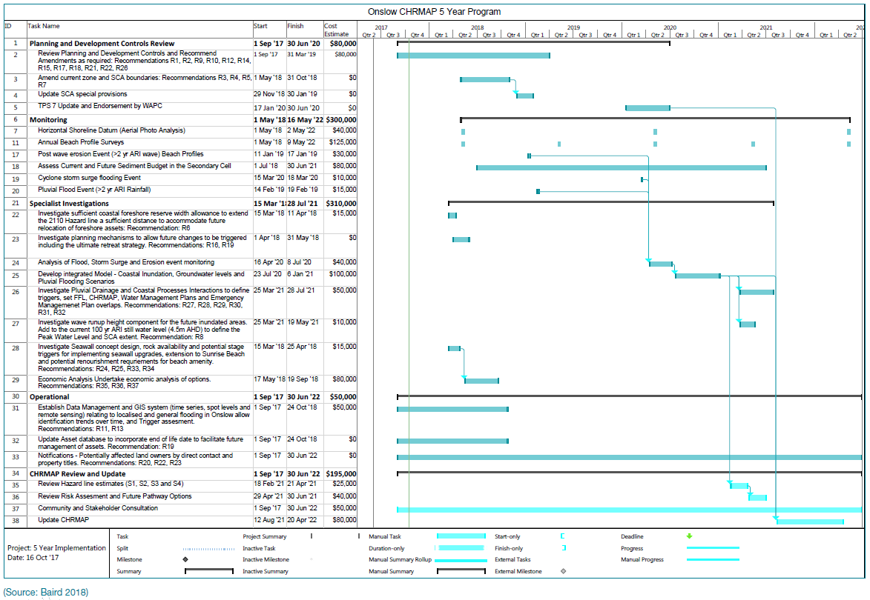

Task 16 – Medium and long-term Implementation Plan
Develop medium-term (25 – 50 years) and long-term (50 – 100 years) strategic implementation plans.

Task 17 – Land Use Planning Instruments
It is essential that land use planning instruments (such as local planning strategies, local planning scheme, local planning policies, and structure plans) are used to respond to coastal risks. The consultant is to identify and provide details for any required changes, updates or amendments to existing or proposed planning instruments.
The consultant is expected to provide details on proposed wording, implementation method/s, when to apply, relevant trigger points if required, and any other supporting information that may be needed for the decision-maker to implement risk management measures.

Task 18 – Funding
Risk management measures will require funding to deliver effective implementation and will require consideration of the capacity of existing budget, revenue sources and mechanisms for raising additional funds for implementing risk management measures. Any implementation plan must identify the cost of recommended risk management measures and all revenue-raising mechanisms available for obtaining additional funds to assist implementation.
The consultant will identify which revenue-raising mechanisms are recommended, and the governance framework through which such revenue is to be raised. For example, revenue-raising mechanisms available to local government include rates, special purpose levies, proportioning a percentage of annual operating budgets to coastal management, and funding from beneficiaries of risk management measures.
The consultant will also undertake a Benefit Distribution Analysis to assist in apportioning the costs (capital and recurrent) of implementing chosen risk management measures, based on the beneficiary pays principle. For further information, refer to the SPP2.6 Guidelines (WAPC, 2020) section 4.5.1.

Stage 6 Deliverables
A chapter report detailing:
- short-term implementation plan (present – 25 years)
- medium and long-term strategic implementation plan (25 – 50 and 50 – 100 years)
- Gantt chart
- detailed land use planning instrument requirements for implementation of chosen risk management measures
- detailed funding proposal based on the Benefit Distribution Analysis, for implementation of chosen risk management measures.

STAGE 7 – MONITOR AND REVIEW

Task 19 – Monitoring Plan
The report should detail any monitoring and review that may be required to ensure that the risk management measures remain relevant. The consultant should refer to the CHRMAP Guidelines for further information.
The monitoring plan should include (but not be limited to) the following:
- review and recommendations of the existing monitoring and maintenance program
- monitoring and review of coastal hazard projections outlined in the erosion hazard assessments, including locations, methods and indicative costs
- triggers and timeframes for updating the CHRMAP and implementation plans
- triggers that may alter community values
- triggers that have a consequential impact on the proposed risk management measures and implementation plans.

Deliverables
No separate chapter report is required for this stage.

STAGE 8 – FINAL CHRMAP

Task 20 – Draft CHRMAP
A draft CHRMAP is to be prepared and is to contain executive summary, chapters for each of the above stages, and maps and figures to show the locations of each proposed risk management measures. The report should be written in clear and concise language for non-technical readers and use images and diagrams that clearly explain key concepts.
The use of appendices should be considered for technical data. A summary is to be provided within the report, to ensure non-technical readers can fully understand the recommendations within the draft CHRMAP report.

Task 21 – Review of draft CHRMAP
The local government will circulate the draft CHRMAP report to relevant internal stakeholders and the Steering Committee for review and comment. Any comments received will be collated by the local government and forwarded to the consultant for consideration in a table format (excel document). The consultant shall respond to each comment in writing within the table (excel document). The project timeframe should consider a period of 30 days for the review.

Task 22 – Preparation of final draft CHRMAP and Public Comment
The consultant will update the draft CHRMAP report based on the outcomes of the peer review (as required) and produce a final draft CHRMAP for the local government.
The final draft CHRMAP report will be presented to Council and provided to stakeholders and the community for consultation through a public comment process. The public comment period will be a minimum of four weeks and undertaken in accordance with the Stakeholder and Community Engagement Plan, as developed in Stage 1.

Task 23 – Finalisation of CHRMAP
Further to public advertising of the CHRMAP report by the local government, the consultant will update and finalise the CHRMAP report, taking into account any relevant issues arising through the advertising process. Any submissions received will be collated by the local government and provided to the consultant in a table format (excel document). The consultant shall respond to each comment in writing within the table (excel document). Depending on the nature of the comments made, the consultant will be required to provide responses and detail any changes to the CHRMAP arising from the submissions within the table format (excel document). A final CHRMAP will be produced and provided to the local government and the Steering Committee for final review.
The consultant should consider adding a table containing all public comments collected through the public comment period and responses to these comments into an appendix of the report.
The final CHRMAP will be presented to Council for endorsement.

Stage 8 Deliverables
The deliverables for this stage are as follows:
- draft CHRMAP
- final draft CHRMAP
- Table of responses to any submissions (as required)
- final CHRMAP presented to Council for endorsement

REPORT STRUCTURE
The CHRMAP shall address the Study Scope and Objectives and include as a minimum:
- executive summary, introduction and scope
- process undertaken to identify risk management strategies
- all assessment criterions and methodologies developed and implemented for the project
- risk management strategies for the identified sectors of the study area.
- concluding remarks
- data appendices as a separate document
- digital archive of data generated in raw and processed form – formats to be discussed and agreed upon with the Project Steering Committee.

MEETINGS
The consultant should propose a meeting schedule commensurate with the outcomes and deliverables outlined in this document. The items are suggested;
- inception meeting at the Principal’s office in [insert location], within one month of award
- fortnightly one-on-one teleconference meetings to discuss progress
- progress meetings with Steering Committee to discuss Stages 2 and 3
- progress meetings with Steering Committee to discuss Stages 4 and 5
- progress meetings with Steering Committee to discuss Stages 6 and 7
- meeting at the Principal’s office in [insert location] to present the draft CHRMAP
- councillor and community engagement meetings in [insert location] to present the draft CHRMAP
- community engagement meetings in [insert location] to inform the community of the Council-endorsed CHRMAP.

TIMEFRAMES
The consultant is to provide a detailed timeline for the project and consider the stages or tasks that can be undertaken concurrently.
The whole project is to be completed by [insert date]. Community engagement activities must commence shortly. It is expected that the first draft CHRMAP report is delivered within 18 months from appointment (considering timeframes needs for community consultation). The proposed timeframes will be discussed in depth during the inception meeting.
Quotes are to be delivered in electronic format by [insert location]. Any questions regarding this Request for Quote should be communicated in writing only to [insert email address].
Consultants should allow 48 hours for a response.

COSTS
A detailed cost estimate is to be provided based on each stage. Any additional items that the consultant deems necessary are to be provided as additional items.

OTHER CONSIDERATIONS
All mapping must be provided in high resolution format at a scale of 1:4000 or smaller.
All consultants submitting a quote must provide evidence of third party and professional indemnity insurances.
The successful consultant will be required to provide fortnightly progress updates via email to the project manager.

SELECTION CRITERIA
The submissions received will be assessed on the following criteria:
Criteria | Weighting
Relevant Experience  Demonstrate your experience and skill in performing services of a similar nature to the services referred to in this RFQ. Please provide relevant details of the project scope, project outcomes, and issues that arose during the project and how they were managed to the benefit of the client. | 30%
Key Personnel  Outline the key personnel that will be involved in this project, including their role in the performance of the contract and their previous experience performing services of a similar nature to the services referred to in this RFQ.  Demonstrate skills in community consultation and engagement, coastal engineering, economics and land use planning. | 20%
Consultant Resources  Provide a resource schedule demonstrating current commitments, forecast workload and availability for each of the nominated personnel. Please include contingency resources for nominated staff during leave of absence to ensure continuity of service. | 10%
Methodology  Provide an overview of the methodology in accordance with the requirements of Stages 1-6. This shall include a detailed project timeline outlining how the Scope of Work will be completed within the contract timeframe. | 30%
Value for Money  Provide a Fee Schedule setting out a fixed price lump sum fee for each of the Stages of the Contract outlined in this Scope of Work. The Fee Schedule should include an estimate of all expected disbursements, including all travel and accommodation cost, vehicle hire, printing and the like. The estimate of disbursements must specifically state the anticipated number of meetings or workshops (with duration) in [insert location] based on the methodology presented.  Provide a schedule of hourly rates for all nominated personnel to be used for negotiating variations to the Contract, if necessary. Secretarial and office administration personnel costs must be covered in the rates for other personnel and are not to be billed separately. | 10%

A consultant or consortium of consultants that comprise skills in but not limited to land use planning, community consultation and engagement, coastal engineering and economics.

