A Guide to
Enduring Power of Guardianship
in Western Australia

Preface

This guide is produced by the Public Advocate, the independent statutory officer appointed by the Western Australian Government to protect and promote the human rights of Western Australian adults with a decision-making disability. It provides information for people wanting to understand or complete an Enduring Power of Guardianship.
Changes to the Guardianship and Administration Act 1990, brought about by the Acts Amendment (Consent to Medical Treatment) Act 2008, introduced Enduring Powers of Guardianship and Advance Health Directives in Western Australia in February 2010.

These two tools enable Western Australians to plan for how decisions about their future lifestyle and health care will be made. They provide the opportunity for individuals to state their preferences about their future lifestyle and treatment decision-making, including choosing the people they would like to make such decisions on their behalf, should they later become unable to do so.

Enduring Powers of Guardianship and Advance Health Directives are independent but complementary documents that can be completed by any person 18 years of age or older, who is capable of understanding the implications of their decisions (referred to in the legislation as having “full legal capacity”).

Significant developments occurred in April 2020, when further changes to the Act were made through the Guardianship and Administration Amendment (Medical Research) Act 2020. As a result, a person with a decision-making disability can now have access to new treatments and healthcare options which are offered as part of medical research. This can occur where the Enduring Guardian is appointed with all functions authorised or where they have been given specific authority to make medical research decisions.

Both Enduring Powers of Guardianship and Advance Health Directives empower people to make choices about their future.

Pauline Bagdonavicius PSM
Public Advocate
May 2020

Copies of this guide and the Enduring Power of Guardianship form can be downloaded from the Office of the Public Advocate’s website. Further information and advice can also be obtained from the Office’s Telephone Advisory Service: 1300 858 455.
Office of the Public Advocate
PO Box 6293, East Perth, WA 6892
E: opa@justice.wa.gov.au
W: www.publicadvocate.wa.gov.au

For further information on Advance Health Directives or a copy of the booklet ‘Preparing an Advance Health Directive’ which contains information to assist people considering making an Advance Health Directive, and a copy of the form contact:
The Department of Health
T: (08) 9222 2300
E: acp@health.wa.gov.au
W: www.health.wa.gov.au/advancecareplanning

Contents

Introduction 1

Using this guide 3

FOR THE APPOINTOR (the person making the EPG)

1 Planning Tools
1.1 What is an Enduring Power of Guardianship (EPG)? 4
1.2 Why appoint an enduring guardian? 4
1.3 Can my spouse or de facto partner make decisions for me 4
1.4 Can I appoint more than one enduring guardian? 4
1.5 Can I appoint a substitute enduring guardian? 4
1.6 What is an Advance Health Directive? 4
1.7 Why make an Advance Health Directive? 5
1.8 How can an EPG and Advance Health Directive help me plan
for the future? 5
1.9 When would my EPG come into effect? 5
1.10 What if there is doubt over my capacity to continue making
decisions for myself? 6
1.11 What if there is doubt about my capacity to make an EPG? 6
1.12 What if I lose decision-making capacity only temporarily? 6
1.13 How much will it cost me to make an EPG? 6
1.14 Will an EPG made in Western Australia be valid interstate
and vice versa? 7
1.15 Where should I keep my EPG? 7
1.16 Should I give copies of my EPG to anyone else? 7
1.17 What if I want someone to manage my financial affairs? 7

2 The Functions of an Enduring Guardian
2.1 What decisions can an enduring guardian make? 8
2.2 Is there anything an enduring guardian cannot do? 9

3 Making an Enduring Power of Guardianship
3.1 Who can appoint an enduring guardian? 10
3.2 Who can be appointed as an enduring guardian? 10
3.3 How do I appoint an enduring guardian? 10
3.4 How do I choose an enduring guardian? 10
3.5 What if I cannot read or write, sign my name and/or
understand English? 11
3.6 What happens if my enduring guardian loses capacity or dies? 11
3.7 What happens if my joint enduring guardians cannot agree on decisions? 12
3.8 Have I got it right? My final checklist for choosing an enduring
guardian 12

4 Completing an Enduring Power of Guardianship Form
4.1 Completing clauses 1 to 6 13
4.2 Signing the form 15
4.3 Optional statement about Advance Health Directive 16
4.4 Acceptance by appointee(s) 16
4.5 Witnessing requirements 16
4.6 Have I got it right? My final checklist for completing an EPG 18
FOR THE ENDURING GUARDIAN

5 Becoming an Enduring Guardian
5.1 What should I know about the role 19
5.2 Should I accept the role? 19
5.3 How do I accept? 19
5.4 When would I act in the role? 20
5.5 What kinds of decisions would I make? 20
5.6 How must I act as an enduring guardian? 21
5.7 Can I claim expenses? 22
5.8 How do I sign for the appointor? 22

6 Making Decisions About Treatment
6.1 What is meant by treatment? 23
6.2 What is the difference between urgent and non-urgent treatment? 23
6.3 What is the process for deciding who makes a decision? 23
6.4 When do I make decisions? 24
6.5 How will decisions be made if treatment is needed urgently? 25
6.6 How will decisions be made if treatment is not urgent? 25
6.7 What steps should I follow when making treatment decisions? 25
6.8 How should I inform health professionals of my decisions? 26
6.9 How do I record treatment decisions? 26
6.10 Can I make decisions about the appointor being involved
in approved medical research? 26

7 Making Decisions About Personal and Lifestyle Matters

7.1 What is meant by personal and lifestyle matters? 28
7.2 Who can make decisions about personal and lifestyle matters? 28
7.3 What information should I gather before making a personal
or lifestyle decision? 28
7.4 What is meant by available and willing? 28
7.5 How should I record the personal and lifestyle decisions
I have made? 29
7.6 Where can I get advice to assist with making decisions? 29
GENERAL INFORMATION

8 Enduring Power of Guardianship and Guardianship
8.1 What is a guardian? 30
8.2 What is the difference between a guardian and
an enduring guardian? 30
8.3 Will it ever be necessary to apply for a guardianship order? 30
8.4 Who can advise on whether an application for
a guardianship order would be appropriate? 30
8.5 Who can apply for a guardianship order? 30

9 The State Administrative Tribunal
9.1 What is the role of the State Administrative
Tribunal in EPGs? 31
9.2 Who can apply to the Tribunal to intervene in an EPG? 31
9.3 How do I apply to the Tribunal? 32
9.4 When does a decision made by the Tribunal come into force? 32
9.5 Can Tribunal decisions be appealed? 32

10 Investigative Role of the Public Advocate
10.1 Who is the Public Advocate? 33
10.2 What authority does the Public Advocate have
to investigate concerns about EPGs? 33

11 Revoking / Renouncing an EPG
11.1 Why might an EPG end? 34
11.2 Revoking an EPG 34
11.3 What if an enduring guardian wants to resign? 34
11.4 How does an enduring guardian resign? 35
11.5 What happens if an enduring guardian loses capacity
or dies while an EPG is operation? 35
11.6 What happens if the Tribunal discharges an enduring guardian? 35
11.7 What happens if an appointor divorces or separates from an
enduring guardian? 35
11.8 What happens if an appointor makes another EPG? 36
11.9 Can an appointor change the content of an EPG? 36

12 Further Information
12.1 Office of the Public Advocate 37
12.2 State Administrative Tribunal (the Tribunal) 37
12.3 Department of Health 37

APPENDICES
Appendix A: Hierarchy (order of priority) of treatment decision-makers 38
Appendix B: Hierarchy (order of priority) of
medical research decision-makers 39
Appendix C: Marksman and readover clauses 40
Appendix D: People authorised to witness
Enduring Powers of Guardianship 42
Appendix E: Certifying copies of documents 44
Appendix F: Glossary of terms used in this guide 45

Disclaimer
The materials presented in this Guide are provided voluntarily as a public service. The information and advice provided is made available in good faith but is provided solely on the basis that readers will be responsible for managing their own assessment of the matters discussed herein and that they should verify all relevant representations, statements and information. Neither the State of Western Australia (“State”) nor any agency or instrumentality of the State nor any employee or agent of the State or any agency or an instrumentality of the State shall be responsible for any loss or damage howsoever caused and whether or not due to negligence arising from the use or reliance on any information or advice provided in the Guide. Changes in circumstances after the date of publication of the Publication may impact on the currency of the information contained in the Publication. No assurance is given that the information contained in the Publication is current at the time it is provided to the reader.
© State of Western Australia 2020

Introduction

The choices you make about your life such as where you live, the activities you pursue and the health care treatment you receive, all involve personal decisions guided by your individual set of beliefs and values.
If an accident or illness prevented you from being able to make decisions about your life, you might want to have some level of control over who made these decisions on your behalf and how these decisions were made.
Enduring Powers of Guardianship and Advance Health Directives are two tools that enable you to plan for this possibility, thereby giving you control over how decisions will be made for you in the future if you become unable to make them for yourself.
Enduring Powers of Guardianship and Advance Health Directives were introduced in Western Australia on 15 February 2010, following changes to the Guardianship and Administration Act 1990, brought about by the Acts Amendment (Consent to Medical Treatment) Act 2008.
In the same way that making an Enduring Power of Attorney enables you to appoint someone to make financial decisions on your behalf, making an Enduring Power of Guardianship enables you to appoint someone to make personal, lifestyle, treatment and medical research decisions on your behalf in the event that you lose the capacity to make such decisions for yourself.

An Advance Health Directive allows you to make decisions about the health care you receive in the future. You can use it to provide or withhold your consent to receive specified medical, surgical and dental treatments and other health care, including life-sustaining measures or palliative care.

These three tools – Enduring Powers of Attorney, Enduring Powers of Guardianship and Advance Health Directives – are individual but complementary documents. Depending on your individual circumstances, you might choose to complete all three documents, a combination of two, or none at all. Your stage in life may affect when, if ever, you chose to use these tools. As you move through life, the different tools might become of use to you and you may decide to complete them at different times.

If you decide to make an Enduring Power of Guardianship, this guide will assist you to choose an enduring guardian, determine the scope of their authority and complete the form. People who have been asked to be an enduring guardian will also find this guide helpful.

While this guide contains brief information about Advance Health Directives, more detailed information can be found in the booklet ‘Preparing an Advance Health Directive’ produced by the Department of Health (see part 12 for contact details).

Making an Enduring Power of Guardianship is straightforward and most people will be able to complete the form without legal or other assistance.

If you have further queries about an Enduring Power of Guardianship contact the Office of the Public Advocate’s Telephone Advisory Service on 1300 858 455.

USING THIS GUIDE

Every attempt has been made to keep this guide as simple and user-friendly as possible. It is made up of three main parts.

- Parts 1 to 4 are aimed at people planning to appoint an enduring guardian.

- Parts 5 to 7 are aimed at people who have been asked to become an enduring or substitute enduring guardian.

- Parts 8 to 12 contain general information.

Although the term “enduring guardian” is used, a person can appoint any number of enduring and substitute enduring guardians.

The “Act” refers to the Guardianship and Administration Act 1990.

The “Tribunal” refers to the State Administrative Tribunal.

The “appointor” is the person who makes an Enduring Power of Guardianship.

The “appointee” is the person being appointed as enduring guardian.

“Full legal capacity” means the capacity to make a formal agreement and to understand the implications of statements contained in that agreement.

A full list of the terms used in this guide (a glossary) is at the end of the publication.

FOR THE APPOINTOR (the person making the EPG)

1 PLANNING TOOLS

What is an Enduring Power of Guardianship (EPG)?
An Enduring Power of Guardianship is a legal document that enables you (the appointor) to appoint a person of your choice to make important personal, lifestyle, treatment and medical research* decisions on your behalf should you ever become incapable of making these decisions for yourself. This person becomes your enduring guardian.
* See the glossary for a definition of ‘treatment’ and ‘medical research’.

Why appoint an enduring guardian?
By appointing an enduring guardian you will be giving a person you know and trust the authority to make personal, lifestyle, treatment and medical research decisions on your behalf, if you become unable to do so in the future due to a decision-making disability. This may be caused by illness, accident or trauma.

Can my spouse or de facto partner make decisions for me?
If you wish your spouse or de facto partner to make decisions on your behalf you should name that person as your enduring guardian. If you name another person as your enduring guardian, that person - and not your spouse or de facto partner - will have decision-making authority.

Can I appoint more than one enduring guardian?
You can appoint more than one enduring guardian. They would be referred to as “joint enduring guardians” and would have to act together and agree on all decisions made on your behalf.

If you want to appoint joint enduring guardians, you should consider whether they would be able to work together to make decisions in your best interests.

Can I appoint a substitute enduring guardian?
You can appoint one or more substitute enduring guardians who would take over in the role as your enduring guardian if one or all of your enduring guardians were unable to continue in the role.

What is an Advance Health Directive?
An Advance Health Directive is a legal document that allows you to provide or withhold consent for specific health care, medical, surgical or dental treatment or procedures, including life-sustaining measures or palliative care, and medical research.

1.7 Why make an Advance Health Directive?
If you required treatment but were unable to make decisions about or communicate your wishes regarding your treatment, your Advance Health Directive would speak for you. An Advance Health Directive would come into effect only if you lost the capacity to make decisions for yourself.

Health professionals would have to refer to your Advance Health Directive even if you had an enduring guardian because the Act states that an Advance Health Directive has priority over the authority of an enduring guardian (see part 6.3 or Appendix A).

1.8 How can an EPG and Advance Health Directive help me plan for the future?
An EPG and Advance Health Directive can give you an element of control over your future. They can ensure that if you become incapable of making decisions for yourself, your views and wishes are known and can be respected.
The difference between the two documents is that an Advance Health Directive enables you to state your treatment decisions, while an EPG enables you to appoint an enduring guardian to make personal, lifestyle, treatment and medical research decisions for you.
Therefore, if you want to ensure that future personal, lifestyle, treatment and medical research decisions are made in a way that reflects the choices you would make yourself, you may want to consider completing an EPG and an Advance Health Directive.

More information on Advance Health Directives is available from the Department of Health (see part 12).

1.9 When would my EPG come into effect?
Your EPG would come into effect only if you lost the capacity to make decisions for yourself.
Under no circumstances would it come into operation while you were still able to make reasonable judgements about your personal, lifestyle or treatment matters.
The loss of capacity is often a gradual process. It would be possible for your enduring guardian to take responsibility for more complex matters, while you continued making more simple decisions.

1.10 What if there is doubt over my capacity to continue making decisions for myself?
If there is uncertainty over your capacity to make decisions for yourself, your general practitioner should be asked to make an assessment or provide a referral for an assessment of your capacity.
If the situation is still unclear, an application should be made to the State Administrative Tribunal for a decision.
In some cases the Tribunal might decide that while you are still capable of making certain types of decisions, you are no longer able to make reasoned judgements about other aspects of your life. For example, the Tribunal may decide that you are capable of deciding where you should live but not about the treatment you should receive.

1.11 What if there is doubt about my capacity to make an EPG?
You must have full legal capacity to make an EPG. Doubt about your capacity to make an EPG could result in the EPG being declared invalid by the Tribunal.
If you are considering making an EPG but your capacity to do so might be questioned, you are advised to seek the opinion of at least one doctor qualified to assess your capacity. When seeking this opinion, you should advise the doctor of your intention to make an EPG and request a written report on the assessment which clearly states whether or not you have capacity.
If you require an assessment of your capacity and English is not your first language, it is recommended you have an accredited interpreter attend the assessment.
If you are assessed as having full legal capacity it is advisable that the doctor, who made the assessment, be one of the two people who witnesses your EPG. If you are assessed as not having capacity, you will be unable to make an EPG.

1.12 What if I lose decision-making capacity only temporarily?
In some situations your ability to make reasoned decisions may fluctuate with the severity of your condition, for example if you have a mental illness. In these circumstances, your enduring guardian will assume decision-making responsibility during times when you are unable to make decisions for yourself.

This is something you could clarify in the directions of your EPG. For example, you might include the direction:

I have been diagnosed with clinical depression and want my enduring guardian to act when my doctor states I lack capacity.

1.13 How much will it cost me to make an EPG?
There is no cost in making an EPG and the form can be downloaded free of charge from the Office of the Public Advocate’s website: www.publicadvocate.wa.gov.au

1.14 Will an EPG made in Western Australia be valid interstate and vice versa?
If you move interstate you will need to check with the relevant authority in that State or Territory to find out whether your EPG will be recognised.
If you have moved to Western Australia and want to know if a similar document made in another State or Territory is valid in this State, you will need to make an application to the State Administrative Tribunal for recognition of that document (see part 9).
If you have full legal capacity when you move interstate, it may be easier to make a new EPG in that State or Territory.

1.15 Where should I keep my EPG?

As there is no formal registration process for EPGs it is essential that you and your enduring guardian know where the original document is so that it can be found easily should your enduring guardian need to act on its authority. It is recommended that you tell your enduring guardian where your EPG is kept.

If you have also made an Advance Health Directive or Enduring Power of Attorney, or you have made more than one EPG, it is recommended that all of these documents are kept together.

1.16 Should I give copies of my EPG to anyone else?
The Public Advocate recommends that you make certified copies of your EPG and provide them to any enduring or substitute enduring guardian, your general practitioner and any other health professionals or service providers with whom you are in contact. You might also want to provide copies to family members and friends.
A certified copy is a document that is certified by a person – authorised to sign legal documents – as being a genuine copy of the original. The person certifying your copy will need to sight your original document (see Appendix E).

1.17 What if I want someone to manage my financial affairs?
If you want someone to manage your property and financial affairs you should make an Enduring Power of Attorney. This enables you to appoint someone who is known as an attorney, to manage your financial matters.
If you want to appoint the same person as your attorney and enduring guardian you must complete both forms – an Enduring Power of Attorney form to appoint them as your attorney and an Enduring Power of Guardianship form to appoint them as your enduring guardian.
The Office of the Public Advocate produces a range of information about Enduring Powers of Attorney. This includes a Guide to Enduring Power of Attorney, which provides detailed information on the role of an attorney and the prescribed form, and a less detailed information kit which also contains the prescribed form. All relevant information is available from the Office of the Public Advocate’s website: www.publicadvocate.wa.gov.au

2 THE FUNCTIONS OF AN ENDURING GUARDIAN

2.1 What decisions can an enduring guardian make?
An enduring guardian can make personal, lifestyle and health care decisions.
You can give your enduring guardian the power to make all of these decisions or you can limit their decision-making authority. You determine their authority in clause 4 of your EPG form (see part 4 of this guide).
If you want your enduring guardian to make all personal, lifestyle, treatment and medical research decisions you should complete clause 4A of your EPG form. This will give them the authority to:
- decide where you live, whether permanently or temporarily
- decide who you will live with
- decide whether you work and if so, any matters related to that work
- provide or refuse consent, on your behalf, to any medical, surgical or dental treatment or other health care (including palliative care or life-sustaining measures such as assisted ventilation and cardiopulmonary resuscitation)
- provide or refuse consent, on your behalf, to any new or experimental treatments proposed for you as part of approved medical research relevant to your condition
- decide what education and training you receive
- determine who you will associate with
- commence, defend, conduct or settle any legal proceedings on your behalf, except proceedings that relate to your property or estate
- advocate for and make decisions about the support services you will have access to
- seek and receive information on your behalf.

These are the same powers that can be given to a plenary (or full) guardian appointed by the Tribunal (see part 8).
If, on the other hand, you want to limit the types of decisions your enduring guardian can make, you must complete clause 4B of your EPG form. For example, you might authorise your enduring guardian to make treatment decisions, but not decisions about where you live.
An enduring guardian cannot make decisions for you on property or financial matters. If you wish to give someone the authority to make financial decisions on your behalf, you will need to make an Enduring Power of Attorney (see part 1.17).

2.2 Is there anything an enduring guardian cannot do?
An enduring guardian cannot:
- make decisions about your finances, property or estate
- vote for you in an election
- consent to an adoption
- consent to a marriage involving you or a person under 18 years of age
- consent to you being sterilised without the approval of the Tribunal
- make or change your Will without an order from the Supreme Court.

If you lose capacity and wish to be divorced, the Public Advocate recommends that your enduring guardian organise an assessment of your capacity to determine whether you understand the implications of getting divorced, including possible financial implications. If it is determined that you have this capacity, your enduring guardian will need to apply to the Tribunal to obtain authority to act on your behalf in divorce proceedings.

For information on what happens if an appointor divorces or separates from an enduring guardian, see part 11.7.

3 MAKING AN ENDURING POWER OF GUARDIANSHIP

3.1 Who can appoint an enduring guardian?
If you are 18 years of age or older and have full legal capacity (can make a formal agreement and are able to understand the implications of statements contained in the document) you can appoint an enduring guardian by making an EPG.
Making an EPG on behalf of another person is not possible under any circumstance. This includes the making of an EPG by another person on behalf of someone whose capacity might be in doubt due to mental illness, acquired brain injury, cognitive impairment or dementia.

3.2 Who can be appointed as an enduring guardian?
You can appoint anyone as your enduring guardian, provided they are 18 years of age or older and have full legal capacity.
Your enduring guardian does not need to reside in Western Australia although their availability should be considered and they should be easily contactable to assist in decision making.

3.3 How do I appoint an enduring guardian?
To appoint an enduring guardian you must complete an EPG form. To be legally enforceable, your EPG must be in the form, or substantially in the form, specified in Schedule 1 of the Guardianship and Administration Regulations 2005. The form at the back of this guide meets these requirements.
Additional copies of the form and supporting information can be downloaded from the Office of the Public Advocate’s website: www.publicadvocate.wa.gov.au

3.4 How do I choose an enduring guardian?
As your enduring guardian will have legal decision-making authority, it is important to carefully consider who you choose. The best way to ensure that your enduring guardian follows your wishes, is to choose someone you know well and trust and who is aware of your personal beliefs and lifestyle preferences.
If you want your spouse or de facto partner to make decisions on your behalf, you need to appoint them as your enduring guardian. If you appoint someone else as your enduring guardian, your spouse or de facto partner will not have decision-making authority.
Before completing your EPG you should talk to the person you want to appoint, to ensure that they understand what an EPG is and the role and responsibilities of an enduring guardian. They should confirm that they understand the role and are willing to make the types of personal, lifestyle and treatment decisions that you intend to include in your EPG.
You should ensure that you have your proposed enduring guardian’s correct name and residential address because this information must be included on the form.
You may also want to inform family members and close friends that you have made an EPG to ensure all the important people in your life are aware of who you have appointed as your enduring guardian. This may be helpful if there is any discussion later among your family or friends about how you chose your enduring guardian and your intentions and wishes.

3.5 What if I cannot read or write, sign my name and/or understand English?
Being unable to read or write, sign your name or understand English will not prevent you from making an EPG. If you are unable to sign your name, because for example:
- you understand English but cannot write
- you understand English but cannot read or write
- you do not understand English and cannot write,
a mark of any kind, including an initial, cross or even a thumb print is sufficient. However an explanatory clause known as a ‘marksman clause’ will need to be included in your EPG.

If you cannot understand English the form must be read to you by an accredited interpreter to ensure you understand exactly what you are doing by completing an EPG. An explanatory clause known as a ‘readover clause’ must be inserted into your EPG stating that the form has been read to you by an accredited interpreter and that you understand the effect of making an EPG.

The Public Advocate recommends that you seek legal advice (from a solicitor or community legal centre) if a marksman or readover clause needs to be included in the EPG.

Examples of marksman and readover clauses can be found at Appendix C.

3.6 What happens if my enduring guardian loses capacity or dies?
When you complete your EPG, you can if you wish appoint a substitute enduring guardian who can take over the role if your enduring guardian loses capacity or dies.
If you do not appoint a substitute enduring guardian and your enduring guardian loses capacity or dies, provided you still have full legal capacity you can make a new EPG.
If you do not have capacity and decisions need to be made, it may be necessary for an application to be made to the State Administrative Tribunal for the appointment of a guardian (see part 9).

3.7 What happens if my joint enduring guardians cannot agree on decisions?
When you complete your EPG, you can if you wish appoint more than one enduring guardian. They would be referred to as “joint enduring guardians” and would have to act together and agree on all decisions made on your behalf.

If your joint enduring guardians are not able to work together to agree on decisions in your best interests, it may be necessary for an application to be made to the State Administrative Tribunal (see part 9).

Every situation would vary, but this could result in the Tribunal deciding, for example, that it is best for only one of your enduring guardians to carry on in the role, and discharge the other. Or the Tribunal might revoke the enduring power of guardianship and appoint someone else as your guardian.

3.8 Have I got it right? My final checklist for choosing an enduring guardian

When selecting an enduring guardian, consider the following questions:
- Is this person someone I trust to:
consider my wishes
make the decisions I would be likely to make in the same circumstances
always act in a manner that is in my best interests?
- Would this person be likely to make decisions from a similar belief and value basis as my own?
- Will this person be easy to contact to ensure that decisions can be made in a timely manner?
- Could my choice of enduring guardian cause conflict within my family? If so, is there someone else more suitable for the role?
- Is this person likely to have the time and ability to carry out the role of enduring guardian?
- Is this person likely to be willing to take on such decision-making responsibilities?
- If I am appointing joint enduring guardians, could these people work together to make unanimous decisions on my behalf?

4 COMPLETING AN ENDURING POWER OF GUARDIANSHIP FORM

4.1 Completing clauses 1 to 6

These instructions refer to the EPG form, which can be found in the PDF format of this guide. If you use an alternative version of the EPG form (for example, a form provided by a solicitor) some details on the form may differ (for example, the page numbers).

In the spaces provided insert:
- the date (day, month and year) that you are filling out your EPG form
- your full name and residential address
- your date of birth (day, month and year).

1 Appointment of enduring guardian(s)

If you want to appoint one person as your sole enduring guardian, write their name and address in the space provided under clause 1A then cross out and initial clause 1B.

OR

If you want to appoint two or more people as joint enduring guardians, write their names and addresses in the spaces provided under clause 1B then cross out and initial clause 1A.

If you want to appoint more than two people as joint enduring guardians, write their names and addresses on another piece of paper and attach it to this form. This page will need to be signed by yourself and the witnesses.

2 Appointment of substitute enduring guardian(s)

If you want to appoint one or more substitute enduring guardians complete clause 2.

In the space provided, write the circumstances in which you want your substitute enduring guardian(s) to act.

For example:
  - If either of my joint enduring guardians are unable to continue in the role for any reason, then the substitute enduring guardian named here is to take the place of either enduring guardian.
  - If my sole enduring guardian is overseas for periods of three months or more at any time, my substitute enduring guardian is to act in his/her place.

If you only want to appoint one substitute enduring guardian cross out and initial the space for the second substitute enduring guardian.

OR

If you do not want to appoint a substitute enduring guardian cross out and initial clause 2.

3 Death of a joint enduring guardian

If you are not appointing joint enduring guardians, cross out and initial clauses 3A and 3B.

If you are appointing joint enduring guardians:
If you want your surviving joint enduring guardian(s) to continue acting if one or more joint enduring guardians die, cross out and initial clause 3B.

OR
If you do not want your surviving joint enduring guardian(s) to continue acting if one or more joint enduring guardians die, cross out and initial clause 3A.

4 Functions of the enduring guardian(s)

The functions of an enduring guardian are limited to personal, lifestyle and treatment decisions. You can give your enduring guardian(s) the authority to make all of these decisions OR you can limit their authority to specific functions.

If you want your enduring guardian(s) to be able to perform all of the functions of an enduring guardian, cross out and initial clause 4B.

OR

If you want to limit the functions that your enduring guardian(s) may perform, cross out and initial clause 4A and cross out and initial any of the functions listed under clause 4B which you do not want your enduring guardian(s) to perform.

For example:
- If you do not want your enduring guardian(s) to have a role in deciding accommodation issues on your behalf, paragraphs (a) and (b) should be crossed out and initialled.
- If you do not want your enduring guardian(s) to have the authority to consent or refuse treatment on your behalf, paragraph (d) should be crossed out and initialled.

If you would like your enduring guardian(s) to perform one or more functions that are not listed on the form, write these additional functions on another piece of paper and attach it to this form. This page will need to be signed by the witnesses.

You may not authorise your enduring guardian(s) to make financial or property decisions. An Enduring Power of Attorney form must be completed to appoint someone to perform this function.

5 Circumstances in which enduring guardian(s) may act

If you want your enduring guardian(s) to be able to act in all circumstances, cross out and initial clause 5.

OR

If there are certain circumstances in which you want your enduring guardian(s) to act, write these circumstances in the space provided in clause 5.

For example:
- My enduring guardian is only to act while they live in the same town as me.
- I have a diagnosed mental illness and my enduring guardian is to act only at times when my doctor states I am unwell and do not have capacity.

6 Directions about how enduring guardian(s) are to perform functions

If you do not have any specific directions, cross out and initial clause 6.

OR

If you have directions for your enduring guardian, write these in full in clause 6.

For example:
- If I need to move into residential care, I want to live in a facility located near my current home.
- I would prefer to continue seeing my current GP, Dr X, for my general medical needs as she has been my GP for many years.
- If possible, all of my children are to be consulted before any major decisions are made on my behalf.

4.2 Signing the form

You, the appointor must sign with your normal signature in front of two witnesses in the space provided on page 3. The signing and witnessing of your EPG form completes the making of the power. You should therefore complete the form, sign it and have it witnessed on the same day.

It is also recommended that you sign or initial in the space provided on pages 1 and 2 to safeguard against pages of your EPG being substituted.

The role of the two witnesses is to confirm that the person signing the form is the person making the Enduring Power of Guardianship.

The Public Advocate recommends that legal advice is sought to ensure the EPG is completed correctly if you use a marksman or readover clause (see part 3.5).

4.3 Optional statement about Advance Health Directive

If you have made an Advance Health Directive, it is recommended that you indicate this in the space provided on the EPG form. This will alert health professionals and service providers to its existence.

Your EPG will still be valid if you choose not to complete this box.

If you have not made an Advance Health Directive at the time of making your EPG, but do so at a later date, you can mark the box at that time.

4.4 Acceptance by appointee(s)

Appointee(s) do not need to be present when the appointor signs the form, but the EPG will not become valid until the acceptance of appointment as enduring guardian has been signed by all appointees and their signatures have been witnessed as required.

Substitute enduring guardians must also sign the acceptance of appointment as substitute enduring guardian, which must also be witnessed as required.

Each appointee must sign that he/she accepts the appointment in the presence of two witnesses. The role of the witnesses is to confirm that the person accepting the appointment is the person (the appointee) nominated as enduring guardian. Different witnesses can witness each appointee’s signature.

4.5 Witnessing requirements

Signatures of both the appointor and appointee(s) must be witnessed by two people.

The witnesses must be at least 18 years of age and one of the two witnesses must be a person authorised to witness statutory declarations under the Oaths, Affidavits and Statutory Declarations Act 2005 (see Appendix D).

The appointor, any person who has signed on behalf of the appointor, or any person named as an enduring guardian or substitute enduring guardian cannot be a witness.

There is no requirement for the witnesses to confirm that the appointor has full legal capacity. If there is any doubt about capacity, a witness may suggest professional medical advice be sought prior to the document being signed.

When providing name and address details of the witness, it is preferred that a street address, rather than a post office box is given. This can be the business, place of employment or residential address.

Witnesses must:
- sign the EPG form with their usual signature
- include their full name and address
- state their qualifications to be a witness (for example, a teacher or a person over 18 years of age)
- write the date on which they are witnessing the signature.

4.6 Have I got it right? My final checklist for completing an EPG

To ensure you have completed your EPG correctly, you must:
- be at least 18 years of age and have full legal capacity
- have nominated only people as enduring guardian(s) and substitute enduring guardian(s) who are at least 18 years of age and have full legal capacity
- have used the form at the back of this guide or a form which meets the legislative requirements
- have provided the full names and current residential addresses of your enduring guardian(s) and substitute enduring guardian(s)
- have completed all sections of the form as required and crossed out and initialled clauses that do not apply to your situation
- have indicated the functions you wish your enduring guardian(s) to perform by carefully completing clause 4
- have set out the circumstances in which your enduring guardian(s) may act OR crossed out and initialled clause 5 if you do not want to specify particular circumstances
- have given directions about how your enduring guardian(s) are to perform their role OR crossed out and initialled clause 6 if you do not want to make any directions
- have signed the form, including any pages you have added to your EPG with your usual signature or have followed the terms of a marksman or readover clause (see Appendix C)
- have considered signing and having witnessed, the first two pages of the EPG in the space provided (optional)
- have had two eligible witnesses (see Appendix D) present when you signed the EPG or when it was signed using a marksman or readover clause
- have had two eligible witnesses sign and date the form, including any additional pages you have added to your EPG
- have had one witness state their qualifications as an authorised witness
- have had all enduring and substitute enduring guardian(s) accept the appointment by completing the acceptance section of the form
- have had each acceptance witnessed by two eligible witnesses who were both present when the enduring guardian(s) signed the acceptance of appointment
- have considered completing the optional statement to advise if you have also made an Advance Health Directive.

FOR THE ENDURING GUARDIAN

5 BECOMING AN ENDURING GUARDIAN

5.1 What should I know about the role?
Being an enduring guardian is a voluntary role. As an enduring guardian you would have legal authority to make decisions on behalf of another person (the appointor) if they ever lost the ability to make those decisions for themselves.

The matters on which you would be required to act would be stated in the EPG and could include personal, lifestyle, treatment and medical research* decisions. In making decisions you would be legally required to act in the appointor’s best interests at all times.
If you no longer wanted to act as enduring guardian you would need to resign or be discharged from the role. How you did this would depend on whether the appointor still had capacity (see part 11).
* See the glossary for a definition of ‘treatment’ and ‘medical research’.

5.2 Should I accept the role?
Never accept a request to become an enduring guardian unless you are confident the appointor has full legal capacity.
Other questions you should ask yourself before deciding whether to accept include:
- Do I know the appointor well enough to make decisions that would be in line with their wishes and beliefs, and the decisions they would make for themselves?
- Do I understand what I would be required to do and am I confident I could carry out the role?
- If I was a joint enduring guardian, could I work with the other enduring guardian and agree on the decisions which we might need to make?
- If the appointor has made an Enduring Power of Attorney, could I work with their attorney?
- Has the appointor given me copies of other documents relevant to decision making such as their Advance Health Directive?

5.3 How do I accept?
To accept an appointment as enduring guardian you must complete the section of the EPG form entitled “acceptance of appointment as enduring guardian”.
Two people must witness your signature, one of whom must be a person authorised to witness official documents (see Appendix D) and both of whom must be 18 years of age or older and have full legal capacity.
All enduring guardians or substitute enduring guardians being appointed must sign the acceptance section and ensure it is witnessed as required.

Enduring guardians / substitute enduring guardians do not need to be present when the appointor signs but the EPG is not valid until all parties have signed.
It is not necessary for parties to have their signatures witnessed by the same witnesses.

5.4 When would I act in the role?
You would only have authority to make decisions on behalf of the appointor at any time they lacked capacity to make decisions for themselves.

To make a decision, you must be appointed with the appropriate authority for that decision.

5.5 What kinds of decisions would I make?
As an enduring guardian, the kinds of decisions you can make on behalf of the appointor are specified in clause 4 of the EPG form.
If you are appointed under clause 4A, you can make all decisions about health care and lifestyle. This includes:
- where the appointor lives, whether permanently or temporarily
- who the appointor lives with
- whether the appointor works, and if so, any matters related to that work
- provide or refuse consent, on the appointor’s behalf, to any medical, surgical or dental treatment or other health care (including palliative care or life-sustaining measures such as assisted ventilation and cardiopulmonary resuscitation)
- provide or refuse consent, on the appointor’s behalf, to any new or experimental treatments proposed as part of approved medical research relevant to the appointor’s condition
- what education and training the appointor receives
- who the appointor associates with
- commence, defend, conduct or settle any legal proceedings on the appointor’s behalf, except proceedings that relate to the appointor’s property or estate
- advocate for and make decisions about the support services the appointor has access to
- seek and receive information on the appointor’s behalf.

If you have been appointed under clause 4B, your decision-making authority is limited to the areas specified by the appointor in that section of the EPG form. You should be fully aware of what authority you have been given in the EPG, to ensure that you make only decisions that you are authorised to make.
Clarifying your role with the appointor at the time they make the EPG will ensure you both understand the kinds of decisions you will be able to make.
If you are given limited functions, there may be times when you are asked to make a decision which you are not authorised to make. If this happens it may be necessary for you, or another person, to apply to the Tribunal to change the terms of the EPG or to appoint a guardian with the required authority.

5.6 How must I act as an enduring guardian?
As an enduring guardian, you must always act in the best interests of the appointor.
The principles guiding you to make such decisions are detailed in Section 51 of the Act and include:
- advocating for the person
- encouraging the person to participate as much as possible in community life
- encouraging and assisting the person to care for themselves and make decisions about their own life
- protecting the person from neglect, abuse and exploitation
- consulting with the person and considering their wishes
- maintaining any supportive relationships the person may have
- maintaining the cultural, linguistic and religious environment of the person.

Making decisions on behalf of another person can be difficult. It is important not to feel pressured into making a decision until you are confident you have been given all relevant information required to make an informed decision.
While the principle of consulting with the person should be followed and their preferences respected as far as practicable, it may not always be possible for you to make decisions that are precisely in accordance with the person’s wishes. The case study below shows how you may take the wishes of the appointor into account, even though in making a decision in the appointor's best interests it may not always be possible to act fully in accordance with their wishes.

Case study

Issue | Health professionals have recommended that the appointor move into an aged-care facility.
Function | The enduring guardian must have authority to decide where the appointor will live.
Decision to be made | Where the appointor will live.
Consultation with appointor | The appointor wants to stay in his own home where he is in familiar territory and close to friends.
Decision made by enduring guardian | Based on professional advice the enduring guardian decides it is not practical for appointor to remain at home but investigates local accommodation providers and finds an aged-care facility close to appointor’s home and friends.

If the appointor has more than one enduring guardian, all would need to agree on the decision.

5.7 Can I claim expenses?
The Act makes no provision for you to be reimbursed for expenses incurred.
If you think you will incur significant expenses in carrying out your role, discuss this with the appointor’s attorney (a person appointed under an Enduring Power of Attorney to manage finances) or administrator (a person appointed by the Tribunal to manage finances) in advance. In making decisions in the appointor’s best interests there may be circumstances in which you incur costs, however the reimbursement of these expenses is at the discretion of the attorney or administrator.
For example, if you needed to visit several aged-care facilities to find accommodation for your appointor, the attorney or administrator could be asked to consider authorising payment for your travel costs.
If you are also the appointor’s attorney, you may be seen as having a conflict of interest in relation to the reimbursement of expenses. If this is an issue, it is recommended you apply to the Tribunal for directions in relation to expenses. Alternatively, you may apply for the appointment of an administrator or guardian to avoid any perceived conflict of interest.

5.8 How do I sign for the appointor?
When signing documents on behalf of the appointor, sign your own name and on the line below, write: Enduring Guardian for …. (inserting the appointor’s name).
For example: Joe Bloggs
Enduring guardian for Rita Smith

6 MAKING DECISIONS ABOUT TREATMENT

6.1 What is meant by treatment?

In the Guardianship and Administration Act 1990 (the Act), the term ‘treatment’ is defined as any medical, surgical or dental treatment or other health care, including a life-sustaining measure (such as assisted ventilation or cardiopulmonary resuscitation [CPR]) or palliative care.

In the Act, for the purposes of ‘Part 9B – advance health directives’ and ‘Part 9E – medical research’, ‘treatment’ is as defined above and includes medical research*.

A treatment decision is a decision to consent, or refuse consent, to start, stop or continue any treatment of the person.

* See the glossary for a definition of ‘medical research’.

6.2 What is the difference between urgent and non-urgent treatment?

The Act defines urgent treatment as treatment which is required to save a person’s life, prevent serious damage to their health or to prevent them suffering continued pain or distress. All other treatment would be considered as non-urgent.

However, if sterilisation is being considered as a treatment option an application must be made to the Tribunal. The Act states that written consent from the Tribunal and the guardian is required before an operation for sterilisation can be performed.

6.3 What is the process for deciding who makes a decision?

When a health professional requires consent to treat a person lacking capacity to make their own judgements, the health professional must follow a set order in seeking this consent. This order is contained in the Act and referred to as the hierarchy of treatment decision-makers (see Figure 1). The health professional must first refer to your Advance Health Directive. If you have not made an Advance Health Directive or it does not cover the treatment required, the health professional must seek a treatment decision from the first person on the list who is 18 years of age or older, has full legal capacity and is willing and available to make the decision.

Where a person higher in the list is not willing or available to make the decision, the health professional can move down the list until they find someone who meets the criteria to make the decision.

If the decision relates to the appointor being involved in approved medical research, there are additional steps to be followed.
For more information see part 6.10 and Appendix B: Hierarchy (order of priority) of medical research decision-makers.

6.4 When do I make decisions?
As an enduring guardian you can make treatment decisions only when authorised to do so. The Act contains a hierarchy in relation to treatment decisions (see Figure 1). It is essential that you are aware of this hierarchy and how it works.

For example, if the appointor has made an Advance Health Directive which covers the treatment decision required, you are not authorised to make that decision, as the Advance Health Directive takes precedence over your authority to make a decision for the appointor.

Figure 1: Hierarchy of treatment decision-makers
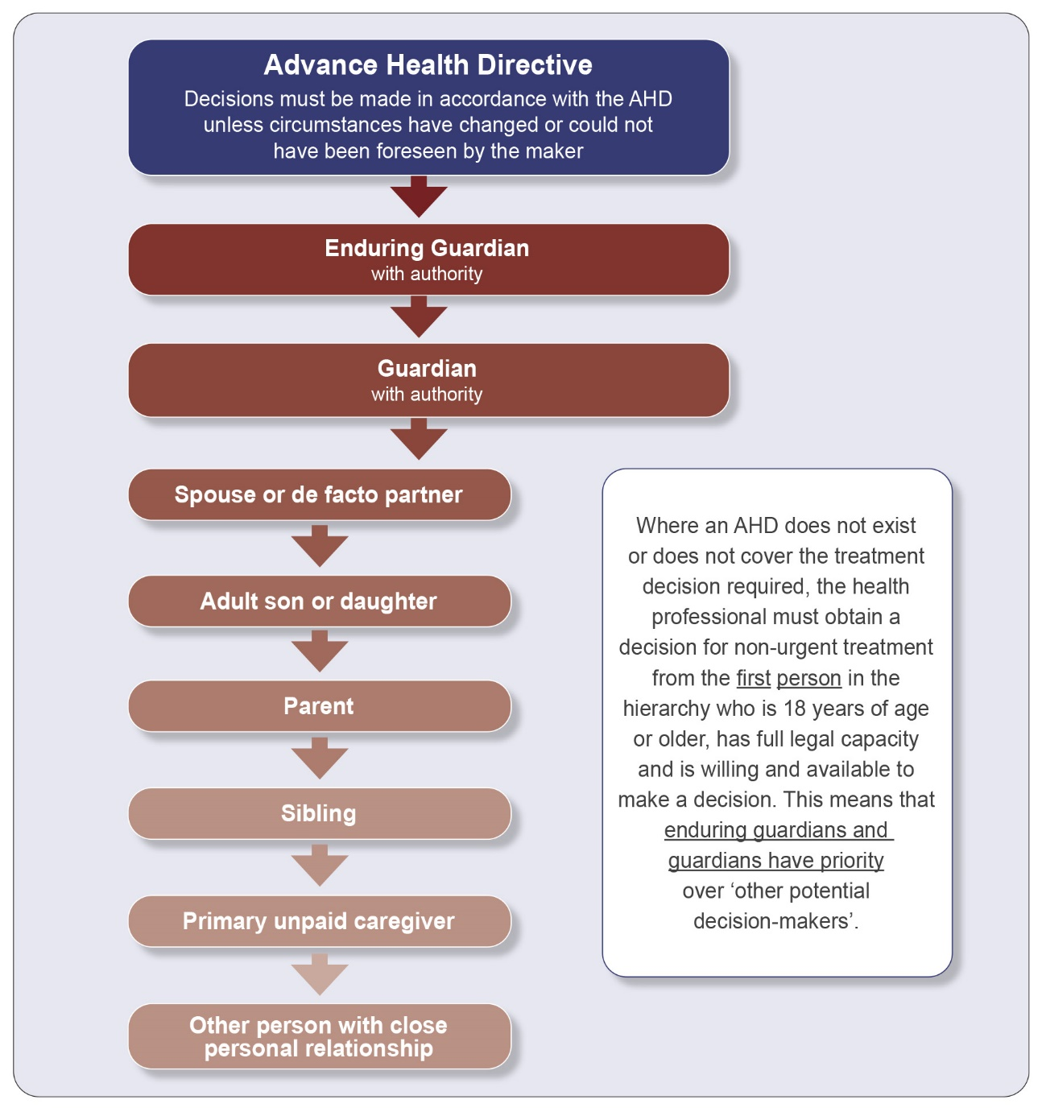

6.5 How will decisions be made if treatment is needed urgently?
If treatment is needed urgently and you are not immediately available, but another person in the hierarchy is available, the responsible health professional should seek a treatment decision from that person.
If no one in the hierarchy is immediately available the responsible health professional can make the required treatment decision.

6.6 How will decisions be made if treatment is not urgent?
If the appointor has made an Advance Health Directive that covers the required treatment, the treatment will be provided or withheld according to that directive. However, if circumstances have changed since the Advance Health Directive was made, for example, improved treatments have become available for the condition, the health professional is likely to consult you – the enduring guardian – before a decision is made.
If the appointor has not made an Advance Health Directive, or it does not cover the treatment decision required, you will be asked to make a decision provided you have authority to make treatment decisions and are willing and available to make such a decision.
If you do not have authority to make treatment decisions, the next person in the hierarchy of treatment decision-makers will be asked to make the decision.

6.7 What steps should I follow when making treatment decisions?
Making treatment decisions can be difficult especially if you have a choice of treatment options. It is important to familiarise yourself with the appointor’s general health and any diagnosed conditions, in particular any conditions about which you might be required to make a treatment decision.
To assist you in making treatment decisions:
- Talk to the appointor, members of their family, their general practitioner and other health professionals.
- Ask the appointor’s general practitioner about any health checks they might need and how often these should occur.
- Meet the treating doctor to discuss the diagnosis, the advantages, disadvantages and risks of any proposed treatment and the prognosis following treatment. You might also investigate other treatment options.
- Seek a second opinion before making any major decisions.
- If you have the authority to make medical research decisions, seek a written determination from an independent medical practitioner before making any research decisions (see part 6.10).
- Make decisions only when you are confident you have all the information necessary to make a decision in the appointor’s best interests. It might also be helpful to discuss treatment options with other family members.

You should provide the general practitioner and any other health professionals with your contact details so you can be reached easily if decisions need to be made.

6.8 How should I inform health professionals of my decisions?
If you are present at a medical appointment you can make the treatment decision in person and the health professional can give you the required forms to sign. If you cannot attend a medical appointment you will need to discuss with the health professional how your decision should be provided. You might be able to give your decision over the phone or send any required forms by fax or email.

6.9 How do I record treatment decisions?
It is not a legal requirement to keep records of treatment decisions, however the Public Advocate recommends you keep details of any decisions you make, including how each was reached.
For example, if you make a treatment decision you could note:
- the decision (whether consent was given for treatment and if so, which treatment was chosen)
- the date the decision was made
- the names of any health professionals or other persons you consulted in the process
- the treatment options available for the specific condition
- the main reasons for making that decision.
These records can be important if decisions are ever questioned, or if another party with an interest in the matter makes an application to the Tribunal.

6.10 Can I make decisions about the appointor being involved in approved medical research?
If you are an enduring guardian with all functions authorised, or if the appointor has provided you with specific authority in their EPG to make decisions about medical research, you have authority to make research decisions. This would include consenting, on behalf of the appointor, to participation in medical research which has been approved by a Human Research Ethics Committee.

First check if the appointor has made a valid Advance Health Directive which covers the treatment decision required (see part 6.4).

Before making a decision to consent, or refuse consent, to any new or experimental treatments proposed as part of approved medical research, you must seek information (known as a determination) from an independent medical practitioner that the medical research is in the best interests of the appointor, or not adverse to their interest.

The independent medical practitioner must provide you with the existing treatment options, and advise if the proposed medical research treatments involve substantial risk to the represented person greater than if they did not participate in the research. The independent medical practitioner’s determination must be provided in writing.

You must be convinced that the new or experimental treatments are in the best interests of the appointor, or not adverse to their interest, before consenting.

For more information see Appendix B: Hierarchy (order of priority) of medical research decision-makers, and refer to the Position Statement: Decisions about medical research available on the Office of the Public Advocate’s website: www.publicadvocate.wa.gov.au

7 MAKING DECISIONS ABOUT PERSONAL AND LIFESTYLE MATTERS

7.1 What is meant by personal and lifestyle matters?

Besides making treatment decisions you may need to make decisions about personal and lifestyle matters. These may include where a person lives, the type of support services they receive and the people with whom they have contact. The areas over which you are authorised to make decisions will be stated in the EPG.

7.2 Who can make decisions about personal and lifestyle matters?

As an enduring guardian, you would be the first person asked to make personal and lifestyle decisions, assuming you have been appointed with the appropriate authority and are willing and available.

If you do not have the appropriate authority or are not willing or available to make a decision, and a guardian appointed by the Tribunal has the appropriate authority, they must make the decision.

If no one has the appropriate authority, you can apply to the Tribunal to vary the terms of the EPG or be appointed guardian with the relevant decision-making authority.

7.3 What information should I gather before making a personal or lifestyle decision?

As an enduring guardian you should familiarise yourself with all agencies that support the appointor’s current lifestyle. These might include home help, meals on wheels and nursing agencies. These agencies might be able to provide you with information that will assist you in making decisions.
A home support agency for example, might be able to provide you with information and advice on:
- the appointor’s current support requirements
- whether additional support is available
- ways of minimising risks in the home.

You might still want to seek a second opinion before making a decision. For example, before agreeing to the appointor being moved into new accommodation you might seek a second opinion about whether the person could access the required support to remain in their current home.

7.4 What is meant by available and willing?
It is not always possible to anticipate when decisions will need to be made, but if you have accepted an appointment as an enduring guardian you should be generally available to make the types of decisions listed in the EPG. It is important you provide relevant health and other professionals with your contact details.
Often you will be aware of pending decisions and can plan for these. For example, if a person needs to move into care or requires more home support services, you can arrange to be available when needed. Similarly, non-urgent treatment can usually be scheduled for a time when you will be available to make treatment decisions.
If you are going to be unavailable for a specific period, for example while on holiday, you should leave your contact details with relevant parties so you can be contacted if a decision is needed.
If a decision is required urgently and you are not available, a social worker or other professional may need to apply to the Tribunal for the appointment of a guardian with the power to make the required decision (see parts 8 and 9). In these circumstances you might request a review of the Tribunal’s order when you become available to make a decision, for example on returning from holidays.

7.5 How should I record the personal and lifestyle decisions I have made?
It is not a legal requirement to keep records however the Public Advocate recommends you keep details of any decisions you make, including how each was reached.
For example, if you make a decision about where the appointor should live, you could note:
- the decision (which facility was chosen for the person)
- the date the decision was made
- the names of any service providers, health professionals or other persons you consulted in the process
- the main reasons for making that decision.
These records can be important if decisions are ever questioned or if another party with an interest in the matter makes an application to the Tribunal.

7.6 Where can I get advice to assist with making decisions ?
The Office of the Public Advocate’s Telephone Advisory Service (1300 858 455) operates weekdays between 9am and 4.30pm and can provide you with information and advice. The advisory officer can not make a decision for you but can guide you on the issues you might consider in reaching a decision.

GENERAL INFORMATION

8 ENDURING POWER OF GUARDIANSHIP AND GUARDIANSHIP

8.1 What is a guardian?

A guardian, as opposed to an enduring guardian, is appointed by the State Administrative Tribunal and given legal authority to make personal, lifestyle, treatment and medical research decisions for an adult with a decision-making disability. The decision-making authority of a guardian may be limited to specific areas such as treatment and accommodation (a limited guardianship order) or may apply to all areas (a plenary guardianship order).

8.2 What is the difference between a guardian and an enduring guardian?

Guardian | Enduring Guardian
Appointed by the Tribunal to make decisions for a person who has already lost the capacity to make their own decisions. | Chosen by the person (appointor) to make decisions on their behalf in the future (in the event that they lose capacity).
Decision-making authority is determined by the Tribunal when the appointment is made. | Decision-making authority is determined by the appointor when making their EPG.
Operates under a guardianship order, made by the Tribunal. | Operates under an EPG, made by the appointor.

8.3 Will it ever be necessary to apply for a guardianship order?
If you (the enduring guardian) have been asked to make a decision on a matter that is outside your authority under the EPG, you can apply to the Tribunal for an order to vary the terms of the EPG or for a guardianship order.

8.4 Who can advise on whether an application for a guardianship order would be appropriate?
An advisory officer from the Office of the Public Advocate’s Telephone Advisory Service (1300 858 455) can advise on whether there might be a need to apply to the Tribunal for the appointment of a guardian.

8.5 Who can apply for a guardianship order?
The Act states that anyone with a ‘proper interest’ may apply for a guardianship order. Usually it will be a family member or friend, but health professionals and other service providers may also apply. There is no cost involved in making an application for a guardianship order.

9 THE STATE ADMINISTRATIVE TRIBUNAL

9.1 What is the role of the State Administrative Tribunal in EPGs?
The Tribunal has no role in the appointment of an enduring guardian but can intervene in the operation of an EPG if there is a dispute over:
- the capacity of the appointor
- the operation of the EPG
- the authority of the enduring guardian.

The Tribunal may ask the Office of the Public Advocate to investigate and report back about concerns raised in an application (see part 10.2). The Tribunal would then use the information to assist it in making its decision.

In relation to the operation of EPGs the Tribunal can:
- declare an EPG valid or invalid
- declare an appointor incapable of making reasonable judgements in relation to health and lifestyle matters
- revoke a declaration that an appointor is unable to make reasonable judgements in relation to health and lifestyle matters
- give directions about the operation of an EPG or how the terms of an EPG should be interpreted
- revoke or vary the terms of an EPG.

In relation to an enduring guardian, the Tribunal can:
- revoke the appointment of an enduring guardian (or substitute enduring guardian) if the enduring guardian:
  - wishes to be discharged
  - has been guilty of neglect or misconduct, that in the Tribunal’s opinion makes the person unfit to continue in the role
  - appears to the Tribunal to be incapable (physically or mentally) of carrying out his or her required duties.

The Tribunal can also recognise a document that has been made outside Western Australia as an EPG, provided it meets Western Australia’s legislative requirements.

9.2 Who can apply to the Tribunal to intervene in an EPG?
Anyone with a proper interest can apply to the Tribunal for a decision about any aspect of an EPG or the actions of an enduring guardian.
The Tribunal will decide whether a person has a proper interest. An appointor, enduring guardian or substitute enduring guardian would generally be considered to have a proper interest.
An appointor may apply to the Tribunal, even if he or she has lost capacity.

If you have been appointed as an enduring guardian and are unable to continue in your role for any reason, you can apply to the Tribunal to be discharged from the role (see part 11).

9.3 How do I apply to the Tribunal?
To make an application to the Tribunal visit the eCourts portal: http://ecourts.justice.wa.gov.au/eCourtsPortal/

You can select the relevant application form/s if known, or answer some questions which will direct you to the appropriate application form/s. When you are ready to apply, you will be directed to a login screen (for already registered users) or a registration page (for first time users). Once logged in or registered you can proceed with your application and submit it, or save your progress to complete later.

If you are unable to make an application via the eCourts portal please contact the Tribunal for assistance (see part 12.2).

If you are unsure if you should make an application about the operation of an EPG, you can discuss your concerns with an advisory officer from the Office of the Public Advocate’s Telephone Advisory Service on 1300 858 455.

9.4 When does a decision made by the Tribunal come into force?
A decision made by the Tribunal can come into force when it is made, or at a time specified by the Tribunal. Under the Act, the Tribunal may backdate the time from which an order it has made takes effect.

9.5 Can Tribunal decisions be appealed?
Interested parties may appeal a decision made by the Tribunal. Information on the appeals process can be obtained from the Tribunal at the end of the hearing.

10 INVESTIGATIVE ROLE OF THE PUBLIC ADVOCATE

10.1 Who is the Public Advocate?
The Public Advocate is an independent statutory officer appointed under section 97 of the Guardianship and Administration Act 1990 to protect and promote the human rights of adults with a decision-making disability and to reduce their risk of neglect, exploitation and abuse.

10.2 What authority does the Public Advocate have to investigate concerns about EPGs?
The Public Advocate is authorised under section 97(1)(c) of the Act to investigate any concern or allegation that a person is in need of a guardian or administrator.
If you believe an enduring guardian is not acting in the best interests of an appointor, or may be abusing the appointor, you should contact the Office of the Public Advocate’s Telephone Advisory Service on 1300 858 455 to discuss your concerns.
The Office of the Public Advocate may conduct an investigation or refer you to the Tribunal. The Tribunal can also refer matters before it to the Office of the Public Advocate for further investigation.
If it appears that a criminal offence has been committed, the Public Advocate will refer the matter to the Western Australian Police.

11 REVOKING / RENOUNCING AN EPG

11.1 Why might an EPG end?

There are circumstances in which an EPG may need to end, such as if the:

    - appointor decides to change the arrangements set out in the EPG
    - appointor changes their mind about who they want as their enduring guardian
    - enduring guardian is no longer willing or able to perform the functions required.

The appointor would need to revoke the EPG if they wanted to change the arrangements set out in their EPG.

An enduring guardian or substitute enduring guardian who was no longer willing or able to remain in the role would need to renounce (or resign from) his or her role or apply to the Tribunal to be discharged from the role.

11.2 Revoking an EPG

To revoke an EPG the appointor must have full legal capacity.
The Act does not refer to the process of revocation by the appointor. This is governed by common law. Written revocation of the EPG is not a legal requirement. However, the Public Advocate recommends that the appointor give written notification to all enduring guardians and substitute enduring guardians that they have revoked the EPG. The appointor should request the enduring guardians return all copies of the EPG, which can then be destroyed.
All relevant persons and organisations, including the appointor’s general practitioner, other health professionals and family members, should also be advised in writing of the revocation.
An appointor who has lost capacity cannot revoke an EPG. The Act provides this safeguard to ensure the appointor is not persuaded by others to change their enduring guardian once they have lost capacity.
An appointor who has lost capacity may however apply to the Tribunal for an intervention order.

11.3 What if an enduring guardian wants to resign?

An enduring guardian who wants to resign from their role can do so only while the appointor still has capacity.
Once the appointor has lost capacity and the EPG is in operation, an enduring guardian cannot resign but must apply to the Tribunal to be discharged from the role (see part 12.2).

11.4 How does an enduring guardian resign?

To resign an enduring guardian should notify the appointor in writing and return to them any copies of the EPG and other personal records in their possession.

11.5 What happens if an enduring guardian loses capacity or dies while an EPG is in operation?

If a sole enduring guardian dies or loses capacity while an EPG is in operation and a substitute enduring guardian has been nominated in circumstances including death or loss of capacity of the enduring guardian, the substitute enduring guardian will take over the role. If a substitute enduring guardian has not been nominated, a person with a proper interest in the matter may apply to the Tribunal for the appointment of a guardian, if there is a need for decisions to be made.
If a joint enduring guardian dies or loses capacity while an EPG is in operation, the remaining joint enduring guardian needs to check clause 3 of the EPG form to see if they are authorised to continue in the role. Depending on how clause 3 is completed, they may need to apply to the Tribunal for a variation in the terms of the EPG to ensure they can continue to act as the enduring guardian.

11.6 What happens if the Tribunal discharges an enduring guardian?
If the Tribunal discharges an enduring guardian and there are other enduring guardians or substitute enduring guardians, the EPG will remain in force with the remaining enduring guardians empowered to act.
If there are no other enduring guardians or substitute enduring guardians, the Tribunal may make a guardianship order when it discharges the enduring guardian.
If an EPG is revoked by the Tribunal, or its terms are changed substantially, it is recommended that all relevant persons and organisations be notified by the remaining enduring guardians or appointed guardian.

11.7 What happens if an appointor divorces or separates from an enduring guardian?
Separation or divorce will not affect the validity of an EPG where the appointor and enduring guardian have been married or in a de facto relationship.
An appointor who wants their EPG to continue, does not need to take any action.
An appointor who no longer wants their former spouse or de facto partner to be their enduring guardian, will need to revoke the EPG (see part 11.2).
If the parties have separated or divorced and the appointor does not have capacity, an interested party may apply to the Tribunal for a decision on whether the EPG should continue to operate.

11.8 What happens if an appointor makes another EPG?
If an appointor makes a new EPG, the existing EPG will not automatically become invalid. In some situations, a person may choose to make more than one EPG, appointing different enduring guardians to perform different functions.
If an appointor makes a new EPG to replace their existing EPG, it is strongly recommended that they revoke the existing EPG in writing and attach a copy of the revocation to their new EPG (see part 11.2). This will prevent any confusion about which EPG is valid.

11.9 Can an appointor change the content of an EPG?

If an appointor wants to change any aspect of an EPG the Public Advocate recommends that a new EPG be made and the old EPG be revoked in writing (see part 11.2). This will ensure the EPG reflects the wishes of the appointor and that all parts of the form are completed correctly.

12 FOR FURTHER INFORMATION

12.1 Office of the Public Advocate
PO Box 6293, East Perth WA 6892
Telephone: 1300 858 455
Email: opa@justice.wa.gov.au
Internet: www.publicadvocate.wa.gov.au

The Public Advocate provides advice and information on guardianship and administration, Enduring Powers of Attorney and Enduring Powers of Guardianship. Further copies of this publication, a kit which assists people to complete an EPG, and a guide and kit to assist with the completion of an Enduring Power of Attorney are also available from the office’s website.

12.2 State Administrative Tribunal (the Tribunal)
Level 6, State Administrative Tribunal Building,
565 Hay Street, Perth WA 6000
Telephone: (08) 9219 3111
Email: sat@justice.wa.gov.au
Internet: www.sat.justice.wa.gov.au

The State Administrative Tribunal can be contacted for information and advice on applications for guardianship, administration, Enduring Powers of Guardianship, Enduring Powers of Attorney and Advance Health Directives and to obtain the application forms. Information and application forms are also available from the eCourts portal: http://ecourts.justice.wa.gov.au/eCourtsPortal/

12.3 Department of Health
Telephone: (08) 9222 2300
Email: acp@health.wa.gov.au
Internet: www.health.wa.gov.au/advancecareplanning

The Department of Health provides advice and information on Advance Health Directives. A consumer booklet to assist people considering making an Advance Health Directive is available from the Department of Health’s website.

Appendix A

Hierarchy (order of priority) of treatment decision-makers

To be read in conjunction with sections 110ZD and 110ZJ of the Guardianship
and Administration Act 1990. In the flowchart below, an Advance Health Directive (AHD) may be in the prescribed form or a common law directive.

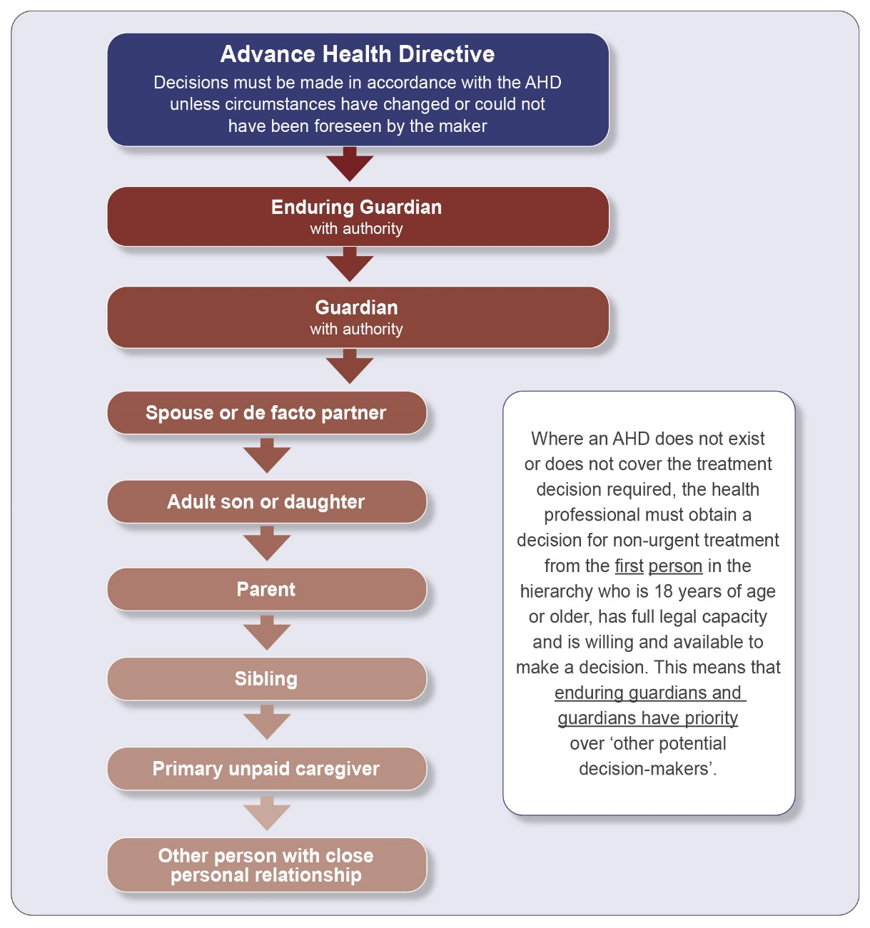

If you are unable to make decisions for yourself and non-urgent treatment is needed, treatment decisions will be made according to the list above. If you do not have an appropriate or valid Advance Health Directive, the health professional will seek a treatment decision from the first person on the list who is 18 years of age or older, has full legal capacity and is willing and available to make the decision.

What if you need urgent treatment?
If urgent treatment is required to save your life or prevent unnecessary pain, health professionals can provide this treatment without seeking consent. However they will need to seek consent for ongoing treatment.
Appendix B

Hierarchy (order of priority) of medical research decision-makers

To be read in conjunction with Sections 110ZP and 110ZQ of the Guardianship and Administration Act 1990. In the flowchart below, an Advance Health Directive (AHD) many be in the prescribed form or a common law directive.

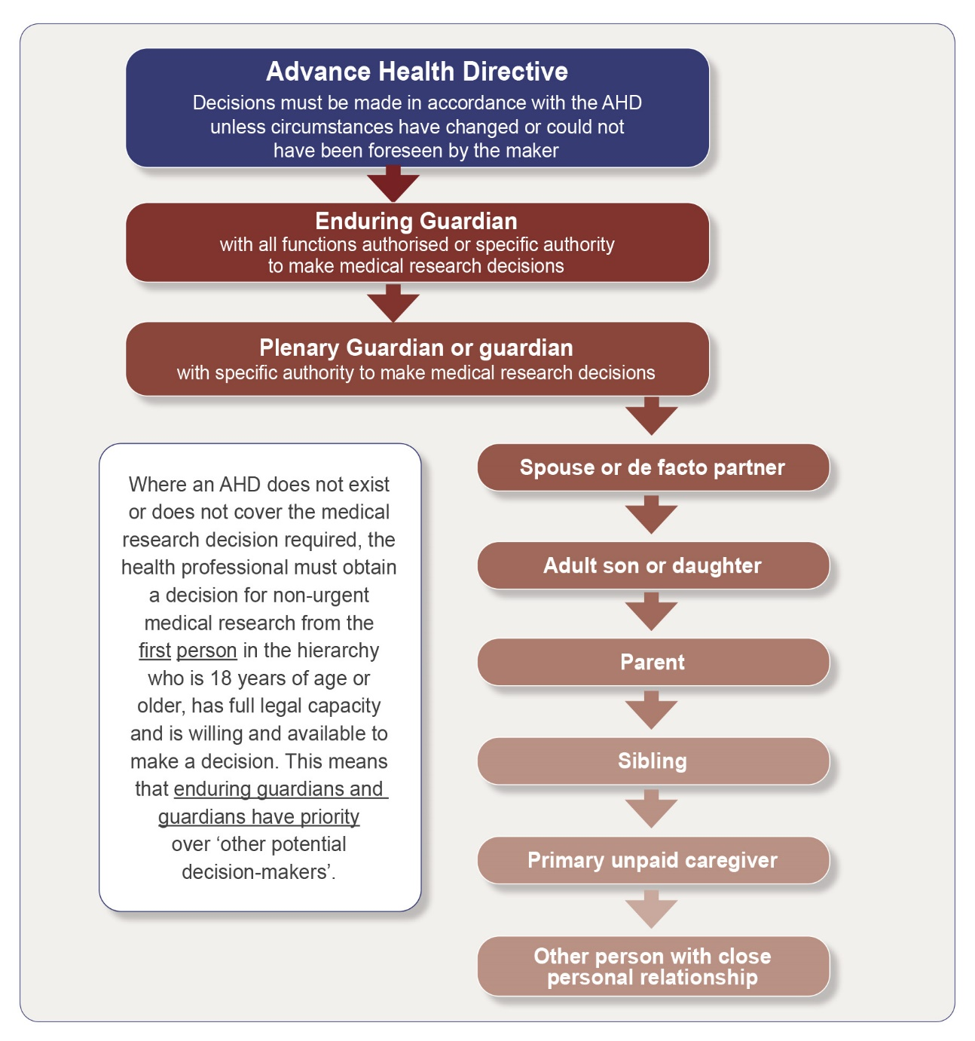

The research decision-maker must seek information (known as a determination) from an independent medical practitioner that the approved medical research is in the best interests of the represented person, or not adverse to their interest. The independent medical practitioner must provide the research decision-maker with existing treatment options, and advise if the proposed medical research treatments involve substantial risk to the represented person greater than if they did not participate in the research. The independent medical practitioner’s determination must be provided in writing.

For more information refer to the Position Statement: Decisions about medical research available on the Office of the Public Advocate’s website: www.publicadvocate.wa.gov.au
Appendix C

Marksman and readover clauses

Samples of these clauses are included below for guidance. All witnesses should meet the requirements of any particular clause. Where necessary, an interpreter should sign the document as witness if qualified to do so or if not so qualified, sign in addition to the two qualified witnesses.

1. A person who understands English but cannot write

Signed by (name of marksman) __________________________________________
by making (his or her) mark, (he or she) being incapable of signing (his or her) name.

Mark ________________________________________________________________
In the presence of (witness’s signature) _____________________________________
(witness’s full name) ____________________________________________________
(witness’s address) _____________________________________________________
(occupation of witness) __________________________________________________
on (date) _____________________________________________________________

2. A person who understands English but cannot read or write

Signed by (name of marksman) __________________________________________
by making (his or her) mark, (he or she) being unable to read or write, after this instrument had been read and explained to (him or her) and (he or she) then appearing to understand fully its nature and effect.

Mark ________________________________________________________________
In the presence of (witness’s signature) _____________________________________
(witness’s full name) ____________________________________________________
(witness’s address) _____________________________________________________
(occupation of witness) __________________________________________________
on (date) _____________________________________________________________

3. A person who does not understand English and cannot write

Signed by (name of marksman) __________________________________________
by making (his or her) mark, (he or she) being unable to read in the English language after this instrument had been read and explained to (him or her) in
(name of second language) ______________________________________________
by (name of interpreter) _________________________________________________
a person understanding both languages, (he or she) then appearing to understand fully its nature and effect.

Mark ________________________________________________________________
In the presence of (interpreter’s signature) ___________________________________
(interpreter’s full name) __________________________________________________
(interpreter’s address) ___________________________________________________
on (date) _____________________________________________________________

4. Execution by a person who does not understand English but who can write

Signed by (name of person) __________________________________________
(he or she) being unable to read in the English language after this instrument had been read and explained to (him or her)
in (name of second language) __________________________________________
by (name of interpreter) _________________________________________________
a person understanding both languages, (he or she) then appearing to understand fully its nature and effect.

Mark ________________________________________________________________
In the presence of (interpreter’s signature) ___________________________________
(interpreter’s full name) __________________________________________________
(interpreter’s address) ___________________________________________________
on (date) _____________________________________________________________

Appendix D

People authorised to witness Enduring Powers of Guardianship

Please note one of your witnesses must be from this list.

Schedule 2 of the Oaths, Affidavits and Statutory Declarations Act 2005 lists the people who are authorised to witness declarations in Western Australia. These are:
Academics (post-secondary institution)
Accountants
Architects
Australian Consular Officers
Australian Diplomatic Officers
Bailiffs
Bank managers
Chartered secretaries, governance advisers or risk managers
Chemists
Chiropractors
Company auditors or liquidators
Court officers
Defence force officers
Dentists
Doctors
Electorate officers of a member of State Parliament
Engineers
Industrial organisation secretaries
Insurance brokers
Justices of the Peace
Landgate officers
Lawyers
Local Government CEOs or deputy CEOs
Local government councillors
Loss adjusters
Marriage celebrants
Members of Parliament
Midwives
Ministers of religion
Nurses
Optometrists
Paramedics
Patent attorneys
Physiotherapists
Podiatrists
Police officers
Post office managers
Psychologists
Public notaries
State & Commonwealth public servants
Real estate agents
Settlement agents
Sheriffs or Deputy Sheriffs
Surveyors
Teachers
Tribunal officers
Veterinary surgeons

and anyone authorised under the Commonwealth Statutory Declarations Act 1959 to take a statutory declaration.

NOTE: No person under the age of 18 years is qualified to witness any Statutory Declarations or instruments.

Different criteria apply for execution of an EPG by witnesses in places other than Western Australia. If the EPG is signed elsewhere you should seek legal advice.

If you need more information about a person’s eligibility to be a witness, see the Office of the Public Advocate’s website www.publicadvocate.wa.gov.au or call the Telephone Advisory Service 1300 858 455.

Appendix E

Certifying copies of documents

What is a certified copy?
A certified copy is a photocopy of a document which has been certified as a direct copy of the original document.

Who can certify a copy?
There is no legislation in Western Australia that stipulates either how to certify a copy of a document or who can do it. However, it is usual for documents to be certified by a person who is authorised as a witness for statutory declarations under the Oaths, Affidavits and Statutory Declarations Act 2005 (see Appendix D).

How do I certify a copy?
Before certifying a document, you must ensure that the copy to be certified is an identical copy of the original. A suggested wording for the certification is as follows:

I certify that this appears to be a true copy of the document produced to me on <date>.
Signature
Name
Qualification (e.g. Justice of the Peace, Doctor)

The person certifying the document is stating their opinion that the document is a true copy, not that the original document is authentic. Certifying a copy does not in any way ‘authenticate’ either the copy or the original document.

Documents in languages other than English
You should not certify a document in a language other than English unless you can be sure that the original and the copy are identical. A solution to this is to have the original photocopied in your presence.

Multiple-page documents
If the original is a multiple-page document, each page must be checked against the copy to ensure that it is correct. You can then proceed as follows:

• sign or initial each page
• number each page of the copy as ‘page 1 of 40’, ‘page 2 of 40’ and so on
• certify the last page as follows:

I certify that this <number of pages> page document, each page of which I have numbered and signed/initialled, appears to be a true copy of the document produced to me on <date>.
Signature
Name
Qualification (e.g. Justice of the Peace, Doctor)

Appendix F

Glossary of terms used in this guide

Act
The Guardianship and Administration Act 1990 (Western Australia).

Advance Health Directive (AHD)
A document in which a person makes decisions about their future treatment.

Amending Act
The Acts Amendment (Consent to Medical Treatment) Act 2008.

Appointor
The person making an Enduring Power of Guardianship (EPG).

Appointee(s)
A person designated, and accepting appointment, as an enduring guardian.

Capacity
The extent to which a person is capable of making reasonable judgements about their personal welfare and treatment. See also ‘full legal capacity’.

Certified copy
A photocopy of a document which has been certified as a direct copy of the original document by an authorised witness (see Appendix D). For details on certifying copies of documents see Appendix E.

Enduring guardian
A person appointed under an Enduring Power of Guardianship to make personal lifestyle, treatment and medical research decisions on behalf of the appointor.

Enduring Power of Attorney (EPA)
A document in which a person nominates someone (known as an attorney) to manage their financial affairs.

Enduring Power of Guardianship (EPG)
A document in which a person nominates someone (an enduring guardian) to make personal, lifestyle, treatment and medical research decisions on their behalf in the event that they lose the capacity to do so themselves.

Full legal capacity
The capacity to make a formal agreement and to understand the implications of statements contained in that agreement.

Health professional
Includes doctors and nurses, surgeons, dentists and allied health practitioners.

Medical research
Research conducted with or about individuals, or their data or tissue, in the field of medicine or health, and includes an activity undertaken for the purpose of that research. Medical research does not include research which only analyses data and which does not result in the disclosure or publication of personal information.

Proper interest
A term used in the Act. It would usually include a person with a close relationship to the appointor, or someone who expressed a genuine concern about the welfare of the appointor.

Public Advocate
The Public Advocate is a statutory officer appointed under the Act to protect and promote the rights of adults with a decision-making disability.

Research decision-maker
A person who has the authority to consent, on behalf of a person with a decision-making disability, to participation in medical research which has been approved by a Human Research Ethics Committee that complies with the National Statement on Ethical Conduct in Human Research issued under the National Health and Medical Research Council Act 1992 (Commonwealth).

State Administrative Tribunal (the Tribunal)
The judicial body which, under the Act, hears matters about the operation of EPGs.

Treatment
Any medical, surgical or dental treatment or other health care, including a life-sustaining measure or palliative care.

In the Act, for the purposes of ‘Part 9B – Advance health directives’ and ‘Part 9E – medical research’, treatment is as defined above and includes medical research.

Treatment decision
A decision to consent or refuse consent, to the commencement or continuation of any treatment of the person.

In Part 9B of the Act, relating to Advance Health Directives, the definition of treatment decision is expanded to include participation in medical research.

