Prison Rule 2 Protection Prisoners
Prison

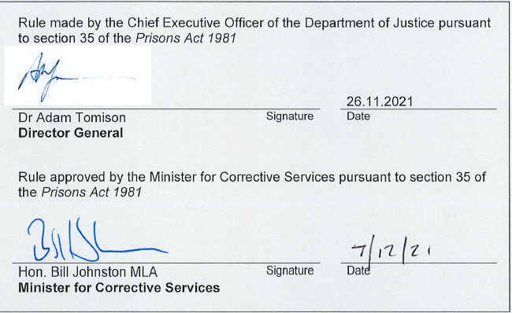

Version 1.0 approved | 7 December 2021
Current version | 1.0
Current version approved | 7 December 2021
Current version effective | 6 December 2021
Document reference | D21/943464

Contents
1 Purpose 3
2 Scope 3
3 Placement of Prisoners 3
4 Management, Control and Security of Protection Units and Protection Prisoners 3
5 Definitions and Acronyms 4
6 Related Legislation 4
7 Related COPPs 4

Purpose

This rule provides for the management, control and security of Protection Units and the protection prisoners therein in accordance with r 54(c) of the Prison Regulations 1982 and s 35 of the Prisons Act 1981.

Scope

This Rule applies to all prisons with a Protection Unit.

This Rule applies to all persons employed by the Department of Justice (the Department), and to all contract workers authorised by the Commissioner in accordance with s 15I (1) of the Prisons Act 1981 to perform a function.

Placement of Prisoners

The Protection Multi-Disciplinary Team Chair shall determine which protection prisoners are placed in a Protection Unit, in accordance with COPP – 4.10 Protection Prisoners.

Management, Control and Security of Protection Units and Protection Prisoners

Subject to paragraph 4.1.2 and 4.1.3 below, protection prisoners in a Protection Unit shall be provided with the same entitlements and privileges in accordance with COPP 10.1 – Prisoner Behaviour Management and shall be subject to the same policies and procedures (as set out in the various COPPs) as mainstream prisoners.

The Superintendent of a prison with a Protection Unit may restrict the movements, recreational activities, employment and education options of protection prisoners in Protection Units to minimise their contact with mainstream prisoners and maintain their safety and security.

Superintendents of a prison with a Protection Unit shall establish procedures and issue orders (as appropriate) regarding the:
- movements;
- access to employment, library, education and recreational activities
- placement options for prisoners on close supervision or separate confinement
- the manner in which visits are conducted.

of protection prisoners in Protection Units to minimise their contact with mainstream prisoners and maintain their safety and security.

Definitions and Acronyms
Term | Definition
Commissioner’s Operating Policy and Procedure (COPP) | Operational Instruments that provide instructions to staff on how the relevant legislative requirements are implemented.
Entitlement | All prisoners are entitled access to certain conditions, services, activities and items. These minimum entitlements are informed by legislation, common law and other relevant instruments.
Privilege | A concession or item available to a prisoner in addition to any entitlement provided under legislation or written instrument.
Superintendent | The Superintendent as defined in s. 36 Prisons Act 1981 includes any reference to the position responsible for the management of a private prison under Part IIIA Prisons Act 1981. This does not extend to the Officer In Charge of the prison.

Related Legislation
- Prisons Act 1981
- Prisons Regulations 1982

Related COPPs
- COPP 4.10 – Protection Prisoners
- COPP 10.1 – Prisoner Behaviour Management
Document version history
Version | Primary author(s) | Description of version | Date completed | Effective date
0.1 | Operational Policy | Initial draft | 24 May 2021 | n/a
0.2 | Operational Policy | Updated following consultation with SSO | 3 November 2021 | n/a
1.0 | Operational Policy | Approved by the Minister for Corrective Services |  | 6 December 2021

